Christ University
Name: Joel Joseph Motha Regno: 2448521
Course: Quantum Computing Component: CIA 3 - B
Question 1
1. Explain the resource advantage of superdense coding?
The superdense coding protocol provides a quantum advantage by doubling the classical information capacity of a qubit. By utilizing a pre-shared entangled resource (a Bell pair), Alice can transmit two classical bits of information to Bob by physically sending only one qubit. In classical physics, sending a single two-state particle could strictly convey only one bit of information.
2. How many qubits are physically transmitted from Alice to Bob?
One qubit. Alice operates on her half of the entangled pair and sends only that single specific qubit through the channel to Bob.
3. How many classical bits are successfully communicated upon measurement?
Two classical bits. Upon performing a Bell measurement (CNOT followed by Hadamard) on the pair, Bob successfully reconstructs the specific two-bit message ($00, 01, 10,$ or $11$) Alice intended to send.

Implementation:
from qiskit import QuantumCircuit, transpile
from qiskit_aer import AerSimulator

def superdense_coding_protocol(message):
# 1. Setup Circuit
qc = QuantumCircuit(2, 2)

# 2. Bell Pair
qc.h(0)
qc.cx(0, 1)

# 3. Alice's Encoding
if message == '00':
pass
elif message == '01':
qc.z(0)
elif message == '10':
qc.x(0)
elif message == '11':
qc.z(0)
qc.x(0)

# 4. Bob's Decoding
qc.cx(0, 1)
qc.h(0)

# 5. Measure
qc.measure([0, 1], [0, 1])

# Execute
backend = AerSimulator()
qc_compiled = transpile(qc, backend)
job = backend.run(qc_compiled, shots=1)
result = job.result().get_counts()

return list(result.keys())[0]

inputs = ["00", "01", "10", "11"]

print(f"{'Input':<10} | {'Received':<10} | {'Status'}")
print("-" * 35)

for msg in inputs:
received = superdense_coding_protocol(msg)
status = "✅ PASS" if msg == received else "❌ FAIL"
print(f"{msg:<10} | {received:<10} | {status}")

Output:
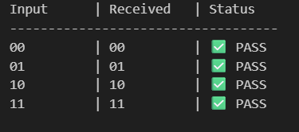
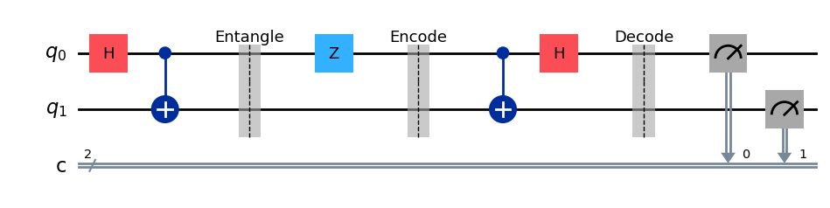

Proof & Analysis:
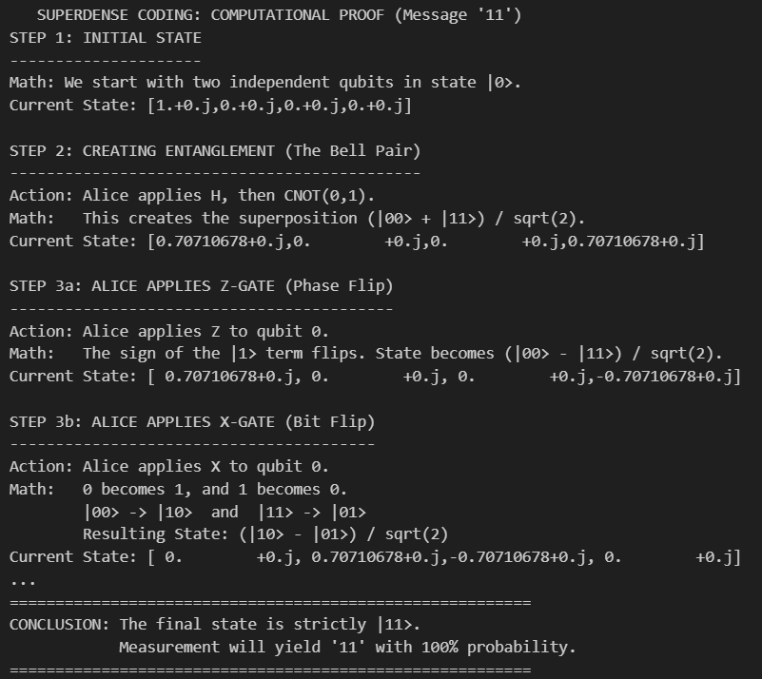

Question 2:
- Diffie–Hellman lets two parties create a shared secret key over an insecure channel using modular arithmetic.
- Public values: a large prime p and generator g
- Private values: Alice picks a, Bob picks b
They exchange:
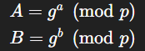
Both compute the same shared key:
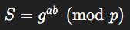
- Security comes from the difficulty of the Discrete Logarithm Problem. Standard DH has no authentication, making it vulnerable to Man-in-the-Middle (MitM) attacks where an attacker intercepts the exchanged values and impersonates both parties.

Implementation:
def diffie_hellman_simulation():
print("--- Diffie-Hellman Key Exchange Simulation ---\n")

# 1. Agree on public parameters
p = 23 # Prime number
g = 5 # Generator
print(f"Public Parameters: Prime (p)={p}, Generator (g)={g}")

# 2. Assign Private Keys (Secret)
a = 6 # Alice's private key
b = 15 # Bob's private key
print(f"Alice's Private Key (a): {a}")
print(f"Bob's Private Key (b): {b}")

# 3. Calculate Public Keys
# Alice computes A = g^a mod p
alice_public = (g ** a) % p

# Bob computes B = g^b mod p
bob_public = (g ** b) % p

print(f"\nCalculated Public Keys:")
print(f"Alice's Public Key (A) = {g}^{a} mod {p} = {alice_public}")
print(f"Bob's Public Key (B) = {g}^{b} mod {p} = {bob_public}")

# 4. Compute Shared Secret
# Alice computes Sa = B^a mod p (using Bob's public key)
shared_secret_alice = (bob_public ** a) % p

# Bob computes Sb = A^b mod p (using Alice's public key)
shared_secret_bob = (alice_public ** b) % p

print(f"\nComputing Shared Secrets:")
print(f"Alice calculates: {bob_public}^{a} mod {p} = {shared_secret_alice}")
print(f"Bob calculates: {alice_public}^{b} mod {p} = {shared_secret_bob}")

# 5. Programmatic Assertion
try:
assert shared_secret_alice == shared_secret_bob
print(f"\n✅ SUCCESS: Shared secrets match! Key = {shared_secret_alice}")
except AssertionError:
print(f"\n❌ ERROR: Shared secrets do not match.")

if __name__ == "__main__":
diffie_hellman_simulation()

Output:
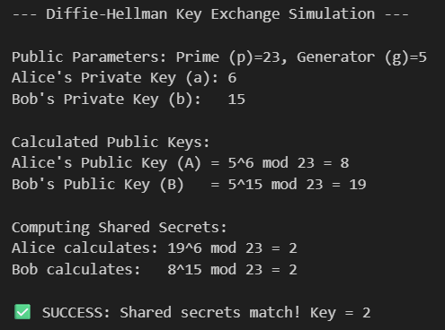
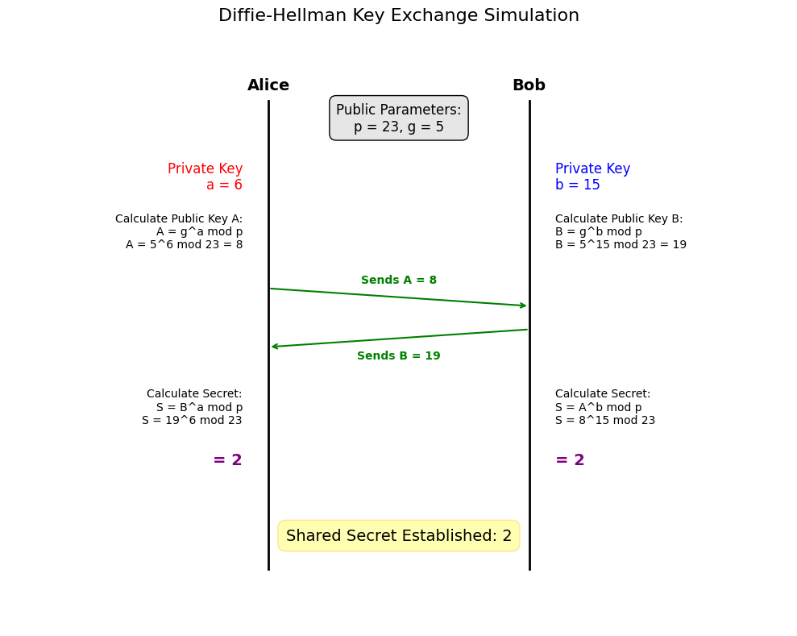

Proof & Analysis:
