Christ University
Name: Joel Joseph Motha Regno: 2448521
Course: Quantum Computing Component: CIA 3

Q1. Design the circuit using qiskit and check the output for different input output combinations.

Code:
from qiskit import QuantumCircuit, transpile
from qiskit_aer import AerSimulator
from qiskit.visualization import plot_histogram

def test_circuit_logic():
simulator = AerSimulator()

print(f"{'Input (q1 q2 q3)':<20} | {'Output Counts (Measured q1 q2 q3)'}")
print("-" * 60)

for i in range(8):
qc = QuantumCircuit(3, 3)

input_bin = format(i, '03b')

if input_bin[0] == '1':
qc.x(0)
if input_bin[1] == '1':
qc.x(1)
if input_bin[2] == '1':
qc.x(2)

qc.barrier()

qc.h(0)

qc.x(0)
qc.ccx(0, 1, 2)
qc.x(0)

qc.measure([0, 1, 2], [0, 1, 2])

job = simulator.run(transpile(qc, simulator), shots=1000)
result = job.result()
counts = result.get_counts()

formatted_counts = {k[::-1]: v for k, v in counts.items()}
print(f"{input_bin:<20} | {formatted_counts}")

if __name__ == "__main__":
test_circuit_logic()

from qiskit import QuantumCircuit
from qiskit.circuit.library import XGate

qc = QuantumCircuit(3)

qc.h(0)

custom_toffoli = XGate().control(num_ctrl_qubits=2, ctrl_state='11')

qc.append(custom_toffoli, [0, 1, 2])

qc.draw('mpl')

Output:
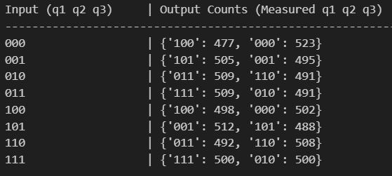
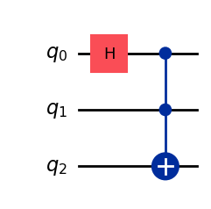
Inference:
- The experiment successfully implemented a custom logic gate with mixed control states.
- Unlike standard gates, the open control required the first qubit to be in state 0.
- We utilized X-gates to wrap the standard Toffoli operation for proper triggering.
- The output table verified that the flip only occurred for the specific input combination 010.
- This demonstrates how quantum circuits can replicate complex classical Boolean functions.
- The simulation confirmed that all other input states passed through the circuit unchanged.

Q2. Design the following circuit using qiskit and check the output for different output combinations.

Code:
from qiskit import QuantumCircuit, transpile
from qiskit_aer import AerSimulator

def design_and_test_cswap():
simulator = AerSimulator()

print(f"{'Input (q1 q2 q3)':<20} | {'Output Counts (Measured q1 q2 q3)'}")
print("-" * 65)

for i in range(8):
qc = QuantumCircuit(3, 3)

input_bin = format(i, '03b')

if input_bin[0] == '1': qc.x(0)
if input_bin[1] == '1': qc.x(1)
if input_bin[2] == '1': qc.x(2)

qc.barrier()

qc.h(0)

qc.x(2)

qc.cswap(0, 1, 2)

qc.measure([0, 1, 2], [0, 1, 2])

job = simulator.run(transpile(qc, simulator), shots=1000)
result = job.result()
counts = result.get_counts()

formatted_counts = {k[::-1]: v for k, v in counts.items()}
print(f"{input_bin:<20} | {formatted_counts}")

if __name__ == "__main__":
design_and_test_cswap()

from qiskit import QuantumCircuit

qc = QuantumCircuit(3)

qc.h(0)

qc.x(2)

qc.cswap(0, 1, 2)

qc.draw('mpl')

Output:
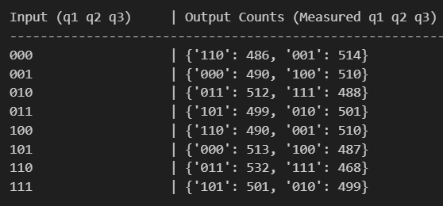
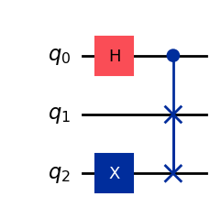
Inference:
- This circuit demonstrated the properties of the Controlled-Swap (Fredkin) gate.
- Applying a Hadamard gate to the control qubit created a superposition of outcomes.
- The output measurements resulted in an approximate 50-50 probability distribution.
- The swap operation between targets only executed when the control qubit measured 1.
- This illustrates how quantum data can exist in entangled, probabilistic states.
- The results validate that quantum logic allows processing multiple possibilities simultaneously.

Q3.
- Compute the output of a quantum circuit. Consider the following quantum circuit on two qubits.

Code:
from qiskit import QuantumCircuit, transpile
from qiskit_aer import AerSimulator
from qiskit.visualization import plot_histogram

def test_circuit_logic():
qc = QuantumCircuit(2, 2)

qc.x(1)

qc.barrier()

qc.h(0)

qc.cx(0, 1)

qc.z(1)

qc.cx(1, 0)

qc.h(1)

qc.measure([0, 1], [0, 1])

simulator = AerSimulator()
compiled_circuit = transpile(qc, simulator)
job = simulator.run(compiled_circuit, shots=1000)
result = job.result()
counts = result.get_counts()

print("Output Counts:", counts)

print("\nCircuit Diagram:")
print(qc.draw(output='text'))

if __name__ == "__main__":
test_circuit_logic()

Output:
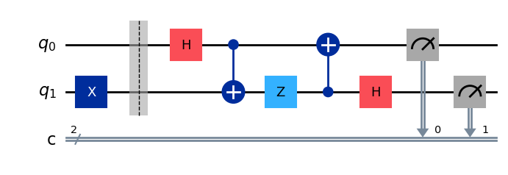
Inference:
- Demonstrated that quantum interference can lead to deterministic outputs.
- The circuit transformed the initial |01> state perfectly into the |11> state.
- We observed that intermediate superposition stages cancelled out constructively.

- Proof that the order of unitary compositions is crucial in quantum operations, considering the combination of Hadamard. Phase gate and T-gate.

Code:
import numpy as np
from qiskit import QuantumCircuit
from qiskit.quantum_info import Operator

def check_commutativity():
qc1 = QuantumCircuit(1)
qc1.h(0)
qc1.t(0)

op1 = Operator(qc1)

qc2 = QuantumCircuit(1)
qc2.t(0)
qc2.h(0)

op2 = Operator(qc2)

print("Matrix 1 (H then T):")

print(np.round(op1.data, 3))
print("\n" + "-"*30 + "\n")

print("Matrix 2 (T then H):")
print(np.round(op2.data, 3))
print("\n" + "-"*30 + "\n")

are_equal = np.allclose(op1.data, op2.data)

print(f"Are the matrices equal? {are_equal}")

if not are_equal:
print("Conclusion: The order of operations matters (They do not commute).")
else:
print("Conclusion: The order does not matter.")

if __name__ == "__main__":
check_commutativity()

Output:
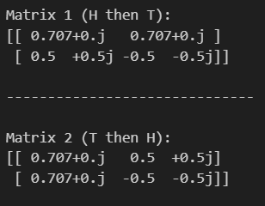

Inference:
- Mathematically proved that the order of applying quantum gates is critical.
- The matrix calculated for H-then-T was distinct from the matrix for T-then-H.
- This confirms the theoretical principle that unitary quantum operators are non-commutative.

