SRS 04.10.2014

Inhalt

1. Introduction 1

1.a. Purpose 1

1.b. Stakeholders 1

1.c. Definitions 2

1.d. System overview 2

1.e. References 2

2. Overall description 2

2.a. Use cases 2

2.b. Actor characteristics 10

3. Specific Requirements 10

3.a. Functional requirements 10

3.b. Non-functional requirements 10

# 1. Introduction

## 1.a. Purpose

The purpose is to provide a system where a Searcher can find a shared apartment and a Provider can place an ad for a shared apartment.

Our goal is to out beat the market with further methods for scheduling an appointment for visiting a shared apartment.

## 1.b. Stakeholders

Bledar Aga and ESE Team 7

## 1.c. Definitions

Searcher: A person who wants to find a room in a shared apartment.

Provider: A person who wants to find a person for a room in his/her apartment.

## 1.d. System overview

-

## 1.e. References

-

# 2. Overall description

## 2.a. Use cases

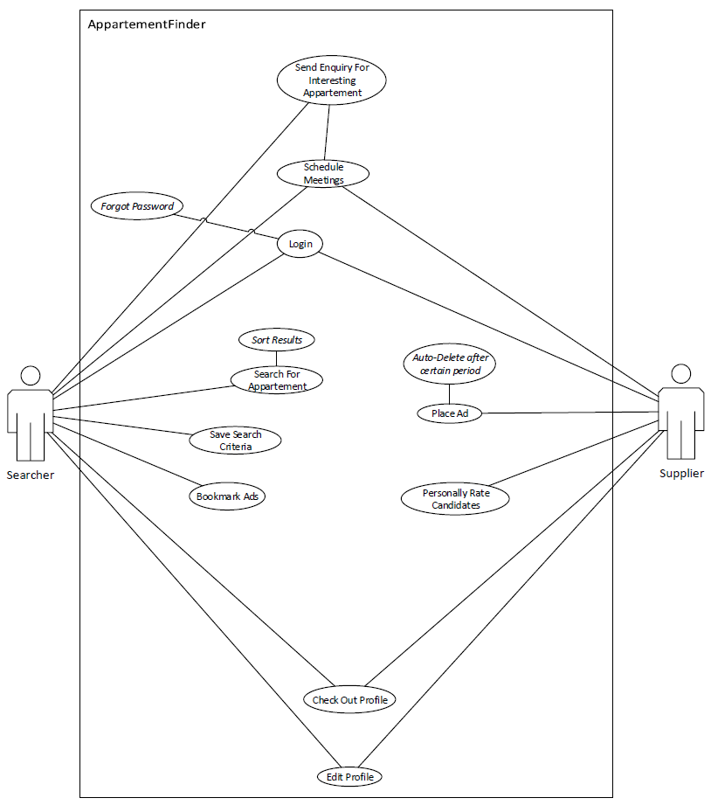

1. **Send Enquiry For interesting Apartment and Schedule Meetings**
   1. **Actors**

**Searcher**

**Provider**

* 1. **Description**

**As a searcher I want to search for a shared apartment, bookmark different options and send enquiries to a provider and schedule appointments with the provider.**

**As a provider I want to make an ad of my shared apartment, answer to enquiries, rank searchers and schedule appointments with the searcher**

* 1. **Trigger**

**Searcher sends enquiry to provider.**

* 1. **Pre-conditions**
     1. **There are apartment ads placed by providers**
  2. **Post-conditions**

1. **Searcher schedules an appointment with the provider successfully.**
   1. **Main Scenario**
2. **Provider places an ad**
3. **Searchers searches and finds ad**
4. **Searchers send an enquiry**
5. **Provider accepts enquiry**
6. **Searchers and Provider schedule appointment**
7. **After successful interaction the ad is deleted.**
   1. **Alternative Scenarios**

**None.**

* 1. **Special Requirements**
  2. **Notes**

1. **Login and forgotten password**
   1. **Actors**

**Searcher**

**Provider**

* 1. **Description**

**As a user I want to log in the system to set my profile settings and organize enquiries.**

* 1. **Trigger**

**User logs in**

* 1. **Pre-conditions**

**There is a valid profile to log in to**

* 1. **Post-conditions**

**User is able to organize enquiries or set/edit profile information.**

* 1. **Main Scenario**

**1. User opens login page**

**2. User fills form and logs in**

**3. User gets to his profile page**

* 1. **Alternative Scenarios**

**1. User forgot password**

**2. User needs to enter correct Email address**

**3. User gets Email with reactivation code**

**4. User logs in with reactivation code and sets up new password**

**5. User gets to his profile page**

* 1. **Special Requirements**
  2. **Notes**

1. **Search For Apartment**
   1. **Actors**

**Searcher**

* 1. **Description**

**The Searcher, an user that searches for certain types of shared apartments finds ads that match his search**

* 1. **Trigger**

**Searcher fills in Search Form and Submits**

* 1. **Pre-conditions**

**There are ads placed that can be browsed.**

* 1. **Post-conditions**

**Ads that match the search criteria are shown and ready to check out.**

* 1. **Main Scenario**

**1. Searcher opens search page**

**2. Fills in his relevant criteria**

**3. Clicks on “Search”**

**4. Is shown relevant ads**

* 1. **Alternative Scenario**

**None**

* 1. **Special Requirements**
  2. **Notes**

**What happens if there is no relevant ad?**

1. **Save Search Criteria**
   1. **Actors**

**Searcher**

* 1. **Description**

**As a searcher I want to be informed about new ads that are relevant to pre-edited search criteria**

* 1. **Trigger**

**New ad that matches Searcher profiles search criteria is placed**

* 1. **Pre-conditions**

**Searcher has set up his search criteria**

* 1. **Post-conditions**

**Email is sent to Searcher that a new relevant ad has been placed**

* 1. **Main Scenario**
     1. **Provider posts for a certain Searcher relevant ad**
     2. **Searcher gets informed by Email that a new promising ad has been placed.**
  2. **Alternative Scenario**

**None**

* 1. **Special Requirements**
  2. **Notes**

1. **Bookmark ads**
   1. **Actors**

**Searcher**

* 1. **Description**

**As a Searcher I want to save certain ads to a personal list**

* 1. **Trigger**

**Searcher finds an ad he wants to be informed about**

* 1. **Pre-conditions**

**There are ads**

* 1. **Post-conditions**

**Searcher has a bookmark list with relevant ads he wants to be informed about**

* 1. **Main Scenario**
     1. **Searcher finds interesting ad**
     2. **Searcher adds ad to his bookmark list**
  2. **Alternative Scenario**
  3. **Special Requirements**
  4. **Notes**

1. **Place Ad and Auto Delete after certain period**
   1. **Actors**

**Provider**

* 1. **Description**

**As a provider I want to place an ad and manage the period of placement**

* 1. **Trigger**

**Provider fills in form for ad and submits the form**

* 1. **Pre-conditions**

**An end date of the ad placement is submitted in the form**

* 1. **Post-conditions**

**Valid ads are kept in the system**

* 1. **Main Scenario**
     1. **Provider fills in ad form**
     2. **Provider submits form**
     3. **Ad is placed**
     4. **One week before ad placement end the provider is informed via Email**
     5. **Provider deletes ad or changes end date**
  2. **Alternative Scenario**
     1. **Provider fills in ad form**
     2. **Provider submits form**
     3. **Ad is placed**
     4. **One week before ad placement end the provider is informed via Email**
     5. **Provider doesn’t react to Email**
     6. **Ad goes inactive**
  3. **Special Requirements**
  4. **Notes**

1. **Personally Rate Candidates**
   1. **Actors**

**Provider**

* 1. **Description**

**As a provider I want to rate interesting candidates (Searchers)**

* 1. **Trigger**

**Provider accepts enquiry of a searcher**

* 1. **Pre-conditions**

**The searcher has sent an enquiry**

* 1. **Post-conditions**

**The provider has a list with ranked interesting candidates**

* 1. **Main Scenario**
     1. **A Searcher sends an enquiry**
     2. **Provider Accepts**
     3. **Provider ranks Searcher**
  2. **Alternative Scenario**

**None**

* 1. **Special Requirements**
  2. **Notes**

1. **Check Out and Edit Profile**
   1. **Actors**

**Searcher**

**Provider**

* 1. **Description**

**User logs in and is able to edit or update his or her profile.**

* 1. **Trigger**

**User logs in.**

* 1. **Pre-conditions**

**There is a valid profile for said user**

* 1. **Post-conditions**

**The profile edits or updates are saved**

* 1. **Main Scenario**
     1. **The User gets to his profile page**
     2. **The user gets into editing mode of the profile information’s**
     3. **The user saves the changes**
  2. **Alternative Scenario**
     1. **The user gets to his profile page**
     2. **Edits profile**
     3. **Closes without saving**
     4. **No changes are saved**
  3. **Special Requirements**
  4. **Notes**

# 2.b. Actor characteristics

**Searcher:** A person who wants to find a room in a shared apartment.

**Provider:** A person who wants to find a person for a room in his/her apartment.

# 3. Specific Requirements

## 3.a. Functional requirements

* The ad content has certain limits (Description letter limit, Pictures size limit).
* The ad form has some spaces that cannot be left empty.
* Users have a login, where they get to organize enquiries, rankings and bookmarks.
* Design a scalable system with mobile version options.
* Searcher gets informed when new ads are placed that matches his set up sear
* Bonus: Social Media linkable

## 3.b. Non-functional requirements