**Team:** J. Schärer, J. Niklaus, A. Sellathurai, S. Berger

**Customer:** Bledar Aga

**Update:** 07.10.2014

| **Version** | **Date** | **Revision Description** |
| --- | --- | --- |
|  |  |  |
|  |  |  |
|  |  |  |
|  |  |  |
|  |  |  |
|  |  |  |

ESE 2014 Project

Software Requirements Specification

Software Requirements Specification

Inhalt

1. Introduction 1

1.a. Purpose 1

1.b. Stakeholders 1

1.c. Definitions 1

1.d. System overview 1

1.e. References 1

2. Overall description 2

2.a. Use cases 2

2.b. Actor characteristics 9

3. Specific Requirements 9

3.a. Functional requirements 9

3.b. Non-functional requirements 9

# 1. Introduction

## 1.a. Purpose

This document is the Software Requirements Specification for the ESE 2014 apartment- and shared room search platform project. This software aims to provide a practical and easy to use environment for searching for apartments and shared rooms, as well as placing advertisements for such.

This document is meant for our customer and us, the development team, to deliver a common base and detailed description of all the criteria the software should meet in the end.

## 1.b. Stakeholders

Bledar Aga and ESE Team 7

## 1.c. Definitions

**Searcher:** A person who wants to find a room in a shared apartment.

**Provider:** A person who wants to find a person for a room in his/her apartment.

## 1.d. System overview

The purpose is to provide a system where a Searcher can find a shared apartment and a Provider can place an ad for a shared apartment.

Our goal is to out beat the market with further methods for scheduling an appointment for visiting a shared apartment.

## 1.e. References

Concerning main functionalities, such as placing an ad and searching for an apartment or shared room, we will take these following websites as examples:

* [www.wgzimmer.ch](http://www.wgzimmer.ch)
* [www.students.ch/wohnen/](http://www.students.ch/wohnen/)
* [www.tutti.ch/ganze-schweiz/immobilien/wg-zimmer](http://www.tutti.ch/ganze-schweiz/immobilien/wg-zimmer)

We will analyze their features and behavior to filter out good practice and improve their weaknesses.

# 2. Overall description

## 2.a. Use cases

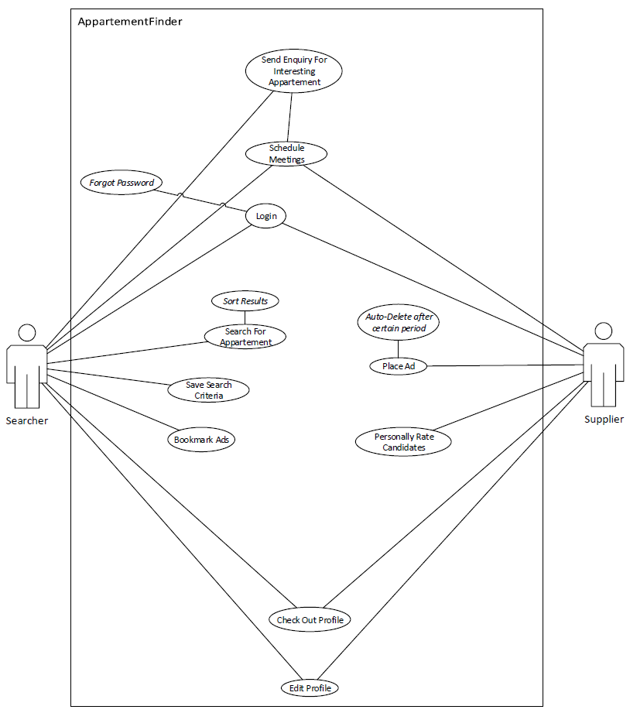

1. **Send Enquiry For interesting Apartment and Schedule Meetings**
   1. **Actors**

**Searcher**

**Provider**

* 1. **Description**

**As a searcher I want to search for a shared apartment, bookmark different options and send enquiries to a provider and schedule appointments with the provider.**

**As a provider I want to make an ad of my shared apartment, answer to enquiries, rank searchers and schedule appointments with the searcher**

* 1. **Trigger**

**Searcher sends enquiry to provider.**

* 1. **Pre-conditions**
     1. **There are apartment ads placed by providers**
  2. **Post-conditions**

1. **Searcher schedules an appointment with the provider successfully.**
   1. **Main Scenario**
2. **Provider places an ad**
3. **Searchers searches and finds ad**
4. **Searchers send an enquiry**
5. **Provider accepts enquiry**
6. **Searchers and Provider schedule appointment**
7. **After successful interaction the ad is deleted.**
   1. **Alternative Scenarios**

**None.**

* 1. **Special Requirements**
  2. **Notes**

1. **Login and forgotten password**
   1. **Actors**

**Searcher**

**Provider**

* 1. **Description**

**As a user I want to log in the system to set my profile settings and organize enquiries.**

* 1. **Trigger**

**User logs in**

* 1. **Pre-conditions**

**There is a valid profile to log in to**

* 1. **Post-conditions**

**User is able to organize enquiries or set/edit profile information.**

* 1. **Main Scenario**

**1. User opens login page**

**2. User fills form and logs in**

**3. User gets to his profile page**

* 1. **Alternative Scenarios**

**1. User forgot password**

**2. User needs to enter correct Email address**

**3. User gets Email with reactivation code**

**4. User logs in with reactivation code and sets up new password**

**5. User gets to his profile page**

* 1. **Special Requirements**
  2. **Notes**

1. **Search For Apartment**
   1. **Actors**

**Searcher**

* 1. **Description**

**The Searcher, an user that searches for certain types of shared apartments finds ads that match his search**

* 1. **Trigger**

**Searcher fills in Search Form and Submits**

* 1. **Pre-conditions**

**There are ads placed that can be browsed.**

* 1. **Post-conditions**

**Ads that match the search criteria are shown and ready to check out.**

* 1. **Main Scenario**

**1. Searcher opens search page**

**2. Fills in his relevant criteria**

**3. Clicks on “Search”**

**4. Is shown relevant ads**

* 1. **Alternative Scenario**

**None**

* 1. **Special Requirements**
  2. **Notes**

**What happens if there is no relevant ad?**

1. **Save Search Criteria**
   1. **Actors**

**Searcher**

* 1. **Description**

**As a searcher I want to be informed about new ads that are relevant to pre-edited search criteria**

* 1. **Trigger**

**New ad that matches Searcher profiles search criteria is placed**

* 1. **Pre-conditions**

**Searcher has set up his search criteria**

* 1. **Post-conditions**

**Email is sent to Searcher that a new relevant ad has been placed**

* 1. **Main Scenario**
     1. **Provider posts for a certain Searcher relevant ad**
     2. **Searcher gets informed by Email that a new promising ad has been placed.**
  2. **Alternative Scenario**

**None**

* 1. **Special Requirements**
  2. **Notes**

1. **Bookmark ads**
   1. **Actors**

**Searcher**

* 1. **Description**

**As a Searcher I want to save certain ads to a personal list**

* 1. **Trigger**

**Searcher finds an ad he wants to be informed about**

* 1. **Pre-conditions**

**There are ads**

* 1. **Post-conditions**

**Searcher has a bookmark list with relevant ads he wants to be informed about**

* 1. **Main Scenario**
     1. **Searcher finds interesting ad**
     2. **Searcher adds ad to his bookmark list**
  2. **Alternative Scenario**
  3. **Special Requirements**
  4. **Notes**

1. **Place Ad and Auto Delete after certain period**
   1. **Actors**

**Provider**

* 1. **Description**

**As a provider I want to place an ad and manage the period of placement**

* 1. **Trigger**

**Provider fills in form for ad and submits the form**

* 1. **Pre-conditions**

**An end date of the ad placement is submitted in the form**

* 1. **Post-conditions**

**Valid ads are kept in the system**

* 1. **Main Scenario**
     1. **Provider fills in ad form**
     2. **Provider submits form**
     3. **Ad is placed**
     4. **One week before ad placement end the provider is informed via Email**
     5. **Provider deletes ad or changes end date**
  2. **Alternative Scenario**
     1. **Provider fills in ad form**
     2. **Provider submits form**
     3. **Ad is placed**
     4. **One week before ad placement end the provider is informed via Email**
     5. **Provider doesn’t react to Email**
     6. **Ad goes inactive**
  3. **Special Requirements**
  4. **Notes**

1. **Personally Rate Candidates**
   1. **Actors**

**Provider**

* 1. **Description**

**As a provider I want to rate interesting candidates (Searchers)**

* 1. **Trigger**

**Provider accepts enquiry of a searcher**

* 1. **Pre-conditions**

**The searcher has sent an enquiry**

* 1. **Post-conditions**

**The provider has a list with ranked interesting candidates**

* 1. **Main Scenario**
     1. **A Searcher sends an enquiry**
     2. **Provider Accepts**
     3. **Provider ranks Searcher**
  2. **Alternative Scenario**

**None**

* 1. **Special Requirements**
  2. **Notes**

1. **Check Out and Edit Profile**
   1. **Actors**

**Searcher**

**Provider**

* 1. **Description**

**User logs in and is able to edit or update his or her profile.**

* 1. **Trigger**

**User logs in.**

* 1. **Pre-conditions**

**There is a valid profile for said user**

* 1. **Post-conditions**

**The profile edits or updates are saved**

* 1. **Main Scenario**
     1. **The User gets to his profile page**
     2. **The user gets into editing mode of the profile information’s**
     3. **The user saves the changes**
  2. **Alternative Scenario**
     1. **The user gets to his profile page**
     2. **Edits profile**
     3. **Closes without saving**
     4. **No changes are saved**
  3. **Special Requirements**
  4. **Notes**

## 2.b. Actor characteristics

**Searcher:** A person who wants to find a room in a shared apartment.

**Provider:** A person who wants to find a person for a room in his/her apartment.

# 3. Specific Requirements

## 3.a. Functional requirements

* The ad content has certain limits (Description letter limit, Pictures size limit).
* The ad form has some spaces that cannot be left empty.
* Users have a login, where they get to organize enquiries, rankings and bookmarks.
* Design a scalable system with mobile version options.
* Searcher gets informed when new ads are placed that matches his set up sear
* Bonus: Social Media linkable

## 3.b. Non-functional requirements

* The system delivers a UI that makes the main features easily accessible to every user with basic PC experience, with no need for further training.
* The application is usable on all platforms and display sizes because responsive webdesign is used (twitter bootstrap).
* Because users might often use the system from mobile devices the performance is greatly optimized.
* The user data is kept confidential and not passed on to third parties.
* The usage of the application is completely free of charge for both the provider and the searcher.
* The most frequently used features (such as bookmarking an object while looking at its profile) are accessible by just one click.
* Every user action has an immediate reaction. For example: If the user clicks “search”, some kind of response is shown, that lets him now the system is processing the request.
* Both database structure and usage are designed to ensure data consistency.