KeyStroke Biometrics with RNN
Joel Poah Zhi Kang
Diploma in Applied Artificial Intelligence and Analytics
School of Computing
Singapore Polytechnic

This technical paper aims to provide a solution to classify various types of sound through supervised learning. The goal will be to successfully classify various sounds using XGboost .
Keywords—classification,sound,supervisedlearning, XGboost,Principal Component Analysis (key words)

Introduction
Keystroke biometrics are a technique to verify an individual's identity by analyzing his or her typing patterns. This technology has several advantages over other security methods, such as machine learning, hardware tokens and password-only access. First, keystroke biometrics are easy to implement and are capable of providing high-level security for both sensitive and non-sensitive applications. Second, individual users can be identified with precision using this technology, which makes it an accurate method for security measures such as two-factor authentication and anti-spam applications. Finally, keystroke biometrics can be used without harming the device or the operating system.

Keystroke biometrics use algorithms to analyze a device's physical keys or keyboard inputs to identify the user. This method is increasingly used in both public and private sectors to ensure that only authorized individuals access information. For example, public transit agencies use keystroke biometrics to allow authorized personnel to access the transportation system while protecting against non-authorized users accessing the system. Additionally, insurance agencies use keystroke biometrics with their customers at claim processing. This allows them to reduce the number of incorrect payments and fraudulent claims while ensuring that only authorized individuals submit claims.

A keystroke biometric dataset consists of a set of input sequences (keystrokes) that are associated with a specific individual and a corresponding set of output sequences (texts). This data can be collected either manually or through an automated system by either capturing the user's actions or installing a keyboard capture driver on the device. Once the dataset is collected, it can be processed using machine learning algorithms to identify suitable sequences for use in keystroke authentication. This process involves constructing Hidden Markov Models (HMMs) from the raw sequences and deconstructing them into features for neural networks. A neural network is then trained using various hyperParameter values before evaluating matches between each user's input and generated HMMs. The best matches are then selected and reported back to the user for analysis. This process allows for accurate identification of users based on their typing habits without any external devices or experts needed.

Once the parameterized models have been developed, training can begin on the specific hardware environments used in real-world applications. In this stage, hyperParameter values are adjusted so that training produces optimal performance when applied to real hardware environments. The parameterized models then undergo live testing in a controlled environment using hardware with known characteristics (i.e., different models for different hardware). Finally, administrators decide whether users should undergo mandatory keystroke biometric testing whenever they use the system or whether they should set up an Authentication Application Programming Interface (API) so users can request authentication themselves whenever they wish.

As uses of keystroke biometrics increase, implementations of this technology become more commonplace. This makes it even easier for organizations to implement high levels of security while letting individual users take control over their security measures with customizable settings through APIs. As these technologies become more refined, it will be easier than ever to implement secure methods of identifying users based on their typing habits!

[1] The implementation of sound classification is widely used from the translation of speech to recognizing sounds, identification of music or songs
and automatic speech recognition. In this technical paper, I will attempt to classify audio and compare the results of XGboost

Related Works
Data Scientists around the world has been working on sound classification in the past.
Past works on urban sound classification has been deeply research on by J., Krishan , A., Ghosh , A.,Kumar , S., Dutta , A.,Charkrabarty[2] using their LSTM model to compare against machine learning techniques that were discovered Convolutional Neural Network (CNN) , Artificial Neural Network (ANN) and Region-Convolutional Neural Network. Their model has proved to be significantly better than models that were used in the past
Other related works includes a research on detection of cough recognition using Mel-Spectrogram and Convolutional Neural Network which was done by Q., Zhou, J., Shen , W., Ding , C., Wang, S.,Yuan , F.,Sun , H.,Li and B.,Fang. The Research was beneficial as detecting cough during the pandemic would help detect in advance the infection of covid 19 and then take precaution to prevent further spread.[6]

Process

Data
The Data was provided by J. Salamon, C. Jacoby and J. P. Bello, "A Dataset and Taxonomy for Urban Sound Research"[3] This data was collected for urban sound research which has various attributes and it is categorized into different types of classes such as ‘dog bark’ ,’children playing’

Exploratory Data Analysis
Importing the data and then viewing a sample .,wav file can show us a longitudinal wave from scipy and when viewing sounds of same classes eg. Dog_bark , we realise that they seem similar and within those signals in the waves , we can extract various features which can then help us implement it into the XGBoost machine learning algorithm.

Feature Engineering / Preproccessing
we use Mel-Frequency Cepstral Coefficients (MFCC) from the audio samples. The MFCC summarises the frequency distribution across the window size, so it is possible to analyse both the frequency and time characteristics of the sound. These audio representations will allow us to identify features for classification.
When MFCC is called on to a .wav file , it instantly extract 173 attributes from the .wav file. With reference to Fig 4,all attributes are made from the pattern or characteristic of a Sound wave. MFCC dives deeper than
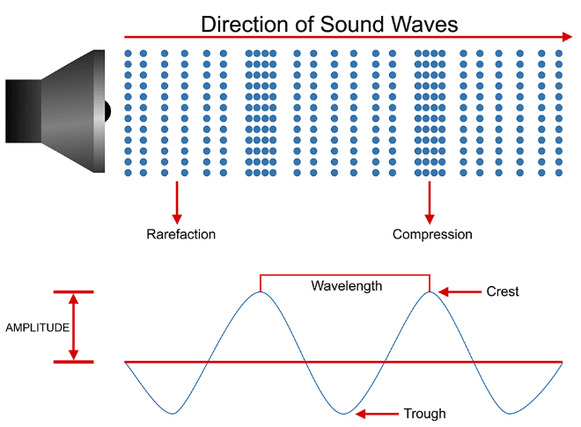
Fig .4 Characteristics of a sound wave

Sound processing
Using librosa we can extract the sample rate of a .wav file and in essence the sample rate refers The sampling rate refers to the number of samples of audio recorded every second. It is measured in samples per second or Hertz (abbreviated as Hz or kHz, with one kHz being 1000 Hz). An audio sample is just a number representing the measured acoustic wave value at a specific point in time. For n number of sample rate (Hz) its not enough for it to be just n number of samples in a second instead each sample has to be 1/n s apart from each other [4]
Looking at Fig 1,The librosa library that is imported attempts to read the .wav file and normalize the sample rate of the file. .Wav files are stereo files which means it has 2 audio channels Fig 2 whereas compared to mono channel audio files Fig 3 which only have 1 audio channel [5]
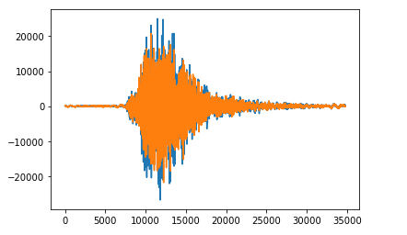
Fig 1 Librosa normalizing .wav file
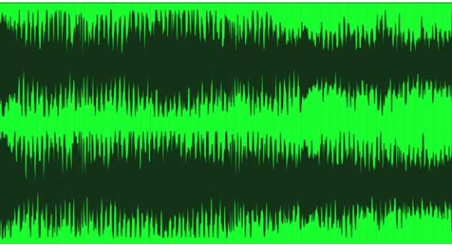
Fig. 2. Duo channel audio file
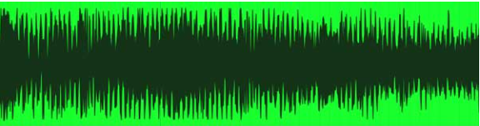 Fig. 3 Mono channel audio file
Sample rate = 1/n s

Extreme Gradient Boosting
To understand XGBoost we will first need to cover what exactly is boosting.

Boosting
Boosting is a method used to grant power to machine learning models to improve their accuracy of prediction. To improve the performance of the machine learning model, Boosting collects and converts weak learner to strong learner by taking the average/weighted average and considering the prediction with the higher vote [6]
Boosting combines predictions from several models into one. It does this by taking prediction from various models sequentially and distributes more weight to those models that perform better. [7]

How XGBoost works
XGBoost is a supervised learning algorithm that tries to predict the target variable through the means of combining estimates of a set of simpler weaker models just like Boosting where it distributes the weight to models that does better.

machine Learning Process
After cleaning up the data and extracting the 173 attributes from the .wav file, the data is split into train and test set where test set is 20% of the whole Urban Audio dataset. With reference to fig 4,a pipeline was then created to prevent data leakage and ‘objective’ of the XGBClassifer is set to ‘multi:softprob’ so that it can handle multiclass attributes better.
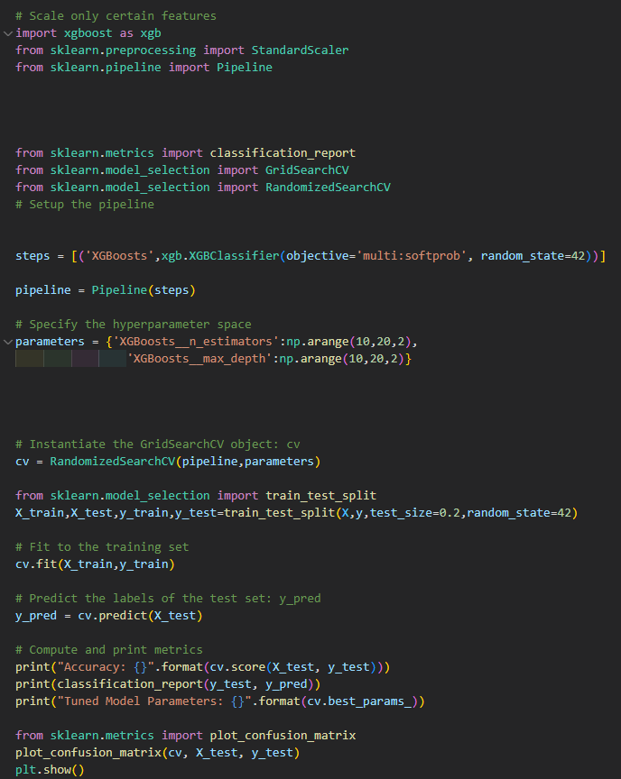
Fig 4 code for Pipeline and Machine Learning model

Conclusion

The model was able to predict and categorise the audio waves into 10 different categories 75% of the time. The XGBoost supervised learning algorithm is easy to deploy for classification. Running it out of the box gave a rather high accuracy. However, the data wrangling part was not as simple as it required quite a bit of understanding and domain knowledge on how Sound waves work.

Acknowledgment
I want to specially give thanks to Dr Wilson for giving me the opportunity to write this technical paper for my assignment

References

- K.,Kevin , M.,Roy,Accompaniment to “Comparing Anomaly-Detection Algorithms for Keystroke Dynamics” [ Available online] https://www.cs.cmu.edu/~keystroke/#sec2 [Accessed 23rd November 2022]
- N.Seth,Introduction to Audio Classificaiton-Emergency vs Nonemergency Vehicle [Available online] https://www.analyticsvidhya.com/blog/2021/07/introduction-to-audio-classification-emergency-vs-nonemergency-vehicle/#:~:text=Audio%20or%20sound%20classification%20is,speech%20recognition%2C%20and%20virtual%20assistants.[Accessed 11th June 2022]
- J., Krishan , A., Ghosh , A.,Kumar , S., Dutta , A.,Charkrabarty,Urban Sound Classification Using Convolutional Neural Networks and Long Short Term Memory Based on Multiple Features.[online] https://ieeexplore.ieee.org/abstract/document/9268723 [Accessed 11 June 2022]
- J. Salamon, C. Jacoby and J. P. Bello, "A Dataset and Taxonomy for Urban Sound Research", 22nd ACM International Conference on Multimedia, Orlando USA, Nov. 2014.
- R., Morkos Sampling Rates, Sample Depths, and Bit Rates: Basic Audio Concepts[online] https://www.vocitec.com/docs-tools/blog/sampling-rates-sample-depths-and-bit-rates-basic-audio-concepts#:~:text=The%20sampling%20rate%20refers%20to,a%20specific%20point%20in%20time. [Accessed 11 June 2022]
- C., hoffman Mono vs. Stereo Sound: The Difference Explained (With Audio Examples)[online] https://www.blackghostaudio.com/blog/mono-vs-stereo-sound-the-difference-explained-with-audio-examples#:~:text=Mono%20signals%20are%20recorded%20and,whereas%20mono%20sounds%20are%20not.[Accessed 11 June 2022]
- S.,Ray Quick Introduction to Boosting Algorithms in Machine Learning[online] https://www.analyticsvidhya.com/blog/2015/11/quick-introduction-boosting-algorithms-machine-learning/ [Accessed 11 June 2022]
- A.,Mello XGBoost: theory and practice[online] https://towardsdatascience.com/xgboost-theory-and-practice-fb8912930ad6 [Accessed 11 June 2022]

