**1: Manipulating Data with dplyr**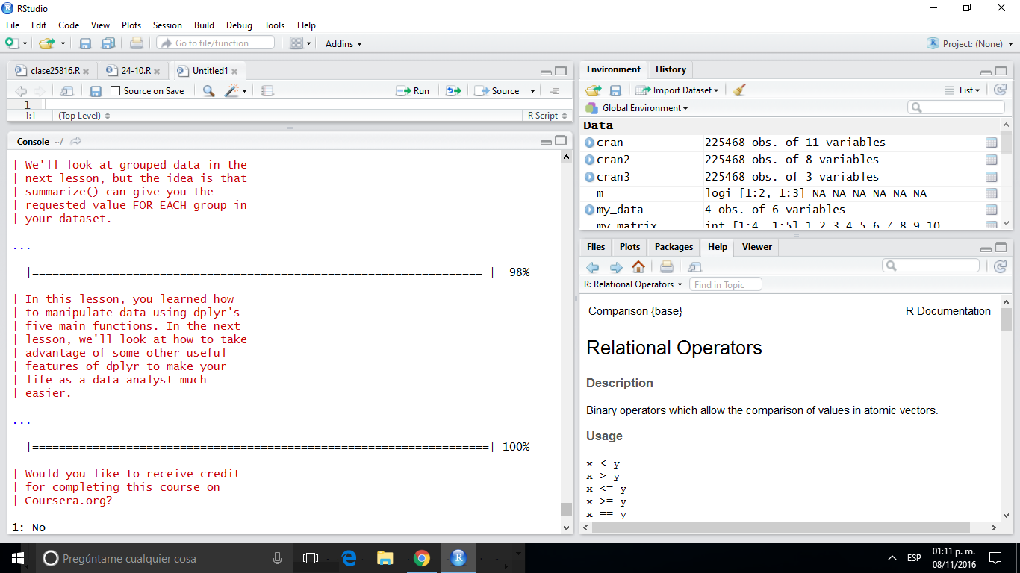

**2: Grouping and Chaining with dplyr**

**JOEL**

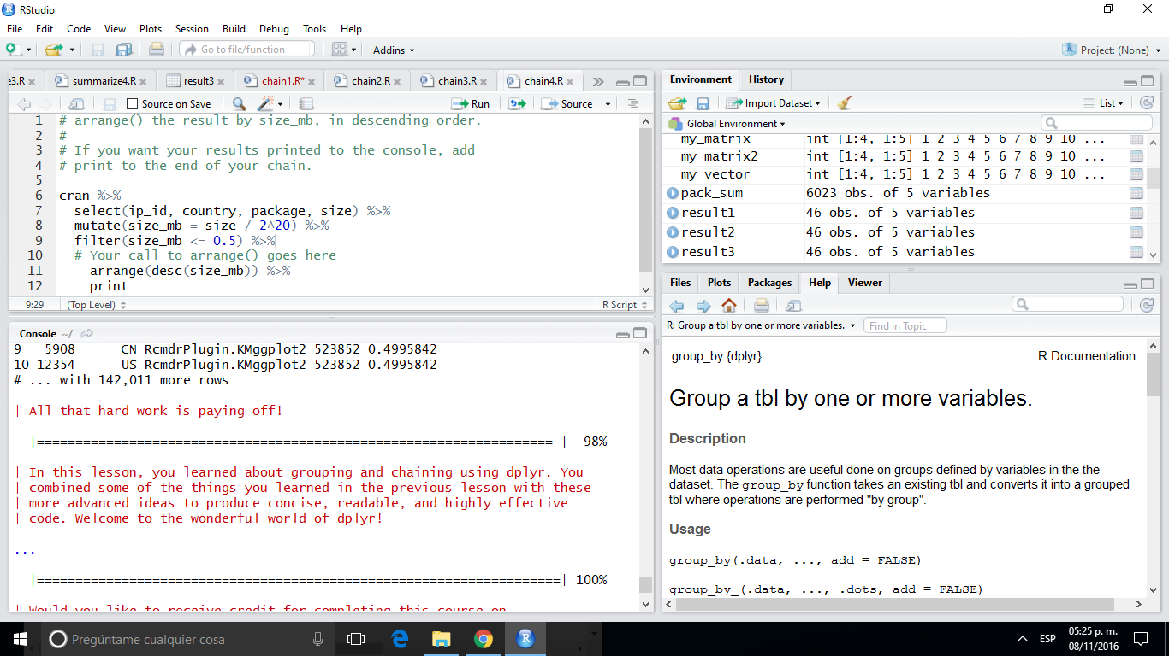

**JOEL**

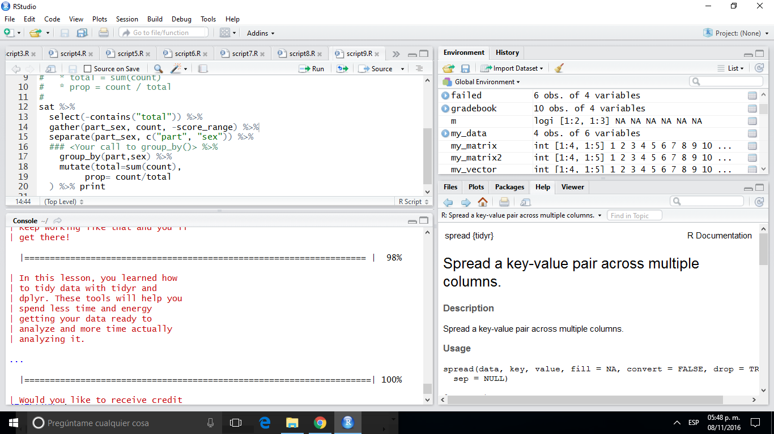**3: Tidying Data with tidyr**

**JOEL**

**4: Dates and Times with lubridate**

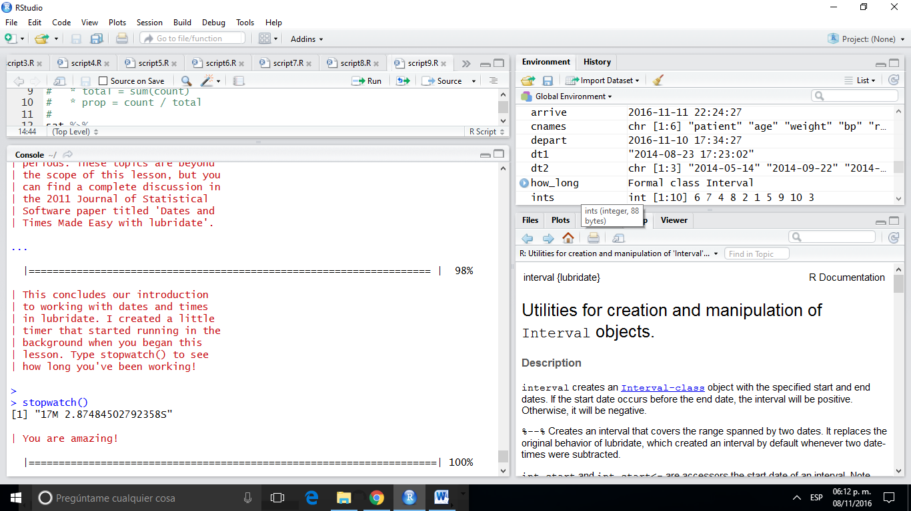

**JOEL**