Term Project: FooCity
Design Document
Table of Contents

1 Introduction 3
1.1 Purpose and Scope 3
1.2 Target Audience 3
1.3 Terms and Definitions 3
2 Design Considerations 4
2.1 Constraints and Dependencies 4
2.2 Methodology 4
3 System Overview 5
4 System Architecture 11
4.1 Graphical User Interface (GUI) 11
4.1.1 Mini-map 11
4.1.2 City map 12
4.1.3 Menu Items 12
4.1.4 Tile Buttons / Tile Menu Items 13
4.2 FooCityManager 13
4.2.1 MapGrid 13
4.2.1.1 Tile 14
4.2.2 FundManager 14
4.2.3 ResidentManager 15
4.2.4 JobManager 15
5 Detailed System Design 16
5.1 FooCityGUI 16
5.1.1 CityViewport 16
5.1.2 MiniMap 17
5.2 FooCityManager 17
5.2.1 MapGrid 18
5.2.1.1 Tile 18
5.2.2 FundsManager 18
5.2.3 ResidentManager 18
5.2.4 JobManager 18

Introduction
This document describes the design for the FooCity software project. It will describe the objects and functions that will need to be written to complete the project, as well as how the objects interact with each other.

Purpose and Scope
This document formally defines and describes the design considerations for FooCity.

Target Audience
This document is written for the developers and future maintainer of FooCity, to define its design, and for the stakeholders to ensure that the design will include the desired features.

Terms and Definitions
Metrics A positive or negative impact on the city. Happiness, Jobs, Pollution, Crimes, Housing, Power, Water
Map 128x128 grid of tiles that constitutes the area for the simulation.
Mini-Map A small view of the entire map.
Terrain Tile The only tiles in place at the start of the game. Dirt, water, grass, beach, and forest
Tile 32x32 pixel area of the grid, each tile has positive and/or negative impact on the city.
Turn
Zoned Tile Man-made tiles that can be placed by the player. Industrial, Commercial, Park, Sewage/Water, Police Station, Solar Power Plant, Natural Gas Plant, Coal Plant, Wind Farm, Residential, and Road.

Design Considerations
This section describes the constraints and dependencies of FooCity and the methodology used in its design.

Constraints and Dependencies
FooCity will be designed to have the back-end classes be completely independent of the GUI classes. There will be no code in the back-end classes that will handle drawing anything to the screen. Likewise, nothing in the GUI code will handle game mechanics.

Methodology
The design of FooCity will utilize Object Oriented Design to give equal importance to operations and data, to limit class responsibilities, reduce class dependencies, and allow portability. The front-end features of FooCity including the GUI will be separated from the back-end features, to allow easy portability to another GUI framework or design. All front-end communication to the back-end components will be through the FooCityManager control class.

System Overview
The front-end or GUI for FooCity will be designed using the swing toolkit provided by Java. The back-end of FooCity will include all of the functional features to manage the city, all of these features will be accessible through the FooCityManager class.

The GUI will be the only interaction between the users of FooCity and its back-end. The GUI will allow the user to:
- Start a new game
- Save the current state of a game
- Load a saved game
- Quit the game
- Navigate the map of the city
- Adjust the viewable area of the city.
- Display available funds for the city.
- Place a tile, either terrain (excluding water/sand) or zoned tile
- Destroy a tile, tile is replaced by dirt
- View reports of the city metrics
- Advance to the next turn.
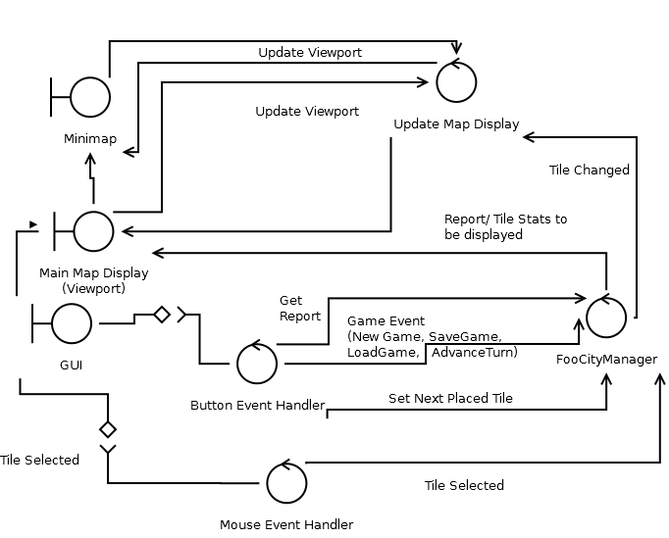
Figure 1: GUI Class Diagram

The FooCityManager class will be the only interface between any UI and the actual game mechanics. FooCityManager will be able to:
- Start a new game
- Save the current state of a game
- Load a saved game
- Quit the game
- Manage city funds, subtract funds for purchased tiles, add funds for taxes at the end of each turn
- Place a tile, either terrain (excluding water/sand) or zoned tile
- Destroy a tile, tile is replaced by dirt
- Determine the metrics of any tile
- Determine the metrics for the entire city
- Generate reports of the city metrics
- Advance to the next turn.
- Calculate the number of new residents for the new turn.
- Determine the number of new residents that were able to locate a job.
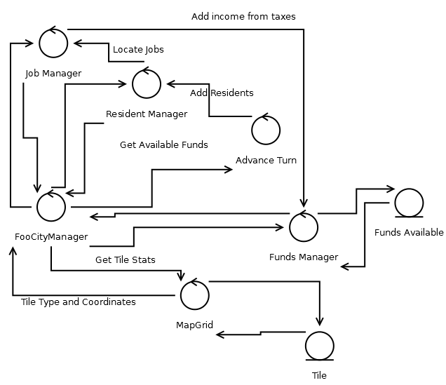
Figure 2: Turn Advancement class diagram
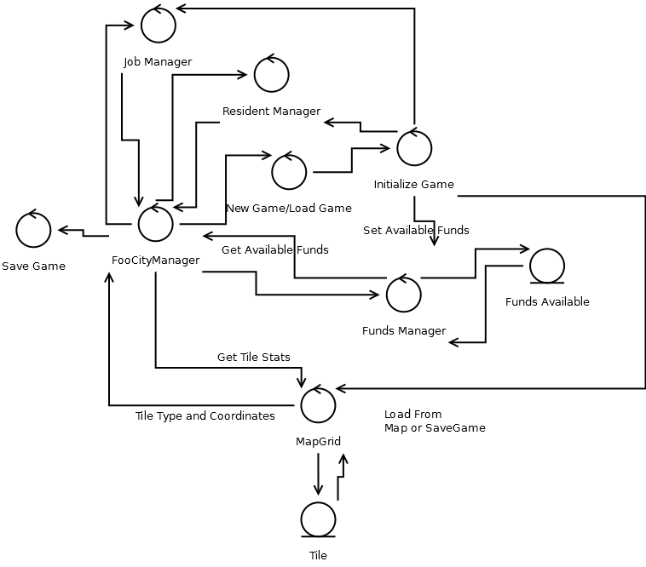
Figure 3: New Game, Load Game, and Save Game class diagram
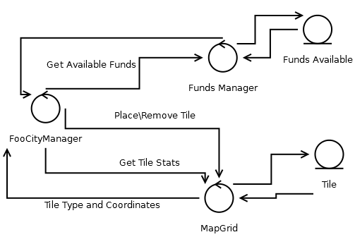
Figure 4: Tile Placement class diagram

System Architecture
This section includes the system-level architecture and the interactions between the classes for FooCity.

Graphical User Interface (GUI)
The GUI includes all user facing features of FooCity. The GUI includes the viewports of the city map and mini-map, as well as buttons and menu items for placing tiles, and other game mechanics (new game, save game, load game, quit, reporting, and turn advancement).

FooCityGUI | Collaborators  - FooCityManager  - CityViewport  - MiniMap
Responsibilities  - Boundary class for frontend features  - API: NewGame(), SaveGame(), LoadGame(), Quit(), PlaceTile(), GenerateReport(), NavigateMap() | Collaborators  - FooCityManager  - CityViewport  - MiniMap

Mini-map
The mini-map is primarily used to show the layout of the entire city. The mini-map can also be used to navigate the main map by clicking and/or dragging the mouse to the desired location to be displayed by the city map. The mini-map is also used to display metrics for each tile, when viewing a particular report the value of the metric will be used to determine the intensity of a map tile; for example when viewing happiness black will represent 0 happiness, varying shades of gray will represent >0 && < max, and white will represent maximum happiness.

MiniMap | Collaborators  - FooCityGUI  - FooCityManager  - CityViewport
Responsibilities
- Boundary class navigating the map and displaying reports
- API: UpdateCurrentView(Point) NavigateMap() DisplayReport()

City map
The city map is the primary display for the users current location on the map. The city map is used to select a tile to view its metrics, place new tiles, and remove tiles. The city map can be navigated through the use of the mini-map, the keyboard keys WASD, the scroll wheel, and the horizontal and vertical scroll bars. The selected tile to be placed is drawn at the mouse cursor.
CityViewport | Collaborators  - FooCityGUI  - FooCityManager  - MiniMap
Responsibilities  - Boundary class for displaying the current view of the city. Used for placing/removing tiles  - API: NavigateMap(), PlaceTile() | Collaborators  - FooCityGUI  - FooCityManager  - MiniMap

Menu Items
Menu items allow the user to start a new game or load a saved game (prompted to save an in-progress game), save the game, quit the program, view a report of city metrics, advance the turn, and place tiles (see 4.1.4 Tile Buttons for the description of tile menu items.

Tile Buttons / Tile Menu Items
The tile buttons allow a user to select terrain (excluding water/sand) and zoned tiles for placement. When a tile button is pressed the tile represented by this button is used for placing tiles until the user selects another button, cancels tile placement, or is unable to afford any further tiles of that type. The tile buttons will be enabled/disabled based on the current funds available provided by the FooCityManager.

FooCityManager
FooCityManager controls all interaction between the UI and the control of the game mechanics. FooCityManager includes the MapGrid, FundsManager, Resident Manager, and JobManager.

FooCityManager | Collaborators  - MapGrid  - FundManager  - ResidentManager  - JobManager
Responsibilities
- Control class for the backend functionality. Maintains the funds available, MapGrid, map metrics.
- API: GetMap() GetMetrics() GetMetrics(int, int) GenerateReport(int) AdvanceTurn()

MapGrid
MapGrid maintains information about the tile locations for the entire city map. MapGrid uses a “has a” relationship with Tile. Through MapGrid, FooCityManager can place/remove tiles and retrieve information about individual tiles.
MapGrid | Collaborators  - Tile class
Responsibilities  - Loads a map of Tiles either from a file (new game) or a SaveGame object.  - API: GetTileAt(int,int), SetTileAt LoadFromFile(String) LoadFromSave(SaveGame) | Collaborators  - Tile class

Tile
Tile collaborates with MapGrid to store individual map grid squares information. Tile information that can be retrieved includes tile provided metrics, tile actual metrics, and tile int value. The value of a tile is a 16-bit integer where the low byte represents the tile type (allowing for 256 tile variations), and the high-bit represents an optional tile variation to allow the UI to display special tiles based on surrounding tiles, without extra calculation (for example showing a beach tile next to water may be displayed with the shoreline on the beach tile).

Tile | Collaborators  - MapGrid
Responsibilities  - Maintains type of tile, and tile metrics  - API: GetTileType() GetTileStats() | Collaborators  - MapGrid

FundManager
FundManager is used to verify that a user can afford to place a particular tile. Funds are added to FundManager at the end of each turn by the JobManager calculated taxes. Funds are removed from FundManager each time a tile is placed.

FundManager | Collaborators  - FooCityManager  - JobManager
Responsibilities  - Maintains funds for FooCity  - API: GetAvailableFunds() SpendFunds(int) | Collaborators  - FooCityManager  - JobManager

ResidentManager
ResidentManager determines whether residents will move into available Residential Tiles in FooCity; polution, crime, and happiness metrics determine the number of residents that will move into a particular tile.

JobManager
JobManager uses pathfinding to locate jobs within driving (15 roads), and/or walking (2 tiles [excluding water]) distance for each residential location in FooCity.

JobManager | Collaborators  - FooCityManager  - ResidentManager  - MapGrid
Responsibilities
- Locates Jobs for all residents using pathfinding

Detailed System Design
This section will provide a detailed description for the design of each object.

FooCityGUI
FooCityGUI includes all user facing features of FooCity. The GUI includes the viewports of the city map and mini-map, as well as buttons and menu items for placing tiles, and other game mechanics (new game, save game, load game, quit, reporting, and turn advancement). At the start of the program the window is drawn, and the buttons and menu items are initialized.
When New Game or Load Game is selected, the NewGame Class loads a window that allow the user to select a map file or a saved game file to load. The selected file is previewed in this window. Upon open, the map/save game is loaded by FooCityManager and UpdateDisplay() is called.
When Save Game is selected, FooCityGUI prompts the user for a file name, this is passed to FooCityManager to run its Save method.
When a tile button is selected, the type of tile is sent to FooCityManager for use with the next place tile event.
Advancing a turn will call the NextTurn method of FooCityManager, and upon return UpdateDisplay will be called.
UpdateDisplay is a method used internally, as well as by the MiniMap and CityViewport classes to update their display as well as the current available funds.
When a report is selected, FooCityGUI will display a window displaying the textual statistics of the report, and the MiniMap will display a graphical display of the report details.

CityViewport
CityViewport is the main display of the city map. The user can navigate the panel using the WASD keys, the scroll wheel on the mouse, and the scroll bars on the panel. Each time the user navigates the CityViewport, the Minimap should be updated as well, through the FooCityGUI method UpdateDisplay.
Each tile that is selected is sent to FooCityManager through the method TileSelected.
When no tile is being placed, the statistics of the location that is selected with the mouse are retrieved from FooCityManager, and displayed.
When a tile is being placed, the tile will be displayed with the mouse cursor when it is over the CityViewport. When a tile is placed, CityViewport and MiniMap are updated through the FooCityGUI method, UpdateDisplay.

MiniMap
MiniMap displays a small (256px x 256px) representation of the city map. The user may click/drag the mouse on the MiniMap in order to navigate CityViewport. The MiniMap is also used when displaying a report to visually represent the various levels of a particular metric over the entire city.

FooCityManager
FooCityManager utilizes a “has a” relationship with the MapGrid, FundManager, ResidentManager, and JobManager classes, and should control all interaction between the current GUI and any future GUI and the rest of the back-end classes.
At the start of a new game, FooCityManager can be passed either a file name, or a MapGrid object (to allow the GUI to preview a map file before loading it).
When a game is loaded a savegame object is retrieved by file name and propagated to the MapGrid, FundManager, ResidentManager, and JobManager classes. Similarly, when a game is saved, a savegame object is created using the information stored by these classes and written to the file name that is passed in.
When the user selects a tile its metrics are returned, if a place tile event was started and there are sufficent funds, the new tile is placed at the selected location.
When the turn is advanced, the FooCityManager will retrieve the income taxes generated this turn and add them to the FundsManager; after this has completed, ResidentManager will determine the number of new residents that moved in this turn, based on happiness, pollution, crime, and potentially other metrics; JobManager will than use path finding to locate jobs for any unemployed residents.

MapGrid
MapGrid holds an instance of the Tile class for each grid square (128 x 128). MapGrid initializes the tiles from either a map file, or is loaded from a savegame object. MapGrid is the gatekeeper for individual tiles, and the MapGrid instance used by FooCityManager should not be available to outside classes (provide a clone if absolutely necessary) as the tiles are created/destroyed without cost through MapGrid functions. The MapGrid object runs the metrics propagation for metrics that affect the surrounding tiles (such as crime).

Tile
Tile stores the type of tile, and the optional tile variation that should be displayed for it. The GUI must use the low byte of the tile type (type & 0xFF) to determine what type of tile should be displayed, the GUI may optionally use the next byte ((type>>8)&0xFF) to select a tile that is influenced by bordering tiles (ie a shoreline on a beach tile). The tile will store the metrics that are from its surrounding tiles, and return those metrics added to the constant metrics provided by itself.

FundsManager
FundsManager maintains the available funds, tax income, and spend funds on placing tiles. FundsManager is an entity class that is used to separate the monetary handling from the other aspects of FooCityManager.

ResidentManager
ResidentManager will decide whether residents move in or out of zones based on the metrics of that tile. Higher crime rates and pollution will push people out of zones, while happiness encourages them to move in.

JobManager
The JobManager class will use a pathfinding algorithm to find a job for each resident, as well as a resident for each job. A resident without a job will not contribute to taxes, nor will a job without a resident to work it.

