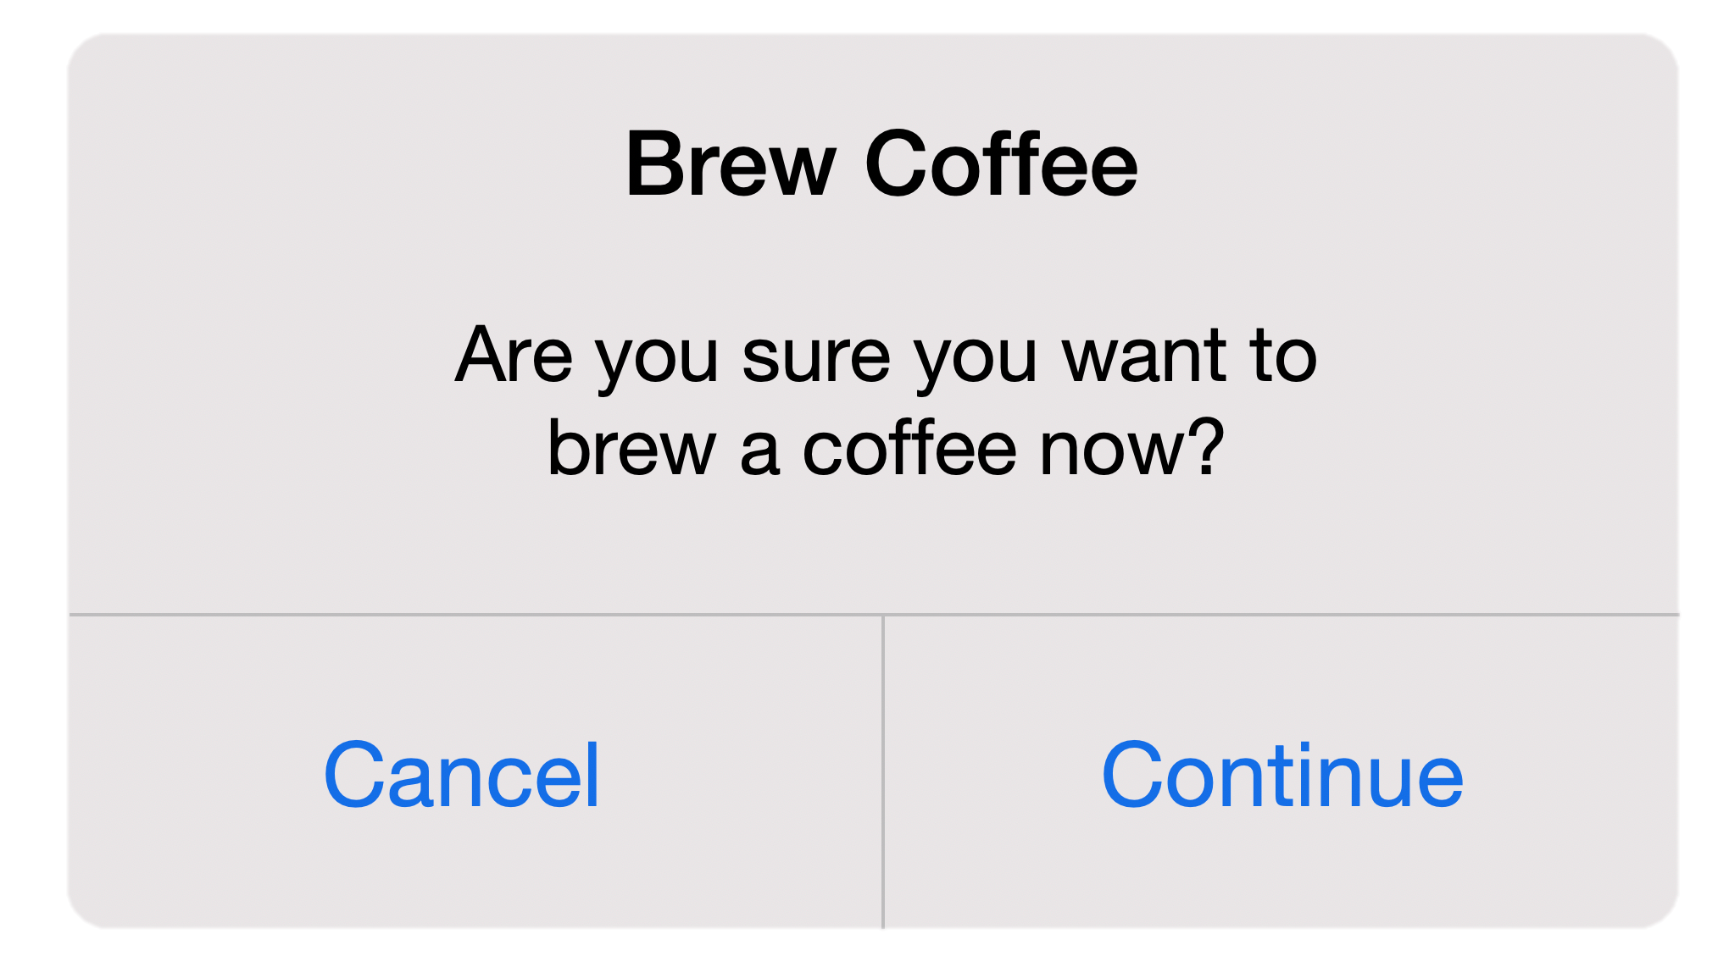

Cancel

Continue

Brew Coffee

Are you sure you want to brew a coffee now?