Faculty of Engineering.

Autonomous University of Querétaro

Career: Automation Engineer.

Subject: Systems with reconfigurable logic.

Student: Martínez Murillo Omar Yarif.

Student: Diego Joel Zúñiga Fragoso.

Student: Daniela del Carmen Manríquez Navarro.

Student: Joselyn Gallegos Abreo.

Practice 3: Switch case,IF,When





**Introduction**

The practice is divided into three parts. The first part involves the use of Karnaugh maps, where the task is to design a system for monitoring environmental conditions. A truth table is generated, and the Karnaugh map is used to obtain the most simplified equation for the Boolean operations. The second part focuses on the use of the switch-case statement in VHDL. Here, the goal is to display the alphabet on an FPGA by creating a truth table, performing a simulation, and then programming it. Lastly, the practice covers the use of the if statement in VHDL to display words, again creating a truth table, performing a simulation, and then programming it.

**Methodology**

* First, we create the Karnaugh map based on the truth table derived from the given conditions.
* Second, the equation is extracted, and the base code is programmed in Aldec-Active-VHDL.

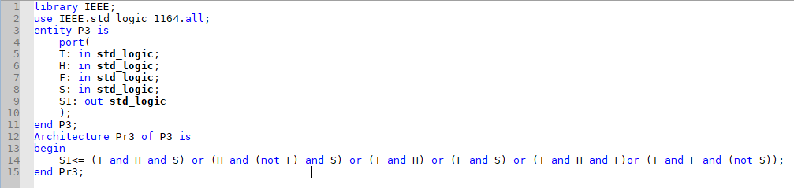

* 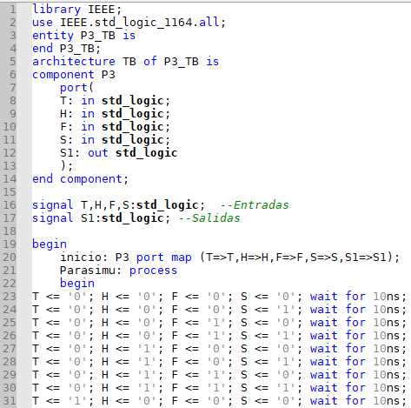Third, a testbench is created for simulation.
* Fourth, a truth table is created for the switch-case code, where specific combinations are defined to represent letters of the alphabet.



* Fifth, the configuration is set up in Aldec-Active-VHDL, followed by simulation.
* 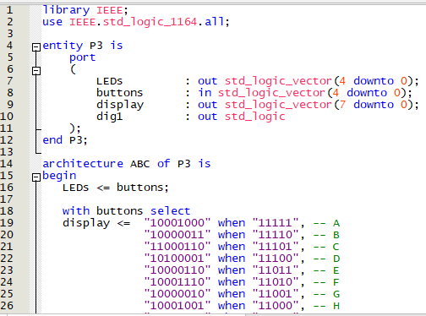Sixth, the configuration is transferred to Quartus, and the pins are assigned.
* Seventh, the program is loaded onto the FPGA.
* Eighth, a truth table is created for the if statement, which should display 4-letter words.
* Ninth, the configuration is set up in Aldec-Active-VHDL, followed by simulation.
* Tenth, the configuration is transferred to Quartus, and the pins are assigned.
* Eleventh, the program is loaded onto the FPGA.

**Results**

Base algorithm Karnaugh

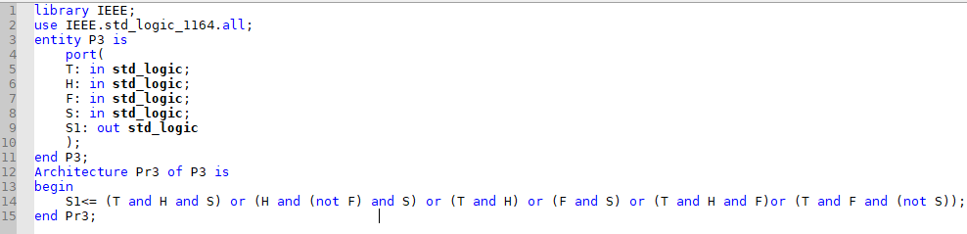

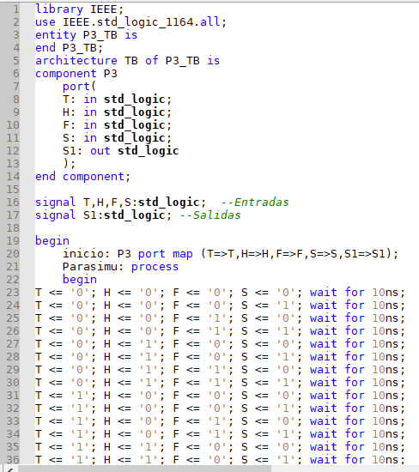Test Bench

Simulation

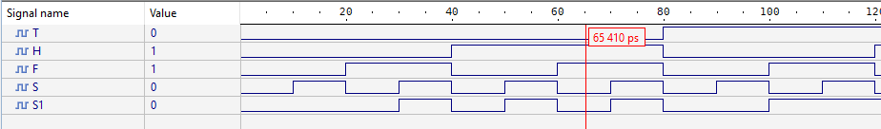

Base algorithm of Switch

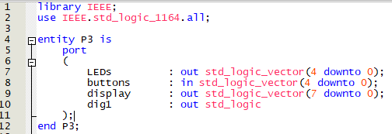

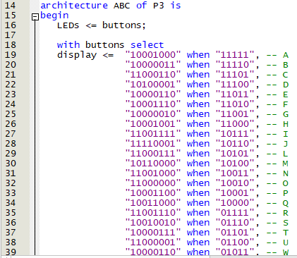

Test Bench

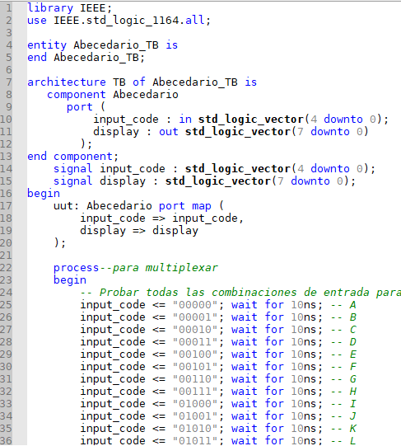

Simulation

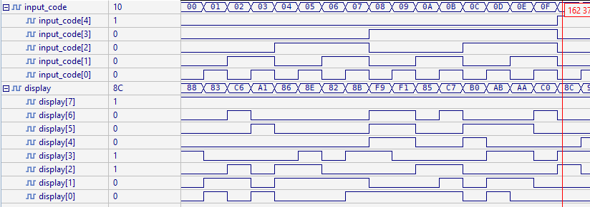

Asigned PIN’s of Switch

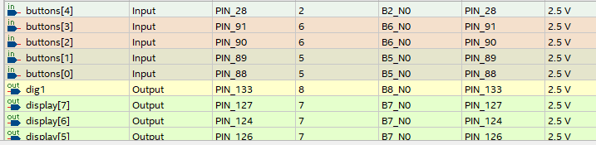

Hardware images

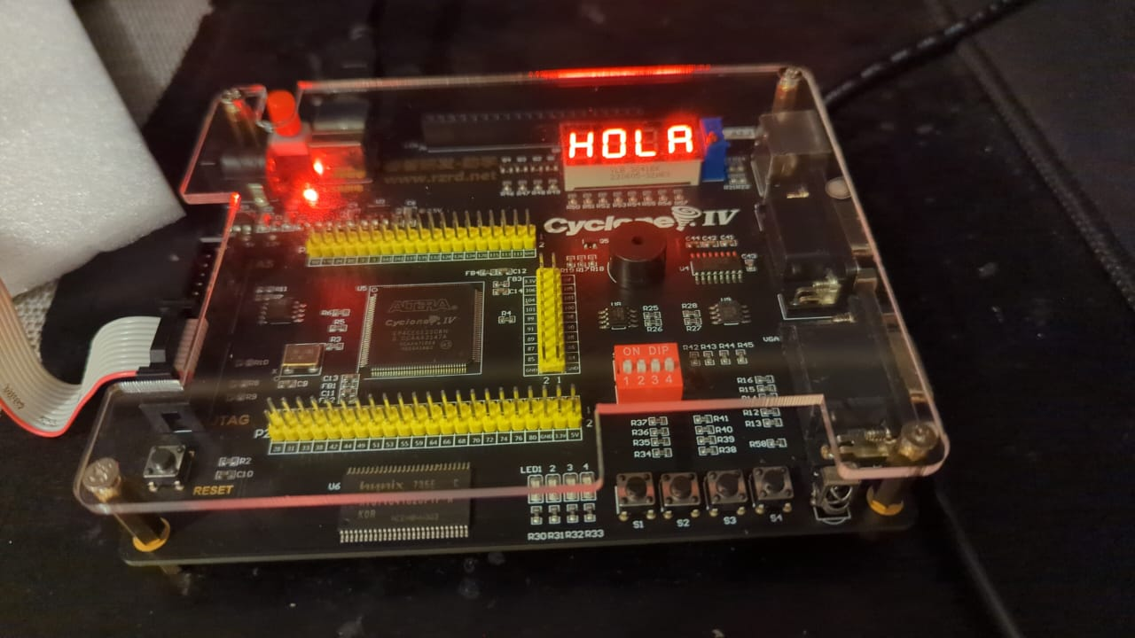

Base algorithm of IF

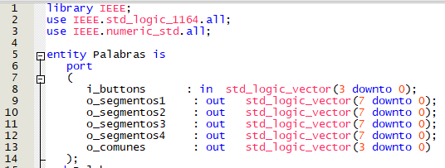

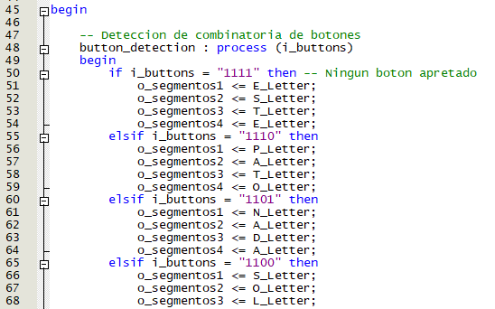

Test Bench

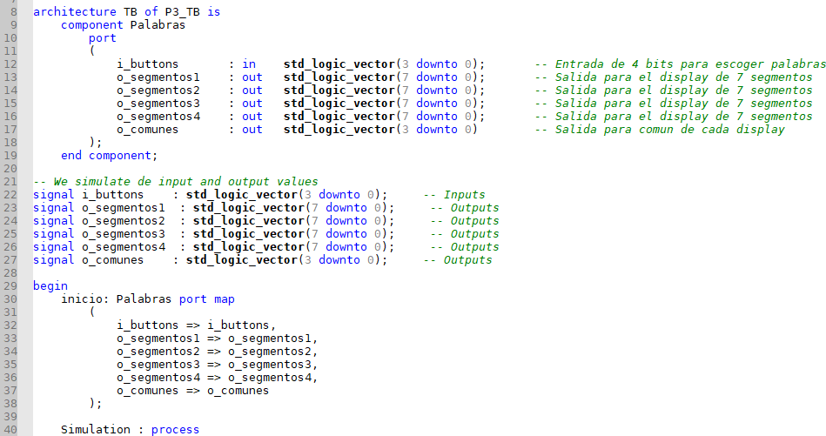

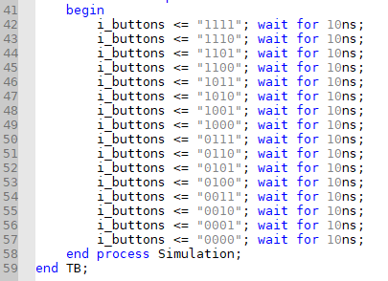

Truth table

Hardware images

**Conclusión**

Throughout the practice, we successfully represented letters on a 7-segment display, configuring each letter through a combination of 5 inputs. Additionally, we gained experience using the Quartus software, which allowed us to become more familiar with VHDL and its selective structures, such as `IF` and `SWITCH`. We also learned to use the `process` block to generate sequential actions, such as multiplexing the displays. This practice gave us a deeper understanding of VHDL programming and the control of displays through combinational and sequential logic.