Joel Whalen, Connor Laitinen
Michael Kowalczyk
CS 480 Senior Project
April 25^{h}, 2018
UP Trail Networks
For a Senior Project, we consider ourselves fortunate. Most don’t get the opportunity to not only expand their knowledge building and researching a new system, but to help a local Professor and the greater community too. The previous solution of haphazardly throwing together text files (with incorrectly formatted date time information) was not only not working well, but could not be scaled to anything larger. That is what we achieved with UP Trail Networks, a collector of trail usage data, streamlined with graph based analytics and database storage. Everything in the full stack was built from almost nothing, from client to server to database and everything maintaining it in between. In this document we will go through, in detail, the original problem, what we planned to do, what actually happened, and what we could have done better.
The Problem
Spanning the area outside the city of Marquette, Dr. Joshua Thompson of the Math and CS Department at NMU has placed 28 Bluettooth-enabled motion sensors whose purpose is to track the usage of the Marquette City trail network. Each sensor has a known latitude and longitude, and builds a text file that lists a time stamp for every time the motion sensor detects something. There is an Android application that users must use to manually travel to each node and collect these files, as well as transfer the files later. A sample of “TRAIL-4.txt” would look like this:
1 12:18:09 11/26/17/4
2 12:18:23 11/26/17/4
…

Notice the redundancy of both the incremental index on the left (we could simply get the length of the readlines() function), and the number 4 on the right telling us which trail node the time stamp belongs to, even though the file is already named accordingly. There is also no location data, so we must depend on an outside dictionary defining the latitude and longitude for each trail node. Most important, however, is the lack of any ISO date standard, which is supposed to be in the form YYYY-MM-DDTHH:MM:SS.
That’s it. There is no central repository or file history, no analytics, just raw text data in the wrong format that needs to be collected, updated, and interpreted manually. Furthermore, the time stamp data said nothing of the path an individual would take or how long they spent on the trail network. All we have is a serious of time stamps and the single node location that recorded it. Our projected solution was to fix all of these problems in one fell swoop, but reality had other plans.
The Projected Solution
We were to build a website running Nodejs with MySQL doing the heavy lifting of running date calculations and data storage and queries. The already existing Android application would need a file transfer protocol so it could automatically send the files to the Nodejs server. Python would do data analysis to determine a path one may take based on the proximity of nodes and timestamps. All of this would be fed into the client side as graphs and maps with a responsive design, working on multiple devices, to make visualization easier. Throughout all of this, we would collaborate through two separate github repositories: one for the Android application, the other for the website and database.
The Actual Solution
Unfortunately, building the infrastructure to piece all of these moving parts together took the bulk of our time and resources, and as such we had to cut features like path and speed calculations. We also struggled with adapting to Android, a technology that neither Connor or I were very familiar with. That all said, we managed to deliver on everything else.
For our first task of converting time stamps into ISO date time objects for our database, we realized MySQL was too unwieldy for the task. It was too difficult to administer (even a simple root password change bricked my MySQL installation) and we didn’t need joins or multiple tables because our data was so simple. Also MongoDB is supported across more platforms (especially so for NodeJS) and the documentation was much easier to read, so we switched to Mongo. This was our best course correction besides removing the Android application from our development cycle. Python’s MongoDB driver, Pymongo, made chopping up the text files, converting the dates, and placing them into the database a piece of cake. Once we had each line of the file isolated to the timestamp itself, it was one line of Python to convert to ISO datetime:
Notice how the format string in the strptime parameter matches the raw text data. The comment above is important too, because we will have to deal with ISO date format in Javascript as for some reason Mongo could not understand Python’s ISO format.
Now that we have our time stamps, we need to match them with the latitude and longitude data and insert each as a document into MongoDB. We keep a list of latitudes, longitudes, and their associated trail node name in a master csv file, which can be easily updated by Dr. Thompson.
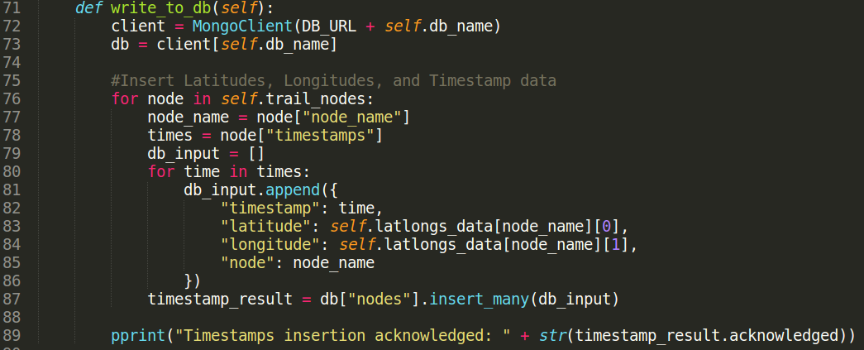
The downside to inserting the latitude, longitude, and trail node name for each time stamp is that we get a lot of repeated data. We tried to mitigate this by placing a separate collection in the database for each trail node, but that turned out to be a gigantic mess when it came time to execute efficient queries, as MongoDB doesn’t support iterating through multiple collections, and manually doing it in Javascript is a nightmare.
In addition to the inefficiency of our data, Mongo isn’t creating date time objects out of the ISO dates that Pymongo gives it. Instead they are saved as strings, which makes date time calculations impossible. For a Mongo function like “$gte” to work with date data, it must be an ISODate object. After much stackoverflow research, we came across a post to do the conversion in Javascript. It works, but it must be called every time new data is added, which can only get worse over time.
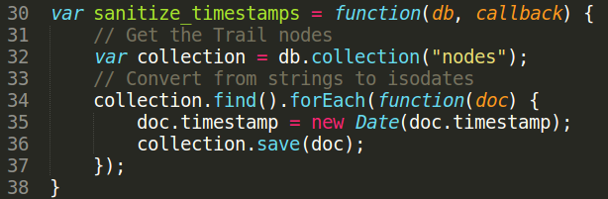
Struggling with MongoDB and Pymongo was worth it. The following MongoDB query is executed on the NodeJS server and quickly retrieves specific date related data for both the website’s graphs and maps.
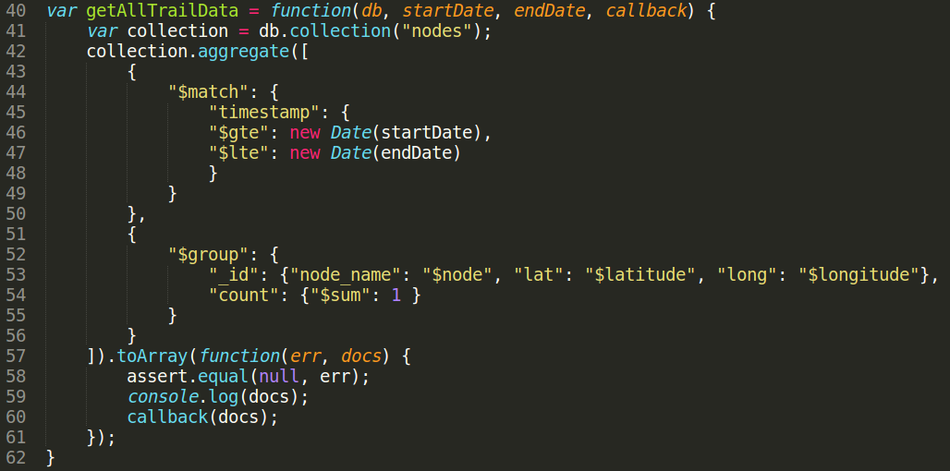
Understanding aggregate functions in MongoDB was an incredibly rewarding experience. It took hours of researching documentation, fixing bugs, and trial and error, but the final product here is beautiful. The above query acts as a pipeline; whatever documents are returned from the “$match” statement (documents that are greater than startDate and less than endDate) are filtered out and passed down to the next segment of the pipeline, the “$group” statement (grouping distinct documents and summing up the individual count of each unique “_id”). Dollar signs imply variables which are interpreted by Mongo as either functions like “$gte” (greater than or equal) or database fields like “$node” (which would resolve to something like “TRAIL-4”). The query is followed by a toArray() function because Mongo queries return a cursor object which must be interpreted by Javascript. In this case we are interpreting it as an array of dictionaries, each entry being a single trail node and the latitude, longitude, and number of timestamps that fit the end and start dates provided. To help visualize this, the first image is what’s in the database, and the second image is what the query returns on this data.
Before query:
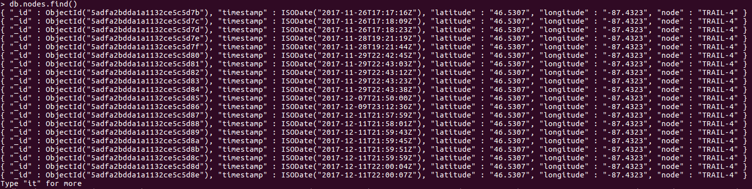
After query:
As you can see, MongoDB makes analysis of this trail data much easier. From here we can take these values and put them into a heat map or a bar graph, or any number of analytical tools.

