Project: <Enter a project name> | Project: Todo Web Application
Course: <Enter the course number and name> | Course: CSD 380 – Software Testing
Description: <Enter a description> | Description: Functional test cases based on Todo Business Requirements document
Date: <Enter a date (yyyy/mm/dd)> | Date: 2026/02/06
To complete the test case plan, fill out the information for Project, Course, Description and Date in the header below.

TABLE OF CONTENTS
Access Todo Application via Standard URL 2
Create a New Todo Item 3
Prevent Empty Todo Submission 4
Edit One of the Existing Todo Item 5
Delete Todo Item 6

For each test, the developer should: provide a test description, a test objective, the developer’s name and date tested. For each step, fill out the actions to be taken and describe the expected results, and indicate yes or no for each step depending upon the result. The peer tester should provide their name, date tested, indicate yes or no for each step depending upon the result, and a screenshot (thumbnail) of the result.

Test 1 | Access Todo Application via Standard URL ( https://buwebdev.github.io/todo/)
 | Test Objective: Access Todo Application via Standard URL (Req #10) | Developer: Juan Macias Vasquez  Date tested: 2026/02/06 | Peer tester: Joel Atkinson  Date tested: 2026/08/02
Step | Action | Expected results: | Developer pass/fail | Tester pass/fail  + Screenshot
1 | Open a web browser | Browser opens successfully | Yes | Yes  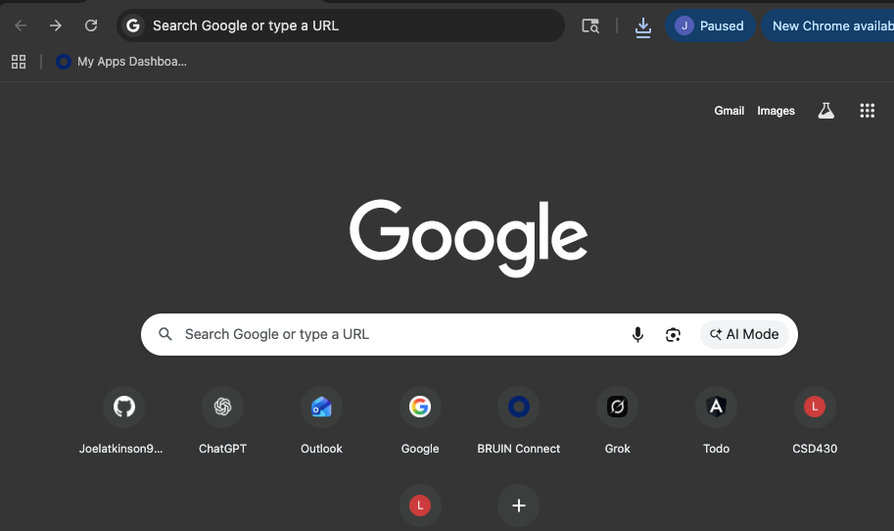
2 | Navigate to https://buwebdev.github.io/todo/ | Todo landing page loads | Yes | Yes  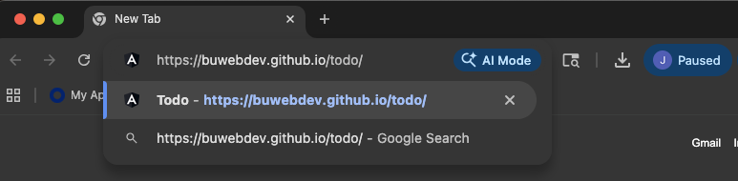
3 | Observe page load | No errors are displayed | Yes | Yes  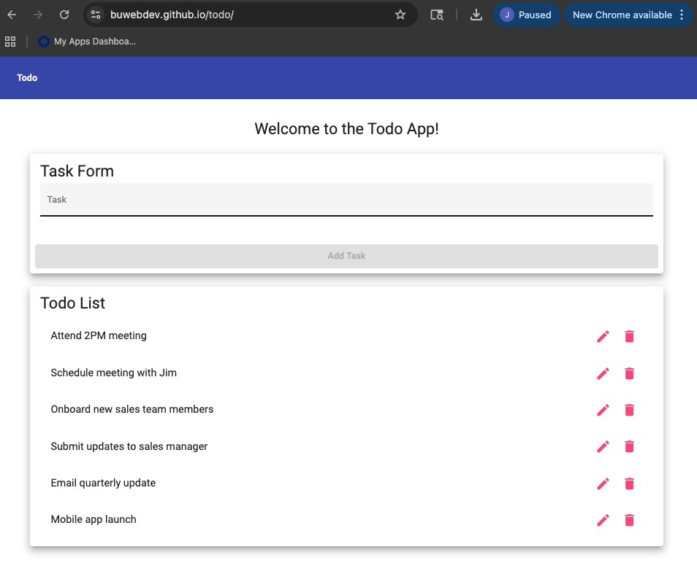
4 | Refresh the page | Page reloads correctly | Yes | Yes  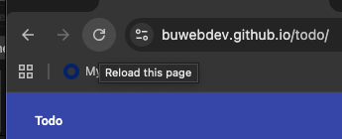
5 | Verify page content | Todo list interface is visible | Yes | Yes  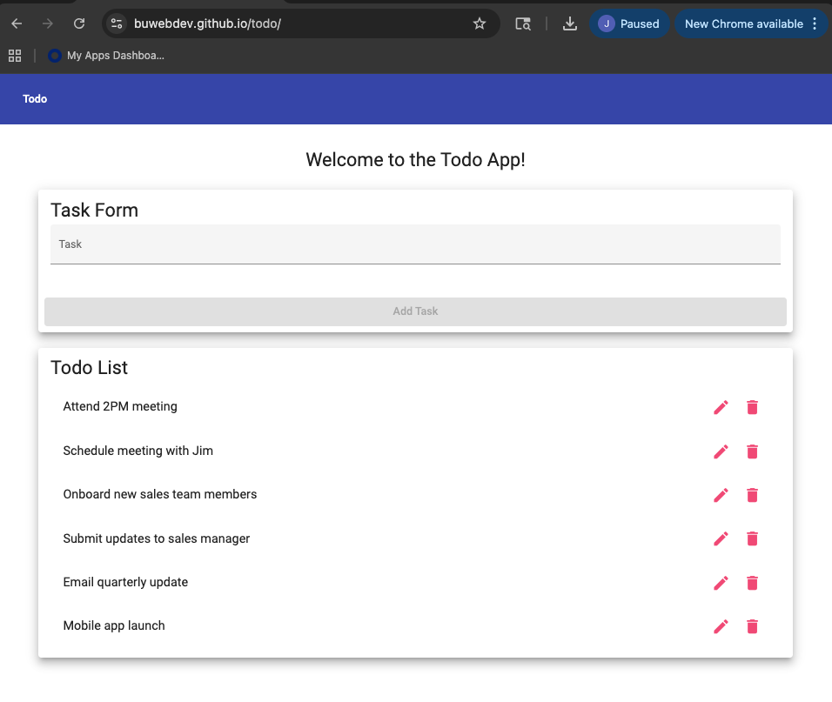
Comments | The test executed as expected based on the defined business requirement. No defects were identified during execution. The functionality aligns with user expectations.

Test 2 | Create a New Todo Item
 | Test Objective: Make sure that users can create a new todo item | Developer: Juan Macias Vasquez  Date tested: 2026/02/06 | Peer tester: Joel Atkinson  Date tested: 2026/02/08
Step | Action | Expected results: | Developer pass/fail | Tester pass/fail
1 | Access the Todo application | Application loads | Yes | Yes
2 | Enter a task in input field | Text is accepted | Yes | Yes  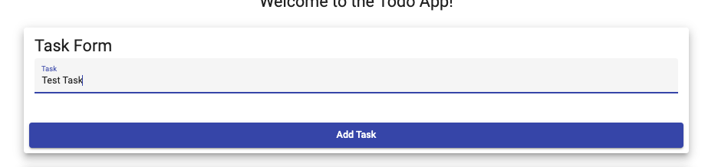
3 | Click Add button | Task is submitted | Yes | Yes
4 | Observe the task list | New task appears | Yes | Yes  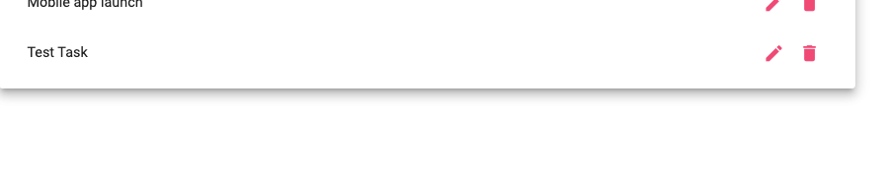
5 | Confirm that there are no errors | Application remains stable | Yes | Yes  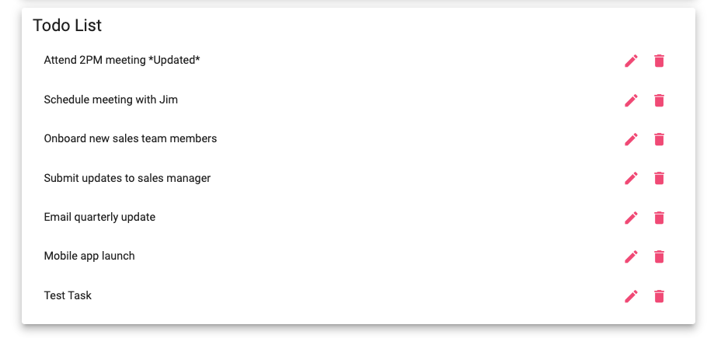
Comments | The test executed as expected based on the defined business requirement. No defects were identified during execution. The functionality aligns with user expectations.

Test 3 | Prevent Empty Todo Submission
 | Test Objective: Verify empty todo items cannot be submitted | Developer: Juan Macias Vasquez  Date tested: 2026/02/06 | Peer tester: Joel Atkinson  Date tested: 2026/02/08
Step | Action | Expected results: | Developer pass/fail | Tester pass/fail
1 | Access the Todo application | Application loads | Yes | Yes
2 | Leave input field empty | No text entered | Yes | Yes  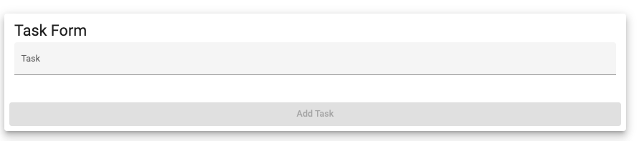
3 | Click Add button | Submission attempted | Yes | Yes
4 | Observe task list | No new task added | Yes | Yes  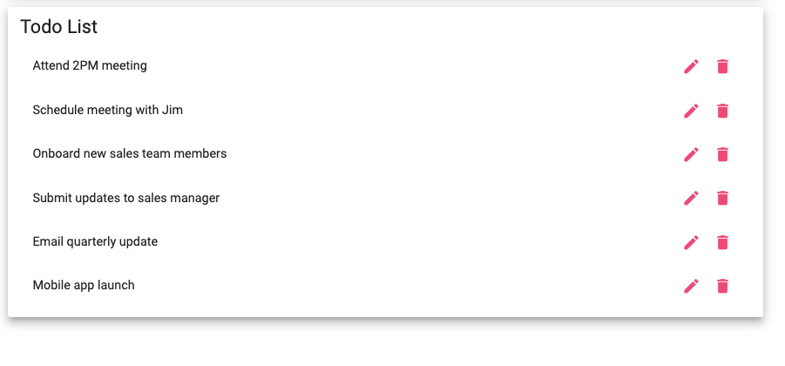
5 | Verify stability | No error or crash occurs | Yes | Yes
Comments | The test executed as expected based on the defined business requirement. No defects were identified during execution. The functionality aligns with user expectations.

Test 4 | Edit One of the Existing Todo Item
 | Test Objective: Verify users can edit a todo item and validation is enforced | Developer: Juan Macias Vasquez  Date tested: 2026/02/06 | Peer tester: Joel Atkinson  Date tested: 2026/02/08
Step | Action | Expected results: | Developer pass/fail | Tester pass/fail
1 | Add a new todo item | Todo item appears | Yes | Yes
2 | Select edit option | Edit view opens | Yes | Yes  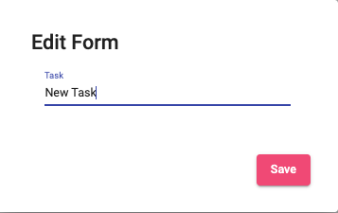
3 | Modify task text | Text is updated | Yes | Yes  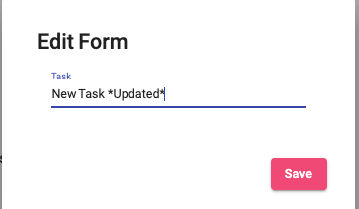
4 | Save changes | Edit is saved | Yes | Yes  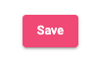
5 | Verify updated text | Updated task is displayed | Yes | Yes
Comments | The test executed as expected based on the defined business requirement. No defects were identified during execution. The functionality aligns with user expectations.

Test 5 | Delete Todo Item
 | Test Objective: Delete Todo Item | Developer: Juan Macias Vasquez  Date tested: 2026/02/06 | Peer tester: Joel Atkinson  Date tested: 2026/02/08
Step | Action | Expected results: | Developer pass/fail | Tester pass/fail
1 | Add a new todo item | Todo item appears | Yes | Yes
2 | Locate delete option | Delete control is visible | Yes | Yes  
3 | Click delete | Delete action executed | Yes | Yes  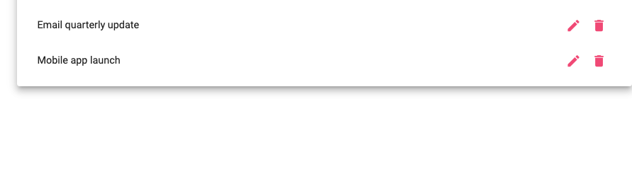
4 | Observe task list | Item is removed | Yes | Yes
5 | Confirm no errors | Application remains stable | Yes | Yes  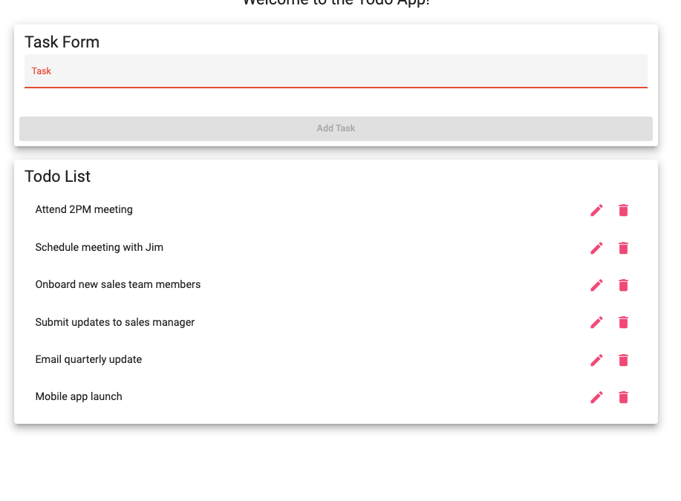
Comments | The test executed as expected based on the defined business requirement. No defects were identified during execution. The functionality aligns with user expectations.

