Project: Test Plan – Zac Baker
Course: CSD380: DevOps
Description: Test plan draft for Todo Business
Date: 2026/02/04

TABLE OF CONTENTS
Visit URL 2
Create Task Item 3
View List 4
Delete Task Item 5
Edit Task Item 6

Test 1 | Visit URL
 | Test Objective: Website should be visited through https://buwebdev.github.io/todo/ | Developer: Zac Baker  Date tested: 2026/02/04 | Peer tester: Joel Atkinson  Date tested: 2026/02/08
Step | Action | Expected results: | Developer  pass/fail | Tester pass/fail  + Screenshot
1 | Enter https://buwebdev.github.io/todo/ into search bar. | URL is exactly as shown and navigates to the correct website. | Yes | Yes  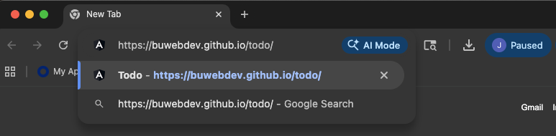
2 | Confirm the page loads correctly without any errors. | Todo main page loads without any errors. | Yes | Yes  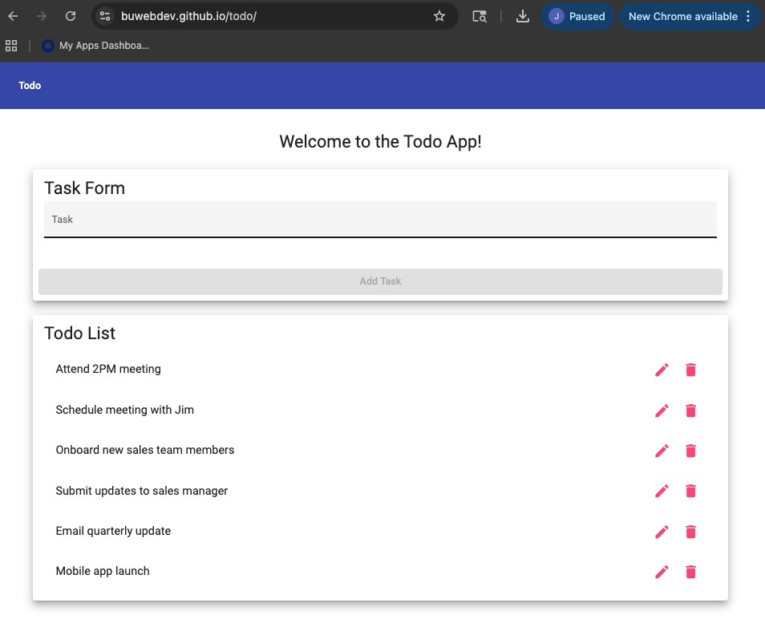
3 | Refresh the browser page. | Todo page refreshes and navigates back to the main page. | Yes | Yes  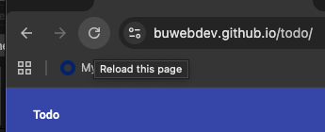
4 | Confirm the page loads correctly without any errors. | Main page loads with the default values for the Todo list. | Yes | Yes  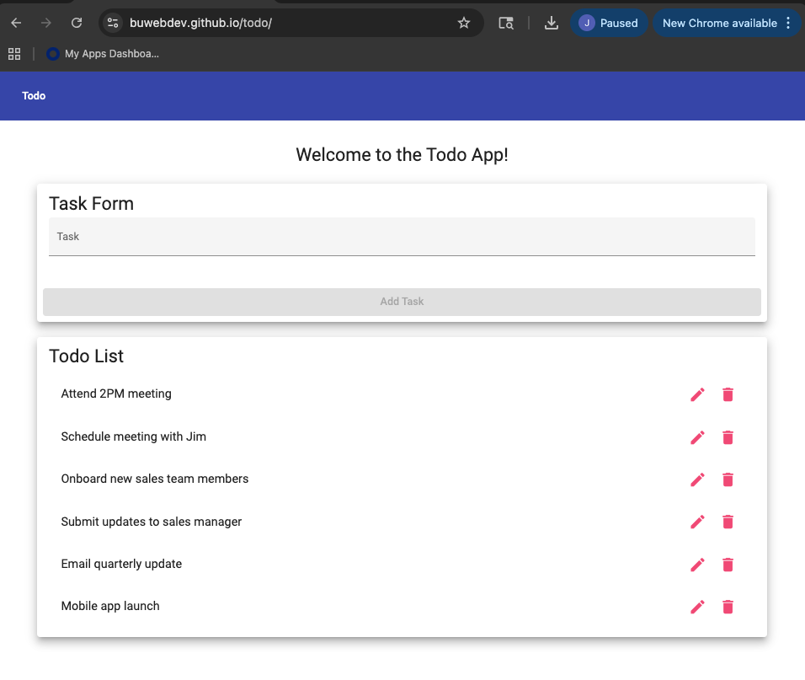
Comments | The ToDo application loaded successfully using the standard URL across multiple browsers. Refreshing the page did not cause any issues or errors to occur and reloaded the page, confirming stability. Overall access to the site meets the business requirements as expected.

Test 2 | Create Task Item
 | Test Objective: Users can create task items for the Todo list. | Developer: Zac Baker  Date tested: 2026/02/04 | Peer tester: Joel Atkinson  Date tested: 2026/02/08
Step | Action | Expected results: | Developer  pass/fail | Tester pass/fail  + Screenshot
1 | Type out task item. | A combination of numbers, letters, and symbols can be used in the input bar. | Yes | Yes  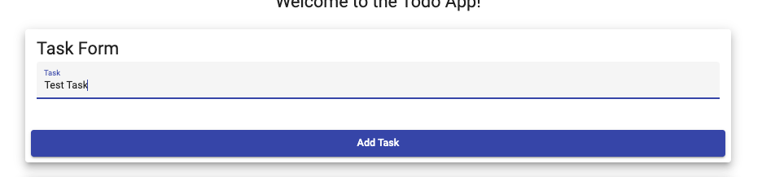
2 | Click “Add Task”. | Clicking the “Add Task” button will add the entered task item to the list. | Yes | Yes
3 | Confirm the added task item is correct. | The added task item will be appended to the bottom of the list. | Yes | Yes  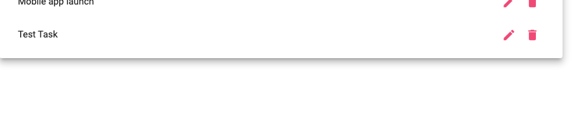
4 | Add another task item. | The Todo app will support multiple entries. | Yes | Yes  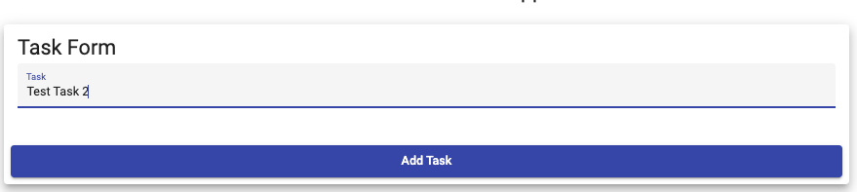
5 | Confirm the added task item is correct. | The added task item will be appended to the bottom of the list. | Yes | Yes  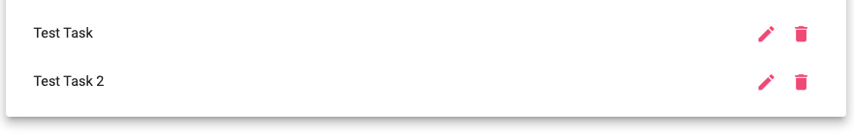
Comments | The application allows users to create new todo items without issue. The task appears in the list immediately after submission, confirming proper functionality. Application allowed for multiple new entries and displayed them without error. This behavior satisfies the core business requirement for creating todo items.

Test 3 | View List
 | Test Objective: The list is visible and dynamically supports adding, deleting, and editing features. | Developer: Zac Baker  Date tested: 2026/02/04 | Peer tester: Joel Atkinson  Date tested: 2026/02/08
Step | Action | Expected results: | Developer  pass/fail | Tester pass/fail  + Screenshot
1 | Confirm the default list is visible. | The page will show the list in a clearly marked and visible area. | Yes | Yes  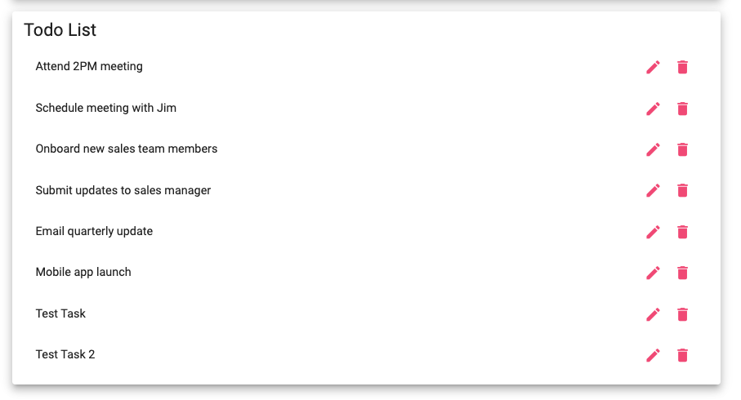
2 | Confirm the list shows added task items. | Added tasks will be visible in the dedicated list area. | Yes | Yes  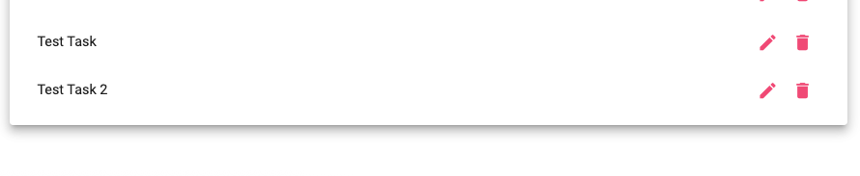
3 | Confirm the list shows deleted task items. | Deleted tasks affect the order and size of the list. | Yes | Yes  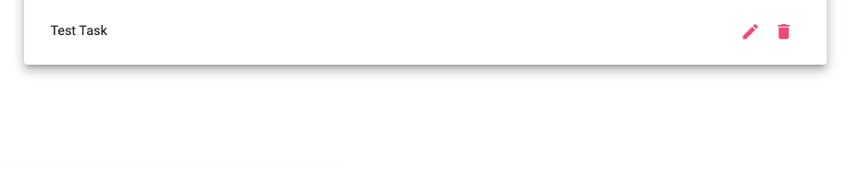
4 | Refresh the browser page. | Refreshing the page will change the entered task items. | Yes | Yes  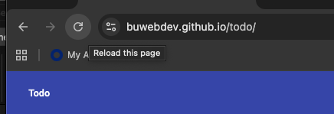
5 | Confirm the default list is visible. | The default list task items will be displayed on refresh. | Yes | Yes  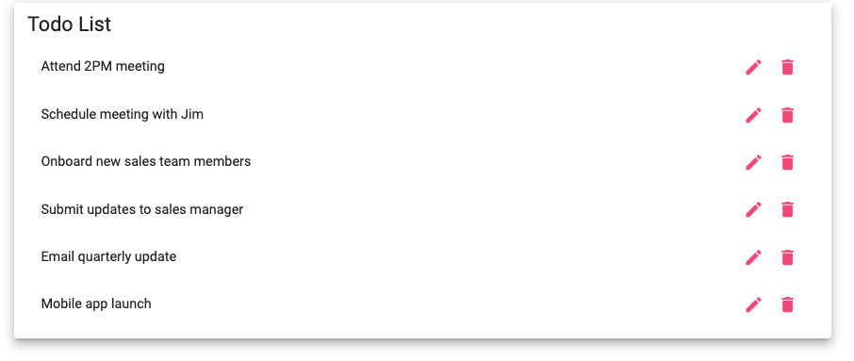
Comments | Default list is visible upon first navigating to URL. After adding items to the list the items are then displayed within the list. After deleting the items the list size shrinks. Upon refreshing page, the list defaults back to original list items. This test satisfies the core business requirements for the todo item.

Test 4 | Delete Task Item
 | Test Objective: Users can delete task items. | Developer: Zac Baker  Date tested: 2026/02/04 | Peer tester: Joel Atkinson  Date tested: 2026/02/08
Step | Action | Expected results: | Developer  pass/fail | Tester pass/fail  + Screenshot
1 | Click the trash icon to the right of a task item. | The delete button icon is functional and readily available. | Yes | Yes  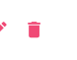
2 | Confirm the task has been deleted. | The delete button deletes the associated task item. | Yes | Yes  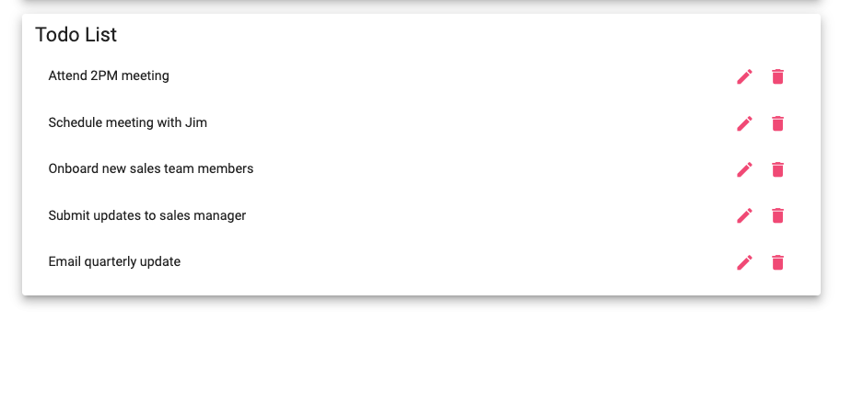
3 | Click the trash icon to the right of ALL task item. | All task items can be deleted. | Yes | Yes  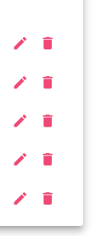
4 | Confirm ALL task items have been deleted. | All task items are deleted showing a blank list. | Yes | Yes  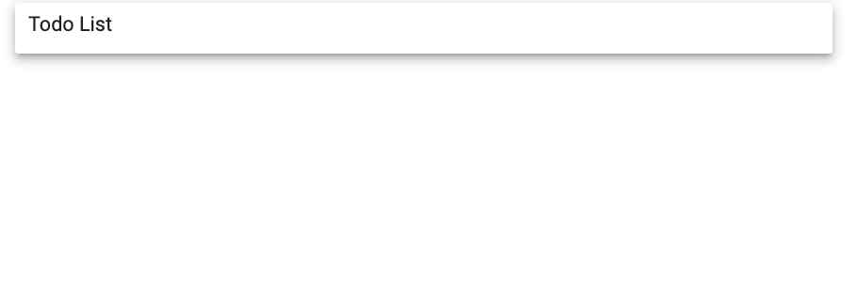
Comments | Clicking the trash can icon next to the list item deletes the item from the list. The item is immediately removed from the list and stays off. All items in the list have a trash can icon next to them. When you click all items trash can icons all items from the list are deleted. This satisfies all requirements of the test.

Test 5 | Edit Task Item
 | Test Objective: Users can edit existing task items. | Developer: Zac Baker  Date tested: 2026/02/04 | Peer tester: Joel Atkinson  Date tested: 2026/02/08
Step | Action | Expected results: | Developer  pass/fail | Tester pass/fail  + Screenshot
1 | Click the pencil icon to the right of task item. | The edit button icon is functional and readily available. | Yes | Yes  
2 | Enter updated task name. | There will be a dedicated input field that users may utilize to enter and update task item name. | Yes | Yes  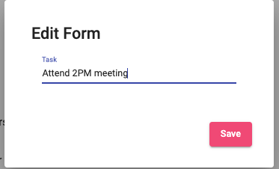
3 | Click “Save”. | There will be a save button or feature that allows the edit to be saved. | Yes | Yes  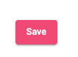
4 | Confirm task item has been edited successfully. | The list will show the updated task item name in the list area. | Yes | Yes  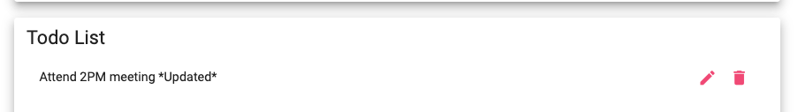
Comments | Hitting the pencil icon next to the list item brings up Edit Form pop up allowing user to enter edited text for the list item. After entering edited text, hitting the save button saves the changes which are then displayed in the list. This satisfies all requirements of the test.

