Week 1 Module 1 Assignment 2
Moffat Bay: TDD Assignment

Joel Atkinson, Zachary Baker, Kyle Klausen, Juan Macias Vasquez, Brittaney Perry-Morgan
Bellevue University
CSD460-H323 Capstone in Software Development (2265-DD)
Adam Bailey
March 28th, 2026

Week 1 Module 1 Assignment 2
Moffat Bay: TDD Assignment
GitHub Repository Link:
https://github.com/Joelatkinson95/Moffat-Bay
Group Team Members:
Joel Atkinson, Zachary Baker, Kyle Klausen, Juan Macias Vasquez, Brittaney Perry-Morgan
Leader Role: Joel Atkinson
Moffat Bay Lodge
Group Roles for this Assignment
Purpose | Zachary Baker
Terminology | Brittaney Perry-Morgan
User Personas | Joel Atkinson
User Stories | Juan Macias Vasquez
Work Estimations (ToDo List) | Kyle Klausen

TDD Structure:
- Introduction
  - Purpose
  - Terminology
  - User Personas
  - User Stories
  - Work Estimations (ToDo List)
- Design (Not done yet)
  - 2.1 Prototypes
  - 2.2 ERD
- QA Testing (Not done yet)
  - 3.1 QA Test Plan

Introduction
Purpose
The San Juan Islands First Nations Development Committee has approved construction of a resort at Moffat Bay on Joviedsa Island, and construction is nearly complete. There are concerns that their reach and customer base may be hindered by a lack of online presence. As a result, a website showcasing the Lodge's services has become a necessity. The San Juan Islands First Nations Development Committee requires a website that allows lodge reservation management, user log-in, a database for reservation information, and a dynamically updated Reservation Lookup page.
These services, when tied together, create the foundation for reservations to proceed smoothly while granting users efficient access to listings. Users being able to view the reservation openings reduces the chances of accidental double-bookings while also streamlining the reservation process. Establishing the service in this manner enables the customer to quickly and efficiently navigate the reservation process.

Terminology
Guest — A user who has registered an account on the Moffat Bay platform and may search for and book lodge accommodations.
Reservation — A confirmed lodge room booking associated with a guest account, check-in/check-out dates, room type, and a unique confirmation number.
Lodge — The hotel facility at Moffat Bay Resort on Joviedsa Island, whose rooms are bookable through the web application.
Reservation Lookup — A dynamically updated page allowing guests or staff to search for and retrieve existing reservation records.
User Registration — The process by which a new guest creates an account on the platform, providing credentials stored securely in the database.
Session — A server-side object that maintains authenticated user state across HTTP requests, managed via Jakarta EE session handling.
Servlet — A Java class that processes HTTP requests and responses, functioning as the controller layer of the application architecture.
JSP (JavaServer Pages) — The view layer technology used to render dynamic HTML content returned to the client browser.
JavaBean — A Java class following standard naming and encapsulation conventions, used to pass data between the servlet and JSP layers.
JDBC (Java Database Connectivity) — The API used to execute parameterized queries against the MySQL database.
ERD (Entity Relationship Diagram) — A diagram representing the database schema, including tables, attributes, and the relationships between them.
TDD (Technical Design Document) — The living project document capturing requirements, personas, user stories, design artifacts, and QA planning for the Moffat Bay application.
Kanban Board — The GitHub Projects board used by the team to track task progress across Check In, To Do, In Progress, and Done columns.

User Personas
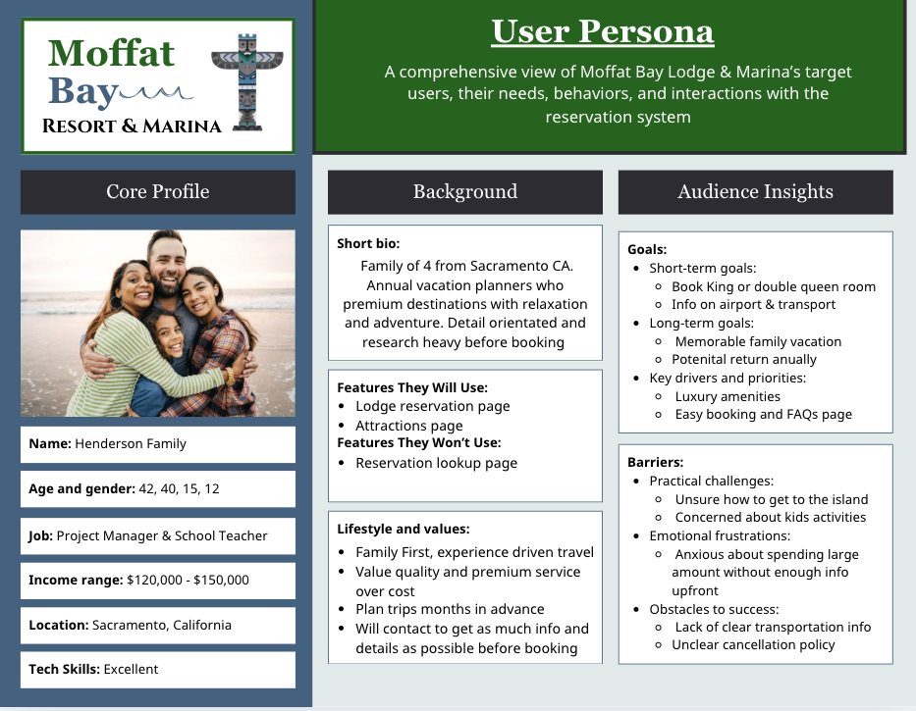
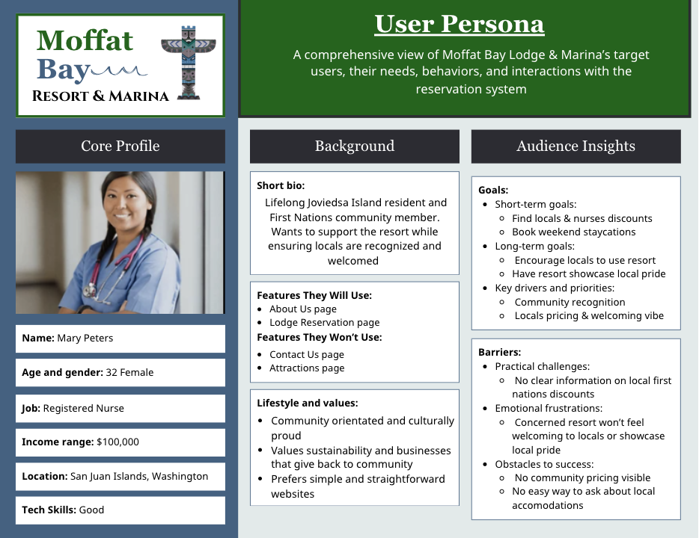
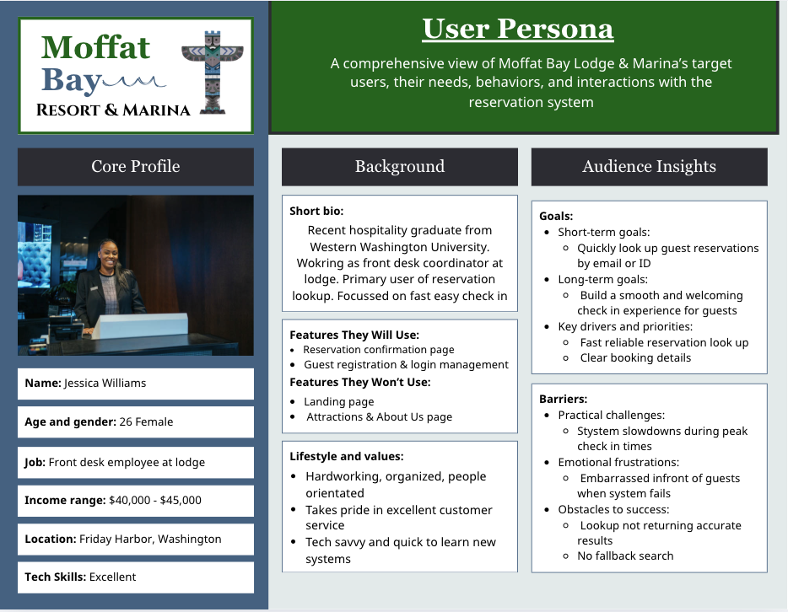
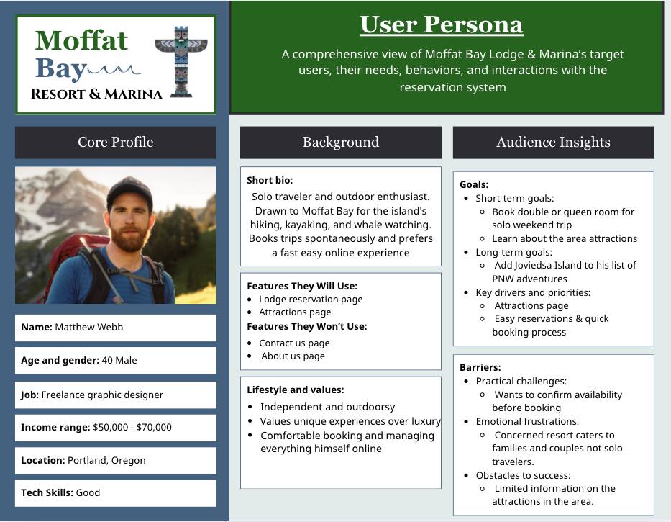
User Stories
Henderson Family (Family Travelers) Persona
Persona insight:
- Wants easy booking
- Needs info about transportation
- Concerned about kids’ activities
User Stories:
- US-1 (High Priority)
“As a family traveler, I want to easily book a king or double queen room, so that my family of four can stay comfortably together.”
- US-2 (High Priority)
“As a family traveler, I want to view transportation options to the island, so that I can plan our trip without confusion or stress.”
- US-3 (Medium Priority)
“As a family traveler, I want to see nearby attractions and kid-friendly activities, so that I can plan fun experiences for my children.”
Mary Peters (Local Resident & Registered Nurse) Persona
Persona insight:
- Easy Local Information / Local Pride
- Wants clear information
- Local Pricing
User Stories:
- US-1 (High Priority)
As a local resident, I want to see any locals or nurse discounts when booking, so that I feel recognized and can take advantage of benefits available to my community.
- US-2 (High Priority)
As a local resident, I want to book weekend staycations easily, so that I can relax without complicated processes.
- US-3 (Medium Priority)
As a local resident, I want clear information about resort events that showcase local culture, so that I can support and participate in community-focused activities.
- US-5 (Low Priority)
As a local resident, I want an easy way to contact resort staff about local accommodations, so that I can ask questions about special local arrangements.
Jessica Williams (Front Desk Employee) Persona
Persona insight:
- Needs a fast and reliable system to quickly check in guests
- Prioritizes accurate reservation details and having an easy search functionality
- Works under pressure during peak times and values efficiency
- Gets frustrated when system delays or errors impact customer experience
User Stories:
- US-1 (High Priority)
As a front desk employee, I want to quickly search for reservations by guest name or ID, so that I can check in guests efficiently.
- US-2 (High Priority)
As a front desk employee, I want to view complete reservation details, so that I can confirm bookings accurately.
- US-3 (High Priority)
As a front desk employee, I want the system to load quickly during peak hours, so that I can avoid delays in guest check-in.
- US-4 (Medium Priority)
As a front desk employee, I want a backup search option (like phone number), so that I can find reservations if primary search fails (If the wrong name was used).
- US-5 (Low Priority)
As a front desk employee, I want a simple and easy-to-use interface, so that I can navigate the system without errors.

Matthew Webb (solo traveler & outdoor enthusiast) Persona
Persona insight:
- Prefers a fast and simple booking process for spontaneous trips
- Values clear information about outdoor activities and local attractions
- Likes to manage everything independently online himself without help
User Stories:
- US-1 (Medium Priority)
As a solo traveler, I want to view nearby outdoor attractions, so that I can plan activities like hiking and kayaking.
- US-2 (Medium Priority)
As a solo traveler, I want clear pricing and room details, so that I can make quick decisions.
- US-3 (Low Priority)
As a solo traveler, I want everything to be handled online, so that I don’t need to contact support.

Work Estimations (ToDo List)

