Week 2 Module 2 Assignment 1
Moffat Bay: Mockups

Joel Atkinson, Zachary Baker, Kyle Klausen, Juan Macias Vasquez, Brittaney Perry-Morgan
Bellevue University
CSD460-H232 Capstone in Software Development (2265-DD)
Adam Bailey
April 1, 2026

Moffat Bay Assignment 2.1: Mockups

Landing Page:


About Us Page:
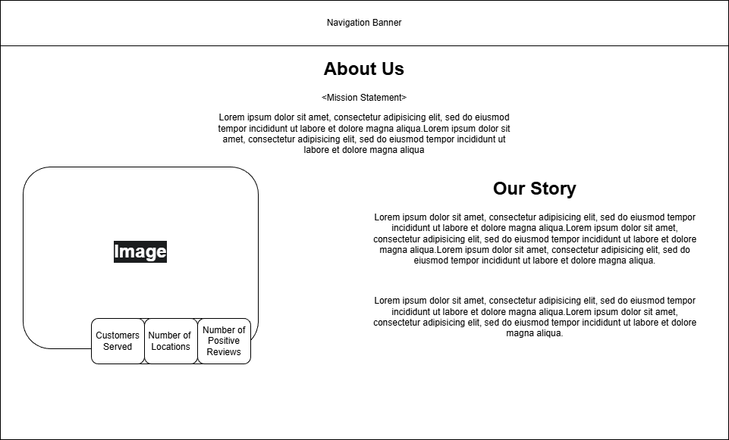
Contact Us Page:
