Week 5 Module 6 Assignment
Room reservation page Test

Juan Macias Vasquez
Bellevue University
CSD460-H323 Capstone in Software Development (2265-DD)
Adam Bailey
April 26th, 2026

Week 5 Module 6 Assignment
Room reservation page Test
GitHub Repository Link:
https://github.com/Joelatkinson95/Moffat-Bay
Group Team Members:
Joel Atkinson, Zachary Baker, Kyle Klausen, Juan Macias Vasquez, Brittaney Perry-Morgan
Module 6 Room reservation page Test

Test 1:
Pictures | Description of what is happening
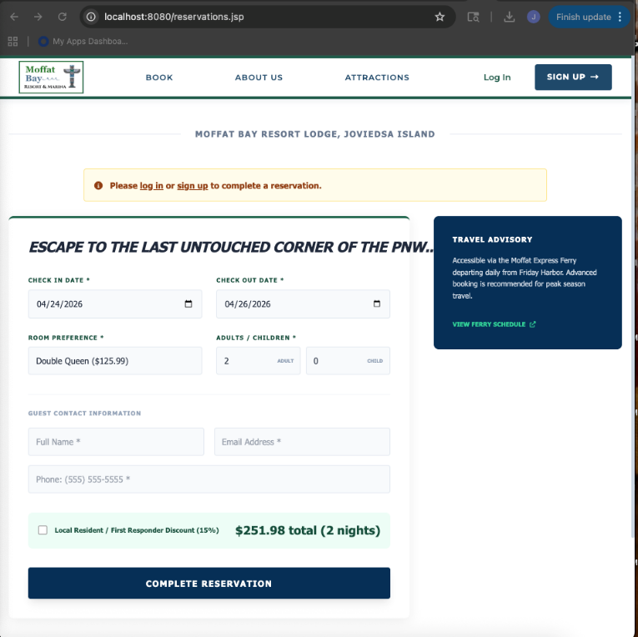 | Navigated to the “book” page at localhost8080/reservations.jsp and the page loaded correctly without error
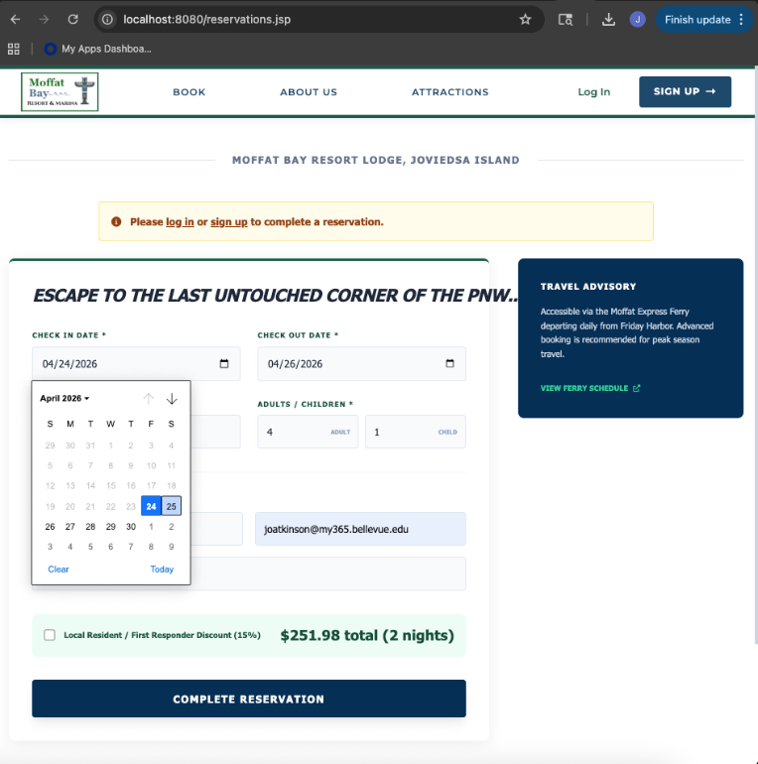 | Checked that all fields were present and displaying their defaults, from there I was able to enter in my data and confirm that all fields were working correctly and allowing data to be entered through text box, calendar or dropdowns.
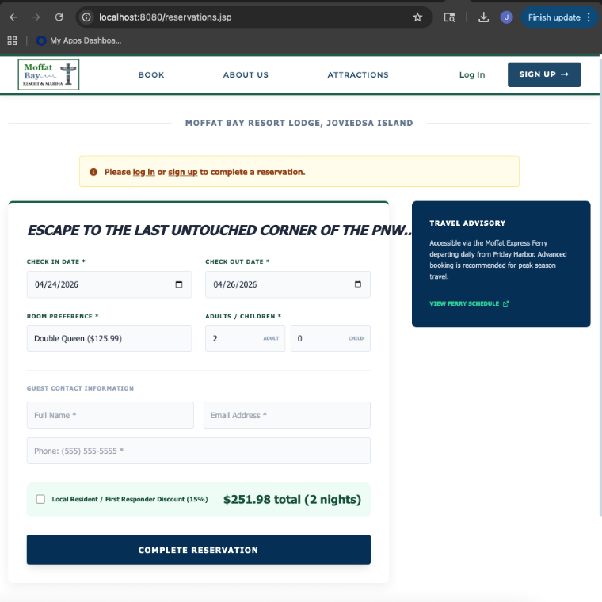 | I then refreshed the page to ensure that it reloaded correctly returned to displaying defaults. The page refreshed without error and adjusted back to displaying its defaults

Test 2
Pictures | Description of what is happening
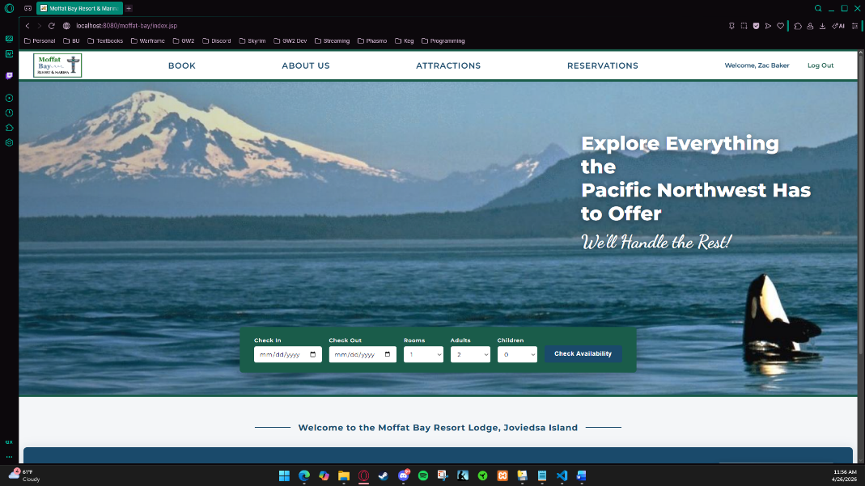 | Navigated to the home page and logged in with a valid account.
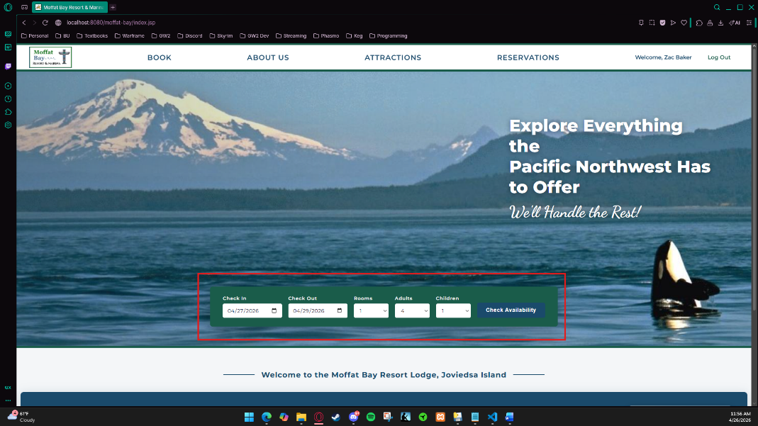 | Used the check availability feature to find rooms that met input requirements. All fields displayed correctly.
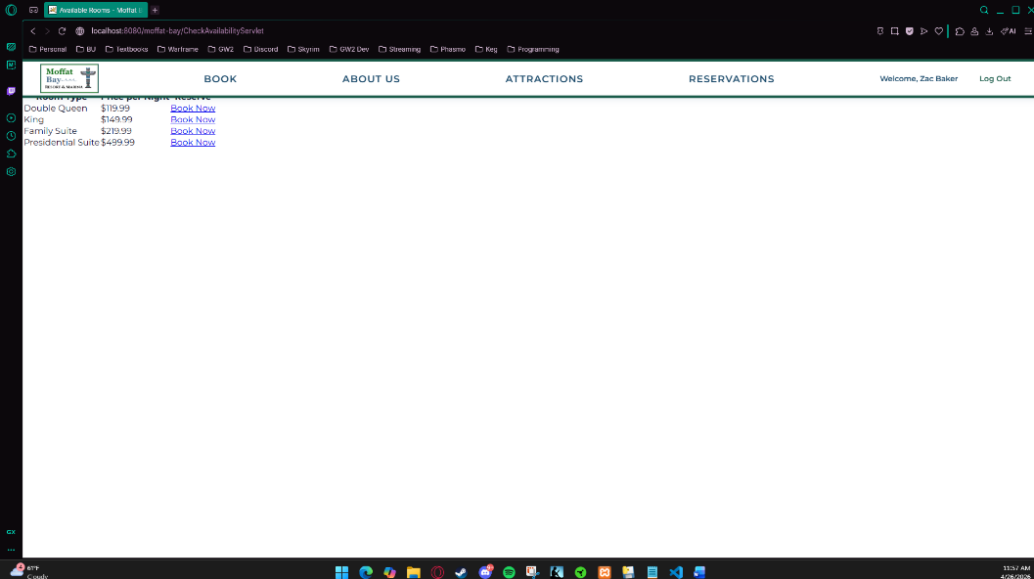 | After clicking the check availability button. Listings showed for all rooms that met the input requirements. Redirected to this page.
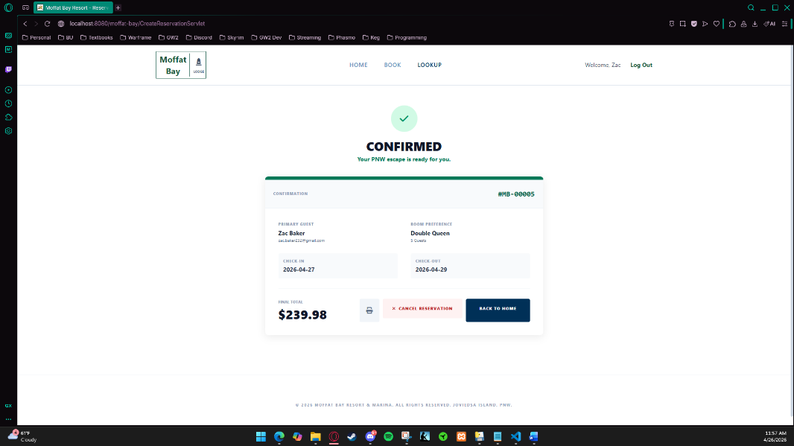 | Both clicking the book now button or redirecting to booking page manually, allowed me to enter my room reservation information. I was able to successfully complete my reservation and the confirmation showed.

Test 3
Pictures | Description of what is happening
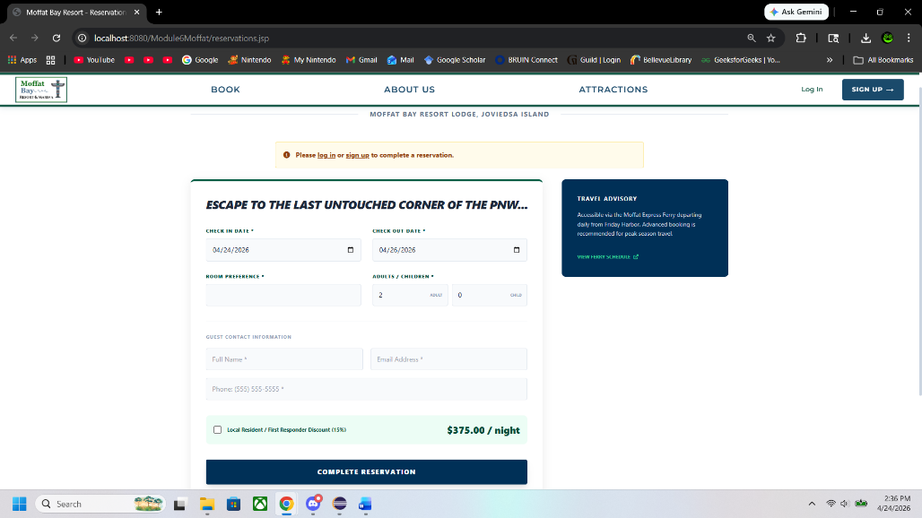 | The page does load correctly
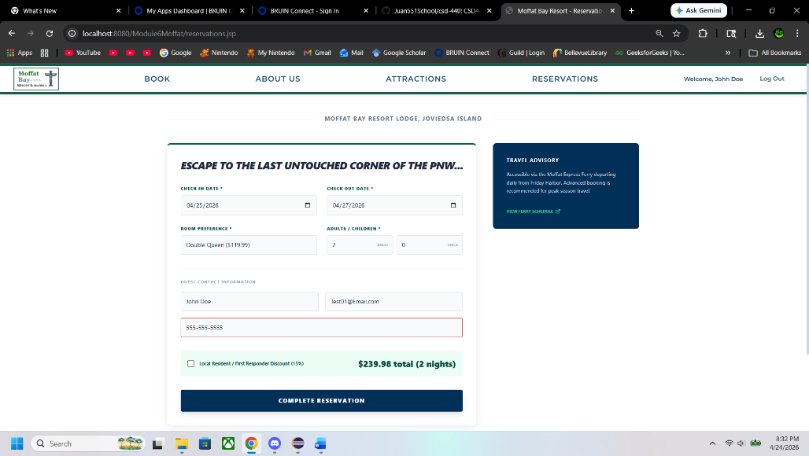 | I was able to input all the information into the fields  And it does show that I am now signed into so that it can add it to my account.
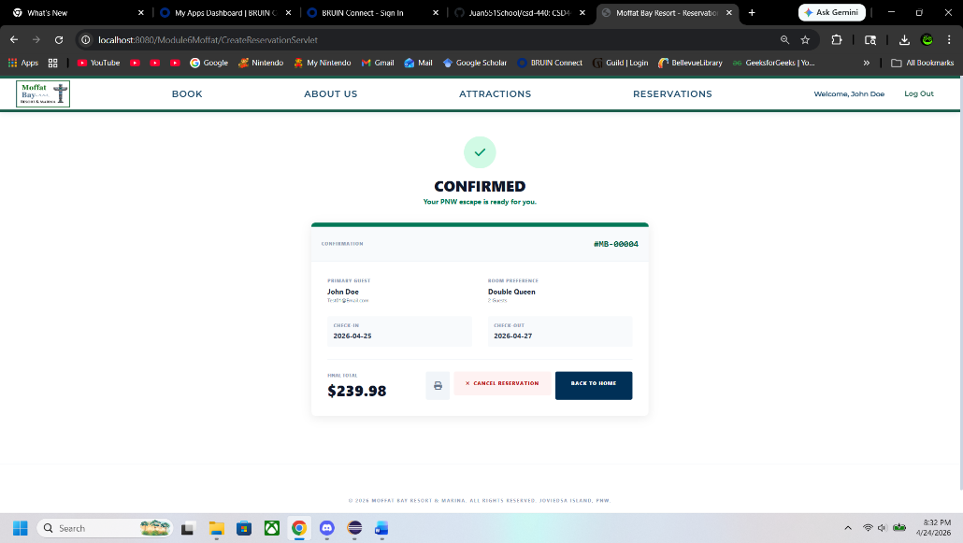 | Was able to geta confirmation page after submitting the information
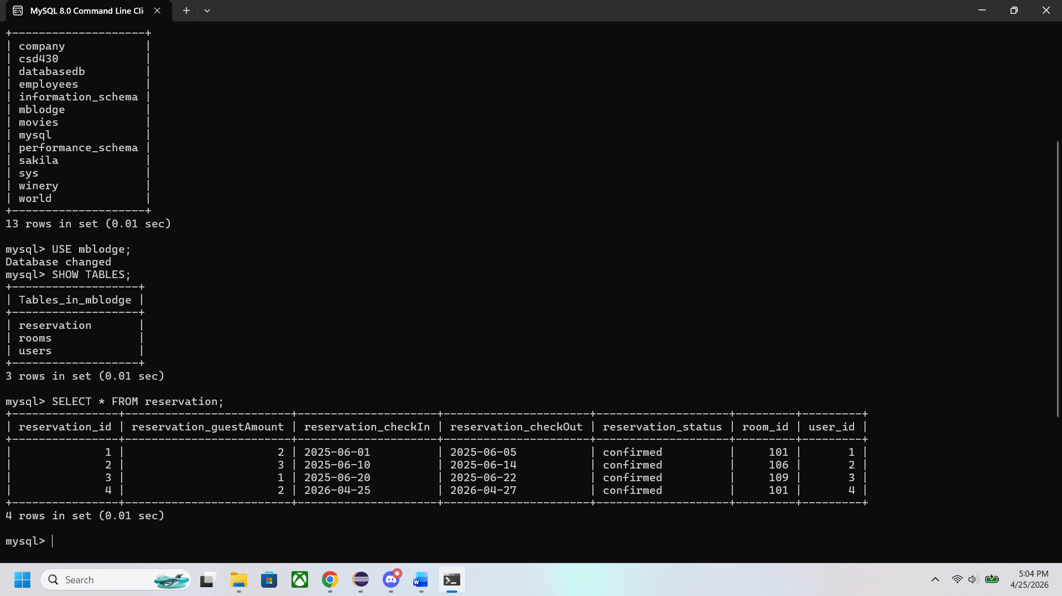 | I was able to check the database to see if the record was correctly added

Test 4 Missing Input
Pictures | Description of what is happening
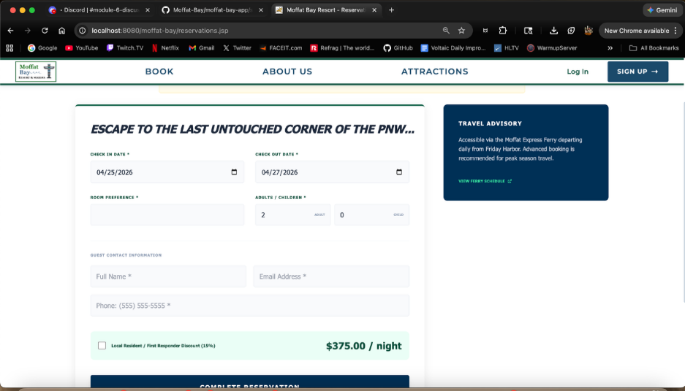 | Test 1 – Navigated to Reservation Page
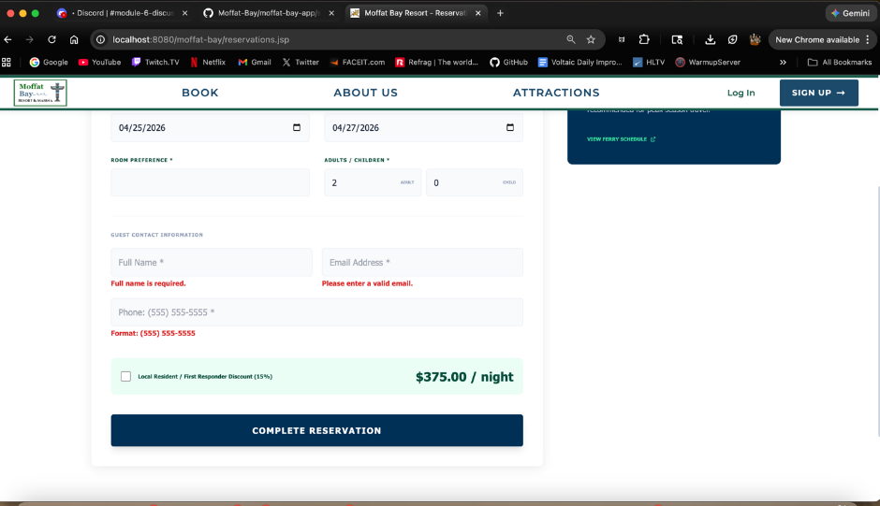 | Test 2 - Leave required fields blank (example name or date)  Received a visual error code and the form was not allowed to be submitted, but the complete resevation button was succesful it allowing me to attempt submission.
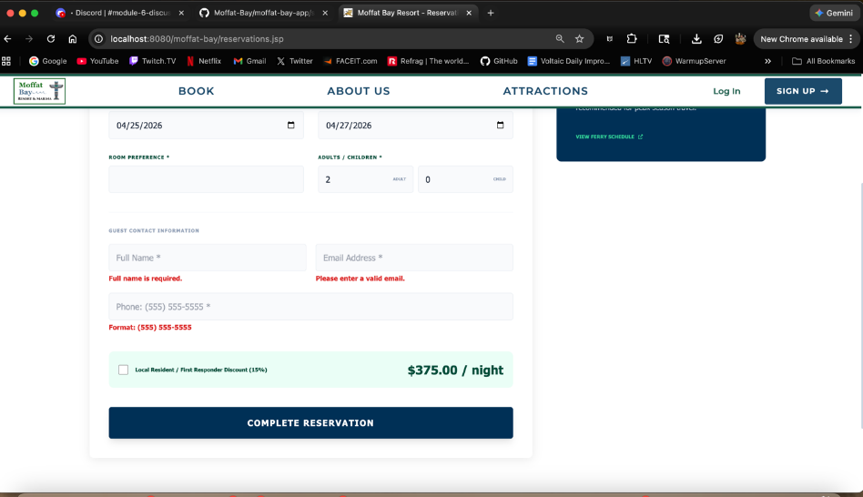 | Test 3 – Submit the form  Received a visual error code and the form was not allowed to be submitted without the required fields being completed.
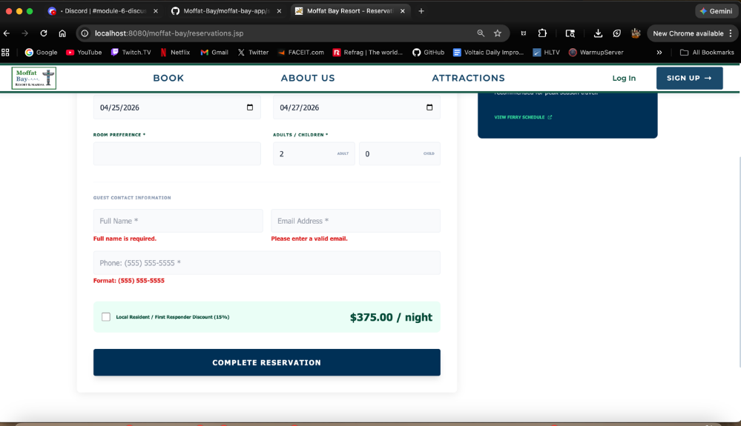 | Test 4 - Observe error messages  The correct error messages are displayed and are tied to their correct boxes for required fields.
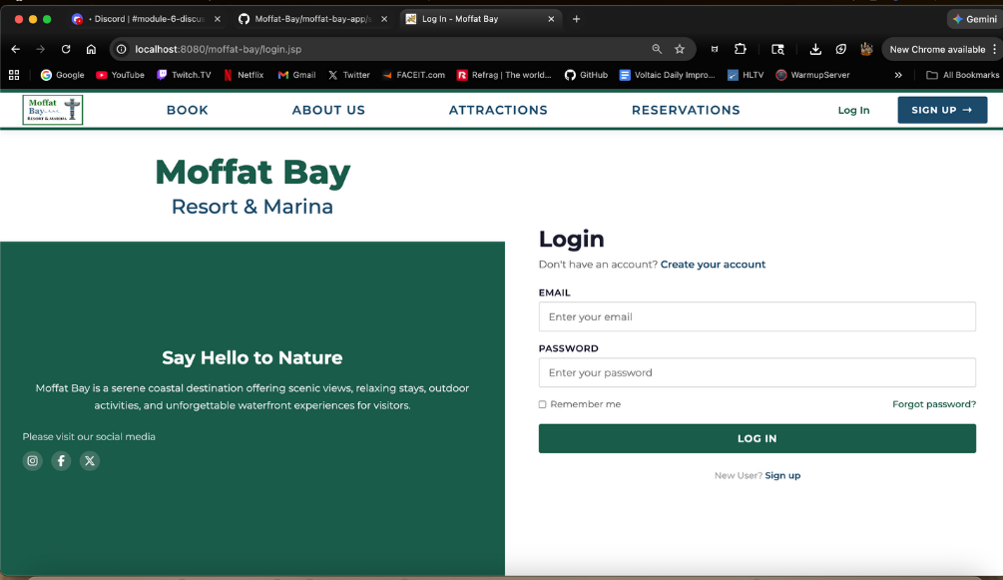 | Test 5 - Correct the input and resubmit  The information was corrected and the reservation page was attempted to be submitted, I was redirected to the login page in order to gain access to my account to reserve. Meaning the test was successful.

