Week 5 Module 7 Assignment
About Us Page and Reservation Summary page Test Pictures

Juan Macias Vasquez
Bellevue University
CSD460-H323 Capstone in Software Development (2265-DD)
Adam Bailey
April 26th, 2026

Week 5 Module 7 Assignment
About Us Page and Reservation Summary page Test Pictures
GitHub Repository Link:
https://github.com/Joelatkinson95/Moffat-Bay
Group Team Members:
Joel Atkinson, Zachary Baker, Kyle Klausen, Juan Macias Vasquez, Brittaney Perry-Morgan
Module 7 Room reservation About Us Page and Reservation Summary page

Test 1 – About Us Page
Pictures | Description of what is happening
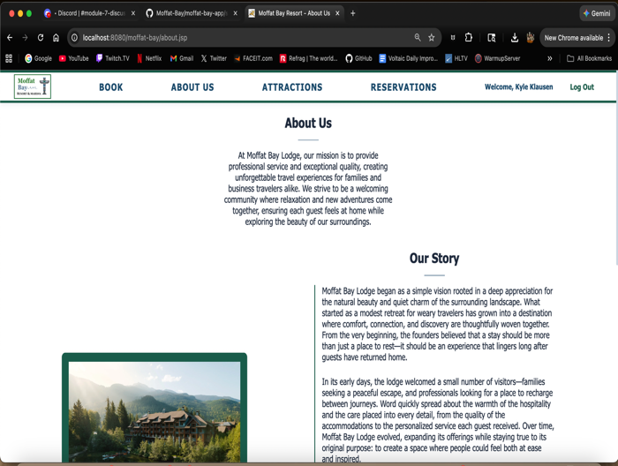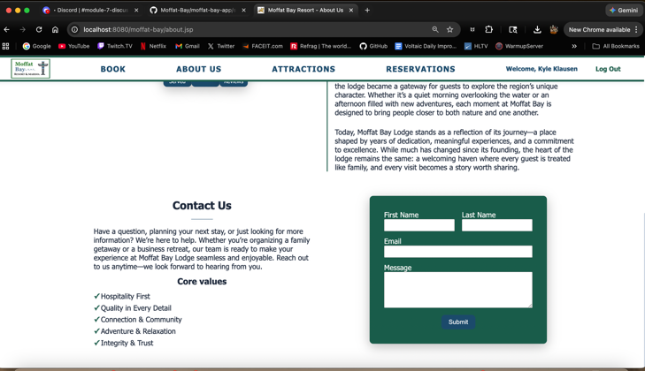 | Test 1- I was able to load the page and all the information and URL was correct.
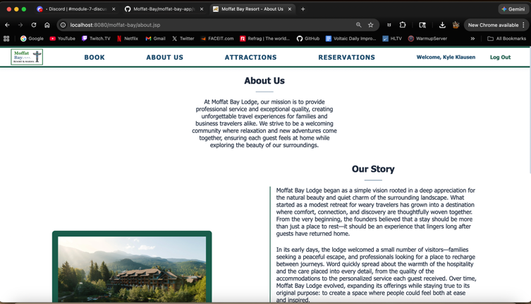 | Test 2 – The page displayed all information is the same style as the rest of the website.
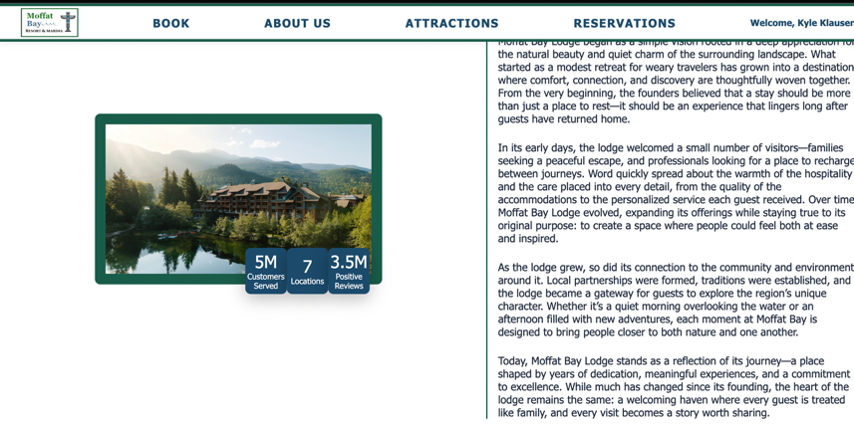 | Test 3 – Any images on the page were accurate and loaded in without any errors.
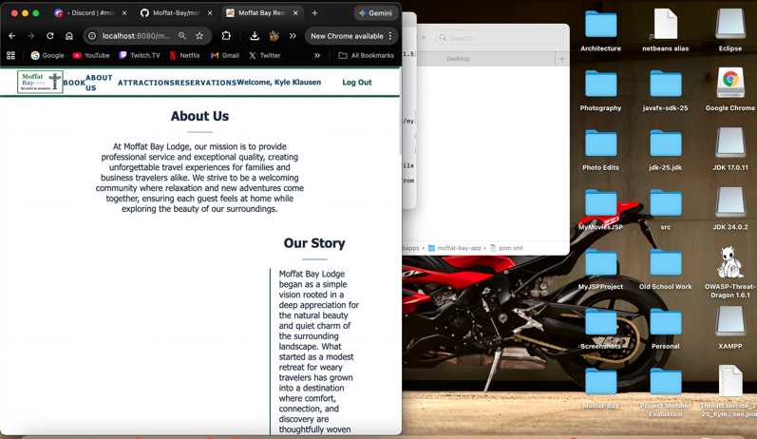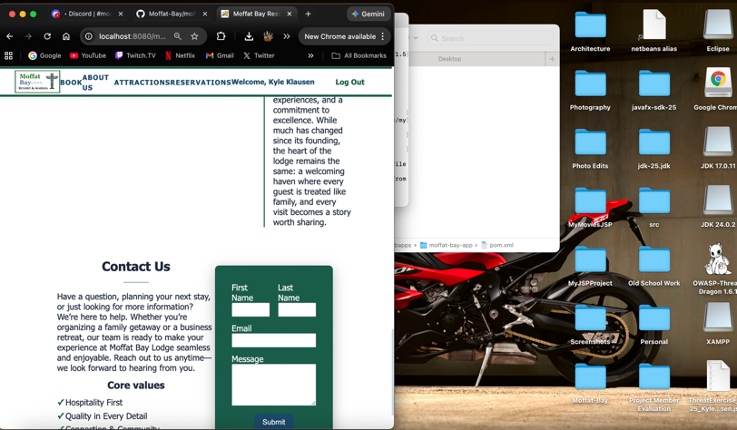 | Test 4 – Resized the browser window to ensure the page corrected its layout and adjusted.
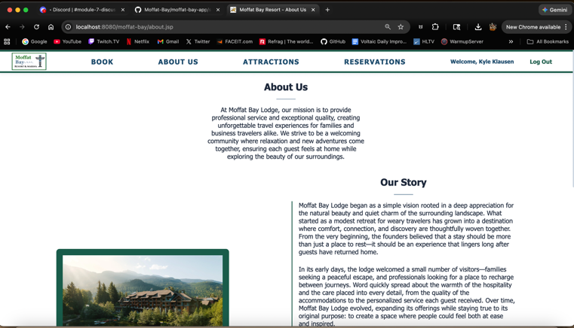 | Test 5 – Refreshed the page and encountered no errors.

Test 2
Pictures | Description of what is happening
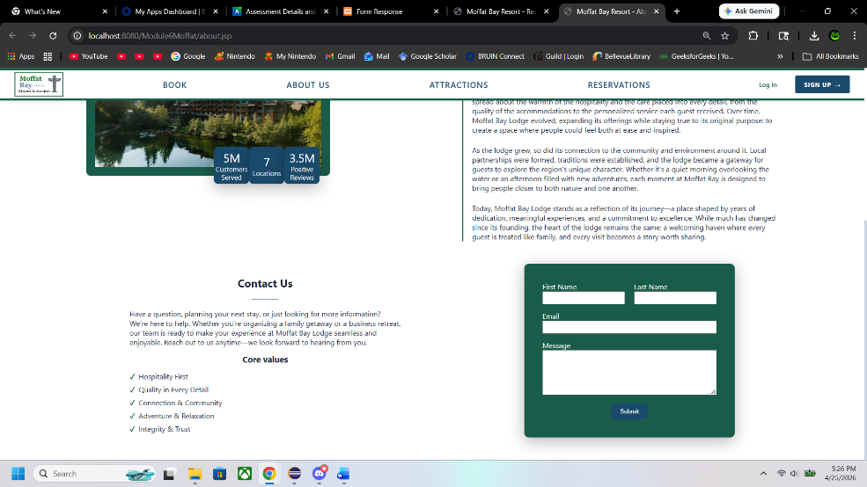 | Was able to load the page and find the contact us sections
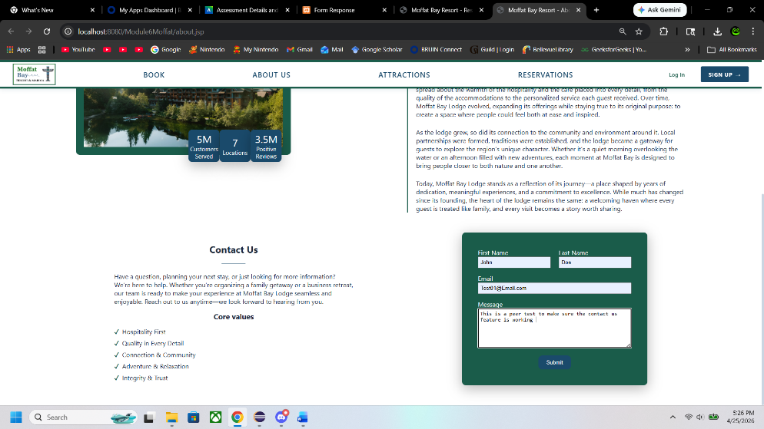 | Added the information  Also made sure that the message portion could display multiple lines not just one.
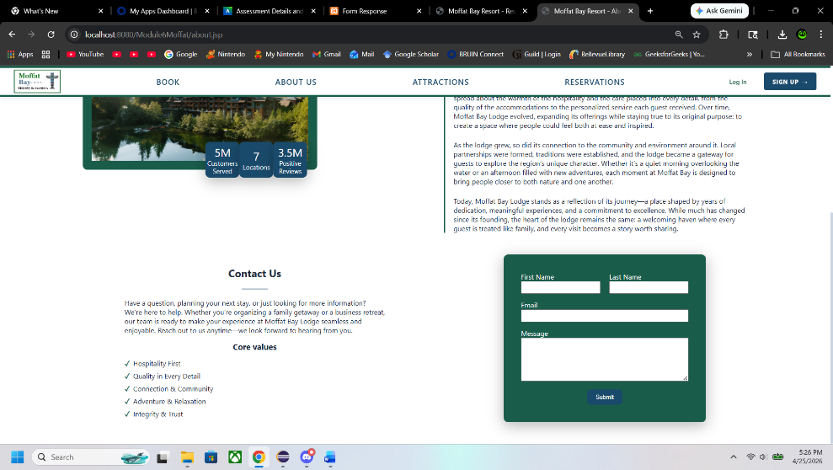 | After submitting it made the input sections blank as intended.

Test 3
Pictures | Description of what is happening
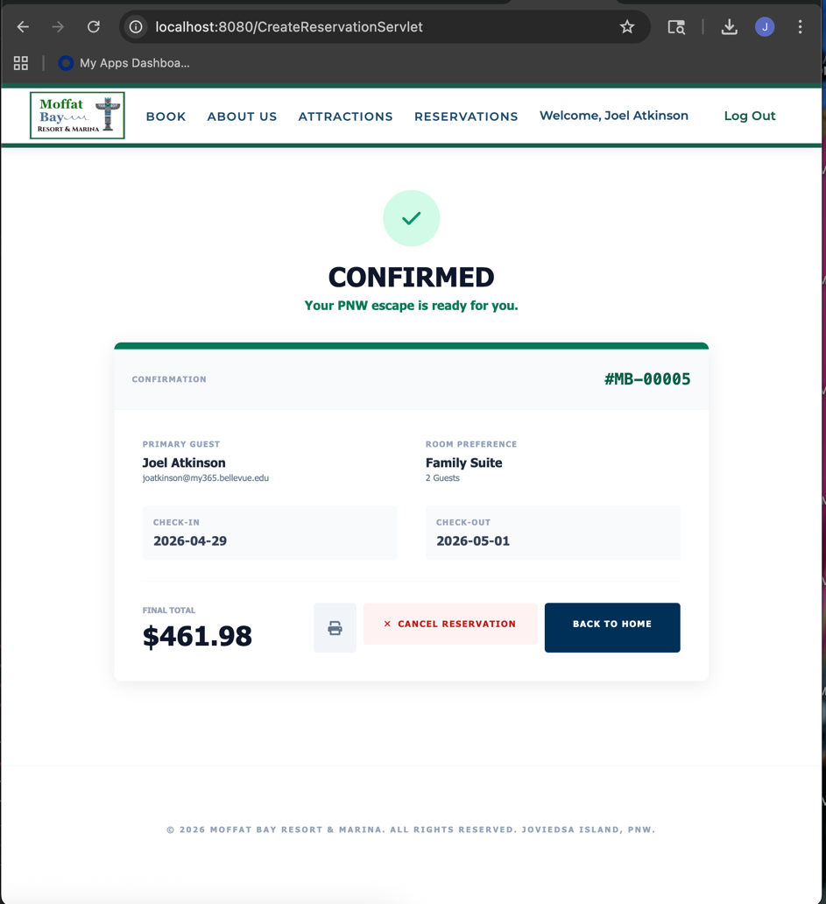 | Made reservation under my Joel Atkinson account and received a confirmation message with confirmation number
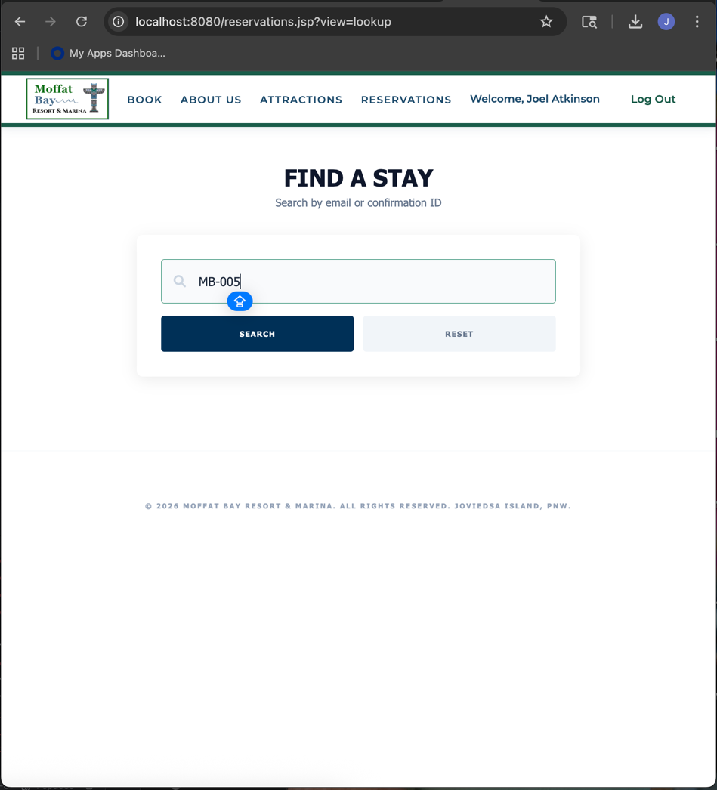 | Navigated to the Reservations tab on the navbar to take my to the reservations lookup page where I entered my confirmation number from my recent booking.
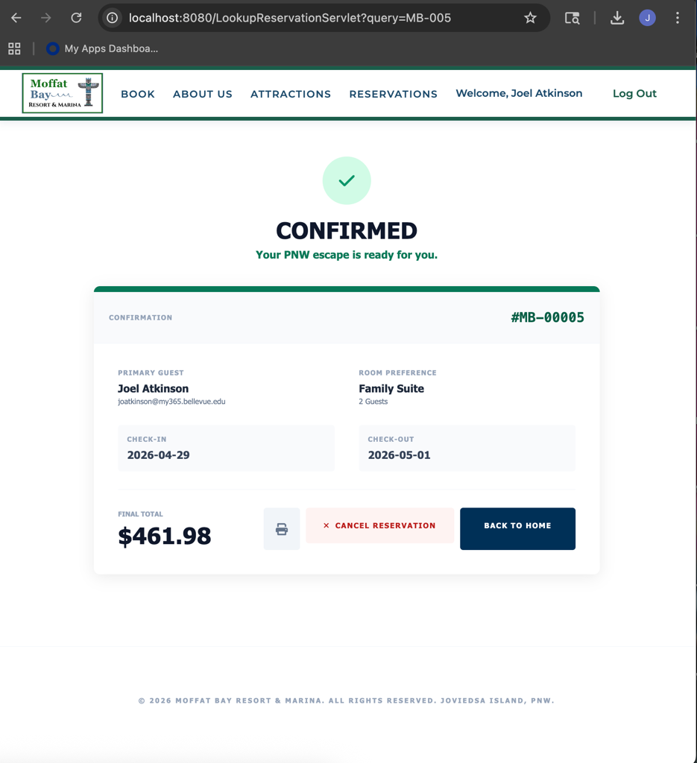 | The page accepted my input of my confirmation number without error and displayed my reservation details without error. I refreshed the page and it still kept my summary details up.

Test 4
Pictures | Description of what is happening
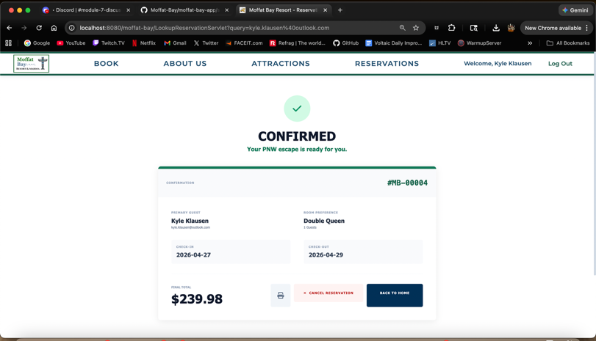 | Test 1 – Summary page loads successfully
 | Test 2 – All information is shown correctly, has all required fields present.
 | Test 3 – All the data is accurate and correct per the booking information submitted.
 | Test 4 – Total price is accurate and corrected based on the amount of days being stayed, also included the local resident price.
 | Test 5 – Page is clear and easy to read. All information is direct and available to the guest.

