Week 3 Module 4 Assignment
Moffat Bay: Database Dev

Joel Atkinson, Zachary Baker, Kyle Klausen, Juan Macias Vasquez, Brittaney Perry-Morgan
Bellevue University
CSD460-H232 Capstone in Software Development (2265-DD)
Adam Bailey
April 12, 2026

Select Statement Screenshots
Users
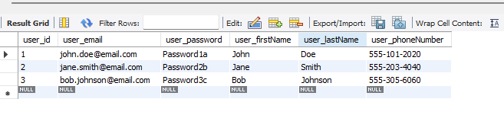
Rooms
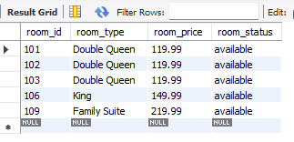
Reservation
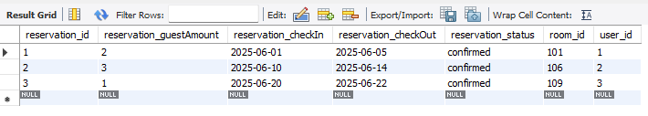

SQL File
-- Moffat Bay Lodge Database
-- CSD-460 Capstone
-- Updated for submission (constraints, trigger fix, data integrity)
-- Authors: Kyle Klausen, Joel Atkinson, Zachary Baker, Juan Macias-Vasquez, and Brittaney Perry-Morgan

DROP DATABASE IF EXISTS mblodge;
CREATE DATABASE mblodge;
USE mblodge;

CREATE USER IF NOT EXISTS 'mbGuest123'@'localhost' IDENTIFIED BY 'mbPass123!';
GRANT ALL PRIVILEGES ON mblodge.* TO 'mbGuest123'@'localhost';
FLUSH PRIVILEGES;

--------------------------------------------------
-- Table: users
--------------------------------------------------

CREATE TABLE users (
user_id INT PRIMARY KEY AUTO_INCREMENT,
user_email VARCHAR(100) NOT NULL UNIQUE,
user_password VARCHAR(255) NOT NULL,
user_firstName VARCHAR(50) NOT NULL,
user_lastName VARCHAR(50) NOT NULL,
user_phoneNumber VARCHAR(20) NOT NULL
);

INSERT INTO users (user_email, user_password, user_firstName, user_lastName, user_phoneNumber) VALUES
('john.doe@email.com', 'Password1a', 'John', 'Doe', '555-101-2020'),
('jane.smith@email.com', 'Password2b', 'Jane', 'Smith', '555-203-4040'),
('bob.johnson@email.com', 'Password3c', 'Bob', 'Johnson', '555-305-6060');

--------------------------------------------------
-- Table: rooms
--------------------------------------------------

CREATE TABLE rooms (
room_id INT PRIMARY KEY,
room_type VARCHAR(50) NOT NULL,
room_price DECIMAL(10,2) NOT NULL,
room_status VARCHAR(20) NOT NULL DEFAULT 'available',
CONSTRAINT check_room_status
CHECK (room_status IN ('available', 'occupied', 'maintenance', 'out_of_service'))
);

INSERT INTO rooms (room_id, room_type, room_price, room_status) VALUES
(101, 'Double Queen', 119.99, 'available'),
(102, 'Double Queen', 119.99, 'available'),
(103, 'Double Queen', 119.99, 'available'),
(106, 'King', 149.99, 'available'),
(109, 'Family Suite', 219.99, 'available');

--------------------------------------------------
-- Table: reservation
--------------------------------------------------

CREATE TABLE reservation (
reservation_id INT AUTO_INCREMENT PRIMARY KEY,
reservation_guestAmount INT NOT NULL,
reservation_checkIn DATE NOT NULL,
reservation_checkOut DATE NOT NULL,
reservation_status VARCHAR(20) NOT NULL DEFAULT 'confirmed',
room_id INT NOT NULL,
user_id INT NOT NULL,

CONSTRAINT check_dates
CHECK (reservation_checkOut > reservation_checkIn),

CONSTRAINT check_guest_amount
CHECK (reservation_guestAmount > 0),

CONSTRAINT check_res_status
CHECK (reservation_status IN ('confirmed', 'cancelled', 'completed', 'no_show')),

FOREIGN KEY (room_id) REFERENCES rooms(room_id)
ON DELETE RESTRICT ON UPDATE CASCADE,

FOREIGN KEY (user_id) REFERENCES users(user_id)
ON DELETE RESTRICT ON UPDATE CASCADE
);

INSERT INTO reservation
(reservation_guestAmount, reservation_checkIn, reservation_checkOut, reservation_status, room_id, user_id) VALUES
(2, '2025-06-01', '2025-06-05', 'confirmed', 101, 1),
(3, '2025-06-10', '2025-06-14', 'confirmed', 106, 2),
(1, '2025-06-20', '2025-06-22', 'confirmed', 109, 3);

--------------------------------------------------
-- Trigger: Prevent Double Booking (FIXED)
--------------------------------------------------

DELIMITER //

CREATE TRIGGER before_reservation_insert
BEFORE INSERT ON reservation
FOR EACH ROW
BEGIN
DECLARE overlap_count INT;

SELECT COUNT(*) INTO overlap_count
FROM reservation
WHERE room_id = NEW.room_id
AND reservation_status = 'confirmed'
AND (
NEW.reservation_checkIn < reservation_checkOut AND
NEW.reservation_checkOut > reservation_checkIn
);

IF overlap_count > 0 THEN
SIGNAL SQLSTATE '45000'
SET MESSAGE_TEXT = 'Error: Room already booked for selected dates.';
END IF;
END;
//

DELIMITER ;

--------------------------------------------------
-- SELECT STATEMENTS (for screenshots)
--------------------------------------------------

SELECT * FROM users;
SELECT * FROM rooms;
SELECT * FROM reservation;

