Delta Air Lines Inc.
Report Analysis

Team 21:

Elizabeth Byrne, Bryan Garcia, Venkat Retineni,
Eric Szymkowski, Michael Zaccaria
Abstract

Through the use of pro-forma statements and sequential valuation, our team valued Delta Air Lines. Foremost, our process consisted of getting the forecasted fundamental financial statements in order to compute free cash flows. Before discounting our cash flows we computed the weighted average cost of capital. With a cost of equity of 7.97 percent and a after tax cost of debt of 2.84 percent, we calculated a WACC of 6.23 percent. We then discounted the free cash flows using this rate to get a npv of $213,867. Lastly, we compared our predicted share price of $212.67 with Delta’s current actual share price of $34.45 as of July 1, 2020. We believe that the prices are different due to Delta being highly leveraged with a debt-to-equity ratio of 50%. Our price differentiation could also have come from the assumptions defined. With an already high debt-to-equity ratio, we made the assumption that the debt-to-equity is static in our forecast, thus increasing Delta’s intrinsic value overtime. Another factor that our predicted price does not account for are the effects of a COVID-19 pandemic. The current market share price is reasonably low because of the unpredictable loss of Delta’s main source of revenue due to mandated lockdowns globally.

Introduction

Brief Overview of Delta Air Lines
What is known today as Delta Air Lines was founded in 1928 as Delta Air Service by Collett Everman Woolman. The company initiated its first commercial passenger flight in 1929 and has evolved this initial business model for over 90 years, becoming the largest airline company in the world. Delta Air Lines, Inc. operates through Airline and Refinery segments. The Airline sector provides scheduled air transportation for passengers and cargo, while the Refinery sector consists of jet fuel products.
Delta Air Lines has reported its tenth straight year of profitability in 2019 with an annual revenue growth of 5.8% to $47 billion, and a jump in net income of 2.11% to $4.8 billion. The company’s record 2019 year was attributed to cheap fuel prices accompanied with high travel demand. Delta Air Lines was also the only major U.S. airline without Boeing 737 MAX planes in its supply and therefore was able to avoid the fallout of Boeing’s wrongdoings that many of their competitors had to face.
Delta Air Lines short-term performance and future profitability is uncertain due to the negative impact that COVID-19 has continued to bring to the travel industry. After the pandemic closed most airline travel, Delta and its competitors have continued to seek government aid to stay afloat. The company’s current CEO Ed Bastain reasoned the financial recovery period could take two to three years post pandemic.
Strategy
To determine the future financial projections of Delta Air Lines, Inc., an excel spreadsheet model was developed using the discounted cash flow and sequential valuation approach. This model will help determine the potential capabilities and ventures of Delta’s performance in the upcoming years.
The discounted cash flow valuation method is used to estimate the value of an investment based on projected future cash flows. To estimate these cash flows, a pro forma income statement and balance sheet must be created for all years into the future until consistent growth is present.
During the preparation of this report we have made the following assumptions:
- Variable costs keep constant at average % of sales from the last 3 years.
- Long term debt stays constant as a % of revenue.
- See all income statement and balance sheet projections in cost and working capital projections below.
Data and Analysis

Sales Forecast
We forecasted sales by first converting historical sales to real from nominal. In doing so, we separated the growth that is attributable to the firm from the growth that is attributable to inflation. From here, we averaged the real growth rate and used the inflation rate of 2.00% to find the nominal growth rate for the revenue. From here, each consecutive projection year of revenue grows by the nominal growth rate from the previous year.

Forecasting Costs
Having sales forecasted, our next step in constructing pro-forma financial statements is to forecast Delta’s operating costs: aircraft fuel, salaries, regional carriers, aircraft maintenance, etc. Instead of using a linear regression model to forecast combined SG&A and COGS that breaks up fixed and variable costs, we projected individual accounts by percentage of sales if it included more variable costs. If the account consisted of more fixed cost we projected its future cost at a constant inflation of two percent.

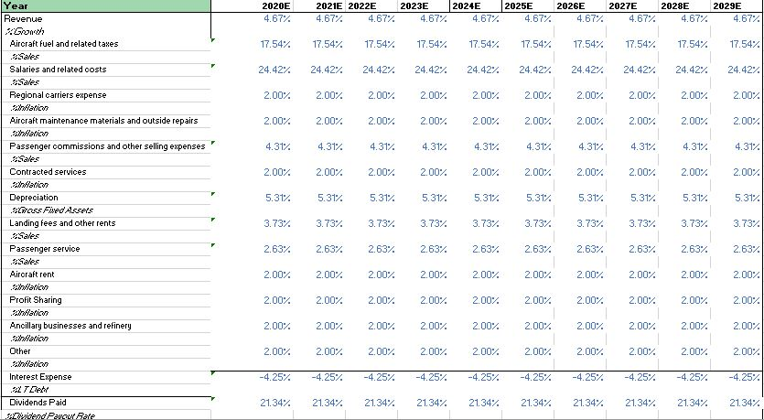
Figure 1. Accounts Forecast

Forecasting Working Capital Accounts
In forecasting Delta’s net working capital accounts, we used ratios such as days sales outstanding ( [avg accounts receivable / revenue] * 365) for Accounts Receivable and days inventory outstanding ( [inventory/cogs] * 365) for fuel inventory and supplies inventory account. Since we did not see any significant trends for the accounts receivable and the fuel inventory, we took the average for those accounts’ corresponding ratios. We did, however, see the supplies inventory steadily grow at a constant rate, we also used an average of their days inventory outstanding ratio.

As for forecasting current liabilities, we calculated the current portion of long-term debt using the average of historical short-term debt to long-term debt . The forecasted accounts payable was calculated by using the average day payable outstanding ratio ( [accounts payable/ cost of goods sold] * 365). The rest of the current liabilities accounts were forecasted as an average percentage of sales or their respective average accounts.
In order to forecast future working capital accounts, we simply multiplied the accounts with their corresponding calculated projection rates as shown in figure 1.

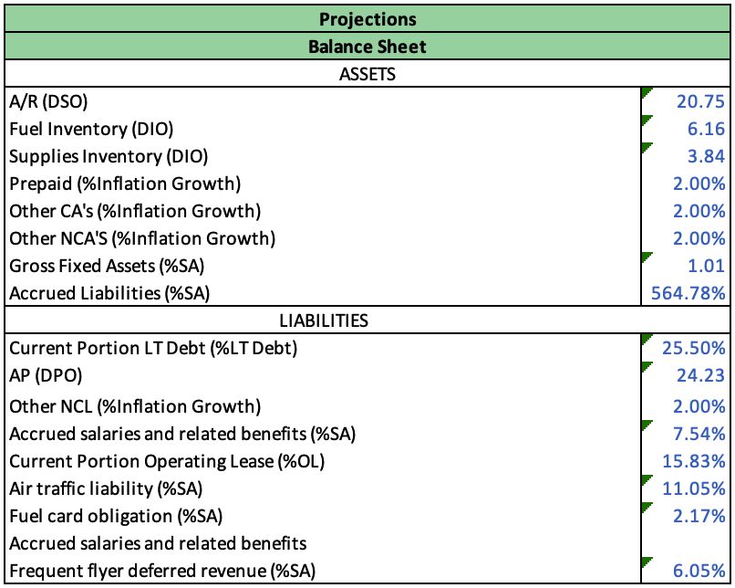
Figure 2. Working capital account forecasts

Forecasting Capital Expenditures, Depreciation, and Miscellaneous
Fixed assets were forecasted as an average percentage of sales. We are assuming that capital expenditures increase as sales grows consistently. Depreciation expense was calculated by averaging previous depreciation expenses divided by sales. We then multiplied previous depreciation expense by this ratio. This depreciation expense was then added to accumulated depreciation allowing us to get gross fixed asset.

The other miscellaneous accounts such as cash restricted for airport construction and goodwill were forecasted with a few assumptions. Goodwill has been static at $9,794 for 2011-2017. So we assumed it was going to stay static for the next ten years. The cash restricted for airport construction we assumed was going to grow at inflation.

WACC and Discounting
In order to discount the free cash flows, we needed to calculate the WACC which consists of the cost of equity and the cost of debt. The formula for WACC is as follows: (Cost of equity)(Weight of equity) + (Cost of debt)(Weight of debt). At the time of the 2020 annual filing, Delta’s had 651M shares outstanding and a market share price of $34.38. We also set a few assumptions regarding the cost of equity and cost of debt calculations. We derived the 0.98% risk free rate directly from the 10yr treasury rate, and the 5.5% market risk premium (expected return - risk free rate) from the slope of the security market line. We defined this market risk premium as the extra return an investor is expected to receive for holding a market portfolio as opposed to risk free investments.

We arrived at our pre-tax cost of debt by dividing Delta’s total interest payment by total debt for the annual year. Our tax rate was calculated through an analysis of historical Income Tax / EBIT ratios (2010-2019). Our market value of equity was calculated by multiplying the market share price by the number of shares outstanding, and our market value of debt is a summation of long-term debt and capital leases.
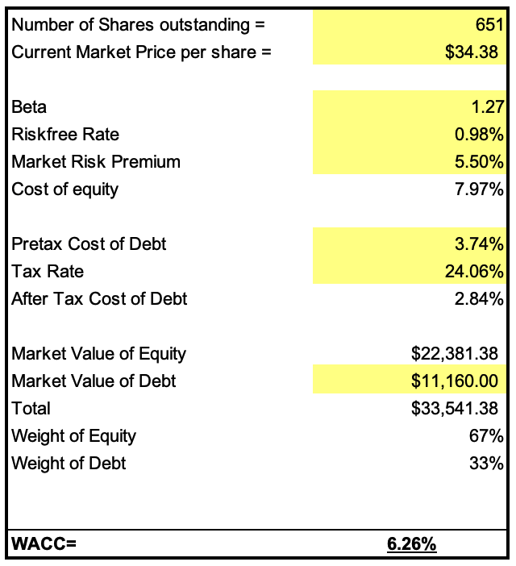
Figure 3. WACC

Firm Valuation
In order to calculate Delta’s intrinsic firm value, we projected free cash flows through 2029. We computed these values by starting with net income and subtracting the increase in net working capital, capex, and after-tax interest income, as well as adding depreciation and the after-tax interest expense. By adding our terminal value of FCF and our PV of FCF, we arrived at Delta’s value of the firm from operations. We added Delta’s cash and marketable securities from 2020 to this value to finalize our calculated intrinsic value of the firm.

At the time of the 10-K filing, Delta had 3.9M stock options outstanding with a weighted average strike price of $49.57 and a 10yr average maturity . By enabling circular references in the model, we were able to subtract the value of the stock options from the enterprise value. We also subtracted debt to get to the equity value to current shareholders. From there, we divided the equity value by the total number of shares outstanding to arrive at a share price of $212.67. When comparing this to the actual share price as of July 1, 2020 and November 2, 2020 it’s clear that our predicted share price highly overestimated the true share price. This is likely due to a few assumptions that we made in our projections. We did not project Delta continuing to take on debt, so interest expense remains very low and does not rise with the growth of the company. Furthermore, due to the debt not rising, the capital structure is more heavily weighted towards equity, resulting in more value to the shareholders.

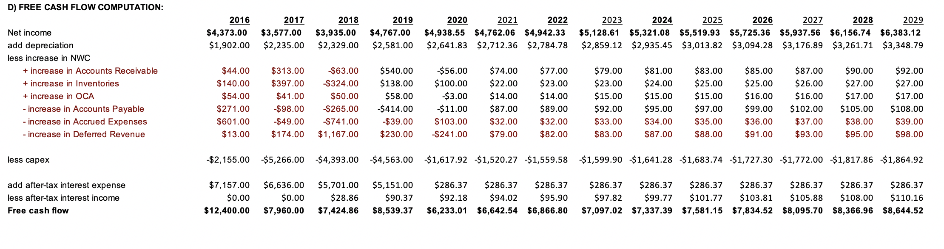
Figure 4. Free Cash Flow

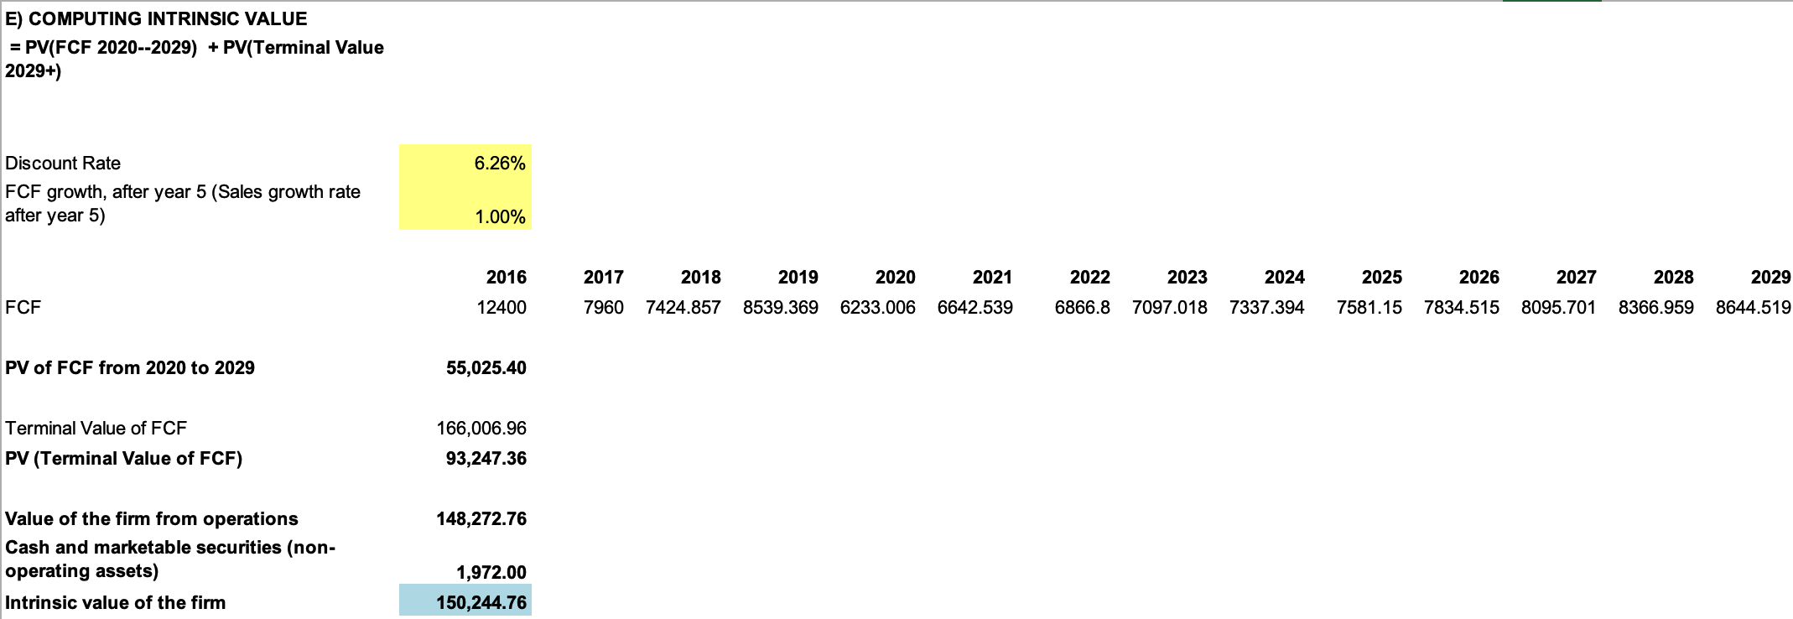
Figure 5. Intrinsic Value

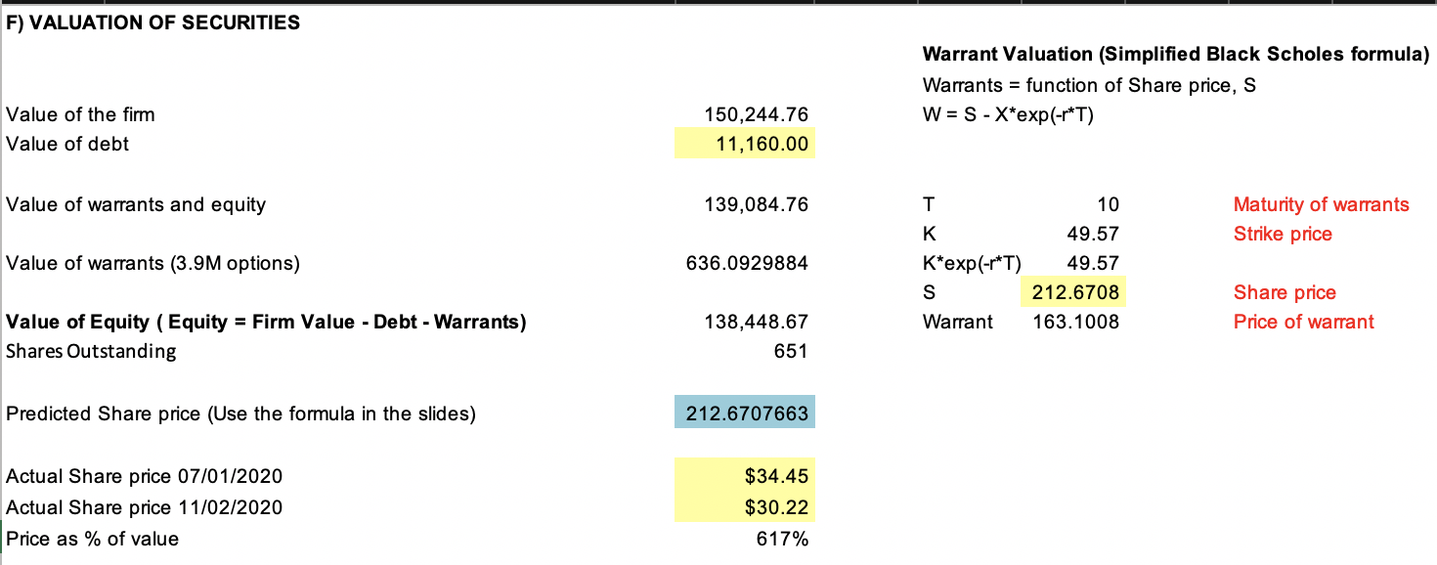
Figure 6. Valuation of Securities

Sensitivity Analysis
For the sensitivity analysis we decided to run two different tests. We calculated enterprise value and equity value with the perpetuity growth method. We then constructed tables that tested different values for WACC and perpetuity growth rates. By doing this we created distinct tables that all show a different aspect of Delta’s sensitivity to changing conditions.

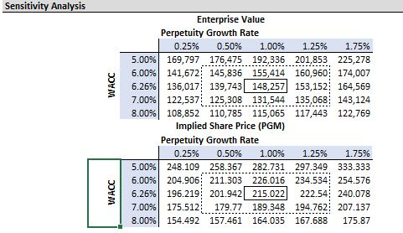
Figure 7. Sensitivity Analysis

Conclusion
The discounted cash flow business valuation method provides a highly accurate estimate of a corporation's value based on its earning potential. Under this method, it was determined through pro forma financial statements that Delta’s projected nominal growth rate will average 4.67%. Delta’s weighted average cost of capital was calculated as 6.22%, which is just below the airline industry average of around 7%. This WACC estimation can be used to project Delta’s expected costs for all of its financing, including payments made on debt obligations and the required rate of return.
Once the intrinsic value of Delta was established, the sequential valuation method was used to calculate Delta’s stock price of $212.67. This price is much higher compared to the actual market price as of July 1, 2020 and November 2, 2020, which were $34.45 and $30.22 respectively. The reason for this high stock price projection is because of Delta's high firm value.

Exhibits
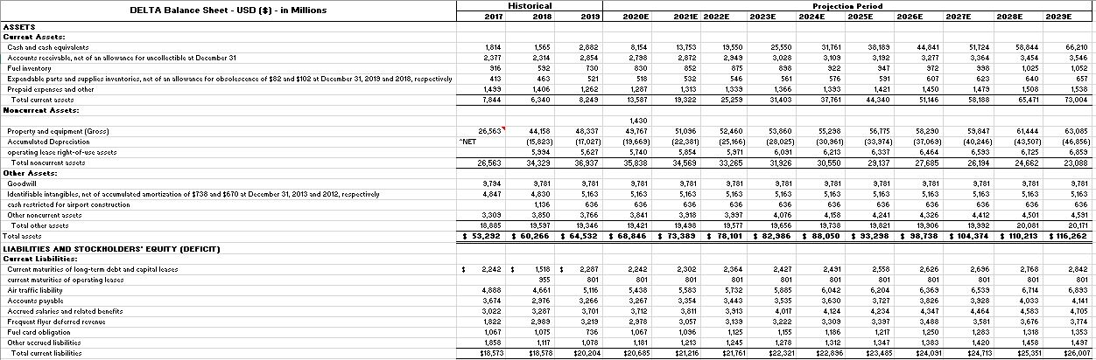
(Projected Balance Sheet 1)
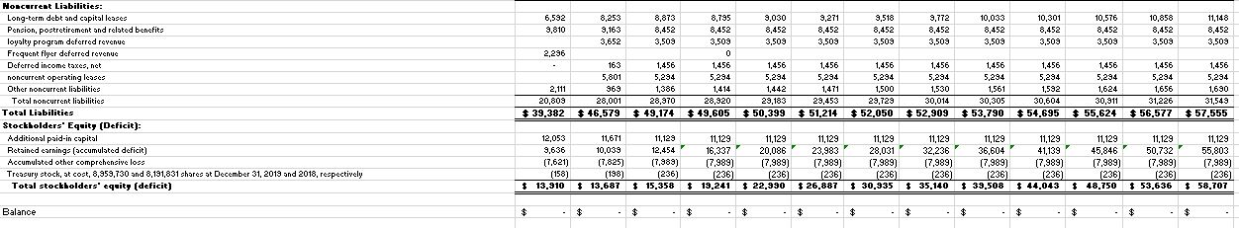
(Projected Balance Sheet 2)
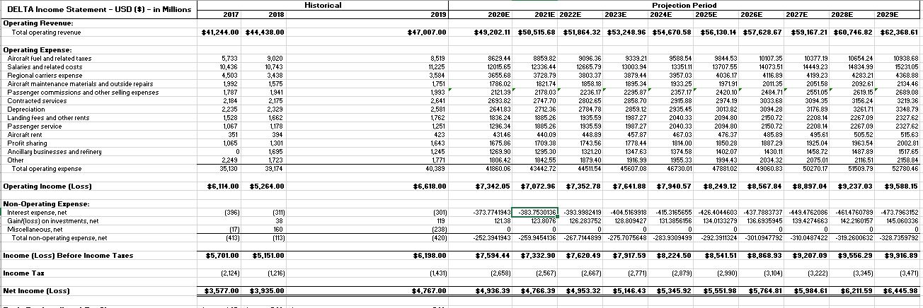
(Projected Income Statement)
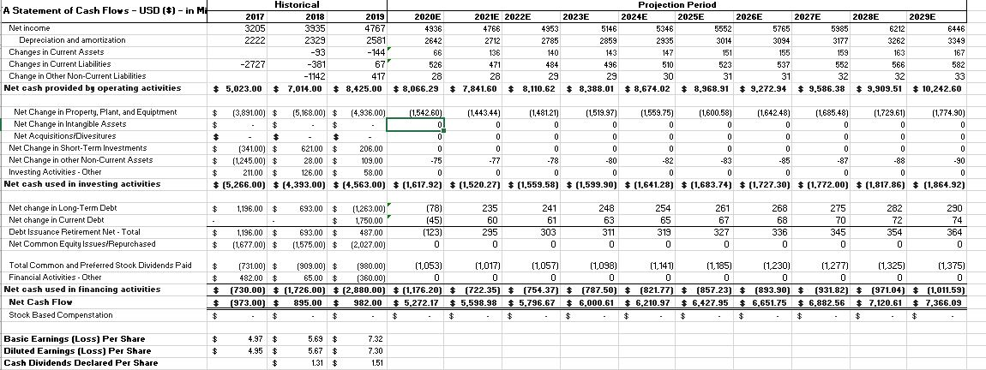
(Projected Statement of Cash Flows)

