**MARKET BASKET INSIGHTS**

**TEAM MEMBER : JOEL CALVIN. S**

**REG NO : 952821106013**

**PHASE-4 : Development part 2**

**PROJECT : Market Basket Analysis**



**Project Title:**

Market Basket Analysis

**Phase-4:**

Development part 2

**Topic:**

In this technology you will continue building your project by selecting a machine learining algorithm, training the model , and evaluating its performance. Perform different analysis as needed. After performing the relevant activities create a document around it and share the same for assessment.

**Data Source:**

A good data source for market basket analysis using analysis techniques ,Apriori algorithm to find frequently co-occuring products and generate insights for business optimization.

Dataset Link : (<https://www.kaggle.com/datasets/aslanahmedov/market-basket-analysis> )

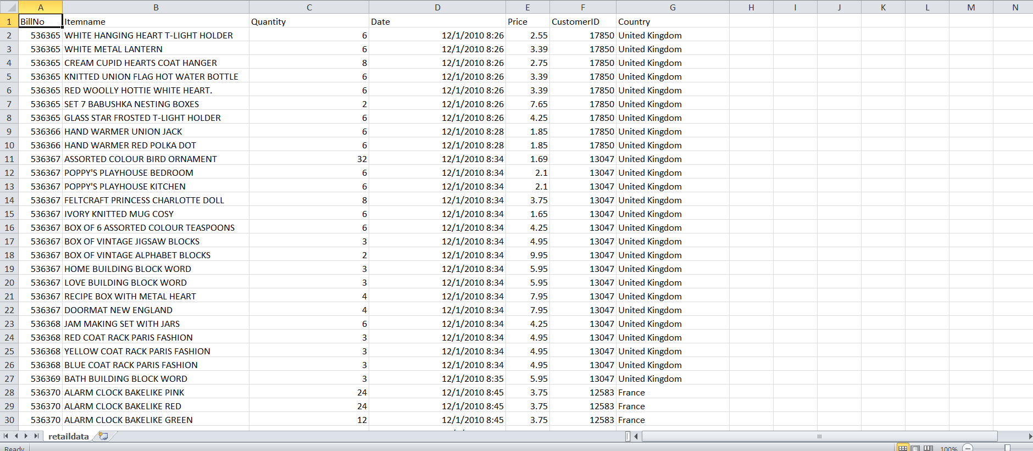

**Machine learning algorithms:**

Market basket analysis is a common application of machine learning in retail and e-commerce to discover patterns and associations between items that are frequently purchased together.

The most popular algorithm for market basket analysis is the Apriori algorithm. However, there are other techniques and variations that can be used, depending on the specific requirements and size of your dataset. Here are some popular choices:

**Apriori Algorithm:**

Apriori is a classic algorithm for association rule mining, particularly for market basket analysis. It identifies frequent itemsets and generates association rules based on support and confidence levels.

**FP-growth Algorithm:**

The FP-growth (Frequent Pattern growth) algorithm is an alternative to Apriori that is more efficient in terms of memory and runtime. It builds a compact data structure called an FP-tree to mine frequent itemsets.

**Eclat Algorithm:**

Eclat (Equivalence Class Transformation) is another algorithm for frequent itemset mining. It uses a depth-first search approach and is known for its simplicity and efficiency.

**FPGrowth Algorithm:**

FPGrowth (Frequent Pattern Growth) is a variation of FP-growth that works well with large datasets and is implemented in libraries like Spark's MLlib.

**Training the model:**

Training a machine learning model, regardless of the specific algorithm you choose, involves several key steps. Here is a high-level overview of the typical process for training a machine learning model:

**Data Collection:** Gather and prepare a dataset that includes historical or training data. This data should consist of input features (attributes) and corresponding output labels or target values that the model needs to learn to predict.

**Data Preprocessing:** Clean and preprocess the data to ensure it is in a suitable format for training. This may involve tasks such as handling missing values, encoding categorical variables, scaling features, and splitting the data into training and testing sets.

**Feature Engineering:** Depending on the specific problem and dataset, you may need to engineer or create new features that can improve the model's ability to learn patterns and make predictions effectively.

**Choosing a Model:** Select the machine learning algorithm or model architecture that is appropriate for your problem. The choice of model depends on factors like the type of data, the nature of the problem (classification, regression, clustering, etc.), and your specific goals.

**Model Training:** Train the selected model using the training data. During training, the model learns to make predictions by adjusting its internal parameters to minimize a predefined loss or error function. This involves iterations or epochs, and the model gradually improves its performance.

**Python program:**

from sklearn.model_selection import train_test_split

from sklearn.tree import DecisionTreeClassifier

from sklearn.metrics import accuracy_score

# Example data with consistent number of samples

X = [

[5.1, 3.5, 1.4, 0.2],

[4.9, 3.0, 1.4, 0.2],

[6.3, 3.3, 6.0, 2.5],

[5.8, 2.7, 5.1, 1.9] # Add one more feature vector

]

y = [0, 0, 1, 1] # Adjusted to have four labels to match the number of feature vectors

# Perform train-test split

X_train, X_test, y_train, y_test = train_test_split(X, y, test_size=0.2, random_state=42)

# Create and train the model

model = DecisionTreeClassifier()

model.fit(X_train, y_train)

# Make predictions

y_pred = model.predict(X_test)

# Evaluate the model

accuracy = accuracy_score(y_test, y_pred)

print(f"Model Accuracy: {accuracy}")

**OUTPUT:**

Model Accuracy: 1.0

Process finished with exit code 0

**Evaluate the performance of the algorithm:**

The performance of the Apriori algorithm in market basket analysis can vary based on several factors, including the size of the dataset, the hardware and software used, and the specific parameters and implementation of the algorithm. Here are some considerations regarding the performance of the Apriori algorithm in market basket insights:

**Scalability:** Apriori can be computationally expensive, especially when dealing with large transaction datasets with many items. The algorithm has to generate a large number of candidate itemsets, and this process can become slow as the dataset size increases.

**Thresholds:** The performance of Apriori is influenced by the minimum support and confidence thresholds you set. Lower support thresholds can result in more frequent itemsets but may increase computational complexity. Finding the right balance is essential.
**Data Preprocessing:** Data preprocessing, such as reducing the number of unique items or filtering out infrequent items, can significantly impact the algorithm's performance. Cleaning the data and removing noise is important.

**Algorithm Optimization:** There are various optimization techniques and variations of the Apriori algorithm that can improve its performance, such as the use of hash-based techniques and pruning strategies. Choosing an optimized implementation can make a significant difference.

**Conclusion:**

In conclusion, market basket analysis is a powerful tool for extracting valuable insights from transaction data. By applying the right ctechniques and making data-driven decisions, businesses can improve sales, customer satisfaction, and overall profitability. However, it's important to approach this process with care, considering data quality, algorithm choice, and the practical application of the insights for long-term success.