**UNIT-5**

**CONTEMPORARY MANAGEMENT PRACTICES**

**Benchmarking**

**Definition**: Benchmarking is the process of continually improving the [business](https://theinvestorsbook.com/business.html) or the organization by evaluating the scope for improvement, comparing the current position with that of the previous one or with the business practices of the relevant competitors, thereby establishing standards to be achieved.

## Types of Benchmarking

Benchmarking is a strategic activity. It requires a lot of research and analysis. To make it efficient, the company must be clear about the type of related strategy it must adapt to treat a specific problem area.

#### ****Internal Benchmarking****

The internal benchmarking refers to the comparison of the organizational performance internally either with its previous performances or with that of its competitors, i.e., the companies belonging to the same industry. Here, the information is usually gathered and circulated within the organization itself.

Following are the various strategies falling under this category:

* **SWOT**: In this benchmarking strategy, the strengths, weaknesses, opportunities and threats of the company are listed out and analyzed by the management.
* **Best Practice Benchmarking**: The management themselves studies and identifies the strategies and practices of the other companies who are the market leaders, to plan the desired course of action.
* **Performance Metrics**: This strategy is based on the statistical metrics derived through the analysis of the client’s preference and the comparison made with competitors. The company can find out the loopholes in its performance and work over it.
* **Financial Benchmarking**: The management conducts a comparative study of the financial forecast with the actual results or financial reports to find out the areas of shortcomings and take corrective actions.
* **Functional Benchmarking**: The company compares its performance and products with that of other related industries to innovatively improve its functionality.

#### External Benchmarking

In external benchmarking, the companies compare their performance with that of its competitors in the industry or across the globe. Usually, by the data collected through associations or third party.

To know about the different external strategies in detail, read below:

* **Collaborative Benchmarking**: To improve the performance standards, the companies belonging to a particular industry collaborate with the industrial associations. These associations provide the benchmarking data on best practices and a comparative analysis of all the companies, to facilitate the improvement of the underperforming companies.
* **Process Benchmarking**: In process benchmarking, the company analyzes the competitor’s methods, tasks, techniques of production, means of distribution, etc. It also studies the standard mechanisms of performing a particular function, to modify its ways accordingly.
* **Product Benchmarking**: This strategy focuses on the in-depth analysis of the competitor’s product to know its features and composition. The company uses this strategy to improve and redesign its products.
* **Corporate Benchmarking**: The company compares its various departments like finance, production, distribution, [marketing](https://theinvestorsbook.com/marketing.html), human resource, etc. with those of its competitors to enhance the efficiency of each division.
* **Strategic Benchmarking**: This strategy is usually adopted when the company plans to implement a new policy or idea or modify the existing one. The team compares the company’s approach with that of the other successful companies in the industry before bringing it into practice.
* **Global Benchmarking**: It is similar to strategic benchmarking, the only difference is that here the company compares its strategies with those of its other branch or the various competitors spread across the globe, to take corrective actions.

**Advantages of Benchmarking**

Benchmarking is essential for organizations to sustain high-level competition and to keep up with the customer’s requirement and needs. Let us go through the various benefits of setting benchmarks in the organization:

* **Improves Learning Methodology**: Benchmarking paves the way for idea generation and sharing of proven business practices which can be seen as a learning experience for the companies.
* **Initiates Technological Upgradation**: Through this strategy, the companies get to know about the new technology and techniques which have been adopted by the market leaders. The companies can accordingly plan for up-gradation of its technology to sustain the competition.
* **Improve Company’s Standards**: The company analyzes and studies the standards of the competitors. This facilitates the company to raise its standard of production and products accordingly.
* **Enhances Work Quality**: It leads to organizational growth since it improves the overall quality of the output and reduces the chances of errors due to the standardization of business operations.
* **Cope Up with Competition**: Knowing about the competitors’ business and their strategy, helps the company to design its strategies efficiently. It also facilitates the company to be updated with the recent developments and technology, hence beating the market competition.
* **Improves Efficiency**: The overall efficiency of the employees increases with this practice since standardization of work motivates them to perform better without making many mistakes.
* **Increases Customer Satisfaction**: Through benchmarking, the company collects sufficient data on customer’s needs and wants through customer feedback. This information helps the company to enhance the customer experience and satisfaction level.
* **Help Overcome Weaknesses**: These strategies help the company in finding out its shortcomings and working over them to get the desired results.

**Disadvantages of Benchmarking**

As we already know that benchmarking requires a lot of expertise and a vast collection of data. It, therefore, becomes difficult for some organization to execute its strategies in the desired manner.

Following are some of its limitations, in this context:

* **Lack of Information**: Sometimes, the company is unable to gather adequate information for benchmarking. This leads to an improper or inadequate comparison of the company’s performance with that of its competitors.
* **Increases Dependency**: The companies tend to depend on other companies’ strategies to become successful. In this process of following the market leaders, they sacrifice their individuality and uniqueness and starts following the path shown by others.
* **Lack of Understanding**: At times, companies adopt benchmarking for the sake of doing so, rather than finding out the necessity of it. It fails to understand its weaknesses while keeping an eye on the functioning of its competitors.
* **Copying Others**: Some organizations don’t understand the actual purpose of this strategy and start copying their competitors in every aspect. This may even lead to a downfall of the business.
* **Incorrect Comparison**: It demands a comparison between two or more companies belonging to the same industry and competes with each other. But sometimes, the companies make irrelevant comparison resulting in poor benchmarks.

**Costly Affair**: It requires a team of experienced personnel who have excellent analytical skills and expertise in the area. Thus, increasing the administrative expenses of the company. Even the implementation of the changes involves capital expenditure at times.

**Management Information System (MIS)**

Management Information System (MIS) is an integrated user-machine system for providing information to support operations, management and decision-making functions in an organization. The system utilizes computer hardware and software, manual procedure, models for analysis, planning, control, decision-making and a data base.

Even though MIS is an integrated system does it not mean that it is a single, monolithic structure, rather it means that the parts fit into an overall design.

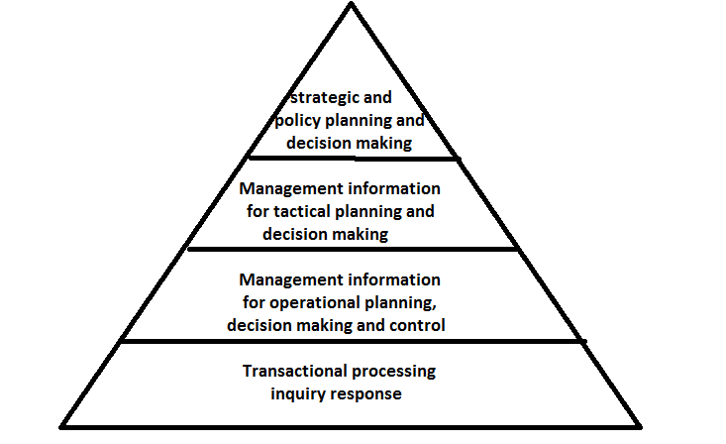

Management Information System

The Management Information System is a pyramidal structure in which the bottom layer consists of information for transaction processing, status inquires etc. the next level consists of information resources in support of day-to-day operations and control. The third level consists of information system resources to aid in tactical planning and decision-making for management control and the top level consists of information resources to support strategic planning and policy making by higher levels of management. Each level of information processing may make use of data provided for lower levels, but net data may also be introduced. For ex. Some of the information to support management and decision-making is provided by the data obtained for transaction processing, while some may be new data about activities external to the organization.

**Different Levels of Management**

Every organization requires some form of management, to ensure that basic functions are performed. Management positions in organizations are often broken into three levels

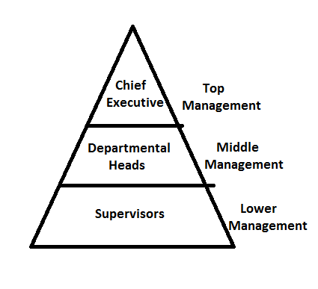

Levels of Management

1. Strategic or Top Level Management:

Top level management positions are mostly in the likes of president, vice-president, managing director, general manager etc. these managers are responsible for long-range strategic planning. They determine the goals, objectives and plans that decide the organizations long range course. These managers need broad based information from external source in a condensed and brief manner.

2. Tactical or Middle level management:

Middle level managers are mostly involved in tactical planning that is determining best way to get the jobs done and control. These managers take concrete action to convert the strategic plans into results. The information needs of middle management are different from top level management. They need tactical system which provides information to effectively monitor and control operations. Tactical system generates a variety of reports including summary report, exception report and adhoc reports.

3. Operational or lower level Management:

Lower level managers are responsible for execution of activities. They plan and control the activities of workers. These managers need detailed information. The lower level planning is called operational planning. Transaction processing system is useful to lower level management.

**Information System:**

Now-a-days whether the organization is small, medium or large cannot survive without information system. The basic reasons why organizations need information system are:

1. Meeting global challenges

2. Capturing opportunities in the market place

3. Supporting corporate strategy

4. Linking departments of different functions

5. Enhancing worker productivity

6. Increasing quality of goods and services

**Principles to prepare reports**:

These are the principles should follow to prepare reports for MIS

* It should be title of the report
* Proper sub headings and paragraphs must be maintained
* It should contain certain facts
* It should not be inclusion of the operations etc.
* It should be prepared in a particular time. The time should be mentioned on the top of the report. The report should be clear, concise and brief.
* In order to keep it brief, the clarity should not be sacrificed
* Reports should be prepared in time. The gap between happening of event and its reporting should not be too much, otherwise quick action cannot be taken.
* The reports should contain information in the form of visuals like graphs, charts, diagrams to have long lasting impression on the mind.

**Advantages**:

* MIS is useful for effective planning and control
* It provides information about the performance of different resources like materials, men, machinery etc.
* It helps in controlling costs by giving information about idle time, wastages, losses, surplus capacity etc.
* It gives information about the strengths of the company
* With strong MIS system, chances of misunderstandings in different departments are less.
* Information is provided in the form of report. It helps for decision-making and future reference.

**Limitations**:

* If the MIS is not designed properly according to the information needs of different levels of management, it will be no use.
* If the proper training is not given to the users of the system, it will be failure.
* The essence of MIS is providing information. If the data and information is obsolete, it will be no use.
* The quality of MIS output depends upon the quality of inputs and programmes.

**Types of Information System:**

The five fundamental types of information systems

1. Transaction processing system:- supports the operational and day-to-day activities of the organization.

2. Management Information System:- facilitates the management of their day-to-day activities.

3. Decision support system:- these are special purpose application that support the decision of less structured problem.

4. Office Automation System:- supports interpersonal communication activities for correspondence.

5. Executive support system:- this is used by senior managers to keep the best of the organization in broad view terms.

**Elaborate the concept of Six Sigma Method**

Six Sigma is a highly disciplined process that helps us focus on developing and delivering near-perfect products and services.

## Features of Six Sigma

* Six Sigma's aim is to eliminate waste and inefficiency, thereby increasing customer satisfaction by delivering what the customer is expecting.
* Six Sigma follows a structured methodology, and has defined roles for the participants.
* Six Sigma is a data driven methodology, and requires accurate data collection for the processes being analyzed.
* Six Sigma is about putting results on Financial Statements.
* Six Sigma is a business-driven, multi-dimensional structured approach for −
  + Improving Processes
  + Lowering Defects
  + Reducing process variability
  + Reducing costs
  + Increasing customer satisfaction
  + Increased profits

The word Sigma is a statistical term that measures how far a given process deviates from perfection.

The central idea behind Six Sigma: If you can measure how many "defects" you have in a process, you can systematically figure out how to eliminate them and get as close to "zero defects" as possible and specifically it means a failure rate of 3.4 parts per million or 99.9997% perfect.

## Key Concepts of Six Sigma

At its core, Six Sigma revolves around a few key concepts.

* **Critical to Quality** − Attributes most important to the customer.
* **Defect** − Failing to deliver what the customer wants.
* **Process Capability** − What your process can deliver.
* **Variation** − What the customer sees and feels.
* **Stable Operations** − Ensuring consistent, predictable processes to improve what the customer sees and feels.
* **Design for Six Sigma** − Designing to meet customer needs and process capability.

Our Customers Feel the Variance, Not the Mean. So, Six Sigma focuses first on reducing process variation and then on improving the process capability.

## Myths about Six Sigma

There are several myths and misunderstandings surrounding Six Sigma. Some of them few are given below −

* Six Sigma is only concerned with reducing defects.
* Six Sigma is a process for production or engineering.
* Six Sigma cannot be applied to engineering activities.
* Six Sigma uses difficult-to-understand statistics.
* Six Sigma is just training.

## Benefits of Six Sigma

Six Sigma offers six major benefits that attract companies −

* Generates sustained success
* Sets a performance goal for everyone
* Enhances value to customers
* Accelerates the rate of improvement
* Promotes learning and cross-pollination
* Executes strategic change

## Origin of Six Sigma

* Six Sigma originated at Motorola in the early 1980s, in response to achieving 10X reduction in product-failure levels in 5 years.
* Engineer Bill Smith invented Six Sigma, but died of a heart attack in the Motorola cafeteria in 1993, never knowing the scope of the craze and controversy he had touched off.
* Six Sigma is based on various quality management theories (e.g. Deming's 14 point for management, Juran's 10 steps on achieving quality).

There are mainly two methodologies of Six Sigma namely **DMAIC** and **DMADV**.

**DMAIC** is a data-driven Six Sigma methodology for improving existing products and processes. The **DMAIC** process should be used when an existing product or process can be improved to meet or exceed the customer’s requirements. **DMAIC** methodology consists of five phases: D – Define, M – Measure, A – Analyze, I – Improve, C – Control.

* Define – Define the problem. In the first phase, various problems which need to be addressed to are clearly defined. Feedbacks are taken from customers as to what they feel about a particular product or service. Feedbacks are carefully monitored to understand problem areas and their root causes.
* Measure – Measure and find out the key points of the current process. Once the problem is identified, employees collect relevant data which would give an insight into current processes.
* Analyze – Analyze the data. The information collected in the second stage is thoroughly verified. The root cause of the defects are carefully studied and investigated as to find out how they are affecting the entire process.
* Improve – Improve the current processes based on the research and analysis done in the previous stage. Efforts are made to create new projects which would ensure superior quality.
* Control – Control the processes so that they do not lead to defects.

**DMADV** is a common DFSS (Design for Six Sigma) methodology used to develop a process or product which does not exist in the company. DFSS is an application of Six Sigma which focuses on the design or redesign of the different processes used in product manufacturing or service delivery by taking into accounts the customer needs and expectations. **DMADV** is used when the existing product or process does not meet the level of customer specification or Six Sigma level even after optimization with or without using **DMAIC**. **DMADV** methodology consists of five phases: D – Define, M – Measure, A – Analyze, D – Design, V – Validate.

* DEFINE the project goals and customer deliverables
* MEASURE the process to determine the current performance level
* ANALYZE and determine the root causes of the defects
* DESIGN the process in detail to meet customer needs
* VALIDATE the design performance and its ability to meet the customer needs
* 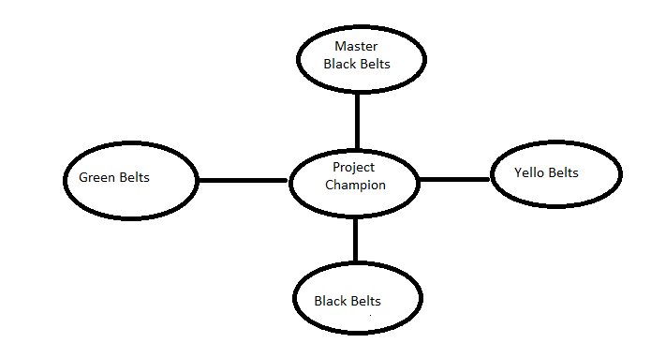
* Six sigma interacting roles

Six sigma identifies several key roles for its successful implementation:

1. Executive leadership includes the support of CEO and other key top management team members. They are responsible for setting up a vision for six sigma implementation.

2. Champions are responsible for the six sigma implementation across the organization in an integrated way. Champions also act as mentors to black belts.

3. Master Black Belts are identified by champions, improving services, processes and procedures for their suppliers, their entire campuses and for their customers.

4. Black Belts operate under master black belts to apply six sigma methodologies to specific projects. They primarily focus on six sigma executions, where as champions and master black belts focus on identifying projects for six sigma.

5. Green Belts are the employees who take up six sigma implementation along with their other job responsibilities. They operate under the guidance of black belts and support them in achieving the overall results.

6. Yellow Belts are employees who have been trained in six sigma techniques as part of a corporate wide initiative, but have not completed a six sigma project and are not expected to actively engage in quality improvement activities.

In many recent programs, green belts and black belts are empowered to initiate, expand and lead projects in their area of responsibility.

**Total Quality Management (TQM)**

**Meaning – Definition**

Total Quality Management (TQM) is an effective system for integrating the quality development, quality maintenance and quality improvement efforts of various groups in an organization continuously, so as to enable marketing, engineering, production and service at the most economic levels which allow for full customer satisfaction.

TQM has been defined as “an integrated organizational effort designed to improve quality at every level. The process to produce a perfect product by a series of measures requires an organized effort by the entire company to prevent or eliminate errors at every stage in production is called Total Quality Management.”

**Characteristics of TQM**

These are the characteristics of TQM

1. Committed management

2. Adopting and communicating about total quality management

3. Closer customer relations

4. Closer provider relations

5. Benchmarking

6. Increased training

7. Open organization

8. Employee empowerment

9. Flexible production

10. Process improvements

11. Process measuring

**TQM Objectives:**

1. Total customer satisfaction

2. Addressing all aspects of dimensions of quality

3. Addressing the quality aspect in everything – products, services, processes, people, resources and interactions

4. Satisfying all customers – internal as well as external

5. Improving profits, as well as generating new business for the future

6. Involving everyone in the organization in the attainment of the said objectives

7. Demanding total commitment from all in the organization towards the achievement of the objective.

**Fundamental factors affecting quality:**

The 9 fundamental factors (9M’s) which are affecting the quality of products and services are: 1. Market, 2. Money, 3. Management, 4. Men, 5. Motivation, 6. Materials, 7. Machinery, 8. Modern Information Methods, 9. Mounting Product Requirements.

**Benefits of TQM**:

The benefits of TQM can be classified into the following two categories:

* + 1. Customer Satisfaction Oriented Benefits
    2. Economic Improvement Oriented Benefits

**A. Customer Satisfaction Oriented Benefits: -**

The benefits under this category are

1. Improvement in product quality

2. Improvement in product design

3. Improvement in production flow

4. Improvement in employee morale and quality consciousness

5. Improvement in product service

6. Improvement in market place

**B. Economic Improvement Oriented Benefits: -**

1. Reduction in operating costs

2. Reduction in operating losses

3. Reduction in field service costs

4. Reduction in liability exposure

**Barriers to TQM Implementation:**

1. Lack of management commitment

2. Inability to change organizational culture

3. Improper planning

4. Lack of continuous training and education

5. Incompatible organizational structure and isolated individuals and department

6. Inefficient measurement techniques

7. Inadequate use of empowerment and team work

8. Failure to continually improve

**Costs of Quality**

Quality related activities that incur costs may be divided into prevention costs, appraisal costs, internal and external failure costs.

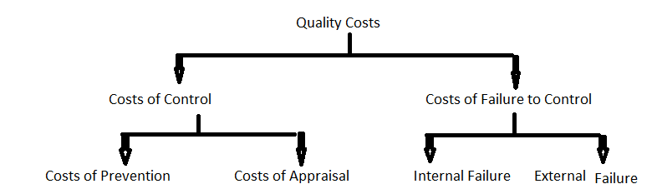

**1. Costs of Control**

The costs of control can be divided into costs of prevention and costs of appraisal

Costs of prevention:-

The costs incurred in keeping failure and appraisal costs to a minimum. It is the least expensive type of quality costs, and so is highly recommended. The following activities involve the costs of prevention

* New product review
* Quality planning
* Supplier capability surveys
* Process capability evaluations
* Quality improvement team meetings
* Quality education and training

Costs of Appraisal: -

Costs of maintaining quality level by means of evaluating procedures like inspection, test, quality audits etc., are accounted under costs of appraisal. They are:

* Tests and inspection of purchased material
* Inspection
* Testing
* Checking labour
* Quality audits etc.

**2. Costs of failure to control**

These are the costs due to defects and non-conformities of products. This can be further classified into internal failure and external failure costs

Internal Failure Costs: -

The costs associated with defects that are found prior to transfer of the product to the customer. This appears in the form of scrapped or reworked goods.

Examples are the costs of:

* Scrap
* Rework
* Re-inspection
* Re-testing
* Material review
* Down grading

External Failure Costs: -

The costs associated with defects that are found after product is shipped to the customer.

Examples are the costs of:

* Processing customer complaints
* Customer returns
* Warranty claims
* Product recalls

**Performance Management**

Performance management is a corporate management tool that helps managers monitor and evaluate employees' work. Performance management's goal is to create an environment where people can perform to the best of their abilities to produce the highest-quality work most efficiently and effectively.

## Performance Management - Definition

Performance management is an ongoing process of communication between a supervisor and an employee that occurs throughout the year, in support of accomplishing the strategic objectives of the organization. The communication process includes clarifying expectations, setting objectives, identifying goals, providing feedback, and reviewing results.

## Managing Employee Performance – The Cycle

Overseeing performance and providing feedback is not an isolated event, focused in an annual performance review. It is an ongoing process that takes place throughout the year. The Performance Management process is a [cycle](https://hr.berkeley.edu/performance/performance-management/cycle), with discussions varying year-to-year based on changing objectives.

The cycle includes Planning, Checking-In, and Review.

* To begin the planning process, you and your employee review overall expectations, which include collaborating on the development of performance objectives. Individual development goals are also updated. You then develop a performance plan that directs the employee's efforts toward achieving specific results to support organizational excellence and employee success.
* Goals and objectives are discussed throughout the year, during check-in meetings. This provides a framework to ensure employees achieve results through coaching and mutual feedback.
* At the end of the performance period, you review the employee's performance against expected objectives, as well as the means used and behaviors demonstrated in achieving those objectives. Together, you establish new objectives for the next performance period.

The main goal of performance management is to ensure that the organization as a system and its subsystems work together in an integrated fashion for accomplishing optimum results or outcomes.

The major **objectives of performance management** are discussed below:

* To enable the employees towards achievement of superior standards of work performance.
* To help the employees in identifying the knowledge and skills required for performing the job efficiently as this would drive their focus towards performing the right task in the right way.
* Boosting the performance of the employees by encouraging employee empowerment, motivation and implementation of an effective reward mechanism.
* Promoting a two way system of communication between the supervisors and the employees for clarifying expectations about the roles and accountabilities, communicating the functional and organizational goals, providing a regular and a transparent feedback for improving employee performance and continuous coaching.
* Identifying the barriers to effective performance and resolving those barriers through constant monitoring, coaching and development interventions.
* Creating a basis for several administrative decisions strategic planning, succession planning, promotions and performance based payment.
* Promoting personal growth and advancement in the career of the employees by helping them in acquiring the desired knowledge and skills.

The process of performance management starts with the joining of a new incumbent in a system and ends when an employee quits the organization.

Performance management can be regarded as a systematic process by which the overall performance of an organization can be improved by improving the performance of individuals within a team framework. It is a means for promoting superior performance by communicating expectations, defining roles within a required competence framework and establishing achievable benchmarks.

According to Armstrong and Baron (1998), Performance Management is both a strategic and an integrated approach to delivering successful results in organizations by improving the performance and developing the capabilities of teams and individuals.

The term performance management gained its popularity in early 1980’s when [total quality management programs](https://www.managementstudyguide.com/total-quality-management.htm) received utmost importance for achievement of superior standards and quality performance. Tools such as job design, leadership development, training and reward system received an equal impetus along with the traditional performance appraisal process in the new comprehensive and a much wider framework. Performance management is an ongoing communication process which is carried between the supervisors and the employees throughout the year. The process is very much cyclical and continuous in nature. A **performance management system includes the following actions**.

* Developing clear job descriptions and employee performance plans which includes the key result areas (KRA') and performance indicators.
* Selection of right set of people by implementing an appropriate selection process.
* Negotiating requirements and performance standards for measuring the outcome and overall productivity against the predefined benchmarks.
* Providing continuous coaching and feedback during the period of delivery of performance.
* Identifying the training and development needs by measuring the outcomes achieved against the set standards and implementing effective development programs for improvement.
* Holding quarterly performance development discussions and evaluating employee performance on the basis of performance plans.
* Designing effective compensation and reward systems for recognizing those employees who excel in their jobs by achieving the set standards in accordance with the performance plans or rather exceed the performance benchmarks.
* Providing promotional/career development support and guidance to the employees.
* Performing exit interviews for understanding the cause of employee discontentment and thereafter exit from an organization.

A **performance management process** sets the platform for rewarding excellence by aligning individual employee accomplishments with the organization’s mission and objectives and making the employee and the organization understand the importance of a specific job in realizing outcomes. By establishing clear performance expectations which includes results, actions and behaviors, it helps the employees in understanding what exactly is expected out of their jobs and setting of standards help in eliminating those jobs which are of no use any longer. Through regular feedback and coaching, it provides an advantage of diagnosing the problems at an early stage and taking corrective actions.

To conclude, performance management can be regarded as a proactive system of managing employee performance for driving the individuals and the organizations towards desired performance and results. It’s about striking a harmonious alignment between individual and organizational objectives for accomplishment of excellence in performance.

**Write about JIT Technique**

Just in time (JIT) is an inventory management system, used to manage the stock that is kept in storage. It involves receiving goods from suppliers as and when they are required, rather than carrying a large inventory at once.

The JIT concept was described by Henry Ford in his 1923 book, ‘My Life and Work’. The technique was first used by the Ford Motor Company during 1920’s, but the technique was subsequently adopted and publicised by Toyota Motor Corporation of Japan as part of its Toyota Production System (TPS). Just-in-Time systems are also known as “Zero Inventory”, “synchronous manufacturing”, “Material as needed”, and “Kan-ban system”.

**Characteristics of JIT System**

1. Zero inventories, emphasis on operation from source to customer.

2. Emphasis on customer service and timing

3. Less lead time

4. Flexibility of operations

5. Efficient flow

6. Use of kanban and visibility

**Objectives of JIT**

The objectives of JIT are achieved through several physical systems. Some of JIT objectives are as follows:

1. To reduce that set-up time and lot sizes

2. To achieve ‘Zero defects’ goal in manufacturing

3. To focus on continuous improvement

4. To concentrate on involving workers and using their knowledge to a greater extent

5. Layout of equipments in such a way so as to minimizes both travel distances and inventories between the machines.

6. To reduce inventories and inventory carrying costs

7. To eliminate waste

8. Produce only the products that customers want

9. Produce products with perfect quality

10. Produce in the minimum possible lead times.

**Benefits of JIT System**

The JIT system is aimed at improving profits and return on investment through cost reductions, inventory reductions and quality improvements. These benefits explain wide acceptance of JIT in industry. The following are some benefits of a JIT system stated by researchers.

1. Customer relations

2. Fast response of engineering changes

3. Improved competitive position

4. Improved equipment efficiency

5. Improved worker efficiency

6. Improve worker motivation

7. Increased administrative efficiency

8. Increased equipment utilization

9. Increased flexibility

10. Increased profit margin

11. Increased team work

12. Less scrap

13. Lower overheads

13. Reduced production cost

14. Reduced production lead time

15. Reduced purchasing lot size

16. Reduced raw materials

17. Improved quality

18. Increased productivity

19. Reduced inventories

20. Reduced labour requirements

21. Reduced paper work

**Disadvantages of just in time inventory management**

JIT unfortunately comes with a number of potential disadvantages, which can have a significant impact on the company if they occur.

**Risk of running out of stock**: By not carrying much stock, it is imperative you have the correct procedures in place to ensure stock can become readily available, and quickly. To do this, you need to have a good relationship with your supplier(s). You may need to form an exclusive agreement with suppliers that specifies supplying goods within a certain time frame, prioritising your company. JIT means that you become extremely reliant on the consistency of your supply chain. What if your supplier struggles with your requirements, or goes out of business? Can you get the products quickly from somewhere else?

**Lack of control over time frame**: Having to rely on the timeliness of suppliers for each order puts you at risk of delaying your customers’ receipt of goods. If you don’t meet your customers’ expectations, they could take their business elsewhere, which would have a huge impact on your business if this occurs often.

**More planning required**: With JIT inventory management, it’s imperative that companies understand their sales trends and variances in close detail. Most companies have seasonal sales periods, meaning a number of products will need a higher stock level at certain times of the year due to higher demand. Therefore, you need to factor that into planning for inventory levels, ensuring suppliers are able to meet different volume requirements at different times.

If run properly, JIT inventory management is seen as one of (if not the) best ways of managing inventory. While it is not without risks, it has significant rewards, and is ideal for those who are able to plan carefully in advance, and build strong relationships with suppliers.

## What is Capability Maturity Model?

The Software Engineering Institute (SEI) Capability Maturity Model (CMM) specifies an increasing series of levels of a software development organization. The higher the level, the better the software development process, hence reaching each level is an expensive and time-consuming process.

## Levels of CMM

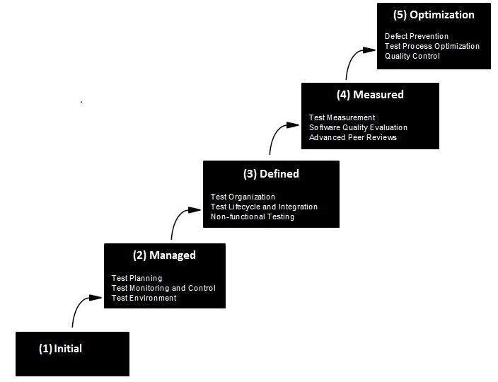

* **Level One :Initial** - The software process is characterized as inconsistent, and occasionally even chaotic. Defined processes and standard practices that exist are abandoned during a crisis. Success of the organization majorly depends on an individual effort, talent, and heroics. The heroes eventually move on to other organizations taking their wealth of knowledge or lessons learnt with them.
* **Level Two: Repeatable** - This level of Software Development Organization has a basic and consistent project management processes to track cost, schedule, and functionality. The process is in place to repeat the earlier successes on projects with similar applications. Program management is a key characteristic of a level two organization.
* **Level Three: Defined** - The software process for both management and engineering activities are documented, standardized, and integrated into a standard software process for the entire organization and all projects across the organization use an approved, tailored version of the organization's standard software process for developing,testing and maintaining the application.
* **Level Four: Managed** - Management can effectively control the software development effort using precise measurements. At this level, organization set a quantitative quality goal for both software process and software maintenance. At this maturity level, the performance of processes is controlled using statistical and other quantitative techniques, and is quantitatively predictable.
* **Level Five: Optimizing** - The Key characteristic of this level is focusing on continually improving process performance through both incremental and innovative technological improvements. At this level, changes to the process are to improve the process performance and at the same time maintaining statistical probability to achieve the established quantitative process-improvement objectives.

### ****Supply Chain Management****

### ****Meaning – Definition****

Supply chain management is the integrated process-oriented planning and control of the flow of goods, information and money across the entire value and supply chain from the customer to the raw material supplier.

[**The Council of Supply Chain Management Professionals (CSCMP)**](https://cscmp.org/CSCMP/Educate/SCM_Definitions_and_Glossary_of_Terms/CSCMP/Educate/SCM_Definitions_and_Glossary_of_Terms.aspx?hkey=60879588-f65f-4ab5-8c4b-6878815ef921)**defines SMC** as

“Supply chain management encompasses the planning and management of all activities involved in sourcing and procurement, conversion, and all logistics management activities. Importantly, it also includes coordination and collaboration with channel partners, which can be suppliers, intermediaries, third party service providers, and customers. In essence, supply chain management integrates supply and demand management within and across companies.”

A supply chain is a network of retailers, distributors, transporters, storage facilities, and suppliers who take part in the production, delivery, and sale of a product that convert and move the goods from raw materials to end users; it describes the processes and organisations involved in converting and conveying the goods from manufactures to consumers.

The activities close to the raw material stage are known as upstream activities and activities between the manufacturer and end consumer are downstream activities. Marketing distribution concerns these downstream activities. A typical supply chain consists of multiple companies which coordinate activities to set themselves apart from the competition.

**A supply chain basically has three key parts:**

**i. Supply:**

It focuses on the raw materials supplied to manufacturing, including how, when, and from what location.

**ii. Manufacturing:**

It focuses on converting these raw materials into finished products.

**iii. Distribution:**

It focuses on ensuring that these products reach the consumers through an organized network of distributors, warehouses, and retailers.

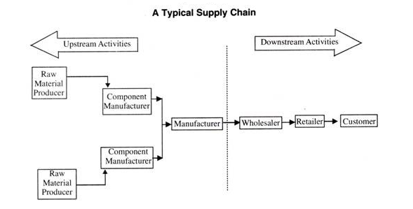

Though often applied to manufacturing and consumer products, a supply chain can also be used to show how various processes supply to one another. The supply chain definition in this sense can apply to Internet technology, finance, and many other industries.

A supply chain strategy defines how the supply chain should operate in order to compete in the market. The strategy evaluates the benefits and costs relating to the operation. While a business strategy focuses on the overall direction a company wishes to pursue, supply chain strategy focuses on the actual operations of the organization and the supply chain that will be used to meet a specific goal.

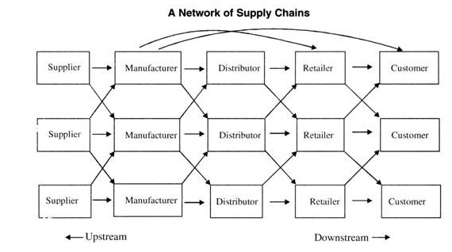

**Example of Supply Chain:**

Consider a customer walks into Spencer Store to purchase beauty soap. The supply chain begins with the customer and his need for beauty soap. The next stage of this supply chain is the Spencer retail store where the customer visits. Spencer stocks its shelves using inventory that may have been supplied from a finished goods warehouse managed by Wal-Mart or received from third party (vendor). The vendor in turn is stocked by the manufacturer [say Hindustan Uni Liver (HUL)].

The HUL manufacturing plant receives raw material from a variety of suppliers who may themselves have been supplied by lower tier suppliers. For example, packaging material may come from Home- foil (an aluminium foil company) while Home-foil receives raw material to manufacture the packaging material from other suppliers. This forms a typical supply chain.

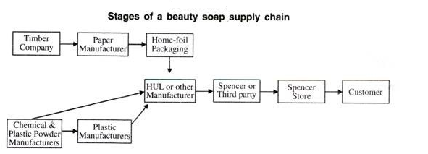

In another example, a customer purchases a wrist watch and travelling bag online from Reliance retail. The supply chain includes, among others, the customer Reliance Website that accepts the customer’s order, the Reliance store, and all of Reliance’s suppliers and their suppliers.

The Reliance Website provides the customer with information regarding pricing, product features, and product availability. After selecting the product, the customer clicks on ‘order form’ and pays for the product. The customer may later return to the Website to check the status of the order.

**Thus a typical supply chain may involve a variety of stages discussed as under:**

(i) Customers.

(ii) Retailers.

(iii) Wholesalers/Distributors.

(iv) Manufacturers.

(v) Component/Raw material supplier.

**Benefits of Supply Chains:**

(1) It bridges the gaps between the suppliers and the customers.

(2) It helps manufacturers in reducing inventories as finished goods are stored nearer to the customers.

(3) It allows firms to conduct operations at an appropriate time and place for the benefits of suppliers and customers.

(4) Effective supply chains results in enhanced customer service as retailers get a choice of goods and also carry less stock.

(5) Supply chains make movements simple, cost-effective and efficient as transport is simpler.

(6) Expertise can be developed in a particular type of operation.

(7) It allows firms to conduct operations at an appropriate time and place for the benefits of suppliers and customers.

### ****Advantages of SCM****

### ****Cost Efficiency****

Supply chain management assist in attaining cost efficiency within the organization. It aims at optimizing all process of business which brings down the production cost, packaging cost; warehousing and transportation cost and avoids any wastage of goods by facilitating timely delivery. It minimizes the overall operating expenses and enhances the overall profitability.

### ****Enhance Output****

The concept of supply chain management aims at maximizing the overall productivity of business. Supply managers monitor all production processes and ensure that all resources are efficiently utilized. Any wastage of resources is avoided which lead to maximize the overall output.

### ****Avoids Delay in Process****

Preventing any delays of business process is one of the major advantages of supply change management. Supply chain manager ensure that all materials are timely acquired for facilitating uninterrupted production of products. Also, they regulate all delivery and logistics services of business which promote delivery at right time at right location thereby avoiding any delays.

### ****Easily Identify Problem Areas****

Supply chain management enable business in recognizing its issue that are adversely affecting its reputation and profitability. Managers can easily track the performance of every department and identify which one is lacking in delivering its duties. In absence of this concept, it will be difficult to detect the issue and every department will blame each other for any problem that erupts.

### ****Better Collaboratio****n

Process of supply chain management brings better collaboration among distinct parties of business. It focuses on developing a proper communication channel within the business for avoiding any confusion or disputes. Smooth flow of information among all stakeholders like employees, customers, suppliers and distribution enhance understanding which leads to create a better collaboration.

**Disadvantages of SCM**

### ****Expensive To Implement****

Major limitation of process of supply chain management is that it is quite expensive to implement. It requires large investment in terms of time, money and other resources that become unaffordable for small businesses.

### ****Complicated****

Process of supply chain management involves numerous complexities as it involves several departments within the organization. It may lead to create confusion and hamper the normal functioning of business. Employees may feel hesitant and demotivated to accept this concept as it is new to them thereby giving rise to several other difficulties.

### ****Lack of Co-Ordination among Departments****

The concept of supply chain management functions properly only if there is better coordination among departments of departments. Establishing coordination among several departments within big corporate is a quite difficult task where this concept may eventually fail to perform.

### ****Requires Trained and Personalized Sta****ff

Supply chain management requires qualified and trained human resources for its effective executive within the company. Company need to incur heavy expenses for acquiring such taskforce that is professional and highly skilled. Small companies may find it unfavourable for their implementation.

### ****Lack of Reliability****

Supply chain management lacks of reliability as it is completely dependent upon the mode of information exchange among several departments. If there is any instance of inaccurate information sharing by any of the department, then it will have adverse effects on performance of whole supply chain.

### What Is Business Process Outsourcing?

Business process outsourcing (BPO) is a type of outsourcing wherein a third-party service provider is employed to carry out one or more business functions in a company. The third party is responsible for carrying out all operations related to the business function.

 BPO is also known as subcontracting or externalization. It was originally used in the manufacturing industry but is now used for numerous business processes.

### What is BPO used for?

Organizations contract with BPO vendors for two main areas:

1. **Back office operations**: They include payment processing, information technology services, quality assurance, etc.
2. **Front office operations**: They include [marketing](https://corporatefinanceinstitute.com/resources/knowledge/other/marketing/), sales, customer relations, and grievance redressal.
3. In many cases, organizations outsource one or more functions. For example, instead of outsourcing all HR functions, the company will outsource just the [payroll](https://corporatefinanceinstitute.com/resources/knowledge/accounting/payroll-accounting/) processes.
4. Over the years, the BPO industry’s expanded considerably and offers a wide range of services and functions to organizations.

### Types of BPO

BPO companies can be divided into several types based on their location:

* **Onshore outsourcing**: When an organization hires a service provider that is located in the same country. It is also called domestic outsourcing.
* **Near shore outsourcing**: When an organization hires a service provider in a neighboring country.
* **Offshore outsourcing**: When an organization hires a service provider in a different country. It is also called off shoring.

### Making the BPO Decision

Transferring in-house work to a BPO company requires change management as it impacts employees, workflow practices, and [business operations](https://corporatefinanceinstitute.com/resources/knowledge/strategy/business-operations/) as a whole. The outsourcing decision-making process involves the following:

1. Company executives arrive at the decision to outsource a business process or a part of it.
2. They weigh the pros and cons of the decision and decide whether it makes strategic sense to the organization.
3. They identify the best BPO for the work and shift the work from in-house to the external services provider.

### Benefits of BPO

#### 1. Lower costs

One of the main reasons organizations outsource is cost reduction. Instead of buying IT equipment and hiring more employees to do different tasks, they can outsource the tasks to a service provider, reducing or even eliminating [overhead costs](https://corporatefinanceinstitute.com/resources/knowledge/accounting/overheads/).

#### 2. Higher efficiency

BPO companies are experienced in different fields and perform at the highest level. They also adopt best practices and use the latest technology. It naturally results in higher efficiency and greater productivity.

#### 3. Focus on core business functions

Many companies, usually start-ups, encounter a difficult time with ancillary business activities. Transferring non-core processes to a BPO company gives the organization more time to focus on its main business activities.

#### 4. Global expansion

If an organization decides to enter an overseas market, some activities that require local market knowledge, national law expertise, or fluency in a foreign language can be assigned to a BPO company. It helps in boosting efficiency and quicker expansion.

### Drawbacks of BPO

#### 1. Security issues

There is the possibility of a security breach while working with a BPO company as sensitive data needs to be shared and processed.

#### 2. Overdependence on the BPO Company

When work is outsourced to a BPO company for a long period, an organization can become accustomed to the way they work and tend to get over dependent on them. It leads to the organization paying higher than the usual costs if demanded.

#### 3. Communication problems

When working with an offshore BPO company, the [language barrier](https://www.businesstopia.net/communication/language-barriers) may turn out to be a hindrance to efficiency. Outsourcing work such as development or IT services, where a lot of people are involved, can lead to mistakes due to miscommunication. It can be extremely costly sometimes.

#### 4. Unforeseen or hidden costs

As work is not always hard and fast, the organization may underestimate the quantity of work, and it can lead to costs that are higher than expected. Working with a BPO company can lead to legal expenses in case of a dispute or disagreement. Delay in delivery of work can also result in indirect costs.

# Business Process Reengineering (BPR)

Business process reengineering is the act of recreating a core [business process](https://tallyfy.com/business-process) with the goal of improving product output, quality, or reducing costs.

Definition: The Business Process Reengineering or BPR is the analysis and redesign of core business processes to achieve the substantial improvements in its performance, productivity, and quality. The business process refers to the set of interlinked tasks or activities performed to achieve a specified outcome.

# Simply, the business process reengineering means to change the way an individual performs the work such that better results are accomplished. The purpose of business process reengineering is to redesign the workflows in order to dramatically improve the customer service, achieve higher levels of efficiency, cut operational costs and become a world-class competitor.

# Steps involved in Business Process Reengineering

**Definition:**The **Business Process Reengineering** is the examination and redesign of business process to achieve the dramatic improvement in its performance, productivity, and quality.

**The Business process reengineering comprises of following steps:**

[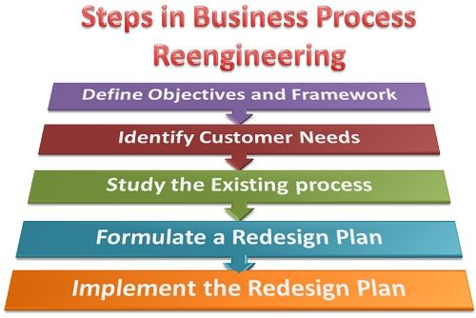](https://businessjargons.com/wp-content/uploads/2016/02/BPR-Process.jpg)

1. **Define Objectives and Framework:** First of all, the objective of re-engineering must be defined in the quantitative and qualitative terms. The objectives are the end results that the management desires after the reengineering. Once the objectives are defined, the need for change should be well communicated to the employees because, the success of BPR depends on the readiness of the employees to accept the change.
2. **Identify Customer Needs:** While, redesigning the business process the needs of the customers must be taken into prior consideration. The process shall be redesigned in such a way that it clearly provides the added value to the customer. One must take the following parameters into the consideration:
   * Type of Customer and customer groups.
   * Customer’s expected utilities in product and services
   * Customer requirements, buying habits and consuming tendencies.
   * Customer problems and expectations about the product or service.
3. **Study the Existing Process:**Before deciding on the changes to be made in the existing business process, one must analyze it carefully. The existing process provides a base for the new process and hence “what” and “why” of the new process can be well designed by studying the right and wrongs of the existing business plan.
4. **Formulate a Redesign Business Plan:**Once the existing business process is studied thoroughly, the required changes are written down on a piece of paper and are converted into an ideal re-design process. Here, all the changes are chalked down, and the best among all the alternatives is selected.
5. **Implement the Redesign:**Finally, the changes are implemented into the redesign plan to achieve the dramatic improvements. It is the responsibility of both the management and the designer to operationalise the new process and gain the support of all.

Thus, the business process reengineering is collection of interrelated tasks or activities designed to accomplish the specified outcome.

**The business process is required to be reengineered because of the following reasons:**

* The processes the company is using might have become outdated or holds no relevance in the current market scenario.
* Often, the sub-divisions in the organization aims at improving their respective division performance and overlook the resultant effects on the other departments. This might lead to the underperformance of the firm as a whole.
* Due to the departmentalization, each employee focuses on the performance of his respective department and may overlook the critical issues emerging in other areas of the firm, and therefore, the need for re-engineering arises so that the role of the employees could be broadened and shall be made more responsible towards the firm.
* The existing business process could be lengthy, time-consuming, costly, obsolete, therefore, is required to be redesigned to match it with the current business requirements.
* The technology keeps on updating and in order to catch up with it, reengineering is a must.

Thus, the business process reengineering focuses on obtaining the quantum gains in terms of cost, time, output, quality and responsiveness towards customers. Also, it emphasizes on simplifying and streamlining the business process by eliminating the unnecessary or time-consuming business activities and speeding up the workflow by making the use of high-tech systems.

**Enterprise Resource Planning (ERP)**

ERP is an integrated, real-time, cross-functional enterprise application, an enterprise-wide transaction framework that supports all the internal business processes of a company.

It supports all core business processes such as sales order processing, inventory management and control, production and distribution planning, and finance.

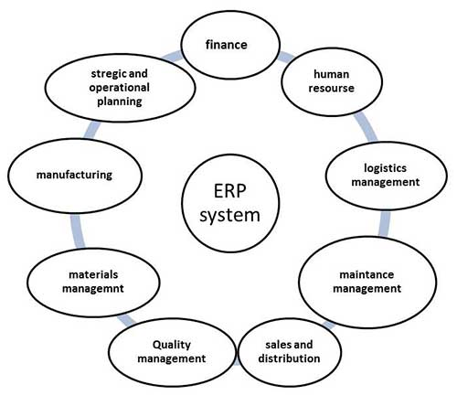

## Why of ERP?

ERP is very helpful in the following areas −

* Business integration and automated data update
* Linkage between all core business processes and easy flow of integration
* Flexibility in business operations and more ability to the company
* Better analysis and planning capabilities
* Critical decision-making
* Competitive advantage
* Use of latest technologies

## Features of ERP

The following diagram illustrates the features of ERP −

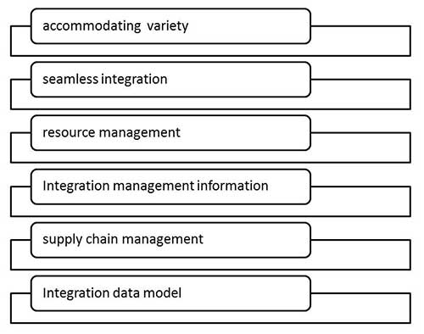

## Scope of ERP

* **Finance** − Financial accounting, Managerial accounting, treasury management, asset management, budget control, costing, and enterprise control.
* **Logistics** − Production planning, material management, plant maintenance, project management, events management, etc.
* **Human resource** − Personnel management, training and development, etc.
* **Supply Chain** − Inventory control, purchase and order control, supplier scheduling, planning, etc.
* **Work flow** − Integrate the entire organization with the flexible assignment of tasks and responsibility to locations, position, jobs, etc.

## Advantages of ERP

* Reduction of lead time
* Reduction of cycle time
* Better customer satisfaction
* Increased flexibility, quality, and efficiency
* Improved information accuracy and decision making capability
* Onetime shipment
* Improved resource utilization
* Improve supplier performance
* Reduced quality costs
* Quick decision-making
* Forecasting and optimization
* Better transparency

## Disadvantage of ERP

* Expense and time in implementation
* Difficulty in integration with other system
* Risk of implementation failure
* Difficulty in implementation change
* Risk in using one vendor

## Balanced Score Card

## Introduction

The balance scorecard is used as a strategic planning and a management technique. This is widely used in many organizations, regardless of their scale, to align the organization's performance to its vision and objectives.

The scorecard is also used as a tool, which improves the communication and feedback process between the employees and management and to monitor performance of the organizational objectives.

As the name depicts, the balanced scorecard concept was developed not only to evaluate the financial performance of a business organization, but also to address customer concerns, business process optimization, and enhancement of learning tools and mechanisms.

## The Basics of Balanced Scorecard

Following is the simplest illustration of the concept of balanced scorecard. The four boxes represent the main areas of consideration under balanced scorecard. All four main areas of consideration are bound by the business organization's vision and strategy.

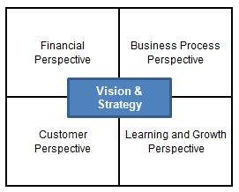

The balanced scorecard is divided into four main areas and a successful organization is one that finds the right balance between these areas.

Each area (perspective) represents a different aspect of the business organization in order to operate at optimal capacity.

* **Financial Perspective -** This consists of costs or measurement involved, in terms of rate of return on capital (ROI) employed and operating income of the organization.
* **Customer Perspective -** Measures the level of customer satisfaction, customer retention and market share held by the organization.
* **Business Process Perspective -** This consists of measures such as cost and quality related to the business processes.
* **Learning and Growth Perspective -** Consists of measures such as employee satisfaction, employee retention and knowledge management.

The four perspectives are interrelated. Therefore, they do not function independently. In real-world situations, organizations need one or more perspectives combined together to achieve its business objectives.

For example, Customer Perspective is needed to determine the Financial Perspective, which in turn can be used to improve the Learning and Growth Perspective.

## Features of Balanced Scorecard

From the above diagram, you will see that there are four perspectives on a balanced scorecard. Each of these four perspectives should be considered with respect to the following factors.

When it comes to defining and assessing the four perspectives, following factors are used:

* **Objectives -** This reflects the organization's objectives such as profitability or market share.
* **Measures -** Based on the objectives, measures will be put in place to gauge the progress of achieving objectives.
* **Targets -** This could be department based or overall as a company. There will be specific targets that have been set to achieve the measures.
* **Initiatives -** These could be classified as actions that are taken to meet the objectives.

## A Tool of Strategic Management

The objective of the balanced scorecard was to create a system, which could measure the performance of an organization and to improve any back lags that occur.

The popularity of the balanced scorecard increased over time due to its logical process and methods. Hence, it became a management strategy, which could be used across various functions within an organization.

The balanced scorecard helped the management to understand its objectives and roles in the bigger picture. It also helps management team to measure the performance in terms of quantity.

The balanced scorecard also plays a vital role when it comes to communication of strategic objectives.

One of the main reasons for many organizations to be unsuccessful is that they fail to understand and adhere to the objectives that have been set for the organization.

The balanced scorecard provides a solution for this by breaking down objectives and making it easier for management and employees to understand.

Planning, setting targets and aligning strategy are two of the key areas where the balanced scorecard can contribute. Targets are set out for each of the four perspectives in terms of long-term objectives.

However, these targets are mostly achievable even in the short run. Measures are taken in align with achieving the targets.

Strategic feedback and learning is the next area, where the balanced scorecard plays a role. In strategic feedback and learning, the management gets up-to-date reviews regarding the success of the plan and the performance of the strategy.

## The Need for a Balanced Scorecard

Following are some of the points that describe the need for implementing a balanced scorecard:

* Increases the focus on the business strategy and its outcomes.
* Leads to improvised organizational performance through measurements.
* Align the workforce to meet the organization's strategy on a day-to-day basis.
* Targeting the key determinants or drivers of future performance.
* Improves the level of communication in relation to the organization's strategy and vision.
* Helps to prioritize projects according to the timeframe and other priority factors.

## Conclusion

As the name denotes, balanced scorecard creates a right balance between the components of organization's objectives and vision.

It's a mechanism that helps the management to track down the performance of the organization and can be used as a management strategy. It provides an extensive overview of a company's objectives rather than limiting itself only to financial values. This creates a strong brand name amongst its existing and potential customers and a reputation amongst the organization's workforce.

**Some Questions and answers**

**1.a. Write a brief notes on the Essential Skills of Managers**

The major skills required or expected out of managers are:-

**Technical skills** – Pertaining to knowledge and proficiency in activities involving methods and procedures;

**Human skills** – Ability to work effectively with other persons and to build up cooperative group relations to accomplish organizational objectives;

**Conceptual skills** – Ability to recognize significant elements in a situation; and to understand the relationship among those elements; and

**Design skills** – Ability to solve problems in ways that will benefit the enterprise

**b. List out the Principles of Organization**

1.Principle of Objective:-

2.Principles of Specialization:-

3.Principle of Co-ordination:-

4.Principle of /authority and Responsibility:-

5. Principle of Definition

6. Span of control:-

7.Principles of Balance:-

8.Principles of /continuity:-

9.Principle of Uniformity:-

10.Principle of unity of command:-

11.Principle of Exception:-

12.Principle of simplicity:-

13.Principle of Efficiency:-

14.Scalar principle:-

**c. Describe Systems Theory**

The view of organizations as open social systems that must interact with their environments in order to survive is known as the systems theory approach. Organizations depend on their environments for several essential resources: customers who purchase the product or service, suppliers who provide materials, employees who provide labor or management, shareholders who invest, and governments that regulate. According to Cutlip, Center, and Broom, public relations’ essential role is to help organizations adjust and adapt to changes in an organization’s environment.

**d. Explain the Uses of Organization Chart**

1. The organization chart pinpoints the weakness of an organization. This will helps to overcome the short coming of organization.

2. It tells quickly who is responsible for particular function.

3. It is useful in showing nature of an organization and changes if any in the existing staff and new comers.

**e. Define Contingency Theory**

The contingency approach is a management theory that suggests the most [appropriate style of management is dependent on the context of the situation](https://www.hrzone.com/lead/strategy/modern-leadership-why-a-responsive-management-style-is-the-future) and that adopting a single, rigid style is inefficient in the long term. Contingency managers typically pay attention to both the situation and their own styles and make efforts to ensure both interact efficiently.

**2. Give a brief idea about F.W.Taylor’s Scientific Management Thought**

F.W.Taylor is well known as the ‘’ Father of Scientific Management ‘’. Fredrick Winslow Taylor spent a lot of time for finding solutions to the problems on shop floors with an aim to increase the efficiency. Taylor noted in his observations that the tools and equipments used by the workers on shop floors were primitive in nature and the workers intentionally delayed the work. Taylor was able to support the workman and workers on the shop floor by giving solutions to the problems faced as he himself spent his life time on a shop floor as a worker and rose to the level of manager. Taylor developed and designed tools and equipments which could reduce the fatigue of the workers by using standardized equipments which led to increase in the efficiency and ultimately productivity of the shop.

Scientific Management is the process of application of scientific principles to systematic analyzes the work and to find solutions for all the problems associated with improving the efficiency of the methods of working.

The elements of the principles of scientific management suggested by F.W.Taylor are as follows:

1. Separation of Planning and Doing:- Taylor emphasizes the separation of planning aspect from actually doing the work. He said that planning should be left to the supervisor and the worker should emphasize only on operational work.
2. Functional foremen ship:- Taylor evolved the concept of functional foreman ship based on specialization of functions, which could improve the planning work sufficiently besides keeping supervision on workers.
3. Job Analysis:- Job analysis is undertaken to find out the best way of doing things with the least movements, using less time and cost. This is determined, by taking up time-motion-fatigue studies
4. Standardization:- Standardization should be maintained in respect of instruments and periods of work, working conditions etc.
5. Scientific selection and Training of workers:- Taylor has suggested that workers should be selected on scientific basis taking into account their education, work experience , aptitude, physical strength etc.
6. Financial Incentives:- According to Taylor, wages should be based on individual performance and not on the position which he occupied.
7. Economy:- Taylor suggested adequate consideration to be given to economy and profit.
8. Mental Revolution:- Mutual cooperation between management and workers can be achieved through mental change from conflict to cooperation in both parties.

Criticism of Scientific Management:-

The theory of scientific management was heavily criticized by the employers, the workers and psychologists. The employers criticized the process of scientific approach as costly and unworkable. Some of the other arguments against scientific management were:

* It ignores the functional areas of management such as marketing, finance and so on.

* Individual creativity is ignored by favoring one best way.

* Worker is reduced to a cog in the machine

* Mobility among workers gets restricted because of narrow specialization.

* Workers were not involved in the planning part of the job which was controlled by the management. As a result, some of the jobs created continued to be repetitive and boring.

Workers too, did not like to part with the rule of thumb privilege. They felt more insecure to adhere to the scientific standards given by management.

Benefits from Scientific Management:-

Scientific Management proved to be very beneficial to the industry at largee

* Scientific Management improved working methods and brought enormous increase in productivity.

* It developed a rational approach to measure tasks and processes with a considerable degree of accuracy.

* It initiated certain improvements in working methods, plant design and other things, based on information generated by measurement of tasks and processes.

* Piece rate wage system was introduced and incentive systems were evolved.

* It stimulated the employers and the higher levels of management to take a positive view of leadership at the shop floor operations.

* Physical working conditions for the employees underwent a sea change.

* It laid the foundation for work study and other related techniques.

* The scientific approach replaced the most widely prevalent traditional rule of thumb approach.

----------------------------------------------------------------------------------------------------------------

**3. Discuss about the Duties and Responsibilities of Management**

Management is the process of getting things done through others and the person who does it is called a manager. He may be a director, an executive, a supervisor or a foreman. Management is a dynamic process consisting of several activities. These activities which every manager has to perform, are known as the functions of management.

The following are the different functions of management:

1. Planning
2. Organizing
3. Staffing
4. Directing (i) Leadership (ii) Communication (iii) Motivation
5. Coordinating
6. Controlling

Management Functions

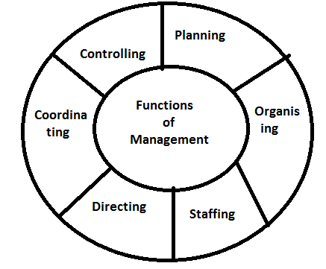

1. Planning:- Planning is nothing but determination of future course of action and it is the primary function of every manager. It touches every aspect of management. Planning is deciding in advance what is to be done, who is to do it and how results are to be evaluated. It consists of formulating the objectives, policies, program mes and progress. Planning requires forecasting of future situation leads to correct decision about future course of actions.
2. Organizing:- Organizing means the creation of a structure of functions and duties to be performed to achieve the goals of the enterprise. Organization also includes the authority and responsibility relationship for the efficient realization of objectives and development. The groups are to be well identified in organization for definition and delegation of authority.
3. Staffing:- It relates to the interrelation between different functions of job, department and personnel of enterprise. Staffing means the recruitment of enough quantity of personnel with required qualities for different positions in the organization. Right person should be selected for the right job. Staffing also includes selection and training functions of manager. It also includes the functions like promotions, demotions, indiscipline action, compensation etc.
4. Directing:- In this function of management the manager will guide, teach and supervise the sub-ordinates for the accomplishment of objectives. The function of directing includes :

(i) Leadership (ii) Communication (iii) Motivation

The main objectives of directing is

To get the work done

To see that the management work more responsibly

(i) Leadership:- It is the process of guiding and influencing the work of sub-ordinates for achieving the goals. Leadership is a function of every manager at every level in the organization.

(ii) Communication:- It is the process of passing information from one person to another person and getting feedback. The communication should be in 2 ways i.e., from superior to subordinate and subordinate to superior. A manager must develop an effective system of communication so that he can pass on orders, instructions and guidance to the subordinates and get the reactions of the subordinates.

(iii) Motivation:- Management can get desired result from the people by motivating them properly. Motivation is nothing but creating an environment where in the employee can work hard for the achievement of organizational goals. For that the management has to create enthusiasm in the minds of the employees. For this purpose management can use financial and non-financial incentives.

1. Coordinating:- Coordinating means building up a team spirit and unity of action among the subordinates to achieve common business objectives. In a business unit, hundreds of persons are busy in numerous jobs in various works in so many different places. So it is necessary managers must coordinate all the workers for achieving the organizational goals.
2. Controlling:- The controlling function involves those activities, which are essential to see that events are processed as planned. Controlling is laying down performance standards, measurements, interpretation and corrective action. Controlling consists of verifying where everything occurs in conformity with the plan, instructions and principles. The process of control involves three things:

* setting of standards for desired performance

* a comparison of actual performance against standards

* taking corrective actions

Conclusion: These functions are not conclusive. The word management is very dynamic and changing. It includes new problems; hence the management has to accept these changes. All the above described functions of management are interrelated. They are not independent and no one can function properly without involving the other. It is circular in nature. So there is no beginning or ending in the process. The only thing is that the relative emphasis on different functions changes according to situation.

1. **a. Narrate the concept of Marketing Mix**

Marketing-mix –Meaning:-

The identification of demand and supply involves various functions of marketing and the combination of these functions is known as Marketing-MIX. There are literally dozens of marketing mix tools but Mc Cathes popularised a 4 factor classification of these tools called the 4 p’s which constitute the core of a company’s marketing system, the product, the price structure, the promotions activities and the place (distribution system).

The elements of the marketing mix:

1. Product mix 2. Price mix 3. Promotion mix 4. Place mix

1. Product mix:- The word ‘’Product Mix’’ is used to describe the assortment of different product types and their varieties. In addition, different tangible and intangible features of the product also form the product mix. A firm may be producing many types of products and in different varieties. For example: Hindustan Machine Tools (HMT) consists of diverse range of products. Such as machine tools, tractors, watches, printing machinery and electric lamps and the group of all these products are called product-mix.

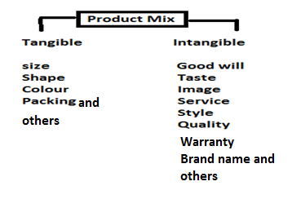

Product is anything that is offered to the market for sale at a price. It can be physical product like toothpaste or a service like transportation, education, insurance, healthcare, entertainment, repairs, etc. The physical product can be further subdivided into two, as follows:

Types of products:

Consumer products:- Goods bought by individual households without requiring further processing are known as consumer goods. These can be further categorised as:

* Durable goods: Which survive many uses and relatively long life (e.g., refrigerators, fans, watches etc.)
* Non-durable goods: Which are consumed in one or a few uses and last a relatively short period (e.g., soft drinks, soaps, bread, etc.)
* Convenience goods: Which are frequently purchased with minimum of efforts in deciding (e.g., newspapers, tooth brushes, etc.)
* Shopping goods: Which are bought after comparison at the retail outlets (e.g., garments, furniture, etc.)
* Speciality goods: Which have unique features and therefore, require special purchasing efforts (e.g., sporting equipments, cars, etc.)

Industrial products:- Industrial products are goods, which are sold to other business firms, either for their own consumption or for producing other goods. They can be either capital goods- machines and plants, or raw materials and parts.

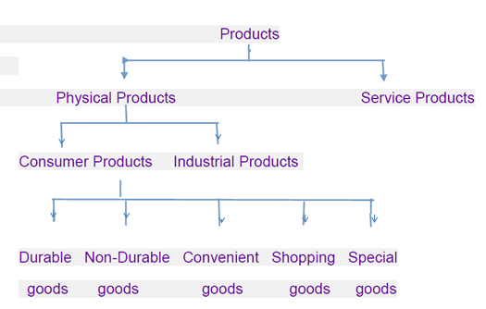

2. Price mix:- Price-mix refers to the decisions relating to the price charged for the product, service or idea. Price means the money value that the customer has to pay in exchange for a period. Generally, marketers pay attention to the following factors before fixing the price of a product.

Target customers: How much they will buy at various processes

Cost: How much it costs to produce and market the product

Competition: Intense competition may indicate a low price and vice versa

Discounts and allowances: How much of the price could be allowed as incentives to dealers and customers in the form of discounts and the profit margin to be maintained.

Producing Pricing:

Pricing decisions are extremely important as they greatly influence the profitability of a firm. Moreover, price is perhaps that handiest tool available to a firm to adopt its marketing strategy to changes in demand, cost, and competitive situations. Many factors, both economic and non-economic, influence the pricing decisions. These are:

Cost, Demand, Competition, Government regulations, Behaviour of the consumer, and Objectives of the enterprise.

Pricing Methods: There are several methods of pricing a product/service. An enterprise can adopt any one of these methods depending upon the above-mentioned economic and non-economic factors. The important pricing methods are:

1. Mark-up or Cost plus Pricing: Under this method, total cost is added up, both fixed and variable, and cost per unit is found. Then a margin of profit is added to determine the selling price.

2. Perceived Value Pricing: According to this, the product is priced on the basis of the buyer’s perceptions of value of product rather than the cost of production.

3. Going Rate Pricing: In this case, an enterprise basis its price largely on competitor’s price. The smaller firms always tend to fallow the leader and price their product more or less equal to the price of the leading product. This is most popular method of pricing and ensures competition.

4. Odd Pricing: Setting the price at extreme higher end of a particular lower price range instead of beginning of the next price range. The best example can be taken is Bata Pricing (e.g., pricing at Rs. 299.95 instead of Rs. 300.00)

5. Discriminating Pricing: Pricing the same product two different levels is known as discriminating pricing. Under certain conditions firms adopt this method of pricing.

6. Promotional Pricing: Provision of cash rebates, sales discounts, special event rebates, low-interest financing, free coupons, offering gifts and prizes, etc. Come under promotional pricing.

7. Skimming Pricing: Price heavily in the initial period of product launching and gradually reducing the same is known as skimming pricing. This is generally applied in case of products, which are subject to obsolete in a short period, eg. Computer software.

8. Penetrating Pricing: Charging low price initially and once the product is accepted by the market, increasing the same gradually is known as penetrating price. Many products are generally based on this method of pricing.

3. Promotion Mix:- Promotion mix refers to the activities relating to promotion of the product, service or idea. It consists of all activities aimed at encouraging and motivating the consumers to buy the product. The various elements of the promotional mix are:

1. Advertising: Advertising consists of all the activities involved in presenting product information to customers. The product message is communicated through media (newspapers, radio, television, etc.) and is paid for by the seller.

2. Sales Promotion: It is the method of increasing the sales through displays, demonstrations, contexts, coupons etc. Sales promotion activities aim at supporting personal selling and advertising efforts.

3. Personal selling: Personal selling is the face to face communication between a seller and a buyer. Some contacts are made with the customers by company sales representative. These representatives assist and persuade a prospective buyer to buy a product in a face to face situation.

4. Publicity: Publicity refers to the mention of a company brand or product in trade journals, newspapers, radio etc. Which is not paid for? Publicity is a relatively minor form of promotion because the manufacturer has no control over what the media will mention.

4. Place or Physical distribution mix: - Place or physical distribution mix refers to the activities that are involved in transferring ownership to consumers and to make products or services available at the right time and place. Distribution mix consists of two things.

a) Physical distribution and

b) Channels of distribution

Physical distribution includes all those activities involved in moving products or services from producer to consumer.

The channels of distribution are those routes through which goods move from the producer to the consumer. Here, the marketing manager has to decide whether the firm should sell through middlemen or directly to customers.

**b. Illustrate the stages in Product Life Cycle with the help of a diagram**

A product is a physical good or service or more often, a combination of both. It is capable of satisfying the buyer’s needs. It has certain tangible and intangible attributes that a seller offers to a potential buyer. It is very interesting to observe the changes in the sales of the product or service once it is launched. It is not necessary that it will have uniformity in case of every product or service. In most of the cases, sales levels will grow up to a particular point of time, and remain static at some level, beyond which the sales start declining particularly when a new product that satisfies the customer’s needs better emerges.

The concept of product life cycle describes these common patterns of sales growth and decline, that can be observed over the life time of a product.

Definitions:

Product life cycle has been defined by Philip Kotler as ‘’ an attempt to recognize distinct stages the sales history of the product’’,

According to D.T.Kollat and J.F.Robenson, product life cycle is ‘’ a generalized model of sales and profit trends for a product category over a period of time’’.

Key elements of product life-cycle:

The product life cycle is a concept that attempts to describe a products sales, profits, customers, competitors and marketing emphasis from its beginning until it is removed from the market. The concept was popularised by Theodore Levitt in 1965. The product life cycle concept has 3 key elements. They are:

1. Products move through the cycle of introduction, growth, maturity and decline at different speeds.

2. Both sales volumes and unit profits rise correspondingly in the growth stage, and fall correspondingly after maturity stage. However, during the maturity stage, sales volume rises but unit profits fall.

3. The functional emphasis required for successful product management change from stage to stage on account of changes in the economics of profitability.

Stages of Product Life Cycle:

Every product or service has a defined life cycle with distinct stages. These stages include

1. Introduction 2. Growth stage 3. Maturity stage 4. Saturation stage 5. Decline stage.

1. Introduction:- This is the very first stage of the life cycle of a product. At this stage, the product is introduced into the market. At this stage, there may not be a ready market for the product. The product is made known to its potential consumers through various programmes of advertisement. At this stage sales revenue begins to grow but the rate of growth is very slow. Profits may not be there because of low sales volume and distribution costs. This stage is the most risky stage and expensive as there is a high percentage of product failure in this period. This stage is also called market pioneering stage.

2. Growth stage:- This is the second stage of product life cycle. In this stage the producer is produced in sufficient quantity and put in the market without delay. The demand generally continues to outpace the supply. The sales and profit curves rise often at a rapid rate. Competitors enter in the market in large number and prices may come down slight sellers shift of ‘’ buy my brand’’ rather than ‘’try my product’’ promotional strategy. This stage is also called market acceptance stage.

3. Maturity stage:- At this stage the customers like and prefer the product. Total volume of sales goes or increasing but the rate of increase in the volume of sales declines. The reason of such decline is the entrance of some new competitors into the market. At this stage, the expenditure of the enterprise on advertising and sales promotion should be increased. So that the demand of product may be maintained. At the same time, the price of the product should be reduced due to the increase in competition. Consequently, the rate of profit of the enterprise declines. Low prices, keener competition, rising costs, and declining profits are the features in this stage.

4. Saturation stage:- When the sales growth slows down to zero, such a stage is called saturation. The size of the market does not increase beyond this stage. This stage continues till substitutes of the product enter into the market. The production goes on increasing and the competitors try to capture the market. Markets are highly segmented the cost of advertisement and sales promotion increase and consequently the profits of the enterprise decrease.

5. Decline stage:- When sales of a product tend to fall, such a stage is called decline. In this stage, the product loses its distinctiveness and dies out in terms of both sales and profit margins, sales drop severely. The important reasons for the decline of the sales of the product are shifts in consumer tastes, technology and increased domestic and foreign competition.

The product life of a product is depicted below:

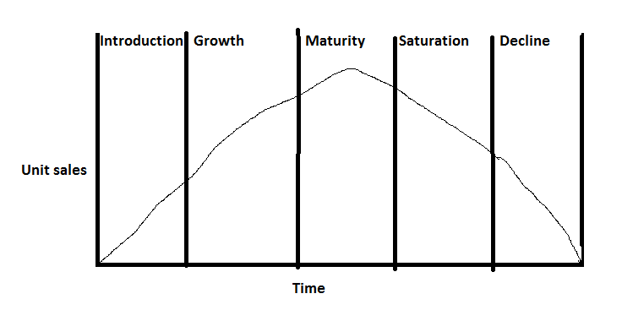

Importance of product life cycle concept:

Importance of the study of product life cycle are:

1. Predictive tool:- Since a product has a predictive life pattern and the problems likely to be encountered in different stage of product life cycle are known, the management is pre-warned of the likely changes in the product position. For ex. Behaviour patterns of sales, profits, dealers and competitors in different stages are known.

2. Planning tool:- The study of product life cycle is an important tool in the hands of management. The management is better placed to plan its strategy in advance so as to fully exploit the product potential.

3. Control tool:- The study of product life cycle help in controlling the marketing activities of the enterprise also. With the help of this study, the marketing manager can make necessary arrangements to make the product available according to the demand. Thus, the product life cycle study serve as an important control tool.

4. Development of new products:- The study of product life cycle is very helpful in the development of new products, and in the improvement of existing product. This study helps the changes taking place in the need, habits, tastes and attitudes of consumers. Keeping in view these changes, necessary decisions may be taken for the improvement of existing products, and development of new products.

Thus, the product life cycle concept is an important forecasting, planning and control tool in the hands of marketers. It is a reliable aid in modifying the marketing strategies. It is quite useful to the marketers in various ways.

**5. What is meant by Plant Location and Plant Layout? Discuss the influencing factors of Plant Location?**

Plant Location

Introduction and meaning:

Plant location refers to the choice of region and the selection of a particular site for setting up a business or factory.

Plant layout:

Plant layout is the arrangement of machines, work areas and service areas within a factory.

But the choice is made only after considering cost and benefits of different alternative sites. It is a strategic decision that cannot be changed once taken. If at all changed only at considerable loss, the location should be selected as per its own requirements and circumstances. Each individual plant is a case in itself. Businessman should try to make an attempt for optimum or ideal location.

Factors Affecting the Plant Location:

When the location of an industrial unit is preplanned, several factors are taken into consideration and carefully analyzed because the location once chosen cannot be changed often as frequent changes in location leads to losses. The main factors, which influence the choice of location, are as follows:

1. Primary factors
2. Nearness to market
3. Nearness to supply of materials
4. Availability of labour
5. Transportation and Communication facilities
6. Availability of power and fuel
7. Supply of capital

B. Secondary factors

1. Natural factors
2. Government incentives
3. Historical and religious factors
4. Initial start and goodwill
5. Financial and other aids
6. Facilities
7. Amenities of particular site
8. Climate
9. Availability of Water
10. Political factors
11. Miscellaneous factors

Primary factors:

1. Nearness to Market: If the plant is located close to the market the cost of transportation can be minimized. This also helps the producers to have direct knowledge of the requirements of the customers.
2. Nearness to supply of raw materials: As far as possible the site selected should be near the source of raw materials, so that the cost of transportation can be minimized and storing cost can be reduced due to shorter lead time
3. Availability of labour: Availability of right kind of labour force in required number at reasonable rates is also a deciding factor in selection of site
4. Transport and Communication facilities: Generally, industries have a tendency to locate the industrial units near the railway station, highway or port areas.
5. Availability of power and fuel: Coal, electricity, oil and natural gas are the important sources of power in the industries. Power shortage leads to tremendous losses due to stoppage of machinery. Ex. Tata iron and steel industry is established near the coalmines of Bihar.
6. Supply of Capital: Large scale production, mechanization and big industries require large amounts of capital for a long period. ‘’ Finance is the life blood of an industry ‘’. The place where financial institutions are ready to assist the industry becomes an industrial hub. Cities like Mumbai, Pune are the centers of industries, because they enjoy better credit facilities. Certain states in our country provide easy loans on subsidized rates, machinery, built-up sheds, etc., to attract industries.

Secondary factors:

7. Natural factors: Land, water, climate are some important natural factors that play an important role in plant location in case of industries like cotton, sugar and jute.

8. Government incentives: The government by giving certain incentives like tax exemptions, price subsidies etc, may bring about the development of industries in backward areas thus resulting in the regional balancing of industries.

9. Historical and Religious factors: Some industries grow because of the historical and religious factors of those cities.

10. Initial start and goodwill: Once an industry is started, other industries also develop at that place. Government rest ructions play a negative role in the location decision. Industries are not permitted to be started or expanded in certain developed urban areas therefore some industries get located at a place because some industrialists start the industry at that place at an early stage.

11.Financial and other aids: For the development of back ward regions central as well as state government provide certain incentives and facilities such as cash subsides, concession, financial assistance, land, power and other facilities at cheaper rates, tax concession etc.

12. Facilities: Factors like an enterprising spirit, innovation, technical know-how and an industrious nature of policy and a favourable government policy create a favourable atmosphere for the purpose of the establishment of industries.

13Amenities of site: Amenities of a particular site like the level of ground, the nature of vegetation and location of allied activities have some influence in determining industrial location. The social amenities include suitable housing and medical facilities serve as an attraction to the labourers.

14. Climatic conditions: Climatic conditions largely affect certain production processes and also the efficiency of the employees.

Ex. Textile mills require moist climate that’s why these plant located at Mumbai and Ahmadabad.

15. Availability of water: Water is used in industries for processing as in paper in chemical industries, for generation of power in hydroelectric power, plants and also require for drinking and sanitary purpose also.

16. Miscellaneous:

* Sufficient supply and proper disposal of water

* Availability of fire-fighting facilities

* Availability of recreational. Medical and educational facilities

* Attitudes of the community

* Aspirations of the people