Beyond Dynamo user guide

# Installation

Download the latest release from GitHub:

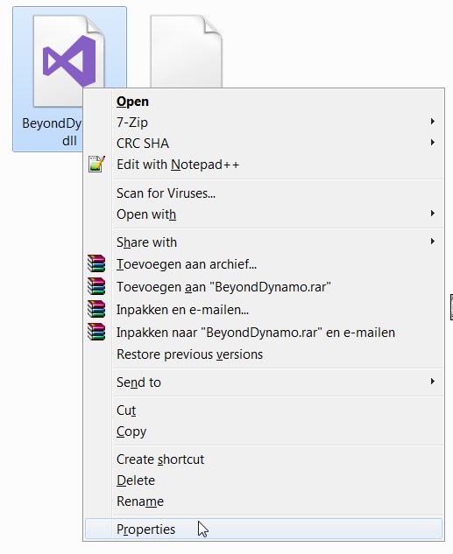<https://github.com/JoelvanHerwaarden/BeyondDynamo1.3/releases>

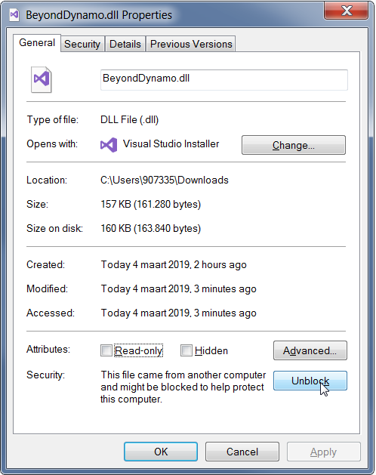After downloading the BeyondDynamo.dll and the BeyondDynamo_ViewExtensionDefinition.xml go ahead a right click the files and go the **Properties**. There click **Unblock.** This will enable Dynamo to load the files when starting.

After copy the following:

**BeyondDynamo.dll** 🡪 **C:\Program Files\Dynamo\Dynamo Core\1.3**

**BeyondDynamo_ViewExtensionDefinition.xml** 🡪 **C:\Program Files\Dynamo\Dynamo Core\1.3\viewExtensions**

# Change Node Colors

This function enables the user to modify the Colorbrushes of the nodes in various states. The function opens a window with different tabs. Each tab represents a node state. The user can change the colors to it’s liking. After changing the colors, Save the Template under the giving name *“DynamoColorsAndBrushes.xaml”.* Copy and paste this file in the Template/Modern directory of Dynamo. You can access this one easily through the *“Open Dynamo Template Directory”* button on the Change node colors window.

Ones you have Copy, paste the file in the Directory, restart Dynamo a enjoy the new fancy Nodes.

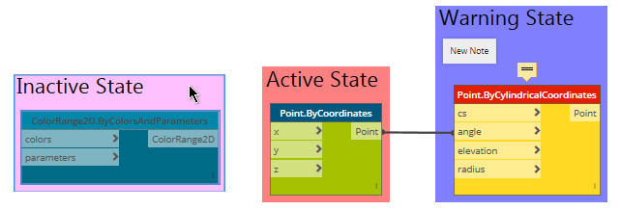

# Remove session trace data from Dynamo Graphs

This function gives a window in which the user can select a Directory. All dynamo files in the directory will be shown in the item box. **TIP:** You can also enter the Directory Path in the “Selected Folder Path” command string. This will automatically change the current directory.

Select the files for which you want to execute the function, all files are automatically select by default. Run the command and Beyond Dynamo will remove the Trace data.

# Order player input

This function lets you select a Dynamo 1.3 file and it will show all the inputs in the current order of the script. Change the order by moving nodes up and down. Ones done, save the file and you can open the file again in the player with the rearranged inputs.

# Remove Session Trace Data from Current Dynamo Graph

This function can be run inside a Dynamo Graph. It will save you Dynamo file and Close it. Then it will remove the Trace Data and open your graph again. **TIP:** This is quite handy to do after you are done working on the graph and if you want to deploy it to other users.

# Change group color

It does what it says it does. Select a one or more groups and click the command. It will open up a color picker window and you can select whatever color you want.

# Import from script

No more copying nodes, closing the graph, open another graph and pasting! This allows you to select a Dynamo file and load it into you current Graph. After you loaded another script it will be in your graph in its original location. Click “Zoom to Fit” to find your imported script. **TIP:** The imported script will be highlighted as selected! You can automatically drag it to the desired location one loaded. Quite handy for really big scripts.

# Edit text notes

This functions opens a resizable text window (the default one is very annoying) for every selected Note in Dynamo. Type your text and click accept to confirm.

# Freeze / Unfreeze multiple node

Freezes or Unfreezes the current selection of nodes. Nothing more…. Why they haven’t done this yet is a mystery…

**TIP:** If you want to do the same with the preview? You can already do this! Select the nodes you want to preview, Right clicking the workspace (not on a Node, I know it’s weird) and click “Hide all Geometry preview”.

# About

It shows the About window for Beyond Dynamo. Here you can find the GitHub with the Source code.

