Applied Numerical Methods with Python

for Engineers and Scientists

Steven C. Chapra

David E. Clough

Errata 3/31/23[1]

p. 18 kg/m should be N/m

N/m

p. 46 replace s with m/s

m/s

p. 47 replace cm2 with cm4

cm4

p. 89 replace 10 with 50

50

p. 95 replace 0 with 1

p. 170 Figure P6.17 replace *vs* with *ws*

p. 177 replace 50 with 55



55

p. 277 replace  with 



p. 293 replace *k* with 2*k*

2*k*

p. 314 ddof=1 required to provide for n-1 in the denominator

cv replaced by cv*100 to convert to %

recommended to replace absolute with abs (either will work)

p. 517 insert * between 900. and x

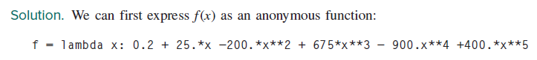

*

p. 517 insert right parenthesis, )



)

p. 558 change *h* to *H*

H

1. We gratefully acknowledge Prof. Jeff Horsburg, Utah State University, for several of these entries.