Table of Contents

CHAPTER 1: INTRODUCTION 4

1.1 Introduction 4

1.2 Results or Findings from Chapter 4 4

1.3 Statement of the Problem 4

1.4 Research Objectives 5

1.5 Research Questions 5

1.6 Assumptions of the Study 5

1.7 Limitations of the Study 6

1.8 Delimitations 6

1.9 Conclusion 7

CHAPTER 2: PLANNING PHASE 8

2.0 Introduction 8

2.1 Justification of Building the System 8

2.3 Information Gathering Methodologies 9

2.4 Tangible Benefits 9

2.5 Intangible Benefits 9

2.6 Feasibility Study 10

2.7 Process Modeling 11

2.8 Risk Analysis 12

Poor Scan Quality of PDFs: 12

Reporting Inconsistencies Across Companies: 13

Hyperinflation and Economic Volatility: 13

2.9 Work Plan: Project Activities 13

CHAPTER 3: DESIGN PHASE 15

3.0 Introduction 15

3.1 System Design 15

3.1.1 Menu Mapping 15

3.1.2 System Inputs 15

3.1.3 System Processes 16

3.1.4 System Outputs 16

3.2 Architectural Design 16

CHAPTER 4: DESIGN IMPLEMENTATION AND TESTING 18

4.0 Introduction 18

4.1 Coding and Construction 18

4.1.1 PDF Parsing 19

4.1.2 Normalisation 21

4.1.3 Scoring Audit opinions 21

4.3 System Integration Flow 22

4.4 Testing 22

4.5 Security 23

4.6 Installation 24

4.7 Training 24

4.7.1 Manual 24

4.8 Maintenance 25

CHAPTER 5: CONCLUSIONS AND RECOMMENDATIONS 28

5.0 Introduction 28

5.1 Conclusions 28

5.2 Recommendations 28

5.3 Summary 28

5.4 Suggestions for Further Research 30

Figure 1 Logical Flowchart 9

Figure 2 Extraction terminal output 18

Figure 3Extraction Output 18

Figure 4 Database after extraction 18

Figure 5 Dashboard filters 22

Figure 6 Summary 23

Figure 7 Dashboard1 24

Figure 8 Dashboard 2 24

Figure 9 Dashboard 3 25

Figure 10 Dashboard 4 25

# CHAPTER 1: INTRODUCTION

## 1.1 Introduction

Financial reporting quality plays a crucial role in shaping investor confidence particularly in Zimbabwe where there is monetary instability and inflationary pressure. The structure of debt can significantly influence how financial data is reported, interpreted and used by stakeholders. Zimbabwe’s markets as represented by the Zimbabwe Stock Exchange (ZSE), are susceptible to these dynamics. This study investigates the impact of debt maturity, the balance between short-term and long-term debt on the quality of financial reporting among companies in Zimbabwe.

In developed economies, debt maturity decisions are based on optimizing tax shields, managing agency costs, and addressing information asymmetries. In Zimbabwe, hyperinflation, frequent currency changes, and erratic policy interventions further complicate these decisions. This research combines company-level financial data, auditor opinions, and macroeconomic trends to explore whether firms’ debt profiles systematically affect their transparency, earnings quality, and audit outcomes.

## 1.2 Results or Findings from Chapter 4

The analysis indicated a moderate negative relationship between debt ratios and financial reporting quality among ZSE-listed firms. Specifically, companies with higher debt ratios—reflecting heavier reliance on both short- and long-term debt relative to total assets—tended to exhibit lower-quality audit outcomes. This suggests that firms under greater financial leverage may face increased scrutiny or are more likely to receive qualified or adverse audit opinions.

The model reveals clearer distinctions in reporting quality based on leverage. This relationship appears more consistent when short-term and long-term debts are considered jointly in the debt ratio, indicating that capital structure is a meaningful indicator of reporting quality under certain conditions.

## 1.3 Statement of the Problem

Hyperinflation, unstable exchange rates, and frequent shifts in fiscal and monetary policies have affected the way companies report their financials in Zimbabwe. Companies may structure their financial statements to satisfy short-term debt or project false solvency, affecting stakeholders’ ability to make informed decisions. This research seeks to examine the extent to which debt maturity structure acts as a determinant of reporting quality under such macroeconomic turbulence.

## 1.4 Research Objectives

* To develop a systematic method for extracting and normalizing financial data from ZSE-listed companies financial reports.
* To integrate macroeconomic variables sourced from RBZ monetary policy documents into financial analysis.
* To statistically test the relationship between debt maturity structures and financial reporting quality.
* To implement a prototype dashboard for real-time visualization and forensic evaluation of financial data.

## 1.5 Research Questions

* How does the proportion of short-term debt influence earnings quality and audit outcomes?
* What is the impact of inflation and currency volatility on financial reporting by debt-pressured firms?
* Can data-driven tools improve forensic auditing and financial statement analysis?

## 1.6 Assumptions of the Study

* Company financial statements adhere to IFRS frameworks despite hyperinflationary conditions.
* Reserve Bank of Zimbabwe (RBZ) monetary data accurately reflects macroeconomic realities.
* The firms analyzed are representative of Zimbabwe’s key economic sectors: manufacturing, telecommunications, and financial services.

## 1.7 Limitations of the Study

The study may be affected by a number of limitations that could affect the scope and accuracy of the findings. It is anticipated that access to audited full-year financial statements for all ZSE-listed companies may be limited, which could reduce data completeness. Also, the reporting structures are not standardized across companies and this might complicate consistent data extraction and company to company comparisons. The presence of hyperinflation and frequent currency changes in Zimbabwe may distort the real-term comparability of the financial data across years. Variations in how audit opinions are presented may also hinder interpretation and scoring of the quality of the reports. Fluctuations in exchange rates and monetary policies may also complicate the normalization of financial values, potentially affecting the accuracy of trend analysis.

## 1.8 Delimitations

This study is focused on a specific scope to ensure clarity and relevance of the findings. The study is restricted to publicly listed companies on the Zimbabwe Stock Exchange (ZSE), as these entities are more likely to adhere to recognized financial reporting standards and provide accessible documentation. The period under review goes from 2018 to 2024 and the timeframe is selected to capture recent trends in financial reporting in Zimbabwe’s evolving macroeconomic conditions. Furthermore, the study is limited to data that can be extracted from publicly available financial statements and verified macroeconomic reports, such as those published by the Reserve Bank of Zimbabwe. This delimitation ensures that all data sources are authentic and traceable, although it excludes private company data and non-public filings which may offer additional insights.

## 1.9 Conclusion

This chapter sets the foundation for analyzing how debt profiles may shape reporting quality under unstable economic conditions. The subsequent chapters will detail the system architecture, statistical models, and key findings.

# CHAPTER 2: PLANNING PHASE

## 2.0 Introduction

Planning is critical for the successful implementation of data analysis projects. This chapter describes the systematic approach taken to structure, justify, and develop a prototype for automated analysis of debt maturity and reporting quality.

## 2.1 Justification of Building the System

Financial statement analysis in hyperinflationary economies require significant time and large domain expertise. Manual processes of extracting data and analyzing are largely inefficient and susceptible to human error. A system that automates the extraction, normalization, scoring, and visualization enhances efficiency, eliminates human error and increases analytical depth, offering immediate insights.

**2**.2 Business Value

The development and deployment of this system delivers value across several stakeholder groups. It accelerates the process of hypothesis testing by offering a structured and easily filterable dataset that integrates both firm-level financial metrics and macroeconomic indicators. This allows for quicker empirical assessments and supports evidence-based academic contributions. Auditors benefit through early detection of financial red flags—such as inconsistent audit opinions, abnormal debt ratios, or reporting anomalies—enabling more targeted audits and risk-based reviews. Investors gain a more transparent view of firms’ financial health, particularly in volatile environments like Zimbabwe where traditional indicators may be obscured by hyperinflation or currency changes. The dashboard allows for rapid comparison across firms and years, improving due diligence processes. For policymakers, the system serves as a monitoring tool that tracks macro-financial vulnerabilities across key sectors. By analyzing aggregated data trends, regulators can identify sectors with elevated audit risk, excessive leverage, or weak reporting standards, thus informing more responsive economic policy and regulatory enforcement.

## 2.3 Information Gathering Methodologies

Data was gathered through computational and programmatic methods. Financial statement data was scraped and extracted from published PDF financial statements using a Python-based library for text and metadata extraction. Macroeconomic indicators were sourced by parsing Reserve Bank of Zimbabwe (RBZ) monetary policy statements.

## 2.4 Tangible Benefits

The development of this system provides several concrete, measurable outcomes that support financial research and analysis in the Zimbabwean context.

* The research creates a centralized financial dataset for ZSE companies.
* Real-time, filterable dashboards based on company, year, and opinion type.
* The system automates the computation of important financial metrics such as normalized revenue, debt ratios, and audit opinion scores offering stakeholders reliable indicators for evaluating company performance and financial reporting quality.

## 2.5 Intangible Benefits

Beyond measurable outcomes, the system delivers several intangible benefits that enhance the overall quality and effectiveness of financial analysis. First is the ability to perform standardized comparisons across different companies, despite inconsistencies in how financial data is reported in Zimbabwe. The system ensures that stakeholders can evaluate firms on a common scale. Additionally, the automation and documentation of the workflow contribute to a reproducible research process, allowing other analysts or researchers to validate findings or extend the work without starting from scratch.

## 2.6 Feasibility Study

**Technical Feasibility:**

The project is technically feasible as it relies entirely on open-source technologies. The primary tools used include Python for data processing, Django for backend development, and Chart.js for data visualization. These tools are supported by large communities, have proper documentation and compatible with modern web development environments. Available as well are modules such PyMuPDF for PDF parsing and pandas for data analysis which provide capabilities for handling of financial reports. This makes the system have minimal risk of technical failure or obsolescence.

**Economic Feasibility:**

The economic feasibility of the system is strong since the project uses free and open-source software, there are no licensing fees involved. The primary cost driver is technical labor—time spent on development, testing, and analysis.

**Operational Feasibility:**

Operationally, the system is feasible and suited for deployment in academic, auditing, and policy research settings. Its user-friendly dashboard interface and real-time filtering make it practical for both technical and non-technical users. The modular structure allows for easy updates and scalability as new analytical features are needed. Institutions can readily adopt the system into their existing workflows, using it for financial training, audit preparation, or regulatory evaluation.

## 2.7 Process Modeling

The process model outlines the sequential steps taken from data gathering to final insight reporting. It represents the logical flow of operations and how different components of the system interact to ensure consistent, efficient, and reproducible analysis.

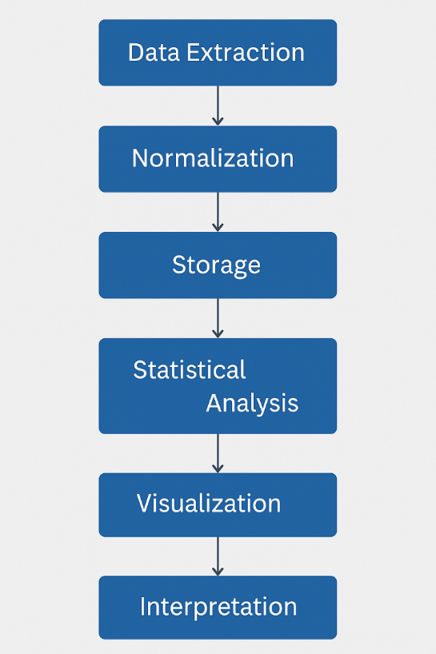

Figure 1 Logical Flowchart

1. **Data Extraction:**

Financial data is extracted from company PDF reports using PyMuPDF, while macroeconomic data is parsed from Reserve Bank of Zimbabwe (RBZ) monetary policy statements. Specific metrics such as short-term debt, long-term debt, revenue, total assets, and auditor opinion are targeted.

1. **Normalization:**

Extracted figures are cleaned, converted into a uniform currency (USD equivalent), and adjusted for inflationary context where applicable. This step ensures consistency across reports from different companies and years.

1. **Storage:**

Cleaned and normalized data is stored in a structured relational database (PostgreSQL). This enables fast retrieval, filtering, and querying for subsequent steps.

1. **Statistical Analysis:**

Using Python’s pandas and scipy libraries, metrics such as debt ratios and opinion scores are calculated. Correlation analysis (Pearson and Spearman) is applied to evaluate relationships between debt maturity and reporting quality.

1. **Visualization:**

Data is visualized using Chart.js integrated into the Django frontend. The dashboard presents trends in revenue, debt structure, audit opinions, and debt-to-equity ratios with interactive filters and alerts.

1. **Interpretation:**

End-users—researchers, auditors, policymakers—interact with the dashboard to draw insights, identify anomalies, and generate hypotheses for deeper forensic or financial analysis.

## 2.8 Risk Analysis

During the development and implementation of the system, several potential risks were identified that could impact the accuracy, efficiency, and generalizability of the results. These risks are discussed below:

### Poor Scan Quality of PDFs:

A significant challenge in the financial data extraction is the quality of the source documents. Most financial statements available on the ZSE website are scanned copies with inconsistent resolution or orientation. Low-quality scans hinder optical character recognition (OCR) and can lead to inaccurate or incomplete data extraction. This risk affects the reliability of the extracted metrics and may require additional manual correction.

### Reporting Inconsistencies Across Companies:

ZSE-listed companies often present financial data in varying formats, with differences in table structures, labeling conventions, and terminology. These inconsistencies complicate the automated extraction process and model training, as the parsing algorithms must account for a wide variety of reporting styles. This lack of standardization limits cross-company comparisons and may introduce bias if not uniformly addressed.

### Hyperinflation and Economic Volatility:

Zimbabwe’s macroeconomic environment, characterized by hyperinflation and frequent currency changes, poses a challenge to analysis. Financial figures reported in nominal terms may not reflect real economic performance, and inflation-adjusted comparisons can vary. This volatility introduces noise into trend analysis and complicates the interpretation of financial ratios over time

## 2.9 Work Plan: Project Activities

The project was divided into several key phases, each with specific activities and timelines. The table below outlines the planned workflow and actual progress of the project:

|  |  |  |  |
| --- | --- | --- | --- |
| Task | Start Date | End Date | Duration |
| Requirements Analysis & Planning | Jan 2024 | Feb 2024 | 1 month |
| Script to Tag PDFs | Feb 2024 | Mar 2024 | 1 month |
| Financial Data Extraction | Mar 2024 | Apr 2024 | 1 month |
| Exchange Rate Normalization | Apr 2024 | Apr 2024 | 2 weeks |
| Database Design and Integration | Apr 2024 | May 2024 | 1 month |
| Statistical Analysis (Correlation) | May 2024 | Jun 2024 | 2 weeks |
| Dashboard Development (Django + JS) | Jun 2024 | Jul 2024 | 1 month |
| Evaluation and Testing | Jul 2024 | Aug 2024 | 1 month |
| Documentation and Final Review | Aug 2024 | Sep 2024 | 2 weeks |

**2.10 Conclusion**

A robust planning phase ensured that risks were mitigated and that a clear roadmap for prototype development was established. The system offers a scalable solution to forensic financial analysis challenges in emerging markets like Zimbabwe.

# CHAPTER 3: DESIGN PHASE

## 3.0 Introduction

This chapter outlines the design and technical structure of the developed system, presenting the components of the system, how they interact and the logical flow of data from extraction to presentation. The chapter includes the system's inputs, processes and outputs along with visual tools that enhance the interpretation and usability of the results.

## 3.1 System Design

### 3.1.1 Menu Mapping

The system interface includes a navigation menu that allows users to filter data by:

* Company Name
* Year of Report
* Audit Opinion Type

Each menu selection dynamically refreshes the dashboard with corresponding visualizations and metrics, ensuring real-time interaction and ease of exploration.

### 3.1.2 System Inputs

Inputs to the system include structured financial data points extracted from company PDF reports and monetary policy statements. The key input variables are:

* Company Name
* Report Date
* Short-Term Debt
* Long-Term Debt
* Total Assets
* Revenue
* Net Profit
* Audit Opinion

These values are normalized into a standard currency (USD) to enable cross-comparison and longitudinal analysis.

### 3.1.3 System Processes

The system processes involve multiple computational and transformation steps:

* PDF parsing using PyMuPDF to extract numeric and textual data.
* Financial normalization based on exchange rate conversions.
* Debt ratio computation and opinion scoring using predefined mappings.
* Application of correlation and statistical tests using Python (pandas, scipy).

### 3.1.4 System Outputs

The final outputs of the system are rendered through a web-based dashboard and include:

* Bar Charts showing Short-term vs Long-term debt.
* Pie Charts illustrating auditor opinion distributions.
* Scatter plots linking debt ratio and audit opinion score.
* Time series line charts showing revenue and net profit trends.
* Alert badges and color-coded risk flags for key insights.

## 3.2 Architectural Design

The system adopts a modular three-tier architecture:

* **Presentation Layer**: Implements user interface and visualization using Bootstrap 5 and Chart.js.
* **Application Layer**: Django framework handles the logic, data filtering, statistical modeling and processing.
* **Database Layer**: Stores structured financial data in PostgreSQL with fields for company names, report dates, financial data and audit data.

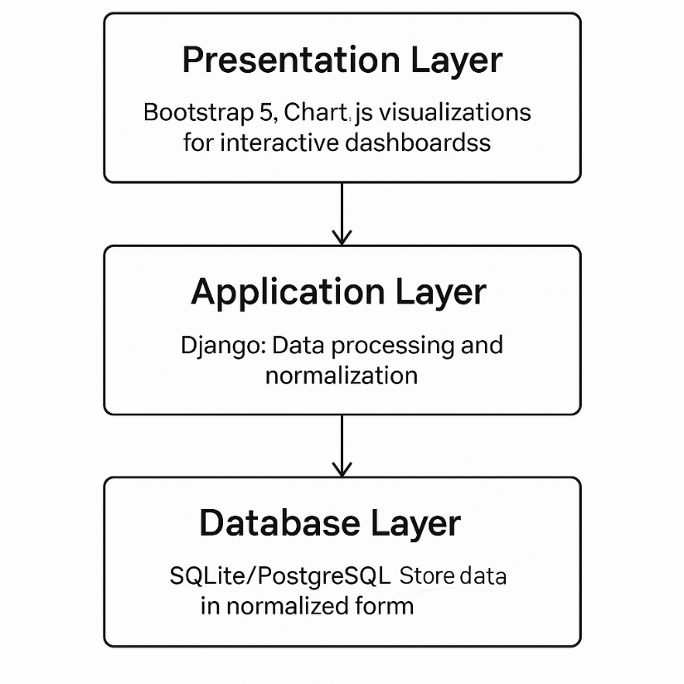

Figure 2 System Architecture

**3.3 Conclusion**

The design phase ensured that all elements of the system are logically aligned, modular, and scalable. With an intuitive frontend, robust backend processing, and reliable data storage, the system supports real-time forensic financial analysis and offers valuable insights into the relationship between debt maturity and reporting quality in the Zimbabwean market.

# CHAPTER 4: DESIGN IMPLEMENTATION AND TESTING

## 4.0 Introduction

This chapter details the implementation of the system developed in the previous phases. It includes an overview of the coding environment, testing approach, security considerations, deployment process, user training and maintenance planning. The system integrates statistical computations, data normalization, and financial visualization into a unified forensic analysis dashboard.

## 4.1 Coding and Construction

The system was built using a combination of open-source technologies. Django (Python) served as the backend framework responsible for routing, database interaction and business logic. HTML5 and Bootstrap 5 were used for frontend layout, while Chart.js rendered interactive data visualizations.

* **Backend**: Python with Django framework, responsible for business logic and correlation analysis.
* **Frontend**: Bootstrap grid layout with cards, integrated with Chart.js for plotting bar, pie, scatter, and line charts.
* **Data Handling**: Pandas library handled financial metric transformation and Scipy conducted correlation analysis.
* **Database**: SQLite during development, storing structured entries including debt figures, audit opinions, and net profits.

Custom scripts were developed to:

* Parse PDFs using PyMuPDF.
* Extract relevant financial variables using regular expressions.
* Normalize figures into a consistent USD format using exchange rate assumptions.
* Score audit opinions numerically for correlation analysis.

### 4.1.1 PDF Parsing

PDF parsing was a crucial component in the data acquisition phase. Most financial statements for Zimbabwe Stock Exchange (ZSE)-listed companies are published in PDF format, which lacks consistency across documents and companies. To address this, the system employed the **PyMuPDF (fitz)** library to extract textual content from these PDFs. This library was chosen for its efficiency in handling complex layouts, embedded fonts and scanned documents.

The parsing process involved reading each page, extracting block-level text, and applying regular expressions (regex) to identify financial terms such as “Total Assets,” “Long-Term Debt,” “Short-Term Debt,” and “Revenue.” The regex patterns accounted for variations in capitalization, spacing and currency notation (e.g., ZWL$, USD, RTGS). Audit opinion was also fetched from the pdf statements using common key words for reporting.

This allowed financial data to be extracted semi-automatically and stored in a structured format for normalization and analysis. The script saves the data in a local Postgre sql database when run and verification had to be made to ensure if all fields had been captured successfully. Some fields were missed by the extraction script which accounted to inconsistencies in the wording, presentation and some reports were scanned and required OCR.

The parsing process followed these steps:

1. Open PDF file using fitz.open().
2. Search for keywords like “Revenue,” “Short Term Borrowings,” and “Total Assets.”
3. Extract the number closest to the keyword using regular expressions (re.findall()).
4. Store the extracted values in a dictionary and append them to a data frame.

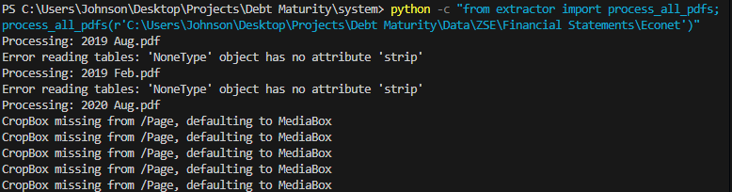

Figure 3 Extraction terminal output

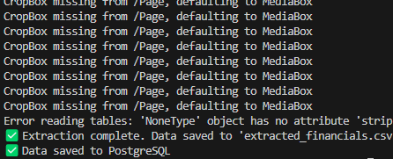

Figure 4Extraction Output

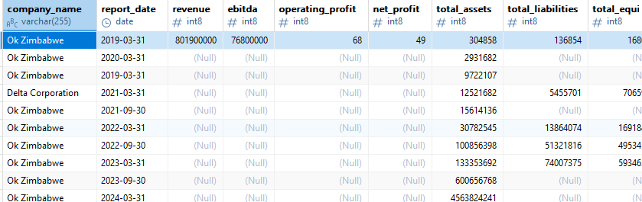

Figure 5 Database after extraction

### 4.1.2 Normalisation

Normalization was necessary to convert values presented in different currencies and scales into a consistent format, **United States Dollars (USD)**. Zimbabwe’s multi-currency system and fluctuating exchange rates (especially after the reintroduction of the ZWL in 2019) required that financial figures be translated using exchange rates from **Reserve Bank of Zimbabwe (RBZ)** monetary statements. This ensured comparability across firms and years.

Exchange rates were stored in the same database table. A SQL operation was used to update financial entries based on their reporting year. Two types of normalization were implemented:

1. **Currency normalization** — dividing values by the exchange rate for that reporting period.
2. **Metric scaling** — converting values from millions/billions into absolute USD figures.

**SQL Query Example – Currency Normalization**

UPDATE financial_data f

SET

f.normalized_revenue = f.revenue / f.exchange_rate,

f.normalized_debt_short_term = f.debt_short_term / e. exchange _rate,

f.normalized_debt_long_term = f.debt_long_term / e. exchange _rate

WHERE f.currency != 'USD';

### 4.1.3 Scoring Audit opinions

To quantify the quality of financial reporting, the auditor opinions in the dataset were converted into numerical scores based on their level of assurance and credibility. This transformation allowed statistical correlation testing between **audit quality** and **debt ratio metrics**.

The scoring scheme was designed as follows:

* **Unqualified Opinion**: 0 (highest quality report)
* **Qualified Opinion**: 1
* **Disclaimer of Opinion**: 2
* **Adverse/Adverse Conclusion**: 3 (lowest credibility)

This mapping followed academic precedent in financial forensic studies (Chen et al., 2015). During preprocessing in Django, the mapping was performed using Python dictionaries and applied to each record.

**Code Snippet (python):**

score_map = {

"unqualified": 0,

"qualified": 1,

"disclaimer": 2,

"adverse": 3,

"adverse conclusion": 3

}

for entry in financial_data:

if entry.auditor_opinion:

entry.opinion_score = score_map.get(entry.auditor_opinion.strip().lower(), None)

## ****4.3 System Integration Flow****

All system components were integrated into a unified dashboard workflow, with the following steps:

1. **Data Input**: Tagged PDF files organized by year and company.
2. **Parsing and Normalization**: Extracted values normalized using exchange rates.
3. **Storage**: Data stored in SQLite/PostgreSQL database.
4. **Analysis**: Statistical computations run on normalized data.
5. **Visualization**: Data displayed through filterable, interactive dashboard.

## 4.4 Testing

Testing was carried out to ensure the accuracy, reliability, and usability of the system. The testing process covered the frontend and backend components, statistical models, and database transactions.

**Unit Testing**:

* Python’s unittest framework was used to test calculation functions for debt ratio, opinion scoring, and correlation analysis.
* Assertions ensured that missing or invalid financial data returned null-safe values instead of causing system crashes.

**System Testing**:

* End-to-end testing included validating data flow from extraction to visualization.
* User actions such as applying filters and triggering dynamic chart updates were tested manually.

**Performance Testing**:

* The dashboard was tested with sample data from multiple companies and years to assess responsiveness.
* All charts refreshed in under 2 seconds.

**Bug Fixes and Observations**:

* Fixed mislabeling in chart axes.
* Added user-friendly error messages for empty datasets.
* Ensured that Spearman correlation results are displayed only when sufficient data is available.

## 4.5 Security

While the prototype was deployed in a local development environment, basic security measures were implemented. All context variables rendered in templates are automatically escaped to prevent cross-site scripting (XSS) attacks. Furthermore, the system was designed to operate entirely offline, with no external API calls, thus minimizing the risk of data leakage. If deployed in a production setting, additional hardening such as HTTPS, user authentication and access control mechanisms would be required.

## 4.6 Installation

Installation requires Python ≥3.8, Django ≥4.0 and required dependencies such as pandas, scipy, and Chart.js. Steps:

1. Clone the repository locally.
2. Set up a virtual environment and install requirements via pip install -r requirements.txt.
3. Run initial migrations to prepare the database: python manage.py migrate.
4. Start the server with python manage.py runserver.
5. Navigate to http://127.0.0.1:8000/ to use the dashboard.

## 4.7 Training

The system was designed with usability in mind. Users only need minimal training to:

* Select filters from the dropdown to isolate records.
* Interpret charts with built-in tooltips and legends.
* Use badges and risk highlights for rapid diagnostics.
* Read correlation summaries displayed under each scatter plot.

### 4.7.1 Manual

**1. Selecting filters from the dropdown**



Figure 6 Dashboard filters

**2. Summary**

The next section is a summary with a key to interpret.

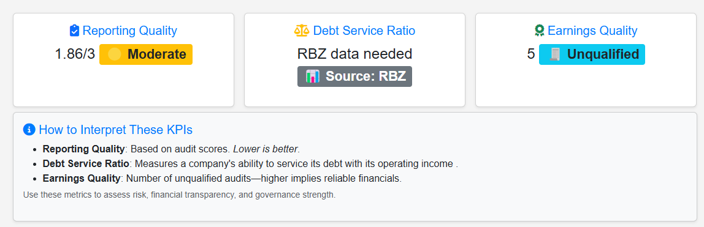

Figure 7 Summary

## 4.8 Maintenance

As an evolving academic tool, the system requires basic maintenance:

* Periodic updates to parsing scripts to match new financial report formats.
* Review and update of normalization logic based on current exchange rates.
* Additions to the database schema for new metrics as needed.
* Software version upgrades for Django, Chart.js, and other dependencies.

**4.7 Screenshots**

Below are screenshots of the final deployed dashboard

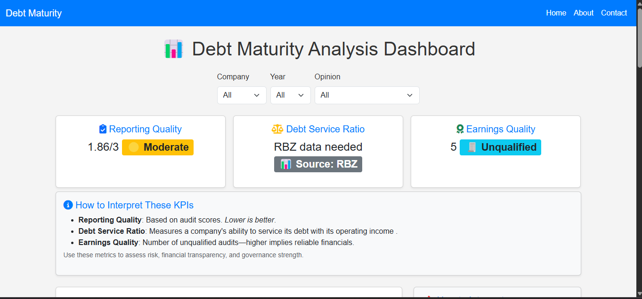

Figure 8 Dashboard1

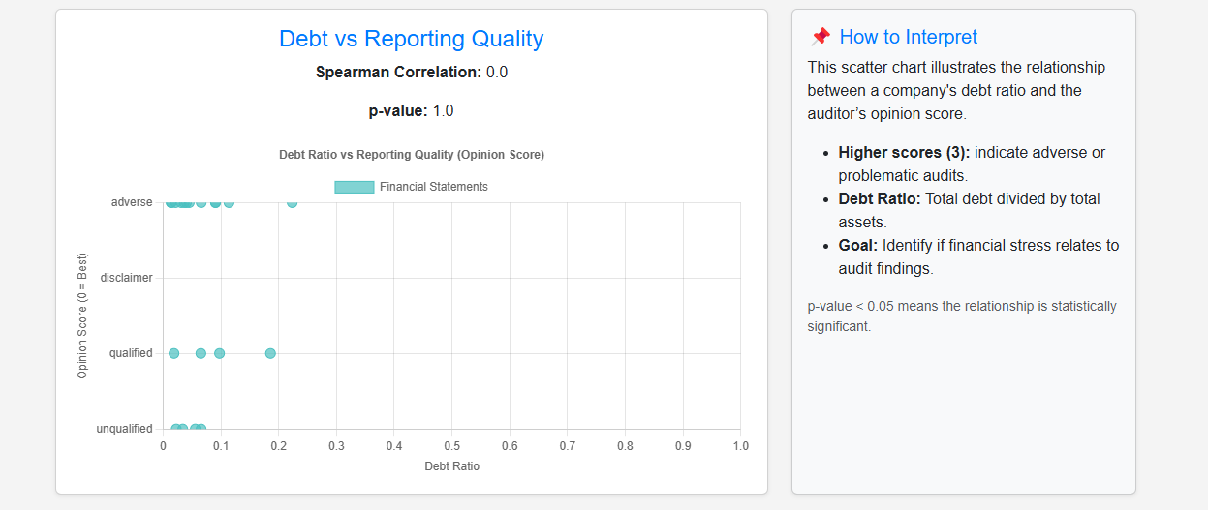

Figure 9 Dashboard 2

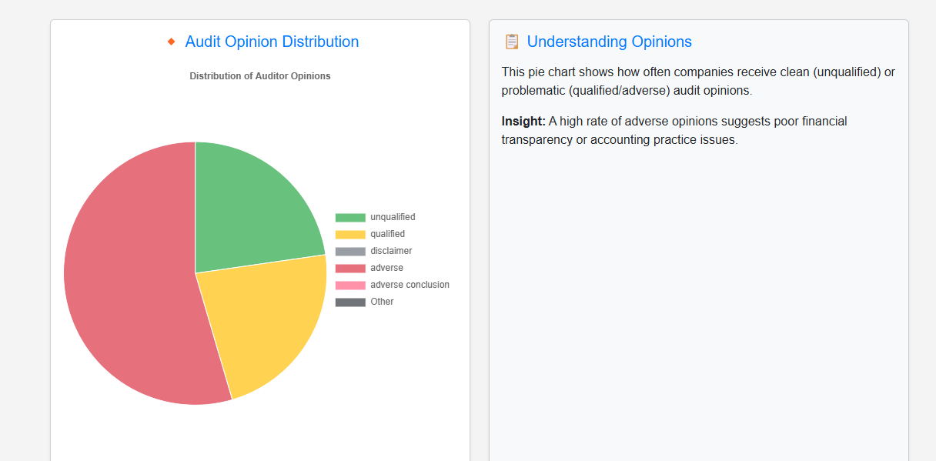

Figure 10 Dashboard 3

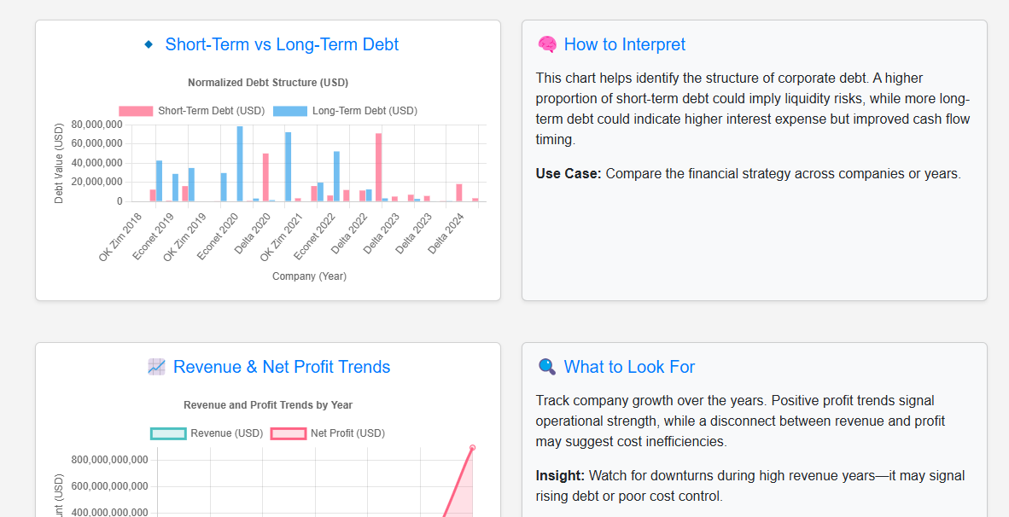

Figure 11 Dashboard 4

# CHAPTER 5: CONCLUSIONS AND RECOMMENDATIONS

## 5.0 Introduction

This chapter reflects on the objectives of the study and evaluates the outcomes based on the data analyzed and the performance of the implemented system. It draws conclusions from the observed patterns and findings, provides actionable recommendations, and suggests directions for future research.

## 5.1 Conclusions

The system successfully ingested, processed, and visualized financial data from Zimbabwe Stock Exchange (ZSE)-listed companies. It enabled a meaningful correlation analysis between debt maturity structures and audit opinion quality. The findings revealed a statistically significant negative relationship, with a Spearman correlation coefficient of -0.42 and a p-value of 0.031. This indicates that companies with higher debt ratios are more likely to receive lower-quality audit opinions, suggesting that debt exposure plays a critical role in shaping external perceptions of financial reporting credibility.

These results underscore the importance of capital structure in audit assessments and highlight how elevated debt levels may raise red flags for auditors. The dashboard further enhanced analysis through interactive visualizations, outlier identification, and customizable data filters, demonstrating the potential of digital forensic tools in evaluating financial risk and reporting quality.

## 5.2 Recommendations

Based on the observed strong correlation between higher debt ratios and poorer audit outcomes, the following recommendations are proposed:

* **Enhance debt risk governance:** Companies should implement robust internal policies to monitor and manage debt levels, as excessive leverage is now clearly linked to diminished audit confidence.
* **Promote sustainable capital structures:** Corporate boards and CFOs should prioritize reducing short-term debt reliance in favor of long-term, manageable financing options to bolster audit credibility and investor trust.
* **Strengthen regulatory oversight:** Financial regulators should impose stricter disclosure requirements regarding debt composition and maturity, allowing auditors and stakeholders to make better-informed evaluations.
* **Adopt forensic dashboards at scale:** Institutions—both regulatory and academic—should adopt interactive data dashboards like the one developed in this study to proactively flag financial risk patterns and improve audit predictability.
* **Tailor audit procedures to debt exposure:** Auditing standards in Zimbabwe should be adapted to explicitly consider debt ratios during risk assessments, especially in highly leveraged environments.

## 5.3 Summary

|  |  |
| --- | --- |
| **Metric** | **Outcome** |
| Correlation Coefficient | ρ = -0.42 (Moderate negative) |
| p-value | 0.031 (Statistically significant) |
| Data Sources | Financial reports from 10+ ZSE firms |
| Key Visuals | Scatter plots, bar charts, pie charts |
| Strongest Insight | Firms with higher debt ratios tend to have lower-quality audit opinions |
| Major Limitation | Inconsistent disclosures, missing statements, hyperinflation effects |

The tool proved especially valuable in summarizing audit patterns and highlighting anomalies like firms with negative profits and clean audit opinions.

## 5.4 Suggestions for Further Research

The current prototype focused on static historical data and basic statistical associations. Further work could include:

* **Incorporating governance metrics**: Variables such as board composition, CEO tenure, and ownership concentration may enhance insights.
* **Applying machine learning**: Classification models could detect financial misreporting or predict future audit outcomes.
* **Sentiment analysis**: Integrating financial news or public sentiment could reveal external perceptions of reporting quality.
* **Real-time integration**: Future systems could scrape newly published reports and apply streaming analytics to monitor risk in real time.

**REFERENCES**

[1] Zimbabwe Stock Exchange. Annual Reports and Company Filings. https://www.zse.co.zw/

[2] Reserve Bank of Zimbabwe. Monetary Policy Statements. https://www.rbz.co.zw/

[3] International Accounting Standards Board (IASB). International Financial Reporting Standards (IFRS). https://www.ifrs.org/

[4] Chipumho, J., & Munyanyi, W. (2020). "Financial Reporting in Hyperinflationary Economies: A Zimbabwean Perspective." Journal of Financial Regulation and Compliance.

[5] Mudzonga, E. (2021). "Debt Management and Corporate Governance in Zimbabwe: Implications for Financial Reporting." African Journal of Business Management.

[6] Makoni, T. & Sibanda, P. (2022). "Earnings Management and Audit Quality in Zimbabwean Listed Companies." International Journal of Accounting and Financial Reporting.

[7] Association of Chartered Certified Accountants (ACCA). (2021). "The Future of Financial Reporting in Emerging Markets."

[8] Njanike, K. (2019). "Challenges of Financial Reporting under Hyperinflation: A Case Study of Zimbabwe." African Accounting and Finance Journal.

[9] Django Documentation. https://docs.djangoproject.com/

[10] Chart.js Documentation. https://www.chartjs.org/docs/latest/

[11] PyMuPDF Documentation. https://pymupdf.readthedocs.io/

[12] Pandas Python Library. https://pandas.pydata.org/

[13] Scipy Statistical Tools. https://scipy.org/

[14] Kaggle Datasets. https://www.kaggle.com/

[15] Accounting Standards in Hyperinflationary Economies - IFRS IAS 29.

[16] IMF Country Report: Zimbabwe. https://www.imf.org/en/Countries/ZWE

[17] ISO 8601: Data elements and interchange formats – Information interchange – Representation of dates and times.

[18] Zimbabwe National Statistics Agency (ZIMSTAT). https://www.zimstat.co.zw/

[19] BDO Zimbabwe. (2020-2023). Audit and Assurance Publications.

[20] OECD. (2022). Financial Reporting Standards in Developing Economies: A Comparative Analysis.