**SIGN LANGUAGE DETECTOR**

This is a guide on how to use the sign language detector

NB* Ensure all the libraries are installed in a .venv folder within your workspace. See README.txt for more details.

1. **Collect data**

Launch collect_data.py from your virtual environment.

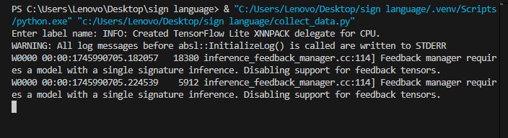

Enter a label name for your gesture

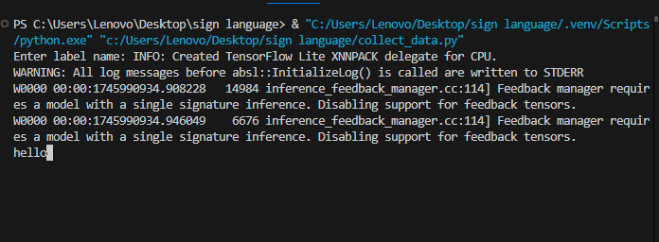

Hold out your hand gesture in different angles to capture frames immediately the webcam turns on.

Press q once done and the data will be saved in a csv file.

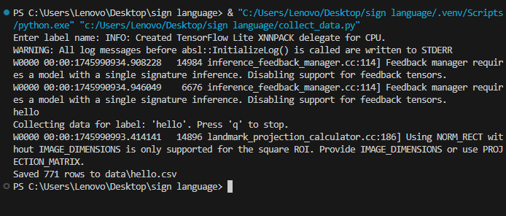

Repeat for other signs.

1. **Train model**

Launch train_model.py from your virtual environment.

This will let the program read your csv data and organize it into a model.

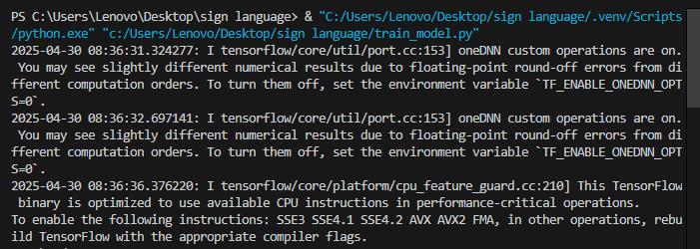

Once done the model is saved in sign_language_model.keras

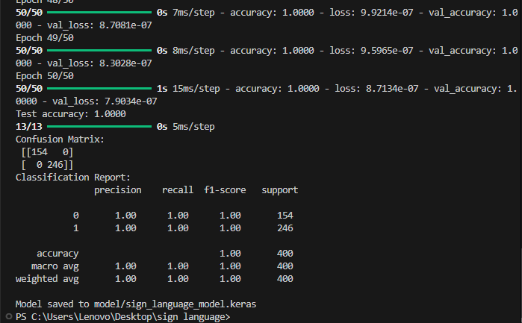

1. **Output**

Launch infer.py from your virtual environment.

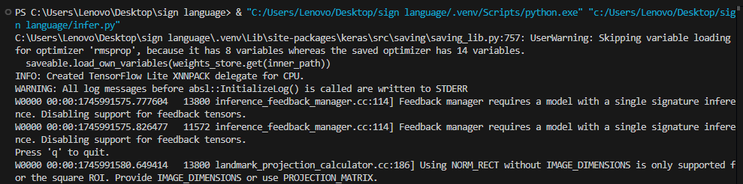

Hold out your hand gesture and the system will detect what it says.

Ok

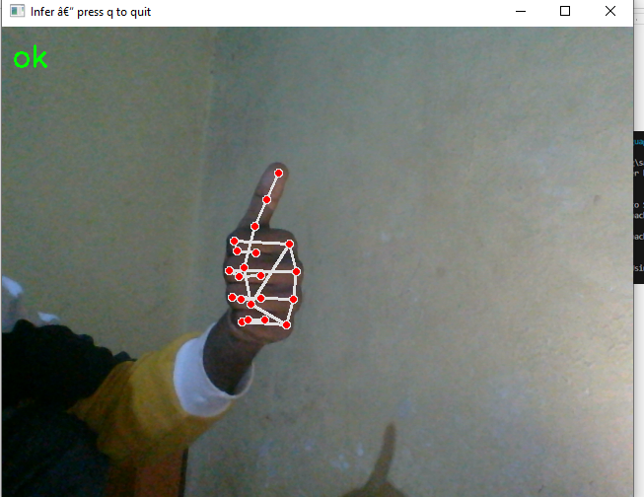

Hello

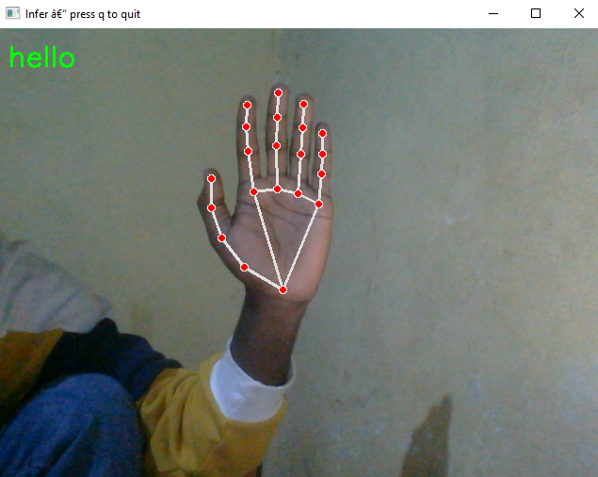

You

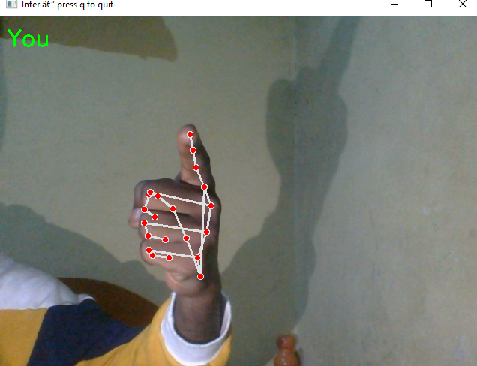

Have you eaten yet?

