2 REVIEW OF RELATED LITERATURE

2.1 Related Literature
This review is structured thematically, referencing key literature such as “Solar Drying Technologies: A Review” (1), “IoT-Enabled Laundry Drying Rack for Smart Home” (2), “Automatic Cloth Drying Line Solution Using IoT” (3), and “The Smart Cloth Racker” (4). These studies comprehensively address the principles of solar drying, advancements in sensor and IoT integration, innovations in control systems for drying rack automation, and holistic solar-powered laundry drying solutions suitable for household application.
(1) Solar Drying Technologies: A Review presents various solar drying methods with emphasis on efficiency improvements and environmental benefits attributed to solar utilization (Unar et al., 2025).
(2) IoT-Enabled Laundry Drying Rack for Smart Home discusses real-time drying monitoring through IoT sensor integration, offering automated adjustments to safeguard fabric and enhance convenience (Kobkiat Saraubon, 2025).
(3) Automatic Cloth Drying Line Solution Using IoT details a microcontroller-driven system employing rain and moisture sensors, automating the extension and retraction of drying racks to minimize manual intervention (Nandan et al., 2022).
(4) The Smart Cloth Racker introduces a solar-powered prototype combining environmental sensing with smart control, effectively preventing re-wetting and over-drying with an emphasis on sustainability and accessibility (Majid & Pramudita, 2024).
Collectively, these studies mark important progress in the development of smart solar drying technologies. However, there is a clear gap regarding the creation of an affordable, fully integrated system specifically tailored for domestic and educational environments. The primary scope of our project focuses on developing a system designed for households and students that automates protection of laundry from rain through automatic precipitation detection and vertical retraction of the rack under a protective cover or housing. This research will evaluate operational efficacy, solar energy sustainability, and overall usability, addressing limitations observed in existing literature while innovating on accessibility and automation.

Source | Key Focus | Key Strengths | Limitations / Gaps for this Project
1. (Unar et al., 2025) | Principles and efficiency of various solar drying methods. | Comprehensive review of solar thermal applications; establishes environmental benefits. | Theoretical focus; lacks integration with modern automation and IoT controls.
2.(Kobkiat Saraubon, 2025) | IoT Integration for real-time monitoring and fabric care. | Advanced sensor data for automated adjustments; high convenience and fabric protection. | No mention of solar power integration; focus is on smart features, not sustainability.
3. (Nandan et al., 2022) | Microcontroller-based automation using rain/moisture sensors. | Effective, low-cost automation for rain protection; hands-free operation. | Limited scope (rain protection only); does not address solar power or holistic sustainability.
4. (Majid & Pramudita, 2024) | Holistic solar-powered prototype with smart control. | Integrates solar power, sensors, and control; addresses both rain and over-drying. | Prototype-stage; affordability and specific tailoring for domestic/educational use not deeply explored.
Table 2-1. From "References" > Insert Caption > Table

2.2 Related System

Design of an Automatic Clothes Drying System Based on Internet of Things (IoT) Technology
This system addresses the problem of clothes being re-wetted by sudden rain by developing an IoT-based automated drying rack. The primary objective was to create a solution that reduces manual intervention through environmental sensing and remote user control.
The system's architecture is built around a Wemos D1 R32 microcontroller, which serves as the central processing and communication unit. For environmental input, it integrates two key sensors: a Light Dependent Resistor (LDR) to detect low light conditions (indicating evening or dark weather) and a rain sensor to detect precipitation. The system's automation is managed through the Blynk application platform, enabling real-time monitoring and manual override control from a user's smartphone.
Functionally, the system performs as designed: it automatically retracts the clothesline into a sheltered area upon triggering conditions—namely, when the LDR sensor detects darkness or the rain sensor detects precipitation. This automation can be manually superseded by a user sending a retract command via the Blynk app.
While this system successfully demonstrates a functional prototype for basic rain and night-time protection, it presents several limitations that this current research seeks to address. Notably, the system relies entirely on grid power for the Wemos board and sensors, lacking any integration of solar energy for sustainability. Furthermore, its operational logic is relatively simplistic; it does not utilize predictive weather data or distinguish between different drying stages, potentially leading to inefficiencies such as retracting clothes that are not yet dry. These gaps in energy autonomy and intelligent control highlight key areas for improvement in the development of more advanced, sustainable drying systems.

2.3 Concept of the Study
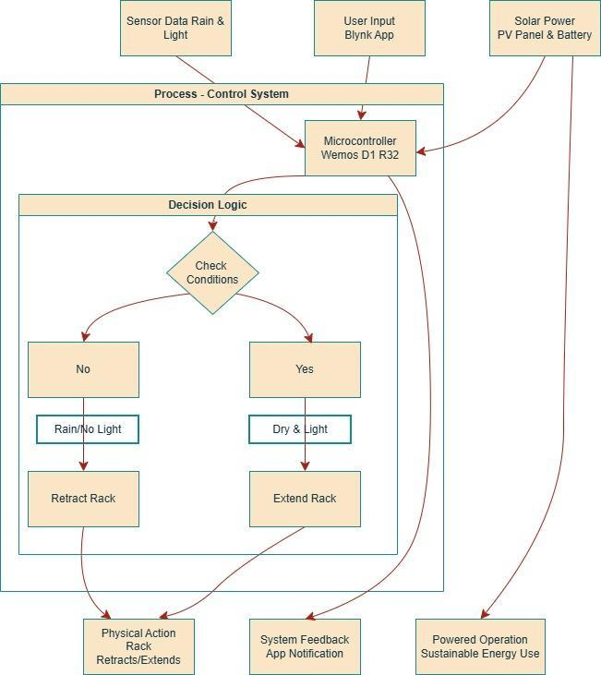
Figure 2-1. Shows how the system works in a conceptual way.

2.4 Definition of Terms
Sensor Data (Rain & Light) - Measurements provided by specialized sensors that detect rainfall and ambient light levels, allowing the system to determine weather conditions for safe laundry drying.
User Input (Blynk App) - Commands or settings adjusted by the end-user through a mobile application (such as Blynk) to monitor or override the automated operations of the drying rack.
Solar Power (PV Panel & Battery) - Electrical energy harnessed from sunlight using photovoltaic (PV) panels, stored in a battery for use in powering the automated drying rack system.
Microcontroller (Wemos D1 R32) - An integrated electronic circuit that acts as the control unit, processing sensor inputs, executing programmed logic, and issuing commands to drive mechanical actions.
Physical Action (Rack Retracts/Extends) - The automated movement of the drying rack, driven by system actuators and guided by control logic, that either pulls the rack under shelter (retraction) or pushes it outward for drying (extension) in response to detected weather or operational conditions—ensuring garments are protected from rain and efficiently air-dried with minimal manual intervention.
System Feedback (App Notification) - Automated alerts or updates sent to the user's device via the mobile app, indicating the current status or actions taken by the system.
Powered Operation (Sustainable Energy Use) - The overall functioning of the drying rack system powered predominantly by renewable solar energy, contributing to efficient and sustainable operation.

REFERENCES
Atsiq, A., Andryan Gunawan, & Amin Alqudri Dwi Nugraha. (2022). Automatic Clothing Drying Using Rain Sensors and Ldr Sensors Based on Arduino UNO. SPECTRUM, 1(02). https://doi.org/10.54482/spectrum.v1i02.174
Kobkiat Saraubon. (2025). IoT-Enabled Laundry Drying Rack for Smart Home. Journal of Information Systems Engineering and Management, 10(52s), 322–332. https://doi.org/10.52783/jisem.v10i52s.10716
Majid, M., & Pramudita, R. (2024). Perancangan Sistem Jemuran Pakaian Otomatis Berbasis Teknologi Internet of Things (IoT). Jurnal Ilmiah Teknologi Infomasi Terapan, 10(3). https://doi.org/10.33197/jitter.vol10.iss3.2024.2010
Nandan, R., Gp, R., & Honnavalli, P. (2022). Automatic Cloth Drying Line Solution Using IoT. 2022 Second International Conference on Advanced Technologies in Intelligent Control, Environment, Computing & Communication Engineering (ICATIECE), 1–5. https://doi.org/10.1109/ICATIECE56365.2022.10046759
Pinem, M., Nasution, C. F., & Suherman. (2021). Automatic Control Circuit Design for a Clothes Dryer. 2021 5th International Conference on Electrical, Telecommunication and Computer Engineering (ELTICOM), 84–87. https://doi.org/10.1109/elticom53303.2021.9590145

Bunda, N., Sunio, V., Palmero, S. S., Tabañag, I. D. F., Reyes, D. J., & Ligot, E. (2023). Stage model of the process of solar photovoltaic adoption by residential households in the Philippines. Cleaner and Responsible Consumption, 9, 100114. https://doi.org/10.1016/j.clrc.2023.100114
Majid, M., & Pramudita, R. (2024). Perancangan Sistem Jemuran Pakaian Otomatis Berbasis Teknologi Internet of Things (IoT). Jurnal Ilmiah Teknologi Infomasi Terapan, 10(3). https://doi.org/10.33197/jitter.vol10.iss3.2024.2010
Pérez-Alarcón, A., Sorí, R., Fernández-Alvarez, J. C., Nieto, R., & Gimeno, L. (2021). Comparative climatology of outer tropical cyclone size using radial wind profiles. Weather and Climate Extremes, 33, 100366. https://doi.org/10.1016/j.wace.2021.100366
Viljoen, M., & Claassen, N. (2023). Pathophysiological aspects of exposure to dampness-associated indoor mould and mycotoxins: A mini-overview. Journal of Hazardous Materials Advances, 9, 100228. https://doi.org/10.1016/j.hazadv.2022.100228

