Lab - Configure ZPFs

Topology
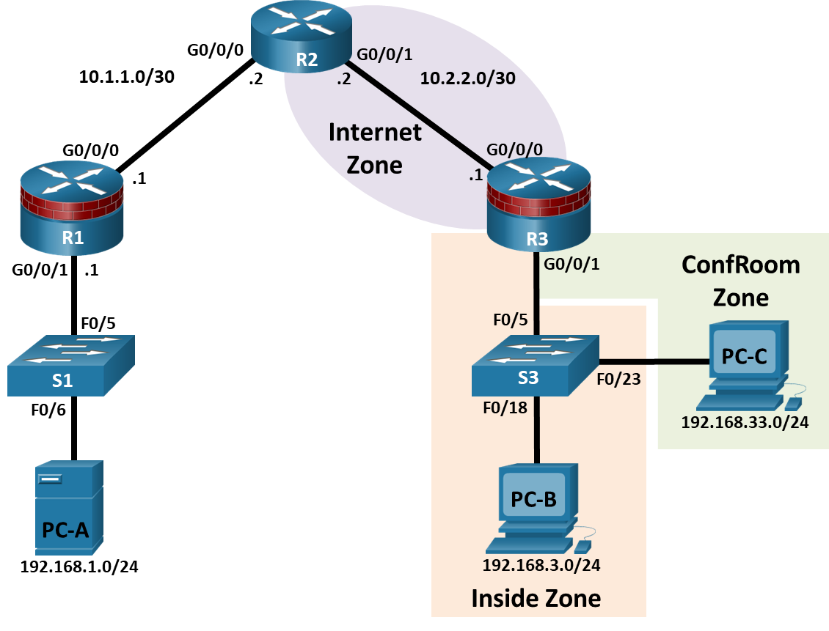

IP Addressing Table
Device | Interface | IP Address | Subnet Mask | Default Gateway | Switch Port
R1 | G0/0/0 | 10.1.1.1 | 255.255.255.252 | N/A | N/A
R1 | G0/0/1 | 192.168.1.1 | 255.255.255.0 | N/A | S1 F0/5
R2 | G0/0/0 | 10.1.1.2 | 255.255.255.252 | N/A | N/A
R2 | G0/0/1 | 10.2.2.2 | 255.255.255.252 | N/A | N/A
R3 | G0/0/0 | 10.2.2.1 | 255.255.255.252 | N/A | N/A
R3 | G0/0/1.3 | 192.168.3.1 | 255.255.255.0 | N/A | S3 F0/5
R3 | G0/0/1.33 | 192.168.33.1 | 255.255.255.0 | N/A | S3 F0/5
PC-A | NIC | 192.168.1.3 | 255.255.255.0 | 192.168.1.1 | S1 F0/6
PC-B | NIC | 192.168.3.3 | 255.255.255.0 | 192.168.3.1 | S3 F0/18
PC-C | NIC | 192.168.33.3 | 255.255.255.0 | 192.168.33.1 | S3 F0/23
Blank Line, No additional information

Objectives
Part 1: Basic Device Configuration
- Configure host names, interface IP addresses, and access passwords on routers.
- Configure the static routes to enable end-to-end connectivity on routers.
- Configure access and trunk ports on a switch.
Part 2: Configuring a Zone-Based Policy Firewall (ZPF)
- Use the CLI to configure a Zone-Based Policy Firewall.
- Use the CLI to verify the configuration.
Part 3: Verify ZPF Firewall Functionality

Background
The most basic form of a Cisco IOS firewall uses access control lists (ACLs) to filter IP traffic and monitor established traffic patterns. A traditional Cisco IOS firewall is an ACL-based firewall.
The newer Cisco IOS Firewall implementation uses a zone-based approach that operates as a function of interfaces instead of access control lists. A Zone-Based Policy Firewall (ZPF) allows different inspection policies to be applied to multiple host groups connected to the same router interface. It can be configured for extremely advanced, protocol specific, granular control. It prohibits traffic via a default deny-all policy between different firewall zones. ZPF is suited for multiple interfaces that have similar or varying security requirements.
In this lab, you build a multi-router network, configure the routers and PC hosts, and configure a Zone-Based Policy Firewall using the Cisco IOS command line interface (CLI).
Note: The routers used with hands-on labs are Cisco 4221 with Cisco IOS XE Release 16.9.4 (universalk9 image). The switches used in the labs are Cisco Catalyst 2960+ with Cisco IOS Release 15.2(2) (lanbasek9 image). Other routers, switches, and Cisco IOS versions can be used. Depending on the model and Cisco IOS version, the commands available and the output produced might vary from what is shown in the labs. Refer to the Router Interface Summary Table at the end of the lab for the correct interface identifiers.
Note: Make sure that the routers and switches have been erased and have no startup configurations.

Required Resources
- 3 Routers (Cisco 4221 with Cisco IOS XE Release 16.9.4 universal image or comparable)
- 2 Switches (Cisco 2960+ with Cisco IOS Release 15.2(7) lanbasek9 image or comparable)
- 3 PCs (Windows OS with a terminal emulation program, such as Tera Term or PuTTy installed)
- Console cables to configure the Cisco IOS devices via the console ports
- Ethernet cables as shown in the topology

Instructions

Basic Device Configuration
In this part of this lab, you set up the network topology and configure basic settings, such as the interface IP addresses, static routing, device access, and passwords.
Note: All tasks should be performed on routers R1, R2, and R3. The procedures are shown for only one of the routers.

Cable the network as shown in the topology.
Attach the devices as shown in the topology diagram, and cable as necessary.

Disable DNS lookup.
Open configuration window
To prevent the router from attempting to translate incorrectly entered commands, disable DNS lookup.

Configure basic settings for each router.
      - Configure host names as shown in the topology.
      - Configure the interface IP addresses as shown in the IP addressing table. The IP address configuration for router R3 is provided below.
R3(config)# interface GigabitEthernet0/0/0
R3(config-if)# ip address 10.2.2.1 255.255.255.252
R3(config-if)# no shutdown
R3(config-if)# interface GigabitEthernet0/0/1
R3(config-if)# no shutdown
R3(config-if)# interface GigabitEthernet0/0/1.3
R3(config-if)# encapsulation dot1Q 3
R3(config-if)# ip address 192.168.3.1 255.255.255.0
R3(config-if)#interface GigabitEthernet0/0/1.33
R3(config-if)# encapsulation dot1Q 33
R3(config-if)# ip address 192.168.33.1 255.255.255.0

Configure static routes on R1, R2, and R3.
      - To achieve end-to-end IP reachability, proper static routes must be configured on R1, R2 and R3. R1 and R3 are stub routers, and as such, only need a default route pointing to R2. R2, behaving as the ISP, must know how to reach R1’s and R3’s internal networks before end-to-end IP reachability is achieved. Below is the static route configuration for R1, R2 and R3. On R1, use the following command:
R1(config)# ip route 0.0.0.0 0.0.0.0 10.1.1.2
      - On R2, use the following commands.
R2(config)# ip route 192.168.1.0 255.255.255.0 10.1.1.1
R2(config)# ip route 192.168.3.0 255.255.255.0 10.2.2.1
R2(config)# ip route 192.168.33.0 255.255.255.0 10.2.2.1
      - On R3, use the following command.
R3(config)# ip route 0.0.0.0 0.0.0.0 10.2.2.2

Configure S3.
      - Configure trunk link:
S3(config)# interface f0/5
S3(config-if)# switchport mode trunk
      - Configure access ports.
S3(config)# interface f0/18
S3(config-if)# switchport mode access
S3(config-if)# switchport access vlan 3
S3(config-if)# interface f0/23
S3(config-if)# switchport mode access
S3(config-if)# switchport access vlan 33

Configure PC host IP settings.
Configure a static IP address, subnet mask, and default gateway for PC-A, PC-B, and PC-C as shown in the IP addressing table.

Verify basic network connectivity.
      - Ping from R1 to R3.
If the pings are not successful, troubleshoot the basic device configurations before continuing.
      - Ping from PC-A on the R1 LAN to PC-B and PC-C on the R3 LANs.
If the pings are not successful, troubleshoot the basic device configurations before continuing.
Note: If you can ping from PC-A to PC-C, you have demonstrated that the end-to-end IP reachability has been achieved. If you cannot ping but the device interfaces are UP and IP addresses are correct, use the show interface, show ip interface, and show ip route commands to help identify problems.

Configure a user account, encrypted passwords and crypto keys for SSH.
Note: Passwords in this task are set to a minimum of 10 characters, but are relatively simple for the benefit of performing the lab. More complex passwords are recommended in a production network.
      - Configure a minimum password length using the security passwords command to set a minimum password length of 10 characters.
R1(config)# security passwords min-length 10
      - Configure a domain name.
R1(config)# ip domain-name netsec.com
      - Configure crypto keys for SSH
R1(config)# crypto key generate rsa general-keys modulus 1024
      - Configure an admin01 user account using algorithm-type scrypt for encryption and a password of cisco12345.
R1(config)# username admin01 algorithm-type scrypt secret cisco12345
      - Configure line console 0 to use the local user database for logins. For additional security, the exec-timeout command causes the line to log out after 5 minutes of inactivity. The logging synchronous command prevents console messages from interrupting command entry.
Note: To avoid repetitive logins during this lab, the exec-timeout command can be set to 0 0, which prevents it from expiring; however, this is not considered to be a good security practice.
R1(config)# line console 0
R1(config-line)# login local
R1(config-line)# exec-timeout 5 0
R1(config-line)# logging synchronous
      - Configure line aux 0 to use the local user database for logins.
R1(config)# line aux 0
R1(config-line)# login local
R1(config-line)# exec-timeout 5 0
      - Configure line vty 0 4 to use the local user database for logins and restrict access to SSH connections only.
R1(config)# line vty 0 4
R1(config-line)# login local
R1(config-line)# transport input ssh
R1(config-line)# exec-timeout 5 0
      - Configure the enable password with strong encryption.
R1(config)# enable algorithm-type scrypt secret class12345

Save the basic running configuration for all three routers.
Save the running configuration to the startup configuration from the privileged EXEC prompt.
R1# copy running-config startup-config
Close configuration wndow

Configuring a Zone-Based Policy Firewall (ZPF)
In this part, you will create a zone-based policy firewall on R3 using the command line interface (CLI), making it act not only as a router but also as a firewall. R3 is currently responsible for routing packets for the three networks connected to it. R3’s interface roles are configured as follows:
G0/0/0 is connected to the Internet. Because this is a public network, it is considered an untrusted network and should have the lowest security level.
G0/0/1.3 is connected to the internal network. Only authorized users have access to this network. In addition, vital institution resources also reside in this network. The internal network is to be considered a trusted network and should have the highest security level.
G0/0/1.33 is connected to a conference room. The conference room is used to host meetings with people who are not part of the organization.
The security policy to be enforced by R3 when it is acting as a firewall dictates that:
- No traffic initiated from the Internet should be allowed into the internal or conference room networks.
- Returning Internet traffic (return packets coming from the Internet into the R3 site, in response to requests originating from any of the R3 networks) should be allowed.
- Computers in the R3 internal network are considered trusted and are allowed to initiate any type traffic (TCP, UDP or ICMP based traffic).
- Computers in the R3 conference room network are considered untrusted and are allowed to initiate only web traffic (HTTP or HTTPS) to the Internet.
- No traffic is allowed between the internal network and the conference room network. There is no guarantee regarding the condition of guest computers in the conference room network. Such machines could be infected with malware and might attempt to send out spam or other malicious traffic.

Verify end-to-end network connectivity.
In this step, you will verify end-to-end network connectivity before implementing ZPF.
Open configuration wndow
      - Ping from R1 to R3 using both of R3’s G0/0/1 interface IP addresses (192.168.3.1 and 192.168.33.1).
If the pings are not successful, troubleshoot the basic device configurations before continuing.
      - Ping from PC-A on the R1 LAN to PC-C on the R3 conference room LAN.
If the pings are not successful, troubleshoot the basic device configurations before continuing.
      - Ping from PC-A on the R1 LAN to PC-B on the R3 internal LAN.
If the pings are not successful, troubleshoot the basic device configurations before continuing.

Display the R3 running configurations.
In this step, you will verify R3 running configurations before implementing ZPF.
      - Issue the show ip interface brief command on R3 to verify the correct IP addresses were assigned. Use the Address Table to verify the addresses.
      - Issue the show ip route command on R3 to verify it has a static default route pointing to R2’s G0/0/1 interface.
      - Issue the show run command to review the current basic configuration on R3.

Creating the security zones.
A security zone is a group of interfaces with similar security properties and requirements. For example, if a router has three interfaces connected to internal networks, all three interfaces can be placed under the same zone named “internal”. Because all security properties are configured to the zone instead of to the individual router interfaces, the firewall design is much more scalable.
In this lab, the R3 site has three interfaces; one connected to an internal trusted network, one connected to the conference room network and another connected to the internet. Because all three networks have different security requirements and properties, we will create three different security zones.
Security zones are created in global configuration mode, and the command allows for zone name definition. In R3, create three zones named INSIDE, CONFROOM and INTERNET:
R3(config)# zone security INSIDE
R3(config)# zone security CONFROOM
R3(config)# zone security INTERNET

Creating Security Policies
Before ZPF can decide if some specific traffic should be allowed or denied, it must be told what traffic is to be considered. Cisco IOS uses class-maps to select traffic. Interesting traffic is a common denomination for traffic that has been selected by a class-map.
While class-maps select traffic, it is not their job to decide what happens to the selected traffic; Policy-maps decide the fate of the selected traffic.
ZPF traffic policies are defined as policy-maps and use class-maps to select traffic. In other words, class-maps define what traffic is to be policed while policy-maps define the action to be taken upon the selected traffic.
Policy-maps can drop, pass or inspect traffic. Because we want the firewall to watch traffic moving in the direction of zone-pairs, we will create inspect policy-maps. Inspect policy-maps allow for dynamic handling of the return traffic.
First, you will create class-maps. After the class-maps are created, you will create policy-maps and attach the class-maps to the policy-maps.
      - Create an inspect class-map to match traffic to be allowed from the INSIDE zone to the INTERNET zone. Because we trust the INSIDE zone, we allow all the main protocols.
In the commands below, the first line creates an inspect class-map. The match-any keyword instructs the router that any of the match protocol statements will qualify as a successful match resulting in a policy being applied. The result is a match for TCP or UDP or ICMP packets.
The match commands refer to specific Cisco NBAR supported protocols. For more information, perform an internet search for Cisco NBAR.
R3(config)# class-map type inspect match-any INSIDE_PROTOCOLS
R3(config-cmap)# match protocol tcp
R3(config-cmap)# match protocol udp
R3(config-cmap)# match protocol icmp
      - Similarly, create a class-map to match the traffic to be allowed from the CONFROOM zone to the INTERNET zone. Because we do not fully trust the CONFROOM zone, we must limit what the server can send out to the Internet:
R3(config)# class-map type inspect match-any CONFROOM_PROTOCOLS
R3(config-cmap)# match protocol http
R3(config-cmap)# match protocol https
R3(config-cmap)# match protocol dns
      - Now that the class-maps are created, you can create the policy-maps.
In the commands below, the first line creates an inspect policy-map named INSIDE_TO_INTERNET. The second line binds the previously created INSIDE_PROTOCOLS class-map to the policy-map. All packets matched by the INSIDE_PROTOCOLS class-map will be subjected to the action taken by the INSIDE_TO_INTERNET policy-map. Finally, the third line defines the actual action this policy-map will apply to the matched packets. In this case, the matched packets will be inspected.
The next three lines creates a similar policy-map named CONFROOM_TO_INTERNET and attaches the CONFROOM_PROTOCOLS class-map.
The commands are as follows:
R3(config)# policy-map type inspect INSIDE_TO_INTERNET
R3(config-pmap)# class type inspect INSIDE_PROTOCOLS
R3(config-pmap-c)# inspect
R3(config)# policy-map type inspect CONFROOM_TO_INTERNET
R3(config-pmap)# class type inspect CONFROOM_PROTOCOLS
R3(config-pmap-c)# inspect

Create the Zone Pairs
A zone pair allows you to specify a unidirectional firewall policy between two security zones.
For example, a commonly used security policy dictates that the internal network can initiate any traffic towards the Internet but no traffic originating from the Internet should be allowed to reach the internal network.
This traffic policy requires only one zone pair, INTERNAL to INTERNET. Because zone-pairs define unidirectional traffic flow, another zone-pair must be created if Internet-initiated traffic must flow in the INTERNET to INTERNAL direction.
Notice that Cisco ZPF can be configured to inspect traffic that moves in the direction defined by the zone pair. In that situation, the firewall watches the traffic and dynamically creates rules allowing the return or related traffic to flow back through the router.
To define a zone pair, use the zone-pair security command. The direction of the traffic is specified by the source and destination zones.
For this lab, you will create two zone-pairs:
INSIDE_TO_INTERNET: Allows traffic leaving the internal network towards the Internet.
CONFROOM_TO_INTERNET: Allows Internet access from the ConfRoom network.
      - Creating the zone-pairs:
R3(config)# zone-pair security INSIDE_TO_INTERNET source INSIDE destination INTERNET
R3(config)# zone-pair security CONFROOM_TO_INTERNET source CONFROOM destination INTERNET
      - Verify the zone-pairs were correctly created by issuing the show zone-pair security command. Notice that no policies are associated with the zone-pairs yet. The security policies will be applied to zone-pairs in the next step.
R3# show zone-pair security
Zone-pair name INSIDE_TO_INTERNET
Source-Zone INSIDE Destination-Zone INTERNET
service-policy not configured
Zone-pair name CONFROOM_TO_INTERNET
Source-Zone CONFROOM Destination-Zone INTERNET
service-policy not configured

Applying Security Policies
      - As the last configuration step, apply the policy-maps to the zone-pairs:
R3(config)# zone-pair security INSIDE_TO_INTERNET
R3(config-sec-zone-pair)# service-policy type inspect INSIDE_TO_INTERNET
R3(config)# zone-pair security CONFROOM_TO_INTERNET
R3(config-sec-zone-pair)# service-policy type inspect CONFROOM_TO_INTERNET
      - Issue the show zone-pair security command once again to verify the zone-pair configuration. Notice that the service-polices are now displayed:
R3# show zone-pair security
Zone-pair name INSIDE_TO_INTERNET
Source-Zone INSIDE Destination-Zone INTERNET
service-policy INSIDE_TO_INTERNET
Zone-pair name CONFROOM_TO_INTERNET
Source-Zone CONFROOM Destination-Zone INTERNET
service-policy CONFROOM_TO_INTERNET
To obtain more information about the zone-pairs, their policy-maps, the class-maps and match counters, use the show policy-map type inspect zone-pair command:
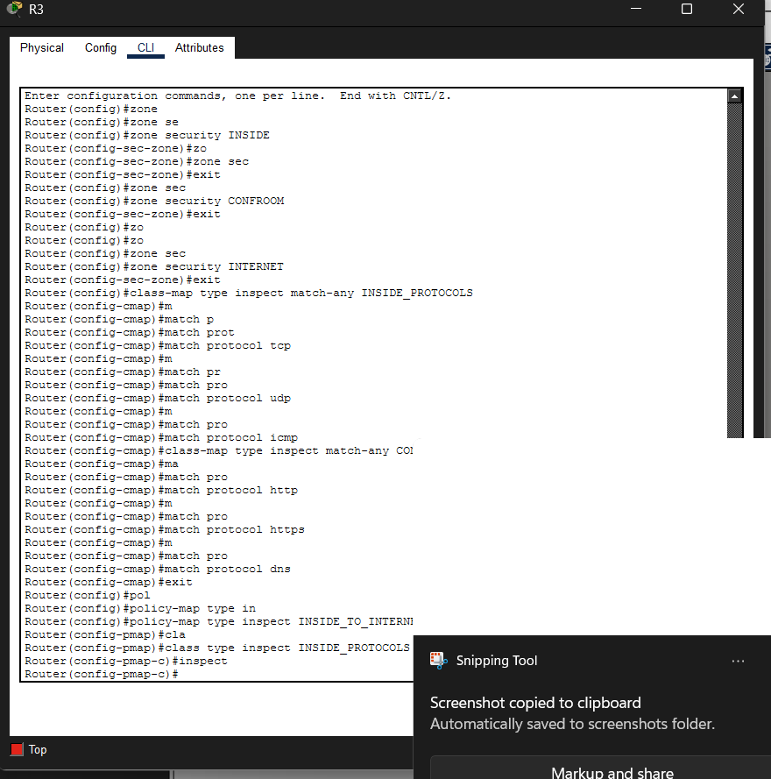
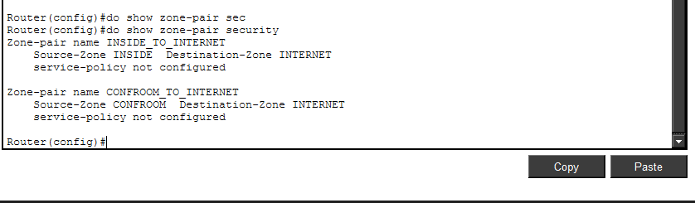
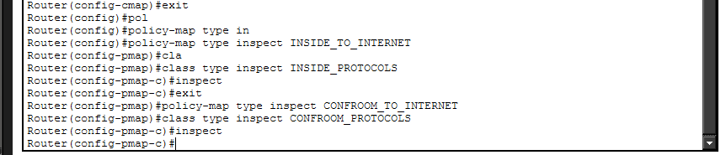
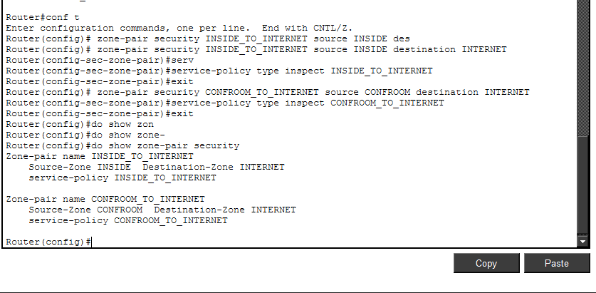
R3# show policy-map type inspect zone-pair
Zone-pair: CONFROOM_TO_INTERNET
Service-policy inspect : CONFROOM_TO_INTERNET

Class-map: CONFROOM_PROTOCOLS (match-any)
Match: protocol http
Match: protocol https
Match: protocol dns
Inspect
Session creations since subsystem startup or last reset 0
Current session counts (estab/half-open/terminating) [0:0:0]
Maxever session counts (estab/half-open/terminating) [0:0:0]
Last session created never
Last statistic reset never
Last session creation rate 0
Last half-open session total 0

Class-map: class-default (match-any)
Match: any
Drop (default action)
0 packets, 0 bytes
Zone-pair: INSIDE_TO_INTERNET
Service-policy inspect : INSIDE_TO_INTERNET

Class-map: INSIDE_PROTOCOLS (match-any)
Match: protocol tcp
Match: protocol udp
Match: protocol icmp
Inspect
Session creations since subsystem startup or last reset 0
Current session counts (estab/half-open/terminating) [0:0:0]
Maxever session counts (estab/half-open/terminating) [0:0:0]
Last session created never
Last statistic reset never
Last session creation rate 0
Last half-open session total 0

Class-map: class-default (match-any)
Match: any
Drop (default action)
0 packets, 0 bytes <output omitted>

Assign Interfaces to the Proper Security Zones
Interfaces (physical and logical) are assigned to security zones with the zone-member security interface command.
      - Assign R3’s G0/0 to the CONFROOM security zone:
R3(config)# interface g0/0/1.33
R3(config-if)# zone-member security CONFROOM
      - Assign R3’s G0/1 to the INSIDE security zone:
R3(config)# interface g0/0/1.3
R3(config-if)# zone-member security INSIDE
      - Assign R3’s S0/0/1 to the INTERNET security zone:
R3(config)# interface g0/0/0
R3(config-if)# zone-member security INTERNET

Verify Zone Assignment
      - Issue the show zone security command to ensure the zones were properly created, and the interfaces were correctly assigned:
R3# show zone security
zone self
Description: System defined zone

zone service
Description: System defined zone

zone INSIDE
Member Interfaces:
GigabitEthernet0/0/1.3

zone CONFROOM
Member Interfaces:
GigabitEthernet0/0/1.33

zone INTERNET
Member Interfaces:
GigabitEthernet0/0/0
      - Even though no commands were issued to create a “self” zone, the output above still displays it.

Question:
Why is R3 displaying a zone named “self”? What is the significance of this zone?
Type your answers here.
Close configuration wndow

Verify ZPF Firewall Functionality

Traffic originating on the Internet
      - To test the firewall’s effectiveness, ping PC-B from PC-A. In PC-A, open a command prompt and issue a ping to 192.168.3.3.
PC-A:\> ping 192.168.3.3

Question:
Was the ping successful? Explain.
No. The ICMP packets sent by PC-A enter R3 through its Serial0/0/1 interface. Because R3’s G0/0/0 was assigned to the INTERNET zone, R3 correctly sees these ICMP packets as Internet originating packets. PC-B has an IP address of 192.168.3.3 which belongs to the IP range assigned to R3’s G0/0/1.3 interface. Because R3’s G0/0/1.3 was assigned to the INSIDE zone, R3 correctly assumes PC-B is a member of the INSIDE zone. Based on the security policy in place in R3, Internet originating packets should not be allowed to reach the internal network, and the ICMP packets generated by PC-A’s ping are dropped.
Type your answers here.
      - Ping PC-C from PC-A. In PC-A, open a command window and ping 192.168.33.3.
PC-A:\> ping 192.168.33.3

Question:
Was the ping successful? Explain.
No. The ICMP packets sent by PC-A enter R3 through its Serial0/0/1 interface. Because R3’s G0/0/0 was assigned to the INTERNET zone, R3 correctly sees these ICMP packets as Internet originating packets. PC-C has an IP address of 192.168.33.3 which belongs to the IP range assigned to R3’s G0/0/1.33 interface. Because R3’s G0/001.33 was assigned to the CONFROOM zone, R3 correctly assumes PC-C is a member of the CONFROOM zone. Based on the security policy in place in R3, Internet originating packets should not be allowed to reach the conference room network, and the ICMP packets generated by PC-A’s ping are dropped.
      - Ping PC-A from PC-B. In PC-B, open a command window and issue a ping to 192.168.1.3.
PC-B:\> ping 192.168.1.3

Question:
Was the ping successful? Explain.
Yes. The ICMP packets sent by PC-B enter R3 through its G0/1 interface. Because R3’s G0/0/1.3 was assigned to the INSIDE zone, R3 correctly sees these ICMP packets as INSIDE originating packets. PC-A has an IP address of 192.168.1.3 which does not belong to any of R3’s networks; R3 must use its default route through R2 to reach this destination. Because the packets will exit R3 via R3’s G0/0/0 towards R2, R3 correctly concludes the ICMP packets are originating in the INSIDE zone towards the INTERNET zone. Based on the security policy in place in R3, INSIDE originating TCP, UDP and ICMP packets moving towards the INTERNET zone should be allowed; therefore, the ICMP packets related to the ping can reach PC-A. Notice that because the relevant policy-maps and class-maps are configured to inspect the traffic, R3 automatically creates rules to allow the responses from PC-A to reach PC-B. The result is a successful ping between PC-B and PC-A.Type your answers here.
      - Ping PC-A from PC-C. In PC-C, open a command window and ping 192.168.1.3
PC-C:\> ping 192.168.1.3

Question:
Was the ping successful? Explain.
No. The ICMP packets sent by PC-C enter R3 through its G0/0 interface. Because R3’s G0/0/1.33 was assigned to the CONFROOM zone, R3 correctly sees these ICMP packets as ConfRoom originating packets. PC-A has an IP address of 192.168.1.3 which does not belong to any of R3’s networks; R3 must use its default route through R2 to reach this destination. Because the packets will exit R3 via R3’s G0/0/0 towards R2, R3 correctly concludes the ICMP packets are originating in the CONFROOM zone towards the INTERNET zone. Based on the security policy in place in R3, ConfRoom originating packets moving towards the INTERNET zone should only be allowed if they are HTTP or HTTPS or DNS packets. Because the ping generates ICMP packets, they are dropped and not able to reach PC-A.Type your answers here.

The Self Zone Verification
      - From PC-A ping R3’s G0/0/1.3 interface:
PC-A:\> ping 192.168.3.1

Question:
Was the ping successful? Is this the correct behavior? Explain.
Yes, the ping is successful and yes, the behavior is correct. The security policy in place in R3 blocks Internet originating traffic going to the INSIDE or CONFROOM zones. While R3 sees the ICMP packets generated by PC-A as Internet originating traffic, the ICMP packets are targeting R3’s own IP assigned to G0/0/1.3. All of R3’s own IP addresses (10.2.2.1, 192.168.33.1 and 192.168.3.1) are considered part of the Self zone. Because no policies were explicitly configured for the Self Zone, R3 follows the default behavior and allows the packets.e your answers here.
      - From PC-C ping R3’s G0/0/1.3 interface:
PC-C:\> ping 192.168.3.1

Question:
Was the ping successful? Is this the correct behavior? Explain.
Yes, the ping is successful and yes, the behavior is correct. The security policy in place in R3 blocks ConfRoom originating traffic going to the INSIDE zone. While R3 sees the ICMP packets generated by PC-C as ConfRoom originating traffic, the ICMP packets are targeting R3’s own IP assigned to G0/0/1.3. All of R3’s own IP addresses (10.2.2.1, 192.168.33.1 and 192.168.3.1) are considered part of the Self zone. Because no policies were explicitly configured for the Self Zone, R3 follows the default behavior and allows the packets.Type your answers here.

Challenge (optional)
Create the proper zone-pair, class-maps, and policy-maps and configure R3 to prevent Internet originating traffic from reaching the Self Zone.

Appendix – Multiple Interfaces under the Same Zone (optional)
One benefit of ZPF firewalls is that they scale well compared to the classic firewall. If a new interface with the same security requirements is added to the firewall, the administrator can simply add the new interface as a member of an existing security zone. However, some IOS versions will not allow devices connected to different interfaces of the same zone to communicate by default. In those cases, a zone-pair must be created using the same zone as source and destination.
Traffic between similarly zoned interfaces will always be bidirectional due to the fact that the zone-pair’s source and destination zones are the same. Because of that, there is no need to inspect traffic to allow for automatic return traffic handling; return traffic will always be allowed because it will always conform to the zone-pair definition. In this case, the policy-map should have a pass action instead of inspect. Because of the pass action, the router will not inspect packets matched by the policy-map, it will simply forward it to its destination.
In the context of this lab, if R3 had a G0/0/1.2 interface also assigned to the INSIDE zone, and the router IOS version did not support allowing traffic between interfaces configured to the same zone, the extra configuration would look like this:
New zone-pair: Inside to Inside; allows routing of traffic among the internal trusted interfaces.
Creating the policy-map (notice that no explicit class-map is needed because we use the default “catch-all” class):
R3(config)# policy-map type inspect inside
R3(config-pmap)# class class-default
R3(config-pmap-c)# pass
Creating the zone-pair and assigning the new policy-map to it. Notice that the INSIDE zone is both the source and the destination of the zone-pair:
R3(config)# zone-pair security INSIDE source INSIDE destination INSIDE
R3(config-sec-zone-pair)# service-policy type inspect inside
To verify the existence of the new pair, use show zone-pair security:
R3# show zone-pair security
Zone-pair name INSIDE_TO_INTERNET
Source-Zone INSIDE Destination-Zone INTERNET
service-policy INSIDE_TO_INTERNET
Zone-pair name CONFROOM_TO_INTERNET
Source-Zone CONFROOM Destination-Zone INTERNET
service-policy CONFROOM_TO_INTERNET
Zone-pair name INSIDE
Source-Zone INSIDE Destination-Zone INSIDE
service-policy inside

Router Interface Summary Table
Router Model | Ethernet Interface #1 | Ethernet Interface #2 | Serial Interface #1 | Serial Interface #2
1900 | Gigabit Ethernet 0/0 (G0/0) | Gigabit Ethernet 0/1 (G0/1) | Serial 0/0/0 (S0/0/0) | Serial 0/0/1 (S0/0/1)
2900 | Gigabit Ethernet 0/0 (G0/0) | Gigabit Ethernet 0/1 (G0/1) | Serial 0/0/0 (S0/0/0) | Serial 0/0/1 (S0/0/1)
4221 | Gigabit Ethernet 0/0/0 (G0/0/0) | Gigabit Ethernet 0/0/1 (G0/0/1) | Serial 0/1/0 (S0/1/0) | Serial 0/1/1 (S0/1/1)
4300 | Gigabit Ethernet 0/0/0 (G0/0/0) | Gigabit Ethernet 0/0/1 (G0/0/1) | Serial 0/1/0 (S0/1/0) | Serial 0/1/1 (S0/1/1)
Blank Line, No additional information
Note: To find out how the router is configured, look at the interfaces to identify the type of router and how many interfaces the router has. There is no way to effectively list all the combinations of configurations for each router class. This table includes identifiers for the possible combinations of Ethernet and Serial interfaces in the device. The table does not include any other type of interface, even though a specific router may contain one. An example of this might be an ISDN BRI interface. The string in parenthesis is the legal abbreviation that can be used in Cisco IOS commands to represent the interface.
end of document

