FINAL PROJECT DOCUMENTATION

Evaluation Rubric
Criteria for checking the final project documentation, scored over 100 points.

Point Distribution
# | Criterion | What Is Checked | Points
1 | Cover Page and Table of Contents | Complete cover details; automatic and accurate table of contents | 5
2 | Project Summary | Primary purpose, problem, target users, objectives, and scope | 5
3 | Use Case Descriptions | Two or more complete descriptions with clear, logical flows | 10
4 | Use Case Diagrams | Correct UML notation; each diagram follows its description | 10
5 | Entity-Relationship Diagram | Entities, attributes, keys, relationships, and cardinality | 10
6 | Relational Schema | Relations, keys, data types, and constraints that match the ERD | 10
7 | Normalization Proof (UNF to 3NF) | Each normal form shown with dependencies and justification | 15
8 | System Architecture and Technology Stack | Architecture diagram with labeled parts; complete stack with roles | 10
9 | GitHub Repository | Accessible repository with complete files and shared contributions | 10
10 | Deployed API | Live PHP or FastAPI endpoints that support the use cases | 10
11 | Overall Consistency and Presentation | No guide text left; all sections agree with each other | 5
 | Total |  | 100

Performance Levels
Excellent  Fully meets every requirement with no significant errors. | Proficient  Meets the requirements with minor gaps or errors. | Developing  Partly meets the requirements; several gaps or errors. | Beginning  Attempted, but largely incomplete or incorrect. | Missing  Section is absent or the link does not work. Score 0.
DETAILED RUBRIC

Criteria and Descriptors
Choose the level that best describes the work, then give a score within its range.
Criterion | Excellent | Proficient | Developing | Beginning
1  Cover Page and Table of Contents  5 points  0 if missing | 5 pts  Cover shows the system name, group number (SWU-XXX), all members in Last Name, First Name M.I. format, and the month and year. The table of contents is generated automatically and its headings and page numbers match the document. | 4 pts  All cover details are present, with one formatting error (such as name or date format), or the table of contents is slightly outdated. | 2–3 pts  One required cover detail is missing, or the table of contents is typed manually or its page numbers do not match. | 1 pt  Several cover details are missing, or there is no usable table of contents.
2  Project Summary  5 points  0 if missing | 5 pts  Clearly states the primary purpose of the system, the specific problem it solves, and who it is for. Objectives are specific and match what the system does. Scope and limitations are defined. Concise and specific to the group’s system. | 4 pts  Purpose, problem, and target users are stated, but the objectives or scope are vague or incomplete. | 2–3 pts  One core element (purpose, problem, or target users) is missing or too general to describe the system. | 1 pt  Minimal, generic, or largely copied from the sample.
3  Use Case Descriptions  10 points  0 if missing | 9–10 pts  Two or more use cases cover the core functions of the system. Every description is complete: ID, name, actors, description, trigger, preconditions, postconditions, basic, alternative, and exception flows, and include or extend relationships. Steps are numbered and alternate clearly between actor and system. | 7–8 pts  Two or more use cases with mostly complete descriptions. Minor gaps, such as a missing exception flow or a vague postcondition. | 4–6 pts  Only one use case, or several fields are missing. Flows are unclear, out of order, or do not reflect the system. | 1–3 pts  Descriptions are minimal or largely copied from the sample.
4  Use Case Diagrams  10 points  0 if missing | 9–10 pts  Each description is followed by its diagram. Correct UML notation throughout: actors, system boundary, associations, and correct «include» and «extend» arrow direction. Each diagram matches its description exactly. | 7–8 pts  Correct order, with one or two notation errors (such as a reversed «include» or «extend» arrow) or a small mismatch with the description. | 4–6 pts  Diagrams are out of order, the system boundary is missing, or there are several notation errors. | 1–3 pts  Diagrams are missing for most use cases or do not represent the described use cases.
5  Entity-Relationship Diagram  10 points  0 if missing | 9–10 pts  All entities and attributes the system needs are shown, with primary and foreign keys marked. Every relationship is labeled and has the correct cardinality, using one notation consistently. Many-to-many relationships are resolved. The diagram is clear and readable. | 7–8 pts  Mostly complete, with one or two missing attributes or cardinality errors. | 4–6 pts  Several entities or attributes are missing, keys are unclear, there are multiple cardinality errors, or many-to-many relationships are unresolved. | 1–3 pts  Incomplete, unreadable, or does not reflect the system.
6  Relational Schema  10 points  0 if missing | 9–10 pts  Every entity is mapped to a relation. Primary keys are underlined and foreign keys are marked. Data types and constraints are given for all attributes. The schema matches the ERD and the 3NF result exactly. | 7–8 pts  Complete, with minor gaps such as a missing data type or an unmarked foreign key. | 4–6 pts  Some relations are missing, or there are several inconsistencies with the ERD. | 1–3 pts  Largely incomplete or unrelated to the ERD.
7  Normalization Proof (UNF to 3NF)  15 points  0 if missing | 14–15 pts  Starts from a realistic UNF that identifies repeating groups and non-atomic attributes. Each step (1NF, 2NF, 3NF) shows the resulting relations with keys and functional dependencies. The justification explains which partial and transitive dependencies were removed and why. Final relations match the schema. | 11–13 pts  All normal forms are shown with correct results, but the justification is brief or the functional dependencies are incompletely listed. | 7–10 pts  A normal form is skipped or incorrect (such as a partial dependency left in 2NF), or the justification is generic or missing for some steps. | 1–6 pts  Only the final tables are shown with no proof, or there are major conceptual errors.
8  System Architecture and Technology Stack  10 points  0 if missing | 9–10 pts  Includes a clear architecture diagram showing the client, API, database, and hosting, with every connection labeled. The description explains how a request moves through the system. The technology stack lists each technology with its version and role, and it matches the repository and deployment. | 7–8 pts  Diagram and stack are present, but a component is missing, connections are unlabeled, or the description is brief. | 4–6 pts  Diagram is unclear or generic rather than specific to the system, or the stack is incomplete or does not match the repository. | 1–3 pts  No diagram, or only a list of technologies with no explanation.
9  GitHub Repository  10 points  0 if missing | 9–10 pts  Link opens without errors (public, or the instructor is a collaborator). Contains complete source code, a database script, and a README with setup instructions. Commit history shows contributions from all members. No passwords or keys are exposed. | 7–8 pts  Accessible and complete, but the README is thin or contributions are uneven. | 4–6 pts  Accessible but missing key items (such as the database script or README), or the code was uploaded in one or two bulk commits. | 1–3 pts  Link is broken or private, or the repository is nearly empty.
10  Deployed API  10 points  0 if missing | 9–10 pts  Live, reachable URL built with PHP or FastAPI. Documented endpoints work and return proper JSON and status codes, and they support the documented use cases. Documentation is available (FastAPI /docs or a Postman collection). | 7–8 pts  Live, and most endpoints work, with minor errors or incomplete endpoint documentation. | 4–6 pts  Live, but several endpoints fail or the endpoints do not match the use cases. | 1–3 pts  Link is down, or only a localhost address is provided.
11  Overall Consistency and Presentation  5 points  0 if missing | 5 pts  No red guide text or sample content remains. Formatting is consistent throughout. Users, entities, attributes, endpoints, and technologies are named the same way in every section. Writing is clear with few errors. | 4 pts  One or two leftovers from the template, or minor formatting or grammar issues. | 2–3 pts  Noticeable leftover guide text, or inconsistent naming between sections. | 1 pt  The template is largely unedited, or there are many errors.

Checking Notes
- Open the GitHub and API links in a private browser window to confirm that they work without signing in.
- Test at least one GET and one POST endpoint. For FastAPI, this can be done directly on the /docs page.
- Place the ERD, the Relational Schema, and the final 3NF relations side by side. Entity and attribute names should match in all three.
- Check the repository’s commit history to confirm that every member contributed.
- Compare the technology stack with the repository (for example, requirements.txt or composer.json) and the deployed API to confirm that the listed tools were actually used.
- Confirm that the target users in the Project Summary appear as actors in the use cases.
- Search the document for leftover red text or the sample system name “BookNest” to find unchanged template content.
SCORE SHEET
Final Project Score Sheet
Group Number  SWU-001 |  | System Name  LabConnect |  | Date Checked  October 16, 2026

Group Members
Anana, Marshall Dave; Salibio, Joenz Ruiz G.; Verallo, Daniel

# | Criterion | Max | Score | Remarks
1 | Cover Page and Table of Contents | 5 | 4 | - TOC lists only the sections; pages have no page numbers.
2 | Project Summary | 5 | 4 | - Billing objective is not built (billing pages are static).  - Registration and doctor tasks have no use case.
3 | Use Case Descriptions | 10 | 7 | - Include notation malformed; weak alternative and exception flows.  - No release field for results; no rejection reason field.  - Booking conflict check is described but not in the code.
4 | Use Case Diagrams | 10 | 4 | - No stick actors, no system boundary, arrowheads on lines.  - Secondary actors missing; captions unnumbered.
5 | Entity-Relationship Diagram | 10 | 7 | - Uses 1/0..* labels, not crow's foot; labels cut off by lines.  - Two relationships shown only in a footnote.
6 | Relational Schema | 10 | 7 | - PKs not marked in notation; status values not written as CHECKs.  - Schema differs from the tables the code uses; no SQL script.
7 | Normalization Proof (UNF to 3NF) | 15 | 11 | - Final relations listed by name only; four tables not derived.  - FDs use attributes not in the UNF; lossless join not shown.
8 | System Architecture and Technology Stack | 10 | 5 | - Local-only diagram with no hosting; one-way arrows.  - Versions left as "should be filled"; Android code not in repo.
9 | GitHub Repository | 10 | 4 | - No SQL script or Android code; README.txt has no members.  - 5 commits from one account; create_admin.php default password.
10 | Deployed API | 10 | 0 | - API not deployed (local XAMPP only); endpoints are placeholders.
11 | Overall Consistency and Presentation | 5 | 2 | - "Verify" and "to be added" notes left in Sections 06 to 08.  - Template styles and section subtitles not used; no page numbers.
 | Total | 100 | 55

Wilchin Dipolog |  | October 16, 2026
Evaluated by (signature over printed name) |  | Date

Appendix: Visual Diagrams

Appendix: Visual Diagrams
Figure: media_1792215256035_c8b19c70
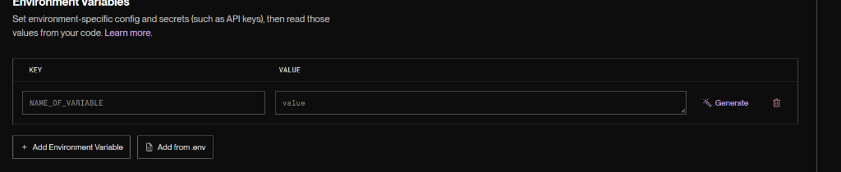

Figure: media_1792052930439_33e2754c
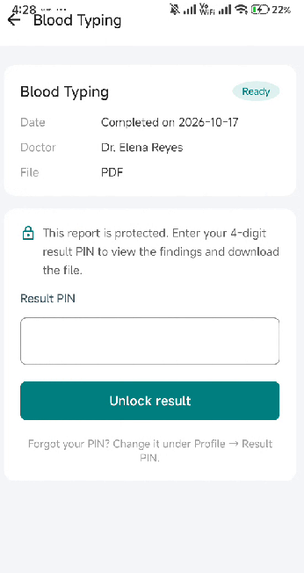

Figure: media_1792052451542_7a35c547
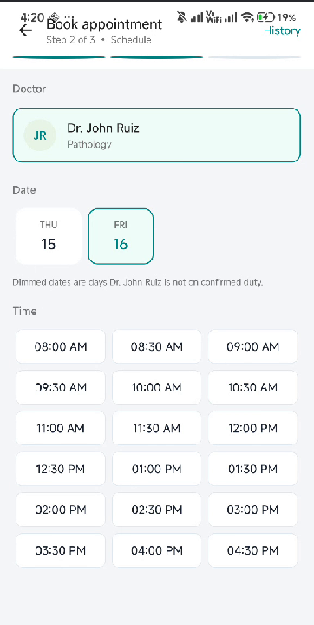

Figure: media_1792051255760_5dcd190b
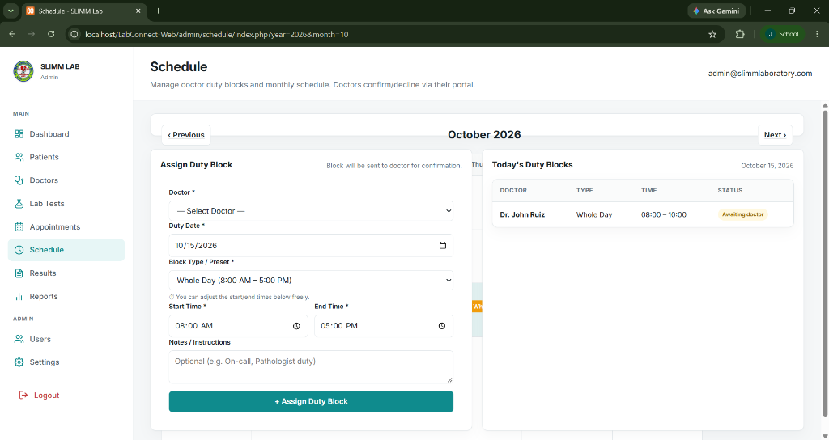

Figure: media_1792049610634_7ee98e95
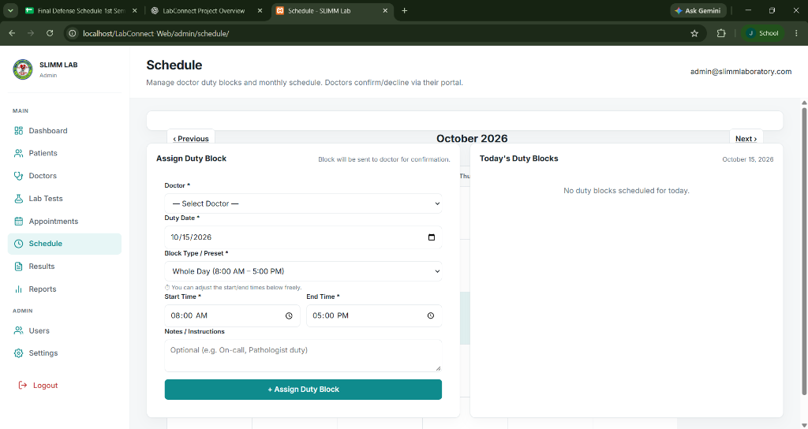

Figure: media_1791919083667
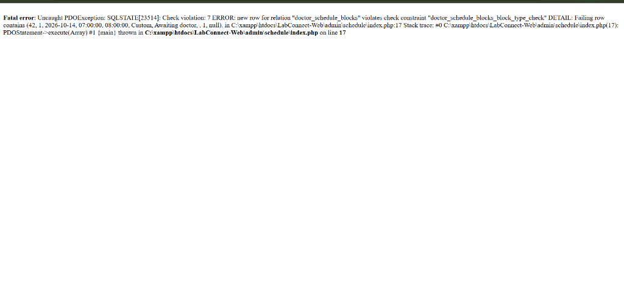

Figure: media_1791917317198


Figure: media_1791915191600
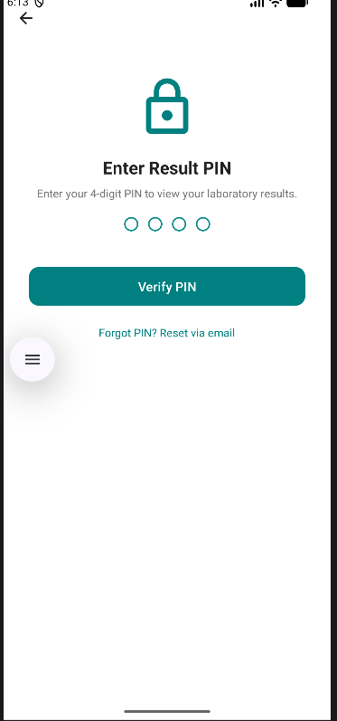

Figure: media_1791914252347
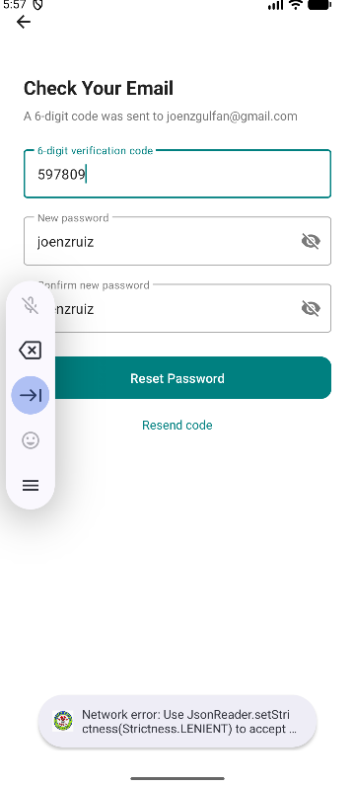

Figure: media_1791913686100
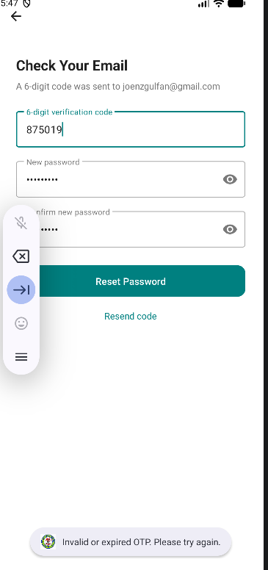

Figure: media_1791908296832
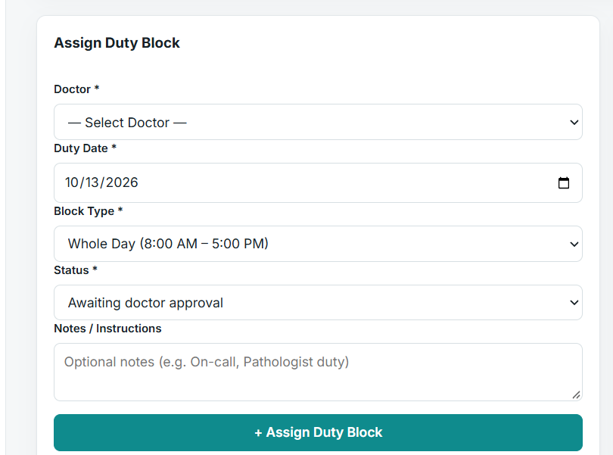

Figure: media_1791906737319
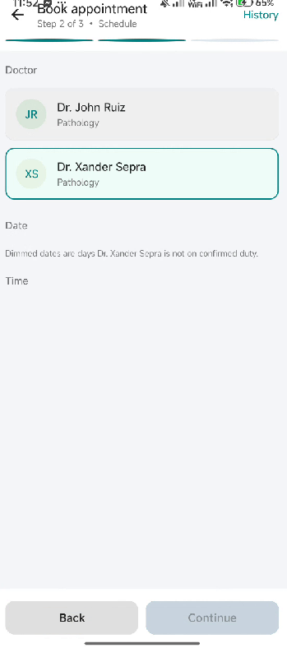

Figure: media_1791904959698
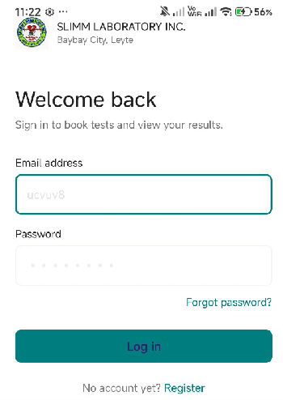

Figure: media_1791904940328
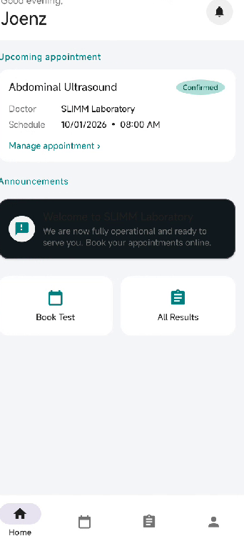

Figure: media_1791904889843


Figure: media_1791154581519
