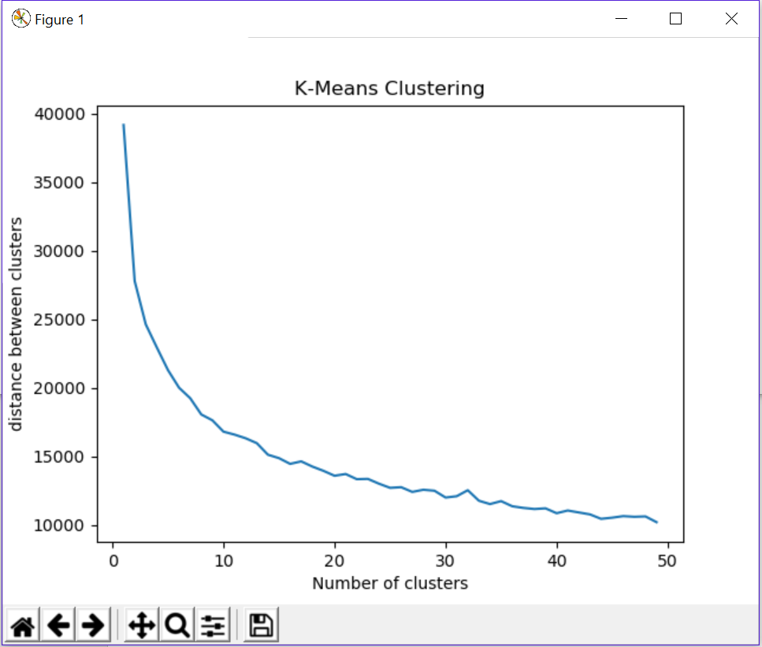

The best K is 3 because there are always 3 different seasons coming out (summer, fall / spring, winter)