

**Business Interoperability Specification**

**OpenPEPPOL AISBL**



**Pre Award Coordinating Community**

**ICT - Models**

Peppol Business Interoperability Specification

Pre-award guide:

Notification & Open Procedure

**Version: 1.0**

**Status: Final Version**

***Statement of copyright***

This PEPPOL Business Interoperability Specification (BIS) document is based on the CEN CWA prepared by the BII workshop specified in the Introduction below.

The original CEN CWA document contains the following copyright notice which still applies:

|  |
| --- |
| © 2012 CEN All rights of exploitation in any form and by any means reserved worldwide for CEN national Members. |

The CEN CWA documents and profiles prepared by the BII workshop are not specific to a business area. Subject to agreement with CEN, customizations have been made by PEPPOL to establish the PEPPOL BIS, detailing and adding further guidance on the use of BII profiles.

OpenPEPPOL AISBL holds the copyright in the customizations made to the original document. The customizations appear from the corresponding conformance statement which is attached to this document. For the purpose of national implementations, customizations covered by the conformance statement may be further refined and detailed by PEPPOL Authorities and/or other entities authorized by OpenPEPPOL AISBL, provided that interoperability with PEPPOL BIS is ensured.

This PEPPOL BIS document may not be modified, re-distributed, sold or repackaged in any other way without the prior consent of CEN and/or OpenPEPPOL AISBL.

**Table of Contents**

1 Introduction 6

2 Scope 7

2.1 Audience 7

2.2 Peppol specifications in scope of the Notification & Open Procedure Guideline 7

2.3 Goals of the Notification & Open Procedure guideline 8

3 Business Environment 10

3.1 Notification procedures in scope of this guideline 10

3.2 Tendering procedures in scope of this guideline 11

4 Business Requirements 13

4.1 High level business requirements 13

4.2 Key examples 14

4.2.1 Key example: Notification 14

4.2.2 Key example: Open Procedure 16

5 Business Process 19

5.1 Actors and Roles 19

5.2 Notification & Open Procedure Use Cases 19

5.3 Notification & Open procedure Business Process 21

5.3.1 Process Map: Notification & Open procedure 22

5.3.2 Process: Notification 23

5.3.3 Process: Procurement Document Access 24

5.3.4 Process: Tender Submission 26

5.3.5 Process: Awarding 27

5.4 Notification & Open Procedure activity detailed descriptions 28

6 Implementation of Notification & Open Procedure 31

6.1 Peppol BIS - P001 - Procurement procedure subscription 31

6.2 Peppol BIS - P002 - Procurement document access 31

6.3 Peppol BIS - P003 - Tender Submission 31

6.4 Peppol BIS - P004 - Call for Tenders Question and Answers 32

6.5 Peppol BIS - P005 - Tender Clarification 32

6.6 Peppol BIS - P006 - Search Notices 32

6.7 Peppol BIS - P007 - Tender Withdrawal 33

6.8 Peppol BIS - P008 - Publish Notice 33

6.9 Peppol BIS - P009 - Notify Awarding 33

6.10 Peppol Code Lists used in Notification & Open Procedure 33

6.11 Other artifacts used in Notification & Open Procedure 34

External References 35

**List of Tables**

Table 1: Peppol BISs supporting the open procedure 8

Table 2: Goals of the Notification & Open Procedure Guideline 8

Table 3: High level business requirements 13

Table 4: Business partners 19

Table 5: Roles & Actors 19

Table 6:Conditions of the open Procedure 21

Table 7: activity detailed descriptions 28

**List of Figures**

Figure 1: Flow of Transactions Open procedure Key Example 16

Figure 2: Open procedure use cases 20

Figure 3: Open procedure process map 22

Figure 4: Notification Process 23

Figure 5: Procurement Document Access process 24

Figure 6: Tender Status Inquiry Process 25

Figure 7: Tender Submission process 26

Figure 8: Awarding Process 27

**Revision history**

|  |  |  |  |  |
| --- | --- | --- | --- | --- |
| **Version** | **Date** | **Author** | **Organisation** | **Description** |
| 0.1 | 14-12-2021 | Ansgar Mondorf | University of Koblenz | Introduction |
| 0.2 | 16-12-2021 | Andreas Schmitz | University of Koblenz | BPMN Models |
| 0.3 | 17-12-2021 | Ansgar Mondorf | University of Koblenz | Scope |
| 0.4 | 04-01-2022 | Ansgar Mondorf | University of Koblenz | Overview Peppol Specs |
| 0.5 | 05-01-2022 | Ansgar Mondorf | University of Koblenz | Business Environment, Requirements |
| 0.6 | 07-01-2022 | Ansgar Mondorf | University of Koblenz | Goals, Example, Process Detailed Description |
| 0.7 | 10-01-2022 | Ansgar Mondorf | University of Koblenz | Use Cases, Tables, References, Figures |
| 0.8 | 11-01-2022 | Ansgar Mondorf | University of Koblenz | Implementation, Diagrams, Final Editing |
| 0.9 | 11-01-2022 | Felicia Tsakonas | Adesso | Links, Process Description |
| 0.95 | 07-02-2022 | Ansgar Mondorf | University of Koblenz | Inclusion of descriptions, examples and use cases clarifying use of eNotificaton |
| 1.0 | 12-02-2022 | Rolf Kewitz | Beschaffungsamt des BMI | Final Review |

**Contributors**

|  |  |  |
| --- | --- | --- |
| Country | Name | Organization (= Beneficiary – Organization in national consortium – Subcontractor) |
| DE | Ansgar Mondorf | University of Koblenz-Landau |
| DE | Andreas Schmitz | University of Koblenz-Landau |
| DE | Felicia Tsakonas | adesso SE |
| DE | Rolf Kewitz | Beschaffungsamt des BMI |

**Abbreviations**

|  |  |
| --- | --- |
| **Abbreviation** | **Description** |
| BII | Business Interoperability Interface |
| BIS | Business Interoperability Specification |
| br | Business rule |
| CWA | CEN Workshop Agreement |
| CEN WS/BII3 | CEN Workshop on Business Interoperability Interfaces for Public Procurement in Europe |
| CAN | Contract Award Notice |
| CN | Contract Notice |
| CA | Contracting Authority |
| EO | Economic operator |
| CEN | European Committee for Standardisation |
| ESPD | European Single Procurement Document |
| Peppol | Pan-European Public Procurement Online |
| PIN | Prior Information Notice |
| P | Profile |
| PB | Publication Body |
| SME | Small and Medium Sized Enterprise |
| eForms | Standard forms for the publication of notices |
| TED | Tenders Electronic Daily |
| Trdm | Transaction Data Model |

# Introduction

Peppol has developed a set of Business Interoperability Specifications (BIS) to support interoperability in the pre- and post-award areas. The scope of Peppol is public procurement but the BISs apply as well to private trade since many private customers use tendering as good business practice. In those cases, official notification of calls and contracts and other transactions are often not applicable [[Peppol](https://peppol.eu/)].

The scope of the Peppol pre-award specifications and guidelines include processes that support the main flow of open procedures such publication of notices, search of notices, calls for tenders, tenders and awarding notifications. During these processes additional support processes may be executed between contracting bodies and economic operators, such as procurement procedure subscription, call for tenders’ questions and answers, tender withdrawal or tender clarifications.

This document describes the choreography to execute open procedures using Peppol. Thus, the Notification & Open Procedure Guideline is a procedural specification. The guideline does not define individual transactions but it refers to Peppol several BISs and underlying standards, in which the transactions and the transaction information requirements are listed and defined. Even though the guideline is based on a set of PEPPOL BISs, its contents are derived from the agreement of the CEN Workshop on Business Interoperability Interfaces for Public Procurement in Europe [[CEN_BII3](https://standards.cencenelec.eu/dyn/www/f?p=205:32:0::::FSP_ORG_ID,FSP_LANG_ID:2073699,25&cs=1764296F93587711762A3AB227353671A)] - E-Tendering - Part 106: Profile BII37 Open Procedure (CWA 17027-106:2016) [[BII37 Open Procedure](https://standards.cencenelec.eu/dyn/www/f?p=205:110:0::::FSP_PROJECT:62023&cs=19453F711D73A2988EC334F37EE564AB1)].

Even though this guideline describes the open procedure as a whole, Peppol eTendering service providers may also implement only certain parts or aspects of the open procurement procedure described here. For example, it is possible to implement only the processes up to the provision of the call for tender documents or to exclusively realize processes and transactions that support the publication and search of notices. Thus, the guideline equally supports the understanding of the implementation of notification procedures using the Peppol infrastructure (eNotification).

The guideline is based upon the directives [2014/24/EU](https://eur-lex.europa.eu/legal-content/DE/TXT/?uri=CELEX%3A32014L0024) on public procurement and [2014/25/EU](https://eur-lex.europa.eu/legal-content/DE/TXT/?uri=CELEX%3A32014L0025) on procurement by entities operating in the water, energy, transport and postal services sectors. Supplementary regulations such as Regulation (EU) 2019/1780 establishing standard forms for the publication of notices [[eForms](https://eur-lex.europa.eu/eli/reg_impl/2019/1780/oj)] and Regulation (EU) 2016/7 establishing the standard form for the European Single Procurement Document [[ESPD](https://eur-lex.europa.eu/eli/reg_impl/2016/7/oj)] have been considered for the collection of the underlying legal requirements.

Based on these legal frameworks, the guideline describes how the available Peppol BISs are used in the context of an open procedure. The guideline therefore illustrates the scope (section 2), the business environment (section 3), the business requirements (section 4), the business process choreography (section 5) and the Peppol artifacts (section 6) to implement an open procedure based on Peppol.

# Scope

## Audience

The audience for this document is organizations wishing to be Peppol enabled for exchanging pre-award business documents, and/or their ICT-suppliers. These organizations may be:

* Service providers
* Contracting Authorities
* Economic Operators
* Publication Bodies
* Software Developers

More specifically, it is addressed towards the following roles:

* ICT Architects
* ICT Developers
* Business Experts

For further information on Peppol/OpenPeppol please see [[Peppol AISBL](https://peppol.eu/what-is-peppol/" \o "https://peppol.eu/what-is-peppol/)].

## Peppol specifications in scope of the Notification & Open Procedure Guideline

Peppol pre-award enables trading partners to exchange standards-based electronic eTendering documents over the Peppol network (based on a 4-corner model) [[Peppol eDelivery](https://peppol.eu/what-is-peppol/peppol-transport-infrastructure/)]. These documents are described as profiles, the PEPPOL Business Interoperability Specifications (BIS), and depict business process like the search of notices, the publication of call for tenders, the submission of tenders, etc [[Peppol BIS](https://peppol.eu/what-is-peppol/peppol-profiles-specifications/" \o "https://peppol.eu/what-is-peppol/peppol-profiles-specifications/)].

The Peppol BISs in the pre-award domain have been developed by the OpenPEPPOL AISBL Pre-Award Domain Community (PrAC) and are published as part of the Peppol specifications [[Peppol Pre Award](https://peppol.eu/downloads/pre-award/)]. Particular intention shall be given to the Peppol BIS pre-award metadata profiles which together constitute the processes and transaction that frame the execution of eTendering procedures [[Peppol eTendering](https://docs.peppol.eu/pracc/)].

The Peppol pre-award BISs and transactions referenced in this guideline are intended to be exchanged between the tendering systems of economic operators and contracting bodies. This means that it is expected that the parties have connected their systems to the internet, and that they have middleware in place to enable them to send and receive the Peppol transactions in a secure way, using an agreed syntax.

In order to implement the Peppol profiles and transactions, however, further guidelines must be considered, in particular:

* Use of transport specifications are described in the BIS eDelivery guide for pre-award [[Pre Award eDelivery](https://docs.peppol.eu/pracc/files/BIS-eDelivery-guide-for-pre-award-v1.2.pdf" \o "https://docs.peppol.eu/pracc/files/BIS-eDelivery-guide-for-pre-award-v1.2.pdf)]
* Use of cryptographic specifications are described in the BIS eDocuments guide for pre-award [[Pre Award eDocuments](https://docs.peppol.eu/pracc/files/BIS-eDocuments-guide-for-pre-award-v1.2.pdf)]

The content model of the Peppol transactions can also be used in procurement platforms or portals, so that these platforms as well as procurement systems of economic operators and contracting bodies are based on the same information and process models, which makes them more interoperable. Even if platforms are not technically interoperable, the processes and content models facilitate a common understanding.

The guideline references and arranges various Peppol BISs in the pre-award domain to describe coherent behavior regarding the execution of Open Procurement Procedures using Peppol. Likewise, only sub-processes of the open procedure such as the publication and search of notices can be implemented (eNotification). In addition to this description, there are other possible applications of the Peppol pre-award BISs, such as restricted procedures, but these are not covered in this guideline.

The set of Peppol BISs for supporting the open procedure in the pre-award area are [[Peppol BIS pre-award](https://docs.peppol.eu/pracc/)]:

Table 1: Peppol BISs supporting the open procedure

|  |  |  |  |  |  |
| --- | --- | --- | --- | --- | --- |
| **PEPPOL Profile ID** | **Profile name** | **CEN Profile ID** | **PEPPOL**  **Transaction ID** | **PEPPOL Transaction name** | **CEN Transaction ID** |
| [P001](https://docs.peppol.eu/pracc/profiles/p001/index.html) | Procurement procedure subscription | [BII46](https://standards.cencenelec.eu/dyn/www/f?p=205:110:0::::FSP_PROJECT:62028&cs=16B7CFE594685D73AD82275DFFE3FCC55) | [T001](https://docs.peppol.eu/pracc/transactions/T001/index.html) | Subscribe to Procedure | Trdm81 |
| [T002](https://docs.peppol.eu/pracc/transactions/T002/index.html) | Subscribe to Procedure Confirmation | Trdm82 |
| [P002](https://docs.peppol.eu/pracc/profiles/p002/index.html) | Procurement document access | [BII60](https://standards.cencenelec.eu/dyn/www/f?p=205:110:0::::FSP_PROJECT:62055&cs=1FA2AB7C9A0F601605C549112B7B93DA3)  [BII47](https://standards.cencenelec.eu/dyn/www/f?p=205:110:0::::FSP_PROJECT:62029&cs=16BDCBBEBAE1A6A235013E1B31A0B78D6) | [T003](https://docs.peppol.eu/pracc/transactions/T003/index.html) | Tender Status Inquiry | Trdm97 |
| [T004](https://docs.peppol.eu/pracc/transactions/T004/index.html) | Call for Tenders | Trdm83 |
| [P003](https://docs.peppol.eu/pracc/profiles/p003/index.html) | Tender Submission | [BII54](https://standards.cencenelec.eu/dyn/www/f?p=205:110:0::::FSP_PROJECT:62036&cs=12EBD786F7FC4B3EEB54EB811F8FCD901) | [T005](https://docs.peppol.eu/pracc/transactions/T005/index.html) | Tender | Trdm90 |
| [T006](https://docs.peppol.eu/pracc/transactions/T006/index.html) | Tender Reception Notification | Trdm45 |
| [P004](https://docs.peppol.eu/pracc/profiles/p004/index.html) | Call for Tenders Questions and Answers | [BII48](https://standards.cencenelec.eu/dyn/www/f?p=205:110:0::::FSP_PROJECT:62030&cs=137D249EEF9A0B7DF6DAD668A740CA477) | [T007](https://docs.peppol.eu/pracc/transactions/T007/index.html) | Tender Questions | Trdm84 |
| [T008](https://docs.peppol.eu/pracc/transactions/T008/index.html) | Tender Answers | Trdm85 |
| [P005](https://docs.peppol.eu/pracc/profiles/p005/index.html) | Tender Clarification | [BII50](https://standards.cencenelec.eu/dyn/www/f?p=205:110:0::::FSP_PROJECT:62032&cs=112E5165F9BCEE578DFD26A6C238464E2) | [T009](https://docs.peppol.eu/pracc/transactions/T009/index.html) | Tender Clarification Request | Trdm84 |
| [T010](https://docs.peppol.eu/pracc/transactions/T010/index.html) | Tender Clarification | Trdm85 |
| [P006](https://docs.peppol.eu/pracc/profiles/p006/index.html) | Search Notice | [BII45](https://standards.cencenelec.eu/dyn/www/f?p=205:110:0::::FSP_PROJECT:62010&cs=1628543602EFDE54C11B8136021A5621A) | [T011](https://docs.peppol.eu/pracc/transactions/T011/index.html) | Search Notice Request | Trdm99, |
| [T012](https://docs.peppol.eu/pracc/transactions/T012/index.html) | Search Notice Response | Trdm100, Trdm78, Trdm79, Trdm80 |
| [P007](https://docs.peppol.eu/pracc/profiles/p007/index.html) | Tender Withdrawal | [BII53](https://standards.cencenelec.eu/dyn/www/f?p=205:110:0::::FSP_PROJECT:62035&cs=15E8443FF9806B2D1F6675A41EA29930F) | [T013](https://docs.peppol.eu/pracc/transactions/T013/index.html) | Tender Withdrawal | Trdm89 |
| [T014](https://docs.peppol.eu/pracc/transactions/T014/index.html) | Tender Withdrawal Notification | Trdm45 |
| [P008](https://docs.peppol.eu/pracc/profiles/p008/index.html) | Publish Notice | [BII10](https://standards.cencenelec.eu/dyn/www/f?p=205:110:0::::FSP_PROJECT:62007&cs=16D9EEBE9B7C024A15F0CCDEE76075355), [BII14](https://standards.cencenelec.eu/dyn/www/f?p=205:110:0::::FSP_PROJECT:62008&cs=16824EF2775A9CE68B4E33893BA1F2A05), [BII43](https://standards.cencenelec.eu/dyn/www/f?p=205:110:0::::FSP_PROJECT:62009&cs=1807B03E8AA497A2C66F5BA5A25A5A3AF) | [T015](https://docs.peppol.eu/pracc/transactions/T015/index.html) | Publish Notice (Contract Notice) | Trdm78, Trdm79, Trdm80 |
| [T016](https://docs.peppol.eu/pracc/transactions/T016/index.html) | Notice Publication Response | Trdm065 |
| [P009](https://docs.peppol.eu/pracc/profiles/p009/index.html) | Notify Awarding | [BII58](https://standards.cencenelec.eu/dyn/www/f?p=205:110:0::::FSP_PROJECT:62038&cs=1438046879E98863C8263389E46ED47C4) | [T017](https://docs.peppol.eu/pracc/transactions/T017/index.html) | Awarding Notification | Trdm94 |

## Goals of the Notification & Open Procedure guideline

The main business benefits to be gained by implementing this guideline are:

Table 2: Goals of the Notification & Open Procedure Guideline

| **ID** | **Description** |
| --- | --- |
| G37-001 | Reduce human errors and resources - Automated matching of the Tender with the Call for Tender document should eliminate human keying errors and facilitates redeployment of resources. |
| G37-002 | No previous bi-lateral setup or agreements. Required - Parties (economic operators and contracting bodies) should communicate without a previous bi-lateral setup or agreements. |
| G37-003 | Facilitate Automated Tender Preparation - e-Tendering/e-Submission solutions should allow Economic Operators (semi)automatically to generate a tender based on the information defined in call for tenders documents |
| G37-004 | Transparency - The contracting body wants to obtain the best value-for-money by maximising the transparency of its tender procedures in order for economic operators to easily find this business opportunity. |
| G37-005 | Equal treatment - The contracting body has the obligation to treat all economic operators equally during the whole tender procedure. |
| G37-006 | Competition - The contracting body wants to obtain the best value-for-money by maximising the competition among bidders. |
| G37-007 | Insurance bid - The economic operator wants insurance that his bid is valid and has been received by the contracting body within the time limit set out in the tender documents. |
| G37-008 | Efficiency - The contracting body wants to increase efficiency in the business process, e.g. when evaluating the received bids, in order to save time and costs. |
| G37-009 | Interoperability - The Member state policymakers want interoperability between all tendering solutions in order to facilitate one single European Market because the better interoperability the more bids. |
| G37-010 | Equal access - economic operators want equal access to all public procurement business opportunities. |
| G37-011 | Integrity of the bid - The contracting body and the economic operator want insurance that the integrity of the bid is secured, i.e. insurance of accuracy and consistency when storing and retrieving data. |
| G37-012 | Authentication - The contracting body wants insurance that it is dealing with real economic operators during the tender procedure. |
| G37-013 | Legal valid bid - The contracting body wants insurance that the bid is signed by persons mandated by the economic operators therefore being a legally valid bid. |
| G37-014 | Administrative burdens - The Member state policymakers want to lower the administrative burden in public procurement for economic operators and contracting bodies. |
| G37-015 | Re-use of information - The economic operator re-uses as much information and documents as possible when preparing a bid in order to save time and costs. |
| G37-016 | Standards - The economic operator wants to receive as much as possible standardized tender documents, in order to easily understand the content and to easily respond by creating a tender and to respond with standardized evidence and product information that are requested. |
| G37-017 | Accountability - The contracting body - being accountable for the procedure - doesn't want to make mistakes during the whole tender procedure. |
| G37-018 | Objectivity - economic operators want an objective evaluation of their bid. |
| G37-019 | SME - SME's get better and easier access to business opportunities. |
| G37-020 | Monitoring - The contracting body wants to be in control during the tender procedure and wants to analyse the results of tender procedures in the past. |
| G37-021 | Non-repudiation of submission - the economic operator must not be able to repudiate submitted and verified tender documents. |
| G37-022 | Non-repudiation of receiving - The contracting body must provide evidence of reception for the tender submission |
| G37-023 | Detect infringement of access prohibition - Where access prohibition to the system is infringed, it may be reasonably ensured that the infringement is clearly detectable. |
| G37-024 | Secure access to logs - Where access prohibition to the system is infringed, it may be reasonably ensured that the infringement is clearly detectable. |

# Business Environment

This guideline is intended to support transmission of electronic documents for processing (semi-)automated open procurement procedures. The legal requirements that were taken into account are requirements from European legislation, in particular the EU Directives on public procurement [2014/24/EU](https://eur-lex.europa.eu/legal-content/DE/TXT/?uri=CELEX%3A32014L0024) and [2014/25/EU](https://eur-lex.europa.eu/legal-content/DE/TXT/?uri=CELEX%3A32014L0025). Additionally, supplementary regulations such as Commission Implementing Regulation (EU) 2019/1780 establishing standard forms for the publication of notices [[eForms](https://eur-lex.europa.eu/eli/reg_impl/2019/1780/oj)] and Commission Implementing Regulation (EU) 2016/7 establishing the standard form for the European Single Procurement Document [[ESPD](https://eur-lex.europa.eu/eli/reg_impl/2016/7/oj)] have been considered relevant for the collection of legal requirements.

The descriptions in this section describe the business environment of an open procedure. The illustration thereby points to the relevant Peppol BISs that depict a particular business process. Additionally, the guideline references the underlying CEN BII3 Workshop Agreement. The CEN BII3 workshop is a standardisation initiative within CEN (European Committee for Standardisation). It provides a framework for interoperability in pan-European electronic transactions expressed as a set of technical specifications ("Profiles") [[CEN_BII3](https://standards.cencenelec.eu/dyn/www/f?p=205:32:0::::FSP_ORG_ID,FSP_LANG_ID:2073699,25&cs=1764296F93587711762A3AB227353671A)].

The profiles provided by CEN BII3 and Peppol are designed to facilitate effective public e-procurement based on a modular approach for implementation, with a focus on global interoperability. Thereby, BII profiles can be seen as “agreements” on message contents and business processes and are the baseline for many Peppol BISs which add specific technical implementation perspectives that are further illustrated in section 6. Thus, the CEN profile descriptions rather focus on the core information elements that typically cater to the majority of user requirements applicable across Europe and lower the need for detailed bilateral agreements between the trading partners whereas Peppol provides a framework for their implementation and adaption.

## Notification procedures in scope of this guideline

Official notification through publishing bodies is part of many procurement procedures. Many pre-award opportunities first become visible to the economic operators in the form of notices describing upcoming or current procurement procedures (prior information notices or contract notices). At the end of a procedure, a contract award notice about the result of the procedure is published.

eNotification covers the transfer of electronic procurement notices for publication and dissemination with the ultimate aim of opening business opportunities. eNotification profiles are addressed to all those who exchange procurement notices for publication and further information processing. eNotification is therefore generally addressed to eTendering Plattform Providers, Contracting Bodies, publishers, print shops, information brokers or monitoring or statistical services. eNotification can be carried out at various levels and between different levels (regional, state, European etc). The legal obligation of publishing notices at the correct level is the responsibility of the contracting bodies.

The content model of procurement notices in Europe is based on Regulation (EU) 2019/1780 [eForms] and upon Directive 2014/24/EU and Directive 2014/25/EU and their annexes, particularly the annex describing the standard forms to be used for the publication of procurement notices. eForms are at the core of the digital transformation of public procurement in the EU. Through the use of a common standard and terminology, they can significantly improve the quality and analysis of data. Well-implemented eForms increase the ability of businesses and other organisations to find opportunities. They will also reduce the administrative burden for buyers, increase the ability of governments to make data-driven decisions about public spending, and make public procurement more transparent [eForms].

eNotification covers the electronic transfer of electronic notices for publication and dissemination services. The publication of notices is executed between a contracting body or his representative and a publisher. CEN WS/BII 3 profiles "BII14 Prior Information Notice"(CWA 17026-102), "BII10 Contract Notice"(CWA 17026-101) and "BII43 Contract Award Notice"(CWA 17026-103) describe the exchange of notices between a contracting body or his representative and a publisher. In Peppol, these profiles are covered by the Peppol BIS P008 - "Publish Notice" which provides electronic messaging support to publish a prior information notice, a contract notice or a contract award notice. Thus, Peppol BIS P008 helps contracting bodies to announce business opportunities and contract awards in public procurement procedures.

In the EU, eForms are used to publish notices above threshold on Tenders Electronic Daily (TED)—an online portal for public procurement notices from across the EU. On the national level public procurement decision makers can benefit from eForms through tailoring and defining a national approach to the various aspects of eForms, e.g. using them for contracts below thresholds, considering different policies and requirements.

The Peppol BIS P006 - "Search Notice" supports a process by which a notification platform can be queried along a set of parameters to find relevant notices and related metadata required by other PEPPOL BISs. The profile is based on CEN WS/BII 3 Profile BII45 — Search Notice (CWA 17026-104:2016). The transactions, specified in BIS P006 - "Search Notice" are intended to be exchanged between eTendering systems and Publication Bodies but they can be adopted by many other actors. Since the BIS P006 - "Search Notice" provides access to Open Data, it also provides possibilities for the establishment of new business models that allow monitoring, the provision of statistical information or easy access for economic operators to business opportunities in different countries across different eTendering and eNotification platforms.

In order to execute the Peppol BIS P008 - "Publish Notice" and Peppol BIS P006 - "Search Notice", it is necessary that the parties have Peppol eDelivery in place to enable them to send and receive the transactions in a secure way. Implementers must also support eForms content model because the transactions are based on the EU-wide eForms standard.

## Tendering procedures in scope of this guideline

For the purpose of initiating electronic tendering via Peppol, the Profile P006 - "Search Notice" plays a significant role. When the contracting body has published a notice, the interested economic operators who finds it may want to subscribe to this procedure by using PEPPOL P001 - Procurement procedure subscription. Thereby, the Profile P006 - "Search Notice" delivers necessary organisational and technical information to identify the procedure and contracting authority. This information is required because the request for procurement procedure subscription must be directed to the entity responsible for the procurement procedure.

eTendering can be put in place using different procedures, depending on the value and the type of the contract to be awarded, on the legal nature of the contracting body and on specific member state national legislation (Directive 2014/24/EU art. 26). Article 26 to 32 from Directive 2014/24/EU and article 43 to 50 from Directive 2014/25/EU describe the different tendering procedures that can be used by contracting bodies. For the purpose of electronic tendering, some of these procedures have been described in CEN WS/BII 3 "BII37 Open Procedure"(CWA 17027-106) and CEN WS/BII 3 "BII39 Restricted Procedure"(CWA 17027-108). This guideline depicts the open procurement procedure.

In open procedures, any economic operator can access the tender documents (including the call for tenders) and submit a tender before the time expires, without any previous assessment of their capabilities. In restricted and negotiated procedures and in a competitive dialogue the interested economic operators must submit a request to participate in order to be invited in the tendering process by the contracting body. When the contracting body has published a notice, the interested economic operators may subscribe to obtain tendering information using profile CEN WS/BII 3 "BII46 Subscribe to Procedure"(CWA 17027-111) covered by Peppol BIS P001 - Procurement procedure subscription. Restricted and negotiated procedures require sending the invitation to tender (profile CEN WS/BII 3 "BII52 Invitation to Tender" (CWA 17027-117) to the identified candidates.

Once the interested economic operator has subscribed to an open procedure, the contracting authority provides the procurement documents by using Peppol BIS P002 - Procurement document access. The BIS P002 is based on CEN WS/BII 3 "BII60 Tender Status Inquiry” (CWA 17027-123) and CEN WS/BII 3 "BII47 Call for Tenders” (CWA 17027-112) and provides the call for tender documents. It can be repeated at any time until the tender submission deadline to receive the latest version of the procurement documents. Additionally, contracting authorities must push updates to the economic operators that subscribed to a procedure.

Within the call for tenders, contracting authorities must inform economic operators how to qualify for the procedure. This may be done by an European Single Procurement Document (ESPD) defined by the Commission Implementing Regulation (EU) 2016/7 [[ESPD](https://eur-lex.europa.eu/eli/reg_impl/2016/7/oj)] for which Peppol develops the BIS ESPD 3.0 based on the ESPD Exchange Data Model version 3.0 [[ESPD EDM](https://github.com/OP-TED/ESPD-EDM)]. Additionally, call for tenders may include pre-award catalogue information to describe products and services in a common format allowing economic operators to send offers in a structured way and contracting authorities to evaluate products and services automatically through their tendering tools. The Peppol BIS pre-award catalogue can be used for this purpose and was defined according to the CEN WS/BII 3 Profile “BII35 Advanced Tendering” [[BIS Pre-Award catalogue](https://docs.peppol.eu/pracc/catalogue/1.0/bis/)] .

Once the economic operator has received the call for tenders, it can use the Peppol BIS P004 - "Call for Tenders Questions and Answers" for the business process of answering questions about a call for tenders. The BIS P004 is based upon CEN WS/BII3 profile “BII48 Call for Tenders Questions and Answers” (CWA 17027-113) and supports economic operators asking questions about call for tenders. Answers of the contracting authority then have to be sent to all economic operators that subscribed to the procedure and additionally the call for tenders should be updated and pushed to the subscribers of the procedure.

In case the economic operator decides to submit a tender, he can use the Peppol BIS P003 - "Tender Submission". After the submission of a tender, the contracting body notifies the economic operator of having received the tender. The BIS P003 is based upon CEN WS/BII3 profile “BII54 Tendering” (CWA 17027-119). On the contrary, economic operators can decide to withdraw a tender that was previously submitted by using the Peppol BIS P007 "Tender Withdrawal". The BIS P007 was derived from CEN WS/BII3 profile “BII53 Tender Withdrawal” (CWA 17027-118) and provides electronic messaging support for the economic operator to withdraw a tender. The contracting body notifies the economic operator of having received the tender withdrawal. After the tender withdrawal, an economic operator may submit a new offer at any time before the tender submission deadline.

On the opening date, the contracting authority gathers and opens all received tenders. The opening board members can now evaluate the received tenders. If questions about specific offers arise during the course of the evaluation, they can be answered through the Peppol BIS P005 - "Tender Clarification". The BIS P005 supports the contracting authority to clarify questions on a tender which has been submitted. The BIS P005 was defined according to the requirements gathered by the CEN WS/BII3 profile “BII50 Tender Clarification” (CWA 17027-115).

At the end of the evaluation process, the contracting authority needs to inform the participating economic operators upon the results of the tender evaluation. For this purpose, contracting authorities can use the Peppol BIS P009 - "Notify Awarding" which provides electronic messaging support to inform the bidders that a contract has been awarded to a particular economic operator. The BIS P009 is based upon the CEN WS/BII3 profile “BII58 Notify Awarding” (CWA 17027-121). The contracting authority can use BIS P009 to inform the winner(s) at the same time as they inform the unsuccessful tenderers and they must individually declare the reasons why they failed. The notification of the awarding decision imitated by BIS P009 shall also start the standstill period clock. After the stand still period, the contracting authority can finalize the contract with the winning supplier and also send a contract award notice using BIS Peppol BIS P008 - "Publish Notice".

# Business Requirements

## High level business requirements

Table 3: High level business requirements

| **Req. ID** | **Requirement statement** | **Ref. to goal** |
| --- | --- | --- |
| BR-001 | All transactions in the procurement procedure, such as subscribe to procedure or status inquiry, and documents, such as call for tenders or catalogues, shall be based on common standards. | G37-002 |
| BR-002 | Being interoperable means business partners shall implement the same profiles and transactions. Ideally, business partners should implement the entire set of transactions required for an open procedure. However, contracting bodies and economic operators may wish to state conformance to some individual transactions (or small groups of transactions), instead of to the entire notification and open procedure process. | G37-003 |
| BR-002 | The value of digitization lies in the implementation of all transactions in a procedure. A contracting body shall therefore be able to enforce a business process (tendering procedure), consisting of multiple transactions, on economic operators. Both contracting bodies and economic operators shall be able to state compliance of their system to the entire process by expressing conformance with each profile described in this guideline. | G37-002 |
| BR-003 | Code lists shall be consistent for all transactions in a complete procedure. | G37-016 |
| BR-004 | For contracting bodies and economic operators to be able to process individual transactions, they (or their systems) need to know to what business process the transaction belongs to. The process type and the process instance shall be identified at two levels: the level of the procedure and the level of the profile. | G37-020 |
| BR-005 | All economic operators shall be able to query publication portals (where the contract notices are being published) to find interesting business opportunities. | G37-004 |
| BR-006 | All economic operators shall be able to access public tender documents. | G37-010 |
| BR-007 | The economic operator shall be able to subscribe to an interesting business opportunity in order to receive the latest information about the call for tender. | G37-004 |
| BR-018 | All subscribed economic operators shall be informed when new versions of the tender documents are published. | G37-004 |
| BR-009 | All economic operators shall be able to send questions regarding the tender documents to the contracting body. | G37-010 |
| BR-010 | The contracting body shall answer the questions from economic operators equal and transparent. | G37-010 |
| BR-011 | The contracting body shall be able to send messages to all subscribed economic operators, to a selection of economic operators or to one economic operator. | G37-010 |
| BR-012 | The economic operator shall be able to withdraw his bid as long as the time limit to submit bids has not been passed. | G37-007 |
| BR-013 | The contracting body shall be able to send the results of the bid evaluation to all economic operators who submitted a bid. | G37-005 |
| BR-014 | The contracting body shall be able to award the winning economic operator. | G37-006 |

## Key examples

This section illustrates key examples for the execution of an open procedure using Peppol. Thereby, the first examples focus on the particularities of the notification process, being a particular part of the open procedure. The second example then concentrates on the actual business process of the open procedure and thereby generalizes the part of the publication.

### Key example: Notification

This section illustrates a key example for the execution of a notification procedure using Peppol. The initial diagram is accompanied by a textual description. Both, illustrate the flow of transactions that are send between the actors and components. The actors and components involved in this scenario are:

* The contracting body ***PublicHealthBerlin***from Germany
* The eTendering platform ***PublicPurchase***used by *PublicHealthBerlin*
* A **national notification system** used by *PublicHealthBerlin*
* The European notification platfrom **Tenders Electronic Daily (TED)** operated by the *publication office*
* The economic operator ***LisbonMedical***from Portugal
* The eTendering platform ***PowerSeller***used by *LisbonMedical*



***Prior Information Notice (PIN)***

The contracting body *PublicHealthBerlin* from Germany starts a tendering procedure because it wants to buy *Covid‑19 Test Kits* from any European supplier. At first, it starts to prepare a prior information notice (PIN) in its eTendering platform *PublicPurchase*. The PIN is defined along the eForms format and contains details about the project such as the place of performance, the duration and the estimated value of the procurement. All information about the contracting body are included in the notice. Once the PIN has been created on the eTendering platform *PublicPurchase*, the platform uses its Peppol interface to publish the notice on the *National Notification System*. The National *Notification System* confirms the reception of the PIN to the system *PublicPurchase* used by *PublicHealthBerlin*. In Germany, the *National Notification System* is responsible for publishing all announcements of *PublicHealthBerlin* to the European publication platform *Tenders Electronic Daily (TED)* operated by the *Publication Office*. In this scenario, *TED*also offers a Peppol interface, so that it can receive the PIN via Peppol from the *National Notification System[1]***.** *TED* confirms the reception of the PIN to the *National Notification System* which in turn forwards the result of publication to the contracting body *PublicHealthBerlin*.

The different Notification Platforms *TED*and *National Notification System* can be queried by economic operators and/or their eTendering Platforms across Europe to find business opportunities through Peppol. The economic operator *LisbonMedical* from Portugal uses the Peppol enabled eTendering platform *PowerSeller*. Through the platform *PowerSeller*, the supplier *LisbonMedical* queries *TED*and the *National Notification System* along the parameter “Covid-19”. Due to the pandemic, the search on the platforms results in several notices. The platforms answer the search request by sending the matching notices to the tendering system *PowerSeller*. *LisbonMedical* finds the business opportunity and PIN from *PublicHealthBerlin* described above. The notice presents details about the project (ID of the procurement procedure, text description, NUTS codes for location, CPV code for procurement items). *LisbonMedical* is interested in the tender, notes the “ID of the procurement procedure” and is waiting for the publication of the contract notice.

***Contract Notice (CN)***

After the publication of the PIN, the contracting body *PublicHealthBerlin* starts to prepare the relevant procurement documents in its eTendering platform *PublicPurchase*. As part of this process, the contracting body specifies the Contract Notice (CN) in the format of eForms and the Call for Tender documents. The procurement documents contain a detailed product description and the qualification criteria which need to be proven by economic operators which apply for the tendering procedure. Once the CN has been created on the eTendering platform *PublicPurchase*, the platform uses its Peppol interface to publish the CN on the *National Notification System*. The *National* *Notification System* confirms the reception of the PIN to the system *PublicPurchase* used by *PublicHealthBerlin*. Simultaneously, the *National Notification System* uses its Peppol interface in order to send a request for publication of the CN to the European publication platform *TED*. *TED* confirms the reception of the CN to the *National Notification System* which in turn forwards the result of publication to the contracting body *PublicHealthBerlin*.

After a while, the supplier *LisbonMedical* queries all Peppol enabled notification systems along the “ID of the procurement procedure” that was announced by the PIN. The *National Notification System* and *TED* answer the search request by sending the notice matching the ID to the tendering system *PowerSeller*. *LisbonMedical* reads through details of the project and decides not to participate because some requirements of the product specification are not met by *LisbonMedical*.

Throughout the procurement procedure, the contracting body *PublicHealthBerlin* receives a set of tenders that are able to meet the required product specification. *PublicHealthBerlin* awards the contract to the supplier providing the most economically advantageous.

***Contract Award Notice (CAN)***

After the contract award, the contracting body *PublicHealthBerlin* creates the Contract Award Notice (CAN) in the format of eForms. Once the stand-still period has ended, the eTendering platform *PublicPurchase* uses its Peppol interface to publish the CAN on the *National Notification System* which in turn forwards the CAN to *TED*. Both notification systems confirm the reception of the CAN whereas the *National Notification System* forwards both results of publication to the contracting body *PublicHealthBerlin*.

The supplier *LisbonMedical* is interested in the results of the contract award because it wants to learn about the products features and success of its competitors. Thus, the supplier *LisbonMedical* queries all Peppol enabled notification systems along the “ID of the procurement procedure” that was announced by the PIN and the CN. The platforms answer the search request by sending the notice matching the ID to the tendering system *PowerSeller*. The received CAN contains details about the procurement procedures (delay, award criterion, number of candidates) and the awarded contract. *LisbonMedical* finds out that its biggest competitor has won the contract.

### Key example: Open Procedure

This section illustrates a key example for the execution of an open procedure using Peppol. The initial diagram is accompanied by a textual description. Both, illustrate the flow of transactions that are send between the actors and components. The actors and components involved in this scenario are:

* The contracting body ***PublicHealthBerlin***from Germany
* The eTendering platform ***PublicPurchase***used by *PublicHealthBerlin*
* An undefined set of European (e.g. Tenders Electronic Daily) and national***Notification Platforms***
* The economic operator ***LisbonMedical***from Portugal
* The eTendering platform ***PowerSeller***used by *LisbonMedical*

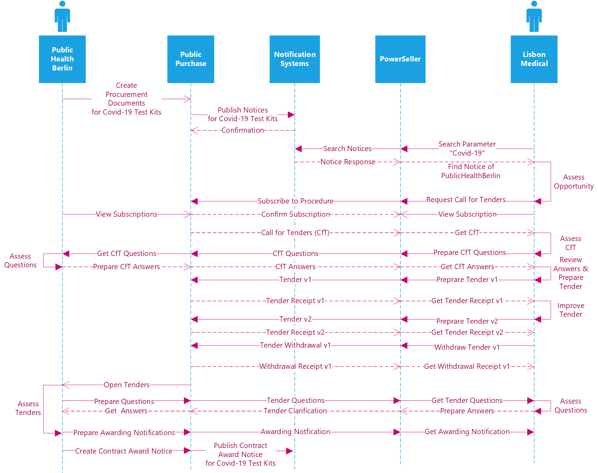

Figure 1: Flow of Transactions Open procedure Key Example

***Preparation Phase***

The contracting body *PublicHealthBerlin* from Germany starts a tendering procedure because it wants to buy *Covid‑19 Test Kits* from any European supplier. At first, it starts to prepare the relevant procurement documents in its eTendering platform *PublicPurchase*, the prior information notice, the contract notice and the call for tenders, in an proprietary format.

As part of this process, the contracting body specifies the products to be bought (catalogue request) and defines qualification criteria along the Single European Procurement Document (ESPD) which need to be proven by economic operators which apply for the tendering procedure. The contracting body adds the standardized qualification criteria (ESPD) and product specification (catalogue request) to the call for tenders. All documents are defined in a standardized XML format according to the requirements and rules described by Peppol.

***Notification***

The eTendering platform *PublicPurchase* used by *PublicHealthBerlin* has a Peppol interface for exchanging notices with national and European *Notification Platforms*. The *Notification Platforms* are required by *PublicHealthBerlin* to publish the tendering procedure prepared for *Covid‑19 Test Kits*.

The different *Notification Platforms* can be queried by economic operators and/or their eTendering Platforms to find business opportunities. The economic operator *LisbonMedical* from Portugal uses the Peppol enabled eTendering platform *PowerSeller*. Through the platform *PowerSeller*, the supplier *LisbonMedical* queries the Notification Platforms along the parameter Covid-19 and finds the business opportunity and contract notice from *PublicHealthBerlin* described above.

***Procurement Document Access***

Through the information established in the relevant notice, the the supplier *LisbonMedical* can subscribe to the public tendering procedures established by *PublicHealthBerlin* using the Peppol eTendering interface. The platform *PublicPurchase* registers subscription of *LisbonMedical* in its database so that the economic operator will be kept up to date.

Based on the subscription, the contracting authority *PublicHealthBerlin* uses its Peppol eTendering interface to provide information related to the Call for Tenders to the supplier *LisbonMedical*. *LisbonMedical* receives the call for tenders including qualification criteria (ESPD) and product specification (catalogue request) and they are sent in a standardized XML format defined by Peppol.

Throughout the procedure, the economic operators *LisbonMedical* decides to use Peppol to send questions about the tendering procedure from the its platform *PowerSeller* to *PublicHealthBerlin*. The contracting body *PublicHealthBerlin* receives the questions via the platform *PublicPurchase* and answers the questions and stores the answers on the platform *PublicPurchase*. The platform *PublicPurchase* forwards the given answers via Peppol to all economic operators that subscribed to the procedure. All economic operator can now review the given answers on their eTendering platforms.

***Tender Submission***

The economic operator *LisbonMedical* decides to participate in the procedure published by *PublicHealthBerlin* and creates a tender for *COVID-19 Test Kits*. The tender documents include standardized catalogue response and ESPD response which were drafted upon the templates provided by *PublicHealthBerlin*.

The economic operator sends his offer from his eTendering platform *PowerSeller* to the eTendering platform *PublicPurchase* used by *PublicHealthBerlin*. Afterwards *LisbonMedical* receives a tender receipt from the eTendering platform *PublicPurchase*. Simultaniously, the platform *PublicPurchase* stores the tender and the tender receipt on its platform.

After the initial submission, the economic operator *LisbonMedical* discovers an error in the offer, corrects it, submits a new tender to the platform *PublicPurchase* and withdraws the old one.

***Awarding***

On the opening date, the contracting authority *PublicHealthBerlin* examines the submitted qualifications in the ESPD response and evaluates the offer including the specified products in the catalogue response. Throughout the evalution process, *PublicHealthBerlin* raises a question related to the tender received from *LisbonMedical* and receives an answer through the Peppol eTendering interface.

The contracting body *PublicHealthBerlin* awards the contract for *Covid‑19 Test Kits* to *LisbonMedical*, prepares awarding notifications for each bidder with individual reasons for failure or success containing information about the winning economic operator. The awarding notification for *LisbonMedical* additionally includes a draft contract. After that, the platform *PublicPurchase* simultaneously sends the awarding notifications to each economic operator that submitted a tender.

After the stand-still period, the contracting body *PublicHealthBerlin* publishes the contract award notification on relevant Notification Platforms.

# Business Process

## Actors and Roles

The following business partners participate in this profile, acting in the roles as defined below.

Table 4: Business partners

| **Business partners** | **Description** |
| --- | --- |
| Customer | The Customer is the legal person or organization who is in demand of a product, service or work. Examples of customer roles are Buyer, Consignee, Debtor and contracting body. |
| Supplier | The Supplier is the legal person or organization who provides a product, service or works. Examples of Supplier roles are Seller, Consignor, Creditor and economic operator. |
| Governmental or private organization | Any organisation. |

Table 5: Roles & Actors

| **Roles & Actors** | **Description** |
| --- | --- |
| Contracting Authority (CA) | The contracting authority or contracting entity who is buying supplies, services or tendering works. |
| Economic operator (EO) | Party participating with a bid in a procurement process to sell goods, services or works. |
| Publication Body (PB) | A Pan-European, national or regional organisation that publishes procurement notices of a contracting body. While the basic role of the publisher may apply to any newspaper, other roles and functions are often restricted to official gazettes. These gazettes are also often responsible to ensure a formal verification of the notices in respect of legislative or other requirements in vigour. Official gazettes may also have the role to receive information exempted from publication (e.g. due to confidential content) used for notification to a supervising authority |

## Notification & Open Procedure Use Cases

Figure 3 shows the Open procedure use cases expressed as Peppol BIS that have to be implemented to support the open procedures using Peppol.

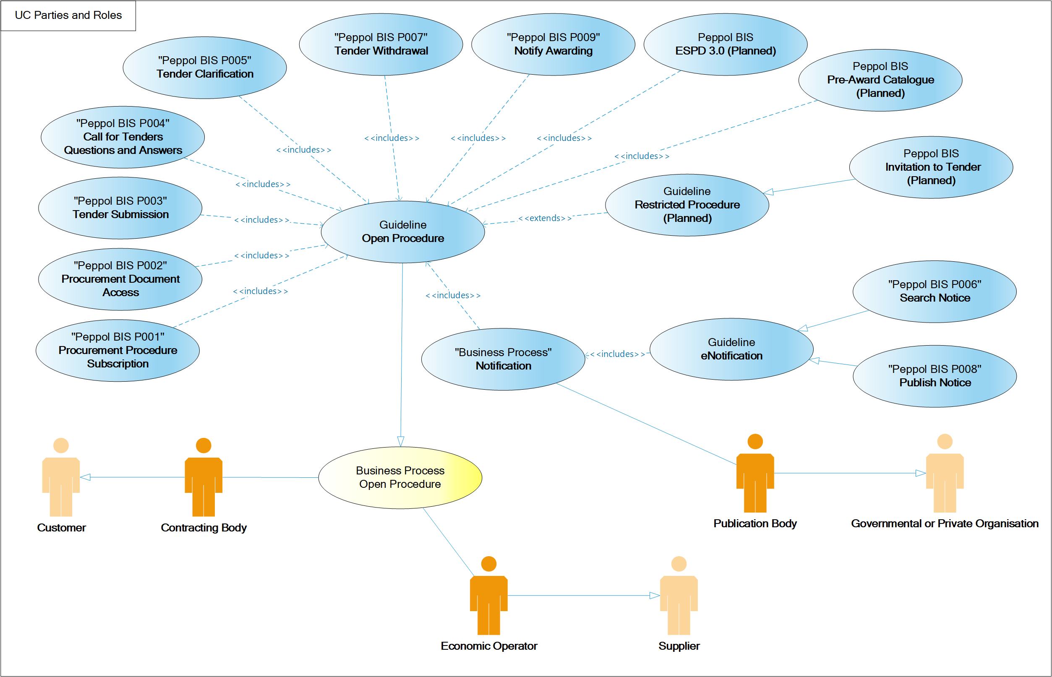

Figure 2: Open procedure use cases

## Notification & Open procedure Business Process

The following diagrams illustrate the choreography of the business process targeted by the Notification & Open Procedure guideline.

Table 6:Conditions of the open Procedure

| **Category** | **Description** |
| --- | --- |
| Description | A contracting body publishes a tender in an open procedure, in which economic operators are invited to tender and to submit their offers. After the opening date, the contracting body awards the winning economic operator. |
| Pre-conditions | The contracting body decided to tender a contract following an open procedure. |
| Post-conditions | The winning economic operator has been contracted and the award notification has been published. |

### Process Map: Notification & Open procedure

The choreography of business collaborations defines the sequence of interactions when an open procedure is executed using Peppol. For better readability the business process has been divided into the subprocesses Notification, Procurement Document Access, Tender Submission, and Awarding illustrated by the process overview below

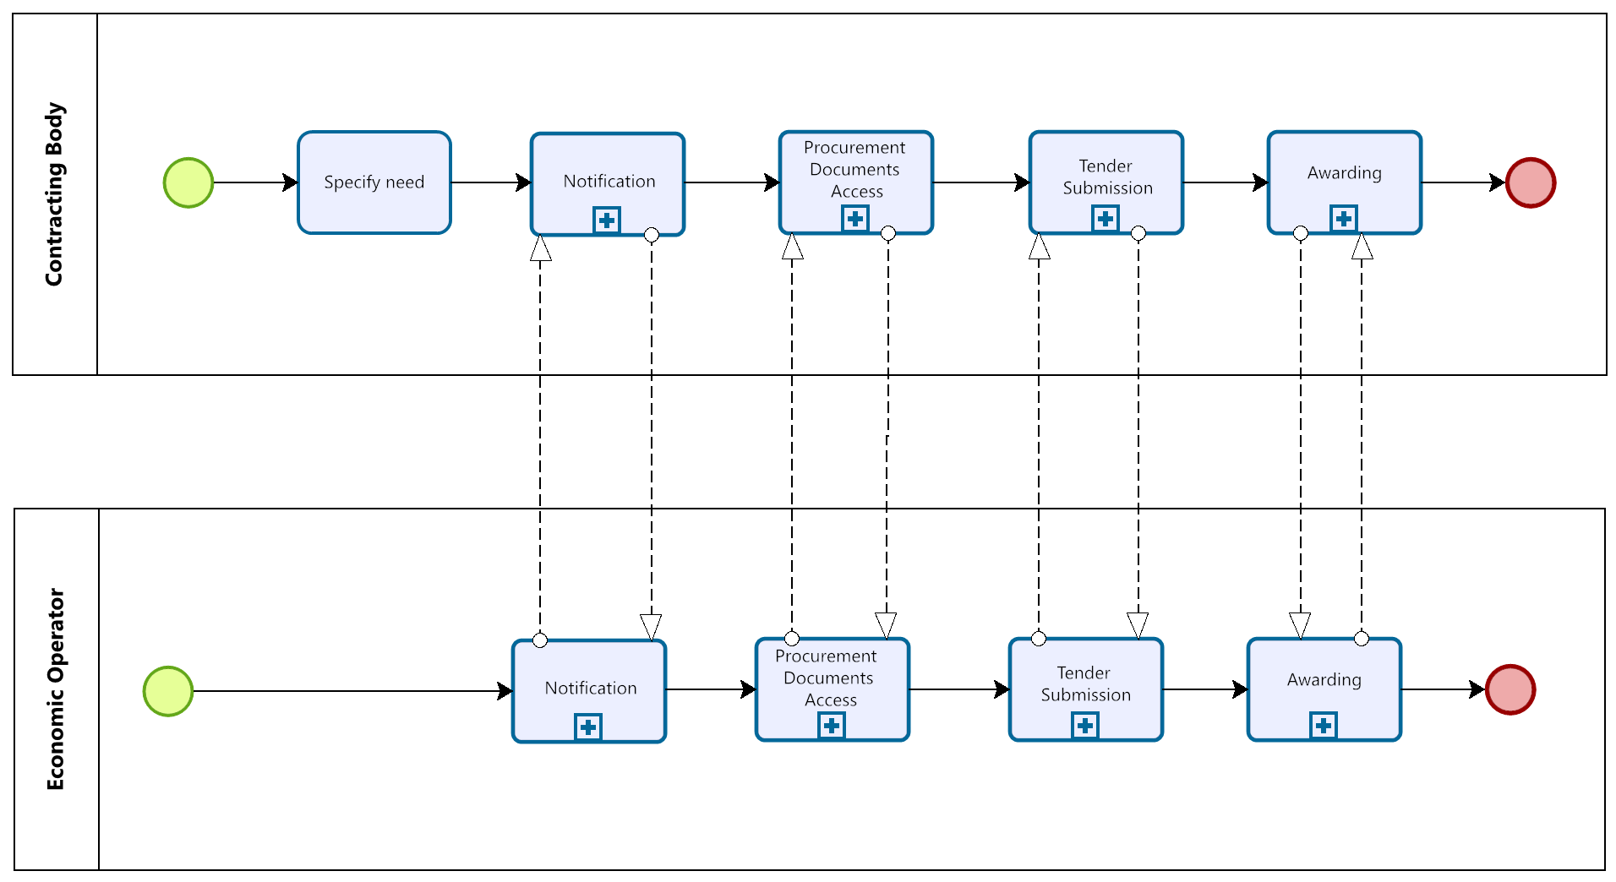

Figure 3: Open procedure process map

### Process: Notification

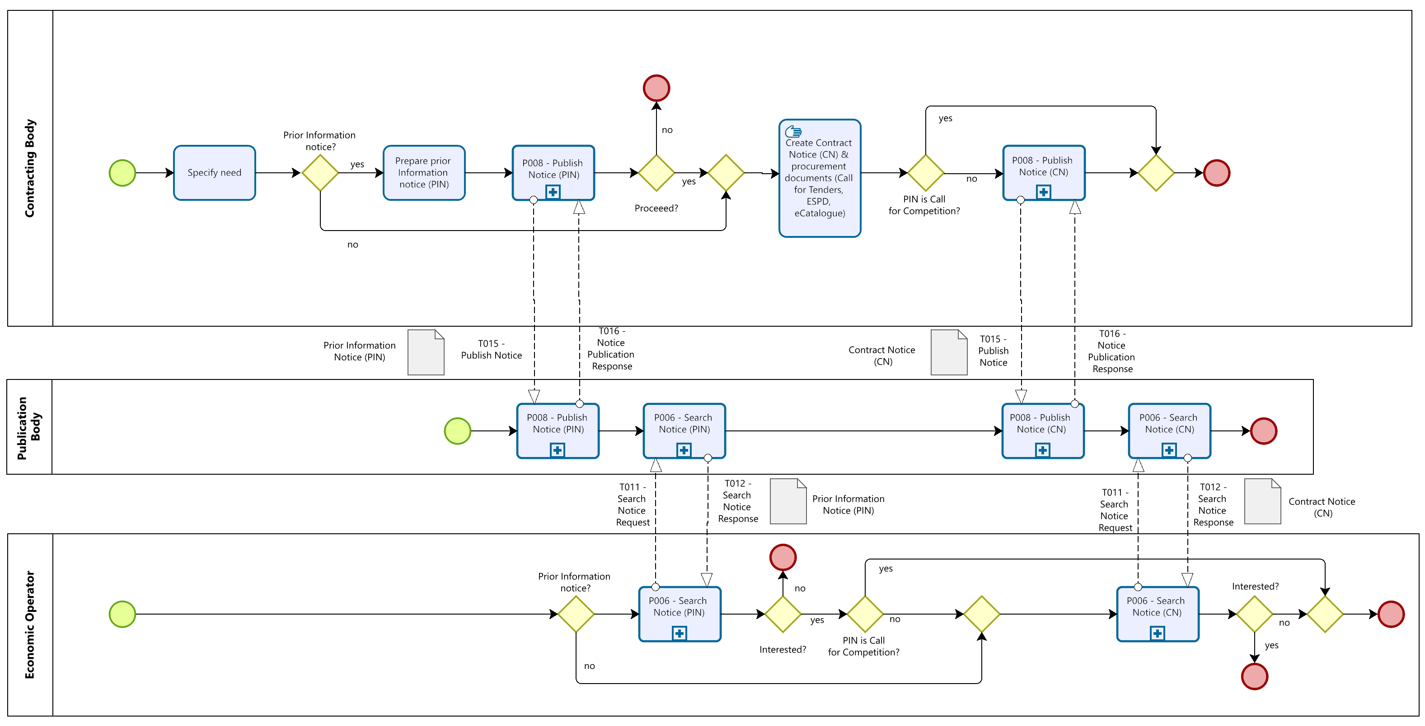

Figure 4: Notification Process

### Process: Procurement Document Access

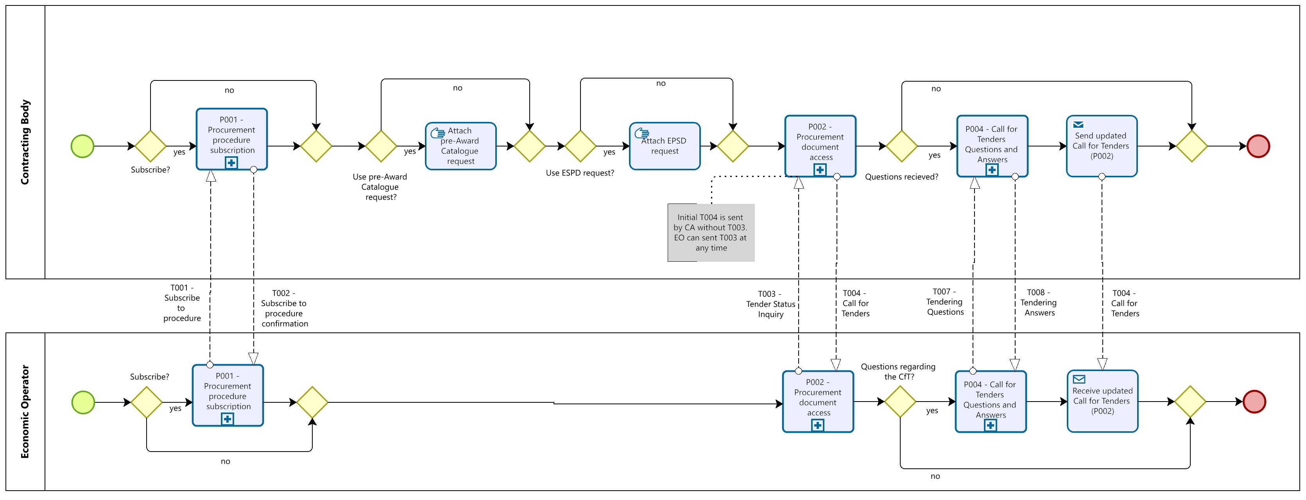

Figure 5: Procurement Document Access process

#### Process: Tender Status Inquiry

At any moment in the procedure before the submission deadline, the economic operator may start an inquiry about the status of the procedure. After the sending of a Tender status inquiry, the economic operator will receive the latest version of the Call for Tenders.

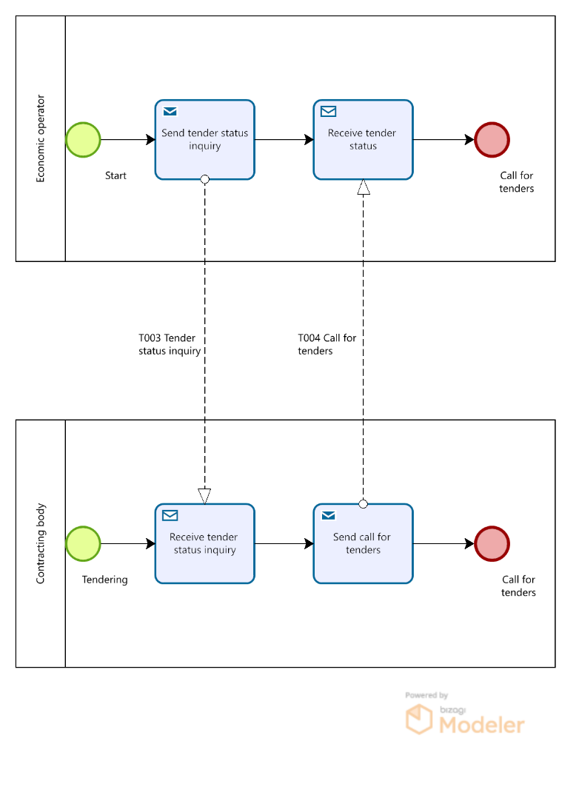

Figure 6: Tender Status Inquiry Process

### Process: Tender Submission

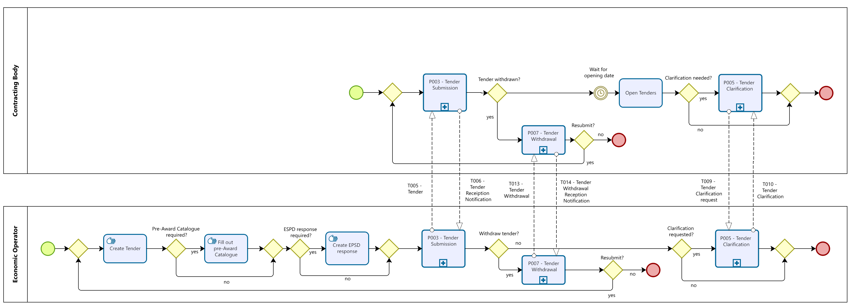

Figure 7: Tender Submission process

### Process: Awarding

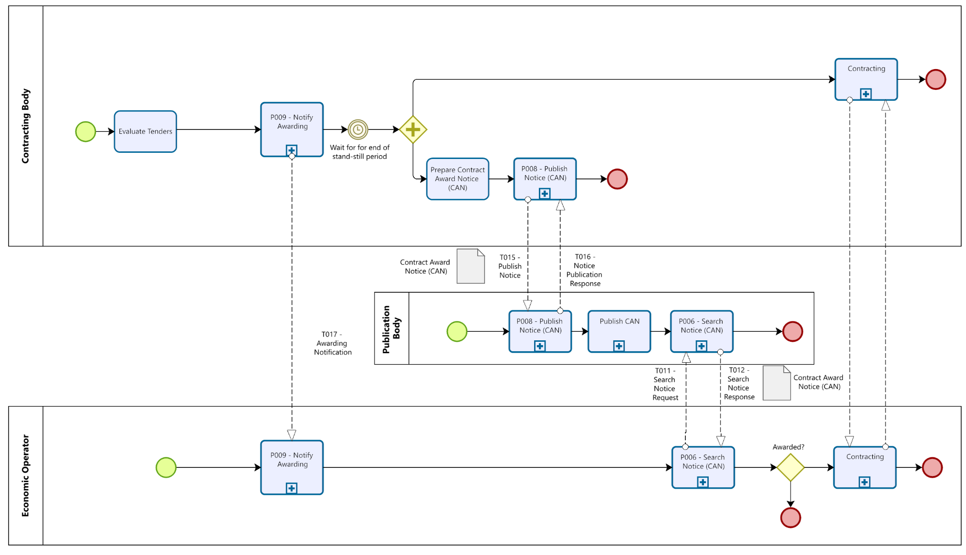

Figure 8: Awarding Process

## Notification & Open Procedure activity detailed descriptions

The following table describes the activities of the BPMN business process diagrams described in section 5.3. Therefore, the table first points to the corresponding BPMN diagram (5.3.2 – Process: Notification, 5.3.3 – Process: Procurement Document Access, 5.3.4 – Process: Tender Submission, 5.3.5 Process: Awarding). Then, the table lists the roles involved in each activity of the BPMN diagram. Additionally, each activity is defined and a reference to the corresponding Peppol BIS is given in case the activity requires bi-lateral communication based on Peppol.

Table 7: activity detailed descriptions

| **Process Map** | **Activity** | **Roles involved** | **Description** | **Peppol BIS** |
| --- | --- | --- | --- | --- |
| Notification | Specify need | CA | The CA needs to specify their need they want to fulfil. Afterwards CA decides whether a prior information notice is needed or not. |  |
| Notification | Prepare Prior Information Notice (PIN) | CA | The CA prepares a Prior Information Notice (PIN) if needed. |  |
| Notification | Publish Notice (PIN) | CA, PB | If created, the CA sends the PIN to the PB, who confirms the entry with the Notice Publication Response. | P008 |
| Notification | Search Notice (PIN) | PB, EO | The EO searches for interesting PINs. The PB provides all matching results for the query and provides the PINs matching the search parameter. The EO investigates the PINs for interesting opportunities. | P006 |
| Notification | Stop Procedure | CA | The CA may decide to stop the procedure at this moment. |  |
| Notification | Create procurement documents | CA | CA prepares the needed procurement documents. It defines the Call for Tenders and optionally   * specifies the products to be bought as a Pre-Award Catalogue Request. * defines qualification criteria along the Single European Procurement Document (ESPD). | (P002) |
| Notification | Publish Notice (CN) | CA, PB | If the PIN is not a Call for Competition the CA will prepare and publish the Contract Notice (CN). The PB confirms the publication with a Notice Publication Response. | P008 |
| Notification | Search Notice (CN) | PB, EO | If the EO has been interested in the PIN and it is not a Call for Competition, the EO can find the corresponding contract notice. The PB will provide all contract notices matching the search parameters of the EO. | P006 |
| Procurement Document Access | Procurement procedure subscription | CA, EO | If the EO is interested, it subscribes to the procurement procedure. The CA subscribes the EO to the procedure and provides a confirmation. | P001 |
| Procurement Document Access | Attach pre-award catalogue request | CA | The CA prepares the dispatch of the Call for Tenders and attaches the Pre-Award Catalogue Request if a structured product descriptions process is applied. |  |
| Procurement Document Access | Attach ESPD request | CA | The CA prepares the dispatch of the call for tenders and attaches the European Single Procurement Document (ESPD) if a structured qualification process is applied. |  |
| Procurement Document Access | Procurement document access | CA, EO | After their expression of interest, the CA automatically sends the Call for Tenders to the EO subscribed to the procedure. Moreover, the EO can request a Tender Status Inquiry at any time before the submission deadline. | P002 |
| Procurement Document Access | Call for Tenders questions and answers | CA, EO | The EO may ask questions on the Call for Tenders. The answers given by the CA are distributed to all subscribed EOs. | P004 |
| Procurement Document Access | Send updated Call for Tenders | CA, EO | When the Call for Tender is updated, it will be provided automatically from the CA to the EO. | P002 |
| Tender Submission | Create Tender | EO | If the EO decides to participate, it prepares his Tender documents. |  |
| Tender Submission | Fill out pre-Award Catalogue | EO | The EO will create a Pre-Award Catalogue Response according to the requirements of the Call for Tender and attach it to the Tender. |  |
| Tender Submission | Create ESPD | EO | The EO will create an ESPD Response according to the requirements of the Call for Tender and attach it to the Tender. |  |
| Tender Submission | Tender Submission | CA, EO | The EO submits its Tender documents and receives a Tender Reception Notification from the CA. | P003 |
| Tender Submission | Tender Withdrawal | CA, EO | The EO may withdraw his submitted Tender and later resubmit a new one (or not). After the Tender Withdrawal the EO receives a Tender Withdrawal Reception Notification from the CA | P007 |
| Tender Submission | Open Tenders | CA | The CA opens the received Tenders at a previously set opening date. |  |
| Tender Submission | Tender Clarification | CA, EO | The CA may require the EO to clarify his Tender or the ESPD Response or the Pre-Award Catalogue Response and sends a Tender Clarification Request to the EO. The EO answers the pending questions and provides a Tender Clarification. | P005 |
| Awarding | Evaluate Tenders | CA | The CA evaluates all received tenders and selects the winning EO. |  |
| Awarding | Notify Awarding | CA, EO | All EOs that submitted Tenders are informed about the individual evaluation result and the winning EO. The winner may receive a draft contract as attachment of the Awarding Notification. | P009 |
| Awarding | Prepare Contract Award Notice | CA | The CA prepares the Contract Award Notice. |  |
| Awarding | Publish Notice (CAN) | CA, PB | After the stand-still period, the CA sends the Contract Award Notice (CAN) to the PB. The PB confirms the receipt and sends a Notice Publication Response. | P008 |
| Awarding | Publish CAN | PB | The PB publishes the CAN. |  |
| Awarding | Search Notice (CAN) | PB, EO | EOs may send a Search Notice Request to the PB looking for the published CAN. The PB provides all matching results for the query and provides the CANs matching the search parameter. | P006 |
| Awarding | Contracting | CA, EO | The CA and EO finalize the contract for the procedure. |  |

# Implementation of Notification & Open Procedure

The tables in section 6 list the Peppol BIS artifacts that have to be considered when implementing the Open Procedure. For each Peppol BIS, the corresponding documentation of the profile and transaction(s) are provided. Additionally, the tables point to the syntax mapping and rules to implement the transactions. Sections 6.10 and 6.11 provide an overview of other relevant artifacts like codelists, schematrons and guidelines which must be considered during the implementation of Peppol pre-award BISs.

## Peppol BIS - P001 - Procurement procedure subscription

|  |  |
| --- | --- |
| Peppol BIS | P001 - Procurement procedure subscription |
| Documentation | <https://docs.peppol.eu/pracc/profiles/p001/index.html> |
| Transaction | **T001 – Subscribe to procedure** |
| Documentation | https://docs.peppol.eu/pracc/transactions/T001/index.html |
| Syntax Mapping | <https://docs.peppol.eu/pracc/syntax/ExpressionOfInterestRequest/tree/> |
| Peppol Rules | <https://docs.peppol.eu/pracc/rules/T001/> |
| Transaction | **T002 - Subscribe to Procedure Confirmation** |
| Documentation | <https://docs.peppol.eu/pracc/rules/T002/> |
| Syntax Mapping | <https://docs.peppol.eu/pracc/syntax/ExpressionOfInterestResponse/tree/> |
| Peppol Rules | <https://docs.peppol.eu/pracc/rules/T002/> |

## Peppol BIS - P002 - Procurement document access

|  |  |
| --- | --- |
| Peppol BIS | P002 - Procurement document access |
| Documentation | <https://docs.peppol.eu/pracc/profiles/p002/index.html> |
| Transaction | **T003 - Tender Status Inquiry** |
| Documentation | https://docs.peppol.eu/pracc/transactions/T003/index.html |
| Syntax Mapping | <https://docs.peppol.eu/pracc/syntax/TenderStatusRequest/tree/> |
| Peppol Rules | <https://docs.peppol.eu/pracc/rules/T003/> |
| Transaction | **T004 - Call for Tenders** |
| Documentation | <https://docs.peppol.eu/pracc/rules/T004/> |
| Syntax Mapping | <https://docs.peppol.eu/pracc/syntax/CallForTenders/tree/> |
| Peppol Rules | <https://docs.peppol.eu/pracc/rules/T004/> |
| CEN BII Rules | <https://docs.peppol.eu/pracc/rules/BIIT004/> |

## Peppol BIS - P003 - Tender Submission

|  |  |
| --- | --- |
| Peppol BIS | P003 - Tender Submission |
| Documentation | <https://docs.peppol.eu/pracc/profiles/p003/index.html> |
| Transaction | **T005 - Tender** |
| Documentation | https://docs.peppol.eu/pracc/transactions/T005/index.html |
| Syntax Mapping | [https://docs.peppol.eu/pracc/syntax/Tender/tree/](https://docs.peppol.eu/pracc/syntax/TenderStatusRequest/tree/) |
| Peppol Rules | <https://docs.peppol.eu/pracc/rules/T005/> |
| CEN BII Rules | <https://docs.peppol.eu/pracc/rules/BIIT005/> |
| Transaction | **T006 - Tender Reception Notification** |
| Documentation | <https://docs.peppol.eu/pracc/rules/T006/> |
| Syntax Mapping | <https://docs.peppol.eu/pracc/syntax/TenderReceipt/tree/> |
| Peppol Rules | <https://docs.peppol.eu/pracc/rules/T006/> |
| CEN BII Rules | <https://docs.peppol.eu/pracc/rules/BIIT006/> |

## Peppol BIS - P004 - Call for Tenders Question and Answers

|  |  |
| --- | --- |
| Peppol BIS | P004 - Call for Tenders Question and Answers |
| Documentation | <https://docs.peppol.eu/pracc/profiles/p004/index.html> |
| Transaction | **T007 - Tendering Questions** |
| Documentation | https://docs.peppol.eu/pracc/transactions/T007/index.html |
| Syntax Mapping | <https://docs.peppol.eu/pracc/syntax/TenderingQuestions/tree/> |
| Peppol Rules | <https://docs.peppol.eu/pracc/rules/T007/> |
| Transaction | **T008 - Tendering Answers** |
| Documentation | <https://docs.peppol.eu/pracc/rules/T008/> |
| Syntax Mapping | <https://docs.peppol.eu/pracc/syntax/TenderingAnswers/tree/> |
| Peppol Rules | <https://docs.peppol.eu/pracc/rules/T008/> |

## Peppol BIS - P005 - Tender Clarification

|  |  |
| --- | --- |
| Peppol BIS | P005 - Tender Clarification |
| Documentation | <https://docs.peppol.eu/pracc/profiles/p005/index.html> |
| Transaction | **T009 - Tender Clarification Request** |
| Documentation | https://docs.peppol.eu/pracc/transactions/T009/index.html |
| Syntax Mapping | <https://docs.peppol.eu/pracc/syntax/TenderClarificationRequest/tree/> |
| Peppol Rules | <https://docs.peppol.eu/pracc/rules/T009/> |
| Transaction | **T010 - Tender Clarification** |
| Documentation | <https://docs.peppol.eu/pracc/rules/T010/> |
| Syntax Mapping | <https://docs.peppol.eu/pracc/syntax/TenderClarification/tree/> |
| Peppol Rules | <https://docs.peppol.eu/pracc/rules/T010/> |

## Peppol BIS - P006 - Search Notices

|  |  |
| --- | --- |
| Peppol BIS | P006 - Search Notices |
| Documentation | <https://docs.peppol.eu/pracc/profiles/p006/index.html> |
| Transaction | **T011 - Search Notice Request** |
| Documentation | https://docs.peppol.eu/pracc/transactions/T011/index.html |
| Syntax Mapping | <https://docs.peppol.eu/pracc/syntax/SearchNoticeRequest/tree/> |
| Peppol Rules | <https://docs.peppol.eu/pracc/rules/T011/> |
| Transaction | **T012 - Search Notice Response** |
| Documentation | <https://docs.peppol.eu/pracc/rules/T012/> |
| Syntax Mapping | <https://docs.peppol.eu/pracc/syntax/SearchNoticeResponse/tree/> |
| Peppol Rules | <https://docs.peppol.eu/pracc/rules/T012/> |

## Peppol BIS - P007 - Tender Withdrawal

|  |  |
| --- | --- |
| Peppol BIS | P007 - Tender Withdrawal |
| Documentation | <https://docs.peppol.eu/pracc/profiles/p007/index.html> |
| Transaction | **T013 - Tender Withdrawal** |
| Documentation | https://docs.peppol.eu/pracc/transactions/T013/index.html |
| Syntax Mapping | <https://docs.peppol.eu/pracc/syntax/TenderWithdrawalRequest/tree/> |
| Peppol Rules | <https://docs.peppol.eu/pracc/rules/T013/> |
| Transaction | **T014 - Tender Withdrawal Notification** |
| Documentation | <https://docs.peppol.eu/pracc/rules/T014/> |
| Syntax Mapping | <https://docs.peppol.eu/pracc/syntax/TenderWithdrawalResponse/tree/> |
| Peppol Rules | <https://docs.peppol.eu/pracc/rules/T014/> |

## Peppol BIS - P008 - Publish Notice

|  |  |
| --- | --- |
| Peppol BIS | P008 - Publish Notice |
| Documentation | <https://docs.peppol.eu/pracc/profiles/p008/index.html> |
| Transaction | **T015 - Publish Notice** |
| Documentation | https://docs.peppol.eu/pracc/transactions/T015/index.html |
| Syntax Mapping | <https://docs.peppol.eu/pracc/syntax/PublishNotice/tree/> |
| Peppol Rules | <https://docs.peppol.eu/pracc/rules/T015/> |
| Transaction | **T016 - Notice Publication Response** |
| Documentation | <https://docs.peppol.eu/pracc/rules/T016/> |
| Syntax Mapping | <https://docs.peppol.eu/pracc/syntax/NoticePublicationResponse/tree/> |
| Peppol Rules | <https://docs.peppol.eu/pracc/rules/T016/> |

## Peppol BIS - P009 - Notify Awarding

|  |  |
| --- | --- |
| Peppol BIS | P009 - Notify Awarding |
| Documentation | <https://docs.peppol.eu/pracc/profiles/p009/index.html> |
| Transaction | **T015 - Publish Notice** |
| Documentation | https://docs.peppol.eu/pracc/transactions/T017/index.html |
| Syntax Mapping | <https://docs.peppol.eu/pracc/syntax/AwardingNotification/tree/> |
| Peppol Rules | <https://docs.peppol.eu/pracc/rules/T017/> |

## Peppol Code Lists used in Notification & Open Procedure

|  |  |
| --- | --- |
| additionalConditionsCode | <https://docs.peppol.eu/pracc/codelist/addCond/> |
| awardCode | <https://docs.peppol.eu/pracc/codelist/addCond/> |
| contractTypeCode | <https://docs.peppol.eu/pracc/codelist/contractType/> |
| documentStatusCode | <https://docs.peppol.eu/pracc/codelist/docStatus/> |
| documentTypeCode | <https://docs.peppol.eu/pracc/codelist/docType/> |
| Electronic Address Scheme (EAS) | <https://docs.peppol.eu/pracc/codelist/EAS/> |
| ISO 6523 ICD list | <https://docs.peppol.eu/pracc/codelist/ICD/> |
| Country codes (ISO 3166-1:Alpha2) | <https://docs.peppol.eu/pracc/codelist/ISO3166/> |
| legalBasisCode | <https://docs.peppol.eu/pracc/codelist/legalBasis/> |
| NoticeResponseCode | <https://docs.peppol.eu/pracc/codelist/noticeResponse/> |
| procedureTypeCode | <https://docs.peppol.eu/pracc/codelist/procedureType/> |
| procurementTypeCode | <https://docs.peppol.eu/pracc/codelist/procurementType/> |
| publicationConditionCode | <https://docs.peppol.eu/pracc/codelist/publicationCondition/> |
| StatusReasonCode | <https://docs.peppol.eu/pracc/codelist/statusReason/> |
| SubmissionMethodCode | <https://docs.peppol.eu/pracc/codelist/submissionMethod/> |
| UBLDocumentSchema | <https://docs.peppol.eu/pracc/codelist/ublDocumentSchema/> |
| Document name code, full list (UNCL1001) | <https://docs.peppol.eu/pracc/codelist/UNCL1001/> |

## Other artifacts used in Notification & Open Procedure

|  |  |
| --- | --- |
| Peppol BIS eDelivery guide for pre-award | <https://docs.peppol.eu/pracc/files/BIS-eDelivery-guide-for-pre-award-v1.2.pdf> |
| Peppol BIS eDocuments guide for pre-award | <https://docs.peppol.eu/pracc/files/BIS-eDocuments-guide-for-pre-award-v1.2.pdf> |
| Schematron files (zip) | <https://docs.peppol.eu/pracc/files/schematrons.zip> |
| Code lists (zip) | <https://docs.peppol.eu/pracc/files/codelists.zip> |

# External References

|  |  |
| --- | --- |
| Reference | Source |
| [2014/24/EU] | <https://eur-lex.europa.eu/legal-content/DE/TXT/?uri=CELEX%3A32014L0024> |
| [2014/25/EU] | <https://eur-lex.europa.eu/legal-content/DE/TXT/?uri=CELEX%3A32014L0025> |
| [BII10] | https://standards.cencenelec.eu/dyn/www/f?p=205:110:0::::FSP_PROJECT:62007&cs=16D9EEBE9B7C024A15F0CCDEE76075355 |
| [BII14] | https://standards.cencenelec.eu/dyn/www/f?p=205:110:0::::FSP_PROJECT:62008&cs=16824EF2775A9CE68B4E33893BA1F2A05 |
| [BII37 Open Procedure] | <https://standards.cencenelec.eu/dyn/www/f?p=205:110:0::::FSP_PROJECT:62023&cs=19453F711D73A2988EC334F37EE564AB1> |
| [BII43] | https://standards.cencenelec.eu/dyn/www/f?p=205:110:0::::FSP_PROJECT:62009&cs=1807B03E8AA497A2C66F5BA5A25A5A3AF |
| [BII45] | https://standards.cencenelec.eu/dyn/www/f?p=205:110:0::::FSP_PROJECT:62010&cs=1628543602EFDE54C11B8136021A5621A |
| [BII46] | https://standards.cencenelec.eu/dyn/www/f?p=205:110:0::::FSP_PROJECT:62028&cs=16B7CFE594685D73AD82275DFFE3FCC55 |
| [BII47] | <https://standards.cencenelec.eu/dyn/www/f?p=205:110:0::::FSP_PROJECT:62029&cs=16BDCBBEBAE1A6A235013E1B31A0B78D6> |
| [BII48] | https://standards.cencenelec.eu/dyn/www/f?p=205:110:0::::FSP_PROJECT:62030&cs=137D249EEF9A0B7DF6DAD668A740CA477 |
| [BII50] | https://standards.cencenelec.eu/dyn/www/f?p=205:110:0::::FSP_PROJECT:62032&cs=112E5165F9BCEE578DFD26A6C238464E2 |
| [BII53] | https://standards.cencenelec.eu/dyn/www/f?p=205:110:0::::FSP_PROJECT:62035&cs=15E8443FF9806B2D1F6675A41EA29930F |
| [BII54] | https://standards.cencenelec.eu/dyn/www/f?p=205:110:0::::FSP_PROJECT:62036&cs=12EBD786F7FC4B3EEB54EB811F8FCD901 |
| [BII58] | https://standards.cencenelec.eu/dyn/www/f?p=205:110:0::::FSP_PROJECT:62038&cs=1438046879E98863C8263389E46ED47C4 |
| [BII60] | https://standards.cencenelec.eu/dyn/www/f?p=205:110:0::::FSP_PROJECT:62055&cs=1FA2AB7C9A0F601605C549112B7B93DA3 |
| [BIS Pre-Award catalogue] | https://docs.peppol.eu/pracc/catalogue/1.0/bis/ |
| [CEN_BII3] | <https://standards.cencenelec.eu/dyn/www/f?p=205:32:0::::FSP_ORG_ID,FSP_LANG_ID:2073699,25&cs=1764296F93587711762A3AB227353671A> |
| [eForms] | <https://eur-lex.europa.eu/eli/reg_impl/2019/1780/oj> |
| [ESPD EDM] | https://github.com/OP-TED/ESPD-EDM |
| [ESPD] | https://eur-lex.europa.eu/eli/reg_impl/2016/7/oj |
| [Peppol AISBL] | <https://peppol.eu/what-is-peppol/> |
| [Peppol BIS] | <https://peppol.eu/what-is-peppol/peppol-profiles-specifications/> |
| [Peppol eDelivery] | <https://peppol.eu/what-is-peppol/peppol-transport-infrastructure/> |
| [Peppol eTendering] | <https://docs.peppol.eu/pracc/> |
| [Peppol Pre Award] | <https://peppol.eu/downloads/pre-award/> |
| [Peppol] | <https://peppol.eu/> |
| [Pre-Award eDelivery] | <https://docs.peppol.eu/pracc/files/BIS-eDelivery-guide-for-pre-award-v1.2.pdf> |
| [Pre-Award eDocuments] | <https://docs.peppol.eu/pracc/files/BIS-eDocuments-guide-for-pre-award-v1.2.pdf> |

1. Alternatively, the platform **PublicPurchase** can publish directly to TED using the Peppol interface.