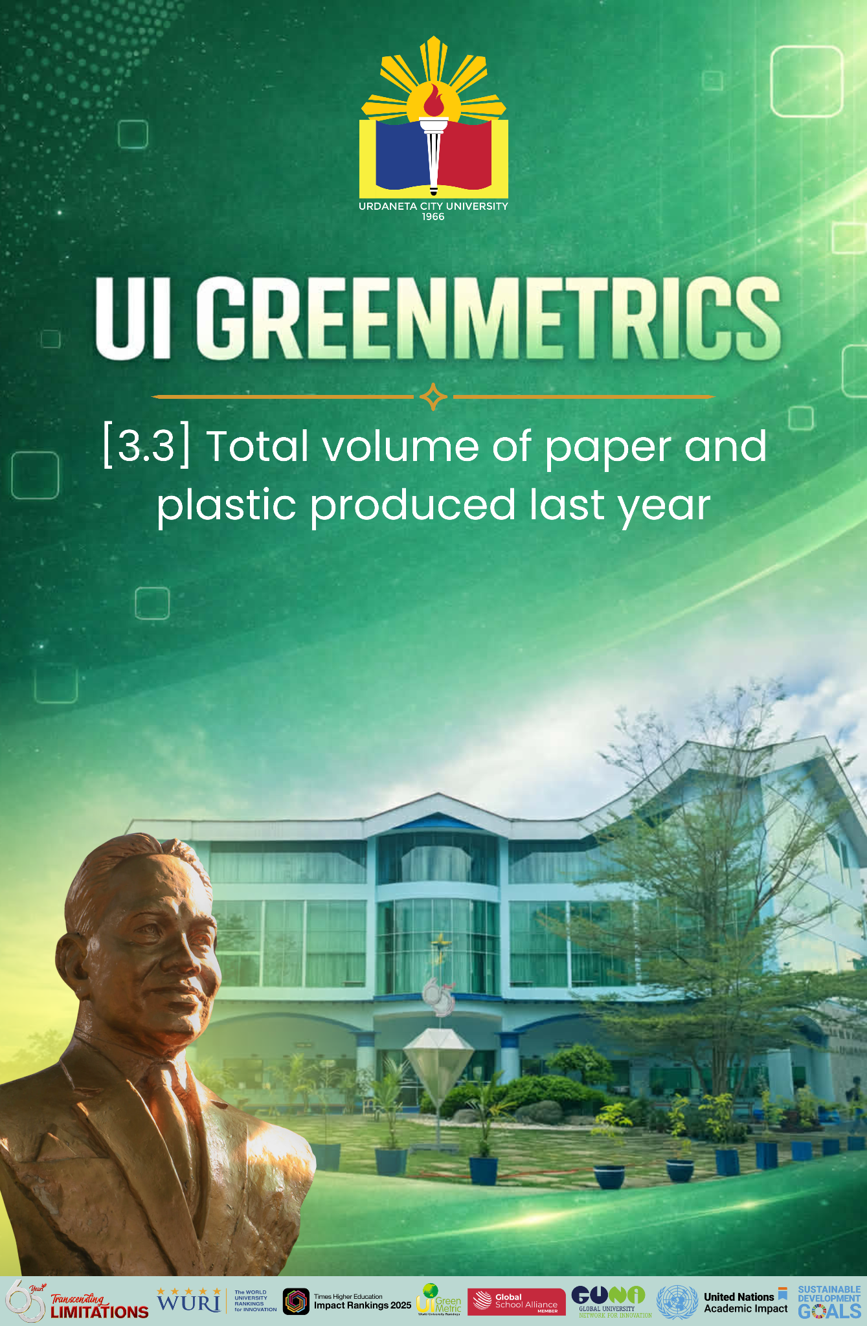

Template for Evidence(s)
UI GreenMetric Questionnaire

University : URDANETA CITY UNIVERSITY
Country : PHILIPPINES
Web Address : ucu.edu.ph

[3] Waste (WS)

[3.4] Program to Reduce the Use of Paper and Plastic on Campus (WS.2)
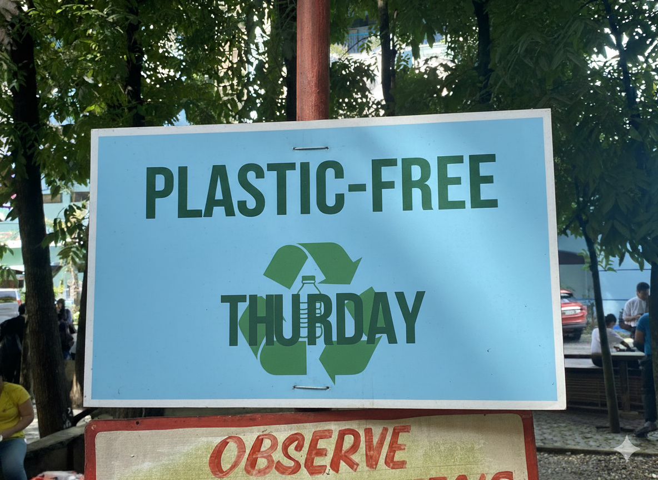
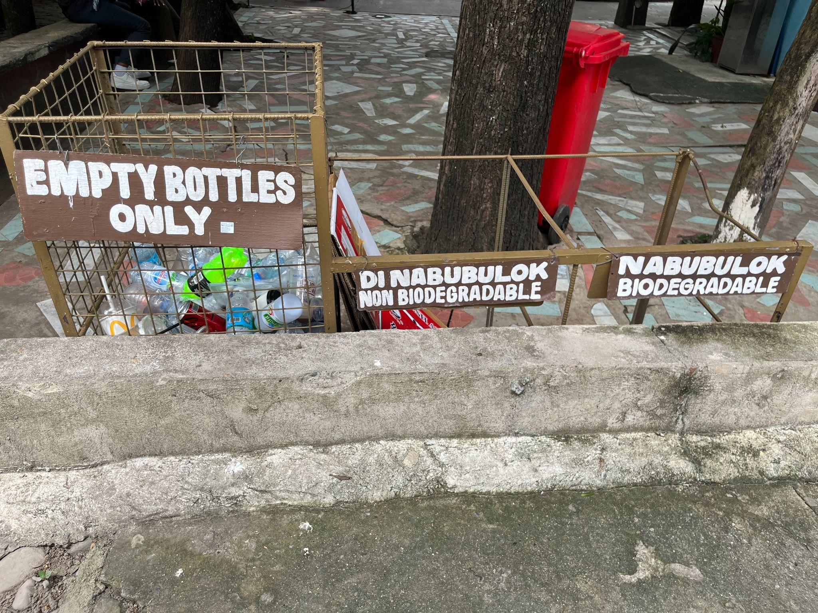
1 | 2
Example of Program to Reduce the Use of Paper and Plastic in Campus (Urdaneta City University, Philippines)

Description:
Urdaneta City University’s Campus Sustainability Initiatives
Description:
Urdaneta City University (UCU) actively advances campus-wide sustainability initiatives focused on reducing paper and plastic consumption, in alignment with the UI GreenMetric World University Rankings, particularly under the Waste (WS), Education & Research (ED), and Setting & Infrastructure (SI) indicators. These initiatives demonstrate the University’s institutional commitment to environmental stewardship, resource efficiency, and sustainable campus operations.
To address paper waste, UCU has institutionalized a paperless system through the digitalization of academic and administrative processes. This includes the online submission of coursework, use of learning management systems, electronic communication, and digital recordkeeping. These measures significantly reduce paper consumption while improving efficiency, accessibility, and data management. The transition to digital platforms directly contributes to waste minimization and supports low-carbon campus operations, consistent with GreenMetric’s sustainability framework.
In response to plastic pollution, UCU implements its comprehensive Waste Reduction and Recycling Program, anchored in its Sustainable Development Goals (SDG) Action Plan. The program promotes behavioral change and resource conservation by discouraging the use of single-use plastics and encouraging the adoption of reusable alternatives such as tumblers, food containers, and eco-bags. These practices are reinforced during campus events, student activities, and daily operations, ensuring consistent application across the university community.
A key flagship initiative, “Plastic-Free Thursday,” serves as a weekly sustainability campaign that challenges students, faculty, and staff to eliminate single-use plastics every Thursday. This initiative fosters environmental discipline, strengthens awareness, and cultivates long-term sustainable habits. It also functions as a participatory platform for sustainability education, encouraging collective responsibility and engagement across stakeholders.
10 university programs that align with the Sustainable Development Goals (SDGs) under the theme “Program to Reduce the Use of Paper and Plastic on Campus.”
- Paperless Campus Initiative
  - Transition administrative processes, student services, and academic transactions to digital platforms.
  - SDGs: 4, 9, 12, 13, 16
- Bring Your Own Reusable (BYOR) Campaign
  - Encourage students and employees to bring reusable tumblers, food containers, utensils, and eco-bags.
  - SDGs: 3, 11, 12, 13, 14
- Single-Use Plastic-Free Campus Policy
  - Eliminate single-use plastics in cafeterias, offices, meetings, and university events.
  - SDGs: 11, 12, 13, 14, 15
- Digital Learning and e-Assessment Program
  - Promote e-books, Learning Management Systems (LMS), online examinations, and electronic submissions.
  - SDGs: 4, 9, 12, 13
- Green Procurement Policy
  - Purchase recycled paper, biodegradable packaging, refillable office supplies, and eco-friendly products.
  - SDGs: 8, 9, 12, 13
- Campus Recycling and Materials Recovery Program
  - Install segregation bins and recycling stations for paper, plastics, and other recyclable materials.
  - SDGs: 11, 12, 13, 14, 15
- Eco-Printing and Smart Printing Initiative
  - Default double-sided printing, set printing quotas, and encourage digital document sharing.
  - SDGs: 9, 12, 13, 15
- Green Office Certification Program
  - Recognize colleges and offices that significantly reduce paper and plastic consumption through sustainable office practices.
  - SDGs: 8, 11, 12, 13, 16
- Sustainability Education and Environmental Awareness Campaign
  - Conduct seminars, webinars, orientations, and student-led campaigns promoting responsible consumption and waste reduction.
  - SDGs: 4, 12, 13, 17
- Zero-Waste Campus Challenge
- Organize annual competitions among colleges and offices to reduce paper use, eliminate single-use plastics, and improve recycling rates.
- SDGs: 11, 12, 13, 15, 17

Overall SDG Alignment
These ten programs collectively support:
- SDG 3 – Good Health and Well-being
- SDG 4 – Quality Education
- SDG 8 – Decent Work and Economic Growth
- SDG 9 – Industry, Innovation and Infrastructure
- SDG 11 – Sustainable Cities and Communities
- SDG 12 – Responsible Consumption and Production (primary SDG)
- SDG 13 – Climate Action
- SDG 14 – Life Below Water
- SDG 15 – Life on Land
- SDG 16 – Peace, Justice and Strong Institutions
- SDG 17 – Partnerships for the Goals
These initiatives primarily advance SDG 12 (Responsible Consumption and Production) while contributing to 11 Sustainable Development Goals through sustainable campus operations and environmental stewardship.
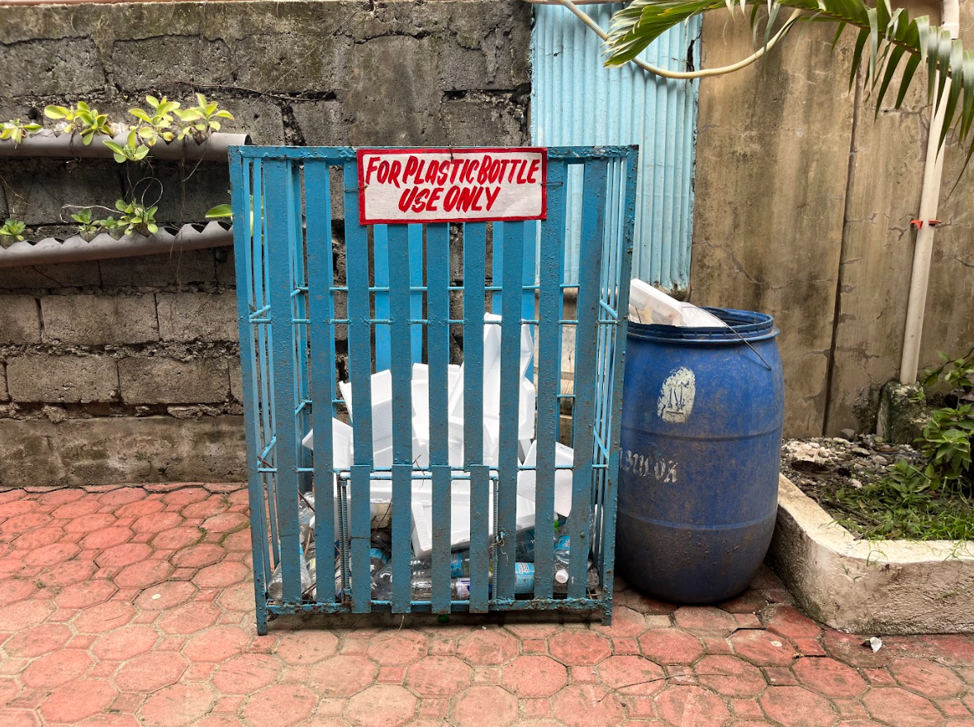
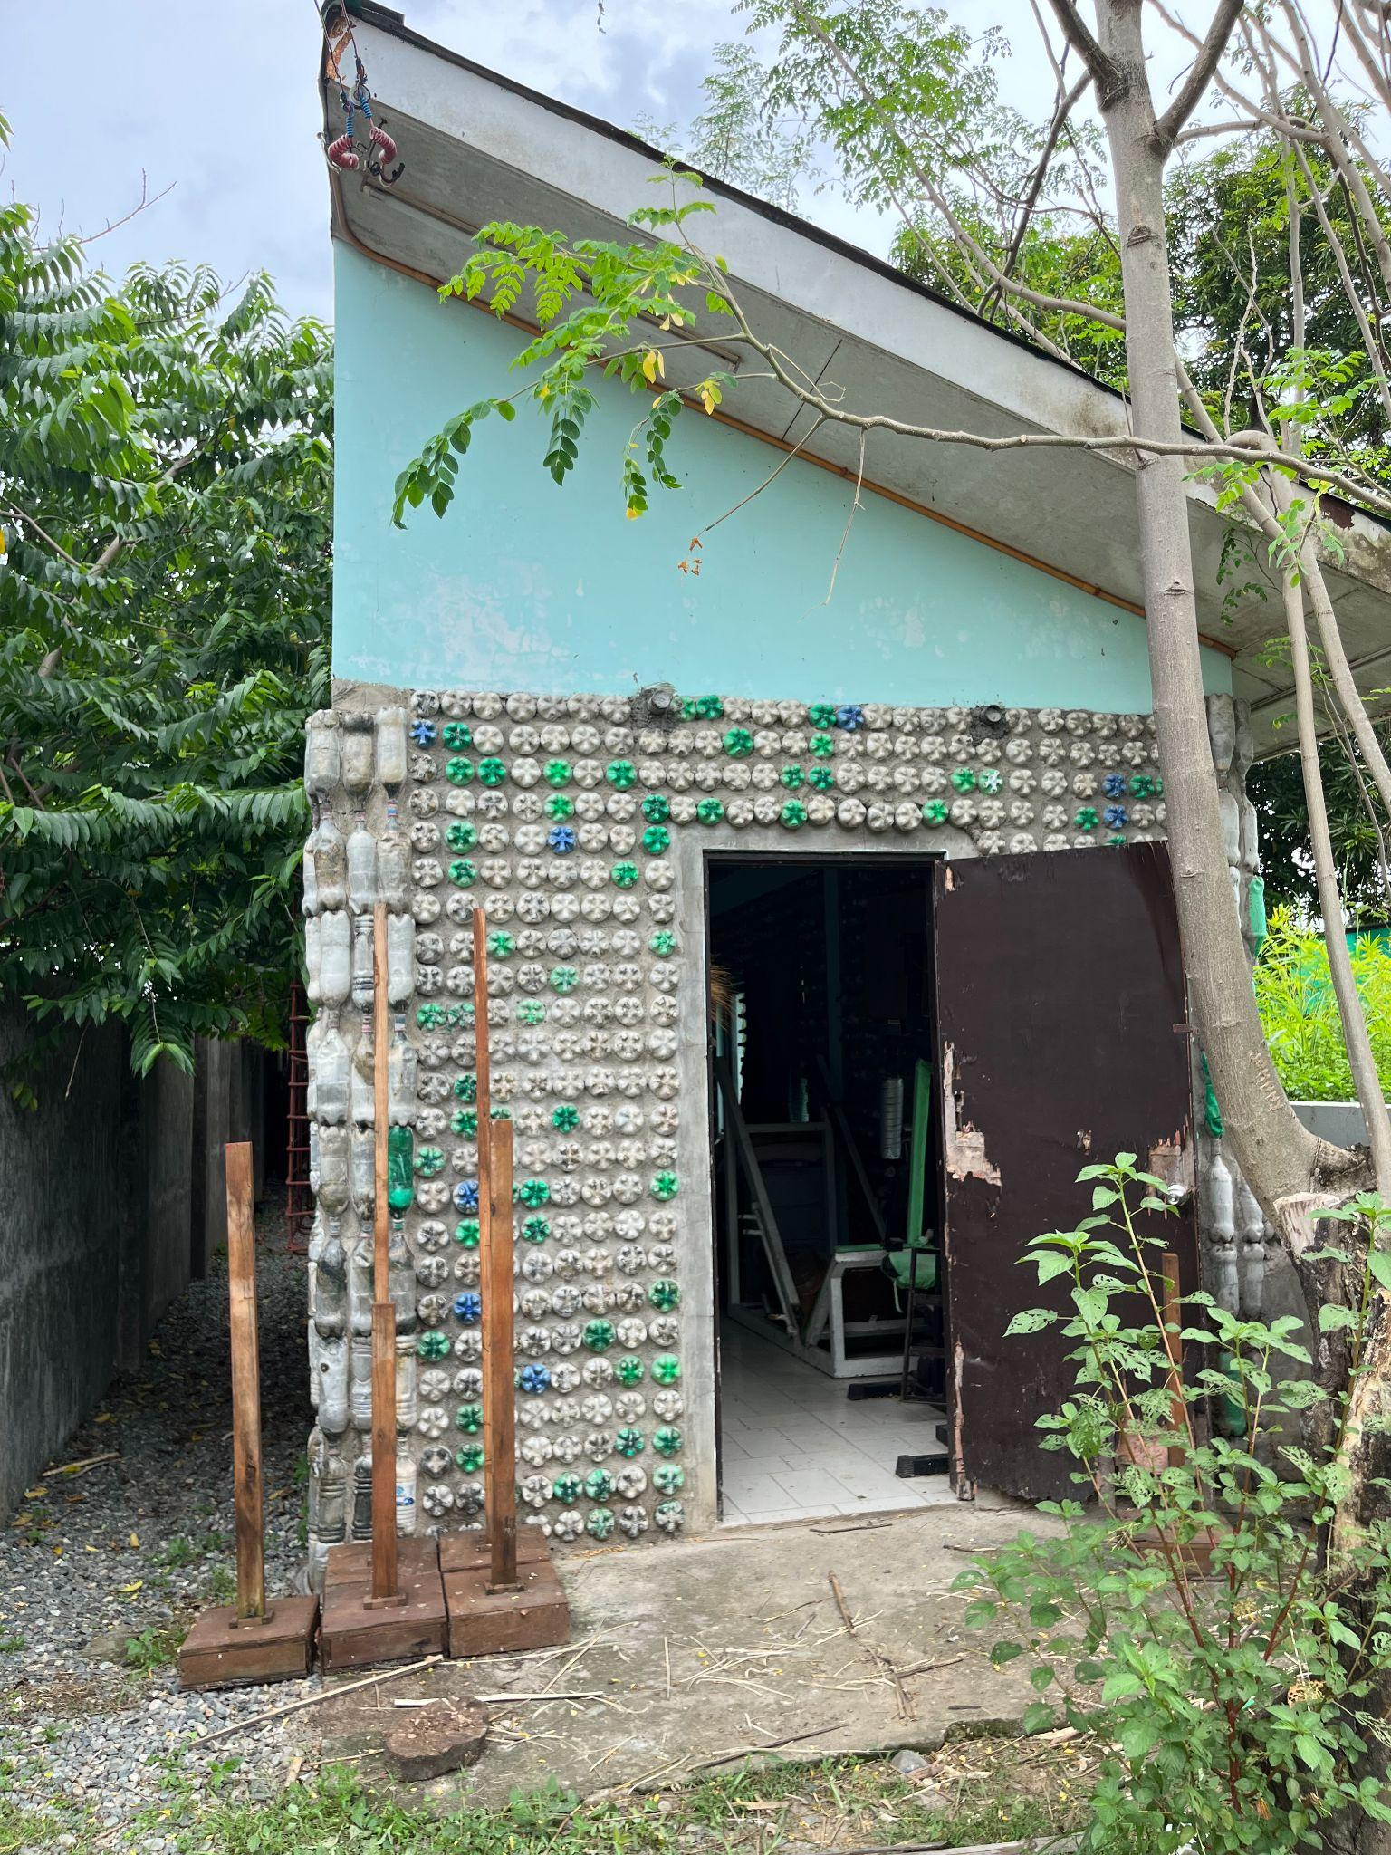
Additional evidence link (i.e., for videos, more images, or other files that are not included in this file):

