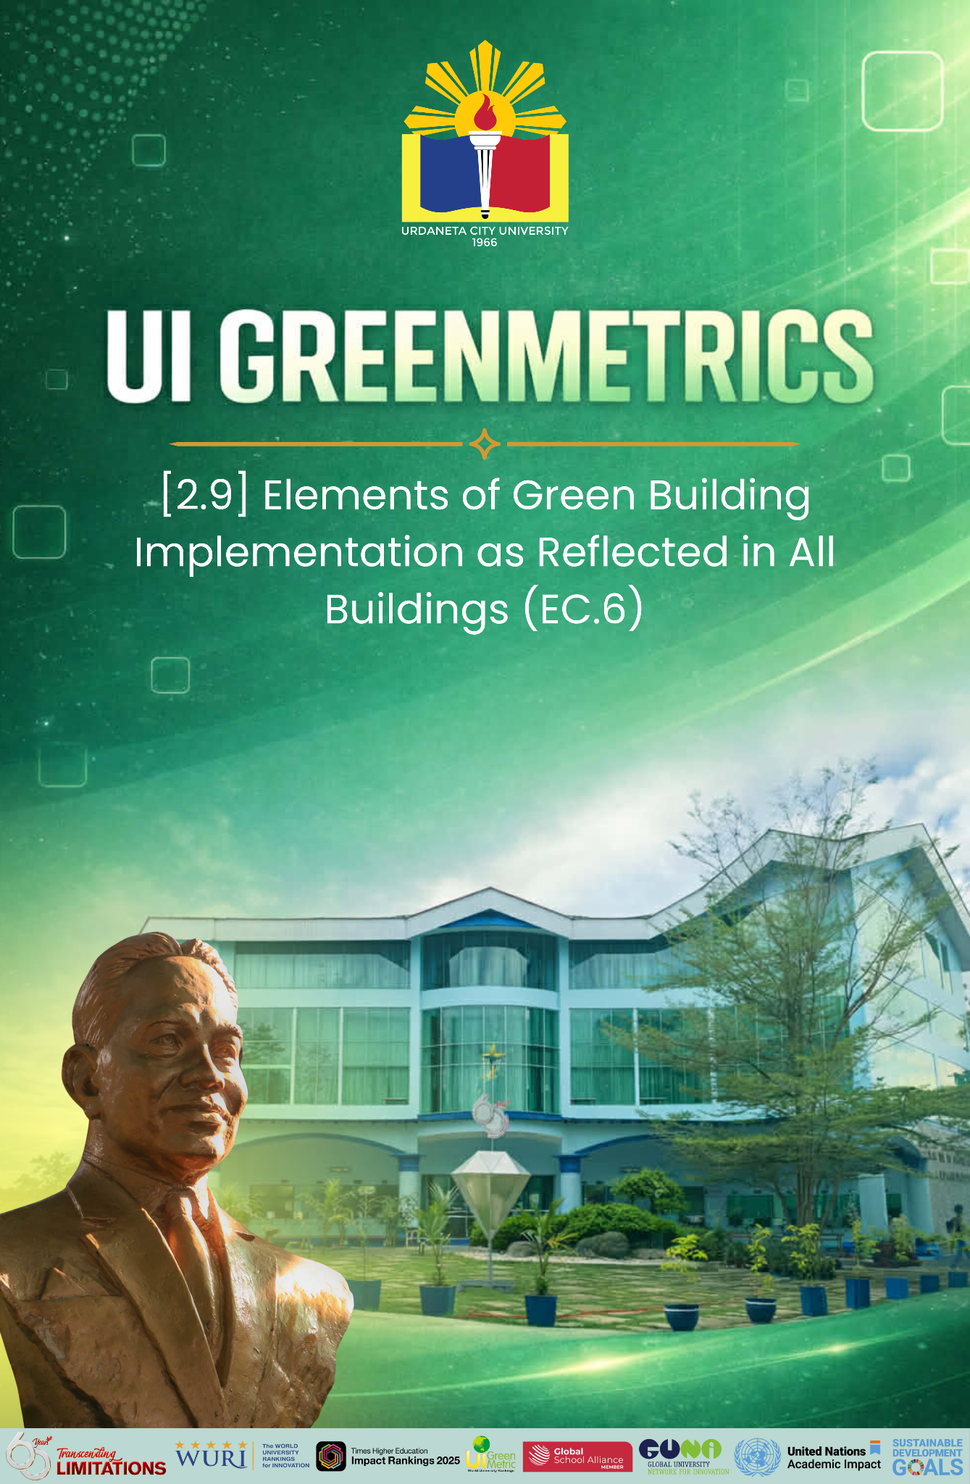

Template for Evidence(s)
UI GreenMetric Questionnaire

University : URDANETA CITY UNIVESITY
Country : PHILIPPINES
Web Address : https://ucu.edu.ph

[2] Energy and Climate Change (EC)

[2.9] Elements of Green Building Implementation as Reflected in All Buildings (EC.6)
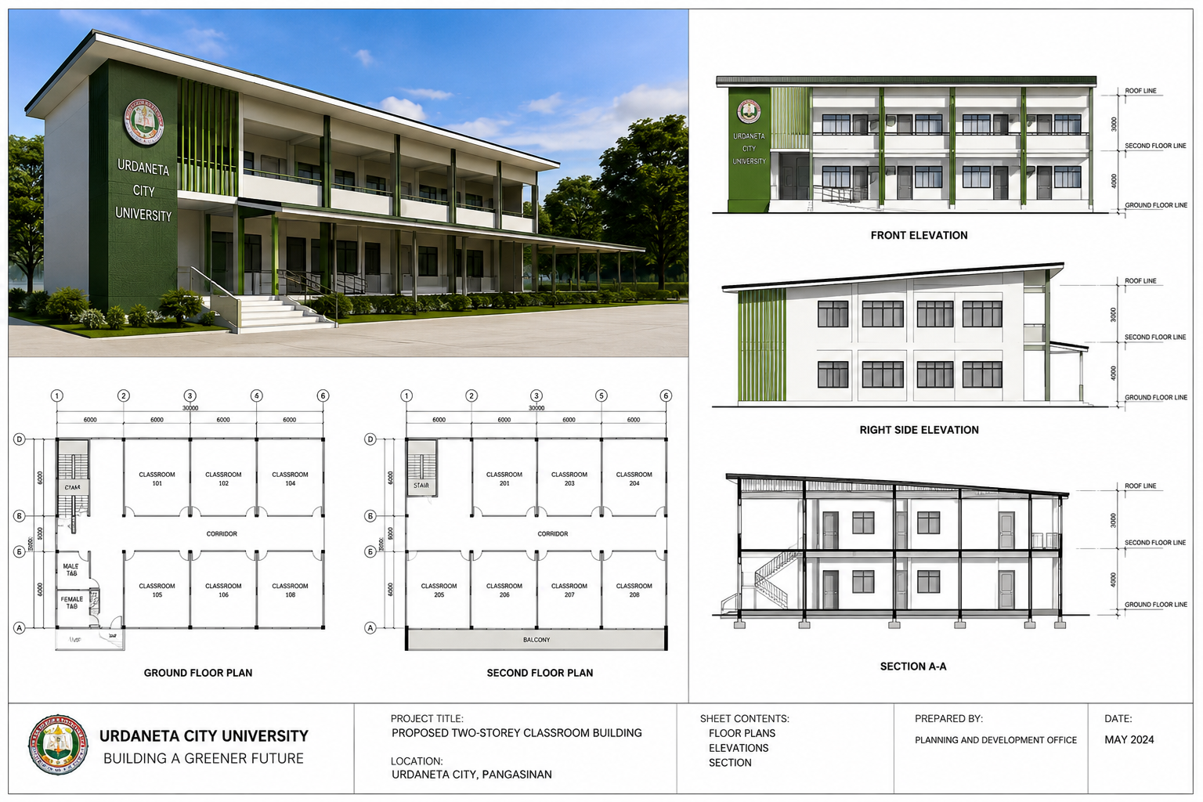

Green Building Implementation Plan
Urdaneta City University: Building a Greener Future

1. Objective
Urdaneta City University is committed to transforming the way we build and renovate. Our goal is to adopt sustainable practices that minimize environmental impact while creating modern, healthy, and inspiring spaces for students, faculty, and staff. Through this plan, we set the foundation for a campus that embodies innovation, responsibility, and care for the planet.

2. Scope
This plan covers all new construction and renovation projects at UCU. By embedding green building principles into every stage of the project lifecycle, we ensure that sustainability is not an afterthought—it’s the standard.

3. Key Elements
a. Site Development
- Conduct environmental impact assessments before choosing project sites.
- Protect existing vegetation and enhance biodiversity.
- Build stormwater management systems to prevent flooding and erosion.
Timeline: Ongoing; assessments before every project.
b. Energy Efficiency
- Use energy modeling software to optimize building design.
- Install high-performance insulation and energy-efficient HVAC systems.
- Expand renewable energy sources, including solar power.
Timeline: Integrated into the design phase of all projects.
c. Water Conservation
- Fit buildings with low-flow fixtures and water-efficient appliances.
- Implement rainwater harvesting and greywater recycling systems.
- Use drought-resistant plants in landscaping.
Timeline: During construction and renovation phases.
d. Sustainable Materials
- Source building materials locally to reduce carbon footprint.
- Prioritize recycled and eco-friendly construction resources.
- Use low-VOC paints, adhesives, and finishes to protect indoor air quality.
Timeline: Ongoing during material procurement.
e. Indoor Environmental Quality
- Incorporate natural lighting and ensure proper ventilation.
- Choose non-toxic, sustainable materials for interiors.
- Regularly monitor and maintain indoor air quality.
Timeline: During and after construction.
f. Waste Management
- Design a comprehensive waste management plan for every project.
- Implement recycling and material reuse strategies.
- Set clear targets to divert construction waste from landfills.
Timeline: From project initiation through completion.
g. Lifecycle Assessment
- Conduct assessments for materials and systems to evaluate long-term impact.
- Consider energy use, maintenance, and end-of-life disposal.
Timeline: Incorporated into planning stages.
h. Innovation and Technology
- Invest in smart building technologies for energy management.
- Explore and adopt cutting-edge construction practices.
Timeline: Continuous evaluation during planning.
i. Community Engagement
- Involve students, staff, and stakeholders in decision-making.
- Share project progress transparently and invite feedback.
Timeline: Ongoing across all project stages.
j. Compliance and Certification
- Align with global green building standards such as LEED.
- Establish measurable benchmarks and track progress consistently.
Timeline: During design and post-construction.

4. Monitoring and Evaluation
A Green Building Task Force will guide and oversee implementation. Regular assessments of energy and water usage, waste management, and indoor environmental quality will ensure goals are met. Results will be shared annually with stakeholders, reinforcing UCU’s accountability and adaptability.

5. Budget and Resources
UCU will dedicate funds to sustainability-driven projects while also pursuing external partnerships, grants, and collaborations to expand our green initiatives.

Conclusion
Through this Green Building Implementation Plan, Urdaneta City University is not just constructing facilities—we are constructing a legacy. Each building will stand as proof of our commitment to sustainability, efficiency, and innovation. Together, we are shaping a campus that enhances learning, nurtures well-being, and combats climate change—one green project at a time.

UCU: Where sustainability isn’t just a practice—it’s our promise for the future.

GBI Non-Residential Existing Building | UCU RRDMC | Administration Building | Dr. Leoncio Ancheta Building 2 | Honasan Building | Dr. Soledad F. Caringal Building | Dr. Orata Building 1 | Dr. Orata Building 2 | Resorts World Building
Element 1. Energy Efficency
Design & Performance
Minimum EE Performance
Lighting Zoning
Electrical Sub-metering
Renewable Energy
Advanced or Improved EE Performance - BEI
Commissioning
Enhanced or Re-commissioning
On-going Post Occupancy Commissioning
Monitoring, Improvement & Maintenance
EE Monitoring & Improvement
Sustainable Maintenance
Element 2. Indoor Environmental Quality
Air Quality
Minimum IAQ Performance
Environmental Tobacco Smoke (ETS) Control
Carbon Dioxide Monitoring and Control
Indoor Air Pollutants
Mould Prevention
Thermal Comfort
Thermal Comfort: Controllability of Systems
Air Change Effectiveness
Lighting, Visual & Acoustic Comfort
Daylighting
Daylight Glare Control
Electric Lighting Levels
High Frequency Ballasts
External Views
Internal Noise Levels
Verification
IAQ Before/During Occupancy
Occupancy Comfort Survey: Verification
Element 3. Sustainable Site Planning & Management
Facility Management
GBI Rated Design & Construction
Building Exterior Management
Integrated Pest Management, Erosion Control & Landscape Management
Transportation
Green Vehicle Priority - Low Emitting & Fuel Efficient Vehicles
Parking Capacity
Reduce Heat Island Effect
Greenery & Roof
Building User Manual
Element 4. Materials & Resources
Reused & Recycled Materials
Materials Reuse and Selection
Recycled Content Materials
Sustainable Materials & Resources and Policy
Sustainable Timber
Sustainable Purchasing Policy
Waste Management
Storage, Collection & Disposal of Recyclables
Green Products
Refrigerants & Clean Agents
Element 5. Water Efficiency
Water Harvesting & Recycling
Rainwater Harvesting
Water Recycling
Increased Efficiency
Water Efficient - Irrigation/Landscaping
Water Efficient Fittings
Metering & Leak Detection System
Element 6. Innovation
Innovation & Environmental Initiatives
Green Building Index Facilitator

Description:
Urdaneta City University is redefining what it means to build sustainably. Through a comprehensive Green Building Implementation Plan, UCU integrates eco-conscious practices into every stage of construction and renovation—proving that progress and responsibility can go hand in hand.

At the heart of this vision is Sustainable Site Development, where the university carefully minimizes land disturbance, preserves green spaces, and enhances biodiversity. Complementing this is a strong focus on Energy Efficiency—from innovative building designs to renewable energy sources like solar panels that power our future.

Water is safeguarded through advanced Conservation Measures such as low-flow fixtures, rainwater harvesting, and drought-resistant landscaping. Meanwhile, the use of Sustainable Materials—locally sourced, recycled, and low-VOC—ensures that every project reduces environmental impact while promoting occupant health.

Inside our buildings, Indoor Environmental Quality takes priority, with natural lighting, proper ventilation, and non-toxic materials fostering healthier, more inspiring spaces. Beyond construction, UCU implements Waste Management strategies, Lifecycle Assessments, and cutting-edge Innovation and Technology to make sure sustainability remains at the forefront of every decision.

What truly sets UCU apart is its culture of Community Engagement and its commitment to global standards like LEED certification. By involving stakeholders, sharing progress, and meeting world-class benchmarks, the university creates not just buildings—but a movement toward a brighter, greener tomorrow.

At Urdaneta City University, sustainability isn’t just a goal—it’s a way of life. Every project is a step toward a campus that empowers people, protects the planet, and sets a shining example of what the future of education should look like.

Additional evidence link (i.e., for videos, more images, or other files that are not included in this file):

