PIG COMMANDS

TO LOAD DATA

space = LOAD '/home/hadoop/spacecraft.txt' USING PigStorage(',') as (sn:int,Name:chararray,LaunchDate:int,LaunchVehicle:chararray,OrbitType:chararray);

dump space;

GROUP DATA

data = GROUP space BY OrbitType;

dump data;

ORDER DATA

data = ORDER space by LaunchDate asc;

dump data;

JOINS

space = LOAD '/home/hadoop/spacecraft.txt' USING PigStorage(',') as (sn:int,Name:chararray,LaunchDate:int,LaunchVehicle:chararray,OrbitType:chararray);

space2 = LOAD '/home/hadoop/spacecraft.txt' USING PigStorage(',') as (sn:int,Name:chararray,LaunchDate:int,LaunchVehicle:chararray,OrbitType:chararray);

space3 = JOIN space by LaunchVehicle,space1 by LaunchVehicle;

dump space3;

LIMITS

data = LIMIT space 3;

dump data;

HIVE COMMANDS

CREATE TABLE

create table space(SN int,Name string,LaunchDate int,LaunchVehicle string,OrbitType string);

describe space;

INSERT VALUES IN TABLE

insert into space values(30,'GPIO',2022,'ASRM','GBA');

insert into space values(34,'GPIU',2002,'ASAM','GBc');

insert into space values(64,'GPI',2008,'ASAM','GB');

DISPLAY TABLE

select \* from space;

ALTER TABLE

alter table space rename to spacecraft;

VIEWS

create view year as select \* from spacecraft where LaunchDate>2002;

select \* from year;

FUNCTIONS

select Name,LaunchDate,sqrt(SN) from spacecraft;

select Name,LaunchDate,round(SN) from spacecraft;

PIG OUTPUT

TO LOAD DATA

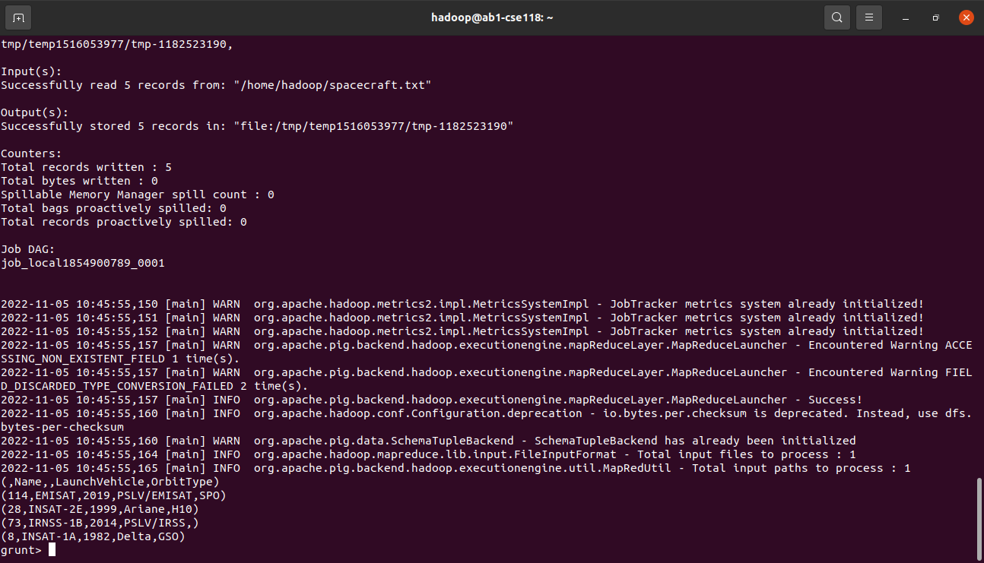

JOINS

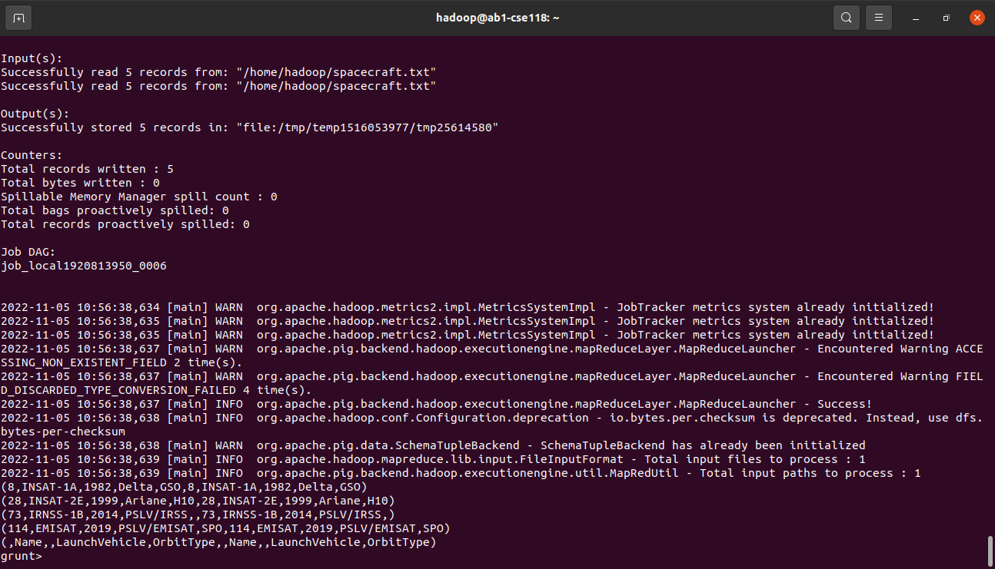

GROUP DATA

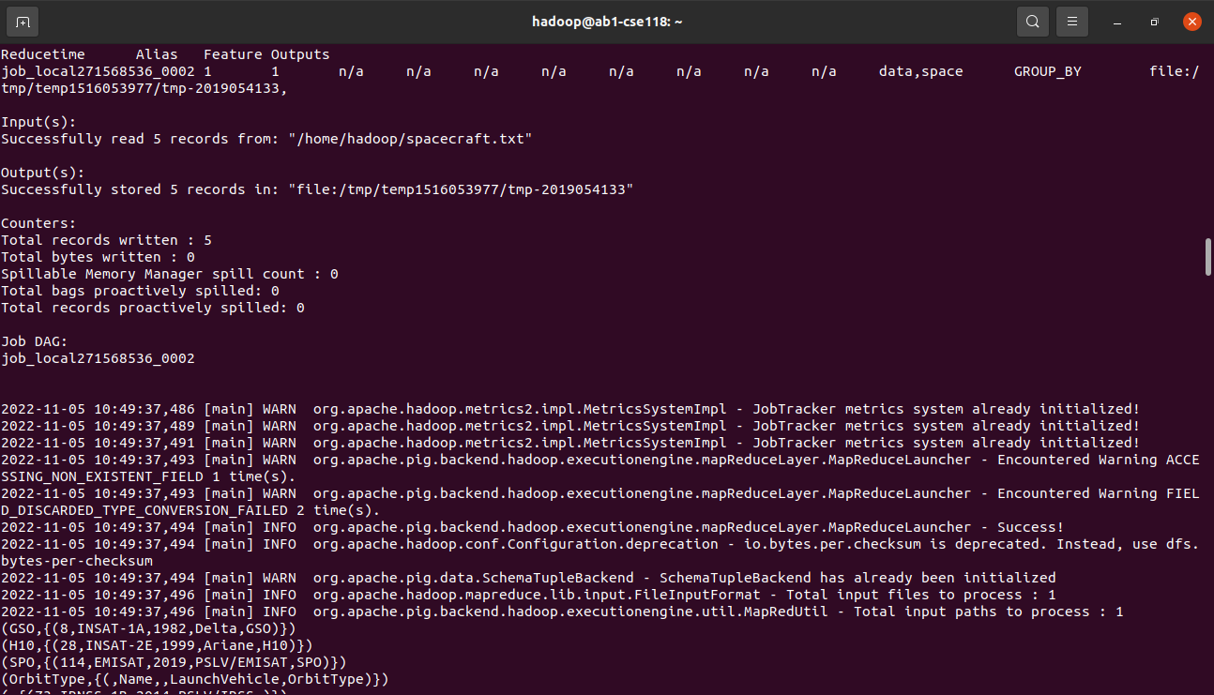

LIMIT DATA

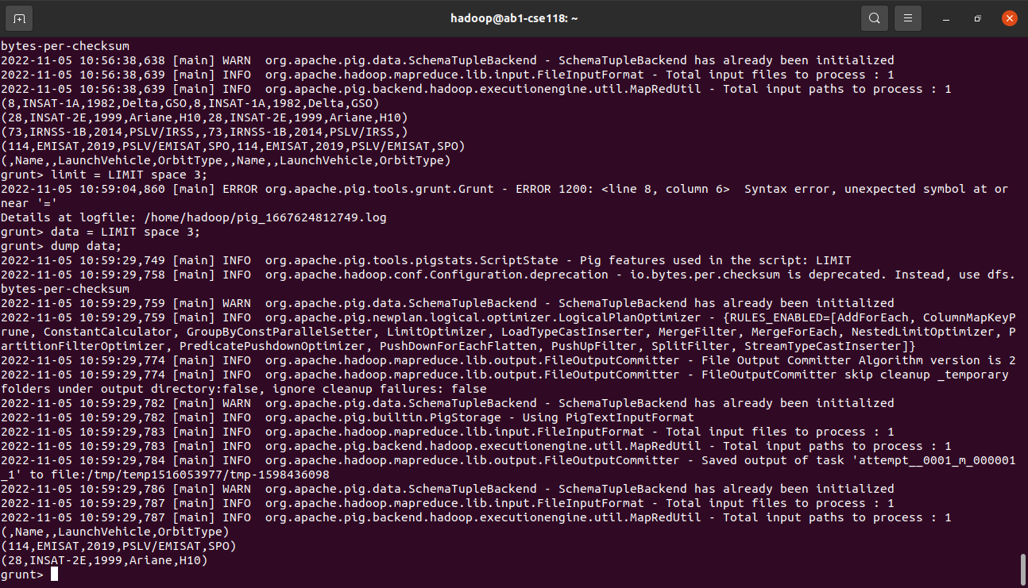

ORDER DATA



HIVE OUTPUT

CREATE TABLE

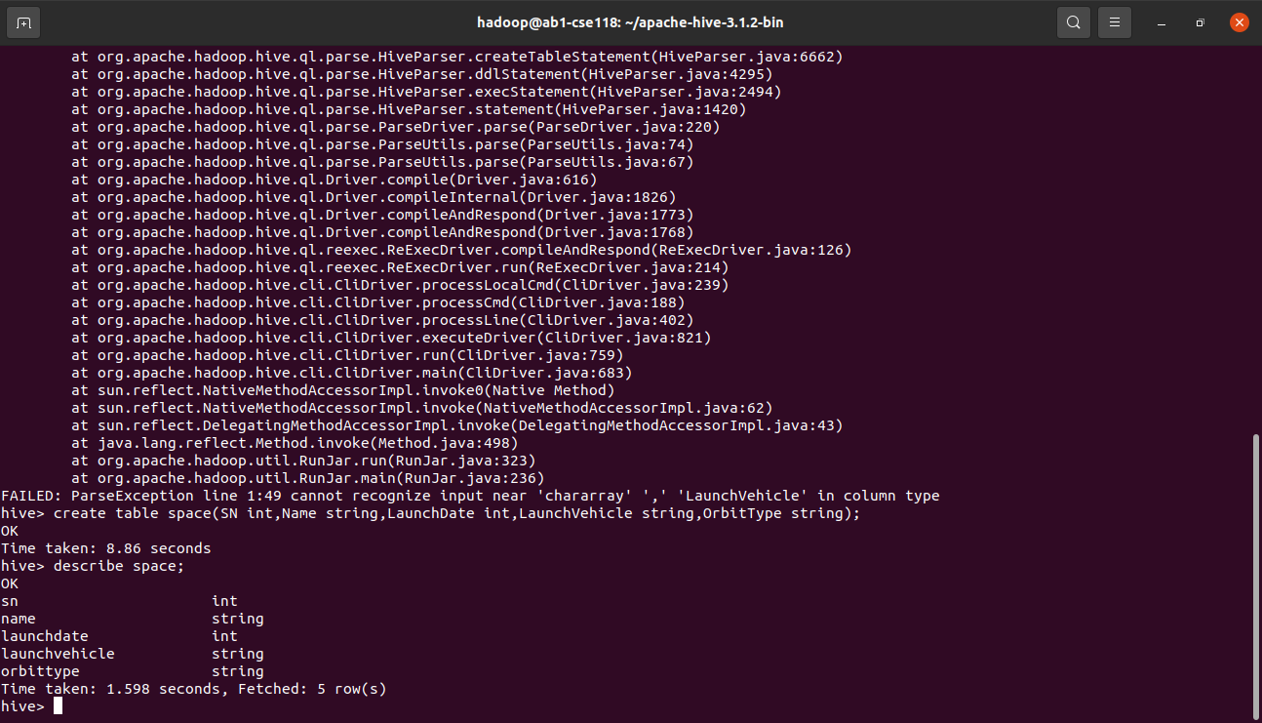

INSERTING VALUES

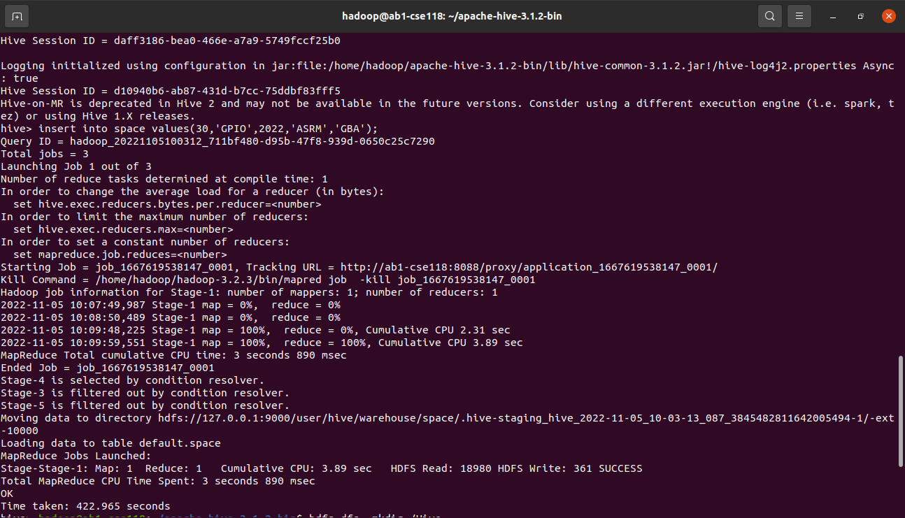

DISPLAY TABLE

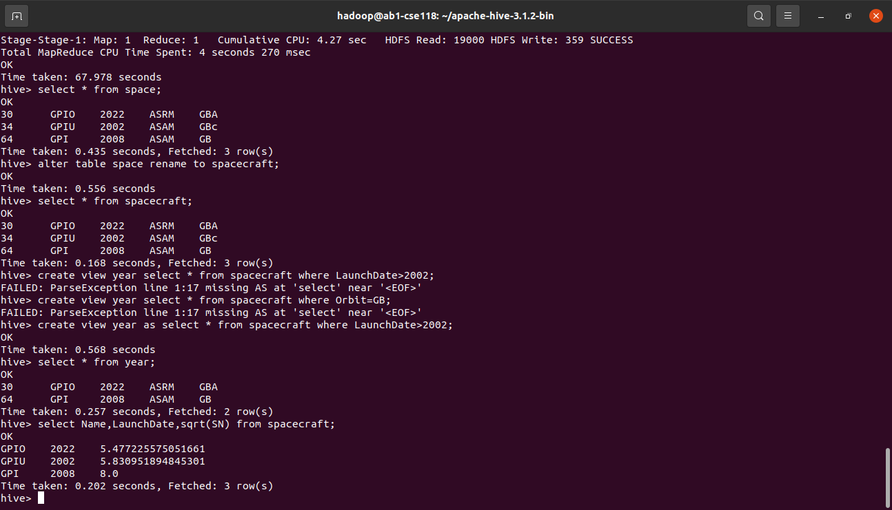

ALTER TABLE

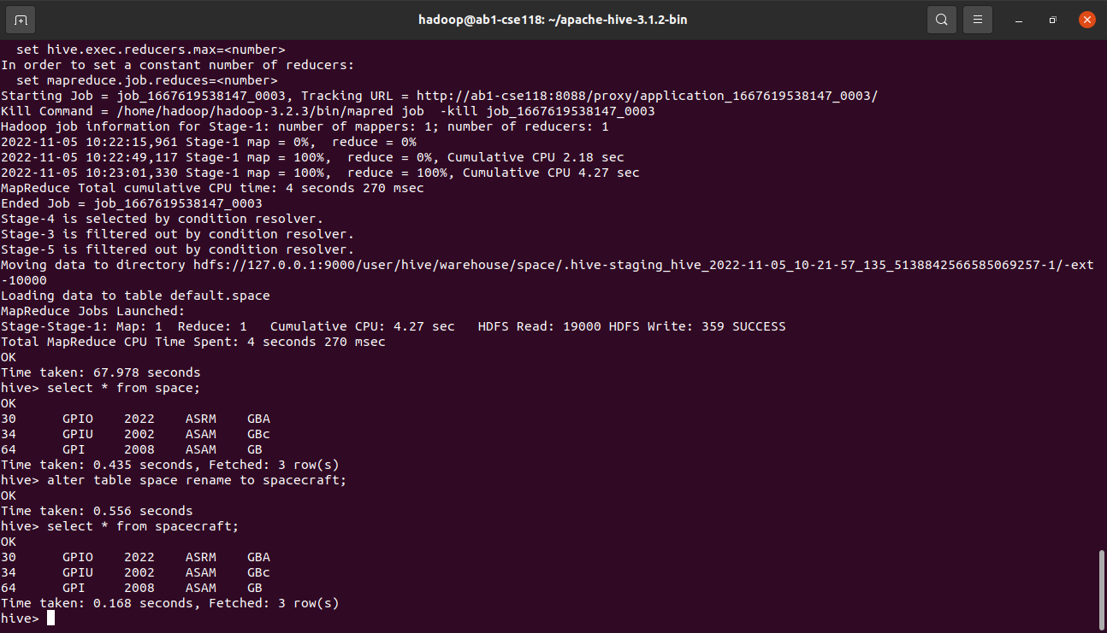

VIEWS



FUNCTIONS

