【秒杀】

技术选择型
- Springboot +接收请求并操作redis和mysql
- Redis 用于缓存+分布式锁
- Rocketmq 用于解耦 削峰，异步
- Mysql 用于存放真实的商品信息
- Mybatis 用于操作数据库的orm框架

架构图
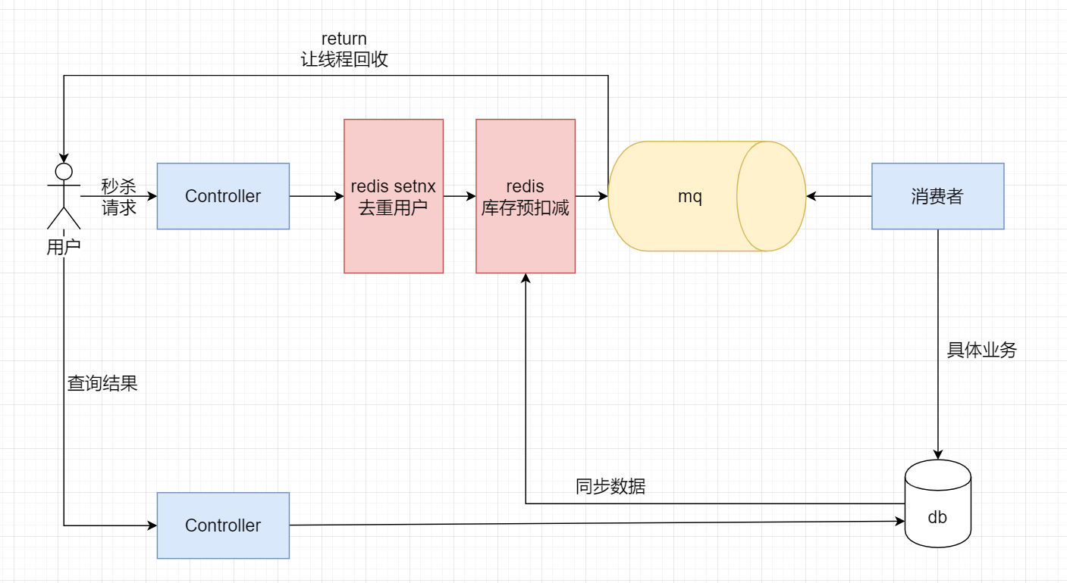

准备工作-数据库
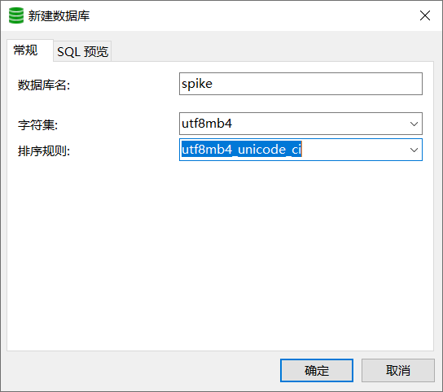
SET NAMES utf8mb4;
SET FOREIGN_KEY_CHECKS = 0;

-- ----------------------------
-- Table structure for goods
-- ----------------------------
DROP TABLE IF EXISTS `goods`;
CREATE TABLE `goods` (
`id` int(11) NOT NULL AUTO_INCREMENT,
`goods_name` varchar(255) CHARACTER SET utf8mb4 COLLATE utf8mb4_unicode_ci NULL DEFAULT NULL,
`price` decimal(10, 2) NULL DEFAULT NULL,
`stocks` int(255) NULL DEFAULT NULL,
`status` int(255) NULL DEFAULT NULL,
`pic` varchar(255) CHARACTER SET utf8mb4 COLLATE utf8mb4_unicode_ci NULL DEFAULT NULL,
`create_time` datetime(0) NULL DEFAULT NULL,
`update_time` datetime(0) NULL DEFAULT NULL,
PRIMARY KEY (`id`) USING BTREE
) ENGINE = InnoDB AUTO_INCREMENT = 4 CHARACTER SET = utf8mb4 COLLATE = utf8mb4_unicode_ci ROW_FORMAT = Dynamic;

-- ----------------------------
-- Records of goods
-- ----------------------------
INSERT INTO `goods` VALUES (1, '小米12s', 4999.00, 1000, 2, 'xxxxxx', '2023-02-23 11:35:56', '2023-02-23 16:53:34');
INSERT INTO `goods` VALUES (2, '华为mate50', 6999.00, 10, 2, 'xxxx', '2023-02-23 11:35:56', '2023-02-23 11:35:56');
INSERT INTO `goods` VALUES (3, '锤子pro2', 1999.00, 100, 1, NULL, '2023-02-23 11:35:56', '2023-02-23 11:35:56');

-- ----------------------------
-- Table structure for order_records
-- ----------------------------
DROP TABLE IF EXISTS `order_records`;
CREATE TABLE `order_records` (
`id` int(11) NOT NULL AUTO_INCREMENT,
`user_id` int(11) NULL DEFAULT NULL,
`order_sn` varchar(255) CHARACTER SET utf8mb4 COLLATE utf8mb4_unicode_ci NULL DEFAULT NULL,
`goods_id` int(11) NULL DEFAULT NULL,
`create_time` datetime(0) NULL DEFAULT NULL,
PRIMARY KEY (`id`) USING BTREE
) ENGINE = InnoDB AUTO_INCREMENT = 1 CHARACTER SET = utf8mb4 COLLATE = utf8mb4_unicode_ci ROW_FORMAT = Dynamic;

SET FOREIGN_KEY_CHECKS = 1;

创建项目选择依赖spike-web（接受用户秒杀请求）

Pom.xml
<?xml version="1.0" encoding="UTF-8"?>
<project xmlns="http://maven.apache.org/POM/4.0.0" xmlns:xsi="http://www.w3.org/2001/XMLSchema-instance"
xsi:schemaLocation="http://maven.apache.org/POM/4.0.0 https://maven.apache.org/xsd/maven-4.0.0.xsd">
<modelVersion>4.0.0</modelVersion>
<parent>
<groupId>org.springframework.boot</groupId>
<artifactId>spring-boot-starter-parent</artifactId>
<version>2.6.13</version>
<relativePath/> <!-- lookup parent from repository -->
</parent>
<groupId>com.powernode</groupId>
<artifactId>spike-web</artifactId>
<version>0.0.1-SNAPSHOT</version>
<name>spike-web</name>
<description>Demo project for Spring Boot</description>
<properties>
<java.version>1.8</java.version>
</properties>
<dependencies>
<dependency>
<groupId>org.springframework.boot</groupId>
<artifactId>spring-boot-starter-data-redis</artifactId>
</dependency>
<dependency>
<groupId>org.springframework.boot</groupId>
<artifactId>spring-boot-starter-web</artifactId>
</dependency>
<dependency>
<groupId>org.springframework.boot</groupId>
<artifactId>spring-boot-configuration-processor</artifactId>
<optional>true</optional>
</dependency>
<dependency>
<groupId>org.projectlombok</groupId>
<artifactId>lombok</artifactId>
<optional>true</optional>
</dependency>
<dependency>
<groupId>org.springframework.boot</groupId>
<artifactId>spring-boot-starter-test</artifactId>
<scope>test</scope>
</dependency>
<!-- rocketmq的依赖 -->
<dependency>
<groupId>org.apache.rocketmq</groupId>
<artifactId>rocketmq-spring-boot-starter</artifactId>
<version>2.2.1</version>
</dependency>
<dependency>
<groupId>com.alibaba.fastjson2</groupId>
<artifactId>fastjson2</artifactId>
<version>2.0.14</version>
</dependency>
<dependency>
<groupId>org.apache.commons</groupId>
<artifactId>commons-pool2</artifactId>
</dependency>
</dependencies>
<build>
<plugins>
<plugin>
<groupId>org.springframework.boot</groupId>
<artifactId>spring-boot-maven-plugin</artifactId>
<configuration>
<excludes>
<exclude>
<groupId>org.projectlombok</groupId>
<artifactId>lombok</artifactId>
</exclude>
</excludes>
</configuration>
</plugin>
</plugins>
</build>
</project>

修改配置文件
server:
port: 7001
spring:
application:
name: spike-web
redis:
host: 127.0.0.1
port: 6379
database: 0
lettuce:
pool:
enabled: true
max-active: 100
max-idle: 20
min-idle: 5
rocketmq:
name-server: 192.168.188.129:9876 # rocketMq的nameServer地址
producer:
group: powernode-group # 生产者组别
send-message-timeout: 3000 # 消息发送的超时时间
retry-times-when-send-async-failed: 2 # 异步消息发送失败重试次数
max-message-size: 4194304 # 消息的最大长度

创建SpikeController
package com.powernode.controller;
import com.alibaba.fastjson.JSON;
import org.apache.rocketmq.client.producer.SendCallback;
import org.apache.rocketmq.client.producer.SendResult;
import org.apache.rocketmq.spring.core.RocketMQTemplate;
import org.springframework.beans.factory.annotation.Autowired;
import org.springframework.data.redis.core.StringRedisTemplate;
import org.springframework.web.bind.annotation.GetMapping;
import org.springframework.web.bind.annotation.RestController;
import java.util.HashMap;
import java.util.concurrent.atomic.AtomicInteger;
@RestController
public class SeckillController {
@Autowired
private StringRedisTemplate redisTemplate;
@Autowired
private RocketMQTemplate rocketMQTemplate;
/**
* 压测时自动是生成用户id
*/
AtomicInteger ai = new AtomicInteger(0);
/**
* 1.一个用户针对一种商品只能抢购一次
* 2.做库存的预扣减 拦截掉大量无效请求
* 3.放入mq 异步化处理订单
*
* @return
*/
@GetMapping("doSeckill")
public String doSeckill(Integer goodsId /*, Integer userId*/) {
int userId = ai.incrementAndGet();
// unique key 唯一标记 去重
String uk = userId + "-" + goodsId;
// set nx set if not exist
Boolean flag = redisTemplate.opsForValue().setIfAbsent("seckillUk:" + uk, "");
if (!flag) {
return "您以及参与过该商品的抢购，请参与其他商品抢购!";
}
// 假设库存已经同步了 key:goods_stock:1 val:10
Long count = redisTemplate.opsForValue().decrement("goods_stock:" + goodsId);
// getkey java setkey 先查再写 再更新 有并发安全问题
if (count < 0) {
return "该商品已经被抢完，请下次早点来哦O(∩_∩)O";
}
// 放入mq
HashMap<String, Integer> map = new HashMap<>(4);
map.put("goodsId", goodsId);
map.put("userId", userId);
rocketMQTemplate.asyncSend("seckillTopic3", JSON.toJSONString(map), new SendCallback() {
@Override
public void onSuccess(SendResult sendResult) {
System.out.println("发送成功" + sendResult.getSendStatus());
}
@Override
public void onException(Throwable throwable) {
System.err.println("发送失败" + throwable);
}
});
return "拼命抢购中,请稍后去订单中心查看";
}
}

创建项目选择依赖spike-service（处理秒杀）
<?xml version="1.0" encoding="UTF-8"?>
<project xmlns="http://maven.apache.org/POM/4.0.0" xmlns:xsi="http://www.w3.org/2001/XMLSchema-instance"
xsi:schemaLocation="http://maven.apache.org/POM/4.0.0 https://maven.apache.org/xsd/maven-4.0.0.xsd">
<modelVersion>4.0.0</modelVersion>
<parent>
<groupId>org.springframework.boot</groupId>
<artifactId>spring-boot-starter-parent</artifactId>
<version>2.6.13</version>
<relativePath/> <!-- lookup parent from repository -->
</parent>
<groupId>com.powernode</groupId>
<artifactId>spike-service</artifactId>
<version>0.0.1-SNAPSHOT</version>
<name>spike-service</name>
<description>Demo project for Spring Boot</description>
<properties>
<java.version>1.8</java.version>
</properties>
<dependencies>
<dependency>
<groupId>org.springframework.boot</groupId>
<artifactId>spring-boot-starter-data-redis</artifactId>
</dependency>
<dependency>
<groupId>org.springframework.boot</groupId>
<artifactId>spring-boot-starter-jdbc</artifactId>
</dependency>
<dependency>
<groupId>org.springframework.boot</groupId>
<artifactId>spring-boot-starter-web</artifactId>
</dependency>
<dependency>
<groupId>org.mybatis.spring.boot</groupId>
<artifactId>mybatis-spring-boot-starter</artifactId>
<version>2.3.0</version>
</dependency>
<dependency>
<groupId>com.mysql</groupId>
<artifactId>mysql-connector-j</artifactId>
<scope>runtime</scope>
</dependency>
<dependency>
<groupId>org.springframework.boot</groupId>
<artifactId>spring-boot-configuration-processor</artifactId>
<optional>true</optional>
</dependency>
<dependency>
<groupId>org.projectlombok</groupId>
<artifactId>lombok</artifactId>
<optional>true</optional>
</dependency>
<dependency>
<groupId>org.springframework.boot</groupId>
<artifactId>spring-boot-starter-test</artifactId>
<scope>test</scope>
</dependency>
<dependency>
<groupId>com.alibaba</groupId>
<artifactId>druid-spring-boot-starter</artifactId>
<version>1.2.6</version>
</dependency>
<!-- rocketmq的依赖 -->
<dependency>
<groupId>org.apache.rocketmq</groupId>
<artifactId>rocketmq-spring-boot-starter</artifactId>
<version>2.2.1</version>
</dependency>
<dependency>
<groupId>org.apache.commons</groupId>
<artifactId>commons-pool2</artifactId>
</dependency>
<dependency>
<groupId>com.alibaba.fastjson2</groupId>
<artifactId>fastjson2</artifactId>
<version>2.0.14</version>
</dependency>
</dependencies>
<build>
<plugins>
<plugin>
<groupId>org.springframework.boot</groupId>
<artifactId>spring-boot-maven-plugin</artifactId>
<configuration>
<excludes>
<exclude>
<groupId>org.projectlombok</groupId>
<artifactId>lombok</artifactId>
</exclude>
</excludes>
</configuration>
</plugin>
</plugins>
</build>
</project>

修改yml文件
server:
port: 7002
spring:
application:
name: spike-service
datasource:
driver-class-name: com.mysql.cj.jdbc.Driver
url: jdbc:mysql://127.0.0.1:3306/spike?useUnicode=true&characterEncoding=UTF-8&serverTimezone=UTC
username: root
password: 123456
type: com.alibaba.druid.pool.DruidDataSource
redis:
host: 127.0.0.1
port: 6379
database: 0
lettuce:
pool:
enabled: true
max-active: 100
max-idle: 20
min-idle: 5
mybatis:
configuration:
log-impl: org.apache.ibatis.logging.stdout.StdOutImpl
mapper-locations: classpath*:mapper/*.xml
rocketmq:
name-server: 192.168.188.129:9876

逆向生成实体类等

修改启动类
@SpringBootApplication
@MapperScan(basePackages = {"com.powernode.mapper"})
public class SpikeServiceApplication {
public static void main(String[] args) {
SpringApplication.run(SpikeServiceApplication.class, args);
}
}

修改GoodsMapper
List<Goods> selectSeckillGoods();

修改GoodsMapper.xml
<!-- 查询数据库中需要参于秒杀的商品数据 status = 2 -->
<select id="selectSeckillGoods" resultMap="BaseResultMap">
select `id`,`stocks` from goods where `status` = 2
</select>

同步mysql数据到redis

方法1
package com.powernode.config;
import com.powernode.domain.Goods;
import com.powernode.mapper.GoodsMapper;
import org.springframework.beans.factory.annotation.Autowired;
import org.springframework.data.redis.core.StringRedisTemplate;
import org.springframework.scheduling.annotation.Scheduled;
import org.springframework.stereotype.Component;
import org.springframework.util.CollectionUtils;
import javax.annotation.PostConstruct;
import java.util.List;
/**
* 将mysql的参与抢购的商品的数据
* 同步到redis里面去
* 在上游服务需要使用redis来做库存的预扣减
*/
@Component
public class DataSyncConfig {
@Autowired
private GoodsMapper goodsMapper;
@Autowired
private StringRedisTemplate redisTemplate;
// 业务场景是搞一个定时任务 每天10点开启
// 为了 测试方便 项目已启动就执行一次
/**
* spring bean的生命周期
* 在当前对象 实例化完以后
* 属性注入以后
* 执行 PostConstruct 注解的方法
*/
@PostConstruct
@Scheduled(cron = "0 10 0 0 0 ?")
public void initData() {
List<Goods> goodsList = goodsMapper.selectSeckillGoods();
if (CollectionUtils.isEmpty(goodsList)) {
return;
}
goodsList.forEach(goods -> redisTemplate.opsForValue().set("goods_stock:" + goods.getId(), goods.getStocks().toString()));
}
}

方法2
package com.powernode.data;
import com.powernode.domain.Goods;
import com.powernode.mapper.GoodsMapper;
import org.springframework.boot.CommandLineRunner;
import org.springframework.data.redis.core.StringRedisTemplate;
import org.springframework.data.redis.core.ValueOperations;
import org.springframework.stereotype.Component;
import javax.annotation.Resource;
import java.util.List;
/**
* 描述: 暂无
* 作者: 动力节点
* 时间: 11:12
*/
@Component
public class MySqlToRedis2 implements CommandLineRunner {
@Resource
private GoodsMapper goodsMapper;
@Resource
private StringRedisTemplate stringRedisTemplate;
@Override
public void run(String... args) throws Exception {
initData();
}
private void initData() {
//1,查询数据库中需要参于秒杀的商品数据
List<Goods> goodsList = goodsMapper.querySpikeGoods();
ValueOperations<String, String> operations = stringRedisTemplate.opsForValue();
// //2,把数据同步到Redis
for (Goods goods : goodsList) {
operations.set("goods:" + goods.getGoodsId(), goods.getTotalStocks().toString());
}
}
}

创建秒杀监听
package com.powernode.listener;
import com.alibaba.fastjson.JSON;
import com.alibaba.fastjson.JSONObject;
import com.powernode.service.GoodsService;
import org.apache.rocketmq.common.message.MessageExt;
import org.apache.rocketmq.spring.annotation.RocketMQMessageListener;
import org.apache.rocketmq.spring.core.RocketMQListener;
import org.springframework.beans.factory.annotation.Autowired;
import org.springframework.data.redis.core.StringRedisTemplate;
import org.springframework.stereotype.Component;
import java.util.concurrent.TimeUnit;
/**
* 时间 14:27
* 默认负载均衡模式
* 默认多线程消费
*/
@Component
@RocketMQMessageListener(topic = "seckillTopic3", consumerGroup = "seckill-consumer-group")
public class SeckillMsgListener implements RocketMQListener<MessageExt> {
@Autowired
private GoodsService goodsService;
@Autowired
private StringRedisTemplate redisTemplate;
// 20s
int time = 20000;
@Override
public void onMessage(MessageExt message) {
String s = new String(message.getBody());
JSONObject jsonObject = JSON.parseObject(s);
Integer goodsId = jsonObject.getInteger("goodsId");
Integer userId = jsonObject.getInteger("userId");
// 做真实的抢购业务 减库存 写订单表 todo 答案2 但是不符合分布式
// synchronized (SeckillMsgListener.class) {
// goodsService.realDoSeckill(goodsId, userId);
// }
// 自旋锁 一般 mysql 每秒1500/s写 看数量 合理的设置自旋时间 todo 答案3
int current = 0;
while (current <= time) {
// 一般在做分布式锁的情况下 会给锁一个过期时间 防止出现死锁的问题
Boolean flag = redisTemplate.opsForValue().setIfAbsent("goods_lock:" + goodsId, "", 10, TimeUnit.SECONDS);
if (flag) {
try {
goodsService.realDoSeckill(goodsId, userId);
return;
} finally {
redisTemplate.delete("goods_lock:" + goodsId);
}
} else {
current += 200;
try {
Thread.sleep(200);
} catch (InterruptedException e) {
e.printStackTrace();
}
}
}
}
}

修改GoodsService
void realDoSeckill(Integer goodsId, Integer userId);

修改GoodsServiceImpl
@Resource
private GoodsMapper goodsMapper;
@Autowired
private OrderRecordsMapper orderRecordsMapper;
/**
*
* @param goodsId
* @param userId
*/
@Override
@Transactional(rollbackFor = RuntimeException.class)
public void realDoSeckill(Integer goodsId, Integer userId) {
// 扣减库存 插入订单表
Goods goods = goodsMapper.selectByPrimaryKey(goodsId);
int finalStock = goods.getStocks() - 1;
if (finalStock < 0) {
// 只是记录日志 让代码停下来 这里的异常用户无法感知
throw new RuntimeException("库存不足：" + goodsId);
}
goods.setStocks(finalStock);
goods.setUpdateTime(new Date());
// insert 要么成功 要么报错 update 会出现i<=0的情况
// update goods set stocks = 1 where id = 1 没有行锁
int i = goodsMapper.updateByPrimaryKey(goods);
if (i > 0) {
// 写订单表
OrderRecords orderRecords = new OrderRecords();
orderRecords.setGoodsId(goodsId);
orderRecords.setUserId(userId);
orderRecords.setCreateTime(new Date());
// 时间戳生成订单号
orderRecords.setOrderSn(String.valueOf(System.currentTimeMillis()));
orderRecordsMapper.insert(orderRecords);
}
}
/**
* mysql行锁 innodb 行锁
* 分布式锁
* todo 答案1
*
* @param goodsId
* @param userId
*/
// @Override
// @Transactional(rollbackFor = RuntimeException.class)
// public void realDoSeckill(Integer goodsId, Integer userId) {
// // update goods set stocks = stocks - 1 ,update_time = now() where id = #{value}
// int i = goodsMapper.updateStocks(goodsId);
// if (i > 0) {
// // 写订单表
// OrderRecords orderRecords = new OrderRecords();
// orderRecords.setGoodsId(goodsId);
// orderRecords.setUserId(userId);
// orderRecords.setCreateTime(new Date());
// // 时间戳生成订单号
// orderRecords.setOrderSn(String.valueOf(System.currentTimeMillis()));
// orderRecordsMapper.insert(orderRecords);
// }
// }

