User manual for blox gone wild!

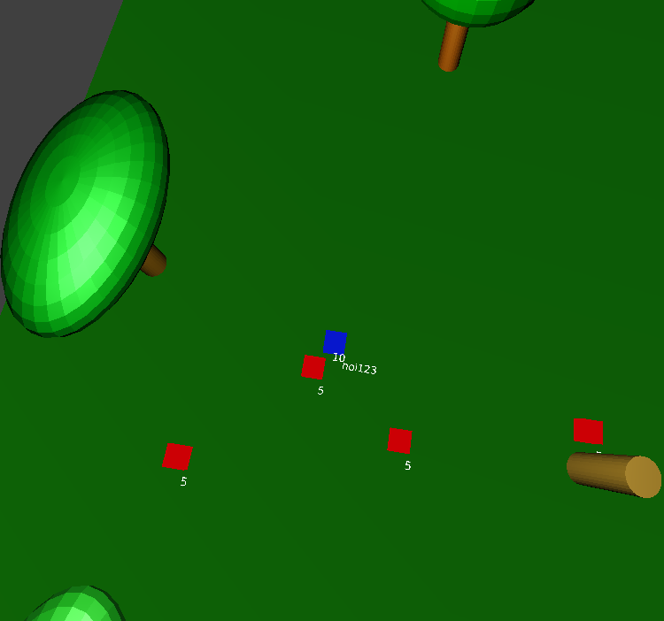

|  |  |
| --- | --- |
| Team: | Tentakels (groen-4) |
| Members: | Joey, Jacintha, Osman. |
| commissioning company: | Blender institute |

Table of Contents

Introduction 3

Welcome to Blox Gone wild! 3

How to start the game 4

How to play 5

The goal 6

Scoring points 6

The end of the game 6

The quick-guide 7

# Introduction

## Welcome to Blox Gone wild!

This is a fun multiplayer adventure game set in the mysterious haunted forest. This game is made to challenge your friends to a duel! Who can survive the longest? And who can take down as many wild blox while they are in the haunted forest? Let’s find out! *Beware* your ability to survive will be tested!

# How to start the game

After running the program, the start menu will appear. Here you will find three options. The first option will be **‘Story’**. If you are ready to play the game, press the story button. The second option will be **‘Options’**, if you forget how the keys work, this gives a very short game manual, that tells you the basics of this game. If you want to stop the game, you can press the **‘Exit’** option.

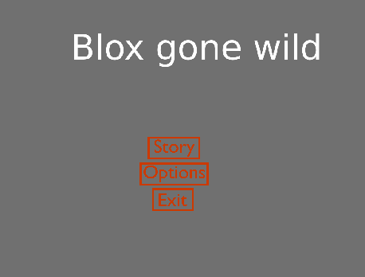

# How to play

After you have pressed the **‘Story’** option (see ‘How to start the game’) you will enter the game scene.

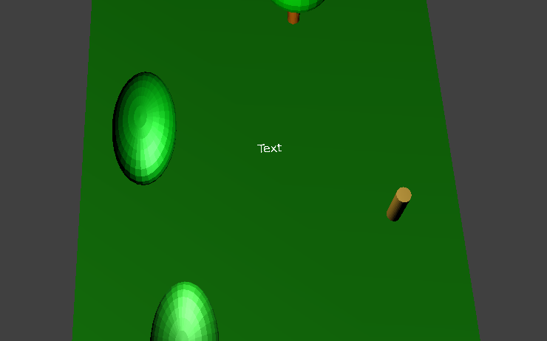

Here you can see the ‘Text’ box. This is where you should enter your username. Do this by first deleting the text (using your backspace key) and then entering your own username. This could be anything you like! If you are ready to enter the game, press enter.

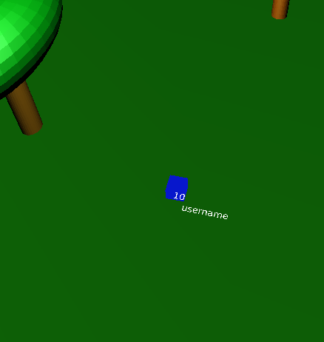

After pressing enter, a blue cube will appear in the middle of the scene. This cube is your player! It carries your username with it, so you can always find yourself on the screen. Next to the username you will see a number, this number will be your health. At the start of the game it will be ten.

## The goal

The goal of this game is to kill as many blox as you can, or better to kill more blox than your friend! The person that can kill the most blox before he/she dies wins the game. When you enter the playing field, wild blox will try to chase you and attack you. If they get too close and touch your avatar, you will lose 2 health. Starting off with 10, you can only be hit 5 times and then you will be dead.

## Scoring points

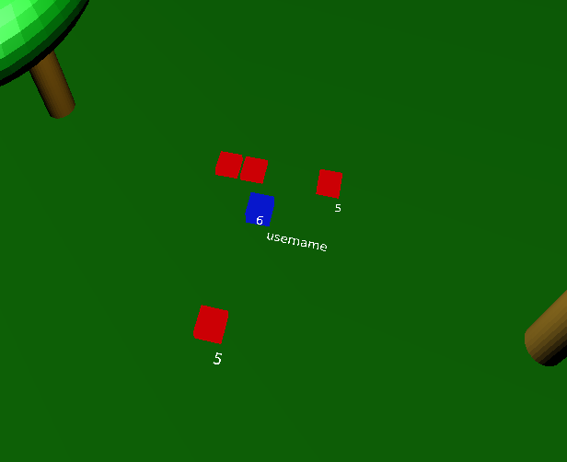To get points you will have to kill the wild blox. This can be done by moving around and attacking them. To move around you need the **W, A, S, D** keys. **W** will move you forward, **A** will move you to the left, **S** will move you backwards and **D** will move you to the right. In order to kill the enemies, you will need your **left mouse button**. But the enemies need to be in range. Think of this as holding a sword and striking with your mouse button. If they are too far away the sword won’t reach them. Enemies will start off with a health of 5 (you can see their health by looking at the number they carry), but they will get stronger and faster the longer you survive. If you strike them, they will be pushed back and lose 2 health. If you kill an enemy they will explode, damaging surrounding enemies as well. But don’t worry their explosion won’t hurt you, you can only lose health by being touched by a blox. If you get touched by an enemy, you will lose 2 health and the enemy that touched you will explode, yet again damaging surrounding enemies as well. This gives you a small reset moment after you have been attacked.

## The end of the game

After you have both died, the game will end. When the game ends you will see both your scores on the screen. The player with the highest score, wins the game!

# The quick-guide

Press STORY to start the game.

*You will now enter the playing field.*

Enter your USERNAME and press ENTER.

*Your avatar will now spawn on the playing field with your username and health.*

Use WASD-movement to walk around.

*Your avatar will move around.*

Press the LEFT MOUSE BUTTON when enemies are near.

*Enemies will be pushed back and lose 2 HP.*

**Throughout the game: avoid being touched and hit as many enemies as possible!**

Have fun playing this thrilling game!

|  |  |
| --- | --- |
| Team: | Tentakels (groen-4) |
| Members: | Joey, Jacintha, Osman. |
| commissioning company: | Blender institute |