## Functional diversity in aquatic ecosystems yields enhanced nutritional benefits

## Abstract

While food provisioning is one of the most widely acknowledged ecosystem services provided by aquatic ecosystems, the role of seafood as a source of valuable micronutrients scarce in the human diet is often overlooked. The ecological mechanisms responsible for a nutritionally diverse set of seafood species are not well understood, despite heavy research emphasis on the ecological mechanisms responsible for fisheries productivity. A primary challenge in linking ecological processes to human well being is identifying comparable metrics for ecological properties and human benefits. For nutritional value, one metric that facilitates comparisons is the nutrient content in an edible portion relative to daily reference intake values (DRI). The nutrition benefits that humans derive from seafood are not directly related to the whole body stoichiometry of aquatic species, since the commonly consumed parts of aquatic species (i.e. the edible portion), range from the whole body (i.e. for shrimps) to highly restricted portions of muscle tissue (i.e. tuna fillets), and nutrients are not evenly distributed across all tissues. To address this issue of selective human dietary practices, we used dietary food composition data, which is restricted to the edible portion, to analyze the relationship between species’ traits and their nutritional value in terms of DRI. We find that there is a high degree of variability in nutrient profiles across taxa, and that increasing functional diversity contributes to increased dietary nutritional diversity. Finally, we test whether functional traits explain variation in species’ nutritional value to human consumers, a metric of human well-being, for 430 species of fish from all major oceanic and freshwater eco-regions. We find that an ecological functional trait-based approach is effective at simplifying the nutritional complexity of aquatic food webs into a few key axes that strongly control the composition of micronutrients in fish assemblages. For some, but not all, nutrients we analyzed (e.g. Ca, Hg, EPA, DHA), the nutrient content of edible portions varied predictably among species with latitude and body size, consistent with the physiological functional roles of micronutrients in fish. Our results suggest that the availability of micronutrients in fish assemblages may depend on geography and functional composition of the catch. Our approach integrates ecological variation and patterns in the human consumption of species to explicitly link ecological structure with one metric of human well-being to suggest that a diverse fish assemblage can support a more nutritious diet to local seafood consumers.

**Introduction**

**Nutrition as an ecosystem function and service**

Despite its clear links to human well being, the role of aquatic assemblages in provisioning of essential micronutrients has been under-represented in marine ecosystem service concepts. For both human and non-human consumers, the nutritional quality of prey species plays a fundamental role in ecosystem function. Food webs characterized by nutritionally valuable prey support higher consumer and predator biomass and have higher trophic transfer efficiencies (Hecky 1984, Muller Navarra et al. 2000, Brett et al. 2009). Changes in forage fish communities from lipid-rich to lipid-poor fish in the Pacific Ocean have caused predatory marine birds and mammals to shift their diet to less nutritionally valuable lipid-poor fish and suffer population declines (Rosen and Trites 2006; Romano et al. 2006, Osterblom et al. 2008).

For human consumers, fish are a good source of high quality protein, a range of micronutrients and essential fatty acids (Tacon and Metian 2013). In 2009, aquatic species accounted for 16.6% of the global total supply of animal protein, providing more than three billion people with almost 20% of their average per capita intake of animal protein (FAO ref). However, the value of fish as a source of essential micronutrients may be even greater than as a source of protein (Allison et al. 2007). Fish is important in the diets of many poor populations suffering from vitamin and mineral deficiencies (Roos et al. 2007, Tacon and Metian 2013). In many vulnerable communities around the world, fish consumption plays an important role in combating micronutrient deficiencies (Kawarazuka and Bene 2011). For example, in rural Bangladesh, some of the poorest communities are heavily dependent on small fish from capture fisheries to meet their micronutrient needs. Consumption of small indigenous fishes contributes 40% and 31% of the total recommended intakes of vitamin A and calcium, respectively, at household level in the peak fish production season (Roos et al. 2007). Locally caught seafood contributes significantly to micronutrient intakes in Arctic Canadian Indigenous populations (Kuhnlein and Receveur 2007, Johnson-Down and Egeland 2010).

**Dietary Reference Intake as a metric of nutritional value**

The ecology of food security is not just about predicting yields, it is about understanding the ecological conditions that lead to a stable supply of nutritionally diverse foods. A primary challenge of linking ecological processes with human well-being is finding comparable units and metrics for ecological properties and human benefits. In the context of human nutrition, one metric that facilitates comparisons is the nutrient content in an edible portion relative to dietary reference intake values (DRI). The value of a fish species in terms of human nutrition benefits can be quantified as the nutrient content in an edible portion relative to Dietary Reference Intake (DRI) values. The DRI is the daily intake level of a nutrient that is considered to be sufficient to meet the requirements of 97–98% of healthy individuals in every demographic (National Academies of Sciences 2011).

Fish species vary widely in their concentration of essential nutrients (USDA 2011). For example, assuming a serving size of 85g of fish, sardines (1.9 g DHA per 100 g tissue) and Pacific herring (0.83 g DHA/100g) provide the recommended level of 1.0g/day EPA and DHA in a single serving, while pink salmon, canary rockfish and surf smelt would require 1.2-1.5 servings, while pacific hake (0.15g/100g DHA) and pollock (0.24 g DHA/100g) would require 4-5 servings to meet the recommended daily requirements (Hyuhn and Kitts 2009). Thus, not all species are equally nutritionally valuable. This variability in essential fatty acid (EFA) content per serving size may be related to the total fat content of the fish: the characteristically lean fish like pollock and hake have relatively low contents of EFAs, while the more lipid-rich fish have higher EFA contents.

Here, we draw on two well-established nutritional metrics: nutrient content/100g edible portion and DRI, as well as ecological traits such as body size and trophic position, to explicitly characterize the relationship between aquatic species’ ecological traits such as body size and their nutritional value for human well-being.

**Micronutrients in seafood and how humans consume them**

We hypothesize that species’ nutritional profiles are linked to functional traits because elements that are of nutritional value to humans also serve functional roles in organismal physiology and because human dietary practices map onto functional traits such as body size and (exo)skeleton morphology (table 1). Functional traits such as trophic position may be related to the nutritional content of seafood species because they affect the dietary range and quantity of nutrients to which an organism is exposed, as well as the physiological constraints on body composition (Simpson and Raubenheimer 2012). In aquatic food webs, some evidence suggests that nutritional profile may be related to species traits: the distribution of trace metals in fish tissues has been related to feeding guild (Bernhard and Andreae 1984), body size, stage of life cycle and reproductive status (Shearer 1984). Disease state, water quality and other environmental factors may also modify tissue mineral distribution (Lall and Olivier 1993). Although aquatic organisms readily absorb metals from the environment, the ability to regulate abnormal concentrations varies among species. Certain species are able to excrete high proportions of excessive metal intake and regulate the concentration in the body at relatively normal levels (Bryan 1976). This occurs for essential elements such as Cu, Zn, and Fe. However, non-essential minerals such as Hg, Cd, and Pb are more poorly regulated (Karimi et al. 2006). Different metals localize or accumulate in different organs or tissues. For example, Fe concentrations are highest in hematopoietic tissues while Hg is most abundant in the muscle tissues. Since each element is under different levels of homeostatic control, we expect the relationship between elemental content and species’ traits to vary by nutrient. For those nutrients that are more tightly regulated, we expect more consistent patterns across species.

Not only are functional traits related to the ways in which nutrients accumulate in fish bodies, they are also related to the ways in which humans consume aquatic species. For example, in large bodied finfish such as tunas, human typically consume the muscle tissue only. In contrast, humans typically consume a much broader range of body tissues in crustacean taxa such as shrimps (i.e. whole body) and crabs (muscle tissue and organs such as the hepatopancreas). Taken together, the patterns of functional morphology and human dietary practices suggest that the edible portions of species from different taxonomic and functional groups may have vastly different nutrient profiles.

Here, we synthesize nutritional content data for the edible portions of 430 aquatic species from all major oceanic and freshwater ecoregions (Fig X). For each of these species, we also collected ecological trait data including body size, trophic position and habitat associations, which are broadly related to the function and form of species in aquatic systems (Woodward et al. 2005, other ref?). **We analyzed this dataset to (1) quantify variation in nutritional quality among aquatic taxa, (2) test whether ecological traits are related to variation in nutritional profile from the perspective of a human diet and (3) assess the contribution of species diversity to the nutritional benefits of a human diet that includes multiple seafood species.** We assessed the nutritional benefits provided by a seafood assemblage as the number of distinct micronutrient >15% DRI targets reached. We chose to analyze a selection of ions and compounds that affect the nutritional value to human consumers, while also being implicated in a range of biologically important processes that affect growth and reproduction. We examined fatty acid concentration (which reflects fish diet and physiological condition), a toxic metal for which increased concentrations are negative for humans (Hg), two metals beneficial at low concentrations but toxic at high concentrations (Zn and Fe) and one mineral (Ca). We applied this approach to a ‘global seafood’ diet, but this approach could be easily applied to the species available in local seafood diets.

## Methods

We aimed to document the range of variation in nutrient content across commonly consumed aquatic taxa. To understand how nutrient content varies among species, we tested whether ecological traits known to be both biologically important and exhibit predictable scaling relationships could explain this variation. [We synthesized SPATIALLY AND SIZE EXPLICIT DATA, TO IDENTIFY THRESHOLDS IN GEOGRAPHY AND OR BODY SIZE THAT INDICATE THAT A SPECIES ACHIEVES 25% RDI IN A SINGLE PORTION.]

### Literature search and data collection

To test how nutrient profile varies with ecological traits, we assembled a dataset of nutrient content in the edible portions of 400 aquatic species. We defined the nutritional profile of a species as the quantity of a given nutrient in 100 g of edible tissue - a metric that is commonly used in the human food composition literature (Nowak et al. 2014). We aimed to include as many species as possible, from marine and freshwater systems, covering a wide geographic range. We searched the literature for analytical compositional values for each of these species. We searched the peer-reviewed literature as well as food composition databases or tables, such as the Food and Agriculture Organization’s INFOODS database (FAO/INFOODS 2014) and the United States Department of Agriculture’s Nutrient Files (USDA 2012). We restricted our analysis to include only the edible portions of wild, raw fish (thus excluding prepared or farmed seafood items). Our dataset includes quantities for the following microelements: calcium; iron; zinc; mercury and two fatty acids: eicosapentaenoic acid (EPA); and docosahexaenoic acid (DHA). To address inconsistencies in fatty acid data reporting, we standardized fatty acid measurements using the fatty acid conversion factors proposed by Nowak et al. (2014).

Ecological trait information was collected for each species from FishBase (Froese and Pauly 2014) and SeaLifeBase (Palomares and Pauly 2014). We included body size (maximum length), fractional trophic position, temperature preference (using latitude as a proxy) and habitat preference (Marine, Freshwater, brackish…). We converted body length data into body mass, using established length-mass relationship data (*mass*= *a*length^b*). We used species-specific or taxon-specific *a* and *b* parameter values published in Froese et al. (2013).

### Statistical Analysis

We modeled the relationship between nutrient content and species’ traits with linear regression models using a log-transformed power function. The full model included the entire set of predictors:

ln(nutrient content) = *Β0.i* + *Β1.i*\*ln(body size)*latitude + *Β2.i*\*ln(body size)*(trophic position) + *Β3.i*\*ln(body size)*(habitat) + εi

We created models from subsets of the full model that represented hypotheses based on the known physiological roles of micronutrients **and their relationships to our set of predictors**. We identified the best subset of models using the Akaike Information Criterion, adjusted for small sample sizes (AICc). We used AICc, δaic and Akaike weights (w) to compare models. We ranked models based on w, and selected the set of models that produced a cumulative w > 0.95, meaning that we are 95% confident that the chosen set includes the best model (Burnham and Anderson 2002).

We report all models with AICc differences ( δaic = AICi − AICmin) less than or equal to two ( δaic ≤ 2). In cases where we could not obtain measurements of all traits for all species, we performed model selection on reduced datasets without missing values (Appendix A). To account for model uncertainty, we performed model averaging of coefficients in all models with δaic < 2, and included zeros as coefficients when variables did not enter a particular model (Burnham and Anderson 2002). We conducted all our analyses in R version 3.1.2 (R Core Development 2014) using the MuMIn package (<http://r-forge.r-project.org/projects/mumin/>).

-somewhere here, need to address multi-collinearity of predictor variables etc.

**Results:**

**Main messages:**

1. **There is considerable variability in nutritional profile among aquatic taxa (fig 1).**

Variability for each nutrient separately:

Calcium in the edible portion varied by over 3 orders of magnitude in the 99 species for which we found data, from an average of 10.78mg/100g in the cods, hakes and haddocks to 782.60 mg/100 mg in the abalones, winkles and conchs (Figure 1).

Zinc in the edible portion varied by two orders of magnitude in the 101 species for which we found data, from an average of 0.36 mg/100g in the cods, hakes and haddocks to 11.87 mg/100 mg in the oysters (Figure 1).

Iron in the edible portion varied by two orders of magnitude in the 238 species for which we found data, from an average of 0.19 mg/100g in the cods, hakes and haddocks to 20.31 mg/100 mg in the abalones, winkles and conchs (Figure 1).

EPA in the edible portion varied by an order of magnitude in the 238 species for which we found data, from an average of 0.02 g/100g in the sharks and rays to 0.53 g/100 g in the herrings, sardines, anchovies (Figure 1).

DHA in the edible portion varied by an order of magnitude in the 235 species for which we found data, from an average of 0.065 g/100g in the shrimps and prawns to 1.28 g/100 g in the Tunas, bonitos, billfishes (Figure 1).

Protein in the edible portion varied by an order of magnitude in the 251 species for which we found data, from an average of 10.68g/100g in the clams, cockles, arkshells to 21.85 g/100 g in the Tunas, bonitos, billfishes (Figure 1).

Fat in the edible portion varied by an order of magnitude in the 277 species for which we found data, from an average of 1.08 g/100g in the sharks and rays to 12.74 g/100 g in the shads (Figure 1).

2. **Functional groups have distinct multi-nutrient profiles (mds plot with finfish/crustaceans/molluscs color coded).**

Not sure how to write about this yet! But the result is that when considering just the minerals and all the micronutrients, the functional group (i.e. finfish vs. crustaceans vs molluscs) means in multivariate nutrient trait space are different from each other (PERMANOVA, p = 0.001)

1. **Within functional groups, some traits such body size and latitude are strongly associated with nutritional profile.**
2. **Few species contain reach DRI targets for multiple nutrients.**

**Figure 2.**

**This is how many species reach DRI targets, by nutrient:**

**10% RDI: calcium: 28/99, zinc: 39/101, iron: 23/104, EPA: 117/238, DHA: 168/235, Fat: 47/277, Protein: 251/251**

1. **Functional group diversity enhances dietary nutritional diversity and nutritional benefits that human communities may derive from seafood assemblages. (nutrient accumulation curve).**
2. **ADD SOME SORT OF CASE STUDY THAT LOOKS AT NUTRITIONAL FUNCTIONAL DIVERSITY IN A GIVEN COUNTRY OR TAXON??**

**Discussion:**

We found that the substantial variation in the nutritional content of an edible portion among seafood species can be explained partly major ecological traits: functional group, latitude, body size and habitat associations.

In particular, some functional groups, such as molluscs, have ….and this group may be particularly vulnerable to climate changes such as acidification.

In the context of DRI, very few species reach 25% of DRI for more than one micronutrient in a single portion. This means that to achieve RDI targets for a broad range of micronutrients, human diets must contain a variety of seafood species.

There is a much higher level of functional redundancy for macronutrients than micronutrients

Both local and global scales

Need a stronger stoichiometric framework for micronutrients.

Broader impact: food security and climate change

**List of figures:**

1. **Boxplot of nutrient concentrations, raw and in terms of DRI**

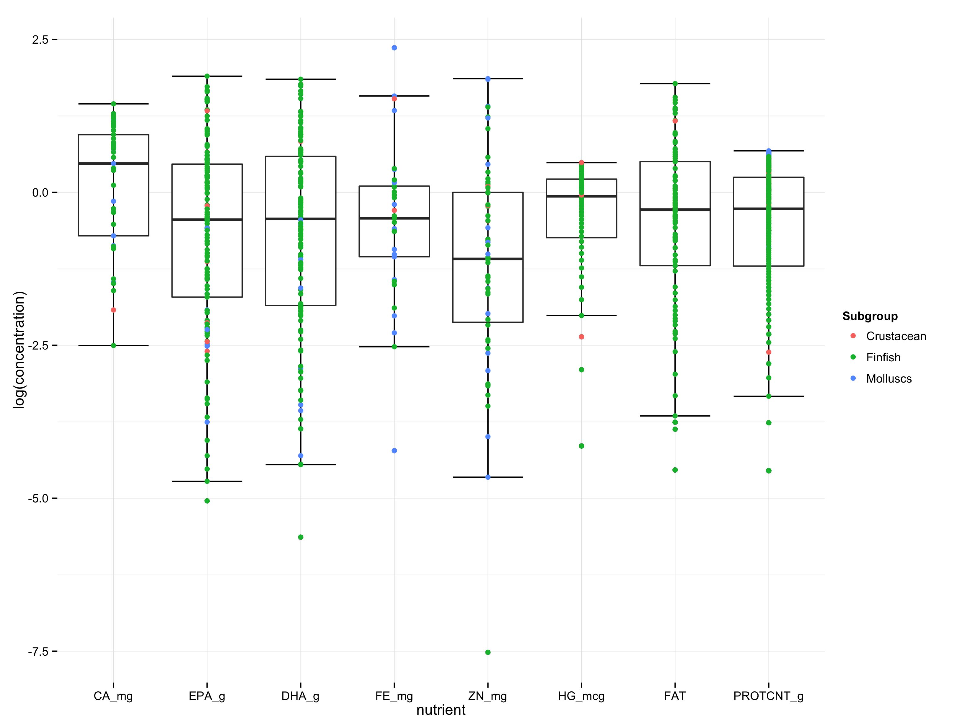

1. **Figure that shows proportion of body consumed and number of DRI targets**

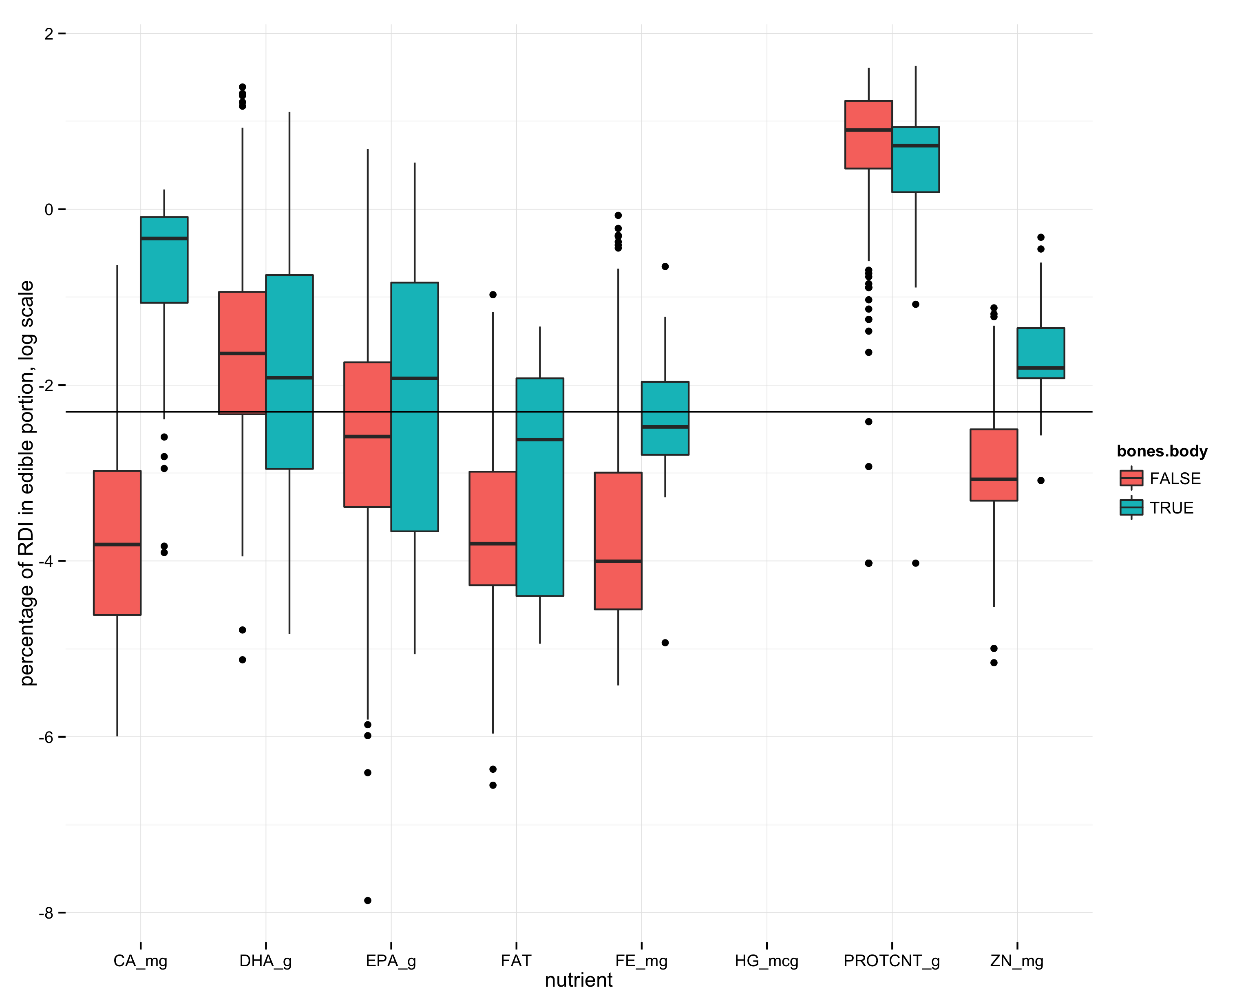

1. **nutrient accumulation curve**

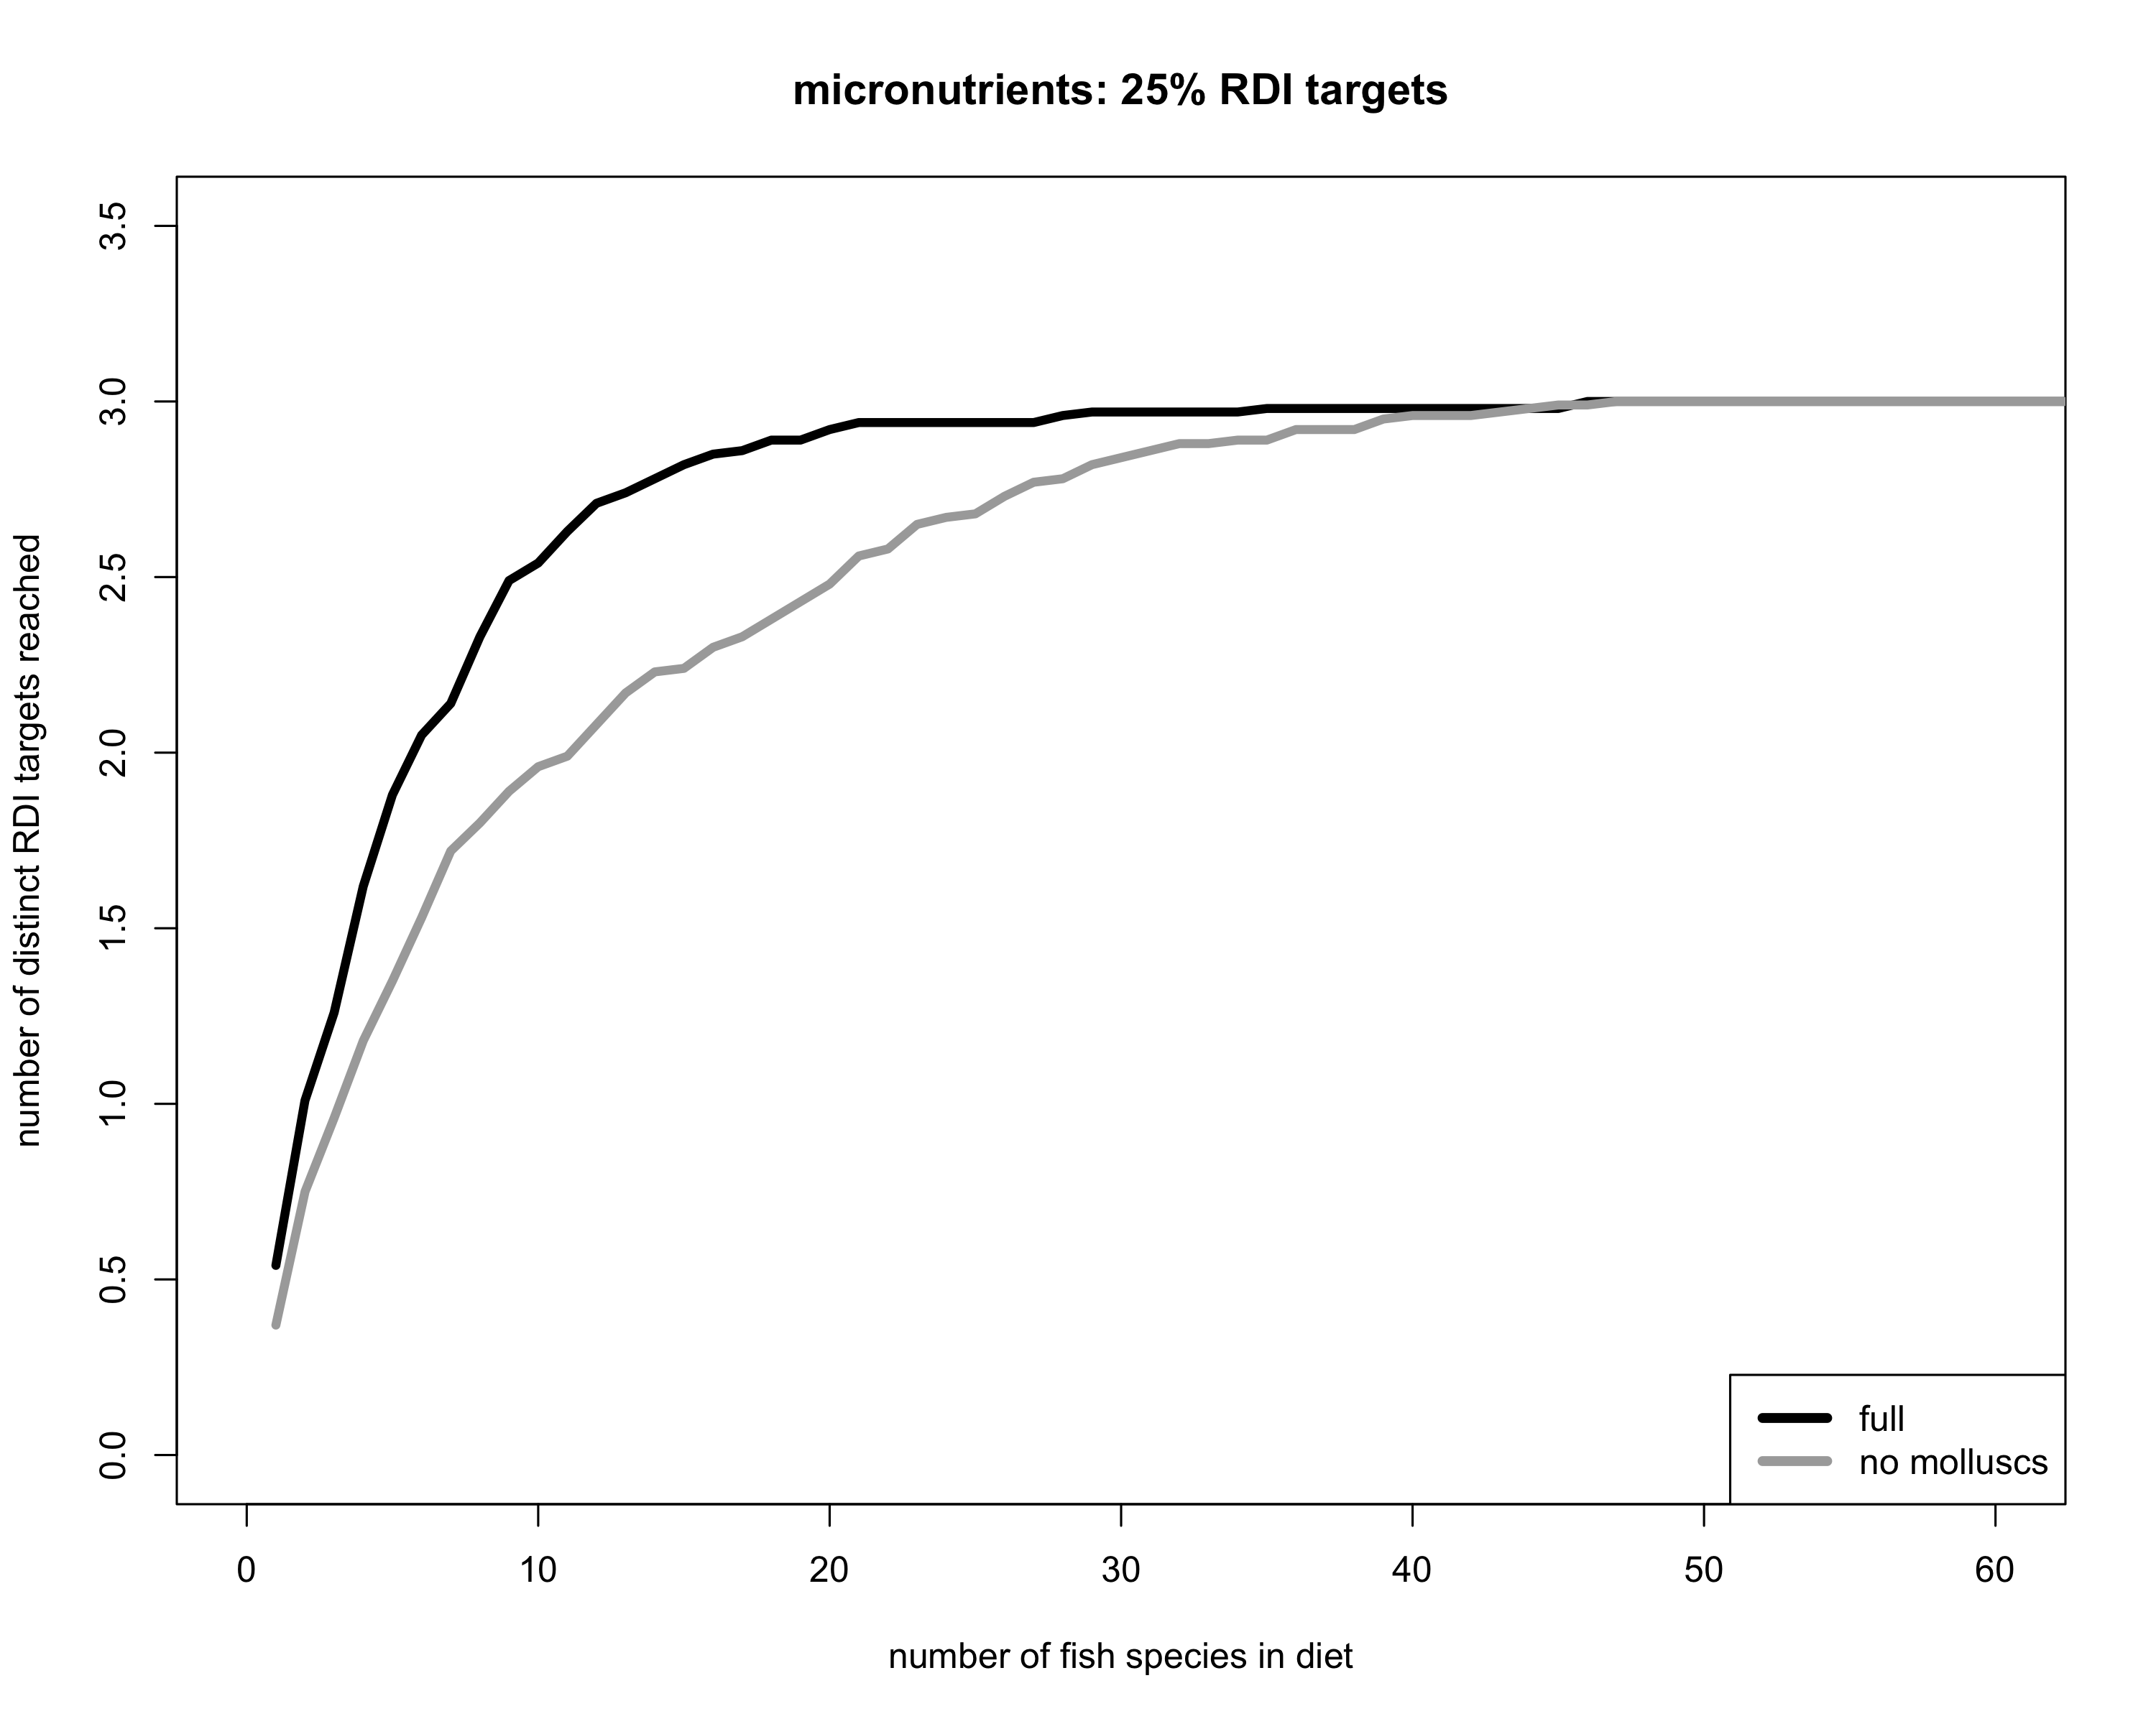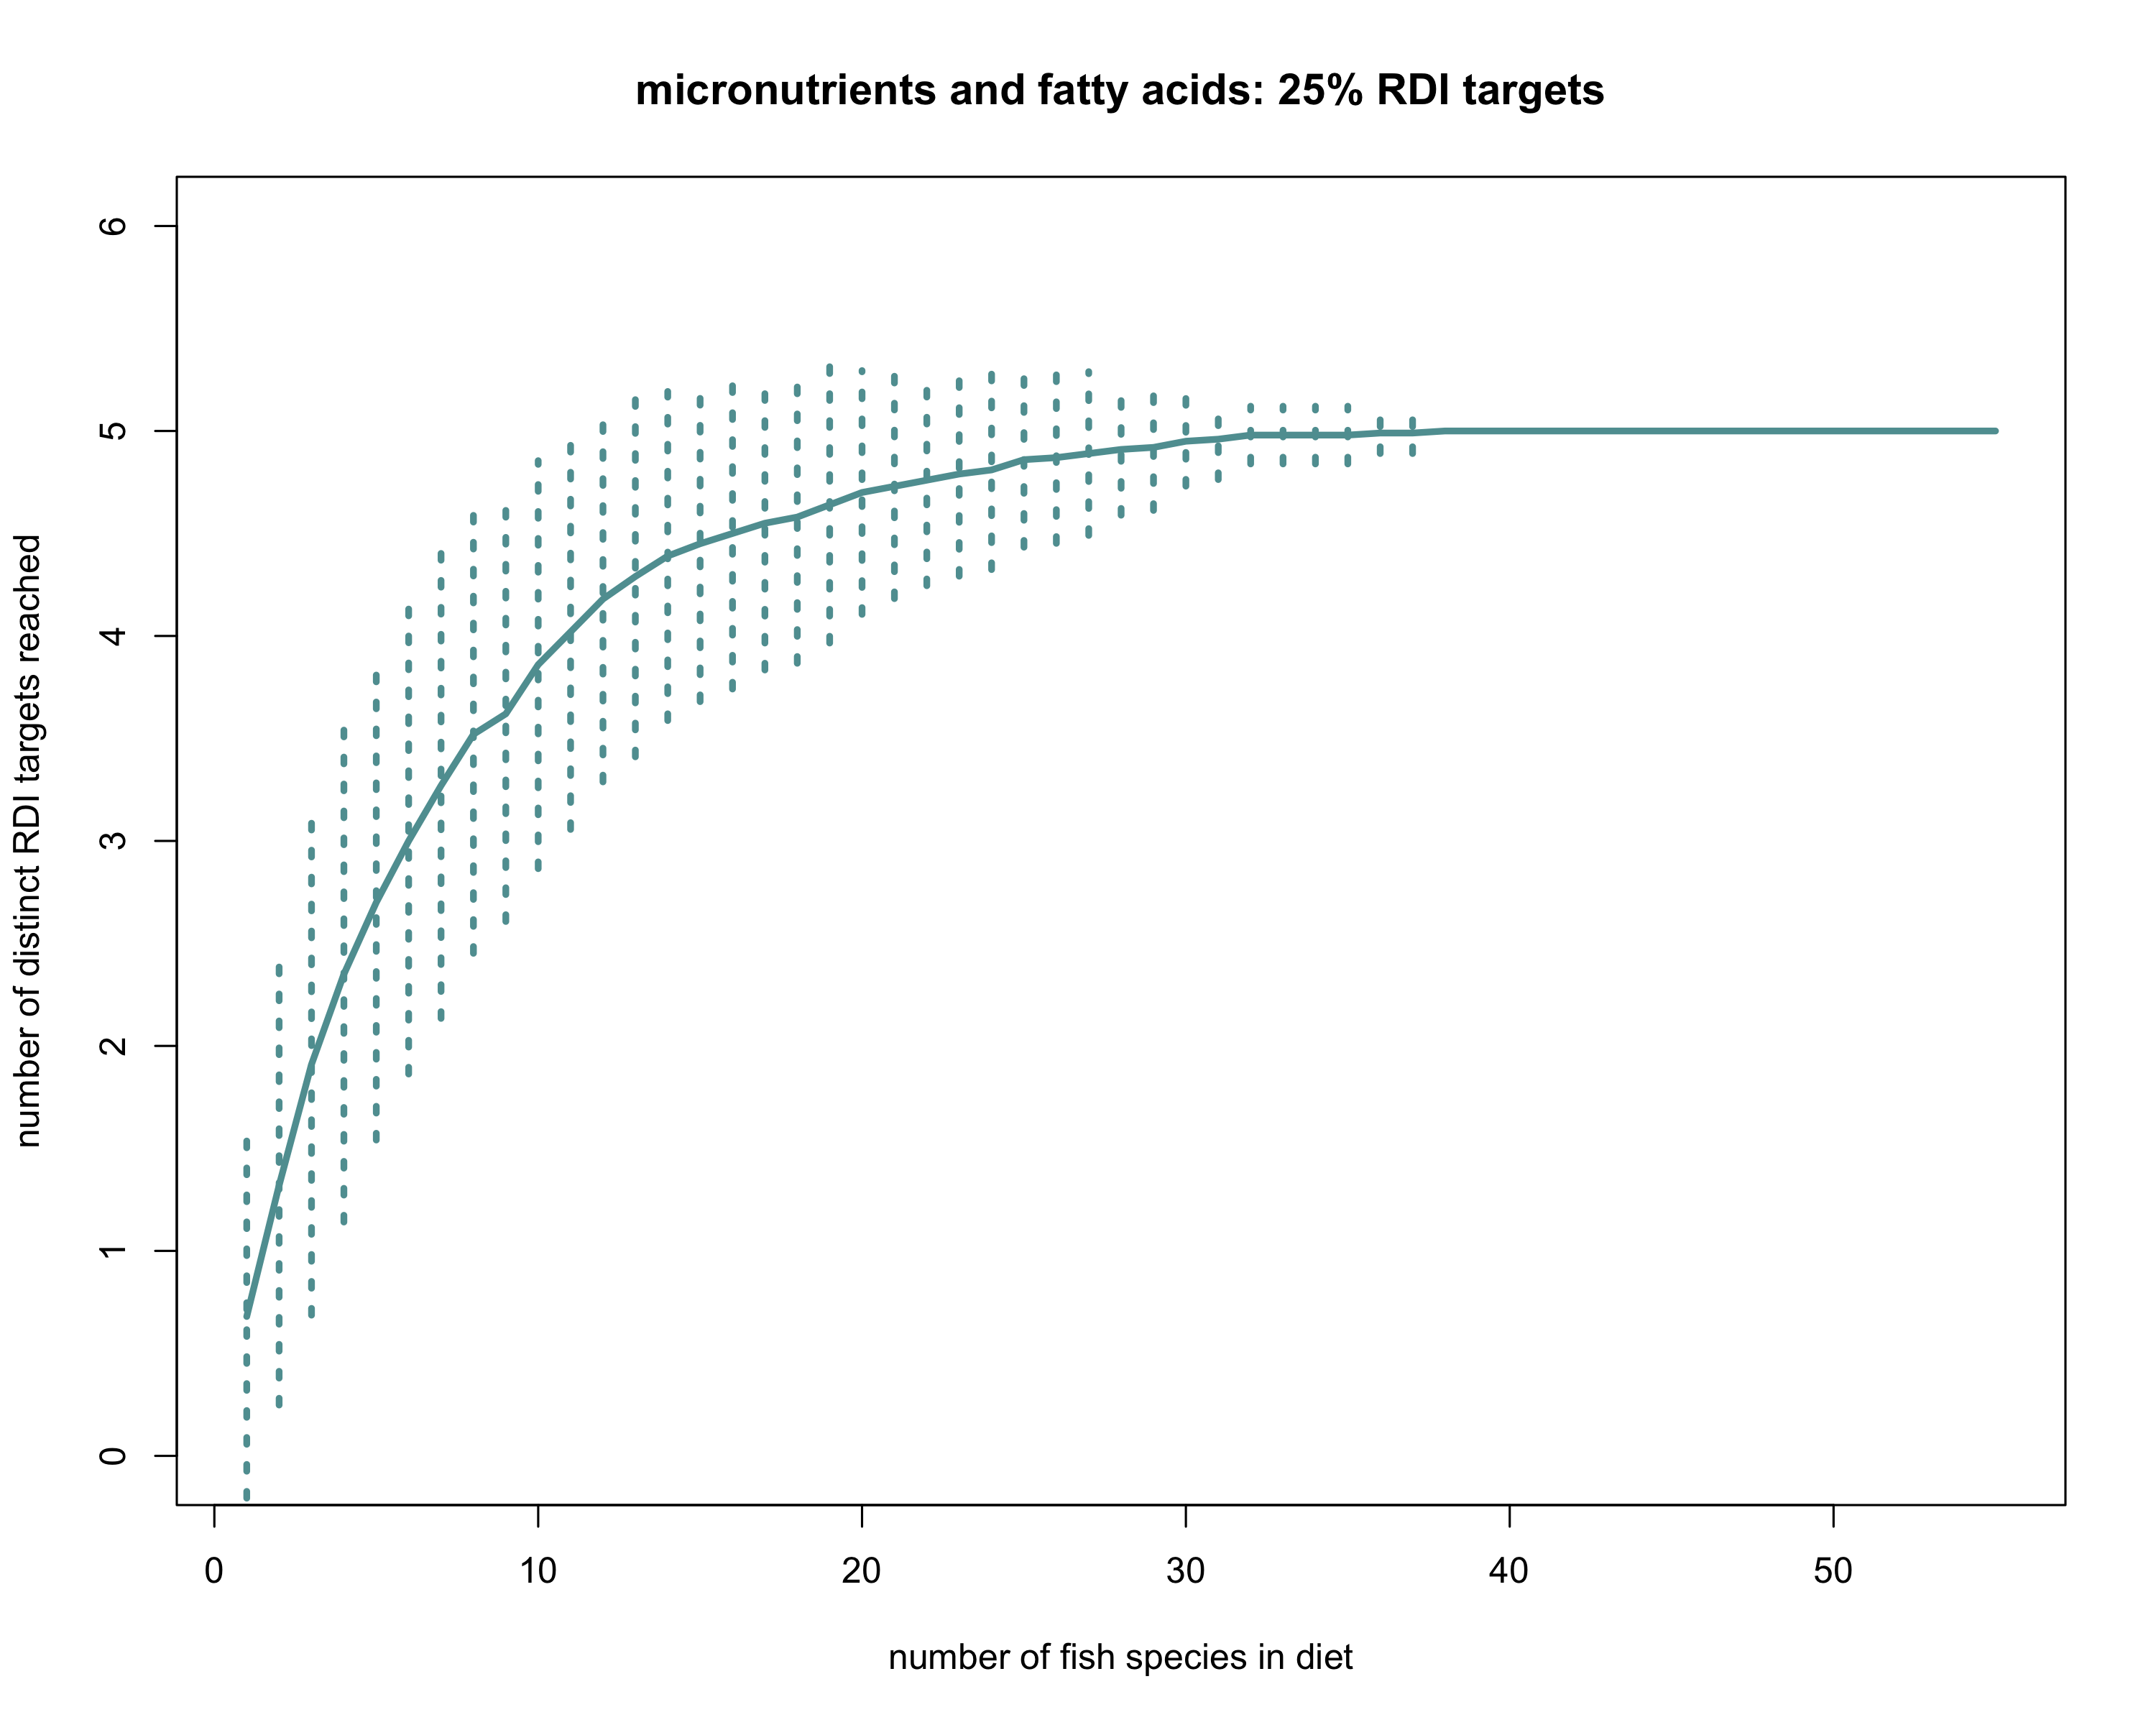

1. **nmds plot**
2. **coefficient plot for some nutrients or traits across nutrients**

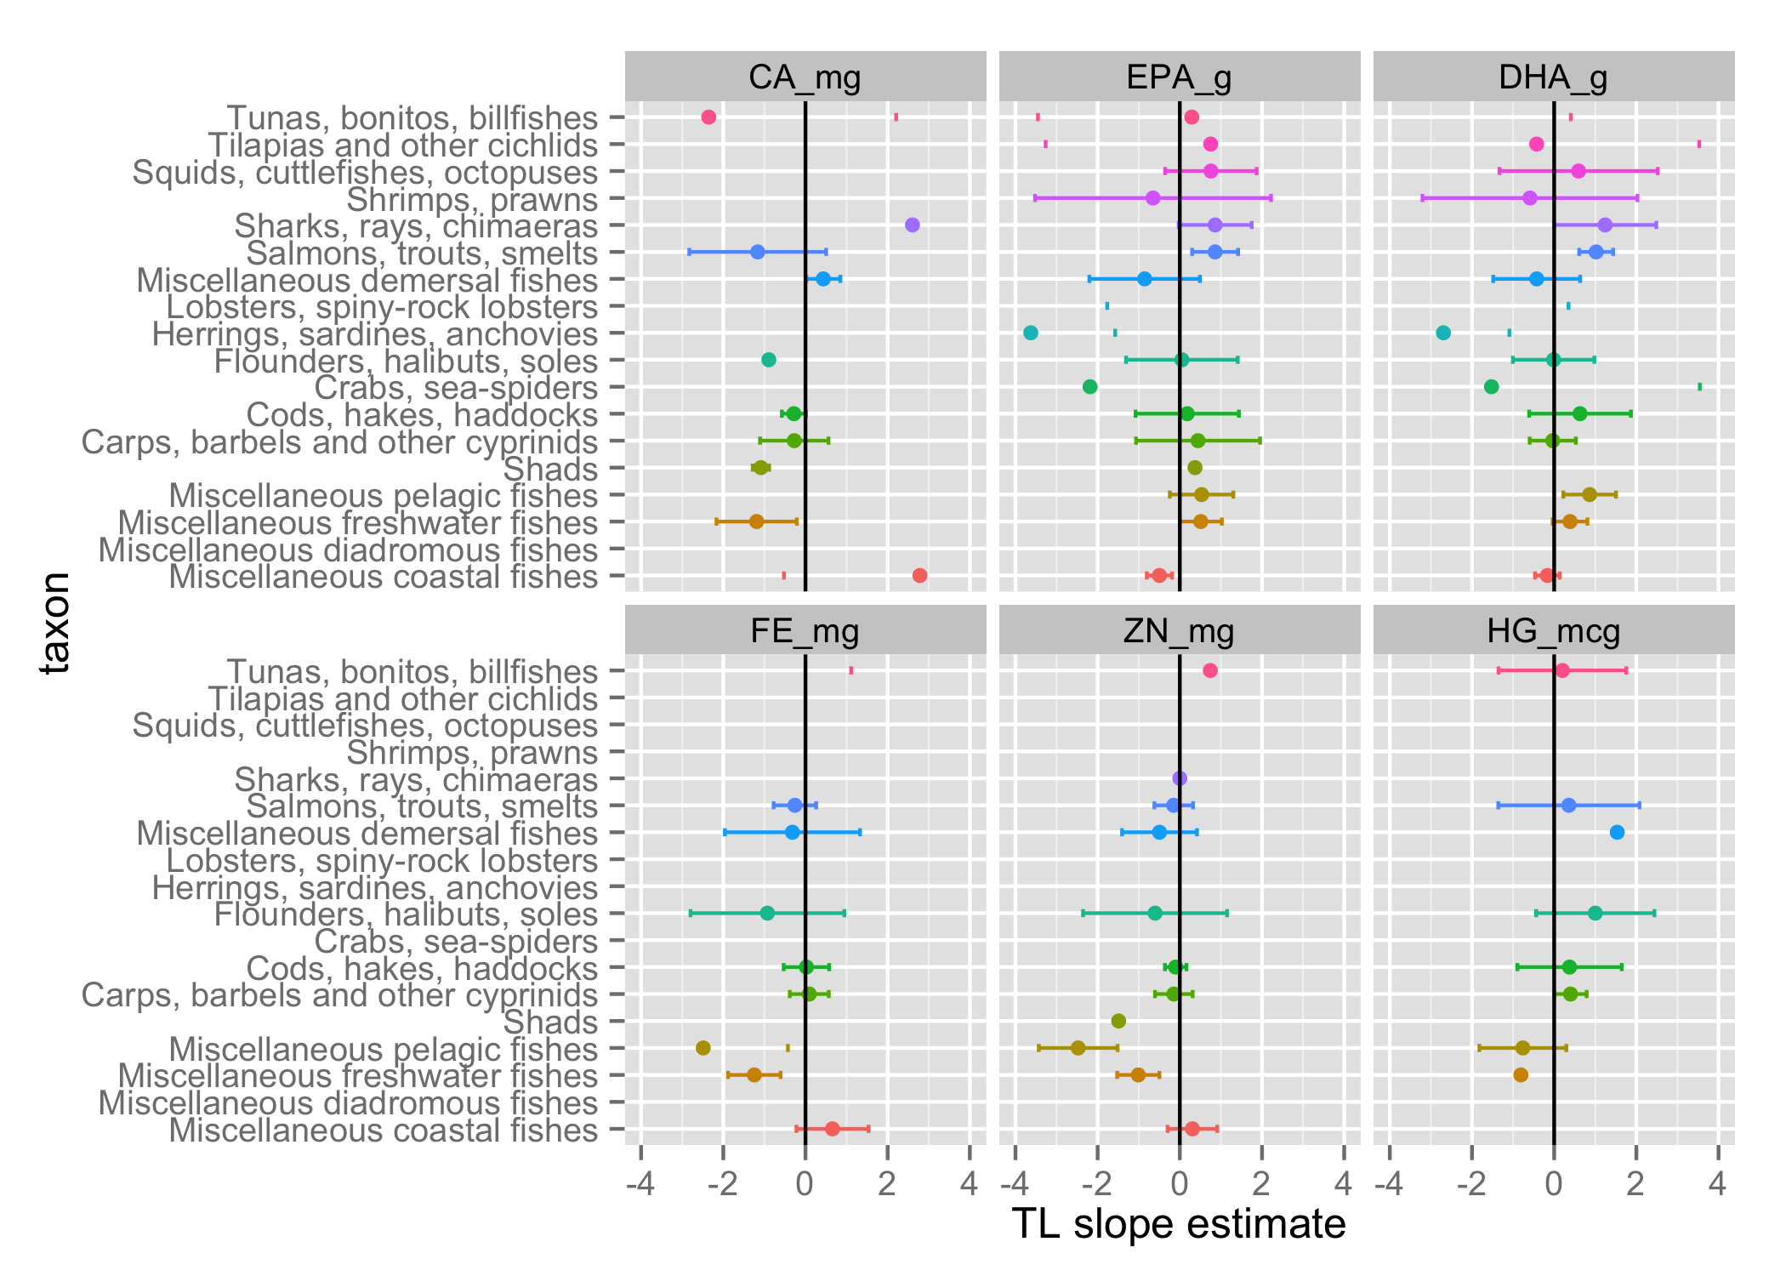

1. **map of sampling locations**

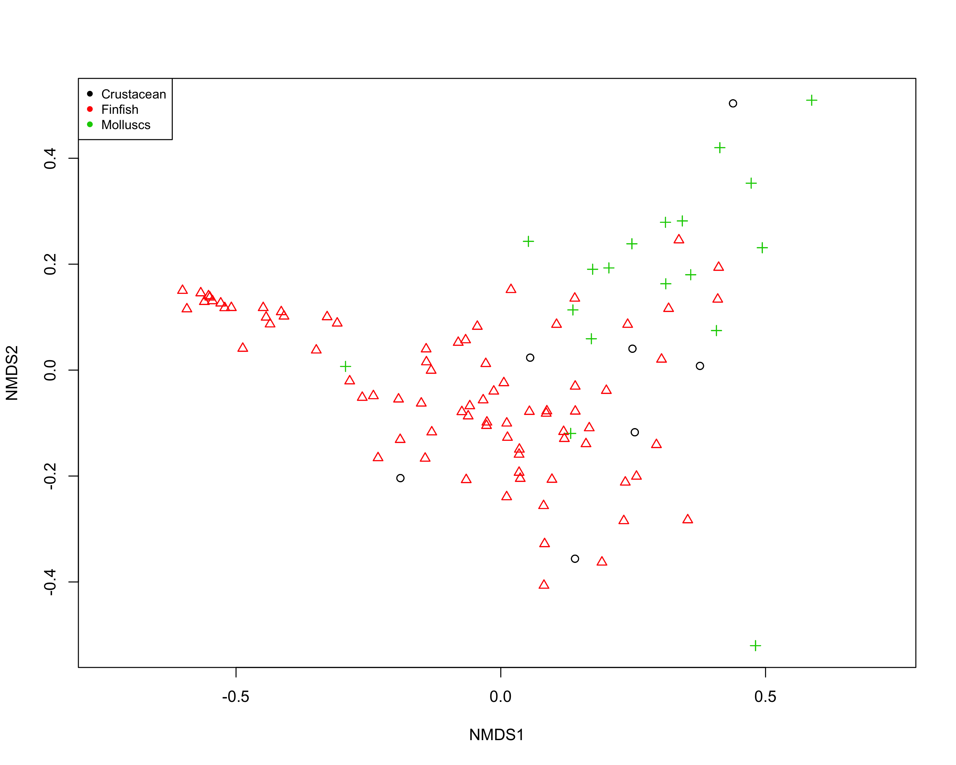

**Tables:**

1. **Micronutrients in seafood: their roles in physiology and human health**