## Functional diversity in aquatic ecosystems yields enhanced nutritional benefits

## Abstract

While food provisioning is one of the most widely acknowledged ecosystem services provided by aquatic ecosystems, the role of seafood as a source of valuable micronutrients scarce in the human diet is often overlooked. The ecological mechanisms responsible for a nutritionally diverse set of seafood species are not well understood, despite heavy research emphasis on the ecological mechanisms responsible for fisheries productivity. A primary challenge in linking ecological processes to human well-being is identifying comparable metrics for ecological properties and human benefits. For nutritional value, one metric that facilitates comparisons is the nutrient content in an edible portion relative to daily reference intake values (DRI). The nutrition benefits that humans derive from seafood are not directly related to the whole body stoichiometry of aquatic species, since the commonly consumed parts of aquatic species (i.e. the edible portion), range from the whole body (i.e. for shrimps) to highly restricted portions of muscle tissue (i.e. tuna fillets), and nutrients are not evenly distributed across all tissues. To address this issue of selective human dietary practices, we used dietary food composition data, which is restricted to the edible portion, to analyze the relationship between species’ traits and their nutritional value in terms of DRI. We find that there is a high degree of variability in nutrient profiles across taxa, and that increasing functional diversity contributes to increased dietary nutritional diversity. Finally, we test whether functional traits explain variation in species’ nutritional value to human consumers, a metric of human well-being, for 430 species of fish from all major oceanic and freshwater eco-regions. We find that an ecological functional trait-based approach is effective at simplifying the nutritional complexity of aquatic food webs into a few key axes that strongly control the composition of micronutrients in fish assemblages. For some but not all nutrients we analyzed (e.g. Ca, Hg, EPA, DHA), the nutrient content of edible portions varied predictably among species with latitude and body size, consistent with the physiological functional roles of micronutrients in fish. Our results suggest that the availability of micronutrients in fish assemblages may depend on geography and functional composition of the catch. Our approach integrates ecological variation and patterns in the human consumption of species to explicitly link ecology with one metric of human well-being to suggest that a diverse fish assemblage can support a more nutritious diet to seafood consumers.

**Introduction**

Despite its clear links to human wellbeing, the role of aquatic assemblages in provisioning of essential micronutrients has been under-represented in marine ecosystem service research. Like many other ecosystem services, the connections between the ecological processes responsible the supply of services and human well-being are poorly understood. These relationships are difficult to quantify because changes in many attributes of ecological systems do not translate directly into changes in ecosystem service supply and human well-being. Further, our ability to quantify these changes in ecosystem service value and human well-being is hindered by a lack of appropriate metrics of human well-being (Reyers ref?). Here we overcome this challenge by defining nutrient provisioning as an ecosystem service, and drawing on established nutritional metrics, such as Dietary Reference Intakes (DRIs) to investigate how attributes of aquatic ecosystems are related to the nutritional benefits that humans may derive from seafood consumption.

**Nutrition as an ecosystem function and service**

For both humans and other consumers, the nutritional quality of prey species plays a fundamental role in ecosystem function. Food webs characterized by nutritionally valuable prey support higher consumer and predator biomass and have higher trophic transfer efficiencies (Hecky 1984, Muller Navarra et al. 2000, Brett et al. 2009). For example, changes in forage fish communities from lipid-rich to lipid-poor fish in the Pacific Ocean have caused predatory marine birds and mammals to shift their diet to less nutritionally valuable lipid-poor fish and suffer population declines (Rosen and Trites 2006; Romano et al. 2006, Osterblom et al. 2008).

For humans, fish are a good source of high quality protein, a range of micronutrients and essential fatty acids (Tacon and Metian 2013). In 2009, aquatic species accounted for 16.6% of the global total supply of animal protein, providing more than three billion people with almost 20% of their average per capita intake of animal protein (FAO ref). However, the value of fish as a source of essential micronutrients may be even greater than its value as a source of protein (Allison et al. 2007). Fish is important in the diets of many poor populations suffering from nutritional deficiencies (Roos et al. 2007, Tacon and Metian 2013). In many vulnerable communities around the world, fish consumption plays an important role in combating micronutrient deficiencies (Kawarazuka and Bene 2011). For example, in rural Bangladesh, some of the poorest communities are heavily dependent on small fish from capture fisheries to meet their micronutrient needs. During peak fish production season, consumption of small indigenous fishes contributes 40% and 31% of the total recommended intakes of vitamin A and calcium, respectively, at the household level (Roos et al. 2007). Locally caught seafood also contributes significantly to micronutrient intake among Indigenous populations in Arctic Canada (Kuhnlein and Receveur 2007, Johnson-Down and Egeland 2010).

**Dietary Reference Intake as a metric of nutritional value**

The ecology of food security is not simply about predicting yields, it is about understanding the ecological conditions that lead to a stable supply of nutritionally diverse foods. A primary challenge of linking ecological processes with human well-being is finding comparable units and metrics for ecological properties and human benefits. In the context of human nutrition, one metric that facilitates comparisons is the nutrient content in an edible portion relative to dietary reference intake values (DRI). The value of a fish species in terms of human nutrition benefits can be quantified as the nutrient content in an edible portion relative to Dietary Reference Intake (DRI) values. The DRI is the daily intake level of a nutrient that is considered to be sufficient to meet the requirements of 97–98% of healthy individuals in every demographic (National Academies of Sciences 2011).

Fish species vary widely in their concentration of essential nutrients (USDA 2011). For example, assuming a serving size of 85g of fish, sardines (1.9 g DHA per 100 g tissue) and Pacific herring (0.83 g DHA/100g) provide the recommended level of 1.0g/day EPA and DHA in a single serving, while pink salmon, canary rockfish and surf smelt would require 1.2-1.5 servings, while pacific hake (0.15g/100g DHA) and pollock (0.24 g DHA/100g) would require 4-5 servings to meet the recommended daily requirements (Hyuhn and Kitts 2009). Thus, not all species are equally nutritionally valuable. This variability in essential fatty acid (EFA) content per serving size may be related to the total fat content of the fish: the characteristically lean fish like pollock and hake have relatively low contents of EFAs, while the more lipid-rich fish have higher EFA contents.

Here, we draw on two well-established nutritional metrics: nutrient content/100g edible portion and DRI, as well as ecological traits such as body size and trophic position, to explicitly characterize the relationship between aquatic species’ ecological traits, such as body size and their nutritional value for human well-being.

**Micronutrients in seafood and how humans consume them**

We hypothesize that species’ nutritional profiles are linked to functional traits because elements that are of nutritional value to humans also serve functional roles in organismal physiology and because human dietary practices map onto functional traits such as body size and (exo)skeleton morphology (table 1). Functional traits such as trophic position may be related to the nutritional content of seafood species because they affect the dietary range and quantity of nutrients to which an organism is exposed, as well as the physiological constraints on body composition (Simpson and Raubenheimer 2012). In aquatic food webs, some evidence suggests that nutritional profile may be related to species’ traits: the distribution of trace metals in fish tissues has been related to feeding guild (Bernhard and Andreae 1984), body size, stage of life cycle, and reproductive status (Shearer 1984). Disease state, water quality and other environmental factors may also modify tissue mineral distribution (Lall and Olivier 1993). Although aquatic organisms readily absorb metals from the environment, the ability to regulate abnormal concentrations varies among species. Certain species are able to excrete high proportions of excessive metal intake and regulate the concentration in the body at relatively normal levels (Bryan 1976). This occurs for essential elements such as Cu, Zn, and Fe. However, non-essential minerals such as Hg, Cd, and Pb are more poorly regulated (Karimi et al. 2006). Different metals localize or accumulate in different organs or tissues. For example, Fe concentrations are highest in hematopoietic tissues while Hg is most abundant in the muscle tissues. Since each element is under different levels of homeostatic control, we expect the relationship between elemental content and species’ traits to vary by nutrient. For those nutrients that are more tightly regulated, we expect more consistent patterns across species.

Not only are functional traits related to the ways in which nutrients accumulate in fish bodies, they are also related to the ways in which humans consume aquatic species. For example, in large bodied finfish such as tunas, human typically consume the muscle tissue only. In contrast, humans typically consume a much broader range of body tissues in crustacean taxa such as shrimps (i.e. whole body) and crabs (muscle tissue and organs such as the hepatopancreas). Taken together, the patterns of functional morphology and human dietary practices suggest that the edible portions of species from different taxonomic and functional groups may have vastly different nutrient profiles.

Here, we synthesize nutritional content data for the edible portions of 430 aquatic species from all major oceanic and freshwater ecoregions (Fig X). For each of these species, we also collected ecological trait data including body size, trophic position and habitat associations, which are broadly related to the function and form of species in aquatic systems (Woodward et al. 2005, other ref?). **We analyzed this dataset to (1) quantify variation in nutritional quality among aquatic taxa, (2) test whether ecological traits are related to variation in nutritional profile from the perspective of a human diet and (3) assess the contribution of species diversity to the nutritional benefits of a human diet that includes multiple seafood species.** We chose to analyze a selection of ions and compounds that affect a species’ nutritional value for humans and that are implicated in a range of biologically important processes that affect growth and reproduction. We examined fatty acid concentration (which reflects fish diet and physiological condition);), a toxic metal for which increased concentrations are negative for humans (Hg);), two metals beneficial at low concentrations but toxic at high concentrations (Zn and Fe);) and one mineral (Ca). We applied this approach to a ‘global seafood’ diet, but this approach could be easily applied to the species available in local seafood diets. In a set of case studies, we assessed the nutritional benefits provided by a seafood assemblage as the number of distinct micronutrient >15% DRI targets reached.

## Methods

We aimed to document the variation in nutrient content across commonly consumed aquatic taxa. To understand how nutrient content varies among species, we tested whether ecological traits known to be both biologically important and that exhibit predictable scaling relationships could explain this variation. [We synthesized SPATIALLY AND SIZE EXPLICIT DATA, TO IDENTIFY THRESHOLDS IN GEOGRAPHY AND OR BODY SIZE THAT INDICATE THAT A SPECIES ACHIEVES 25% RDI IN A SINGLE PORTION.]

### Literature search and data collection

To test how nutrient profile varies with ecological traits, we assembled a dataset of nutrient content in the edible portions of 400 aquatic species. We defined the nutritional profile of a species as the quantity of a given nutrient in 100 g of edible tissue - a metric that is commonly used in the human food composition literature (Nowak et al. 2014). We aimed to include as many species as possible, from both marine and freshwater systems, and covering a wide geographic range. We searched the literature for analytical compositional values for each of these species. We searched the peer-reviewed literature as well as food composition databases or tables, such as the Food and Agriculture Organization’s INFOODS database (FAO/INFOODS 2014) and the United States Department of Agriculture’s Nutrient Files (USDA 2012). We restricted our analysis to include only the edible portions of wild, raw fish (thus excluding prepared or farmed seafood items). Our dataset includes quantities for the following microelements: calcium; iron; zinc; mercury and two fatty acids: eicosapentaenoic acid (EPA); and docosahexaenoic acid (DHA). To address inconsistencies in fatty acid data reporting, we standardized fatty acid measurements using the fatty acid conversion factors proposed by Nowak et al. (2014).

Ecological trait information was collected for each species using FishBase (Froese and Pauly 2014) and SeaLifeBase (Palomares and Pauly 2014). We included body size (maximum length), fractional trophic position, temperature preference (using latitude as a proxy) and habitat preference (Marine, Freshwater, brackish…). We converted body length data into body mass, using established length-mass relationship data (*mass*= *a*length^b*). We used species-specific or taxon-specific *a* and *b* parameter values published in Froese et al. (2013).

### Statistical Analysis

We modeled the relationship between nutrient content and species’ traits with linear regression models using a log-transformed power function. The full model included the entire set of predictors:

ln(nutrient content) = *Β0.i* + *Β1.i*\*ln(body size)*latitude + *Β2.i*\*ln(body size)*(trophic position) + *Β3.i*\*ln(body size)*(habitat) + εi

We created models from subsets of the full model that represented hypotheses based on the known physiological roles of micronutrients **and their relationships to our set of predictors**. We identified the best subset of models using the Akaike Information Criterion, adjusted for small sample sizes (AICc). We used AICc, δaic and Akaike weights (w) to compare models. We ranked models based on w, and selected the set of models that produced a cumulative w > 0.95, meaning that we are 95% confident that the chosen set includes the best model (Burnham and Anderson 2002).

We report all models with AICc differences ( δaic = AICi − AICmin) less than or equal to two ( δaic ≤ 2). In cases where we could not obtain measurements of all traits for all species, we performed model selection on reduced datasets without missing values (Appendix A). To account for model uncertainty, we performed model averaging of coefficients in all models with δaic < 2, and included zeros as coefficients when variables did not enter a particular model (Burnham and Anderson 2002). We conducted all our analyses in R version 3.1.2 (R Core Development 2014) using the MuMIn package (<http://r-forge.r-project.org/projects/mumin/>).

-somewhere here, need to address multi-collinearity of predictor variables etc.

**Results:**

We found considerable variability in nutritional profiles among aquatic taxa. Variability was lowest for the macronutrients we considered (i.e. protein, fat and fatty acids) and highest for the micronutrients (minerals: calcium, iron and zinc). All of macronutrients varied over one order of magnitude, while the micronutrients varied over two or three orders. Protein (n = 251 species) ranged from an average of 10.68g/100g in the clams, cockles, arkshells to 21.85 g/100 g in the Tunas, bonitos, billfishes (Figure 1). Fat (n = 277 species) ranged from an average of 1.08 g/100g in the sharks and rays to 12.74 g/100 g in the shads (Figure 1). EPA in the edible portion (n = 238 species) ranged from an average of 0.02 g/100g in the sharks and rays to 0.53 g/100 g in the herrings, sardines, anchovies (Figure 1). DHA in the edible portion (n= 235 species) ranged from an average of 0.065 g/100g in the shrimps and prawns to 1.28 g/100 g in the Tunas, bonitos, billfishes (Figure 1).

Calcium in the edible portion (n = 99 species) ranged from an average of 10.78mg/100g in the cods, hakes and haddocks to 782.60 mg/100 mg in the abalones, winkles and conchs (Figure 1). Zinc in the edible portion (n = 101) ranged from an average of 0.36 mg/100g in the cods, hakes and haddocks to 11.87 mg/100 mg in the oysters (Figure 1). Iron in the edible portion (n= 238) ranged from an average of 0.19 mg/100g in the cods, hakes and haddocks to 20.31 mg/100 mg in the abalones, winkles and conchs (Figure 1).

Few species reach RDI targets for more than one nutrient (Figure 2). When considering a target of 25% of DRI, more than half of the species (i.e. 65 species) reach no targets, while 41 species reach 1 or more targets, 39 reach two or more targets and 2 reach all three targets. When considering a target of 10% of DRI, 56 species reach no targets, 50 reach one or more targets, 41 reach 2 or more targets, and 15 reach all three targets.

Body size of the species and dietary practices of consumers (eg. eating bones or multiple body tissues) have a large effect on the likelihood that a given edible portion will reach RDI targets (Figure 3). For macro- and micronutrients grouped together, 79.21% of the observations of species for which it is customary to eat multiple tissues reached RDI targets, whereas this number drops to 39.59% for species in which only the muscle tissue is eaten.

Functional groups have distinct multi-nutrient profiles (Figure 4). NOT SURE HOW TO WRITE THIS YET! But the result is that when considering just the minerals and all the micronutrients, the functional group (i.e. finfish vs. crustaceans vs molluscs) means in multivariate nutrient trait space are different from each other (PERMANOVA, p = 0.001).

**Result 5. Within functional groups, some traits such body size and latitude are strongly associated with nutritional profile (fig 5 coefficients plot).**

**Result 6. Functional group diversity enhances dietary nutritional diversity and nutritional benefits that human communities may derive from seafood assemblages. (fig 6 nutrient accumulation curve).**

Need to sample from 14 species to get a median of all three minerals, and need to sample from 8 species to get a median of 3 minerals when molluscs are included.

When all five micronutrients are considered, need to sample from 15 species to reach a median of all 5 micronutrient targets (when molluscs are included), need to sample from 22 species when molluscs are excluded

**ADD SOME SORT OF CASE STUDY THAT LOOKS AT NUTRITIONAL FUNCTIONAL DIVERSITY IN A GIVEN COUNTRY OR TAXON??**

**Discussion:**

Seafood is widely recognized as a valuable source of protein for more than a third of the global population. SOME SENTENCE ON THE IMPORTANCE OF SEAFOOD TO FOOD SECURITY. Our global analysis of the nutrient content of the edible portion of commonly consumed aquatic taxa revealed a high degree of variability in nutritional profile across taxonomic groups. The degree of variability was particularly high for the micronutrients vs. macronutrients. We found that the substantial variation in the nutritional content of an edible portion among seafood species can be explained partly major ecological traits: functional group, latitude, body size and habitat associations. Below we discuss these patterns of variability across functional groups and implications of these findings for dietary diversity and human health.

**Variation in nutrient concentrations among aquatic taxa**

In contrast to much of the existing work on stoichiometry in fishes, which addresses patterns of macro-element and macronutrient variability in whole body samples, here we focused on variability in micro-elemental composition in tissues contained in the edible portion. We found even greater levels of variability in micronutrient stoichiometry than have been documented in the literature for macro-elements (eg C, N, and P). In general, we found that patterns in nutrient content were less variable for the macronutrients we considered (protein and fat) than micronutrients. We found that calcium content per edible portion varied by more than 500-fold (min=2.99, max=1503.00, median=45.15 mg/100 g). Fatty acids varied by X amount. Essential microelements varied by X fold, while non-essential elements such as mercury varied by X amount. This finding is consistent with expectations based on the functional roles of nutrients in organismal physiology and lower levels of homeostasis associated with non-essential elements (Karimi et al. 2006).

**Human dietary practices influence nutritional profile**

The degree of variability we documented in the edible portion is substantially higher than variability documented among whole body measurements of elemental composition of fishes documented in the ecological literature. This could be due to the fact we are sampling across a much broader range of latitudes, habitats ad taxonomic groups, or because nutrient deposition is not uniform across body tissues, and our dataset contains data only for the edible portion, which encompasses different body tissues depending on the species. Importantly, implicit in our dataset are human dietary practices, which may influence the relationship between body size, taxonomic identity and nutritional content. Sometimes the edible portion contains organs such as liver and skeleton, sometimes it is just muscle tissue. For example, for some small-bodied indigenous fishes in Cambodia, it is common to consume the entire body, including the bones and head of the fish. In contrast, for larger fishes such as carp (which are comparable in terms of habitat, trophic position and latitude), the edible portion is restricted to muscle tissue, and the concentrations of calcium, iron and zinc are substantially lower.

**Nutrient variability in the context of dietary reference intakes**

In the context of DRI, very few species reach 25% of DRI for more than one micronutrient in a single portion. This finding suggests that human diets must include several distinct seafood species to DRI for multiple nutrients. For example, to reach DRI for calcium, iron and zinc, a human diet must contain on average eight distinct species. Further, some groups were more likely to reach DRI targets. For example, 80% of the molluscs reached at least one DRI target while only 25% percent of the finfish reached at least one DRI target. Thus, if molluscs are not included in the diet, the number of species required to reach the calcium, iron and zinc DRIs rises to 22 species. In contrast to the micronutrients, there is a much higher level of functional redundancy for macronutrients. The DRI for protein was reached in almost all species in our dataset. In contrast, the DRIs for the micronutrients, calcium, iron and zinc were reached by 22%-39% of species.

As a result, the contribution of species diversity to the likelihood of reaching DRIs is greater for micronutrients than macronutrients. Given that the role of fish in combating nutritional deficiencies may be even more important for essential micronutrients than protein (Allison et al. 2007), species diversity in human diets may be particularly important to the health benefits provided by seafood assemblages.

**Implications of anthropogenic impacts on nutritional benefits from aquatic ecosystems**

Identifying the axes that influence nutrient content of aquatic taxa reveals that the supply of some nutrients might be more vulnerable to stressors such as climate change or overfishing. For example, XX percent of the species in the dataset that reached of iron and zinc DRIs were of XX size and or XX taxonomic group.

In conclusion, this study provides the first global assessment of patterns in nutrient content of aquatic species. Our results reveal that not all fish species are equally nutritionally value to humans and that increasing the number of seafood species in the human diet will increase the likelihood of reaching a broad range of nutritional benefits.

THE END.

**List of figures:**

**Figure 1. Boxplot of nutrient concentrations**

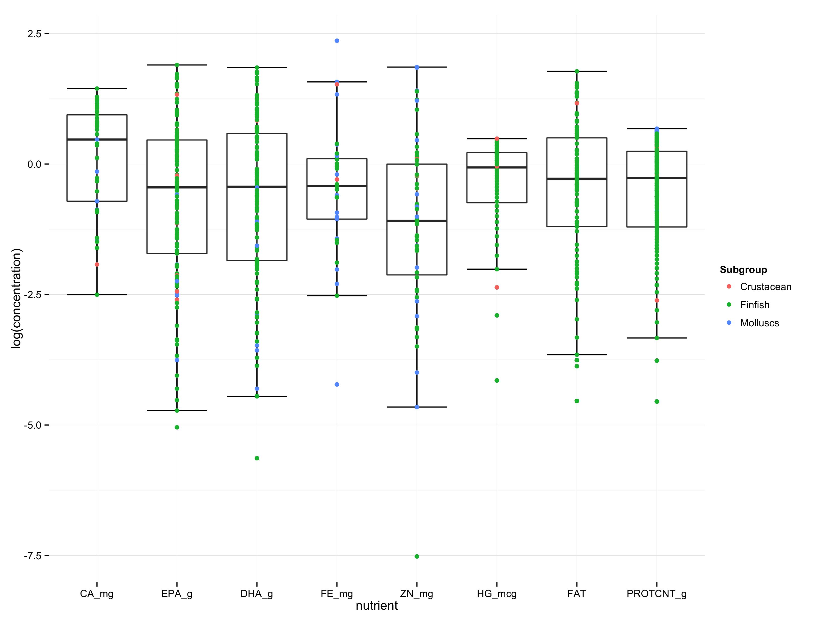

**Figure 2. Few species contain reach DRI targets for multiple nutrients** 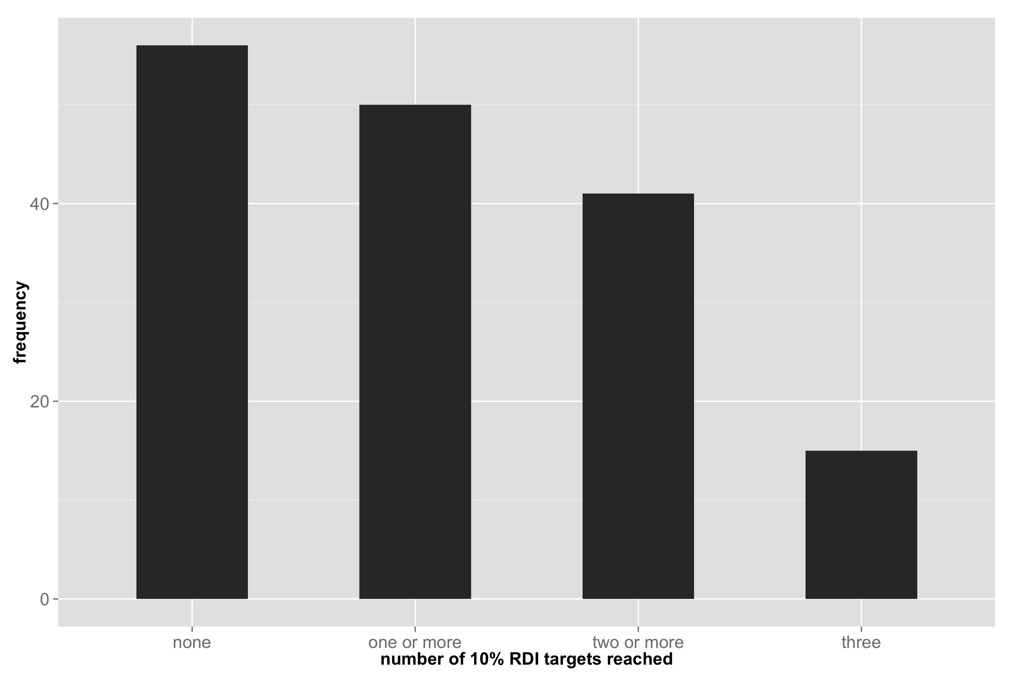

**Figure 3. Shows proportion of body consumed and number of DRI targets**

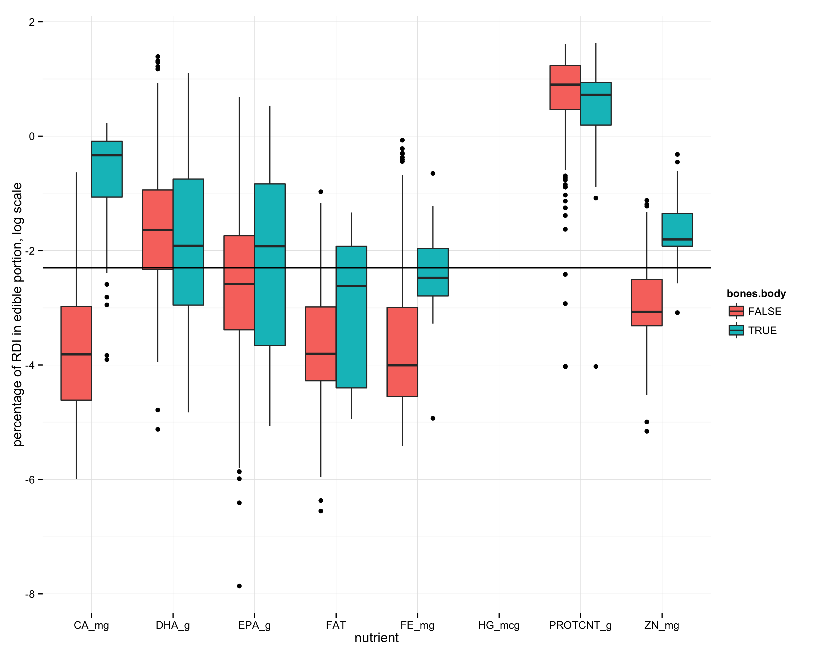

**Figure 4. Functional groups have distinct multi-nutrient profiles (mds plot with finfish/crustaceans/molluscs color coded).**

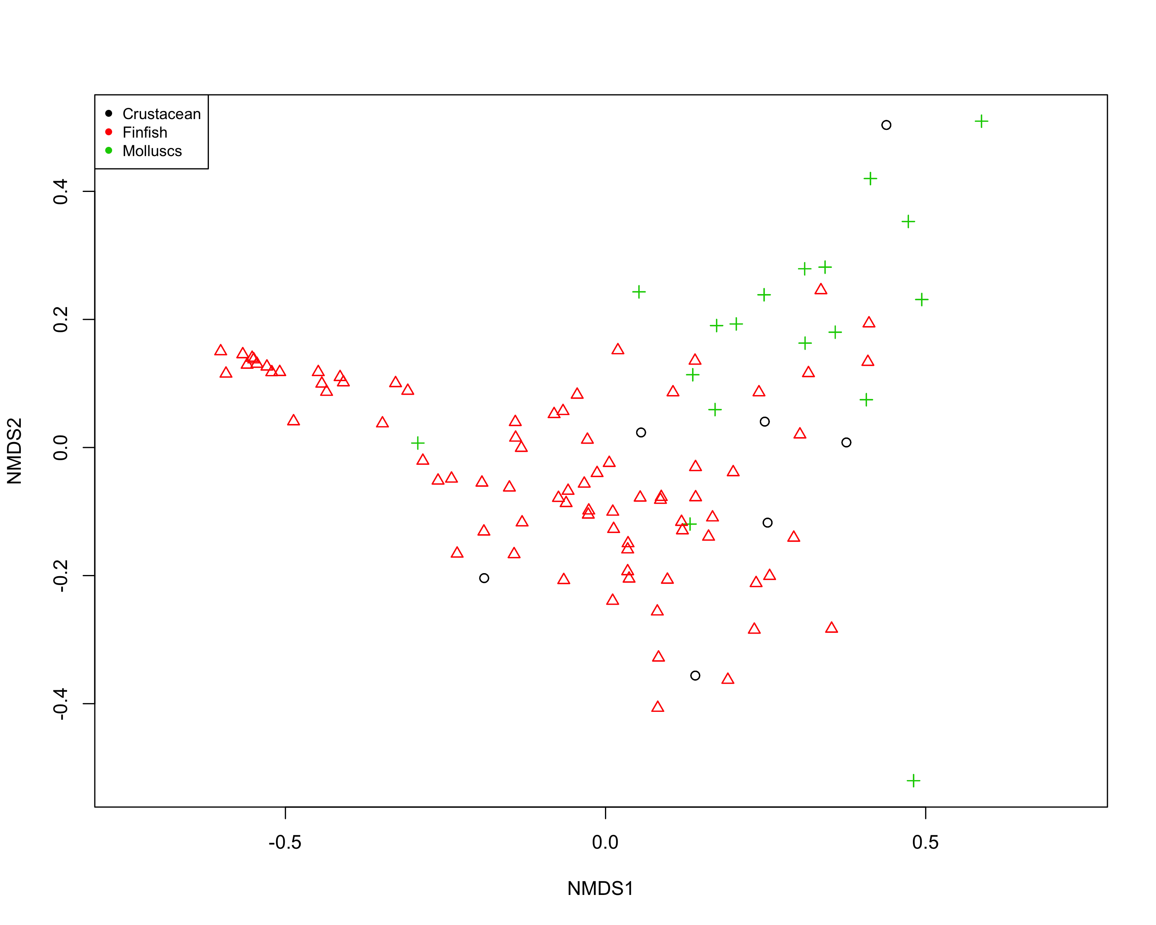

**Figure 5. Within functional groups, some traits such body size and latitude are strongly associated with nutritional profile (fig 5 coefficients plot).**

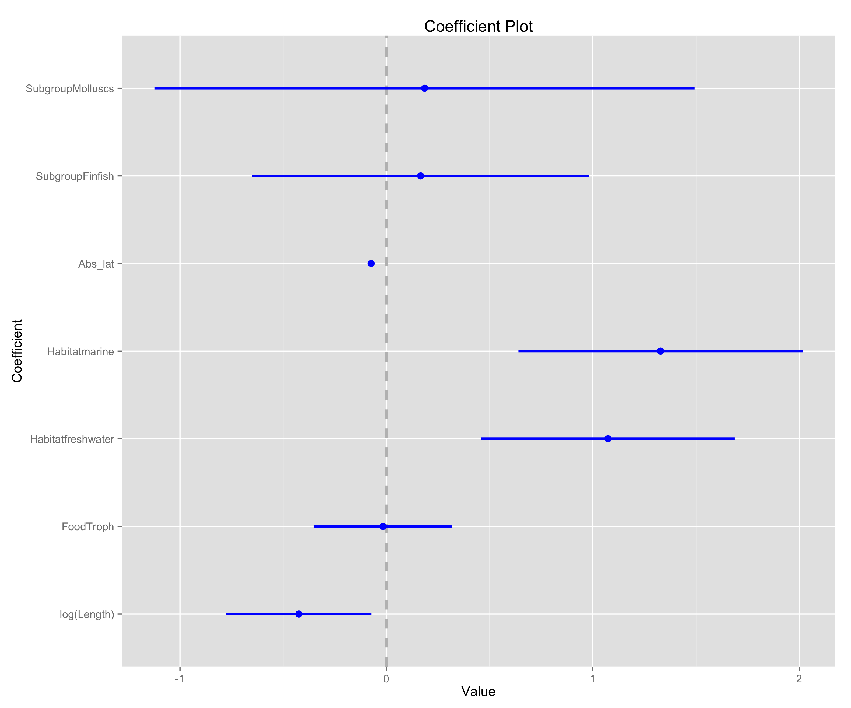

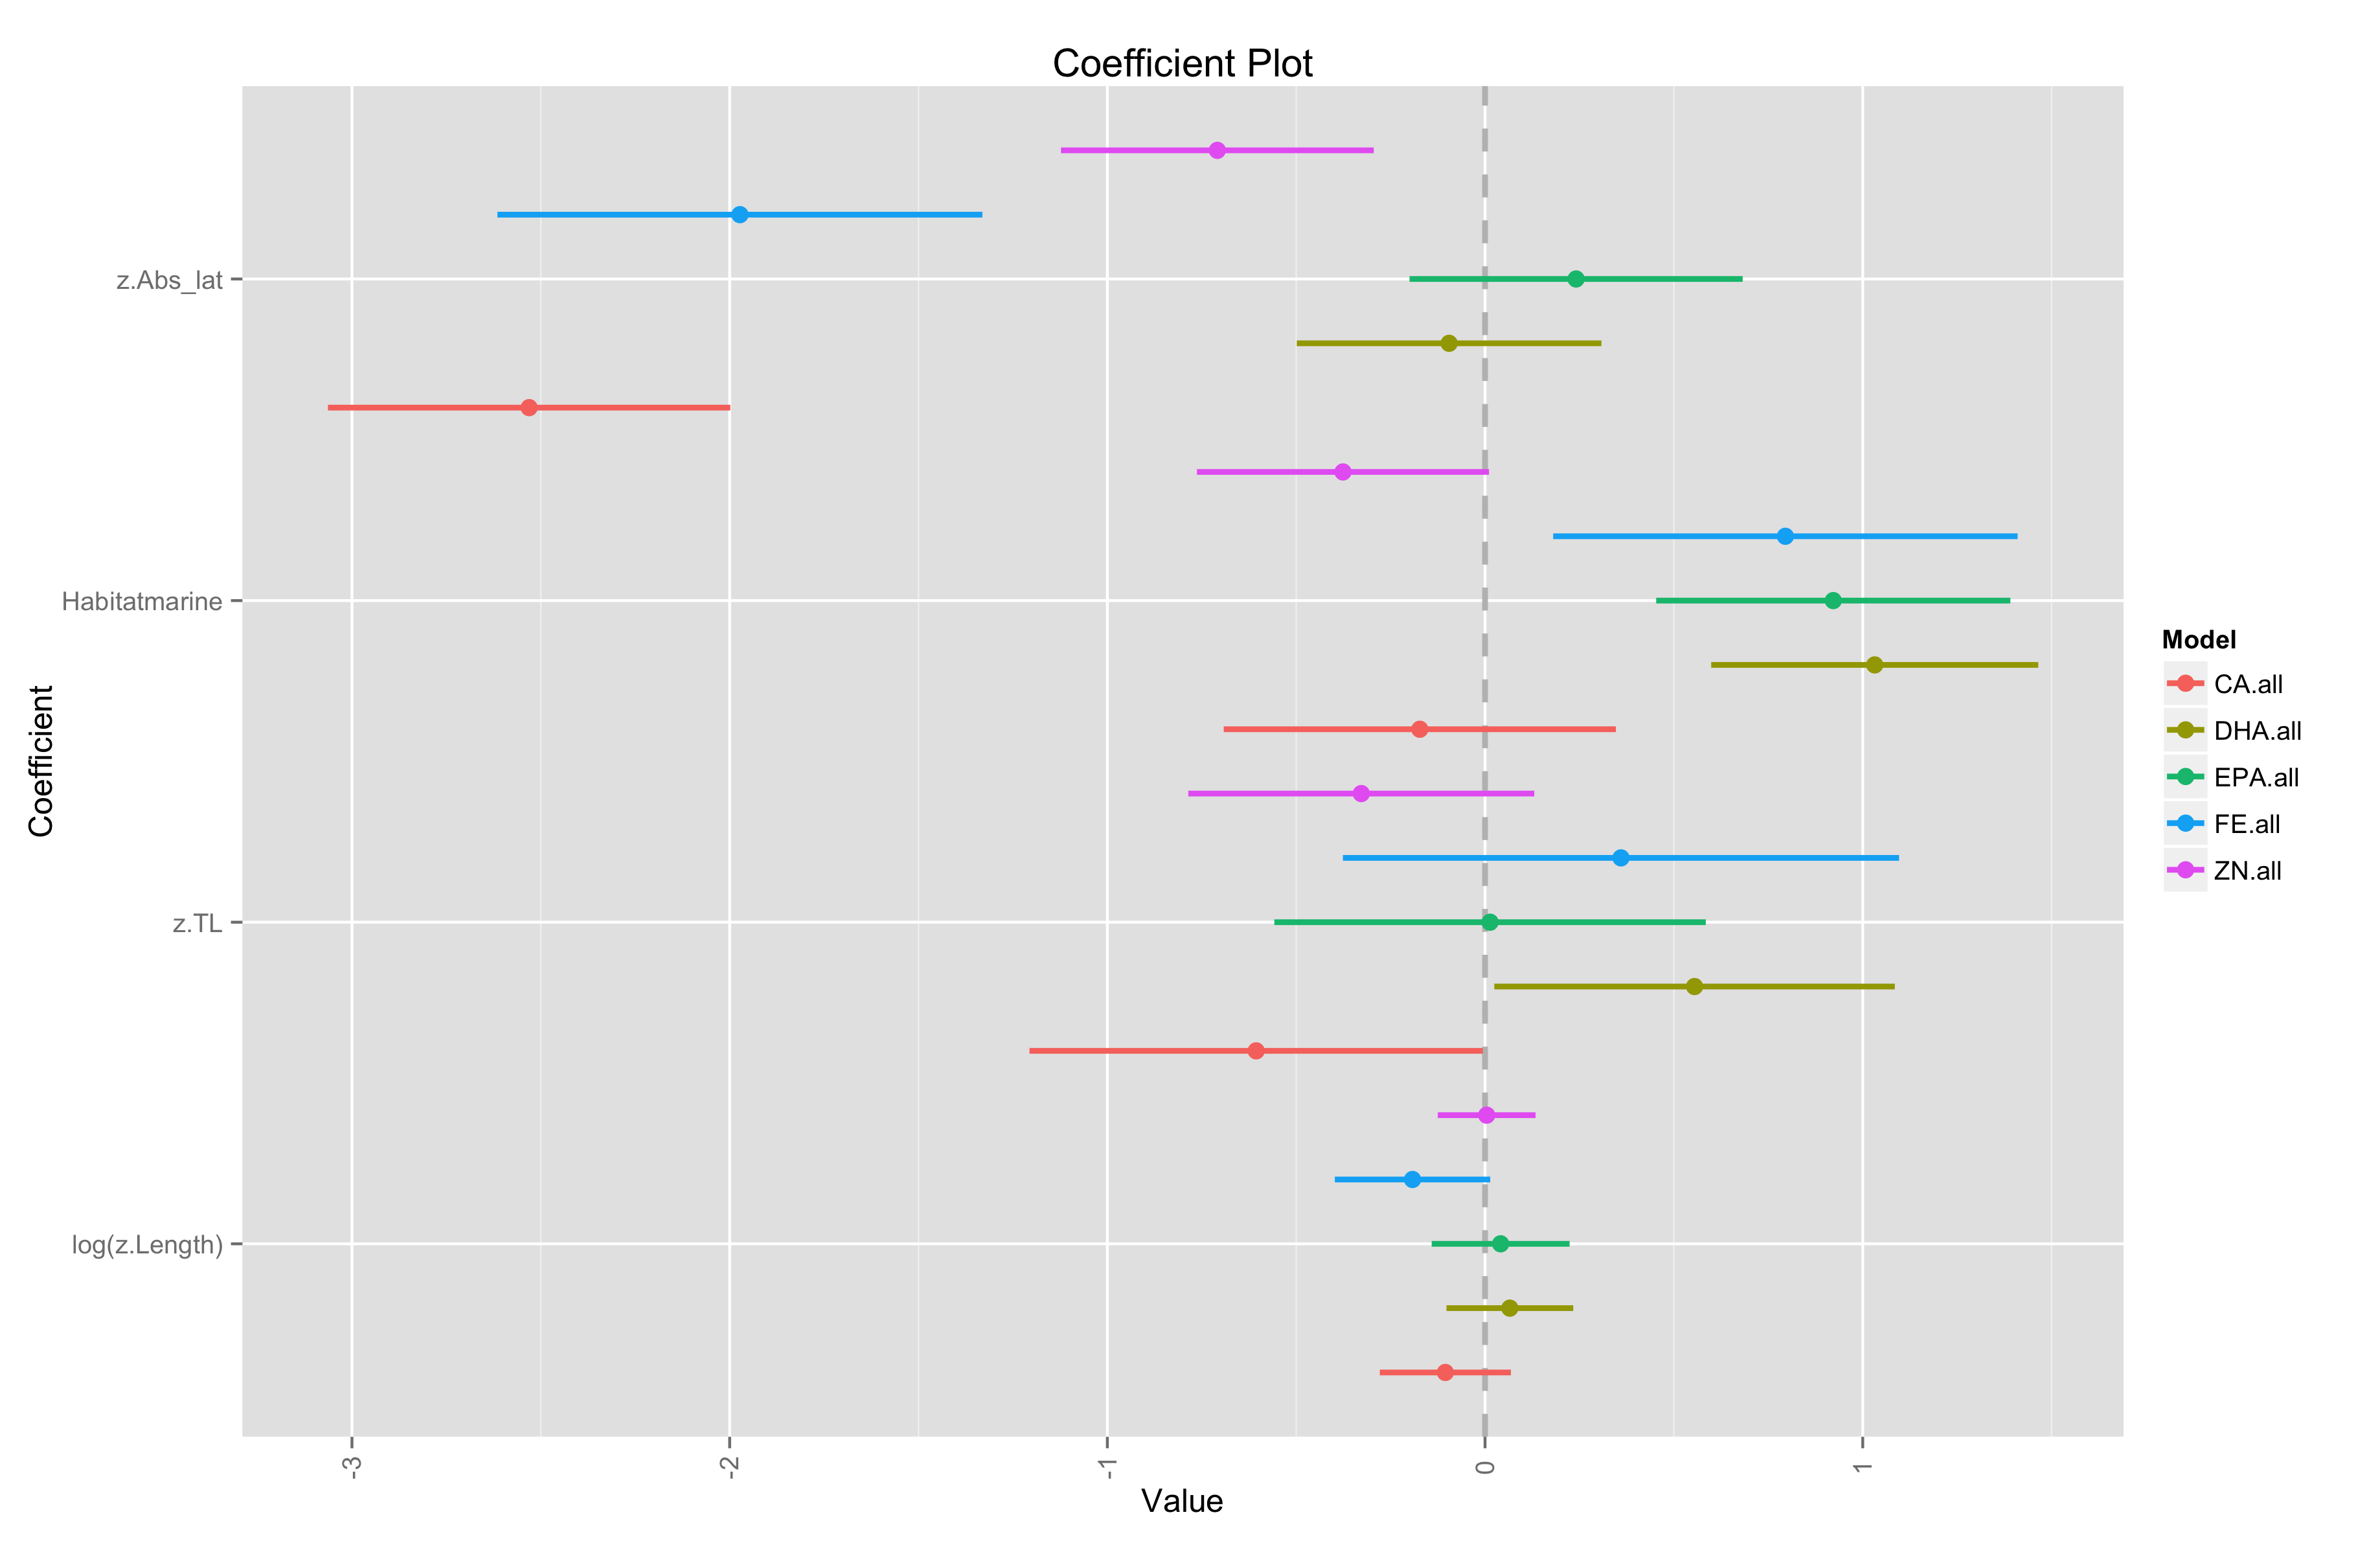

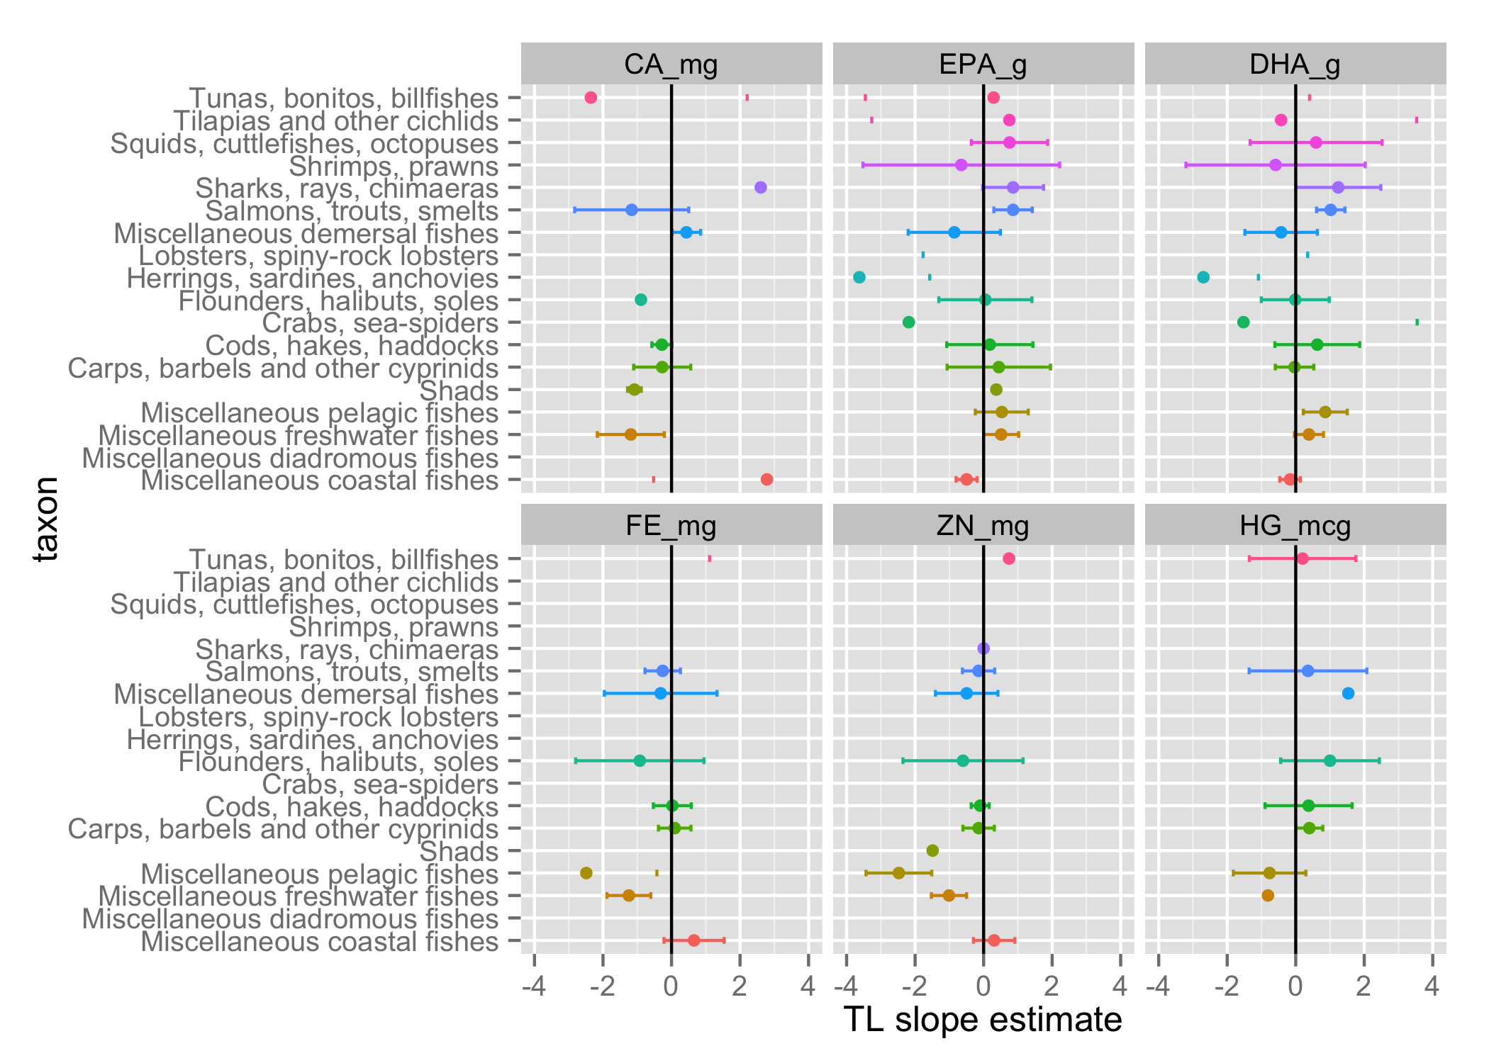

**Figure 6. Functional group diversity enhances dietary nutritional diversity and nutritional benefits that human communities may derive from seafood assemblages. (fig 6 nutrient accumulation curve).**

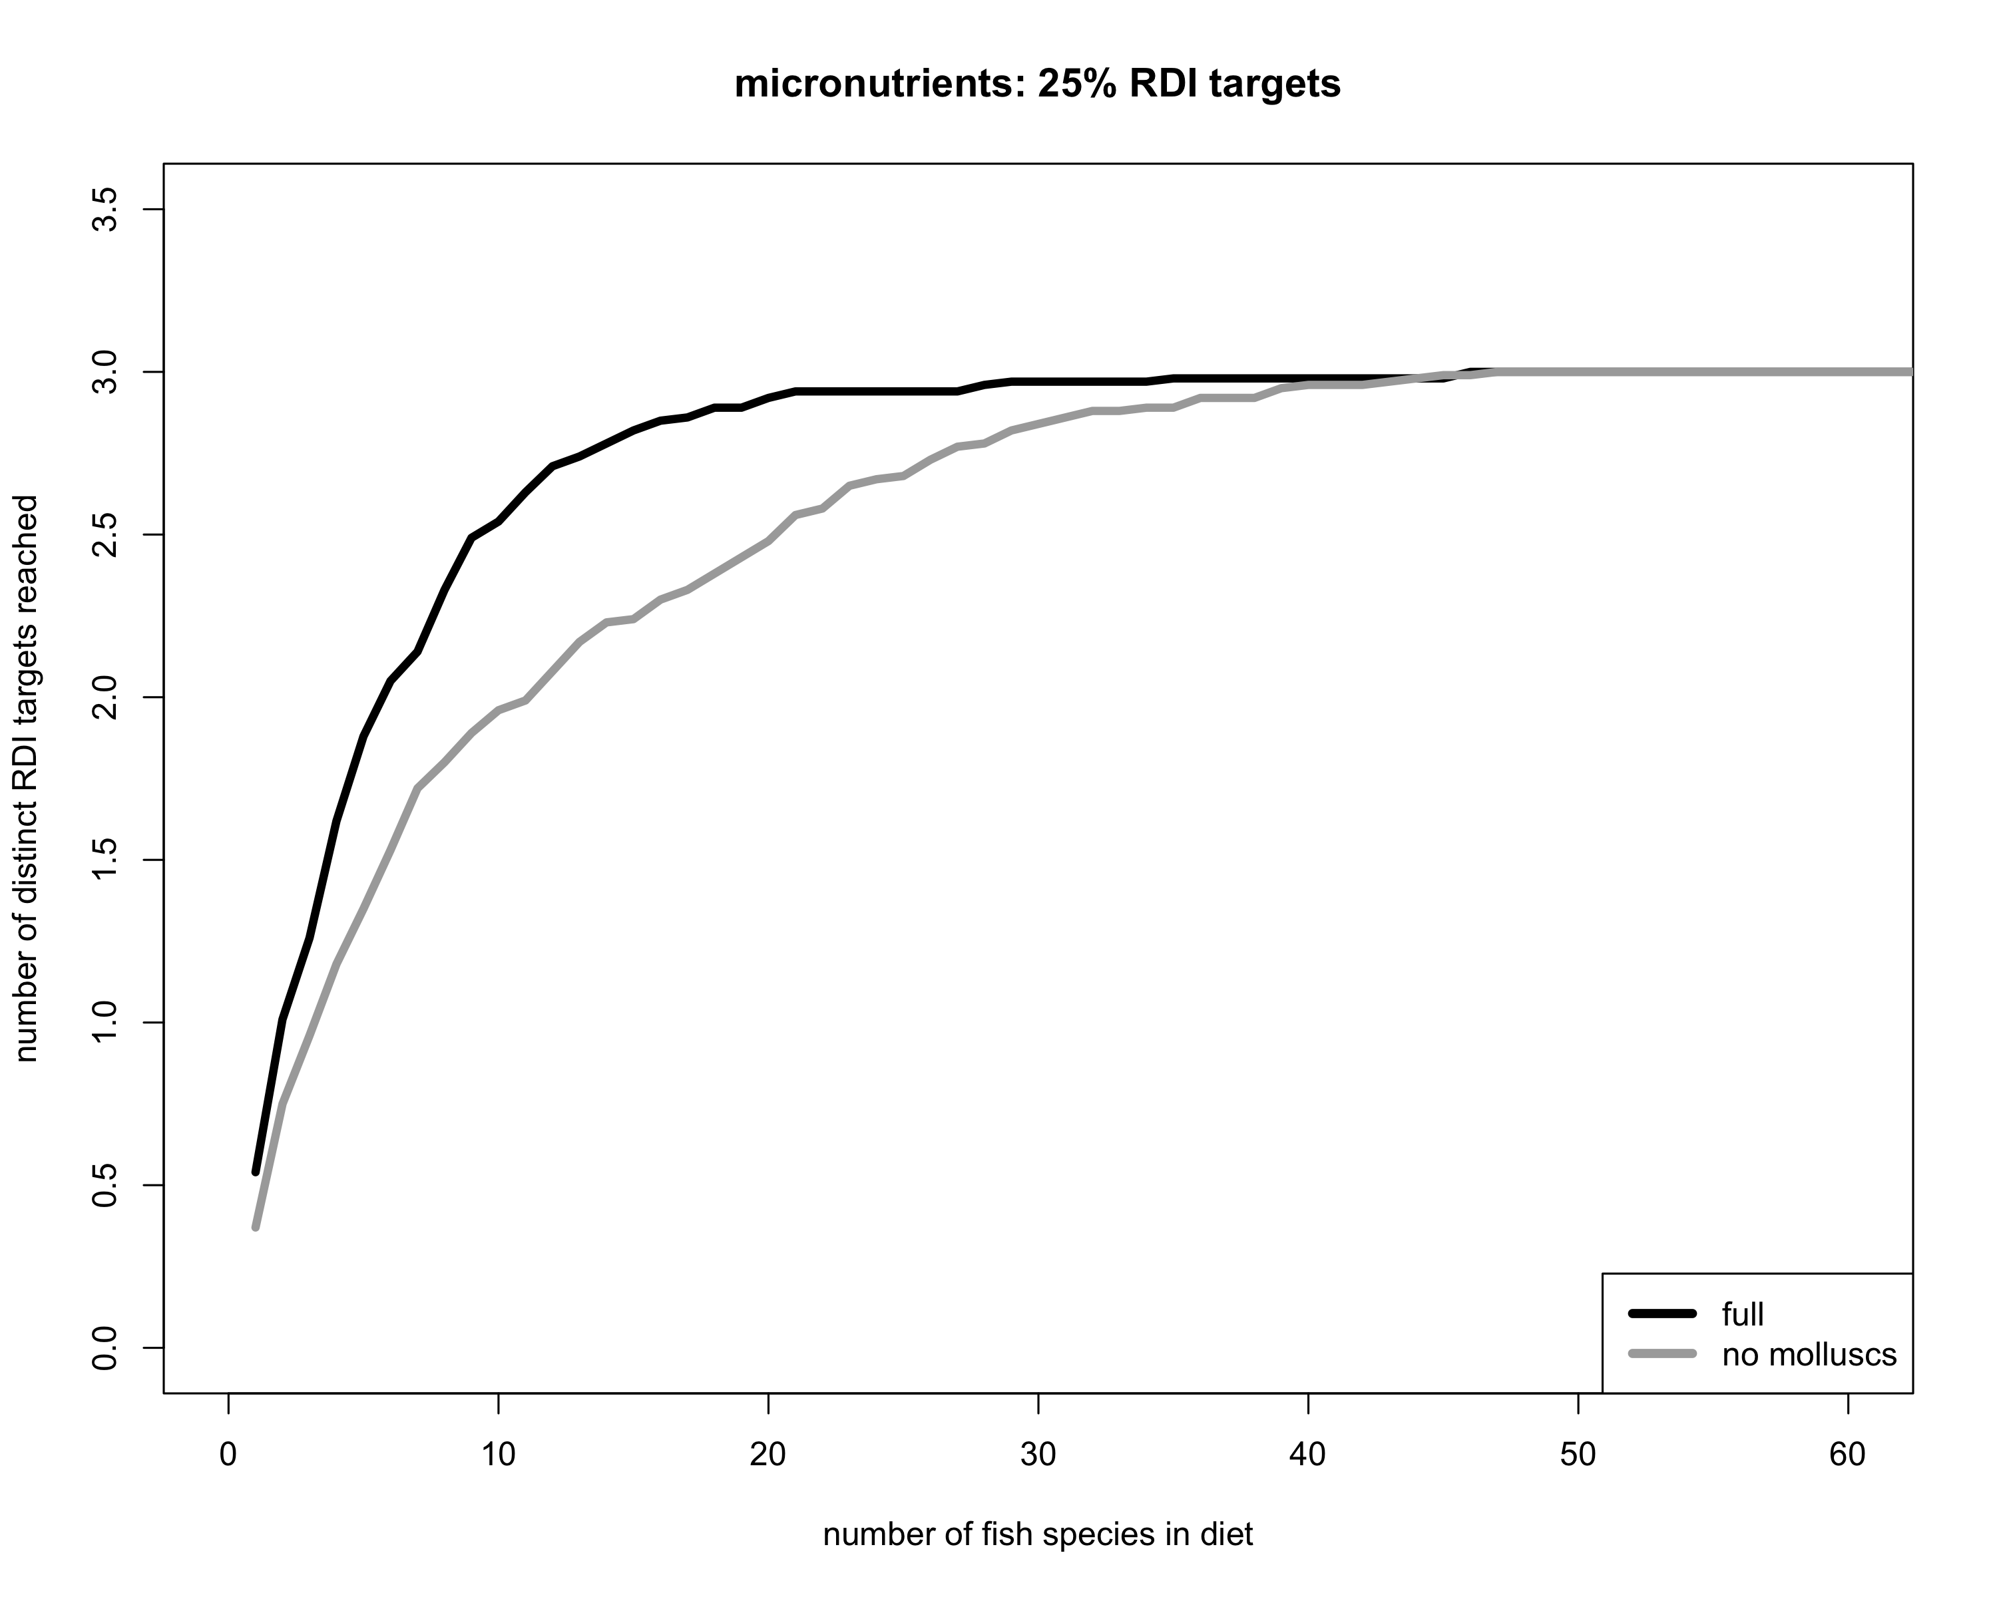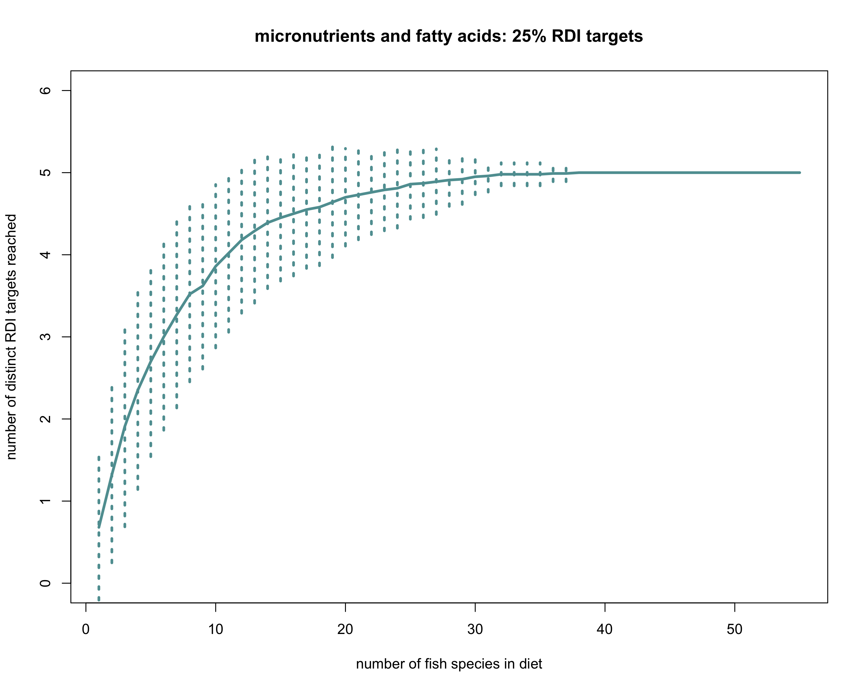

**Supp figures?**

**map of sampling locations**

**Tables:**

1. **Micronutrients in seafood: their roles in physiology and human health**