## Functional diversity in aquatic ecosystems yields enhanced nutritional benefits

## Abstract

While food provisioning is one of the most widely acknowledged ecosystem services provided by aquatic ecosystems, the role of seafood as a source of valuable micronutrients scarce in the human diet is often overlooked. The ecological mechanisms responsible for a nutritionally diverse set of seafood species are not well understood, despite heavy research emphasis on the ecological mechanisms responsible for fisheries productivity. A primary challenge in linking ecological processes to human well-being is identifying comparable metrics for ecological properties and human benefits. For nutritional value, one metric that facilitates comparisons is the nutrient content in an edible portion relative to daily reference intake values (DRI). The nutrition benefits that humans derive from seafood are not directly related to the whole body stoichiometry of aquatic species, since the commonly consumed parts of aquatic species (i.e. the edible portion), range from the whole body (e.g. for shrimps) to highly restricted portions of muscle tissue (e.g. tuna fillets), and nutrients are not evenly distributed across all tissues. To address this issue of selective human dietary practices, we used dietary food composition data, which is restricted to the edible portion, to analyze the relationship between species’ traits and their nutritional value in terms of DRI. We find that there is a high degree of variability in nutrient profiles across taxa, and that increasing functional diversity contributes to increased dietary nutritional diversity. Finally, we test whether functional traits explain variation in species’ nutritional value to human consumers, a metric of human well-being, for 430 species of fish from all major oceanic and freshwater eco-regions. We find that an ecological functional trait-based approach is effective at simplifying the nutritional complexity of aquatic food webs into a few key axes that strongly control the composition of micronutrients in fish assemblages. For some but not all nutrients we analyzed (e.g. Ca, Hg, EPA, DHA), the nutrient content of edible portions varied predictably among species with latitude and body size, consistent with the physiological functional roles of micronutrients in fish. Our results suggest that the availability of micronutrients in fish assemblages may depend on geography and functional composition of the catch. Our approach integrates ecological variation and patterns in the human consumption of species to explicitly link ecology with one metric of human well-being to suggest that a diverse fish assemblage can support a more nutritious diet to seafood consumers.

**Introduction**

The ecology of food security is not simply about predicting yields, it is about understanding the ecological conditions that lead to a stable supply of nutritionally diverse foods. For many vulnerable populations around the world, one of the most valuable aspects of seafood consumption is not only the high quality protein, but also the wide range of micronutrients contained in the tissues of aquatic species (particularly nutrients such as the omega 3 fatty acids EPA and DHA, which are only available from aquatic sources). While almost all aquatic species are equally valuable sources of protein, the tissues of aquatic species are highly variable in their concentrations of essential micronutrients. In contrast to the mechanisms responsible for fisheries productivity, which have been the focus of decades of intensive research, the mechanisms responsible for nutritionally diverse yields are poorly understood. We propose that linking the nutritional profile of species with their ecological and physiological traits may elucidate the attributes of aquatic species assemblages that maintain a stable supply of nutritionally diverse foods. Ecologically relevant species traits may be related to the concentration of trace elements and fatty acids in their tissues, thereby linking the processes that structure species assemblages with the nutritional benefits they provide to humans. Here, we conceptualize seafood micronutrients not only in their role in promoting human health and well-being, but also in the context of their functional roles in fish physiology, and explore the ecological traits associated with diversity in nutritional profiles across aquatic taxa.

**Natural variability in the concentration of trace metals and minerals in fish tissues across aquatic species has meaningful implications for human nutrition.** In some species, the concentration of any given micronutrient is sufficiently high to provide a human consumer with the entire dietary reference intake (DRI) for that nutrient in a single 100g portion, while other species provide only small fractions of the DRI. A consequence of this natural variation in nutrient concentrations is that a human diet that contains more species may provide more nutrients in sufficient quantities to reach a range of dietary intake targets. However, the relationship between species diversity and nutritional diversity in aquatic food webs is unknown. Many other questions arise: Are some nutrients more redundant across species than others? Further, are species’ ecological traits correlated with their nutritional value to humans? Understanding the relationships between aspects of ecological structure at the community level, such as species diversity, and at the individual level, such as body size, and the nutritional profile of aquatic species is an essential step in characterizing the contribution of aquatic ecosystems to human well-being. Here, we aim to characterize these relationships between ecological structure and human nutrition by addressing three questions: (1) How variable are nutritional profiles among aquatic species? (2) Are species’ traits associated with these patterns of variability? and (3) Are aspects of ecological structure such as species- and functional diversity related to the nutritional benefits of a human diet that includes multiple seafood species?

**Trait-based approaches in ecology have proven to be effective in understanding the axes of ecological variation that strongly control ecosystem functions and services** (Cardinale et al. 2012, Diaz papers? ). Recent experiments and theory suggest that a small number of species traits, including organismal body size, dietary generalism and trophic position can predict important aspects of ecosystem structure (Wood et al. 2010, others?). Dozens of biodiversity ecosystem functioning (BEF) studies have shown that the traits of species, not just the number of species, ultimately determine the nature of the relationship between diversity and ecosystem function (Hooper et al 2005, McGill et al. 2006). In plants, the set of trait values of an individual, known as its trait syndrome, reflects functional trade-offs among different plant functions (Diaz and Cabido, 1997). Here, we extend this approach to characterizing the relationship between aquatic species’ ecological traits and their nutritional profile with respect to meeting human dietary reference intakes. Micronutrients such as iron, which are valuable to human health because they play key roles in processes such as red blood cell formation, also play important roles in fish physiology. As such, in the same way that key physiological processes are known to vary with environmental conditions such as temperature, and species’ traits such as life stage and body size, so might the concentration of these key elements in fish tissues.

**Ecologically relevant species traits may be related to the concentration of trace elements and fatty acids in their tissues, thereby linking the processes that structure species assemblages with the nutritional benefits they provide to humans.**  Functional traits such as trophic position may be related to the nutritional content of seafood species because they affect the dietary range and quantity of nutrients to which an organism is exposed, as well as the physiological constraints on body composition (Simpson and Raubenheimer 2012). It has been proposed that in some aquatic species, the distribution of trace metals in fish tissues is related to feeding guild (Bernhard and Andreae 1984), body size, stage of life cycle, and reproductive status (Shearer 1984). Other factors such as disease state, water quality and environmental conditions may also modify tissue mineral distribution (Lall and Olivier 1993). Further, variability in essential fatty acid (EFA) content per serving size may be related to the total fat content of the fish: the characteristically lean fish like pollock and hake have relatively low contents of EFAs, while the more lipid-rich fish have higher EFA contents (Hyuhn and Kitts 2009). Here, we build on these observations and examine the relationship between important species’ traits, including body size, trophic position and thermal niche and their nutritional profiles across a wide range of species collected around the world.

**A set of mechanisms linking traits to nutritional profiles includes allometric scaling of body tissues and homeostatic control.** Different metals localize or accumulate in different organs or tissues. For example, Fe concentrations are highest in hematopoietic tissues while Hg is most abundant in the muscle tissues. These tissues show different patterns of allometric scaling (Calder 1984). While muscle, blood, heart and spleen tend to scale isometrically, fat and skeleton tend to scale with positive allometry, and liver, kidney and brain scale with negative allometry. Thus, depending on where a given nutrient is known to localize among body tissues, we may expect different associations with traits such as body size. In addition to relative accumulation across body tissues, **variability in concentration of macro- and microelements within tissues is inversely related to the degree of homeostatic control.** Nutrients that tend to be under stronger homeostatic control, such as carbon and nitrogen (the primary components of fats and proteins, respectively), tend to be less variable across seasons and taxa than microelements such as zinc (Karimi and Folt, 2006). Non essential metals such as mercury are even more variable than essential microelements. Since each nutrient is under different levels of homeostatic control, we expect the relationship between nutrient content and species’ traits to vary by nutrient. At the assemblage level, we expect the degree of variability in nutrient content to be lowest for those nutrients that are more tightly regulated (including fats and proteins) and highest for the elements that are under weaker homeostatic control (e.g. zinc and mercury).

**From the perspective of human nutrition, the nutritional value of a species is not simply a function of whole body nutrient content, because humans often eat only a small subset of fish tissues.** As such, the nutritional value of a species in the human diet varies as a function of how nutrients localize in different tissues, and also which tissues are commonly included in the edible portion of the fish. **Human dietary practices often map onto functional traits such as body size and (exo)skeleton morphology (table 1)**. For example, in large bodied finfish such as tunas, humans typically consume the muscle tissue only. In contrast, humans typically consume a much broader range of body tissues in crustacean taxa such as shrimps (i.e. whole body) and crabs (muscle tissue and organs such as the hepatopancreas). Taken together, the patterns of functional morphology and human dietary practices suggest that the edible portions of species from different taxonomic and functional groups may have vastly different nutrient profiles.

**We explicitly characterize the relationship between aquatic species’ ecological traits and their nutritional value for human well-being by drawing on two well-established nutritional metrics: nutrient content/100g edible portion and DRI.** We synthesize nutritional content data for the edible portions of 430 aquatic species from all major oceanic and freshwater ecoregions (table s1). For each of these species, we also collected ecological trait data including maximum body size, trophic position and habitat associations, which are broadly related to the function and form of species in aquatic systems (Woodward et al. 2005, other ref?). We chose to analyze a selection of ions and compounds that affect a species’ nutritional value for humans and that are implicated in a range of biologically important processes that affect growth and reproduction. We examined fatty acid concentration (which reflects fish diet and physiological condition), a toxic metal for which increased concentrations are negative for humans (Hg), two metals beneficial at low concentrations but toxic at high concentrations (Zn and Fe), and one mineral (Ca). We applied this approach to a ‘global seafood’ diet, but this approach could be easily applied to the species available in local seafood diets.

We analyzed this dataset to (1) quantify variation in nutritional quality among aquatic taxa, (2) assess the degree of turnover in nutrient profile from one species to another and the contribution of species diversity to nutritional diversity and (3) test whether ecological traits are related to variation in nutritional profile from the perspective of a human diet. Specifically, we asked: how often do species contain DRI targets for more than one nutrient in a single portion? Are DRI targets typically seen in clusters (i.e. is a species with a high concentration of zinc in its edible tissues also likely to have a high concentration of iron)? Understanding how redundant nutrient profiles are across species is important because it will help us understand the nutritional implications of changes in seafood species pools (such as changes caused by over-fishing or climate changes).

We test a set of predictions related to the hypothesis that nutritional profile is linked to species traits. We expected that variability in nutrient concentration in fish tissues would be greater for more weakly regulated trace elements such as iron and zinc than structural elements such as calcium, fatty acids, fat and proteins. Similarly, we expected the degree of redundancy in nutrient profile to be highest for macronutrients (i.e. protein and fat) and lowest for the microelements (e.g. iron and zinc). As such, turnover in nutrient profile should be greater for the micronutrients compared to the macronutrients, and the influence of species diversity on nutritional diversity should be greatest for the nutrients that are typically in the lowest abundance in fish tissues and the most weakly regulated. Finally, we predicted that ecological traits such as body size, trophic position, habitat associations and thermal niche would be related to nutritional profile because they are related to the environmental and physiological factors known to influence the accumulation of micronutrients in fish tissues.

**Methods**

**Understanding links between human well-being and the ecology of diversity in nutritional profiles requires first identifying comparable units and metrics for ecological properties and human benefits.** In the context of human nutrition, one metric that facilitates comparisons is the nutrient concentration in an edible portion relative to dietary reference intake values (DRI). The value of a fish species in terms of human nutrition benefits can be quantified as the nutrient content in an edible portion relative to Dietary Reference Intake (DRI) values. The DRI is the daily intake level of a nutrient that is considered to be sufficient to meet the requirements of 97–98% of healthy individuals in every demographic (National Academies of Sciences 2011).

We documented the variation in nutrient content relative to DRI across commonly consumed aquatic taxa. To understand how nutrient content varies among species, we tested whether ecological traits known to be both biologically important and that exhibit predictable scaling relationships could explain variation in nutrient content. We synthesized spatially explicit and size explicit nutrient data to identify thresholds in geography or body size that correspond to whether or not a species achieves 10% of DRI in a single portion.

**Literature search and data collection**

To test how nutrient profile varies with ecological traits, we assembled a dataset of nutrient content in the edible portions of 400 aquatic species (table S1). We defined the nutritional profile of a species as the quantity of a given nutrient in 100 g of edible tissue - a metric that is commonly used in the human food composition literature (Nowak et al. 2014). We aimed to include as many species as possible, from both marine and freshwater systems, and covering a wide geographic extent. We searched the literature for analytical compositional values for each of these species. We searched the peer-reviewed literature as well as food composition databases or tables, such as the Food and Agriculture Organization’s INFOODS database (FAO/INFOODS 2014). For finfish, we restricted our analysis to include only the edible portions of wild, raw fish (thus excluding prepared or farmed seafood items). However, we included both farmed and wild mollusk species because mollusk farming does not typically involve additional food inputs, which could influence tissue nutrient composition. For each species, we noted which body parts are included in the edible portion. Our dataset includes quantities for the following microelements: calcium; iron; zinc; mercury and two fatty acids: eicosapentaenoic acid (EPA); and docosahexaenoic acid (DHA). To address inconsistencies in fatty acid data reporting, we standardized fatty acid measurements using the fatty acid conversion factors proposed by Nowak et al. (2014).

For each species with nutritional data, we collected ecological trait information from FishBase (Froese and Pauly 2014) and SeaLifeBase (Palomares and Pauly 2014). We included body size (maximum length), fractional trophic position, temperature preference (using latitude as a proxy) and habitat preference (Marine, Freshwater, brackish…). We converted body length data into body mass, using established length-mass relationship data (*mass*= *a*length^b*). We used species-specific or taxon-specific *a* and *b* parameter values published in Froese et al. (2013).

**Statistical Analysis**

We used the vegan package in R (Oksanen et al. 2010) to examine the variation in nutrient profiles among fish species. We log transformed nutrient concentration data to achieve normality. Differences in multi-nutrient profiles (including three minerals and two fatty acids) were visualized through non-metric dimensional scaling (NMDS) using the metaMDS function within the vegan package. The ordination ran for 1000 iterations, and the stress score of 0.029 for the final solution was sufficiently low to enable reliable interpretation in the two dimensions. The effect of subgroup membership (i.e. finfish, mollusk, and crustacean) on nutrient profile was assessed via permutational multivariate ANOVA (PERMANOVA) using the ‘adonis’ function in vegan, based on 999 permutations. An overall (three-way) PERMANOVA was first used to investigate subgroup effects on nutrient profile, before pair-wise tests were used to assess differences between groups. We constructed the distance matrices for NMDS and PERMANOVA using the Bray-Curtis dissimilarity index.

*Turnover in nutrient profiles among aquatic species*

To test the relationship between species diversity and nutritional diversity, we constructed dietary reference intake (DRI) target accumulation curves using the ‘specaccum’ function in the vegan package of R (Oksanen et al. 2012). This function is typically used to assess patterns of beta-diversity, or species turnover, in ecological community composition data. It samples random individuals sequentially in a dataset and counts the number of novel species encountered as individuals are added (Taylor et al. 2013). In an analogous approach, we used this function to assess turnover of nutrients among fish species, treating fish species as sites, and each DRI target as a species. Thus, each fish species is associated with a set of 0s and 1s corresponding to whether or not it achieves the DRI target (i.e. where nutrient content per 100g portion is greater than 10% of DRI) for each of five micronutrients (equivalent to a species presence-absence matrix in community composition data). Here we used the ‘random’ method, which encounters fish species in random order and samples these species without replacement. Distinct DRI targets were accumulated as fish species were sampled in random order. This approach allowed us to explore how likely it would be for human diets containing different numbers of distinct fish species to reach a given number of DRI targets, assuming that fish species were included in the human diet at random. To examine the relative importance of certain functional groups in contributing to dietary diversity, we compared nutrient accumulation curves and 95% confidence intervals for subsets of the dataset with distinct functional groups removed and compared them to the curves constructed for the full dataset.

*Testing for associations between species’ traits and nutrient concentrations*

We modeled the relationship between nutrient content and species’ traits with linear regression models using a log-transformed power function. The full model included the entire set of predictors:

ln(nutrient content) = *Β0.i* + *Β1.i*\*ln(body size)*latitude + *Β2.i*\*ln(body size)*(trophic position)  + *Β3.i*\*ln(body size)*(habitat) + εi

We created models from subsets of the full model that represented hypotheses based on the known physiological roles of micronutrients and their relationships to our set of predictors. We identified the best subset of models using the Akaike Information Criterion, adjusted for small sample sizes (AICc). We used AICc, δaic and Akaike weights (w) to compare models. We ranked models based on w, and selected the set of models that produced a cumulative w > 0.95, meaning that we are 95% confident that the chosen set includes the best model (Burnham and Anderson 2002).

In cases where we could not obtain measurements of all traits for all species, we performed model selection on reduced datasets without missing values. To account for model uncertainty, we performed model averaging of coefficients in all models with δaic < 2 ( δaic = AICi − AICmin), and included zeros as coefficients when variables did not enter a given model (Burnham and Anderson 2002). We conducted all our analyses in R version 3.2.2 (R Core Development 2015) using the MuMIn package.

-somewhere here, need to address multi-collinearity of predictor variables etc.

**Results:**

We found considerable variability in nutritional profiles among aquatic taxa; species are not redundant with respect to concentrations of any micronutrient, or micronutrient profile. Variability was lowest for the macronutrients we considered (i.e. protein, fat and fatty acids) and highest for the micronutrients (minerals: calcium, iron and zinc). All of macronutrient concentrations varied over one order of magnitude, while the micronutrients varied over two or three orders. Here we present the nutrient variability in species grouped according to their membership in FAO’s 'International Standard Statistical Classification for Aquatic Animals and Plants' (ISSCAAP) category, which divides commercial species into 50 groups based on their taxonomic, ecological and economic characteristics. Protein (n = 251 species) ranged from an average of 10.68g/100g in the clams, cockles, and arkshells to 21.85 g/100 g in the Tunas, bonitos, and billfishes (Figure 1). Fat (n = 277 species) ranged from an average of 1.08 g/100g in the sharks and rays to 12.74 g/100 g in the shads (Figure 1). EPA in the edible portion (n = 238 species) ranged from an average of 0.02 g/100g in the sharks and rays to 0.53 g/100 g in the herrings, sardines, and anchovies (Figure 1). DHA in the edible portion (n= 235 species) ranged from an average of 0.065 g/100g in the shrimps and prawns to 1.28 g/100 g in the tunas, bonitos, and billfishes (Figure 1).

In contrast to the macronutrients, the micronutrients were even more variable. Calcium in the edible portion (n = 99 species) ranged from an average of 10.78mg/100g in the cods, hakes and haddocks to 782.60 mg/100 mg in the abalones, winkles and conchs (Figure 1). Zinc in the edible portion (n = 101) ranged from an average of 0.36 mg/100g in the cods, hakes and haddocks to 11.87 mg/100 mg in the oysters (Figure 1). Iron in the edible portion (n= 238) ranged from an average of 0.19 mg/100g in the cods, hakes and haddocks to 20.31 mg/100 mg in the abalones, winkles and conchs (Figure 1).

Few species reach DRI targets for more than one nutrient (Figure 2). When considering a target of 25% of DRI, more than half of the species (i.e. 65 species) reach no targets, while 41 species reach 1 or more targets, 39 reach two or more targets and only two species 2 reach all three targets. When considering a target of 10% of DRI, 56 species reach no targets, 50 reach one or more targets, 41 reach 2 or more targets, and 15 reach all three targets.

Variation among taxa was explained by one trait – body size – and variation in benefits to humans is explained by how dietary preferences relate to body size. Body size of the species and dietary practices of consumers (e.g. eating bones or multiple body tissues) have a large effect on the likelihood that a given edible portion will reach DRI targets (Figure 3). For macro- and micronutrients grouped together, 79.21% of the observations of species for which it is customary to eat multiple tissues reached RDI targets, whereas this number drops to 39.59% for species in which only the muscle tissue is eaten.

Variation among nutrients is explained by clusters of functional traits associated with major ecologically-defined functional groups. Functional groups have distinct multi-nutrient profiles (Figure 4). A PERMANOVA of the nutrient concentration dissimilarity matrix revealed that subgroup membership (i.e. finfish vs. crustaceans vs. molluscs) explained a significant portion of the variation in nutrient composition among aquatic species (PERMANOVA, F 2,103 = 3.429

p = 0.006).

Functional group diversity enhances dietary nutritional diversity and nutritional benefits that human communities may derive from seafood assemblages (figure 5). The DRI accumulation curves show that for a human diet created at random from a given assemblage of aquatic species, the diet needs to include on average 8 species to reach a median of all three mineral DRI targets. If molluscs are removed from the dataset, a human diet would need to sample from 14 distinct species to reach all three DRI targets. When all five micronutrients (i.e. minerals and fatty acids) are considered, a human diet would need to include 15 species to reach a median of all 5 micronutrient targets (when molluscs are included), or 22 species when molluscs are excluded.

Within functional groups, some traits such as body size and latitude are strongly associated with nutritional profile. For all three minerals (calcium, zinc, and iron), concentration in the edible tissue decreases with increasing body size (figure 6, negative slope p < 0.01, R2 = 0.56, 0.37, 0.18 for calcium, zinc and iron respectively). This pattern is opposite for the macronutrients: concentration increases with increasing body size (figure 5, positive slope, p < 0.01), and for the essential fatty acids, there is no association between body size and concentration (figure 5, p > 0.05). For the minerals, there is a negative relationship between latitude and concentration (i.e. higher concentrations at lower latitudes), whereas this pattern is reversed for the fatty acids (i.e. higher concentrations at higher latitudes). Trophic position was not associated with the concentration of the minerals, EPA or fat. Trophic position was, however, strongly associated with the concentration of protein and DHA (figure 5, p < 0.01). The explanatory power of the models including body size, trophic position and latitude was high for minerals (i.e. r2 = 0.56, 0.37, 0.19 for calcium, zinc and iron respectively), and relatively low for the macronutrients and fatty acids (r2 = 0.18, 0.07, 0.06, 0.02 for protein, DHA, EPA and fat respectively).

**Discussion:**

More than two billion people worldwide are estimated to be deficient in essential vitamins and minerals (WHO 2013). Aquatic species may contribute to reducing these deficiencies. However, from a nutritional value perspective, not all fish are created equal. Our global analysis of the nutrient content of the edible portion of commonly consumed aquatic taxa revealed a high degree of variability in nutritional profile across taxonomic groups. The degree of variability was particularly high for the micronutrients vs. macronutrients. We found that the substantial variation in the nutritional content of an edible portion among seafood species can be explained partly major ecological traits: functional group, latitude, body size and habitat associations. Below we discuss these patterns of variability across functional groups and implications of these findings for dietary diversity and human health.

**Variation in nutrient concentrations among aquatic taxa**

In contrast to much of the existing work on stoichiometry in fishes, which addresses patterns of macro-element (i.e. C, N, and P) and macronutrient (i.e. protein and fat), variability in whole body samples, here we focused on variability in micro-elemental composition in tissues contained in the edible portion. We found even greater levels of variability in micronutrient stoichiometry than have been documented in the literature for macro-elements. In general, we found that patterns in nutrient content were less variable for the macronutrients we considered than micronutrients. The minerals varied by over two to three orders of magnitude, while the macronutrients varied over at least one order of magnitude. This finding is consistent with expectations based on the functional roles of nutrients in organismal physiology and lower levels of homeostasis associated with microelements (Karimi et al. 2006).

**Human dietary practices influence nutritional profile**

The degree of variability we documented in the edible portion is substantially higher than variability documented among whole body measurements of elemental composition of fishes documented in the ecological literature. This could be due to the fact we are sampling across a much broader range of latitudes, habitats and taxonomic groups, or because nutrient deposition is not uniform across body tissues, and our dataset contains data only for the edible portion, which encompasses different body tissues depending on the species. Importantly, implicit in our dataset are human dietary practices, which may influence the relationship between body size, taxonomic identity and nutritional content. Sometimes the edible portion contains organs such as liver and skeleton, sometimes it is just muscle tissue. For example, for some small-bodied indigenous fishes in Cambodia, it is common to consume the entire body, including the bones and head of the fish. In contrast, for larger fishes such as carp (which are comparable in terms of habitat, trophic position and latitude), the edible portion is restricted to muscle tissue, and the concentrations of calcium, iron and zinc are substantially lower.

**Nutrient variability in the context of dietary reference intakes**

In the context of DRI, very few species reach 10% of DRI for more than one micronutrient in a single 100g portion. This finding suggests that human diets must include several distinct seafood species to achieve DRI for multiple nutrients. For example, to reach DRI targets for calcium, iron and zinc, a human diet must contain on average eight distinct species. Further, some groups were more likely than others to reach DRI targets. For example, 80% of the molluscs reached at least one DRI target while only 25% percent of the finfish reached at least one DRI target. Thus, if molluscs are not included in the diet, the number of species required to reach the calcium, iron and zinc DRIs rises to 22 species.

In contrast to the micronutrients, there is a much higher level of functional redundancy for macronutrients. The DRI for protein was reached in almost all species in our dataset. In contrast, the DRIs for the micronutrients, calcium, iron and zinc were reached by 22%-39% of species. As a result, the contribution of species diversity to the likelihood of reaching DRIs is greater for micronutrients than macronutrients. Given that the role of fish in combating nutritional deficiencies may be even more important for essential micronutrients than protein (Allison et al. 2007), species diversity in human diets may be particularly important to the health benefits provided by seafood assemblages.

**Implications of anthropogenic impacts on nutritional benefits from aquatic ecosystems**

Identifying the axes that influence nutrient content of aquatic taxa reveals that the supply of some nutrients might be more vulnerable to stressors such as climate change or overfishing. For example, 60% percent of the species in the dataset that reached DRIs for iron and zinc were molluscs or crustaceans. Thus, since molluscs and crustaceans may be, on average, more vulnerable to ocean acidification than finfish, the supply of these minerals may be particularly at risk. [maybe a sentence or two on the role of body size and latitude?]

In conclusion, this study provides the first global assessment of patterns in micronutrient content of aquatic species. Our results reveal that not all fish species are equally nutritionally valuable to humans and that increasing the number of seafood species in the human diet will increase the likelihood of reaching a broad range of nutritional benefits.

**List of figures:**

**Figure 1. Distribution of nutrient concentrations across species**

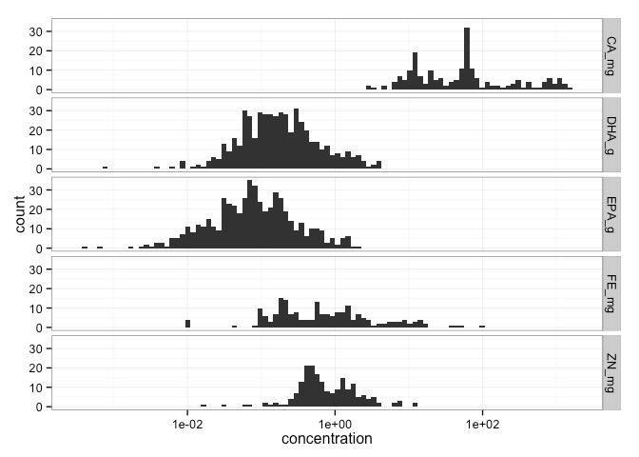

**Figure 2. Few species contain reach DRI targets for multiple nutrients** 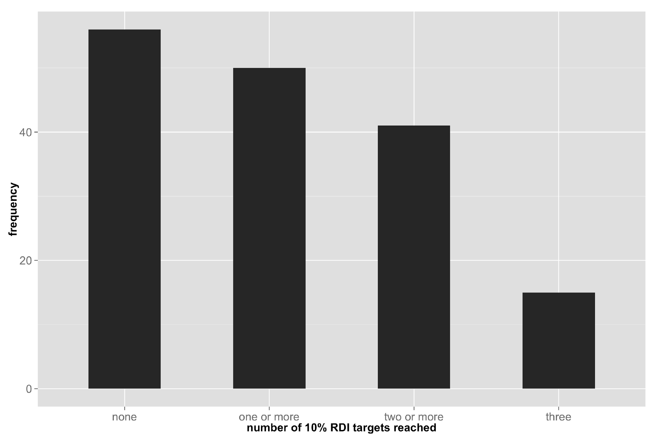

**Figure 3. Shows proportion of body consumed and number of DRI targets**

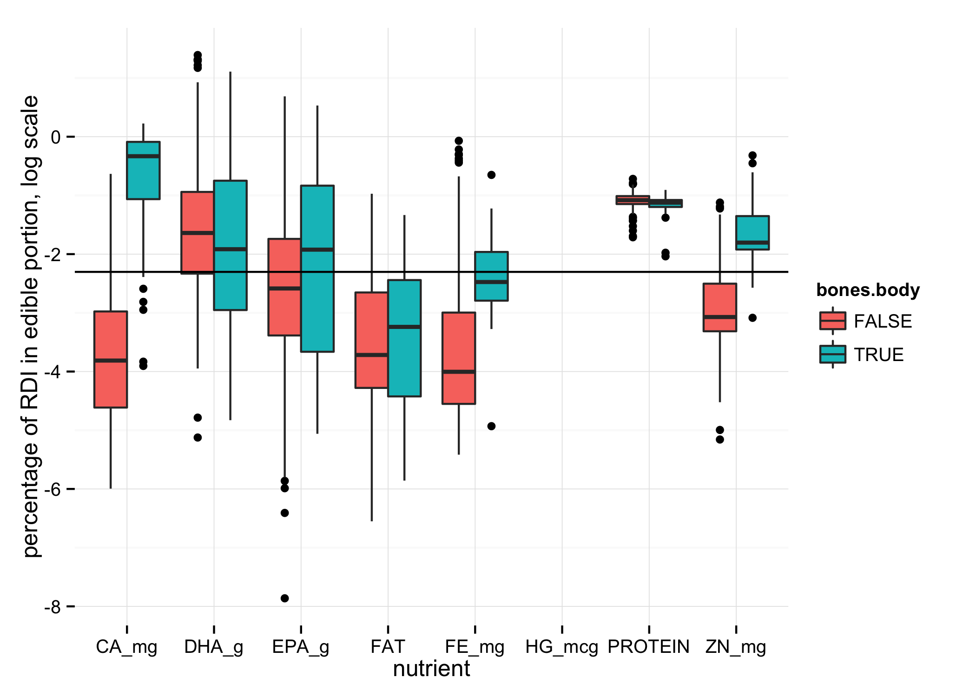

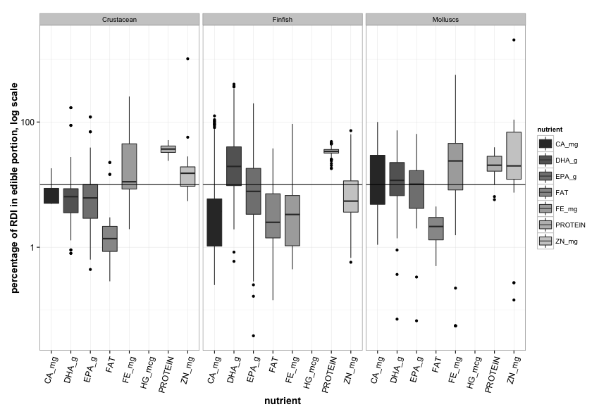

**Figure 4. Functional groups have distinct multi-nutrient profiles (mds plot with finfish/crustaceans/molluscs color coded).**

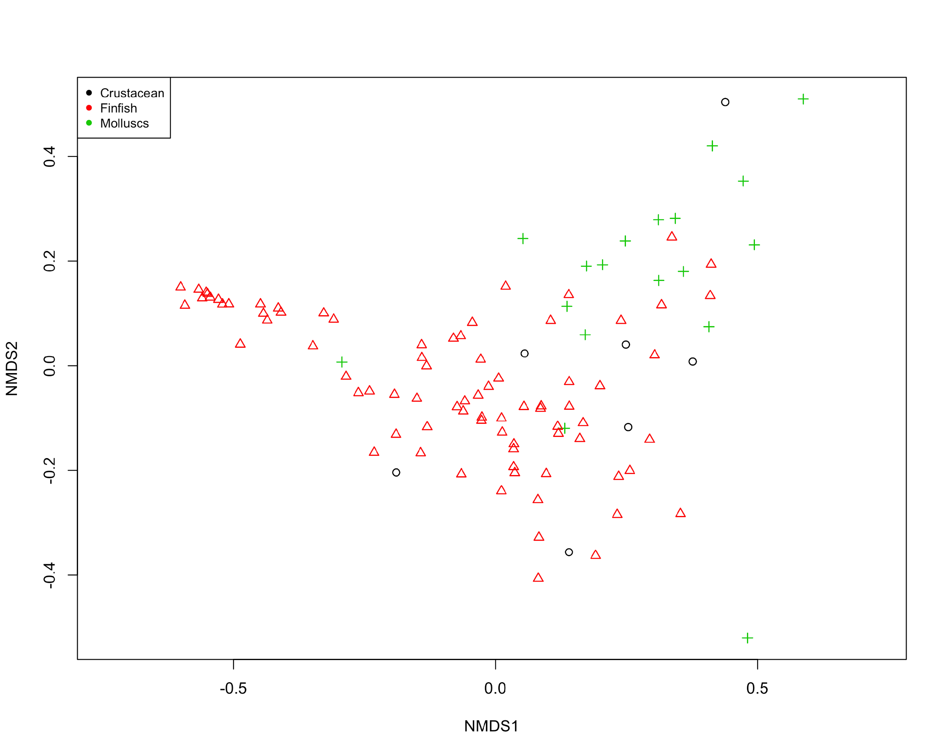

**Figure 5. Within functional groups, some traits such body size and latitude are strongly associated with nutritional profile (fig 5 coefficients plot).**

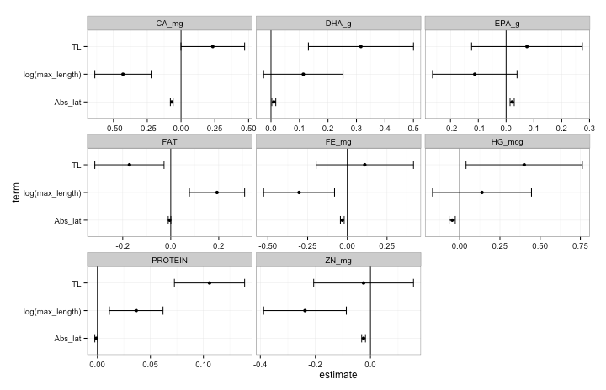

**Figure 6. Functional group diversity enhances dietary nutritional diversity and nutritional benefits that human communities may derive from seafood assemblages. (fig 6 nutrient accumulation curve).**

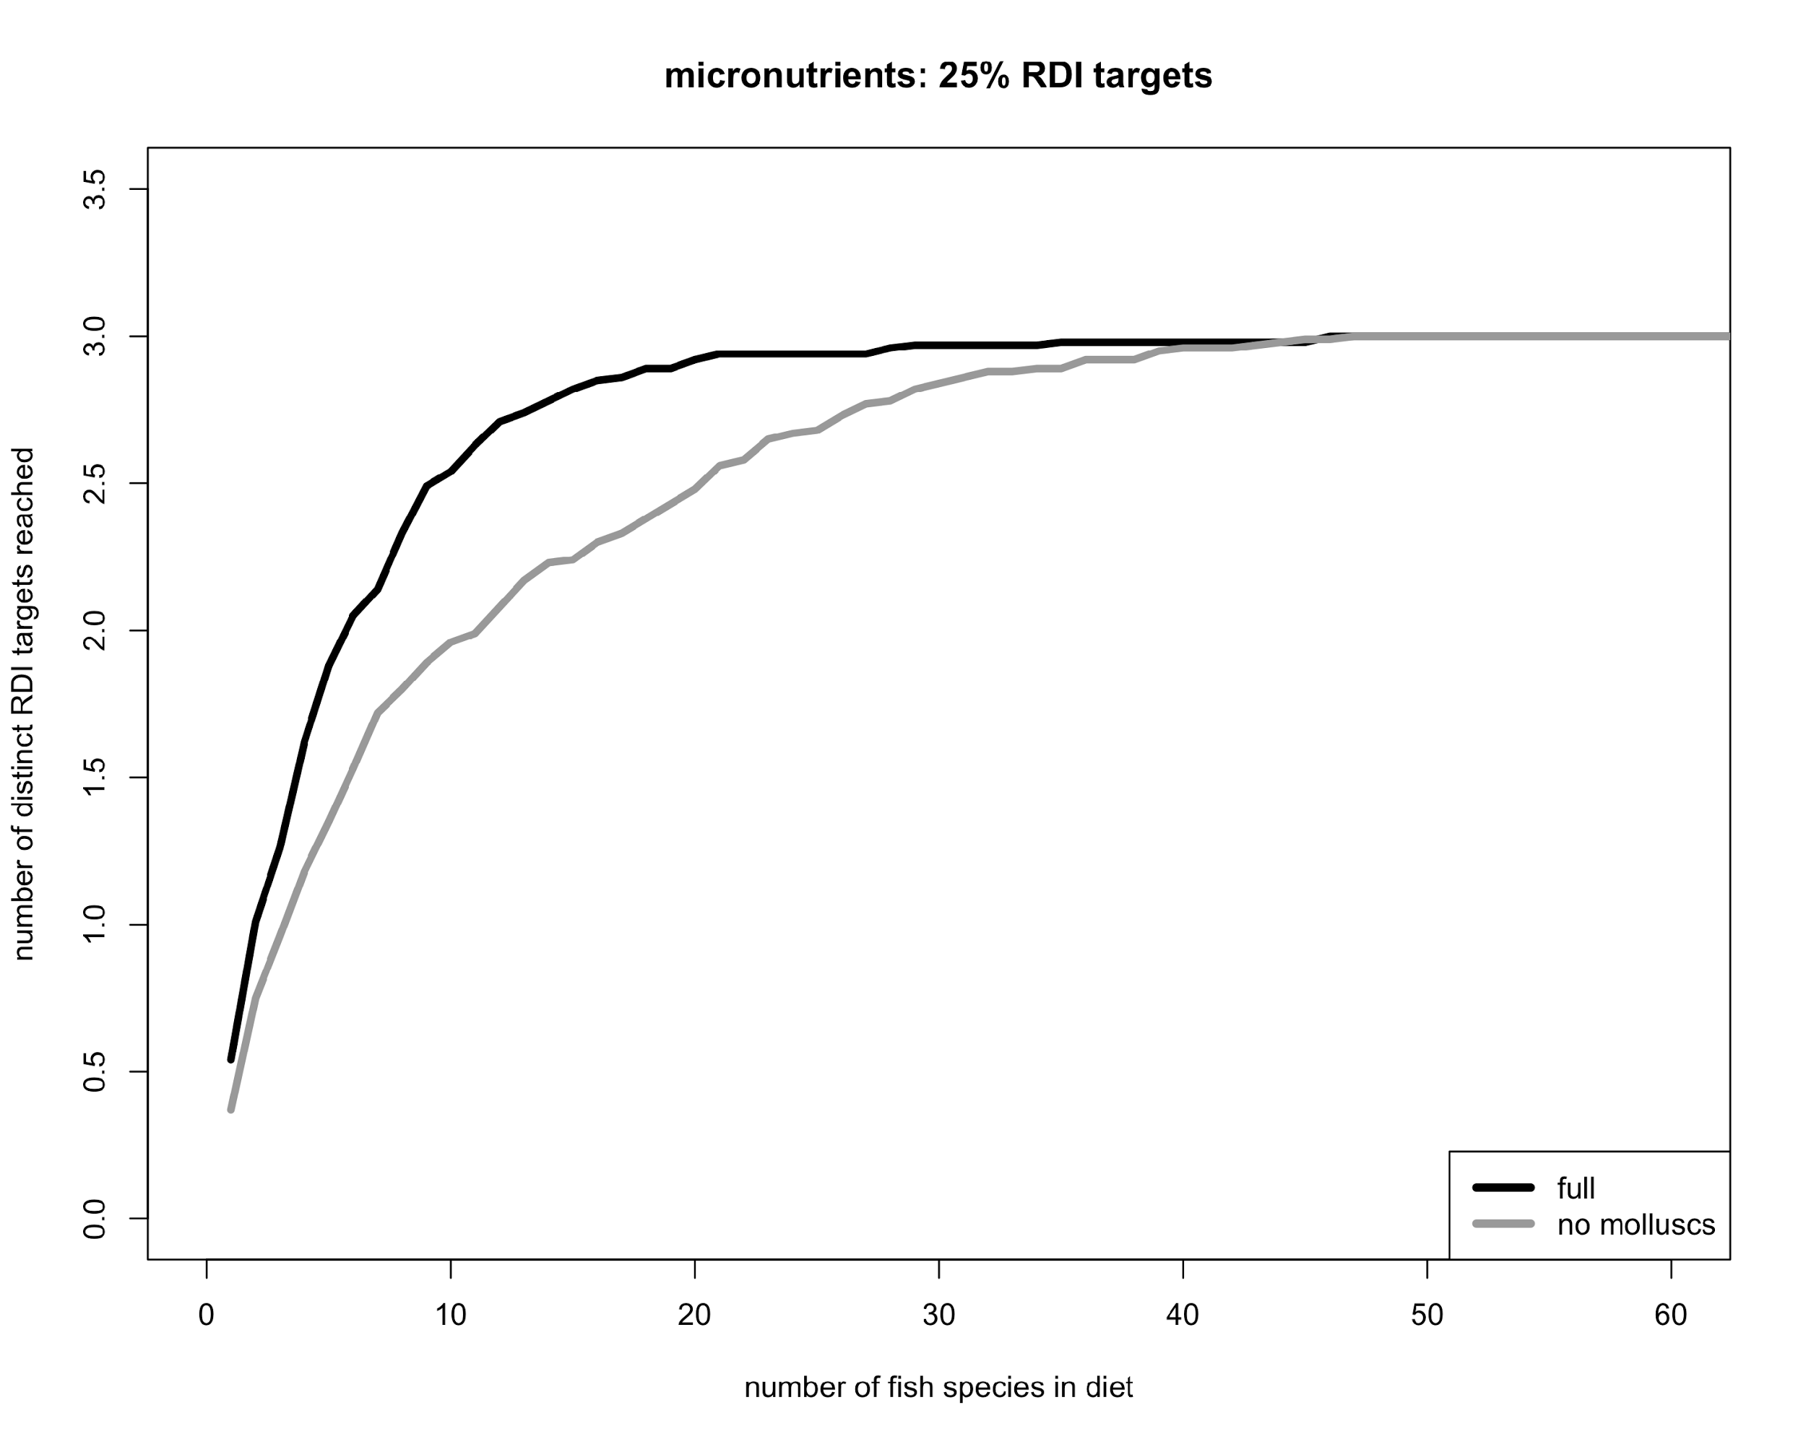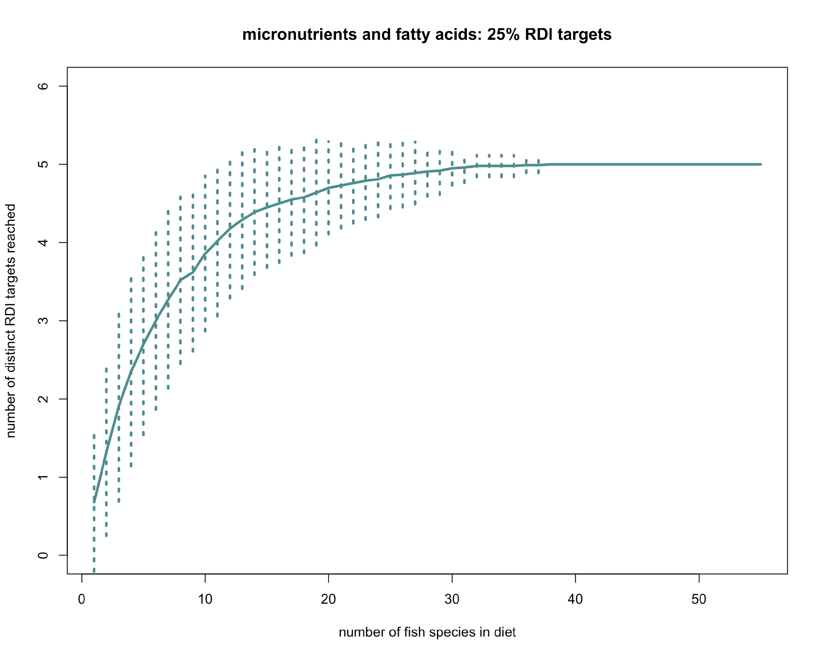

**Supp figures?**

**map of sampling locations**

**Tables:**

1. **Micronutrients in seafood: their roles in physiology and human health**