**Result 1. There is considerable variability in nutritional profile among aquatic taxa (fig 1).**

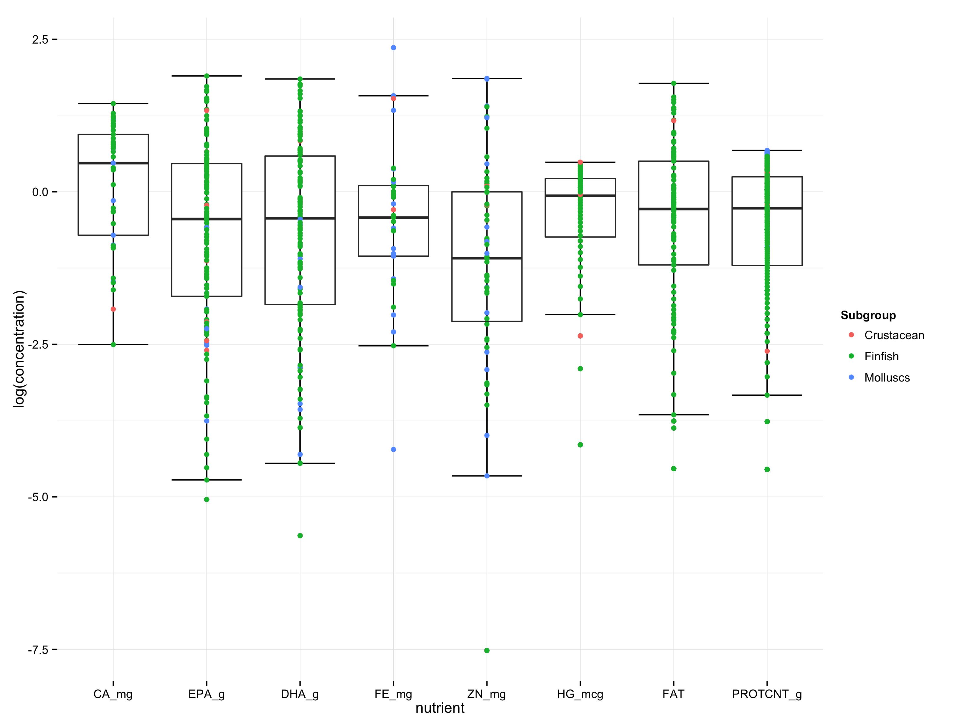

Variability for each nutrient separately:

Calcium in the edible portion varied by over 3 orders of magnitude in the 99 species for which we found data, from an average of 10.78mg/100g in the cods, hakes and haddocks to 782.60 mg/100 mg in the abalones, winkles and conchs (Figure 1).

Zinc in the edible portion varied by two orders of magnitude in the 101 species for which we found data, from an average of 0.36 mg/100g in the cods, hakes and haddocks to 11.87 mg/100 mg in the oysters (Figure 1).

Iron in the edible portion varied by two orders of magnitude in the 238 species for which we found data, from an average of 0.19 mg/100g in the cods, hakes and haddocks to 20.31 mg/100 mg in the abalones, winkles and conchs (Figure 1).

EPA in the edible portion varied by an order of magnitude in the 238 species for which we found data, from an average of 0.02 g/100g in the sharks and rays to 0.53 g/100 g in the herrings, sardines, anchovies (Figure 1).

DHA in the edible portion varied by an order of magnitude in the 235 species for which we found data, from an average of 0.065 g/100g in the shrimps and prawns to 1.28 g/100 g in the Tunas, bonitos, billfishes (Figure 1).

Protein in the edible portion varied by an order of magnitude in the 251 species for which we found data, from an average of 10.68g/100g in the clams, cockles, arkshells to 21.85 g/100 g in the Tunas, bonitos, billfishes (Figure 1).

Fat in the edible portion varied by an order of magnitude in the 277 species for which we found data, from an average of 1.08 g/100g in the sharks and rays to 12.74 g/100 g in the shads (Figure 1).

**Result 2. Few species contain reach DRI targets for multiple nutrients (fig 2).**

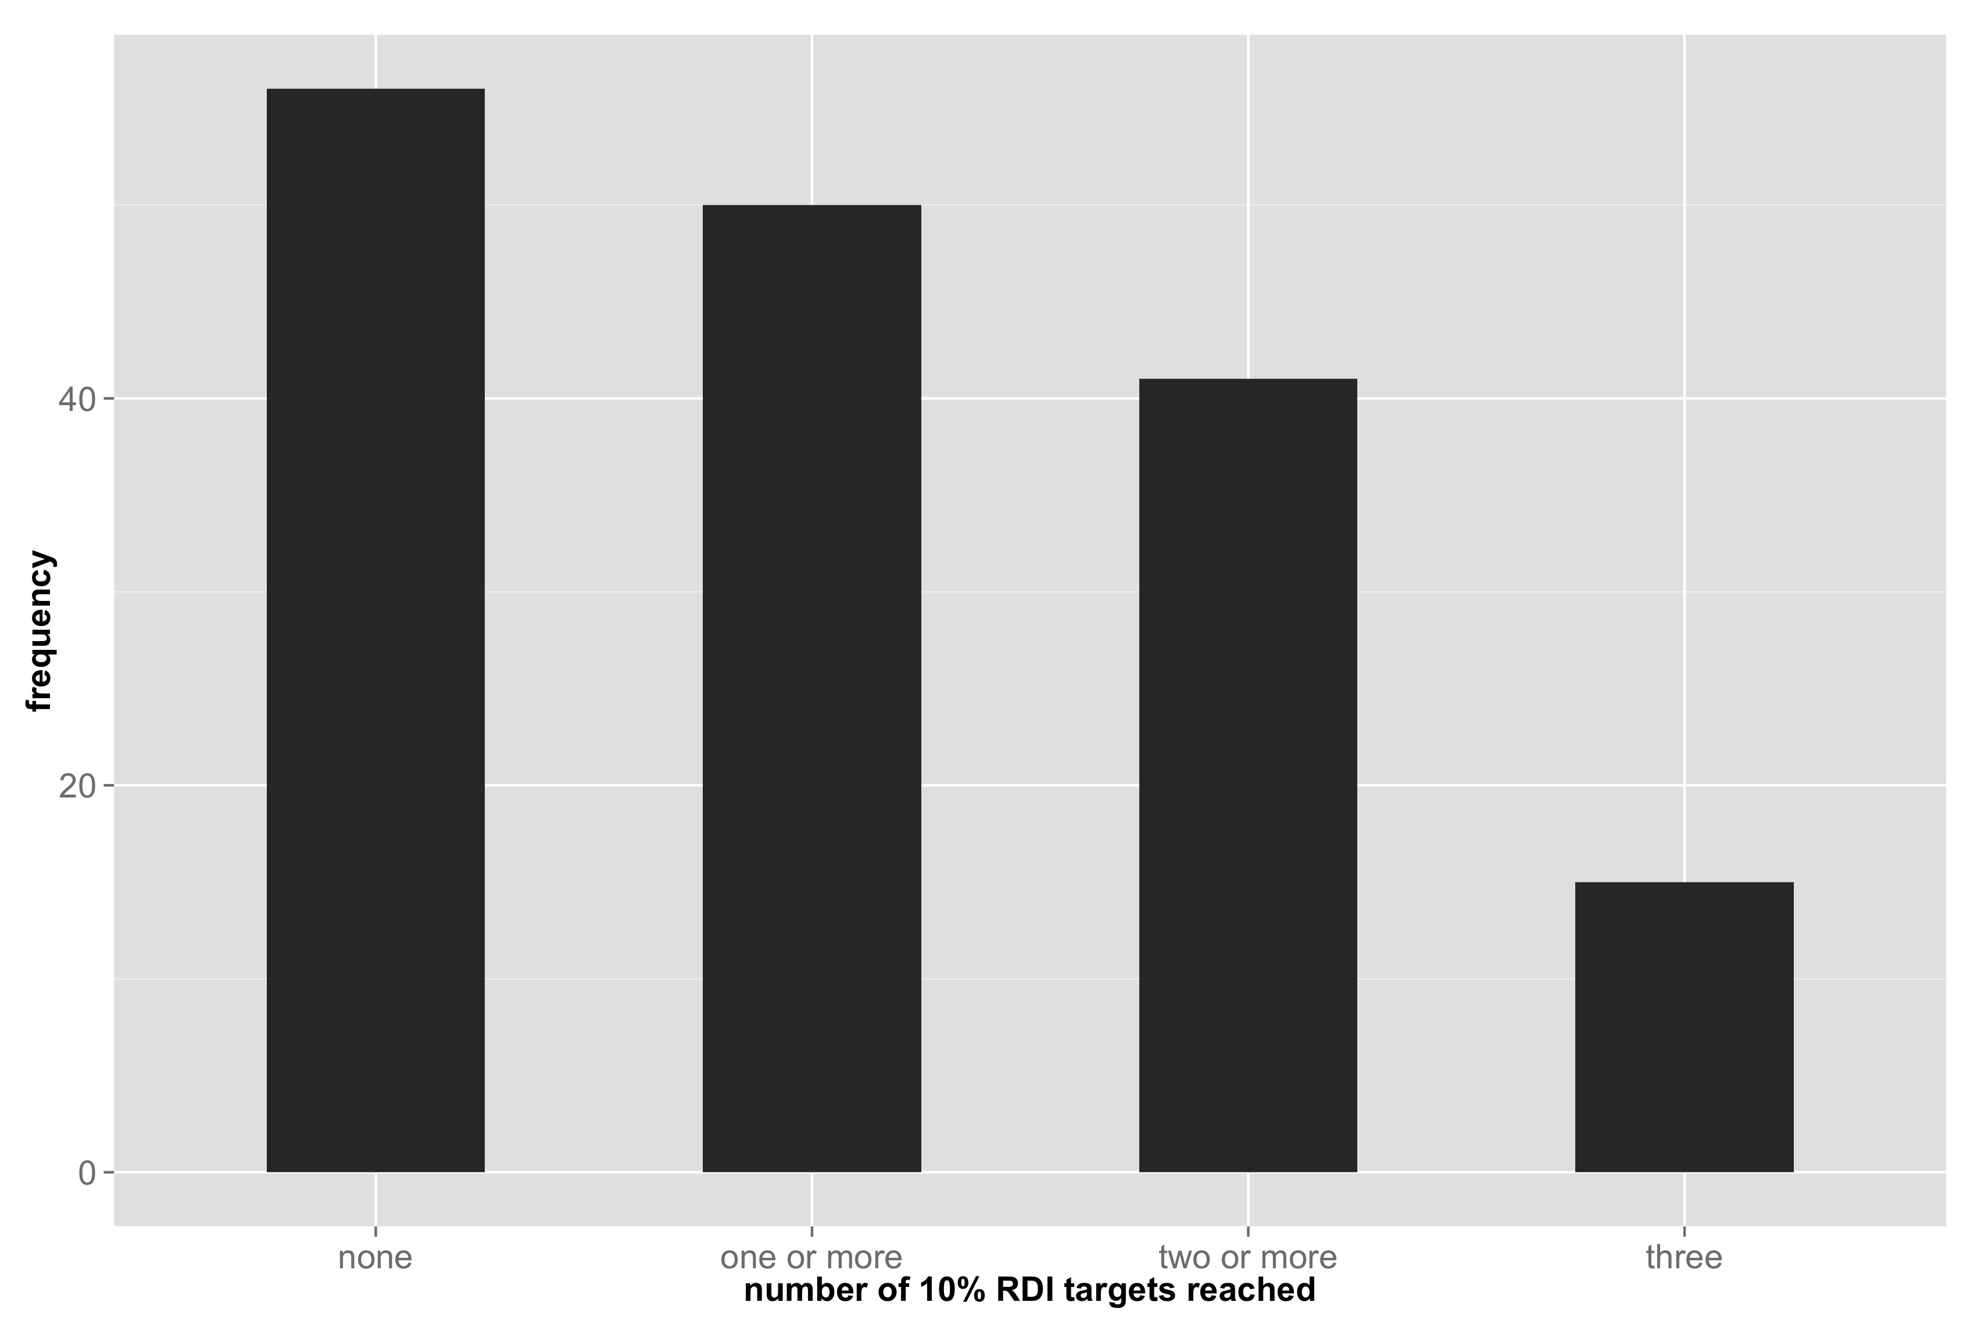

For the 25% RDI targets, for the 106 species for which we have data for all 3 minerals, 65 spp reach 0 targets, 30 reach 1 target, 9 reach 2 targets, and 2 reach all 3 targets. In other words, 41 reach 1 or more targets, 39 reach two or more targets and 2 reach all three targets.

For the 10% RDI targets, 56 reach 0 targets, 9 reach 1 target, 26 reach 2 targets and 15 reach all 3 targets. Or, in other words, 50 reach one or more targets, 41 reach 2 or more targets, and 15 reach all three targets.

This is how many species reach DRI targets, by nutrient:

10% RDI: calcium: 28/99, zinc: 39/101, iron: 23/104, EPA: 117/238, DHA: 168/235, Fat: 47/277, Protein: 251/251

**Result 3. Body size and dietary practices (i.e. eating bones) have a large effect on the likelihood that a given edible portion will reach RDI targets. (fig 3).**

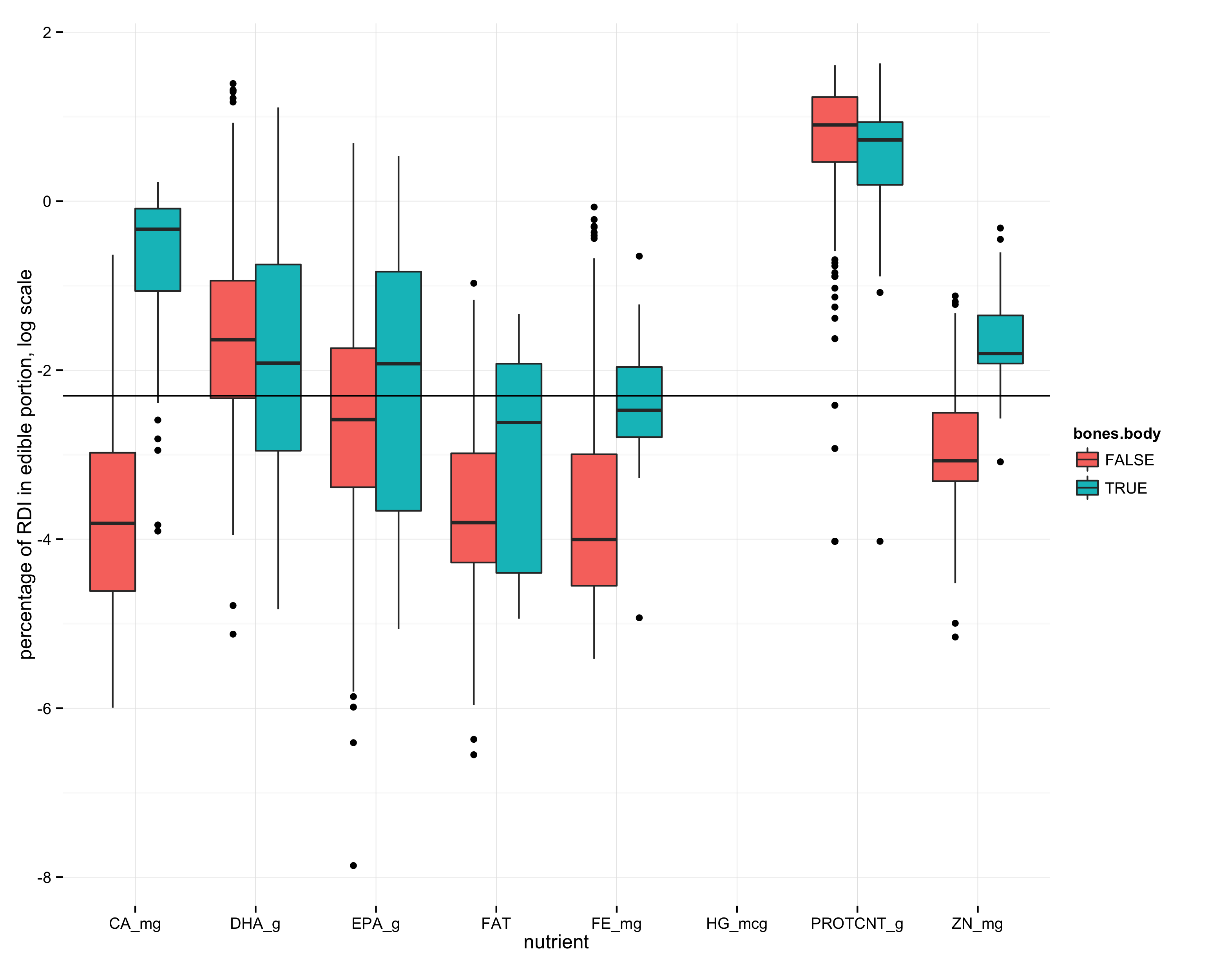 For macro- and micronutrients grouped together, 79.21% of the observations of species for which it is customary to eat multiple tissues reached RDI targets, whereas this number drops to 39.59% for species in which only the muscle tissue is eaten.

**Result 4. Functional groups have distinct multi-nutrient profiles (fig 4 mds plot with finfish/crustaceans/molluscs color coded).**

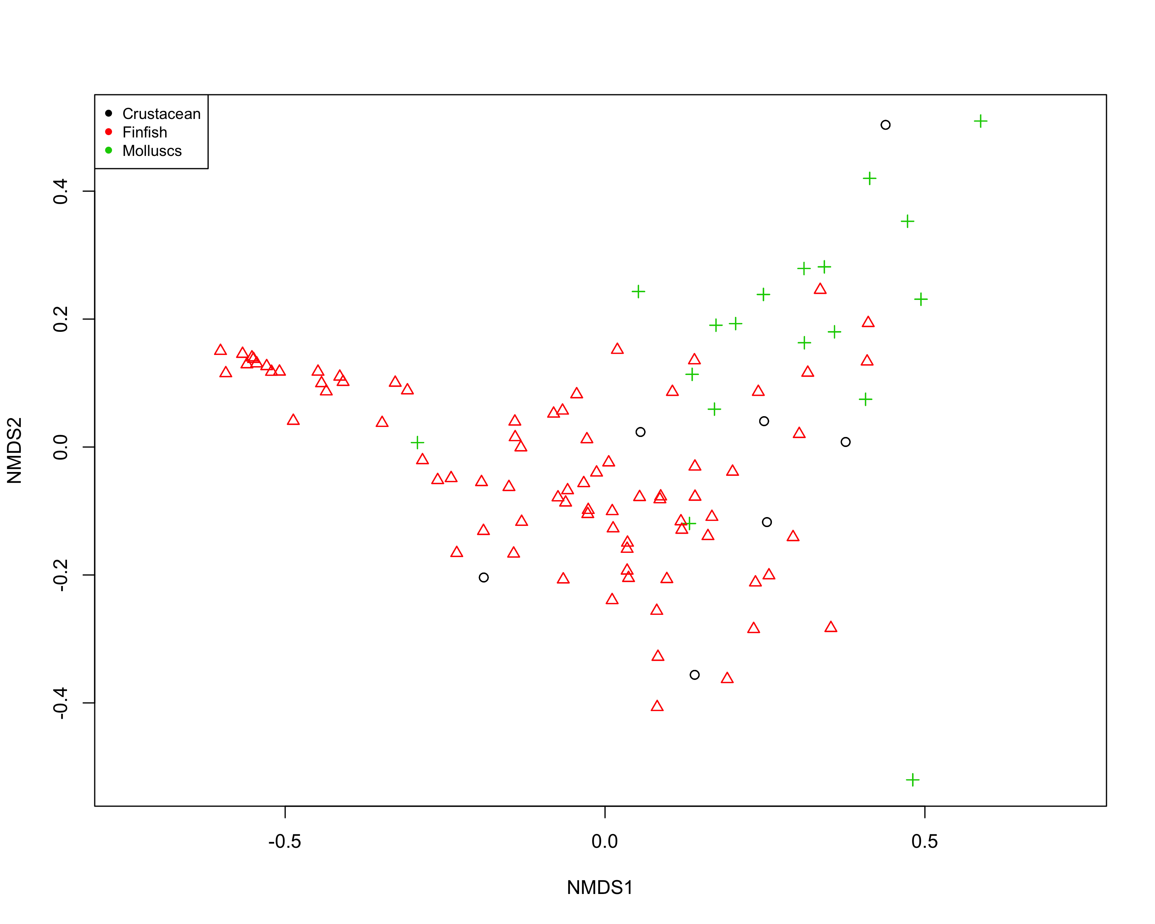

Not sure how to write about this yet! But the result is that when considering just the minerals and all the micronutrients, the functional group (i.e. finfish vs. crustaceans vs molluscs) means in multivariate nutrient trait space are different from each other (PERMANOVA, p = 0.001).

**Result 5. Within functional groups, some traits such body size and latitude are strongly associated with nutritional profile (fig 5 coefficients plot).**

**Result 6. Functional group diversity enhances dietary nutritional diversity and nutritional benefits that human communities may derive from seafood assemblages. (fig 6 nutrient accumulation curve).**

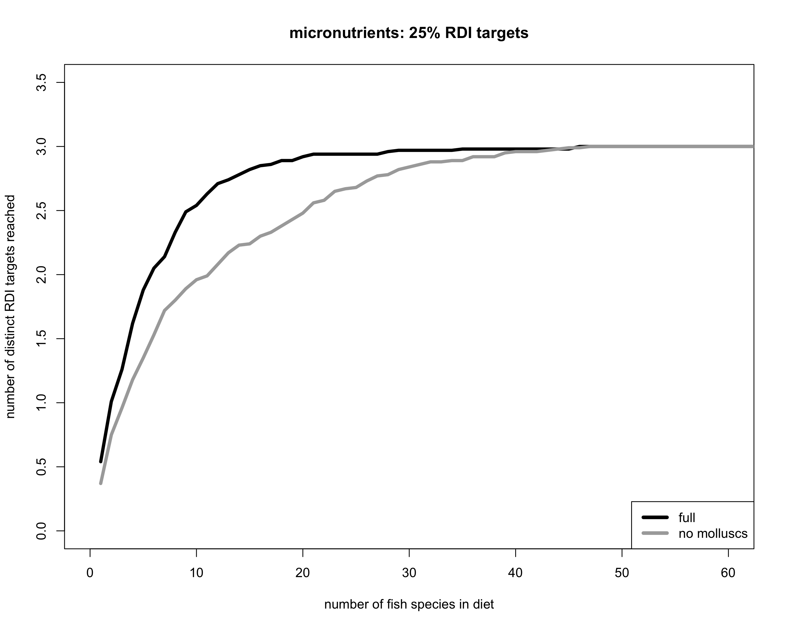

Need to sample from 14 species to get a median of all three minerals, and need to sample from 8 species to get a median of 3 minerals when molluscs are included.

When all five micronutrients are considered, need to sample from 15 species to reach a median of all 5 micronutrient targets (when molluscs are included), need to sample from 22 species when molluscs are excluded