compare growth estimates

Joey

Wed Feb 20 10:45:43 2019

knitr::opts_chunk$set(echo = TRUE)  
knitr::opts_chunk$set(message = FALSE)  
knitr::opts_chunk$set(warning = FALSE)  
knitr::opts_chunk$set(cache = TRUE)

library(tidyverse)  
library(cowplot)  
library(broom)  
library(readxl)  
library(janitor)  
library(plotrix)  
library(here)  
  
  
  
treatments <- read_excel(here("data-general", "ChlamEE_Treatments_JB.xlsx")) %>%   
 clean_names() %>%   
 mutate(treatment = ifelse(is.na(treatment), "none", treatment)) %>%   
 filter(population != "cc1629")   
  
  
# compare growth rate estimates -------------------------------------------

logistic <- read_csv(here("data-processed", "nitrate_exp_growth_logistic.csv")) %>%   
 select(population, ancestor_id, treatment, nitrate_concentration, estimate) %>%   
 mutate(method = "logistic") %>%   
 distinct(population, ancestor_id, treatment, nitrate_concentration, estimate) %>%   
 filter(!is.na(ancestor_id)) %>%   
 mutate(population = as.character(population)) %>%   
 mutate(method = "intrinsic rate of incr via logistic")  
eyeball <- read_csv(here("data-processed", "nitrate_exp_growth_eyeball.csv")) %>%   
 select(population, ancestor_id, treatment, nitrate_concentration.x, estimate) %>%  
 rename(nitrate_concentration = nitrate_concentration.x) %>%   
 distinct(population, ancestor_id, treatment, nitrate_concentration, estimate) %>%   
 filter(!is.na(population))%>%   
 mutate(population = as.character(population)) %>%   
 mutate(method = "eyeball-exponential")  
AIC_exp <- read_csv(here("data-processed", "nitrate_exp_growth_w_growthtools_AIC.csv")) %>%   
 rename(estimate = mu) %>%   
 mutate(method = "exponential via pw regression and AIC") %>%   
 mutate(population = as.character(population))  
AIC_exp <- left_join(AIC_exp, treatments)  
  
AICc_exp <- read_csv(here("data-processed", "nitrate_exp_growth_w_growthtools.csv")) %>%   
 rename(estimate = mu) %>%   
 mutate(method = "exponential via pw regression and AICc") %>%   
 mutate(population = as.character(population))  
AICc_exp <- left_join(AICc_exp, treatments)  
  
all_growth_estimates <- bind_rows(logistic, eyeball, AIC_exp, AICc_exp)

all_growth_estimates %>%  
 group_by(population, nitrate_concentration) %>%   
 ggplot(aes(x = nitrate_concentration, y = estimate, color = method)) + geom_point(shape = 1) +  
 facet_grid(ancestor_id ~ treatment)

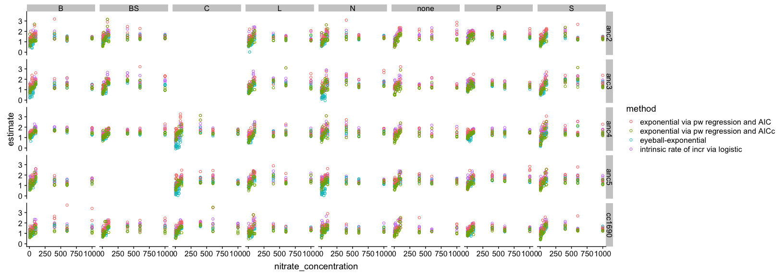

ggsave(here("figures", "comparison_nitrate_monod.png"), width = 15, height = 6)

all_growth_estimates %>%   
 group_by(population, nitrate_concentration, ancestor_id, treatment, method) %>%   
 summarise_each(funs(mean, std.error), estimate) %>%   
 ggplot(aes(x = nitrate_concentration, y = mean, color = method)) + geom_point(shape=1) +  
 geom_errorbar(aes(ymin = mean - std.error, ymax = mean + std.error), width = 0.1) +  
 facet_grid(ancestor_id ~ treatment) + ylab("Mean growth rate (/day)") + xlab("Nitrate (uM)")

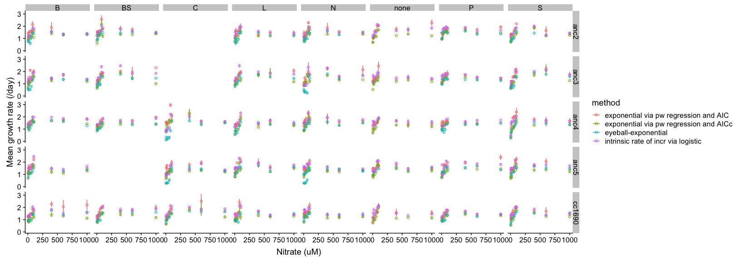

ggsave(here("figures", "comparison_nitrate_monod_means.png"), width = 17, height = 6)