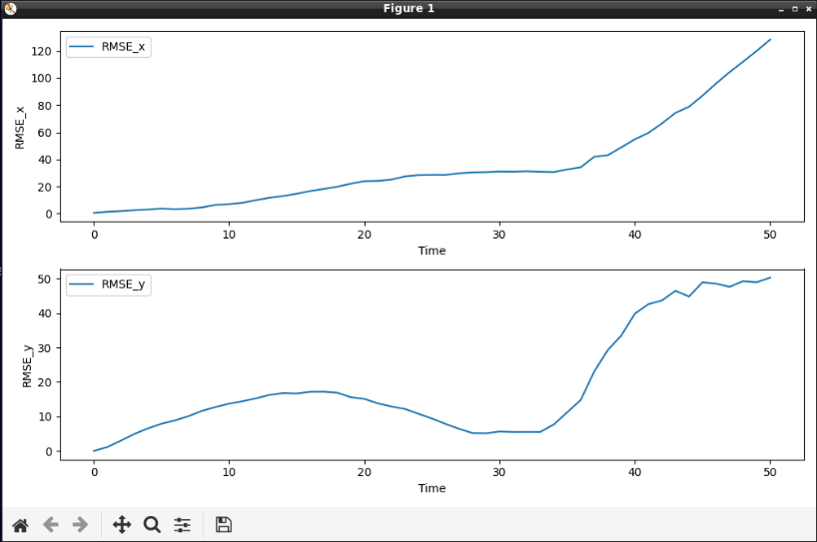  
LM noise = [0.5,0.5 ] u_noise = [0.5,0.5,30] LM noise = [0.5,0.5 ] u_noise = [0.8,0.8,30]

LM noise = [0.5,0.5 ] u_noise = [0.3,0.3,30] LM noise = [0.5,0.5 ] u_noise = [0.3,0.3,20]

LM noise = [0.4,0.4 ] u_noise = [0.3,0.3,30] LM noise = [0.3,0.3 ] u_noise = [0.3,0.3,30]

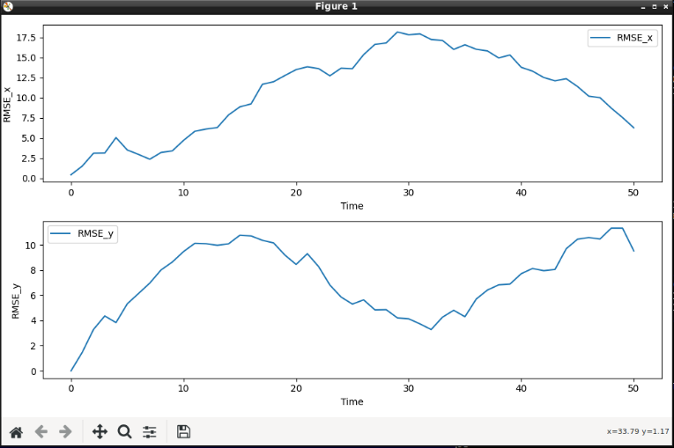

LM noise = [0.35,0.35 ] u_noise = [0.3,0.3,30]