1. Return customers and their orders including customers who placed no orders

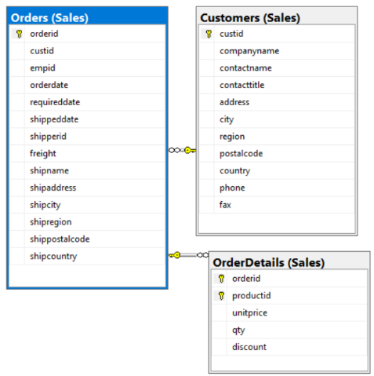

|  |  |
| --- | --- |
| Table Name | Column Name |
| Sales.Customers | custid |
| Sales.Orders | orderid  custid |
| Sales.OrderDetails | Qty  orderid |

SELECT C.custid, COUNT( DISTINCT O.orderid) AS numorders, SUM(OD.qty) AS totalqty

FROM Sales.Customers AS C

INNER JOIN Sales.Orders AS O

ON O.custid = C.custid

INNER JOIN Sales.OrderDetails AS OD

ON OD.orderid = O.orderid

WHERE C.country = N'USA'

GROUP BY C.custid;

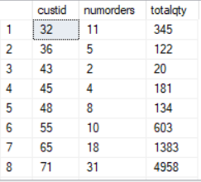

1. Return customers and their orders

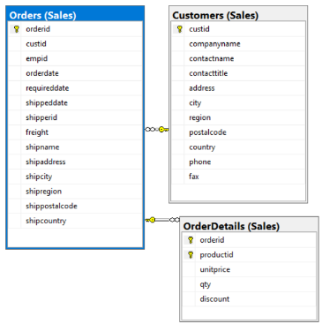

|  |  |
| --- | --- |
| Table Name | Column Name |
| Sales.Customers | custid |
| Sales.Orders | orderid  custid |
| Sales.OrderDetails | Qty  orderid |

SELECT C.custid, COUNT( DISTINCT O.orderid) AS numorders, SUM(OD.qty) AS totalqty

FROM Sales.Customers AS C

INNER JOIN Sales.Orders AS O

ON O.custid = C.custid

INNER JOIN Sales.OrderDetails AS OD

ON OD.orderid = O.orderid

GROUP BY C.custid;

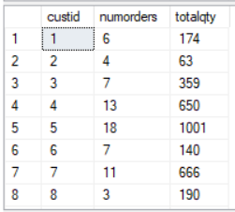

1. Write a query that is similar to the above query but where country is from japan

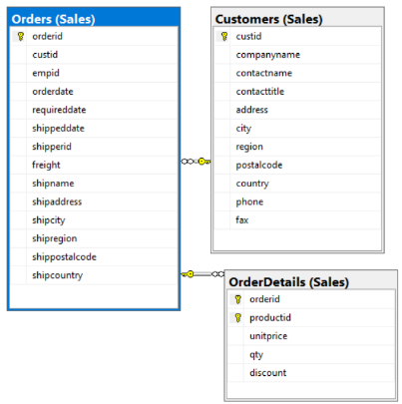

|  |  |
| --- | --- |
| Table Name | Column Name |
| Sales.Customers | custid |
| Sales.Orders | orderid  custid |
| Sales.OrderDetails | Qty  orderid |

SELECT C.custid, COUNT( DISTINCT O.orderid) AS numorders, SUM(OD.qty) AS totalqty

FROM Sales.Customers AS C

INNER JOIN Sales.Orders AS O

ON O.custid = C.custid

INNER JOIN Sales.OrderDetails AS OD

ON OD.orderid = O.orderid

WHERE C.country = N'JPN'

GROUP BY C.custid;



1. Return customers and their orders including customers who placed no orders ordered by numorders

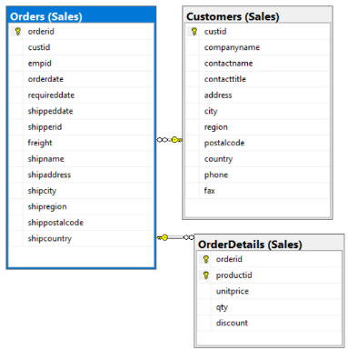

|  |  |
| --- | --- |
| Table Name | Column Name |
| Sales.Customers | custid |
| Sales.Orders | orderid  custid |
| Sales.OrderDetails | Qty  orderid |

SELECT C.custid, COUNT( DISTINCT O.orderid) AS numorders, SUM(OD.qty) AS totalqty

FROM Sales.Customers AS C

INNER JOIN Sales.Orders AS O

ON O.custid = C.custid

INNER JOIN Sales.OrderDetails AS OD

ON OD.orderid = O.orderid

WHERE C.country = N'USA'

GROUP BY C.custid

ORDER BY numorders;

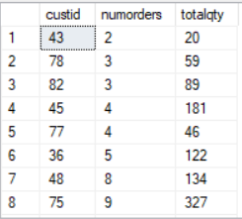

1. Return customers and their orders including customers who placed no orders ordered by numorders in ascending



|  |  |
| --- | --- |
| Table Name | Column Name |
| Sales.Customers | custid |
| Sales.Orders | orderid  custid |
| Sales.OrderDetails | Qty  orderid |

|  |  |  |
| --- | --- | --- |
| Table Name | Column Name | Sort Order |
| Sales.Orders | Numorders | ASC |

SELECT C.custid, COUNT( DISTINCT O.orderid) AS numorders, SUM(OD.qty) AS totalqty

FROM Sales.Customers AS C

INNER JOIN Sales.Orders AS O

ON O.custid = C.custid

INNER JOIN Sales.OrderDetails AS OD

ON OD.orderid = O.orderid

WHERE C.country = N'USA'

GROUP BY C.custid

ORDER BY numorders ASC

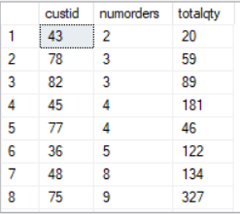

1. Return customers and their orders including customers who placed no orders ordered by numorders in descending

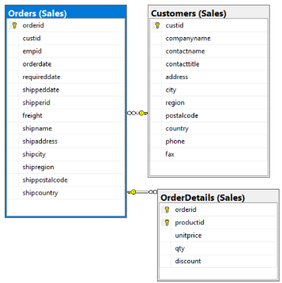

|  |  |
| --- | --- |
| Table Name | Column Name |
| Sales.Customers | custid |
| Sales.Orders | orderid  custid |
| Sales.OrderDetails | Qty  orderid |

|  |  |  |
| --- | --- | --- |
| Table Name | Column Name | Sort Order |
| Sales.Orders | Numorders | DESC |

SELECT C.custid, COUNT( DISTINCT O.orderid) AS numorders, SUM(OD.qty) AS totalqty

FROM Sales.Customers AS C

INNER JOIN Sales.Orders AS O

ON O.custid = C.custid

INNER JOIN Sales.OrderDetails AS OD

ON OD.orderid = O.orderid

WHERE C.country = N'USA'

GROUP BY C.custid

ORDER BY numorders DESC;

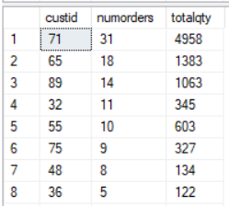

1. Return customers and their orders including customers who placed no orders ordered by

Custid

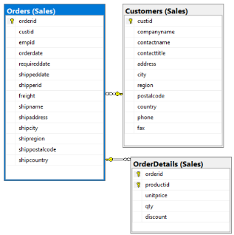

|  |  |
| --- | --- |
| Table Name | Column Name |
| Sales.Customers | custid |
| Sales.Orders | orderid  custid |
| Sales.OrderDetails | Qty  orderid |

SELECT C.custid, COUNT( DISTINCT O.orderid) AS numorders, SUM(OD.qty) AS totalqty

FROM Sales.Customers AS C

INNER JOIN Sales.Orders AS O

ON O.custid = C.custid

INNER JOIN Sales.OrderDetails AS OD

ON OD.orderid = O.orderid

WHERE C.country = N'USA'

GROUP BY C.custid

ORDER BY C.custid;

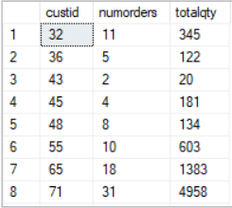

1. Return customers and their orders including customers who placed no orders ordered by

Custid by ascending

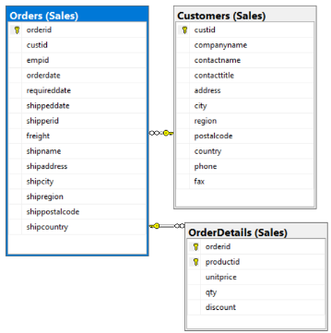

|  |  |
| --- | --- |
| Table Name | Column Name |
| Sales.Customers | custid |
| Sales.Orders | orderid  custid |
| Sales.OrderDetails | Qty  orderid |

|  |  |  |
| --- | --- | --- |
| Table Name | Column Name | Sort Order |
| Sales.Customers | Custid | ASC |

SELECT C.custid, COUNT( DISTINCT O.orderid) AS numorders, SUM(OD.qty) AS totalqty

FROM Sales.Customers AS C

INNER JOIN Sales.Orders AS O

ON O.custid = C.custid

INNER JOIN Sales.OrderDetails AS OD

ON OD.orderid = O.orderid

WHERE C.country = N'USA'

GROUP BY C.custid

ORDER BY C.custid ASC;

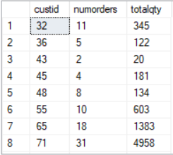

1. Return customers and their orders including customers who placed no orders ordered by

Custid by descending

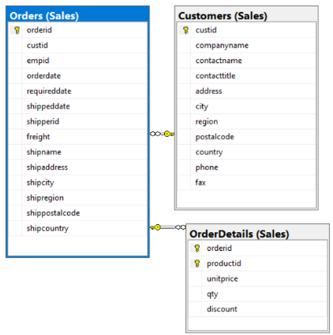

|  |  |
| --- | --- |
| Table Name | Column Name |
| Sales.Customers | custid |
| Sales.Orders | orderid  custid |
| Sales.OrderDetails | Qty  orderid |

|  |  |  |
| --- | --- | --- |
| Table Name | Column Name | Sort Order |
| Sales.Customers | Custid | DESC |

SELECT C.custid, COUNT( DISTINCT O.orderid) AS numorders, SUM(OD.qty) AS totalqty

FROM Sales.Customers AS C

INNER JOIN Sales.Orders AS O

ON O.custid = C.custid

INNER JOIN Sales.OrderDetails AS OD

ON OD.orderid = O.orderid

WHERE C.country = N'USA'

GROUP BY C.custid

ORDER BY C.custid DESC;

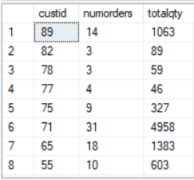

1. Return customers and their orders including customers who placed no orders ordered by

Totalqty

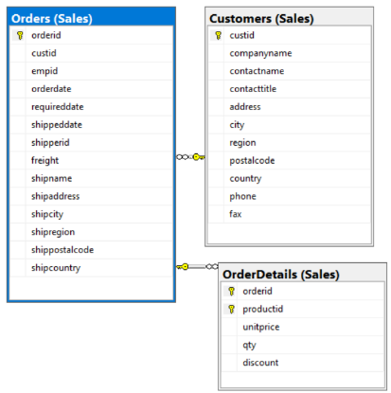

|  |  |
| --- | --- |
| Table Name | Column Name |
| Sales.Customers | custid |
| Sales.Orders | orderid  custid |
| Sales.OrderDetails | Qty  orderid |

SELECT C.custid, COUNT( DISTINCT O.orderid) AS numorders, SUM(OD.qty) AS totalqty

FROM Sales.Customers AS C

INNER JOIN Sales.Orders AS O

ON O.custid = C.custid

INNER JOIN Sales.OrderDetails AS OD

ON OD.orderid = O.orderid

WHERE C.country = N'USA'

GROUP BY C.custid

ORDER BY totalqty;

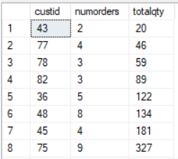

1. Return customers and their orders including customers who placed no orders ordered by

Totalqty by ascending

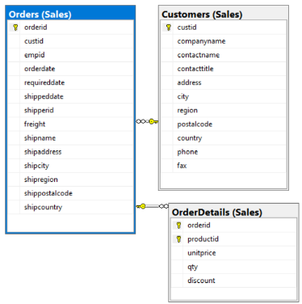

|  |  |
| --- | --- |
| Table Name | Column Name |
| Sales.Customers | custid |
| Sales.Orders | orderid  custid |
| Sales.OrderDetails | Qty  orderid |

|  |  |  |
| --- | --- | --- |
| Table Name | Column Name | Sort Order |
| Sales.OrderDetails | Qty | ASC |

SELECT C.custid, COUNT( DISTINCT O.orderid) AS numorders, SUM(OD.qty) AS totalqty

FROM Sales.Customers AS C

INNER JOIN Sales.Orders AS O

ON O.custid = C.custid

INNER JOIN Sales.OrderDetails AS OD

ON OD.orderid = O.orderid

WHERE C.country = N'USA'

GROUP BY C.custid

ORDER BY totalqty ASC;

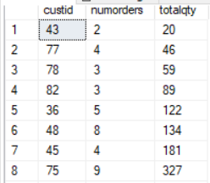

1. Return customers and their orders including customers who placed no orders ordered by

Totalqty by descending

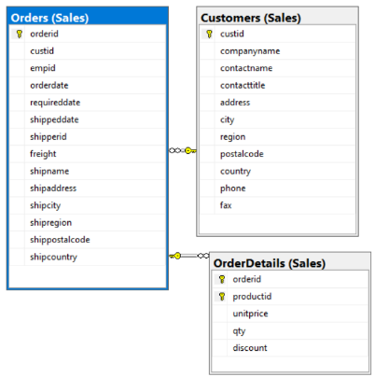

|  |  |
| --- | --- |
| Table Name | Column Name |
| Sales.Customers | custid |
| Sales.Orders | orderid  custid |
| Sales.OrderDetails | Qty  orderid |

|  |  |  |
| --- | --- | --- |
| Table Name | Column Name | Sort Order |
| Sales.OrderDetails | Qty | ASC |

SELECT C.custid, COUNT( DISTINCT O.orderid) AS numorders, SUM(OD.qty) AS totalqty

FROM Sales.Customers AS C

INNER JOIN Sales.Orders AS O

ON O.custid = C.custid

INNER JOIN Sales.OrderDetails AS OD

ON OD.orderid = O.orderid

WHERE C.country = N'USA'

GROUP BY C.custid

ORDER BY totalqty DESC;

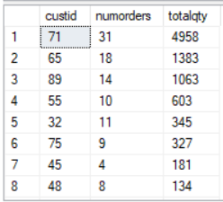

1. Return customers and their orders including customers who placed no orders in JPN

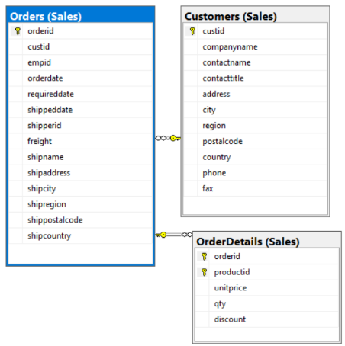

|  |  |
| --- | --- |
| Table Name | Column Name |
| Sales.Customers | custid |
| Sales.Orders | orderid  custid |
| Sales.OrderDetails | Qty  orderid |

SELECT C.custid, COUNT( DISTINCT O.orderid) AS numorders, SUM(OD.qty) AS totalqty

FROM Sales.Customers AS C

INNER JOIN Sales.Orders AS O

ON O.custid = C.custid

INNER JOIN Sales.OrderDetails AS OD

ON OD.orderid = O.orderid

WHERE C.country = N'JPN'

GROUP BY C.custid



1. Return customers and their orders including customers who placed no orders in JPN ordered by totalqty in descending

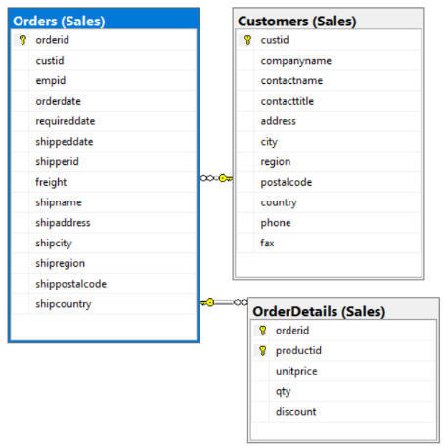

|  |  |
| --- | --- |
| Table Name | Column Name |
| Sales.Customers | custid |
| Sales.Orders | orderid  custid |
| Sales.OrderDetails | Qty  orderid |

|  |  |  |
| --- | --- | --- |
| Table Name | Column Name | Sort Order |
| Sales.OrderDetails | Qty | DESC |

SELECT C.custid, COUNT( DISTINCT O.orderid) AS numorders, SUM(OD.qty) AS totalqty

FROM Sales.Customers AS C

INNER JOIN Sales.Orders AS O

ON O.custid = C.custid

INNER JOIN Sales.OrderDetails AS OD

ON OD.orderid = O.orderid

WHERE C.country = N'JPN'

GROUP BY C.custid

ORDER BY totalqty DESC;



1. Return customers and their orders including customers who placed no orders in JPN ordered by totalqty in ascending



|  |  |
| --- | --- |
| Table Name | Column Name |
| Sales.Customers | custid |
| Sales.Orders | orderid  custid |
| Sales.OrderDetails | Qty  orderid |

|  |  |  |
| --- | --- | --- |
| Table Name | Column Name | Sort Order |
| Sales.OrderDetails | Qty | ASC |

SELECT C.custid, COUNT( DISTINCT O.orderid) AS numorders, SUM(OD.qty) AS totalqty

FROM Sales.Customers AS C

INNER JOIN Sales.Orders AS O

ON O.custid = C.custid

INNER JOIN Sales.OrderDetails AS OD

ON OD.orderid = O.orderid

WHERE C.country = N'JPN'

GROUP BY C.custid

ORDER BY totalqty ASC;



1. Create a query that returns custid from Sales.Order, Sales.OrderDetails, and Sales.OrderDetailsAudit where custid is zero

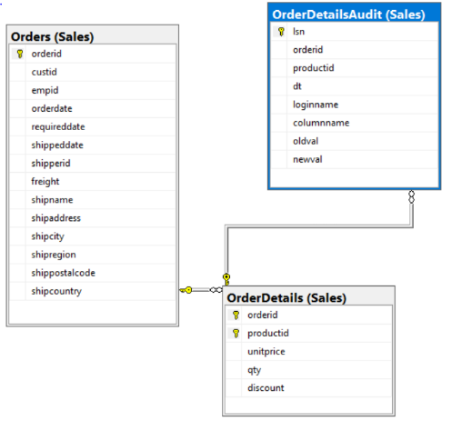

|  |  |
| --- | --- |
| Table Name | Column Name |
| Sales.OrderDetailsAudit | orderid |
| Sales.Orders | orderid  custid |
| Sales.OrderDetails | Qty  orderid |

drop function if exists dbo.GetCustOrders;

go

create function dbo.GetCustOrders

(@cid AS INT) RETURNS TABLE

AS

RETURN

SELECT orderid, custid, empid, orderdate, requireddate, shipregion, shippostalcode, shipcountry

FROM Sales.Orders

WHERE custid = @cid

GO

SELECT C.custid, COUNT( DISTINCT ODA.orderid) AS numorders, SUM(OD.qty) AS totalqty

FROM dbo.GetCustOrders(0) AS C

INNER JOIN Sales.Orders AS O

ON O.custid = C.custid

INNER JOIN Sales.OrderDetails AS OD

ON OD.orderid = O.orderid

LEFT OUTER JOIN Sales.OrderDetailsAudit AS ODA

ON O.orderid = ODA.orderid

GROUP BY C.custid;



1. Create a query that returns custid from Sales.Order, Sales.OrderDetails, and Sales.OrderDetailsAudit where custid is one



|  |  |
| --- | --- |
| Table Name | Column Name |
| Sales.OrderDetailsAudit | orderid |
| Sales.Orders | orderid  custid |
| Sales.OrderDetails | Qty  orderid |

drop function if exists dbo.GetCustOrders;

go

create function dbo.GetCustOrders

(@cid AS INT) RETURNS TABLE

AS

RETURN

SELECT orderid, custid, empid, orderdate, requireddate, shipregion, shippostalcode, shipcountry

FROM Sales.Orders

WHERE custid = @cid

GO

SELECT C.custid, COUNT( DISTINCT ODA.orderid) AS numorders, SUM(OD.qty) AS totalqty

FROM dbo.GetCustOrders(1) AS C

INNER JOIN Sales.Orders AS O

ON O.custid = C.custid



INNER JOIN Sales.OrderDetails AS OD

ON OD.orderid = O.orderid

LEFT OUTER JOIN Sales.OrderDetailsAudit AS ODA

ON O.orderid = ODA.orderid

GROUP BY C.custid;

1. Create a query that returns custid from Sales.Order, Sales.OrderDetails, and Sales.OrderDetailsAudit where custid is two



|  |  |
| --- | --- |
| Table Name | Column Name |
| Sales.OrderDetailsAudit | orderid |
| Sales.Orders | orderid  custid |
| Sales.OrderDetails | Qty  orderid |

drop function if exists dbo.GetCustOrders;

go

create function dbo.GetCustOrders

(@cid AS INT) RETURNS TABLE

AS

RETURN

SELECT orderid, custid, empid, orderdate, requireddate, shipregion, shippostalcode, shipcountry

FROM Sales.Orders

WHERE custid = @cid

GO

SELECT C.custid, COUNT( DISTINCT ODA.orderid) AS numorders, SUM(OD.qty) AS totalqty

FROM dbo.GetCustOrders(2) AS C

INNER JOIN Sales.Orders AS O

ON O.custid = C.custid

INNER JOIN Sales.OrderDetails AS OD

ON OD.orderid = O.orderid

LEFT OUTER JOIN Sales.OrderDetailsAudit AS ODA

ON O.orderid = ODA.orderid

GROUP BY C.custid;



1. Create a query that returns custid from Sales.Order, Sales.OrderDetails, and Sales.OrderDetailsAudit where custid is three



|  |  |
| --- | --- |
| Table Name | Column Name |
| Sales.OrderDetailsAudit | orderid |
| Sales.Orders | orderid  custid |
| Sales.OrderDetails | Qty  orderid |

drop function if exists dbo.GetCustOrders;

go

create function dbo.GetCustOrders

(@cid AS INT) RETURNS TABLE

AS

RETURN

SELECT orderid, custid, empid, orderdate, requireddate, shipregion, shippostalcode, shipcountry

FROM Sales.Orders

WHERE custid = @cid

GO

SELECT C.custid, COUNT( DISTINCT ODA.orderid) AS numorders, SUM(OD.qty) AS totalqty

FROM dbo.GetCustOrders(3) AS C

INNER JOIN Sales.Orders AS O

ON O.custid = C.custid

INNER JOIN Sales.OrderDetails AS OD

ON OD.orderid = O.orderid

LEFT OUTER JOIN Sales.OrderDetailsAudit AS ODA

ON O.orderid = ODA.orderid

GROUP BY C.custid;



1. Create a query that returns custid from Sales.Order, Sales.OrderDetails, and Sales.OrderDetailsAudit where custid is four



|  |  |
| --- | --- |
| Table Name | Column Name |
| Sales.OrderDetailsAudit | orderid |
| Sales.Orders | orderid  custid |
| Sales.OrderDetails | Qty  orderid |

drop function if exists dbo.GetCustOrders;

go

create function dbo.GetCustOrders

(@cid AS INT) RETURNS TABLE

AS

RETURN

SELECT orderid, custid, empid, orderdate, requireddate, shipregion, shippostalcode, shipcountry

FROM Sales.Orders

WHERE custid = @cid

GO

SELECT C.custid, COUNT( DISTINCT ODA.orderid) AS numorders, SUM(OD.qty) AS totalqty

FROM dbo.GetCustOrders(4) AS C

INNER JOIN Sales.Orders AS O

ON O.custid = C.custid

INNER JOIN Sales.OrderDetails AS OD

ON OD.orderid = O.orderid

LEFT OUTER JOIN Sales.OrderDetailsAudit AS ODA

ON O.orderid = ODA.orderid

GROUP BY C.custid;



1. Create a query that returns custid from Sales.Order, Sales.OrderDetails, and Sales.OrderDetailsAudit where custid is five



|  |  |
| --- | --- |
| Table Name | Column Name |
| Sales.OrderDetailsAudit | orderid |
| Sales.Orders | orderid  custid |
| Sales.OrderDetails | Qty  orderid |

drop function if exists dbo.GetCustOrders;

go

create function dbo.GetCustOrders

(@cid AS INT) RETURNS TABLE

AS

RETURN

SELECT orderid, custid, empid, orderdate, requireddate, shipregion, shippostalcode, shipcountry

FROM Sales.Orders

WHERE custid = @cid

GO

SELECT C.custid, COUNT( DISTINCT ODA.orderid) AS numorders, SUM(OD.qty) AS totalqty

FROM dbo.GetCustOrders(5) AS C

INNER JOIN Sales.Orders AS O

ON O.custid = C.custid

INNER JOIN Sales.OrderDetails AS OD

ON OD.orderid = O.orderid

LEFT OUTER JOIN Sales.OrderDetailsAudit AS ODA

ON O.orderid = ODA.orderid

GROUP BY C.custid;



1. Create a query that returns custid from Sales.Order, Sales.OrderDetails, and Sales.OrderDetailsAudit where custid is six



|  |  |
| --- | --- |
| Table Name | Column Name |
| Sales.OrderDetailsAudit | orderid |
| Sales.Orders | orderid  custid |
| Sales.OrderDetails | Qty  orderid |

drop function if exists dbo.GetCustOrders;

go

create function dbo.GetCustOrders

(@cid AS INT) RETURNS TABLE

AS

RETURN

SELECT orderid, custid, empid, orderdate, requireddate, shipregion, shippostalcode, shipcountry

FROM Sales.Orders

WHERE custid = @cid

GO

SELECT C.custid, COUNT( DISTINCT ODA.orderid) AS numorders, SUM(OD.qty) AS totalqty

FROM dbo.GetCustOrders(6) AS C

INNER JOIN Sales.Orders AS O

ON O.custid = C.custid

INNER JOIN Sales.OrderDetails AS OD

ON OD.orderid = O.orderid

LEFT OUTER JOIN Sales.OrderDetailsAudit AS ODA

ON O.orderid = ODA.orderid

GROUP BY C.custid;



1. Create a query that returns custid from Sales.Order, Sales.OrderDetails, and Sales.OrderDetailsAudit where custid is seven



|  |  |
| --- | --- |
| Table Name | Column Name |
| Sales.OrderDetailsAudit | orderid |
| Sales.Orders | orderid  custid |
| Sales.OrderDetails | Qty  orderid |

drop function if exists dbo.GetCustOrders;

go

create function dbo.GetCustOrders

(@cid AS INT) RETURNS TABLE

AS

RETURN

SELECT orderid, custid, empid, orderdate, requireddate, shipregion, shippostalcode, shipcountry

FROM Sales.Orders

WHERE custid = @cid

GO

SELECT C.custid, COUNT( DISTINCT ODA.orderid) AS numorders, SUM(OD.qty) AS totalqty

FROM dbo.GetCustOrders(7) AS C

INNER JOIN Sales.Orders AS O

ON O.custid = C.custid

INNER JOIN Sales.OrderDetails AS OD

ON OD.orderid = O.orderid

LEFT OUTER JOIN Sales.OrderDetailsAudit AS ODA

ON O.orderid = ODA.orderid

GROUP BY C.custid;

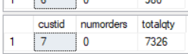

1. Create a query that returns custid from Sales.Order, Sales.OrderDetails, and Sales.OrderDetailsAudit where custid is eight



|  |  |
| --- | --- |
| Table Name | Column Name |
| Sales.OrderDetailsAudit | orderid |
| Sales.Orders | orderid  custid |
| Sales.OrderDetails | Qty  orderid |

drop function if exists dbo.GetCustOrders;

go

create function dbo.GetCustOrders

(@cid AS INT) RETURNS TABLE

AS

RETURN

SELECT orderid, custid, empid, orderdate, requireddate, shipregion, shippostalcode, shipcountry

FROM Sales.Orders

WHERE custid = @cid

GO

SELECT C.custid, COUNT( DISTINCT ODA.orderid) AS numorders, SUM(OD.qty) AS totalqty

FROM dbo.GetCustOrders(8) AS C

INNER JOIN Sales.Orders AS O

ON O.custid = C.custid

INNER JOIN Sales.OrderDetails AS OD

ON OD.orderid = O.orderid

LEFT OUTER JOIN Sales.OrderDetailsAudit AS ODA

ON O.orderid = ODA.orderid

GROUP BY C.custid;



1. Create a query that returns custid from Sales.Order, Sales.OrderDetails, and Sales.OrderDetailsAudit where custid is nine



|  |  |
| --- | --- |
| Table Name | Column Name |
| Sales.OrderDetailsAudit | orderid |
| Sales.Orders | orderid  custid |
| Sales.OrderDetails | Qty  orderid |

drop function if exists dbo.GetCustOrders;

go

create function dbo.GetCustOrders

(@cid AS INT) RETURNS TABLE

AS

RETURN

SELECT orderid, custid, empid, orderdate, requireddate, shipregion, shippostalcode, shipcountry

FROM Sales.Orders

WHERE custid = @cid

GO

SELECT C.custid, COUNT( DISTINCT ODA.orderid) AS numorders, SUM(OD.qty) AS totalqty

FROM dbo.GetCustOrders(9) AS C

INNER JOIN Sales.Orders AS O

ON O.custid = C.custid

INNER JOIN Sales.OrderDetails AS OD

ON OD.orderid = O.orderid

LEFT OUTER JOIN Sales.OrderDetailsAudit AS ODA

ON O.orderid = ODA.orderid

GROUP BY C.custid;



1. Write a query that generates 5 copies out of each employee row

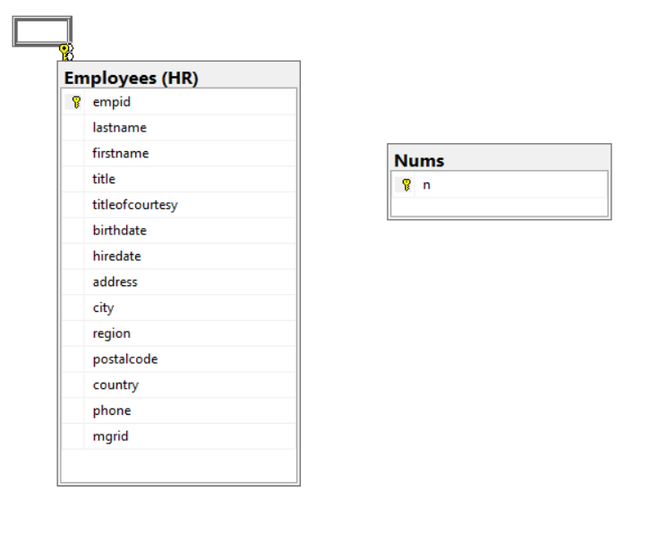

|  |  |
| --- | --- |
| Table Name | Column Name |
| HR.Employees | Empid  Firstname  Lastname |
| Dbo.Nums | n |

SELECT

E.empid, E.firstname, E.lastname, N.n

FROM HR.Employees AS E

CROSS JOIN dbo.Nums AS N

WHERE N.n <= 5

ORDER BY n, empid;

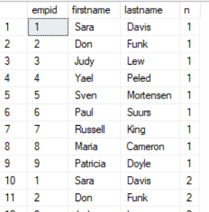

1. Select all from Fact.movement

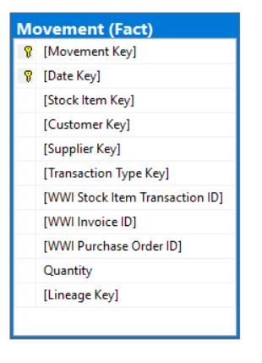

|  |  |
| --- | --- |
| Table Name | Column Name |
| Fact.movement | * |

SELECT * FROM Fact.Movement;

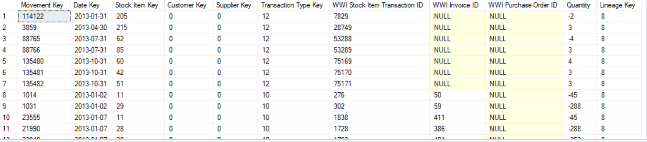

1. Select all from Sales.orders

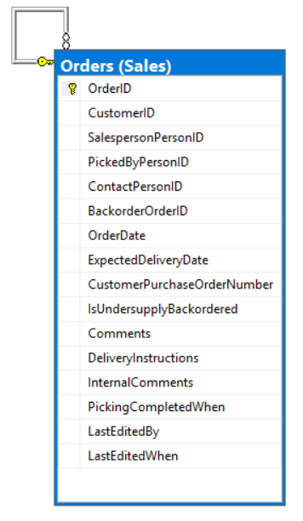

|  |  |
| --- | --- |
| Table Name | Column Name |
| Sales.orders | * |

SELECT * FROM Sales.Orders;

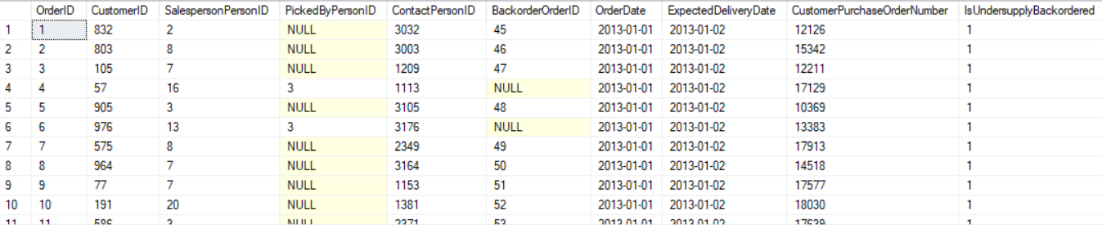

1. Write a query that collects business entity ID's of people and their passwords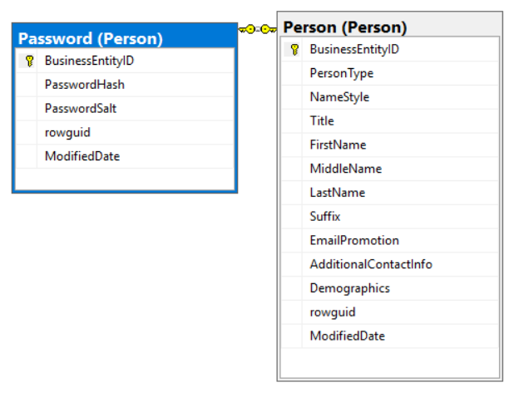

|  |  |
| --- | --- |
| Table Name | Column Name |
| Person.person | BusinessentityID |
| Person.password | BusinessentityID |

SELECT F.BusinessEntityID, P.BusinessEntityID

FROM Person.person AS F

INNER JOIN Person.Password as P

ON F.BusinessEntityID = P.BusinessEntityID;

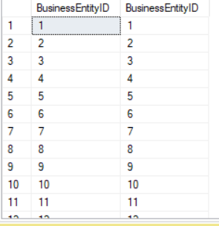

1. Select all from dbo.DimProduct

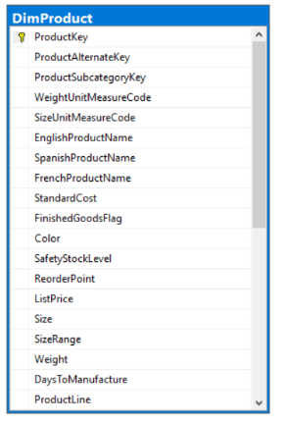

|  |  |
| --- | --- |
| Table Name | Column Name |
| dbo.DimProduct | * |

SELECT * FROM dbo.DimProduct;

