Project 2

[GitHub.com/JoeyDeLizza/Stats](http://github.com/JoeyDeLizza/Stats)

# Stats Library: Distributions

**Binomial Distribution**

public double biDist(int n, int y, double p, double q)

Binomial distribution models the number of successes in a sample size n drawn with replacement from population Size N. The biDist function returns the calculated binomial distribution given the four parameters. The function calls the combinations function from SetOperations on the parameters x and y and multiplies it by

**Hyper Geometric Distribution**

public double geoDist(int y, double p, double q)

Geometric distribution models the probability distribution of the number of fails before the first success. The geoDist returns the calculated geometric distribution given the three parameters. The function utilizes Java’s Math.pow function to calculate numbers raised to a power.

**Hyper Geometric Distribution**

public double hyperGeoDist(int r, int y, int N, int n)

Hyper geometric distribution is a discrete probability distribution that describes the probability of success in draws, without replacement. The hyperGeoDist function calculates the hyper geometric distribution by utilizing the combinations function from SetOperations on the given parameters.

**Poisson Distribution**

public double poisDist(int y, double l)

public double poisDist(int y, int n, double p)

The Poisson distribution is a statistical distribution showing the likely number of times that an event will occur within a specified period of time. The poisDist function is an overloaded function one for calculating the distribution given lambda and one for calculating the distribution with n and p.

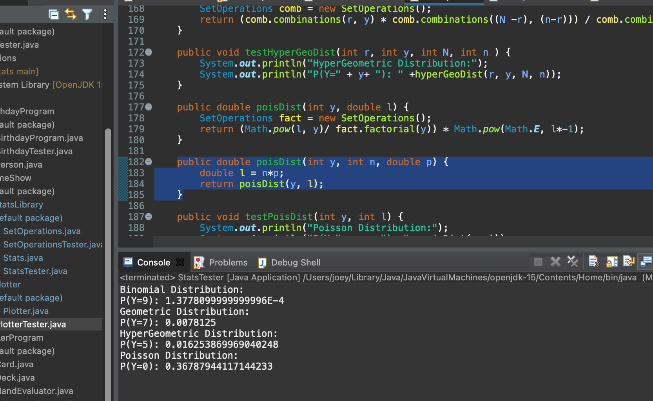

# PokerHandEvaluator Program

The PokerHandEvaluator program has a Deck Object and an ArrayList of Card objects as attributes. The ArrayList of Cards simulates a five-card hand. The Deck object upon construction contains the function ArrayListBuildDeck() that constructs a typical 52-card deck. The Deck object also contains a drawCard function that randomly draws and removes a card from the list. The PokerHandEvaluator uses the Deck’s drawCard function to pick 5 random cards. And the PokerHandEvaluator contains functions to check if the hand contains a pair, two pairs, three of a kind, four of a kind, flush, and straight.

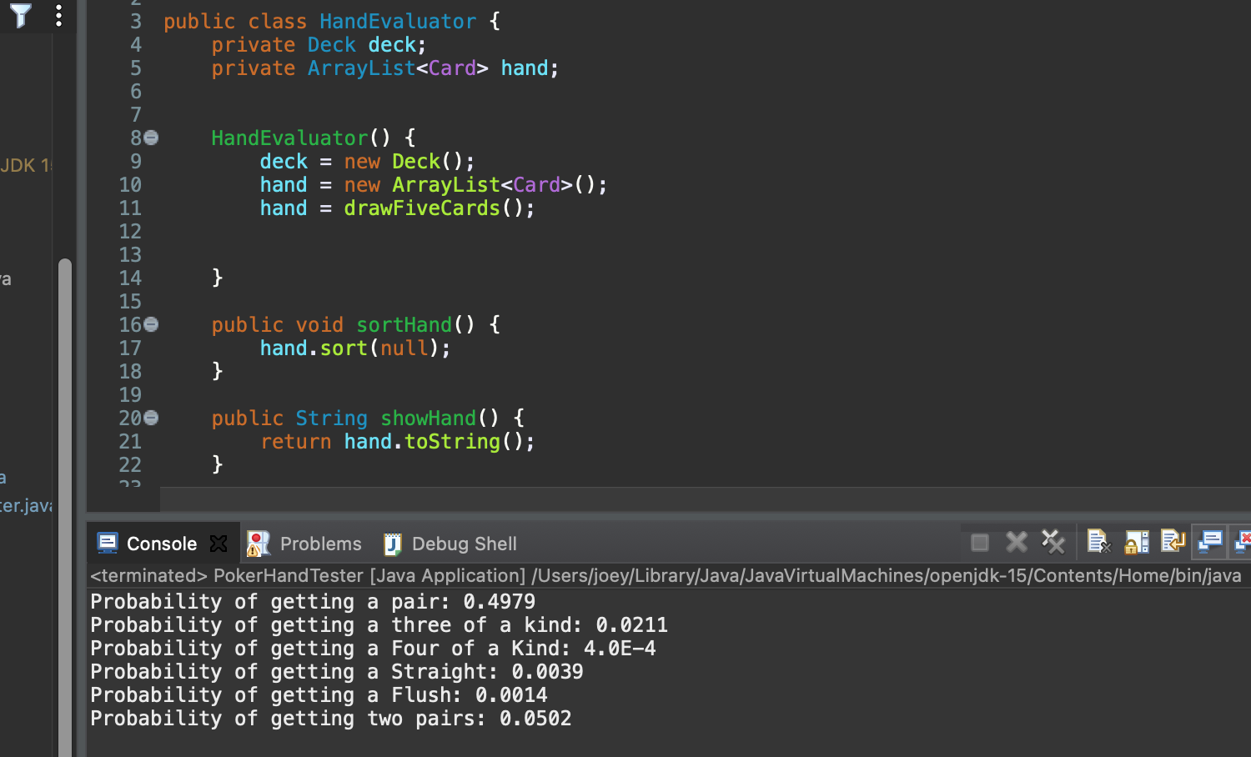

# Plotter Program

The Plotter Object has functions to write x and y coordinates to a csv file. Plotter can write points for a line in the form and logarithmic points. The object also contains functions to salt and smooth the y points. The salt function takes an upper bound and randomly adds or subtracts a random number between 0 and the bound. The smooth function acts as a simple moving average and averages every y-coordinates.

**Original Graph**

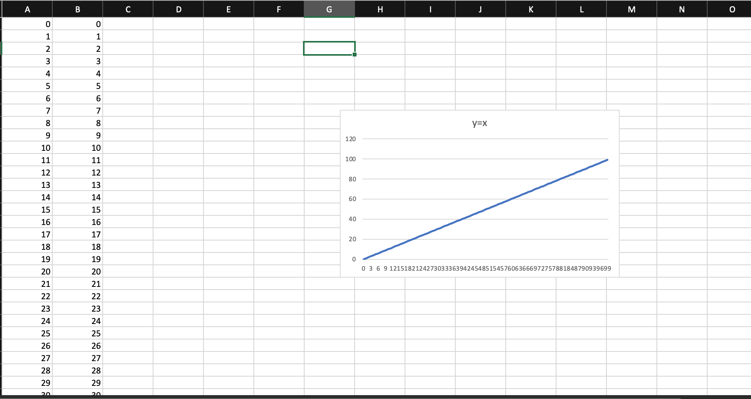

**Salted Graph**

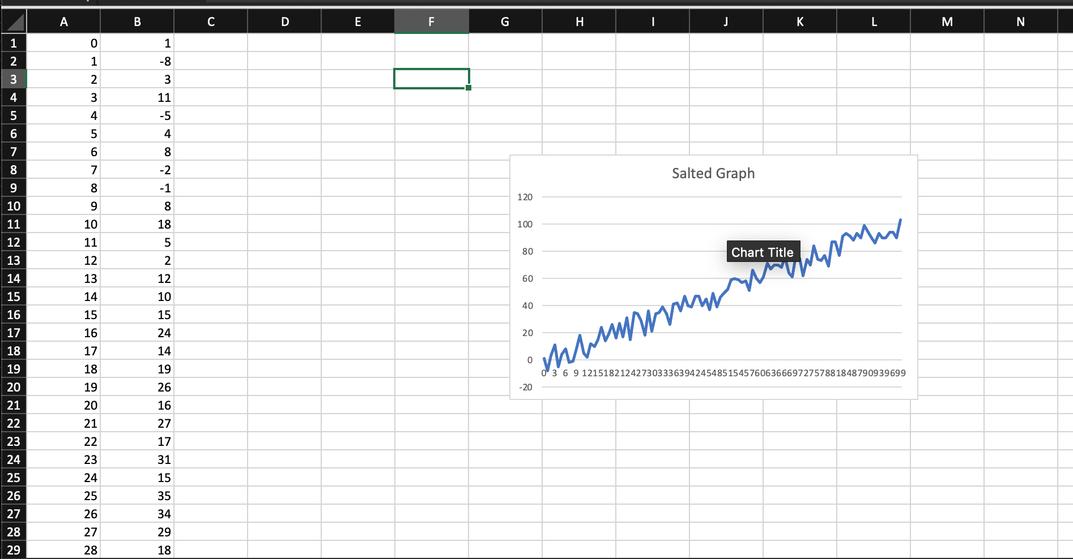

**Smoothed Graph**

