Computer Systems Laboratory – EE 312
Half-Adder & Full-Adder
Joey Gonzalez

OBJECTIVE
This lab sought to implement a half-adder and a full-adder gate in Verilog using only two input gates. Then verify simple digital designs using simulation and a test bench in EDA Playground. Then validate the implementations using EPWave.
Half-Adder
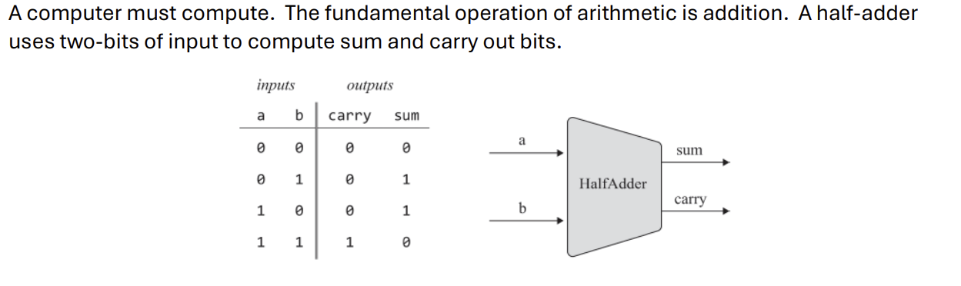
I drew 2 K-maps to create a Sum of Products (SOP) for the logic design of the half adder below.
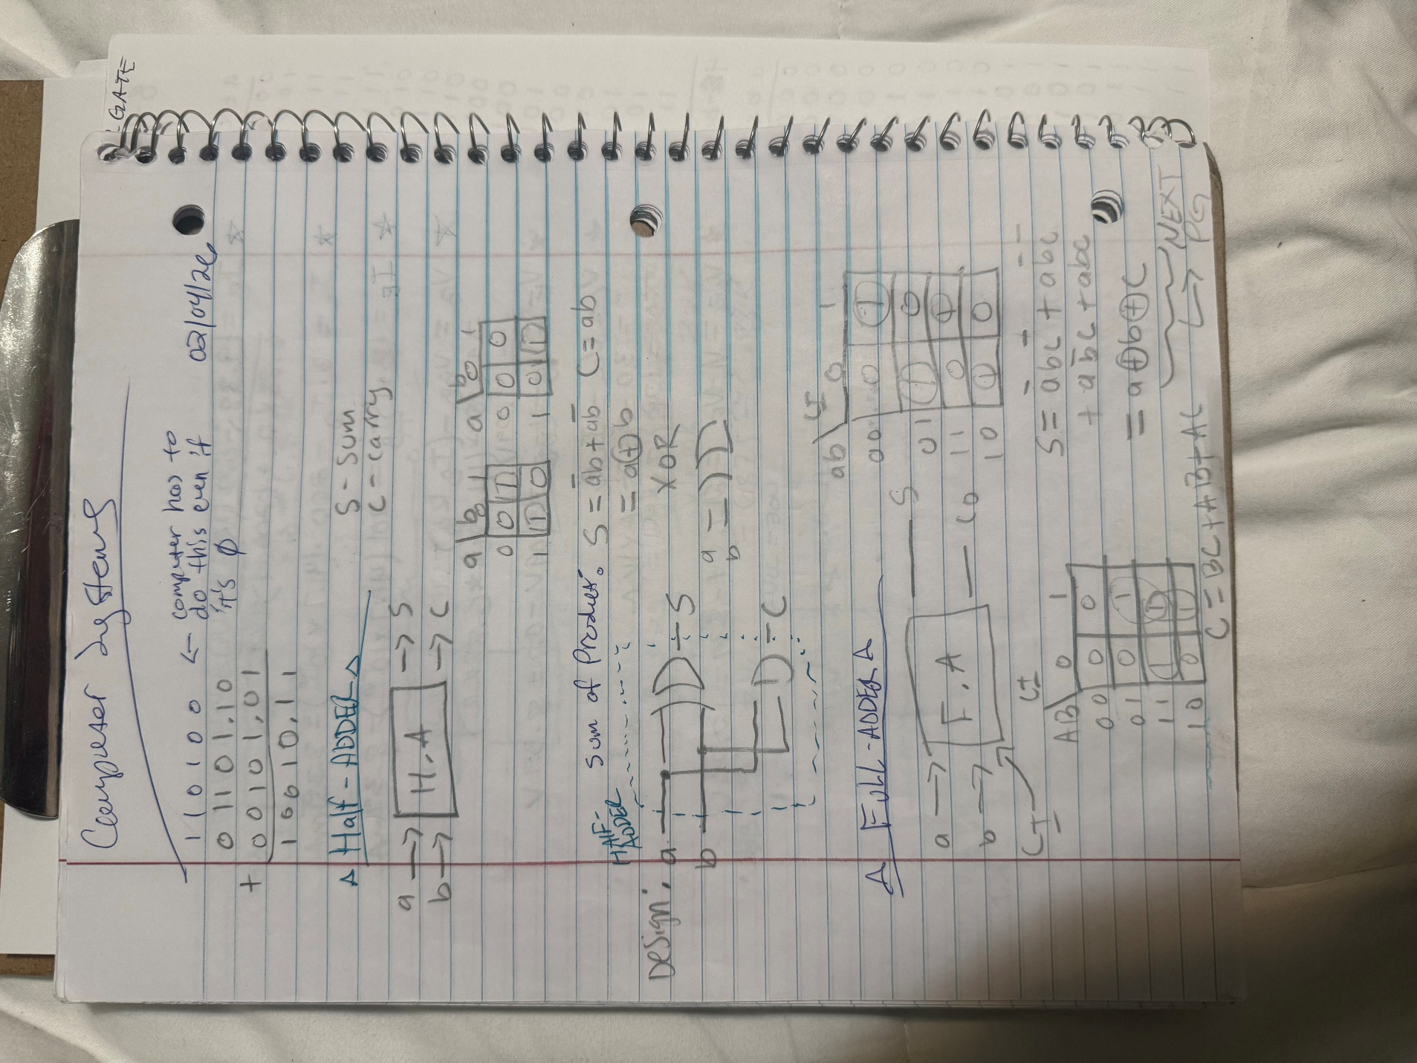

Implementation in Verilog:
module halfadder(
input a,b,
output sum,carry
);

and a1(carry,a,b);
xor x1(sum,a,b);

endmodule
There are only 2 inputs, so we need to test (2^2) = 4 input cases. The test bench file tested for all input cases:

module halfadder_tb;
reg a,b;
wire sum,carry;

halfadder dut (
a,b,sum,carry
);

initial begin
$dumpfile("dump.vcd");
$dumpvars(1,halfadder_tb);

a=0; b=0;
#10; $display("a=%b b=%b sum=%b carry=%b (expected sum=0 carry=0)",a,b,sum,carry);
a=0; b=1;
#10; $display("a=%b b=%b sum=%b carry=%b (expected sum=1 carry=0)",a,b,sum,carry);
a=1; b=0;
#10; $display("a=%b b=%b sum=%b carry=%b (expected sum=1 carry=0)",a,b,sum,carry);
a=1; b=1;
#10; $display("a=%b b=%b sum=%b carry=%b (expected sum=0 carry=1)",a,b,sum,carry);

$finish;
end
endmodule
We got every output we were expecting, which means the half-adder worked as expected. Validating with the EPWave simulation.
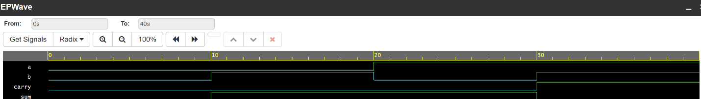
Full-Adder
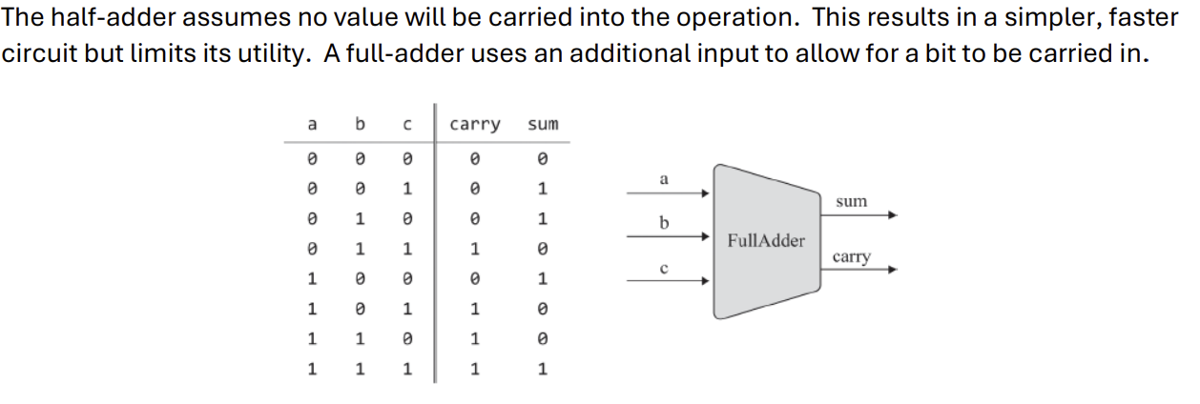



Verilog Implementation in EDA:
module full_adder(
input a,b,c,
output carry,sum
);
wire not_a,not_b,not_c;
wire f,j,k,l;

not n1(not_a,a);
not n2(not_b,b);
not n3(not_c,c);

and a1(f,a,b,not_c);
and a2(j,not_a,b,c);
and a3(k,a,not_b,c);
and a4(l,a,b,c);
or(carry,f,j,k,l);

xor x1(sum,a,b,c);

endmodule

There are 3 inputs: a, b and ci (carry in) so we need to test (2^3) = 8 input cases. The test bench file tested for all input cases:

module full_adder_tb;
reg a,b,c;
wire carry,sum;

full_adder dut (
a,b,c,carry,sum
);

initial begin
$dumpfile("dump.vcd");
$dumpvars(1,full_adder_tb);

// For this full adder the carry in is represented as c

a=0; b=0; c=0;
#10; $display("a=%b b=%b c=%b carry=%b sum=%b (expected carry=0 sum=0)",a,b,c,carry,sum);

a=0; b=0; c=1;
#10; $display("a=%b b=%b c=%b carry=%b sum=%b (expected carry=0 sum=1)",a,b,c,carry,sum);

a=0; b=1; c=0;
#10; $display("a=%b b=%b c=%b carry=%b sum=%b (expected carry=0 sum=1)",a,b,c,carry,sum);

a=0; b=1; c=1;
#10; $display("a=%b b=%b c=%b carry=%b sum=%b (expected carry=1 sum=0)",a,b,c,carry,sum);

a=1; b=0; c=0;
#10; $display("a=%b b=%b c=%b carry=%b sum=%b (expected carry=0 sum=1)",a,b,c,carry,sum);

a=1; b=0; c=1;
#10; $display("a=%b b=%b c=%b carry=%b sum=%b (expected carry=1 sum=0)",a,b,c,carry,sum);

a=1; b=1; c=0;
#10; $display("a=%b b=%b c=%b carry=%b sum=%b (expected carry=1 sum=0)",a,b,c,carry,sum);

a=1; b=1; c=1;
#10; $display("a=%b b=%b c=%b carry=%b sum=%b (expected carry=1 sum=1)",a,b,c,carry,sum);

$finish;
end
endmodule

We got every output we were expecting, which means the full-adder worked as expected. Validating with the EPWave simulation.
