WeRateDogs Twitter Analysis

**Introduction**

WeRateDogs @dog_rates is a twitter account that rates dogs in a hilarious way. This twitter account has over 4 million followers and famous worldwide.

I analyzed their twitter archive in conjunction with real time twitter status data and Udacity’s dog breeds prediction based on the dog images. Here’s what I found.

**Insights 1: Breeds - Most Popular vs Most loved**

As shown in Fig 1-1 and Table 1-2, Golden Retrievers have the most of tweets in WeRateDogs. However, Golden Retrievers does not own the title of most favorited dogs, the French Bulldog does. In fact, French Bulldogs have nearly 5000 more favorites on average compare to Golden Retrievers.

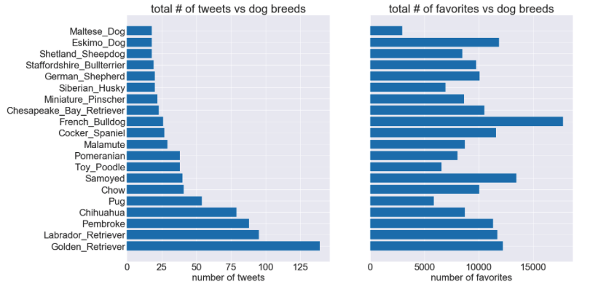

Fig 1-1 summary of tweets and favorites vs dog breeds

Another interesting fact is the top 20 most tweeted dog breeds perfectly overlapped with top 20 most “favorited” dog breeds. My theory is the most favorited dogs are well populated so they get more exposure to the account.

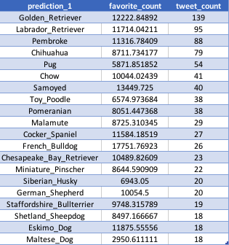

Table 1-1 a detailed summary about top 20 most tweeted dog breeds

**Insight 2: Most popular dog names**

As shown in table 2-2, the most popular dog names are Charlie, Lucy and Oliver. This may not have any practical mean but worth reading if you would like to make names for your little new born puppies.

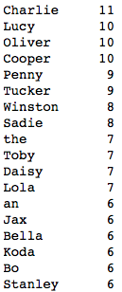

**Insights 3: Rated, 0**

Has WeRateDogs ever rated a dog 0? Can the owner of this account be so mean that not even give any credits to a dog? Here I found the only two tweets where WeRateDogs rated a picture 0. The first one gives to a plagiarism twitter account while in the second picture, the account is making a joke.

 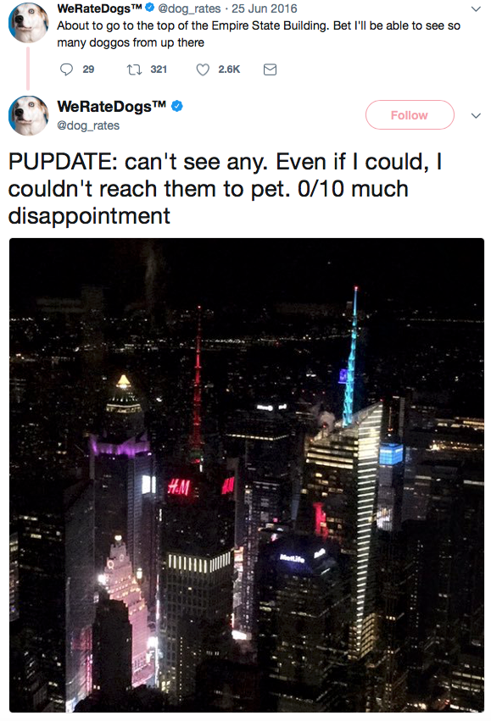

Figure 3-1 two 0 rated pictures

**Visualization**

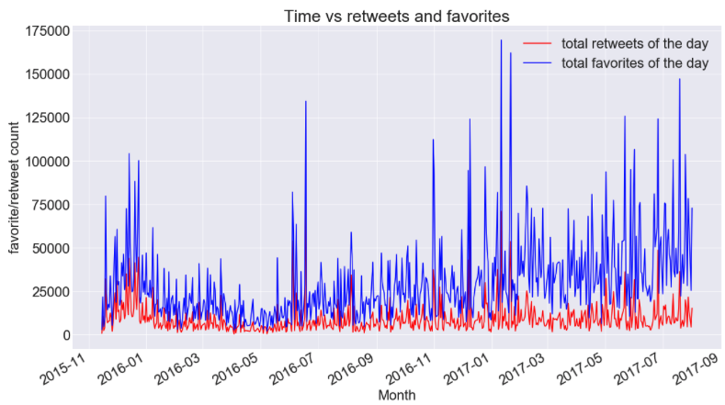

Figure 4-1 Total tweets and favorites vs time

As shown in the Figure 4-1, the general trend of retweets keeps almost the same through 2015 to 2017 while the favorite keep increasing. This trend makes sense because total number of favorite can be easily accumulated over the time but people generally refuse to retweet a tweet from long ago.