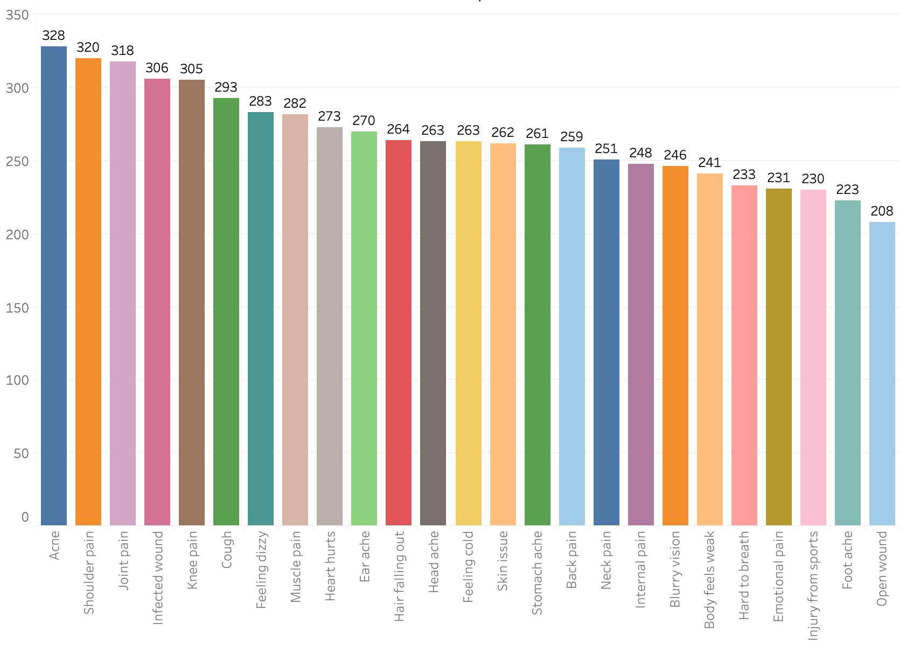

Fig.XX Count of Prompt

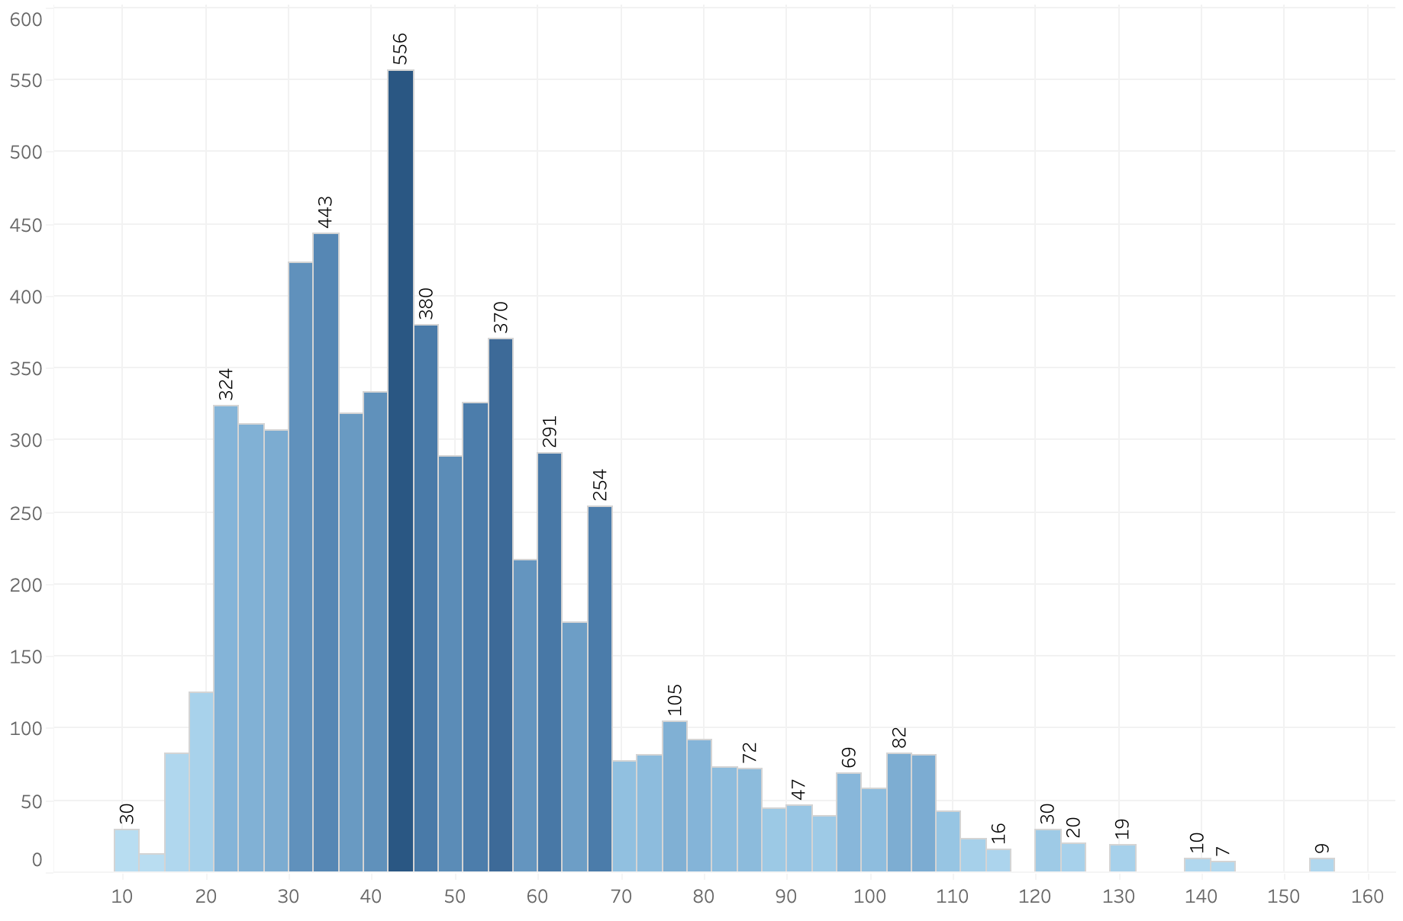

Fig.XX Prase Length Distribution

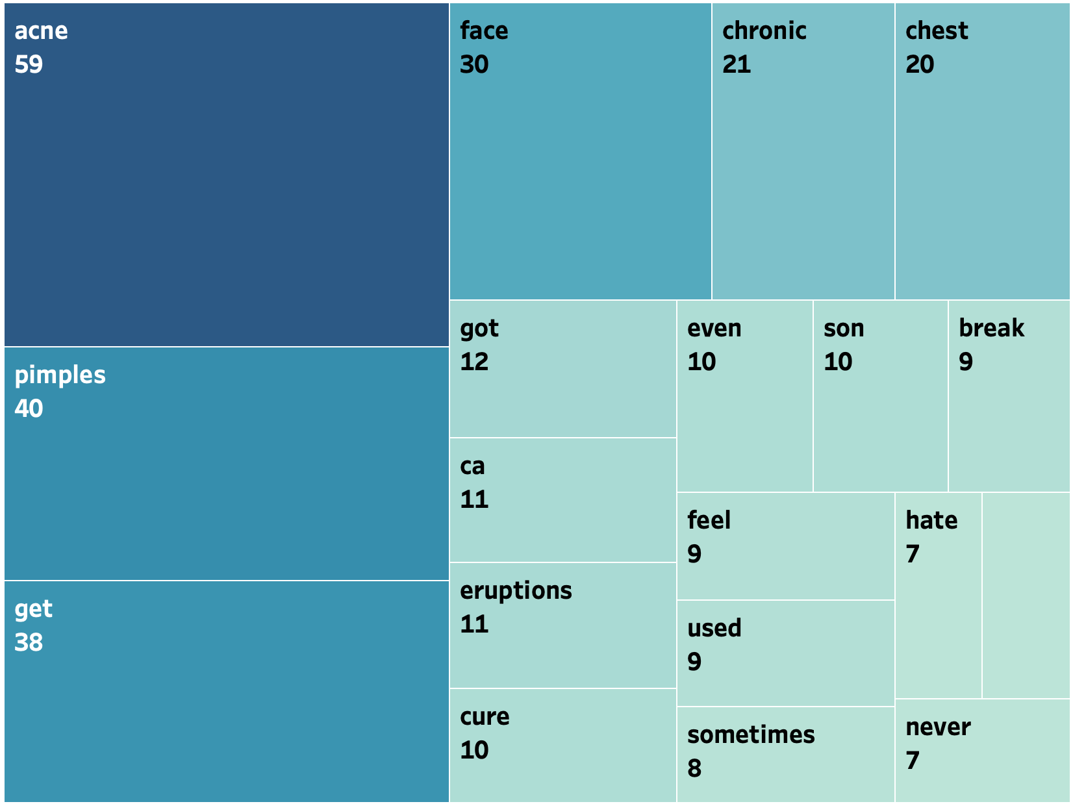

Fig.XX Keywords Treemap for Class Acne

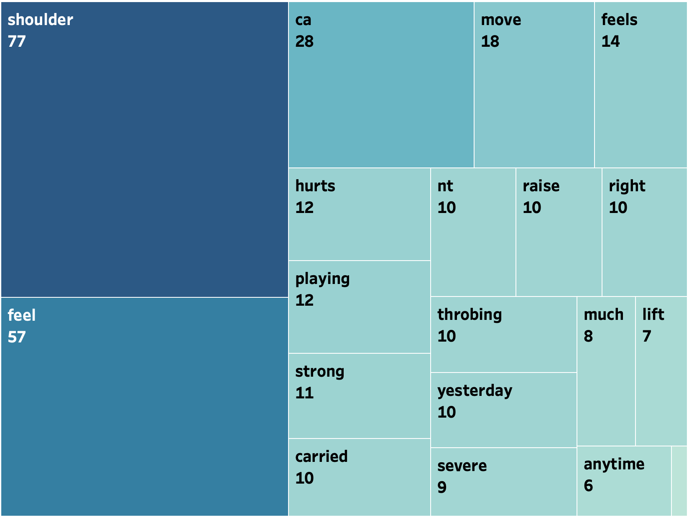

Fig.XX Keywords Treemap for Class Shoulder Pain

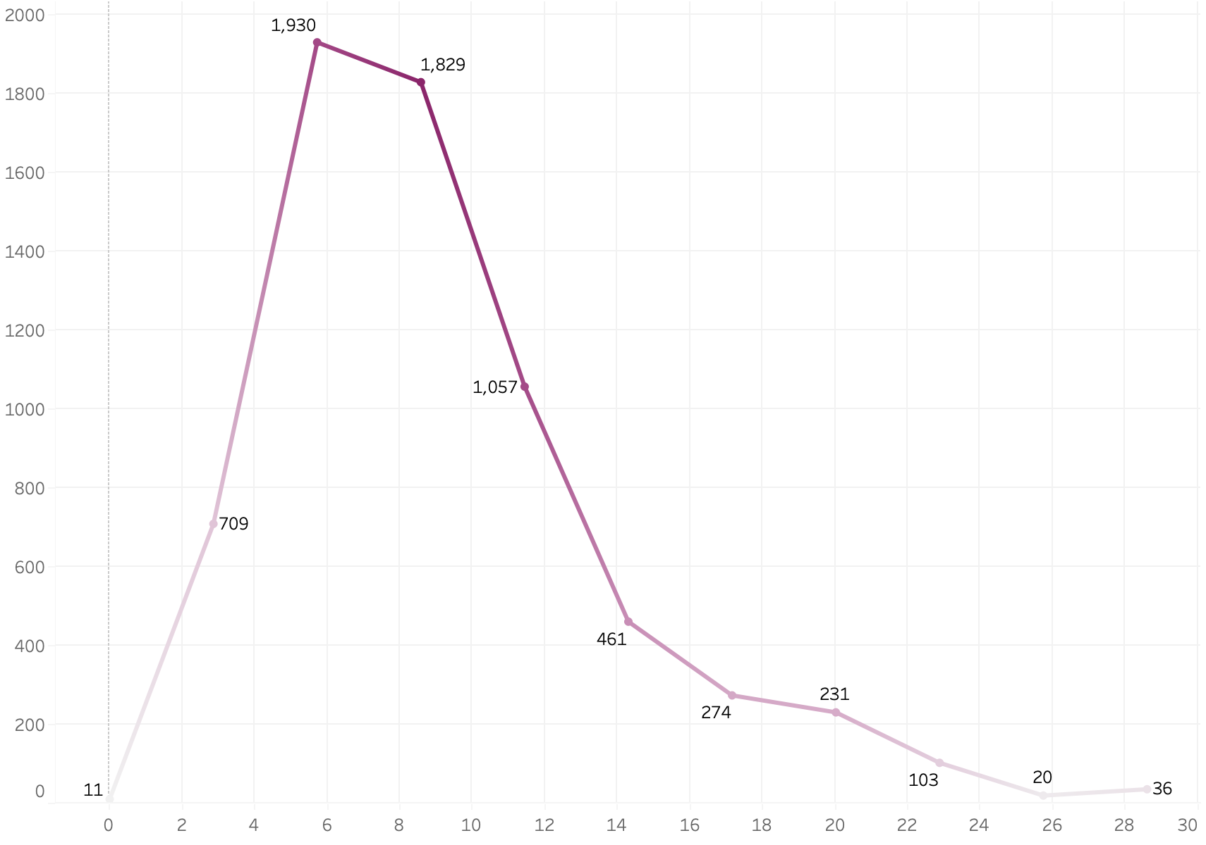

Fig.XX Phrase Number of Words