TEALsim: A Guide to the Java 3D Software

NOTE: Many of the links in this document will only work if you have installed this pdf file in the location described in Section 2.1 below.

IN PDF FORMAT THIS DOCUMENT HAS BOOKMARKS FOR NAVIGATION

CLICK ON THE UPPER LEFT “BOOKMARK” TAB IN THE PDF READER

Version 1.1 December 16, 2007

John Belcher, Andrew Mckinney, Philip Bailey, Michael Danziger

Comments and questions to jbelcher@mit.edu

Supported by NSF Grant DUE-0618558, the d’Arbeloff Fund for Excellence in MIT Education, the Davis Educational Foundation, iCampus, the MIT School of Science, NSF Grant DUE-9950380, the Helena Foundation, and the Classes of 1951, 1955, and 1960.

©2008 Massachusetts Institute of Technology

Table of Contents
(LIVE LINKS)

1 Introduction 7
1.1 Purpose and Intended Audience 7
1.2 What’s New in Release 1.01? 7
1.3 What’s New in Release 1.02? 8
2 Setting up the TEALsim Project 8
2.1 Downloading and Installing the TEALsim Code Base and Documentation 8
2.2 Installing Java and Eclipse in a Windows Environment 9
2.3 Creating a TEALsim Java Project in Eclipse 9
2.4 Instructions for Running a Simulation 10
3 TEALsim Overview 12
3.1 The Simulation (TSimulation, SimEM) 12
3.2 SimPlayer (TFramework) and SimPlayerApp 13
3.3 SimEngine – the Simulation Engine 14
3.4 Viewer and Viewer3D – the Rendering Engine 14
3.5 The User Interface 15
3.6 Units 15
3.6.1 Length, Mass, Time, Force 15
3.6.2 Charge and Current 15
3.6.3 Electric and Magnetic Dipole Moment 15
4 TEALsim Examples 15
4.1 Example_01: 3D objects (native and imported) 15
4.2 Example_02: Simple simulation using theEngine 17
4.3 Example_03: Simple simulation with a graph and a damping slider 19
4.4 Example_04: Two Interacting Electromagnetic Objects (Point Charges) 20
4.5 Example_05: Vector Field Grid 21
4.6 Example_06: Line Integral Convolution 21
4.7 Example_07: Traditional Field Lines 21
4.8 Example_08: Flux Preserving Field Lines Electric 22
4.9 Example_09: Flux Preserving Field Lines Magnetic 22
4.10 Example_10: Constraints 23
5 The Structure of the TEALsim Project 25
5.1 java.src.teal .isocket 25
5.2 java.src.teal 25
5.3 java.src.teal.app 25
5.4 java.src.teal.audio 25
5.5 java.src.teal.browser 25
5.6 java.src.teal.config 25
5.7 java.src.teal.core 25
5.8 java.src.teal.field 25
5.9 java.src.teal.framework 25
5.10 java.src.teal.math 25
5.11 java.src.teal.physics 25
5.11.1 java.src.teal.physics.em 25
5.11.2 java.src.teal.physics.mech 25
5.11.3 java.src.teal.physics.physical 25
5.12 java.src.teal.plot 25
5.12.1 java.src.teal.plot.ptolemy 25
5.13 java.src.teal.render 26
5.13.1 java.src.teal.render.geometry 26
5.13.2 java.src.teal.render.j3d 26
5.13.3 java.src.teal.render.primitives 26
5.13.4 java.src.teal.render.scene 26
5.13.5 java.src.teal.render.viewer 26
5.14 java.src.teal.sim 26
5.14.1 java.src.teal.sim.behavior 26
5.14.2 java.src.teal.sim.collision 26
5.14.3 java.src.teal.sim.constraint 26
5.14.4 java.src.teal.sim.control 26
5.14.5 java.src.teal.sim.engine 26
5.14.6 java.src.teal.sim.function 26
5.14.7 java.src.teal.sim.properties 26
5.14.8 java.src.teal.sim.simulation 26
5.14.9 java.src.teal.sim.spatial 26
5.15 java.src.teal.ui 26
5.15.1 java.src.teal.ui.control 26
5.15.2 java.src.teal.ui.swing 26
5.16 java.src.teal.util 26
5.17 java.src.teal.visualization 26
5.17.1 java.src.teal.visualization.dlic 26
5.17.2 java.src.teal.visualization.image 26
5.17.3 java.src.teal.visualization.processing 27
5.18 java.src.tealsim 27
5.19 java.src.tealsim.physics 27
5.19.1 java.src.tealsim.physics.em 27
5.19.2 java.src.tealsim.physics.examples 27
5.19.3 java.src.tealsim.physics.ilab 27
5.19.4 java.src.tealsim.physics.mech 27
5.20 resources 27
5.20.1 resources.help 27
5.20.2 resources.icons 27
5.20.3 resources.model3d 27
5.20.4 resources.models 27
5.21 java 27
5.21.1 java.jnlp 27
5.21.2 java.lib 27
5.22 javadoc 27
5.23 release 27
5.24 TEALsimDoc 27
5.25 tools 27
5.26 www 27
5.27 xdocs 28
5.28 resources 28
6 TEALsim Applications in 802TEAL3D 28
6.1 Vector Fields 28
6.1.1 Field Mapping Application 28
6.2 Electrostatics 28
6.2.1 Charging a Van de Graff Generator 28
6.2.2 Charges Interacting inside a Pentagon-shaped Box 28
6.2.3 The Capacitor 28
6.2.4 The Electrostatic Force Experiment 28
6.2.5 The Electrostatic Zoo 28
6.2.6 The Electrostatic Videogame 28
6.2.7 Two Point Charges 28
6.2.8 Charging by Induction 28
6.2.9 The Charged Metal Slab 28
6.2.10 Torque on an Electric Dipole in a Constant Field 28
6.3 Magnetostatics 29
6.3.1 Two Current Carrying Rings 29
6.3.2 The Floating Coil 29
6.3.3 Torque on a Magnetic Dipole in a Constant Field 29
6.3.4 The TeachSpin(tm) Applet 29
6.3.5 The Magnetic Field of a Wire and Compass 29
6.4 Faraday’s Law 29
6.4.1 The Falling Coil 29
6.4.2 Faraday's Law 29
6.4.3 Faraday’s Law, Part 2 29
6.4.4 The Falling Magnet 29
6.5 Light 29
6.5.1 Generating Plane Wave Radiation 29
7 A Brief Introduction to Java3D with Tutorials 29
7.1 Java3D 29
7.2 Java3D Tutorials 29
7.2.1 Tutorial_03_01 29
8 TEALsim Overview in the Context of Example_08 29
8.1 The Simulation (SimWorld, TSimulation) : 29
8.2 SimPlayer (TFramework) and SimPlayerApp 30
8.3 SimEngine – the Simulation Engine: 30
8.4 Viewer and Viewer3D – the Rendering Engine: 30
8.5 The User Interface: 30
9 MIT TEALsim Software License 31
10 Appendices 32
10.1 Creating 3D Objects for Import Into Java3D 32
10.1.1 Creating Native Java3D Objects 32
10.1.2 Creating and Importing Autodesk 3ds Max 8 .3DS Scene Files 32
10.1.3 Importing Wavefront .obj Scene Files 32
10.1.4 Importing VRML .wrl Scene Files 32
10.1.5 Importing Lightwave 3D Scene Files 32
10.2 A Guide to Programming Resources for Java 3D 32
10.2.1 The Java Language 32
10.2.2 Java 3D 32
11 Questions for Phil Bailey 33
11.1 What is a serializable class and what does the following error mean (from public class SimEM extends Simulation3D {)? 33
11.2 Setter IntrospectionEx: Method not found: isValue tealsim.physics.examples.Example_01 33
11.3 What do I do it I want to access the direction of directional lights from a tealsim simulation? 33
11.4 Check with Phil to make sure that the path I put for the icons in teal.sim.engine.EngineControl will work when it is put up on the web. 33
11.5 Why don’t we use the static light directions in teal.render.viewer.AbstractViewer3D when we are setting up the lights in ViewerJ3D.setDefaultLights(). 33
11.6 How would I change the abstractviewer3D so I could change the light direction1? 33
11.7 What’s with the version number, how should I change? 33
11.8 Can I change the levels of TDebug to printout particular things, e.g. the stepping of the dynamics, etc. 33
12 References 34
13 Index 35

Figure Captions

Figure 2.1-1: Setting the default .java application reader to Notepad 9
Figure 2.3-1: The Package Structure of the SundquistDLIC Project 10
Figure 2.4-1: Starting a simulation 11
Figure 2.4-2: The Run dialog box 11
Figure 2.4-3: The Arguments panel in the Run dialog box 12
Figure 4.1-1: Screen capture from Example_01 16
Figure 4.1-2: Top view of scene in Example_01, showing Java3D axes and the directions of the three default directional lights. 17
Figure 4.1-3: Front view of scene in Example_01. 17
Figure 4.2-1: The simulation control icons, whose properties are as indicated. 18
Figure 4.2-2: A charge falling toward the floor. 18
Figure 4.3-1: The graph and slider control for the falling charge 20
Figure 4.4-1: Two Electromagnetic Objects Interacting 21
Figure 4.10-1: Screen Capture of Example_08 23
Figure 7.5-1: Controls for Running Tutorial _02_08 30

Introduction

Purpose and Intended Audience

The TEAL simulation system, TEALsim, is designed as a framework for authoring, presenting, and controlling simulations in a variety of domains, beginning with electromagnetism and mechanics, with extensions to biochemistry. The goal of TEALsim is twofold: first, it aims to provide a relatively simple, “API-style” interface, such that non-expert programmers can produce full-featured interactive simulations from the ground up, including all aspects of visualization and user interface, with minimal exposure to the inner workings of the system. Second, it offers a flexible framework for more experienced programmers to extend and expand on the functionality of the system to suit their specific needs. That is, it is built in such a way that the sophisticated user can build simulations in other domains in a straightforward and well defined way.

This document is intended as a general guide to building simulations using the TEALsim environment, and should be used in conjunction with the JavaDocs for the TEALsim project. The TEALsim environment was developed by the Technology Enabled Active Learning (TEAL) Project at MIT. Many examples of the software produced by this project are available on line at

http://web.mit.edu/8.02t/www/802TEAL3D/teal_tour.htm

For those interested in building simulations using the existing platform, our intended audience is undergraduates, graduate students or postdoctoral fellows in science and engineering who have some knowledge of programming but little if any knowledge of 3D graphics and conventions (e.g. scene graphs, branch groups, view platforms, and so on). We have assembled a set of instructions and tutorials that will enable the user with that background to create, package, and post 3D simulations in a short time. We have also provided enough insight into the workings of Java3D for the uninitiated to have a passing knowledge of what goes on, and we have provided references to books and online resources for those interested in expanding that knowledge beyond what we present here.

The organization of this documentation is as follows. We first give instructions for downloading and installing the code in Section 2, including instructions for running the code. We then give a general description of the TEALsim architecture in Section 3. In Section 4, we give examples of building electromagnetic simulations out of standard components in the TEALsim universe. In Section 5, we discuss the structure of the code in detail, package by package. There are cross-references in each of these sections to topics in other sections.

What’s New in Release 1.01?

Compared to release 1.0, we have …...

What’s New in Release 1.02?

Compared to release 1.01, we have added……...

Setting up the TEALsim Project

Downloading and Installing the TEALsim Code Base and Documentation

Go to http://web.mit.edu/viz/soft/ and follow links to the TEALsim code base. You will download three zipped files, one under the link Source Code and named TEALsim.zip, the second under the link TEALsim Documentation and named TEALsimDoc.zip, and the third under the link General Documentation and named generalDoc.zip. Note that if you have previously downloaded generalDoc.zip to support the SundquistDLIC code for Dynamic Line Integral Convolution programs, you do not need to download this files again, as it is identical to the one in the DLIC download.

Create a folder C:\Development\Projects\ on your C-drive and unzip TEALsim.zip into the Projects folder. Unzip the TEALsimDoc.zip into the C:\Development\Projects\TEALsim folder. Unzip the generalDoc.zip file into the C:\Development\Projects\ folder. Once you have done this you will have installed the TEALsim code and documentation. All of the documentation discussed below is now contained in the two folders C:\Development\Projects\TEALsim\TEALsimDoc and C:\Development\Projects\generalDoc. In particular this document in pdf format is contained in the folder TEALsimDoc. If you are not reading this document from that folder, many of the links will not work.

In what follows we will provide links to the documentation on your C-drive assuming that you have installed the source code and documentation as described above. In particular when we discuss particular java files, we will link directly to those files. You may want to set the default application for reading .java files to Notepad. To do this, right click on any .java file, choose “Open With > Choose Program” from the dialog box (see Figure 1.2-1) and in the dialog box that then comes up, choose “Select the program from a list”. In the list that comes up, select Notepad and make sure you check the box labeled “Always use the selected program to open this kind of file”.

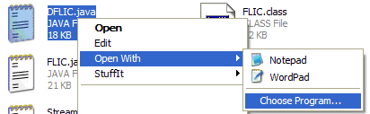
Figure 2.1-1: Setting the default .java application reader to Notepad

Installing Java and Eclipse in a Windows Environment

We discuss the TEALsim software in the context of Eclipse (http://www.eclipse.org/), a free, state-of-the-art Java Integrated Development Environment (IDE). We will assume that you are familiar with the Eclipse IDE interface, and developing Java applications in this environment. Step by step instructions for downloading Eclipse and the Java SDK (SDK stands for Software Development Kit) and creating a SundquistDLIC Java Project in Eclipse are given in a pdf file in your generalDoc folder at this link. To reiterate what active links in this document mean, “right-clicking” on the preceding link will take you to a pdf file named

InstallingJavaEclipseInWindows.pdf

in the folder C:\Development\Projects\generalDoc\. If you have downloaded and installed the code base and documentation in accord with the instructions in Section 2.1 above, the preceding link will open this document.

We also provide a short document with common hints for using Eclipse, which explicitly tells you how to perform the various actions described below in Eclipse. This includes explanations for how to perform certain actions whose explanations are hard to find in the standard Help documentation on the Eclipse taskbar. That document in pdf format is at this link.

Creating a TEALsim Java Project in Eclipse

Follow the directions in Section 3.2 in the pdf file at this link. When you have done this, open a Package Explorer window for the Project. You will see a directory tree for the packages in TEALsim in Eclipse that looks like the one given on the next page in Figure 2.3-1.

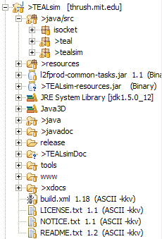

Figure 2.3-2: The Package Structure of the SundquistDLIC Project

Instructions for Running a Simulation

In Eclipse’s Package Explorer, choose SimPlayerApp.java (see Figure 2-4.1) by left-clicking on it.

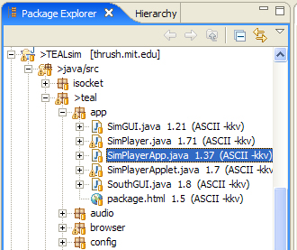

Figure 2.4-3: Starting a simulation

Right-click and choose “Run as > run” from the menu. You will see a dialog box (see Figure 2.4-2). Enter “Example_01” in the Name box. Left-click on the Arguments tab and in the box labeled Program arguments (see Figure 2.4-3). Type
“-n tealsim.physics.examples.Example_01” in the box on top (see Figure 2.4-3). Left-click on Run at the bottom of the dialog box. The Example_01 simulation will come up.

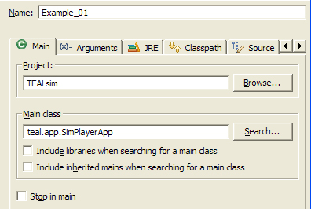
Figure 2.4-4: The Run dialog box
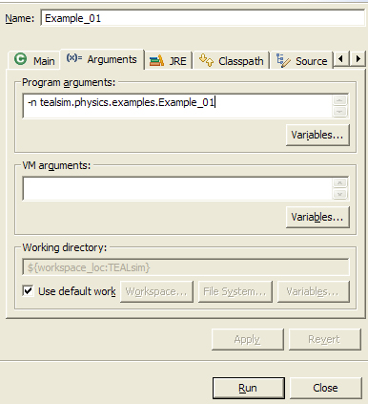
Figure 2.4-5: The Arguments panel in the Run dialog box

If you have a simulation that requests additional memory, set more memory by typing
“-Xmx512m” (or “-Xmx256m”) in the “VM arguments:” box shown in Figure 2.4-3.

TEALsim Overview

The TEAL simulation system, TEALsim, is designed as a framework for authoring, presenting, and controlling simulations in a variety of domains, beginning with physics. Architecturally, TEALsim follows a “Model-View-Control” design pattern, with several major modules representing the three components: the simulation engines make up the “model”; the renderer and viewer make up the “view”; and the user interface makes up the “control.” These three components are combined into a simulation. Each component is largely defined by a set of interfaces that suggest the required functionality of that piece, so that the actual implementation details can be customized as necessary (for example, leaving the specific rendering implementation up to the developer). TEALsim is built using Java Standard Edition 1.5.0_12, Swing and Java3D 1.4.0_01 extensions. All major components of the system are JavaBeans. Most classes implement well defined interfaces, the most basic being TElement.

What follows is a brief description of the basic components.

The Simulation (TSimulation, SimEM)

The TSimulation interface defines the requirements for a complete interactive simulation, collecting together all of the components that make up the entire user experience. Typically this includes: a simulation engine (source.java.core.teal.sim.engine.TSimEngine), a Viewer (source.java.core.teal.render.TViewer), the UI elements, and all of the objects being simulated or otherwise displayed in the Viewer. SimEM (teal\physics\physical\em) is an example of a class that implements TSimulation. It incorporates the EMEngine and a Java 3D viewer and provides the basis for all Electromagnetic simulations.

Any simulation object added to a simulation must implement the TElement interface, which provides a standard set of functionalities for all objects in the world. That is, any object which is specified, included or defined within the simulation must implement the TElement interface. This includes physical objects (e.g. a point charge), graphical elements, control objects and simulation viewers. In particular, the functionalities inherent in the TElement interface include support for Routes and PropertyChangeEvents. This allows any simulation elements in the world to exchange information with any other element in the world, and in particular with User Interface (UI) components. For example, a UI slider can be wired to a property of a simulation object (for example, the mass of an electric point charge) to directly manipulate that quantity. Or, the simulation itself can be wired to a property of a simulation object in order to monitor that property of the object and/or take some action depending on its value.

A completely realized TSimulation class defines the properties of the simulation as a whole, such as the initial spatial configuration of simulation objects, initial conditions of any variables, and any special “wiring” between objects and/or interface components. Essentially, it contains the entire logic specific to a particular simulation.

A TSimulation object is then presented to the user using a SimPlayer, as discussed below.

SimPlayer (TFramework) and SimPlayerApp

A SimPlayer “plays” a TSimulation instance—that is it takes as input a TSimulation object and presents that TSimulation to the viewer. It implements the TFramework interface, which is the glue that holds all of the components in the TSimulation together. SimPlayer is the application inside which all of the components of the TSimulationare running. The TFramework interface contains methods that allow loaded simulations to customize the SimPlayer application window, including modification of the UI and menu bars.

SimPlayerApp contains the main routine of the TEALsim package. When we run SimPlayerApp as specified above in Section 2.4 above, it instantiates a SimPlayer and uses the argument -n tealsim.physics.em.Example_01 to create an instance of the class Example_01 and tells the SimPlayer to play Example_01, which is a Simulation object.

SimEngine – the Simulation Engine

The physics in a TEALsim simulation is contained in a SimEngine object, which represents the simulation engine itself (source.java.core.teal.sim.engine.SimEngine). The simulation engine is responsible for all of the computation involved in the system being simulated. This includes dynamically processing and updating simulation objects (TSimElements) according to the rules of the simulation engine (including adding and removing them from the “world” when necessary), and performing numerical integration of simulation variables. The exact type of processing and integration will depend on the specific type of simulation being implemented; for example, the “electromagnetism” extension of SimEngine, EMEngine, computes the total electromagnetic fields created by field-generating simulation objects (EMObjects), as well as the resulting dynamics of the EMObjects (velocity, position, rotation, etc.). It also handles related tasks, such as collision detection and resolution.

In general, the SimEngine runs a continuous loop that performs the following actions:

- Computes values of dependent simulation variables for the current time step.
- Updates simulation objects to reflect new values.
- Informs the renderer of any visual changes to the simulation.

This loop in the SimEngine represents the main application thread for a TEALsim simulation.

Viewer and Viewer3D – the Rendering Engine

The Viewer (java.src.teal.render.viewer ) is the window into the simulation space, representing the rendering engine and its output. It is responsible for rendering the visual elements of a simulation to the screen in real-time 3D, and managing user interaction with the rendered image. As such, it is tightly coupled to the SimEngine: The SimEngine must inform the Viewer of (visual) changes to simulation elements, and each visual simulation element must have an associated visual representation that can be drawn by the Viewer. Conversely, the Viewer must report back to the simulation when a user manipulates the visual representation of a simulation object (for example, by clicking and dragging on an object in the Viewer).

While the actual implementation of the Viewer can vary, the interface TViewer defines a set of functionality that any Viewer implementation should support. This includes general rendering properties and tasks, such as camera controls, visual effects, maintaining lists of rendered objects, and handling mouse-based “picking” and manipulation of objects in the Viewer. In addition, it should also handle the explicit rendering of the scene.

The current default Viewer implementation is based on Java3D, which is a scene-graph based renderer layered on top of OpenGL or DirectX. In this case, the Viewer sets properties on the scene graph, which is then rendered implicitly through Java3D’s rendering thread. A more direct (or “immediate”) rendering implementation (such as rendering directly through OpenGL) should obviously include explicit rendering instructions for all visual elements.

The User Interface

The user interface (java.src.teal.ui) is the means by which a user interacts with the application (in addition to user interaction through the Viewer), and through which the user receives feedback about a simulation’s properties. It is responsible for producing the types of controls and read-outs necessary to manipulate a simulation. These can include buttons, sliders, checkboxes, combo-boxes, graphs, text fields, and numerical displays.

Units

Length, Mass, Time, Force

A unit length in TEALsim is one meter, a unit mass is one kilogram, a unit time is one second, and a unit force is one Newton.

Charge and Current

A unit charge in TEALsim is 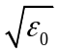 Coulombs, or 2.975 micro Coulombs. (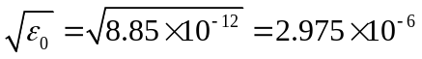). This unit charge arises because we set 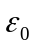 to 1 in teal.config.Teal (javadocs, java). Since the force between two point charges is given by 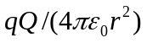, for this force to be in Newtons if r is in meters, we must take the unit charge to have this value.

Electric and Magnetic Dipole Moment

A unit electric dipole moment in TEALsim is

TEALsim Examples

We present a number of examples below to illustrate various features of TEALsim and how to use them to construct simulations. These examples are contained in the package tealsim.physics.examples. As we present the examples we will point out how they implement the overall scheme described above in Section 3.

Example_01: 3D objects (native and imported)

We begin with an example which demonstrates how much of the usual boilerplate for stetting up a Java3D scene is hidden from the user at this level. Here and in the future the links following a reverence to a java file link to the javadocs for that file and the .java file itself, respectively. The example tealsim.physics.examples.Example_01 (javadocs, java), extends SimEM, which has already created the lights, cameras, etc. We create two native Java3D objects, a flat red disk and a green sphere, and add them to the scene. We also import two .3DS files, an orange hemisphere and a tapered cone with a texture applied.

A screen capture from this example is shown in Figure 4.1-1. The coordinate system in Java3D is as follows: the x axis is horizontal and positive to the right; the y-axis is vertical and positive upward; the z-axis completes the right handed system and is out of the page. The lights and the camera in this example are all set in the viewer for this world, teal.render.j3d.ViewerJ3D (javadocs, java), which extends teal.render.viewer.AbstractViewer3D (javadocs, java). The camera is placed at (0.,0.,5.) (see Figure 4.1-2). There are four lights in the scene, one omni light and three directional lights. The directions of the directional lights are: (1) (4., -7., -12.); (2) (-6., -2., -1.); (3) (-6., 2., 1.).

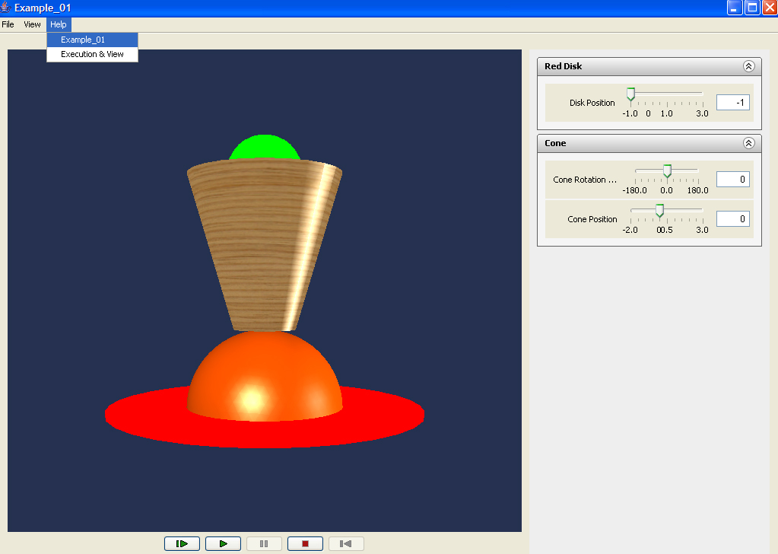
Figure 4.1-6: Screen capture from Example_01

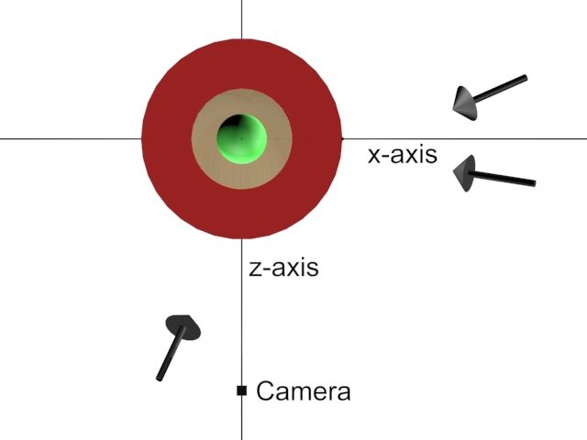
Figure 4.1-7: Top view of scene in Example_01, showing Java3D axes and the directions of the three default directional lights.
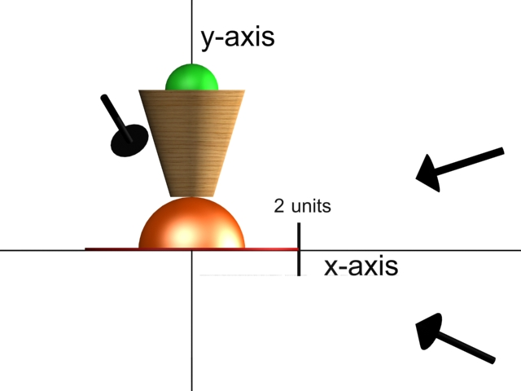
Figure 4.1-8: Front view of scene in Example_01.

We add to the upper tool bar in the simulation (see upper left of Figure 4.1-2) links to two help files, one which explains what the simulation does (resources.help.example_01.html) , and one which explains the view and execution controls (resources.help.executionView.html) for the 3D window and simulation engine, respectively. These files are opened using the browser included in the TEAL project, teal.browser.Browser (javadocs, java).

In terms of the overview provided in Section 3.4 above, all of our examples extend teal.physics.em.SimEM (javadocs, java) which in turn extends teal.sim.simulation.Simulation3D (javadocs, java). Simulations3D sets the viewer to teal.render.j3d.ViewerJ3D (javadocs, java). ViewerJ3D extends teal.render.viewer.AbstractViewer3D (javadocs, java) which in turn extends teal.render.viewer.Viewer (javadocs, java).

The sliders are built out of components in teal.ui.control.PropertyDouble (javadocs, java), which extends teal.ui.control.PropertySlider (javadocs, java). The vertical (y) position of the red disk is controlled by a one slider. The vertical position of the cone is also controlled by a slider, as is its orientation in the xy plane (the plane of the screen as seen from the initial camera position).

Example_02: Simple simulation using theEngine

In Example_01 we only illustrated properties of the Java3D viewer, with no simulation dynamics (that is, nothing happens as world time progresses). In Example_02 (javadocs, java) which again extends SimEM (as does all of our examples), we introduce a simple dynamical situation to illustrate how theEngine and engine controls work. The simulation SimEM sets the simulation engine to teal.physics.em.EMEngine (javadocs, java), which extends teal.sim.engine.SimEngine (javadocs, java). In Example_02 (javadocs, java), we set the dynamical time step to 0.02 seconds using the method theEngine.setDeltaTime, and add to the scene a teal.physics.em.EMObject (javadocs, java) object, the teal.physics.em.PointCharge (javadocs, java) object. This object knows how to interact with the world, as we explain in this example and others to come.

In Example_02, the PointCharge object floatingCharge has mass, which means it will interact with the general gravitation field of the world, which is set by default to
(0.,-9.8,0.) in EMEngine. To show how we change the default gravity in the world, we add a statement which reduces the default value of g to 4.9 meters per second squared in the negative y-direction in this example. We also create a “wall” 1.25 meters beneath the initial position of the charge, which appears in the scene as a transparent rectangle. If we step the dynamics using the step control (see Figure 4.2-1), it takes about 35 steps at the 0.02 second step size in this world for the point charge to fall the 1.25 meters to the position of the wall, which is correct for a gravitational acceleration of 4.9 meters per second squared.

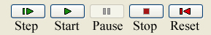
Figure 4.2-9: The simulation control icons, whose properties are as indicated.

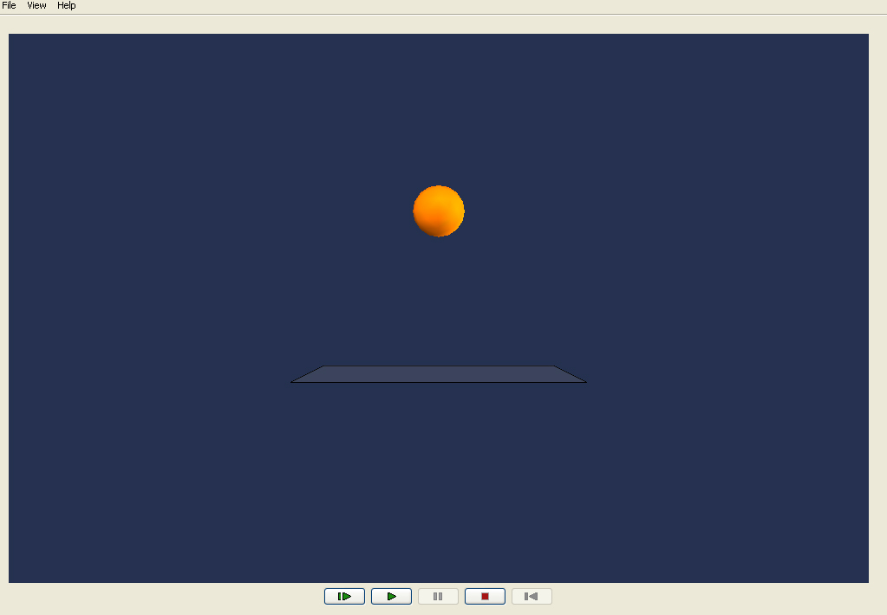
Figure 4.2-10: A charge falling toward the floor.

We added a collision controller to the floatingCharge so that it will be recognized as a colliding object when it touches the “Wall”. The collision controller teal.sim.collision.SphereCollisionController (javadocs, java) is a sphere whose radius is the radius of the floatingCharge, placed at the center of the floatingCharge, This has the effect that when the floatingCharge center position comes within its radius of the “Wall” it “collides” with the “Wall” and the floatingCharge bounces. We set the elasticity of the wall to 1.0, which means the collision is perfectly elastic.

The dynamics of this falling charge is computed as follows. First of all, the six equations of motion for the position x and velocity v of the point charge that we are trying to solve are

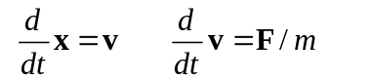 (4.2.1)

(we ignore the rotational dynamics of the object, although this can be included). Thus the dependent variables that we are integrating are the position and velocity of the floating charge. Our point charge object extends EMObject, which extends teal.physics.physical.PhysicalObject (javadocs, java), and therefore has a method getDependentValues(). This method simply returns the current values of the six dependent values of x and v. It inherits from PhysicalObject a method getDependentDerivatives() which calculates the derivatives of these dependent values using equation (4.2.1). This method accomplishes this using a method getExternalForce in PhysicalObject which adds up the total force on the point charge, including gravity, an over all frictional force proportional to the velocity (-friction*v), any electromagnetic forces q(E+vxB) acting on the point charge due to other electromagnetic objects in the world (zero in this example), and a Pauli force which is always repulsive at close distances (we discuss this further in Example_04 below).

Once we have the current values of the dependent variables and their derivatives, we integrate the equations of motion using a fourth order Runge-Kutta scheme teal.math.RungeKutta4 (javadocs, java), using routines in teal.sim.engine.SimEngine (javadocs, java). In particular, the method nextStep in SimEngine advances the world one time step using the integration routine, among other methods.

Example_03: Simple simulation with a graph and a damping slider

Example_03 (javadocs, java) is the same as Example_02 except that we add a graph of the vertical position of the charge and a slider that controls the amount of damping in the world. To accomplish this we must import user interface classes for the panel display, for the damping control slider, and for plotting.

Note that we can change the friction value dynamically between time steps in the world. That is, in the integration for the position of the point charge, before each time step nextStep checks to see if the friction in the world has changed, and computes the next dynamical step using the current value of the friction.

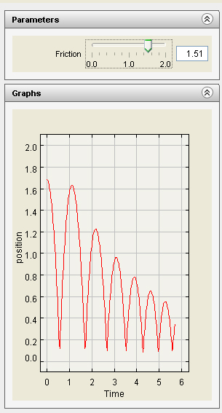
Figure 4.3-11: The graph and slider control for the falling charge

Example_04: Two Interacting Electromagnetic Objects (Point Charges)

In Example_04 (javadocs, java) we create two point charges which interact via their electric fields. The two objects are our point charge from Example_02, free to move along the vertical axis, and a new point charge which is fixed in space 0.8 meters below the wall in Example_02, again on the vertical axis. We set the friction in the world to a high value, so that the floating charge will quickly settle down quickly to its equilibrium position.

The charge on the fixed-in-space charge can be varied between -10 and 50 charge units, where a charge unit is 2.975 micro Coulombs (see Section 3.6.2). The charge on the floating charge is constant at 1 charge unit, its radius is 0.2 meters and its mass is 0.035 kg. The force of gravity on the floating charge, mg, is 0.343 Newtons. For a fixed charge of about 4.4 charge units the upward electrostatic repulsion when the floating charge is resting on the wall (center 1 meter above the fixed-in-space charge) will just about balance the downward force of gravity, and the floating charge will levitate above the wall for values of the charge on the fixed-in-space charge above this value.

Note that if we change fixedCharge.setMoveable(false) to fixedCharge.setMoveable(true) in Example_04, the position and velocity of our fixed charge will be added to the dependent variable list of our world. When we start the simulation we will be integrating 12 dependent variables, 6 for each charge, and the “fixed” charge will begin to fall under gravity etc.

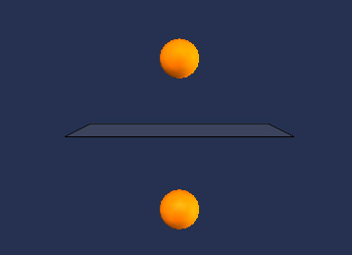
Figure 4.4-12: Two Electromagnetic Objects Interacting

Example_05: Vector Field Grid

In Example_05 (javadocs, java) we add a vector field grid to Example_04 to demonstrate one of three methods we use to visualizing electromagnetic fields.

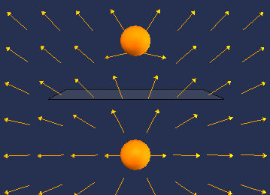
Figure 4.5-13: An example of a vector field grid.

Example_06: Line Integral Convolution

In Example_06 (javadocs, java) we add a line integral convolution example to Example_04 to demonstrate one of three methods we use to visualize electromagnetic fields.

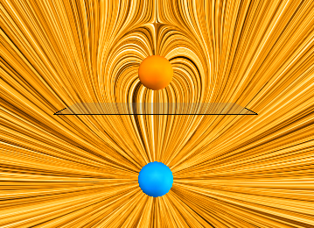
Figure 4.6-14: An example of a line integral convolution.

Example_07: Traditional Field Lines

In Example_07 (javadocs, java) we add field lines to Example_04 to demonstrate one of three methods we use to visualize electromagnetic fields. In this case we add two kinds of field lines.

The first kind (the two red field lines to the right of the vertical center line in Figure 4.7-1) are field lines that always go through the same spatial point, in this case (1,0,0) and (1,2,0). The point at which the field line starts for both of these field lines is shown by a lighter segment along the field line. Note that for the red field lines we construct the field in both directions from the starting point; that is both along the field and opposite the field.

The second kind of field line (the three blue field lines to the left of the vertical center line in the figure) starts out at the radius of the sphere at the same angles (in this case -45, -90, and -135 degrees) measured from the object direction of the object to which it is attached, in this case the floating charge. As the floating charge moves up and down the position at which the blue field lines start is always at the same angle from the axis of the charge direction, moving with the charge.

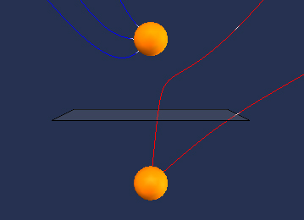
Figure 4.7-15: Examples of two fixed and three relative field lines.

Example_08: Flux Preserving Field Lines Electric

In Example_08 (javadocs, java) we add field lines to Example_04 to demonstrate one of three methods we use to visualize electromagnetic fields. In this case we add field lines which preserve electric flux.

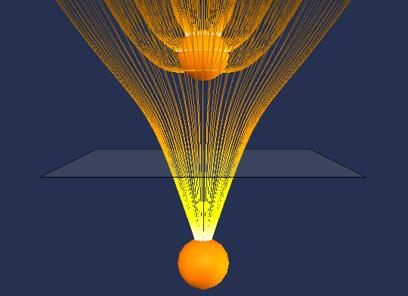
Figure 4.8-16: Flux Preserving Electric Field Lines

Circle search is 0.99*radius of the object from top to bottom on right side.

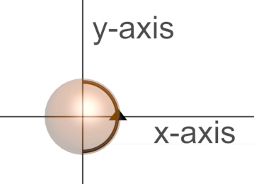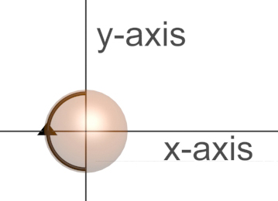

Example_09: Flux Preserving Field Lines Magnetic

In Example_08 (javadocs, java) we add field lines to Example_04 to demonstrate one of three methods we use to visualize electromagnetic fields. In this case we add field lines which preserve electric flux.

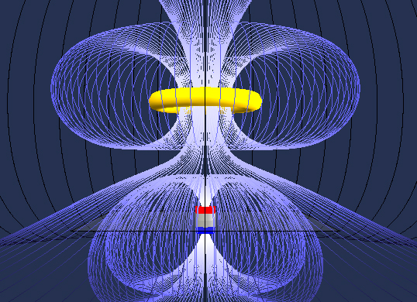
Figure 4.9-17: Flux Preserving Magnetic Field Lines

Example_10: Constraints

In this tutorial, we put everything together, and add an additional .3DS object.

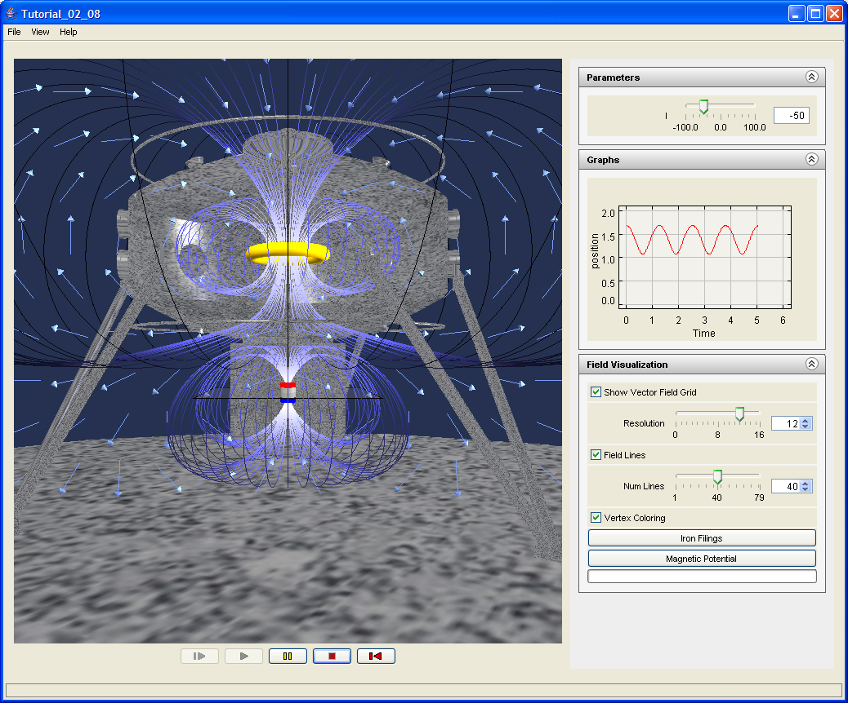
Figure 4.10-18: Screen Capture of Example_08

The Structure of the TEALsim Project

To learn the structure of the TEALsim project, the user should use this document as well as the javadocs and the actual java classes for the TEALsim Project. We first give an overview of the package structure of the Project. This same information is included in the package documentation in the javadocs for the Project.

java.src.teal .isocket

java.src.teal

java.src.teal.app

java.src.teal.audio

java.src.teal.browser

java.src.teal.config

java.src.teal.core

java.src.teal.field

java.src.teal.framework

java.src.teal.math

java.src.teal.physics

java.src.teal.physics.em

java.src.teal.physics.mech

java.src.teal.physics.physical

java.src.teal.plot

java.src.teal.plot.ptolemy

java.src.teal.render

java.src.teal.render.geometry

java.src.teal.render.j3d

java.src.teal.render.primitives

java.src.teal.render.scene

java.src.teal.render.viewer

java.src.teal.sim

java.src.teal.sim.behavior

java.src.teal.sim.collision

java.src.teal.sim.constraint

java.src.teal.sim.control

java.src.teal.sim.engine

java.src.teal.sim.function

java.src.teal.sim.properties

java.src.teal.sim.simulation

java.src.teal.sim.spatial

java.src.teal.ui

java.src.teal.ui.control

java.src.teal.ui.swing

java.src.teal.util

java.src.teal.visualization

java.src.teal.visualization.dlic

java.src.teal.visualization.image

java.src.teal.visualization.processing

java.src.tealsim

java.src.tealsim.physics

java.src.tealsim.physics.em

java.src.tealsim.physics.examples

This package consists of examples of simulations constructing using the elements of TEALsim. The examples cover the various ways of dealing with native and imported 3D objects, the dynamics of simple systems and how they are integrated into the simulation engine, and the user interface controls.

java.src.tealsim.physics.ilab

java.src.tealsim.physics.mech

resources

resources.help

resources.icons

resources.model3d

resources.models

java

java.jnlp

java.lib

javadoc

release

TEALsimDoc

tools

www

xdocs

The doc folder contains the javadocs for the Project, in html format. The main html link is the index.html link in doc.

resources

TEALsim Applications in 802TEAL3D

The web page http://web.mit.edu/8.02t/www/802TEAL3D/ has a number of TEALsim applications, and we discuss each of these in turn.

Vector Fields

Field Mapping Application

Electrostatics

Charging a Van de Graff Generator

Charges Interacting inside a Pentagon-shaped Box

The Capacitor

The Electrostatic Force Experiment

The Electrostatic Zoo

The Electrostatic Videogame

Two Point Charges

Charging by Induction

The Charged Metal Slab

Torque on an Electric Dipole in a Constant Field

Magnetostatics

Two Current Carrying Rings

The Floating Coil

Torque on a Magnetic Dipole in a Constant Field

The TeachSpin(tm) Applet

The Magnetic Field of a Wire and Compass

Faraday’s Law

The Falling Coil

Faraday's Law

Faraday’s Law, Part 2

The Falling Magnet

Light

Generating Plane Wave Radiation

A Brief Introduction to Java3D with Tutorials

Java3D

Java3D Tutorials

Tutorial_03_01

TEALsim Overview in the Context of Example_08

The Simulation (SimWorld, TSimulation) :

We now examine each of the broad categories discussed above in the context of Example_08. This tutorial extends SimWorld. In the tutorial we have a ring of current (the yellow torus in Figure 4-1) interacting with the magnetic field of a fixed magnetic dipole (the red/white/blue cylinder in Figure 4-1). The ring of current is assumed to have negligible inductance and is acted upon by gravity in addition to the field of the dipole.

SimPlayer (TFramework) and SimPlayerApp

SimEngine – the Simulation Engine:

Physically in Example_08 we have a ring of current interacting with the magnetic field of a fixed magnetic dipole. The ring of current is assumed to have negligible inductance and is acted upon by gravity. Computing the force on the ring due to the magnetic dipole is straightforward.

Viewer and Viewer3D – the Rendering Engine:

The User Interface:

The current in the ring is set by the user using the slider on the upper right as shown in Figure 4-1. Figure 4-2 shows the controls at the bottom of the view window that allow the user to start, stop, pause, and reset the simulation, as well as step through the simulation one time step at a time. Once the user presses run, the simulation runs until the user presses pause, stop, or reset. The user can also simply press step, which will advance the simulation one time step. The time step is a basic property of the SimEngine, and is set in this tutorial in line 086 theEngine.setDeltaTime(0.02).

Figure 8.5-19: Controls for Running Tutorial _02_08
When the simulation begins, the ring of current is about 1.7 meters above the magnetic dipole, which is located at zero, and has a current of -50 amps (positive current is counterclockwise when viewed from above). As the simulation runs, the ring of current oscillates up and down with an average height of around 1.3 meters. The position of the ring as a function of time is plotted in the graph on the right. When the user hits reset, the ring is returned to its initial position but the current remains at the last value it was set to using the slider by the user.

At any time as the simulation runs, the user can change the current in the ring by using the slider or by entering the desired current in the box next to the slider and hitting enter. The various parts of the UI control appear in separate panels on the right. Controls for the various visualization methods for the magnetic field are contained in the panel entitled “Field Visualization”. The user can hide the field lines if desired, change their number and color weighting, and change the number of nodes in the vector field grid. The user can also have the simulation stop at any point and calculate a line integral convolution representation of the field by left-clicking on the “Iron Filings” button; left-clicking on the “Magnetic Potential” button displays a field that is everywhere perpendicular to the magnetic field. The simulation is paused as this calculation is being carried out. To restart the simulation, the user simply left-clicks on run again.

MIT TEALsim Software License

Copyright (c) 2008 The Massachusetts Institute of Technology. All rights reserved.

Redistribution and use in source and binary forms, with or without modification, are permitted provided that the following conditions are met:

1. Redistributions of source code must retain the above copyright notice, this list of conditions and the following disclaimer.

2. Redistributions in binary form must reproduce the above copyright notice, this list of conditions and the following disclaimer in the documentation and/or other materials provided with the distribution.

3. The end-user documentation included with the redistribution, if any, must include the following acknowledgment: "This product includes software developed by the Massachusetts Institute of Technology." Alternately, this acknowledgment may appear in the software itself, if and wherever such third- party acknowledgments normally appear.

4. The names "MIT TEALsim," "MIT," and "Massachusetts Institute of Technology" must not be used to endorse or promote products derived from this software without prior written permission. For written permission, please contact the Director of the MIT News Office.

5. Products derived from this software may not be called "MIT TEALsim", nor may "MIT TEALsim" appear in their name, without prior written permission of the Massachusetts Institute of Technology.

THIS SOFTWARE IS PROVIDED "AS IS" AND ANY EXPRESSED OR IMPLIED WARRANTIES, INCLUDING, BUT NOT LIMITED TO, THE IMPLIED WARRANTIES OF MERCHANTABILITY AND FITNESS FOR A PARTICULAR PURPOSE ARE DISCLAIMED.

IN NO EVENT SHALL THE MASSACHUSETTS INSTITUTE OF TECHNOLOGY OR ITS CONTRIBUTORS BE LIABLE FOR ANY DIRECT, INDIRECT, INCIDENTAL, SPECIAL, EXEMPLARY, OR CONSEQUENTIAL DAMAGES (INCLUDING, BUT NOT LIMITED TO, PROCUREMENT OF SUBSTITUTE GOODS OR SERVICES; LOSS OF USE, DATA, OR PROFITS; OR BUSINESS INTERRUPTION) HOWEVER CAUSED AND ON ANY THEORY OF LIABILITY, WHETHER IN CONTRACT, STRICT LIABILITY, OR TORT (INCLUDING NEGLIGENCE OR OTHERWISE) ARISING IN ANY WAY OUT OF THE USE OF THIS SOFTWARE, EVEN IF ADVISED OF THE POSSIBILITY OF SUCH DAMAGE.

Appendices

Creating 3D Objects for Import Into Java3D

Creating Native Java3D Objects

Creating and Importing Autodesk 3ds Max 8 .3DS Scene Files

The scale conversion from 3ds max to java 3D is as follows. The height of the cone imported below in the max 3ds file is 200 inches. This is for "Customize/Units Setup" US Standard Decimal Inches and for "Customize/Units Setup/System Unit Setup" 1 unit = 1 inch in Autodesk 3ds Max 8. The conversion between max units and Java3D units is under these circumstances 1 Java3D unit = 1 Max inch. Thus when we scale the cone by a factor of 0.01 it has a height of 2 Java units

Importing Wavefront .obj Scene Files

The scale conversion from the .obj file to java 3D is as follows: The height of the box imported below in the .obj file is 100 obj units. We have scaled it by a factor of two, and it then appears in Java 3D as 1 unit high. Thus the conversion is 200 obj units = 1 Java 3D unit, or 1 obj unit = .005 Java 3D unit.

Importing VRML .wrl Scene Files

Importing Lightwave 3D Scene Files

More memory VM -Xmx512m

A Guide to Programming Resources for Java 3D

The Java Language

Java 3D

TEALsim is based on Java 3D (http://java.sun.com/products/java-media/3D/) .

This document is intended to be used in conjunction with the browser-accessible, javadoc-generated reference for the code base.

Questions for Phil Bailey

What is a serializable class and what does the following error mean (from public class SimEM extends Simulation3D {)?

Setter IntrospectionEx: Method not found: isValue tealsim.physics.examples.Example_01

What do I do it I want to access the direction of directional lights from a tealsim simulation?

Check with Phil to make sure that the path I put for the icons in teal.sim.engine.EngineControl will work when it is put up on the web.

Why don’t we use the static light directions in teal.render.viewer.AbstractViewer3D when we are setting up the lights in ViewerJ3D.setDefaultLights().

How would I change the abstractviewer3D so I could change the light direction1?

What’s with the version number, how should I change?

Can I change the levels of TDebug to printout particular things, e.g. the stepping of the dynamics, etc.

References

References
B. Cabral and C. Leedom, Imaging Vector Fields Using Line Integral Convolution, Proc. SIGGRAPH ’93, pp. 263-270, 1993. 13
J. Dori and J. Belcher, How does technology-enabled active learning affect student’s understanding of electromagnetism concepts, Journal of the Learning Sciences 14 (2), 2004). 6

Index

.
.3DS 14, 18
.obj 18
C
camera 14
D
directional lights 14
directory tree 8
DirectX 13
downloading Eclipse 8
E
eclipse 8
EMModel 13
EMObjects 13
H
help file 17
hints for using Eclipse 8
I
IDE 8
Integrated Development Environment 8
J
Java SDK 8
javadocs 21
L
links to the documentation 7
M
magnetic dipole 18
main routine 12
memory 11
Model-View-Control 11
O
OpenGL 13
P
pause 25
PropertyChangeEvents 12
R
reset 25
Ring of Current 18
S
SimEngine 13
SimPlayer 12
start 25
stop 25
T
TEALsim 11
TEALsim code base 7
TEALsim.zip 7
TEALsimDoc.zip 7
TElement 11, 12
TFramework 12
thread 13
TViewer 13
U
user interface 14
User Interface (UI) 12
V
Viewer 13

