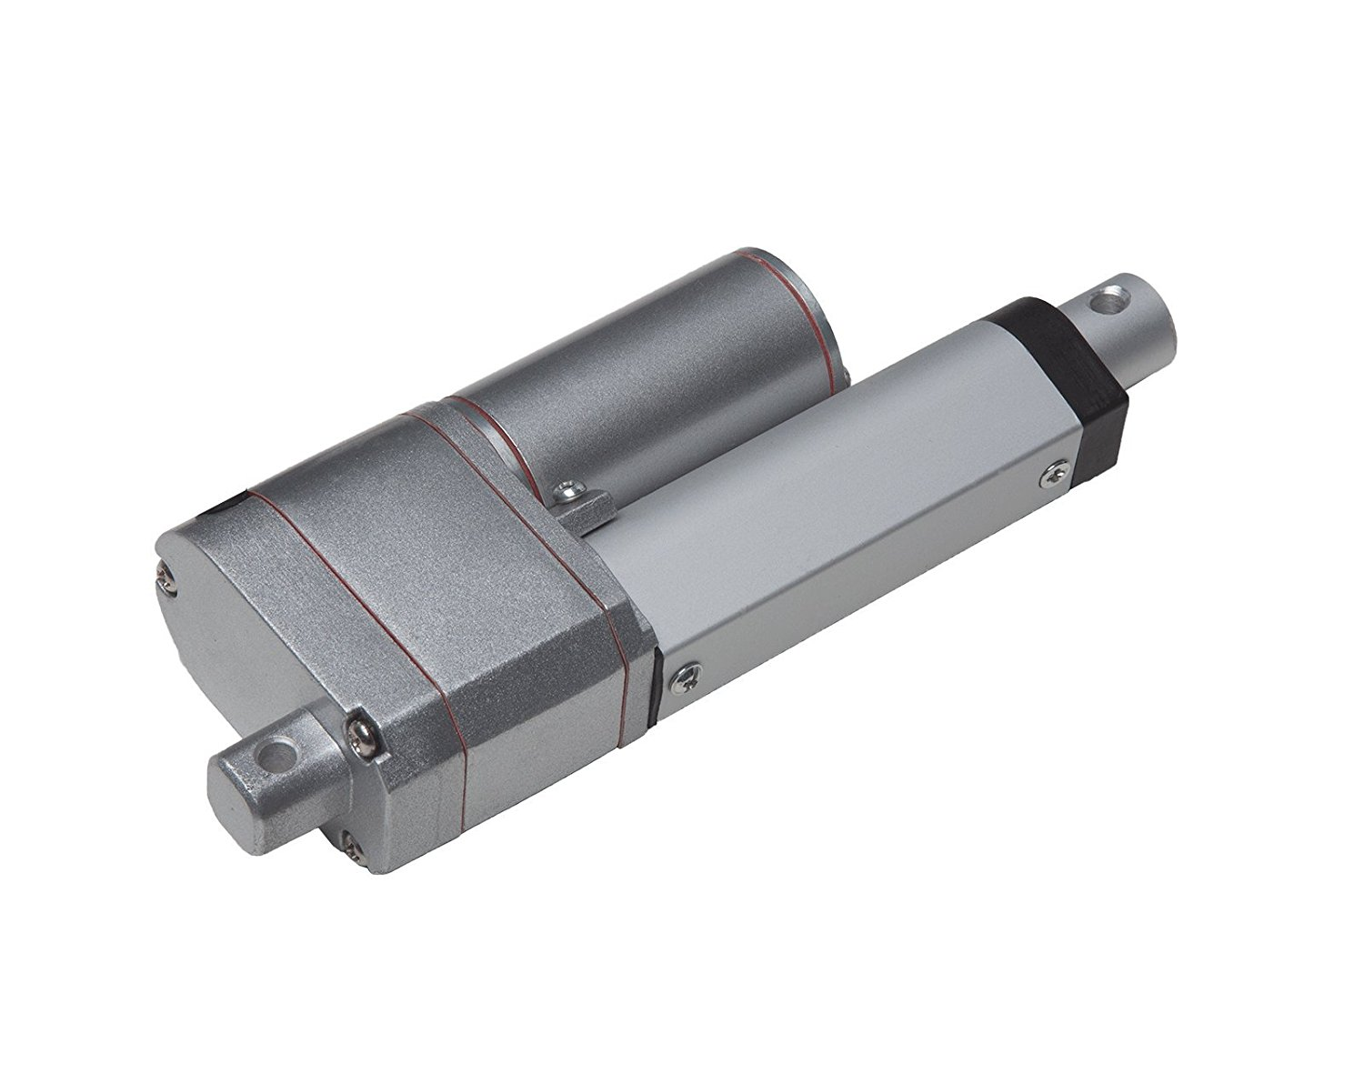

Explanation
1. Red, black for the power cord
2. Blue potentiometer baseline
3. White, yellow variable resistance line
4. When the push rod is elongated, blue, white line resistance gradually increases, blue, yellow line resistance decreasing
5. Stem retracts, blue, white line resistance gradually reduced, blue, yellow line resistance is gradually increased

