**Understanding Ecological Invasions on Complex Networks**

**1.** **Introduction**

Understanding the structures and evolutions of ecological communities is a difficult task due to the high complexity that results from the diversity of nature. Yet, it is important as it can help us create more efficient conservation methods and possibly mitigate the detrimental impacts that may be brought about by ecological changes. Every day, foreign species are brought into Singapore, especially viral pathogens that are introduced by tourists and workers. Foreign species have the potential to become invasive species, and this new addition would introduce a chain of changes in the invaded environment, eventually leading to loss a of genetic, species and ecosystem diversity[1]. A small change in the complex ecological food web can upset ecological balance. Moreover, it could lead to large changes in the trophic level relationships and food web interactions between individual species in the community. Invasive species not only prey on native species, but also increase food competition and may also introduce diseases that threaten the survival of other species[2].

Additionally, they pose a considerable threat to agricultural production, infrastructure, and animal and human health[3]. Recently, the Channel News Asia has brought to public attention sightings of the Red-billed Quelea (*Quelea quelea*), the ‘most destructive bird species in the world’, that was blamed for significantly reducing weaver and munia populations in Singapore[4]. Furthermore, ecological invasion has also cost $100 billion each year in US, and over £239 million in the UK alone[5]. Annual economical losses from ecological invasions have also been calculated to be much higher than losses due to natural disasters[6]. Evidently, there is an urgent need for deeper understanding of ecological invasions to reduce the damages caused.

Although it is true that invasive species may have destructive effects on the environment and economy, most foreign species actually die out quickly due to inability to adapt to the new environment. In particular, by sequencing the genomes of viruses found in confirmed dengue patients, and then building a phylogenetic tree, we know that most dengue cases are caused by our native dengue viruses[7]. Foreign dengue strains are never really able to establish themselves. Previous studies conducted by researchers from Kyushu University and Hokkaido University have indicated that the timing of invasion of predator species can produce vastly different results in the evolution and fates of the ecological community[8]. Yet another study has also shown that trophic position is critical in determining invasion success, and that easily invaded food webs were those with low connectance, high mean biomass and a great number of species[9].

**2. Hypothesis**

So is it easy or hard for foreign species to establish themselves, and become invasive? We believe invasion is a difficult thing to do, since most foreign species die out without establishing themselves. Thus, to understand ecological invasion, and identify the necessary and sufficient conditions for a foreign species to become invasive, in this study, we construct a complex network model of ecological invasion by simulating top-down control food webs and ecological invasion across two different ecosystems through the use of Python.

**3.** **Materials and Methods**

We used Python scripts to generate and match food webs. Another script was also created to simulate the evolution of the ecosystems over time.

3.1 Assumptions

Because we are using generated food webs instead of real data, we have several assumptions:

1. A food web can be divided into several **trophic levels**; any prey must be at a lower trophic level compared to their predator.
2. Any species in same trophic level will have same number of preys in the next trophic level, and the number will be given by a **function** related to the **numbers** of the species in these two trophic levels.
3. Some species may have preys located on trophic levels much lower than itself, and the possibility of forming this kind of relationship will **decrease rapidly**, given by a function which applies to all species in the food web.
4. All the programs run randomly, but under the limitation of certain functions or formulas.

3.2 Artificial Ecosystem Generation

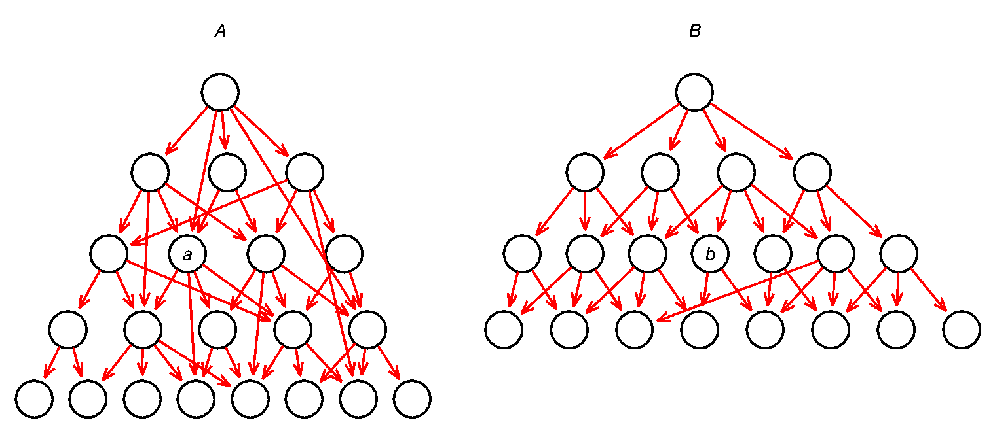

Figures 3.2.1 and 3.2.2 : Model food web A and B

In this model, we have two ecosystems, *origin ecosystem A*, and *destination ecosystem B*(figures 3.2.1 and 3.2.2). The two ecosystems need not be similar. Total number of species and trophic levels can vary. More importantly, a species on trophic level 3 in *A* may be the equivalent of a species on trophic level 2 or 4 in *B*. Therefore, a species *a* on trophic level 3 in *A* can be most similar to species *b* on trophic level 3 in *B*, but it can also be most similar to species on trophic levels 2 or 4 in *B*. This mapping of most similar species in *A* and in *B* need not be complete, i.e. there are some species in *A* that are not mapped to any species in *B*, and vice versa. This gives us the freedom to map species between *A* and *B*.

3.3 Model parameters

At the same time, we developed differential equations for our simulation to follow. We followed the Lotka-Volterra model(Equation 1.1) to construct these equations:

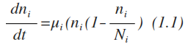 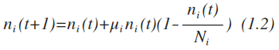

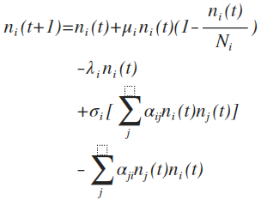

These equations take into consideration the following variables to determine population demography and food web interactions of an individual species: *n* represents current population of species *i*; *µ* represents growth rate per capita; *N* represents maximum population; *λ* represents death rate of the species; σ represents conversion rate of species, which affect the reproduction from predation; α represents predation efficiency.

3.4 Simulations

1. **Generator**: This script will randomly generate a food web according to the number of species in each **trophic level**. With parameter inputs, the script will generate a basic web as seen in figure 3.4. Then, the program will link more nodes across the levels according to the possibility function and modify the network to create different food webs. The output is an excel sheet. The purpose of this model is to find perimeters that enable us to simulate dynamic food webs that follow the interannual fluctuations of a food web in real life for greater accuracy.

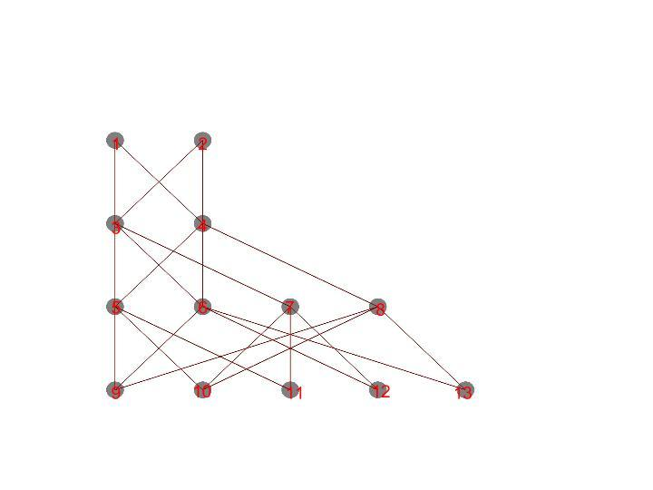

Figure 3.4: Food web structure for both ecosystems

1. **Matcher**: This script will list all the available positions in *destination* food web for the species in the *original* food web to invade. The output will be a list of numbers of available positions in a pure text file for each species in the *original* food web.
2. **Simulator**: This script will assign properties for each species in accordance to the differential equations, and run the simulation to check whether it is a successful invasion.

**4.** **Results and Discussion**

4.1 Generator

In this simulation, the death rate variable, *λ*, was fixed as zero. This indicates that death can only occur through predation, guaranteeing the survival of the top predators. By removing this variable, predator-prey interactions throughout both the evolution and invasion of the food web are more distinct.We discovered that the initial number of preys and predators in a new ecosystem played a significant role in the survival of other species in the web. A slight increase in the population of any species other than a basal species can spark a large change in the populations of other species, both directly and indirectly. This is depicted in figures 4.1.1 and 4.1.2 below, where initial populations of species 6, 7 and 8 were increased by a numerical value of 5. Similar observations were also made for variables σ and α.

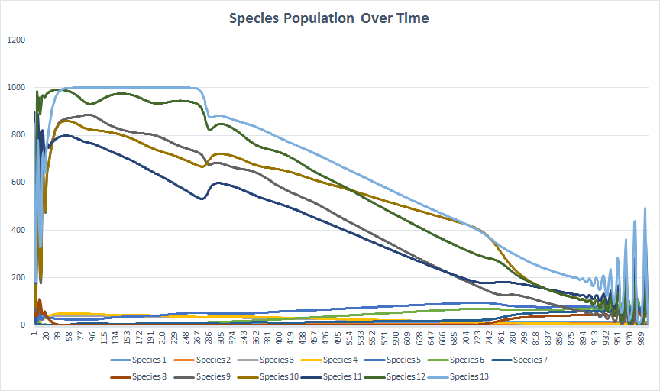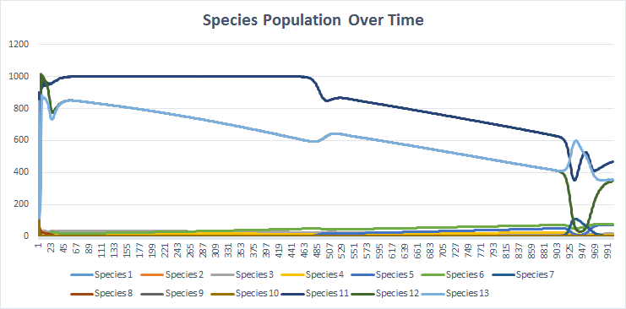

Figures 4.1.1 and 4.1.2 : Difference between species populations as result of increase in initial population

Fluctuations were observed at both the beginning and end of the graph. The fluctuation was small at the start but became bigger towards the end. These correspond to the predator-prey cycles that are a result of the Lotka-Volterra equations. This shows the strong link between predator and prey, and explains how small changes in the prey’s population will heavily affect the predator’s population and vice versa.

4.2 Invasion

The initial population of the invasive species was set as 0.1.

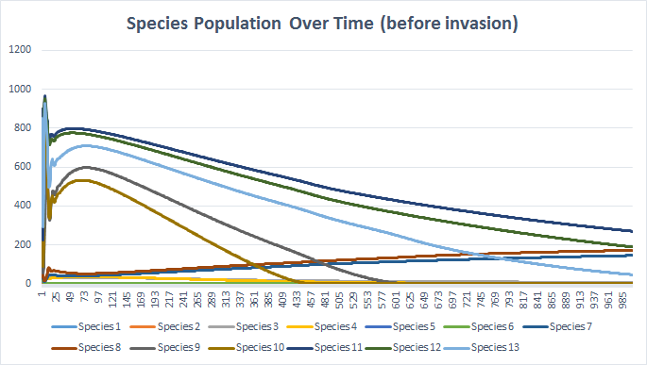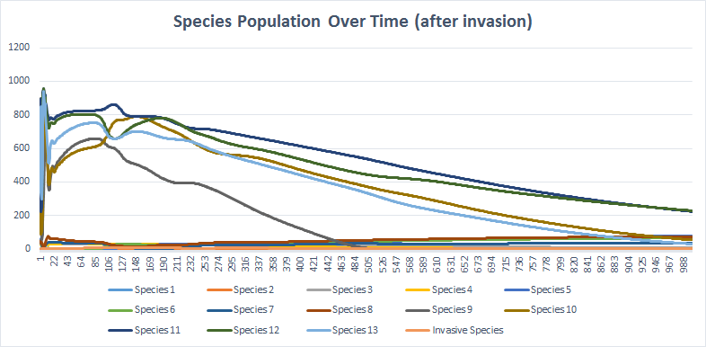

Figures 4.2.1 and 4.2.2 Difference in species population owing to successful invasion

The successful invasion of a foreign species would create chaos in the population dynamics of the ecosystem(figures 4.2.1 and 4.2.2). The haphazard lines observed near the start of figure 4.2.2 is the effect of invasion by a top-level predator into the second level. Owing to increased competition and predation, there is a significantly slower and lesser increase in the populations of species 7 and 8 over time. The population of basal species 11 also decreased after invasion. However, effects due to invasion were not very pronounced as the population of the invasive species was small when introduced, and remained small over time.

In addition, our study uncovered the relationship between percentage invasion and the pattern of species population over time. When 60% of species from the origin food web invaded the destination ecosystem, the graph of species population over time resembled that of the origin food web more closely. On the other hand, when only 1 of the species invaded, the effect generated by the invasion was mild and did not significantly alter the graph of species population over time(figure 4.2.2).

Also, after conducting 39 invasions(table 4.2.3), we uncovered the conditions needed for a successful invasion:

1. Any invasion where the invasive species becomes a top-level predator fails, unless it is was previously a top-level predator.
2. All invasions where the invasive species moves one trophic level down are successful.
3. All invasions in which the invasive species moves one trophic level up fail.
4. There is no one particular trophic level or species position which guarantees invasion success in our model.
5. Invasion of the same trophic level may or may not be successful
   1. For the invasion of basal species, species with the same number of predators in system 1 and system 2 have successful invasions; those with a different number of predators have failed invasions
   2. Success rate of same trophic level invasions is 81.3% (3 s.f.)

|  |  |  |
| --- | --- | --- |
| **Matched Species** | **Invasive Species** | **Final Population** |
| 10 | 11 | 2.28E-29 |
| 11 | 11 | 125.4559781 |
| 12 | 11 | 135.492763 |
| 13 | 11 | 141.1825423 |
| 9 | 11 | 0 |
| 1 | 1 | 0.439017949 |
| 1 | 3 | 9.458885723 |
| 10 | 5 | 0 |
| 10 | 7 | 0 |
| 11 | 5 | 0 |
| 11 | 7 | 0 |
| 12 | 5 | 0 |
| 12 | 7 | 0 |
| 13 | 5 | 0 |
| 13 | 7 | 0 |
| 2 | 1 | 0.439017949 |
| 2 | 3 | 9.458885723 |
| 3 | 1 | 5.65E-10 |
| 3 | 3 | 0.101412387 |
| 3 | 5 | 30.82343168 |
| 3 | 7 | 28.41663659 |
| 4 | 1 | 5.54E-10 |
| 4 | 3 | 0.093923794 |
| 4 | 5 | 31.07206962 |
| 4 | 7 | 28.19072674 |
| 5 | 3 | 0 |
| 5 | 5 | 0.091624737 |
| 5 | 7 | 2.07E-176 |
| 6 | 3 | 0 |
| 6 | 5 | 0.095777648 |
| 6 | 7 | 2.80E-235 |
| 7 | 3 | 5.43E-211 |
| 7 | 5 | 89.59685916 |
| 7 | 7 | 0.122356039 |
| 8 | 3 | 1.42E-207 |
| 8 | 5 | 89.58474785 |
| 8 | 7 | 0.12092658 |
| 9 | 5 | 0 |
| 9 | 7 | 0 |

Table 4.2.3: Invasion results

Any invasion with the final population of the invasive species as ≥0.01 is a successful one.

**5.** **Conclusion and Future Work**

Throughout the evolution of a community, it is natural to experience invasions by foreign species that may alter food web interactions and have profound impacts on the entire food web system. Our major finding is that for two systems sharing similar or identical structures, when the initial population of the invasive species is very small, the whole system will not undergo large changes, but will self-adjust to a stable state with little disturbance.

Additionally, isolated predators that invade with a low initial population are unlikely to experience great population increase. However, when there are too many invaders at the same time, the destination ecosystem is thrown out of order. At the same time, we discovered that if the two systems are similar, the invasion of the species tends to be easier.

Yet, this model is simplified and thus may not very accurately reflect invasions in real life as it is just a theoretical approach. It fails to completely reproduce predator-prey relationships. Therefore, we suggest increasing the accuracy of the model and results by including other predator-prey models in the study, such as the Jacob-Monod model and Cohen’s cascade model, and using actual data to run the program. The study can also be extended to include other variables such as migration and body-size selectivity to gain a better understanding of food web relations. For greater accuracy, phylogenetic constraints and environmental factors should be taken into account.

**6.** **Bibliography of References (in APS format)**

1. Qian, H., & Ricklefs, R. E. (2006). The role of exotic species in homogenizing the North American flora. *Ecology Letters*, *9*(12), 1293-1298. [20 Aug. 2015]

2. Nwf.org. Invasive Species - National Wildlife Federation [Online]. 2016. https://www.nwf.org/Wildlife/Threats-to-Wildlife/Invasive-Species.aspx [11 Jan. 2016].

3. Pimentel, D., Zuniga, R., & Morrison, D. (2005). Update on the environmental and economic costs associated with alien-invasive species in the United States. *Ecological economics*, *52*(3), 273-288. [21 Aug. 2015]

4. Neo C. Fears grow that invasive bird species may cause havoc here [Online]. *Channel NewsAsia* 2015. http://www.channelnewsasia.com/news/singapore/fears-grow-that-invasive/1848736.html [20 Aug. 2015].

5. White, P. C., & Harris, S. (2002). Economic and environmental costs of alien vertebrate species in Britain. *Biological Invasions: Economic and Environmental Costs of Alien Plant, Animal and Microbe Species*, 91-112. [20 Aug. 2015]

6. Ricciardi, A., Palmer, M. E., & Yan, N. D. (2011). Should biological invasions be managed as natural disasters?. *BioScience*, *61*(4), 312-317. [20 Aug. 2015]

7. Schreiber M, Holmes E, Ong S, Soh H, Liu W, Tanner L, Aw P, Tan H, Ng L, Leo Y, Low J, Ong A, Ooi E, Vasudevan S, Hibberd M. Genomic Epidemiology of a Dengue Virus Epidemic in Urban Singapore. *Journal of Virology* 83: 4163-4173, 2009.

8. Romanuk T, Zhou Y, Brose U, Berlow E, Williams R, Martinez N. Predicting invasion success in complex ecological networks. *Philosophical Transactions of the Royal Society B: Biological Sciences* 364: 1743-1754, 2009.

9. Mougi A, Nishimura K. Species Invasion History Influences Community Evolution in a Tri-Trophic Food Web Model. *PLoS ONE* 4: e6731, 2009.

**7.** **Appendices**

Python Modules (third party’s) used:

Python Image Library (PIL) for visualization

All codes are uploaded on Github: https://github.com/JoeyTeng/E-STaR-2015