Exercises from sec.10.2 - 10.3
학번 : 20141510, 이름 : 김민우
1.1 1
1.2 3
2.1 6
3.1 9
3.2 10
3.3 11

1.1
clc
clear
syms x y
F = @(x,y) y.*sin(x);
figure
ezsurf(F)
figure
ezcontourf(F)
colorbar, xlabel('x'), ylabel('y')
dFdx = inline(diff(F(x,y), x));
dFdx(0,-2)
dFdx(1,1)
[X, Y] = meshgrid(-3:.1:3, -3:.1:3);
figure
contourf(X, Y, dFdx(X,Y), -3:1:3)
colorbar, xlabel('x'), ylabel('y')
ans =
-2
ans =
0.5403
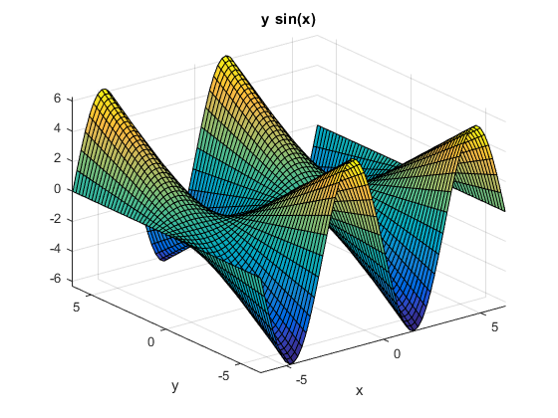
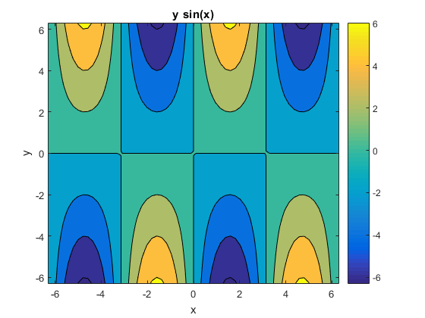
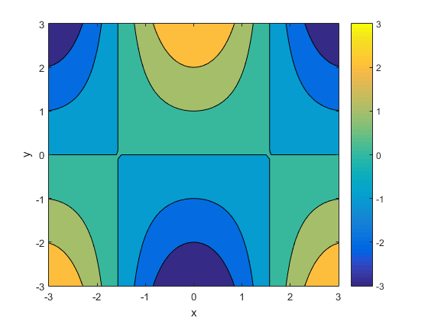

1.2
clear
syms x y
F = @(x,y) exp(-(x.^2 + y.^2));
figure
ezsurf(F)
figure
ezcontourf(F)
colorbar, xlabel('x'), ylabel('y')
dFdx = inline(diff(F(x,y), x));
dFdx(1,1)
dFdx(0,0)
[X, Y] = meshgrid(-2:.1:2, -2:.1:2);
figure
contourf(X, Y, dFdx(X,Y), -1:.1:1)
colorbar, xlabel('x'), ylabel('y')
ans =
-0.2707
ans =
0
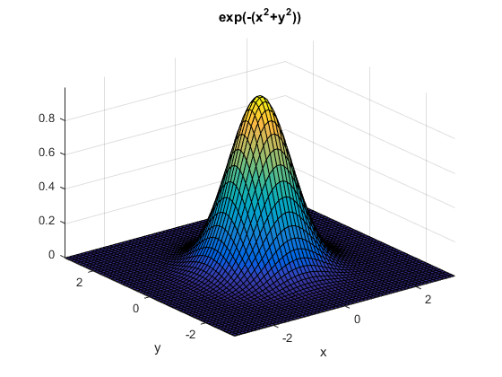
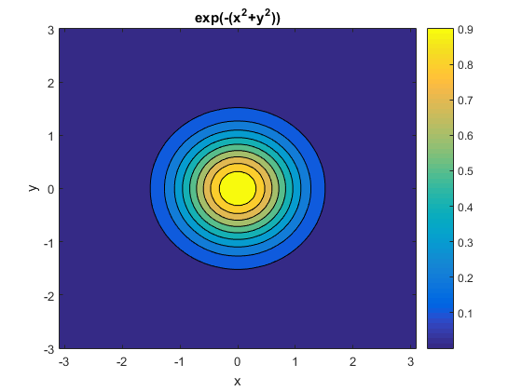
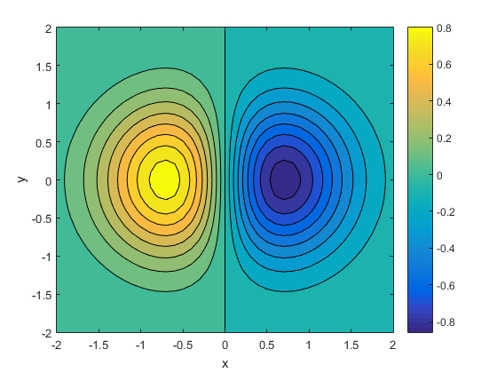

2.1
clear
syms x y
F = @(x,y) y.^2 - 2*x.*(y.^2) + (x.^2) .* (y.^2);
figure
ezsurf(F)
[X,Y] = meshgrid(-0.5:.1:2,-0.5:.1:0.5);
figure
contourf(X, Y, F(X,Y), -2:0.1:2)
colorbar, xlabel('x'), ylabel('y')
dFdx = inline(diff(F(x,y),x))
dFdy = inline(diff(F(x,y),y))
[dFdx_xSoln, dFdx_ySoln] = solve(2*x*(y^2) - 2*(y^2) == 0, x,y);
dFdx_xSoln
dFdx_ySoln
[dFdy_xSoln, dFdy_ySoln] = solve(2*y - 4*x*y + 2*(x^2)*y == 0, x,y);
dFdy_xSoln
dFdy_ySoln
figure
contourf(X, Y, dFdx(X,Y), -2:0.1:2)
colorbar, xlabel('x'), ylabel('y')
figure
contourf(X, Y, dFdy(X,Y), -2:0.1:2)
colorbar, xlabel('x'), ylabel('y')
% since dFdx(0,0) == 0, dFdy(0,0) == 0
% and dFdx(1,0) == 0, dFdy(1,0) == 0,
% (0,0) and (1,0) are critical points of F.
% From ezsurf(F), we know that (0,0) and (1,0)
% are local minima of F
dFdx =
Inline function:
dFdx(x,y) = x.*y.^2.*2.0-y.^2.*2.0
dFdy =
Inline function:
dFdy(x,y) = y.*2.0-x.*y.*4.0+x.^2.*y.*2.0
dFdx_xSoln =
0
1
dFdx_ySoln =
0
0
dFdy_xSoln =
0
1
dFdy_ySoln =
0
0
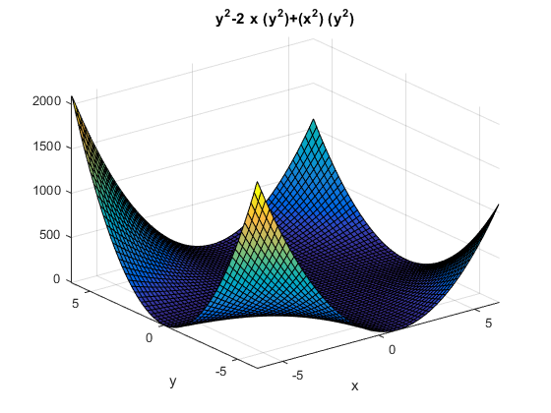
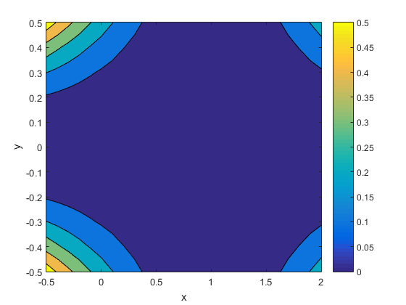
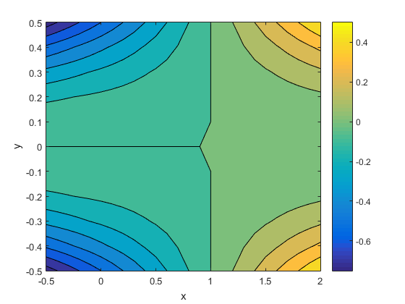
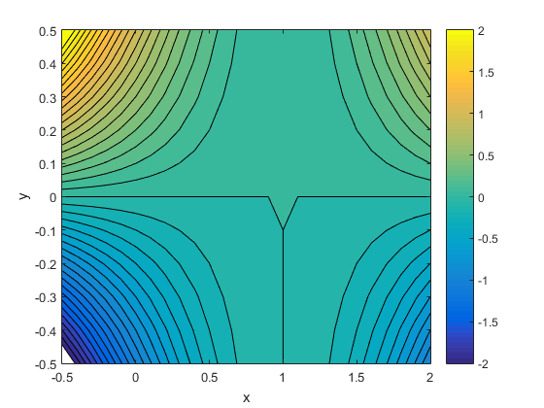

3.1
clear
syms x y
H = @(x,y) x + y;
figure
ezsurf(H,[1,5,0,4])
double(int(int(H,x,1,5),y,0,4))
ans =
80
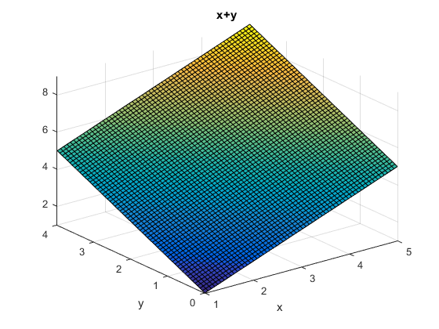

3.2
clear
syms x y
H = @(x,y) cos(x.*y);
figure
ezsurf(H,[0,sqrt(pi),0,sqrt(pi)])
double(int(int(H,x,0,sqrt(pi)),y,0,sqrt(pi)))
ans =
1.8519
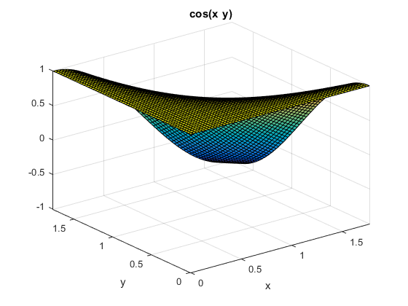

3.3
clear
syms x y
H = @(x,y) 1/(2*pi)*exp(-1/2*(x.^2+y.^2));
figure
ezsurf(H,[-2,2,-2,2])
double(int(int(H,x,-2,2),y,-2,2))
ans =
0.9111
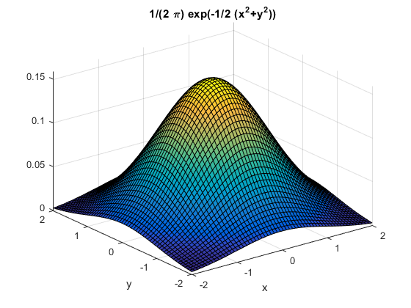
Published with MATLAB® R2015a

