Exercises from sec.11.1
학번 : 20141510, 이름 : 김민우
1.1 1
2.1 1
3.1 2
4.1 5

1.1
clear
syms theta
r = @(theta) cos(theta).*sin(theta);
figure
ezpolar(r,[0,2*pi])
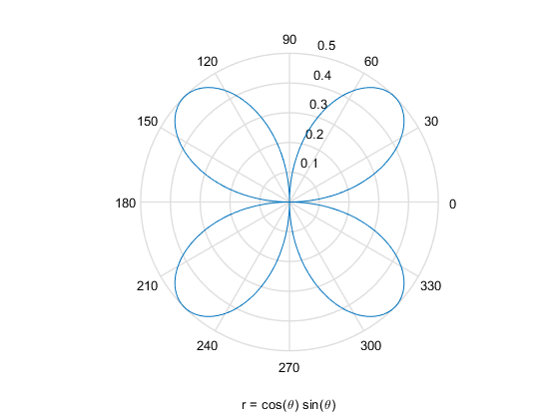

2.1
clear
syms theta
r = @(theta) cos(3*theta);
figure
ezpolar(r,[0,pi])
syms r
int(int(r,r,0,cos(3*theta)),0,pi)
ans =
pi/4
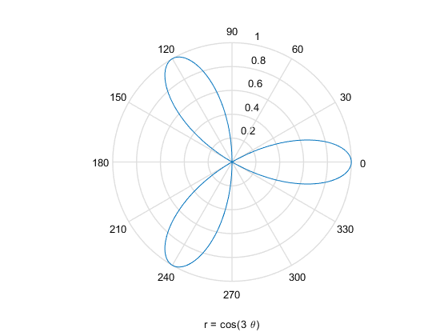

3.1
clear
syms x y r theta
x = r*cos(theta);
y = r*sin(theta);
% cartesian coordinate
figure
ezplot('(x-1)^2 + y^2=9')
axis equal
grid
pol = solve((x-1)^2 + y^2 - 9, r)
% polar coordinate
figure
ezpolar(pol(1))
figure
ezpolar(pol(2))
pol =
(cos(theta) - (9*cos(theta)^2 + 8*sin(theta)^2)^(1/2))/(cos(theta)^2 + sin(theta)^2)
(cos(theta) + (9*cos(theta)^2 + 8*sin(theta)^2)^(1/2))/(cos(theta)^2 + sin(theta)^2)
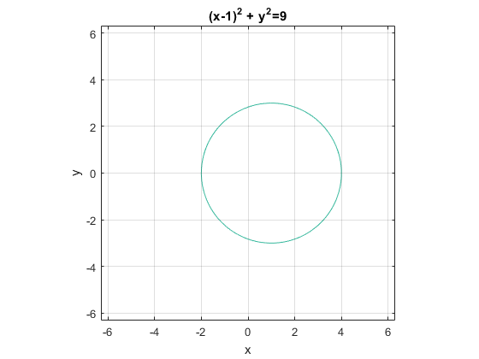
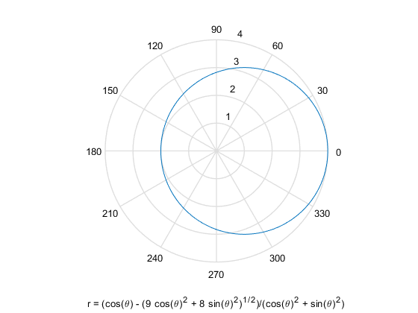
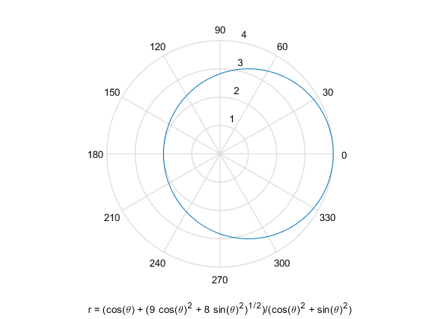

4.1
clear
syms x y r theta
r = sqrt(x^2 + y^2);
theta = atan(x/y);
solve(r-1+sin(theta), y)
ans =
(2^(1/2)*x*(x^2 + 3*x + 2)*((2*x - (1 - 4*x)^(1/2) + 1)/(x*(x + 2)))^(3/2))/4 - (2^(1/2)*((2*x - (1 - 4*x)^(1/2) + 1)/(x*(x + 2)))^(1/2)*(x^2 + x + 1))/2
(2^(1/2)*((2*x - (1 - 4*x)^(1/2) + 1)/(x*(x + 2)))^(1/2)*(x^2 + x + 1))/2 - (2^(1/2)*x*(x^2 + 3*x + 2)*((2*x - (1 - 4*x)^(1/2) + 1)/(x*(x + 2)))^(3/2))/4
(2^(1/2)*x*(x^2 + 3*x + 2)*((2*x + (1 - 4*x)^(1/2) + 1)/(x*(x + 2)))^(3/2))/4 - (2^(1/2)*((2*x + (1 - 4*x)^(1/2) + 1)/(x*(x + 2)))^(1/2)*(x^2 + x + 1))/2
(2^(1/2)*((2*x + (1 - 4*x)^(1/2) + 1)/(x*(x + 2)))^(1/2)*(x^2 + x + 1))/2 - (2^(1/2)*x*(x^2 + 3*x + 2)*((2*x + (1 - 4*x)^(1/2) + 1)/(x*(x + 2)))^(3/2))/4
-(2^(1/2)*(-(2*x + (4*x + 1)^(1/2) - 1)/(x*(x - 2)))^(1/2)*(x - x*(4*x + 1)^(1/2) + (4*x + 1)^(1/2) + 1))/4
(2^(1/2)*(-(2*x + (4*x + 1)^(1/2) - 1)/(x*(x - 2)))^(1/2)*(x - x*(4*x + 1)^(1/2) + (4*x + 1)^(1/2) + 1))/4
-(2^(1/2)*(((4*x + 1)^(1/2) - 2*x + 1)/(x*(x - 2)))^(1/2)*(x + x*(4*x + 1)^(1/2) - (4*x + 1)^(1/2) + 1))/4
(2^(1/2)*(((4*x + 1)^(1/2) - 2*x + 1)/(x*(x - 2)))^(1/2)*(x + x*(4*x + 1)^(1/2) - (4*x + 1)^(1/2) + 1))/4
Published with MATLAB® R2015a

